THE PHARMACOGNSTIC AND PHARMACOLOGICAL PROFILE OF AZADIRACHTAINDICA LEAVES (FAMILY MELIACEAE)

CONTENTS
Chapter -1
  - INTRODUCTION
    - Development of traditional system of medicine in India………………(01-11)
    - Phytochemicals – pharmacological evaluation ……………………………….(11)
  - Literature Review
  - Objective and plan work
    - Objective……………………………………………………………………………………..(11-12)
    - materials and methods………………………………………………………………..(12-13)
Chapter-2
2.1 plant profile ………………………………………………………………………………….(13-14)
2.2 collection of plant …………………………………………………………………………..(15)
2.3 Authentication ………………………………………………………………………………(15)
2.4 Macroscopy …………………………………………………………………………………..(15-16)
2.5 Microscopy …………………………………………………………………………………….(16-20)
2.6 powder Analysis
2.6.1 Organoleptical properties ………………………………………………………………(21)
2.6.2 Powder drug with chemical reagent ………………………………………….(21-22)
2.6.3 Fluorescence Analysis ………………………………………………………………..(23)
2.6.4 Ph Determination ……………………………………………………………………….(23-24)
2.6.5 Quantitative Microscopy
2.7 Physical Evaluation
2.7.1 Loss of Drying ……………………………………………………………………………..(25)
2.7.2 Extractive Value …………………………………………………………………………(26-27)
2.7.3 Ash Value ……………………………………………………………………………………(27-28)
2.7.4 Swelling Index …………………………………………………………………………(29)
Chapter -3
3.1 Phytochemical screening
3.1.1 Drying and Pulverization …………………………………………………………..(30)
3.1.2 Preparation of Extract……………………………………………………………….(30)
3.2 Quantitave chemical Evaluation ………………………………………………..(30-38)
Chapter -4
4.1 Pharmacological Screening
4.1.1 Analgesic Activity …………………………………………………………………………(38-41)
Chapter-5
5.1 Result and Discussion ……………………………………………………………………(42)
Chapter -6
6.1 BIBLIOGRAPHY………………………….………………………………………………(43-44)

Chapter -1
  - Introduction:
The factory has historically served as a source of pharmaceutical raw materials. The Atharva Veda, Charkas, Susrutha, and other ancient scholastic works include a wealth of knowledge on preventative and therapeutic medicines. 13000 plant species are thought to be used as drugs worldwide, according to an estimate.
Thus, from the beginning of time, man has become familiar with plants, some of which have become extensively used as food and others of which have shown therapeutic effects against a variety of human suffering, including disease and injury.
The relationship between plants and knowledge to cure sickness has developed at an accelerated rate, as has the number of new plants. Even vegetables like garlic were kept at home because they were thought to be beneficial in driving away evil spirits .It was not realised at the time that garlic contains antibacterial, antifungal, anticancer, antihypertensive, and other beneficial properties. Thioglycosides and other disulfides are active components found in essential oil.
Many of the opium alkaloids that were once used to treat opium-related illnesses are still employed in modern medicine. The most well-known of these is the analgesic morphine.
The middle of the 19th century saw the first extraction of a combination of so-called cardio active glycosides from foxglove leaves. Since then, clinical techniques have advanced, and we are now able to distinguish between the several digitalis -glycosides.
Since they have been used for a long time to treat human diseases, herbal medicines contain a large number of chemical components. Currently, 67 to 70 percent of modern medications come from natural sources. Due to the increased interest in using medical plants around the world, there has been a tremendous increase in the number of industries based on medicinal plants, which are expanding at a pace of 7–15% per year.
The world is endowed with a rich abundance of medicinal plants, which have global significance. The primary form of medicine in India has always been herbs, and they are currently gaining popularity throughout the developed world as people try to stay healthy in the face of ongoing stress and pollution, and treat illness with drugs that support the body's natural defences.
People consult trend herbal professionals and use plant remedies in Europe, North America, Australia, and India. Rural residents, particularly those in distant areas of developing nations with scant health facilities, rely heavily on medicinal plants for their daily needs.
Due to the existence of many complex chemical compounds with varying compositions that are found as secondary metabolites in one or more portions of these plants, medicinal plants have therapeutic powers.These plant metabolites are classified as alkaloids, glycosides, cortigosteroids, essential oils, etc. based on their chemical makeup.The glycoside from another significant group represented by digoxin (fox glove), glycyrrhizin (liquorice), barbolin (aloin), etc. and the alkaloid from the largest group that includes morphin, codeine (Poppy), strychnine, and brucine (nux vomica), among others. Diosgenin (dioscorea), solasodine (solanum species), and other corticosteroids now attract a high level of global demand. Some essential oils, like peppermint, kutch, and valerian, have medicinal qualities and are employed in the pharmaceutical sector.
From the plains to the high Himalayas, south Asia's forests are home to medicinal and aromatic species. The Himalayas are regarded as a treasure trove of medicinal riches. The Himalayas and Shivalik belt are also referred to as the "land of Ayurveda" in various geographical references.
The usage of herbal medicines has attracted a great deal of attention over the past ten years. India contributes fairly little to the global market for the export of medicinal plants. With careful planning and the use of our biodiversity, Indian products may easily reach international markets. Only by careful cultivation of medicinal plants, standardisation of extracts, and maintenance of quality can this be accomplished. WHO has acknowledged the efficacy of conventional.
85 medicinal plants were recognised by the Indian Pharmacopoeia in 1996, and their components are employed in a variety of pharmaceutical formulations. However, the content is limited to a few significant medicinal plants that are grown for commercial purposes and whose cultivation should be given top importance in our national economy.

Currently, medicinal plants are viewed as a source of money as well as an accessible form of healthcare. based on the WHO report. For their basic medical needs, more than 80% of the world's population turns on traditional medicine, which is primarily based on plants.
Herbs and medicinal plants have traditionally been found in forests. The situation cannot be maintained for very long since, although the areas covered by forests have been progressively decreasing, the uit nen of mealtitial piano at 16 has been rising sharply. As a result, there are now too many 5-medicinal plants in the forests.
Numerous forest plants are destroyed as a result of the unrestrained removal and sale of vast amounts of plant material. Local residents, traditional healers, and dealers of herbal medicines frequently gather roots, bark, and entire bushes. This is a really significant issue.s
Hence, awareness and proper training program on cultivation, preservation, processing and contractual forming of these entire herbal products should be tied up with pharmaceutical and cosmetics producing industries.
The plant Kingdom still holds many species of plans containing substances of medicinal value, which are yet so be discovered. Development of modern drugs from plants is very much needed for the treatment of some of the diseases Many modern medicines and prepared making use of natural products as their main ingredients (eg. Penicillin reserpine from rauwalfia , Ephedrine from Ephedra species, Opium from Papaver somniferum , Quinine from Cinchon species Inspite of them, there are still a large number of conditions like AIDS, viral Hepatitis etc for which suitable drugs are not available in the modern system of medicine
Herbal medicines produce their effects without inducing much of the complicated side effects of modem medicines some of which are life threatening Traditional and pharmacological evaluation of these plants and their taxonomical relatives can lead to the development of invaluable plant drugs for many serious diseases
Herbal preparations are preferred nowadays due to their efficacy, low cost . Easy availability and less side effects. They are prepared either from a single plant or combinations of more than one plant.
Now the whole universe including the west has realized the importance and efficacy of herbal medicines. Even in the west, natural products are now widely available and herbalism is again coming into the world because of its bio medical benefits.
    - Devlopment of traditional system of medicine in India :

The development of Indian System of Medicine gained considerable momentum after independence. The Govt. has established in 1969 the Central Council of Research in Indian Medicine and Homeopathy (CCRIMH) to develop scientific research in different system of medicine vie. Unani, Ayurveda, Siddha Yoga, Naturopathy and Homeopathy. In 1978 the (CRIMH split up into four separate research councils One each for Unani, Ayurveda. Siddha Yoga/Naturopathy and Homeopathy as under to explore the possibilities in TSM in India.

- Central council for research in Ayurveda and Siddha (CCRAS)
- Central council for research in Unani medicine (CCRUM)
- Central council for research in Homeopathy (CCRM)
- Central council for research in Yoga and Naturopathy (CCRYN)

These central councils have again their own research institutes ,labrotories and dispensaries on their individual capacities through out India , which work on the development and propagation of the respective system and there by to get lead compounds from the tradition for the treatment of deadly aliments . Later on in 1995 the department of Indian system of medicine and homeopathy has been made by Government of India in the ministry of health and family welfare which in controlling all the regulation relating to TSM. The manufacture , quality control and sale of all these traditional medicine are regulated through drug and cosmetic acts.
Ayurvedic formulary of India is another clasified treatise on the TSM published by the same ministry. These are the various formulation and standardization parameters .
- Contain single and compound formulation
- Provide standard for medicine used in Ayurvedic practices
- Lay down test for identify, purity and quality
- Ensure uniformity in physical and chemical properties including active constituents composition
- Provide all other information distinguishing character ,preparation dosages , administration , toxicity etc .
The CCRUM established in 1978 in engaged in developing independent and multidimensional research into various fundamental and applied aspects of Unani System of Medicine. The area of research chosen by the council includes clinical research, standardization of single and compound drugs. literary research, cultivation of medicinal plants and family welfare research
    - Phytochemical – pharmacological evaluation
Based on the Traditional System of medicine, the use of a crude plant for a particular therapeutic activity, its extraction and fractionation may be carried out. The fractions of extract may prove to be effective, and less toxic for a particular ailment, when compared to an already existing alternative drug. These extracts may be studied for their pharmacological effects. For this animal models are made use of Since they are expensive. less effective tests are performed which give a better understanding of the action of the drug.
1.3 OBJECTIVE AND PLAN OF WORK
1.3.1 OBJECTIVE
Azadirachta incdica A.juss , belonging to the family of meliaceae is an important medicinal plant used in the traditional system of medicine to treat various disease for the betterment of mandkind . It is commonly known as indian neem or margosa tree which is evergreen and cultivated in various part of indian and sub-continent.Almost every part of the tree is used to treat various disease .The leaves are alternate in arrangement and consist of several leaflets in them with separated edge. Flowers are soft and white in colour .The first is oval , round and skinned . Neem is used in the treatment of diabetes , helminthiasis, respiratory disorders , constipation ,rheumatism, chronic syphilitic sores . indolent ulcer , biliary , afflications , skin ulcers , burning sensation , as a good health promoter insecticidal tumour, pil and in skin disease activities . The plant contain a number of secondary metabolites namely alkaloids , resins , glycosides ,gum. Considering the significant of this plant , the present investigation is directed to remain some pharmacognostic parameter of the leaves as a whole and its Powdered form.
    - Material and Methods
Plant material
The leaves of Azadirachta indica A. juss (family:Meliaceae) were collected in the month of January from CUTM,Rayagada campus of Rayagada District. Odisha India and were authenticated by the Faculty of department of Pharma Cognosy, CUTM,Rayagada,odisha . The herbarium was prepared and kept in the department for future reference . The collected leaves were washed :shade dried and was pulverized with mechanical pulveriser for size reduction . It was then passed through and the fine powder was collected and used for experiment.
Pharmacological studies
Morphological studies were carried out by using simple determination technique ,the shape , size , color , odour , margin and apex .
Leaf constant
Various leaf constant such as vein termination number , vein islet number , palisade ratio , stomatal number and stomatal index were studied with the help of microscope.
Physical & chemical parameter
The parameter was done to evaluate the percentage of total ash , water soluble , acid insoluble ash were calculated per Indian pharmacopoeia . The extract of the Powdered leaves were prepared with the different solvents for the study of extractive value . Fluoscence analysis was also carried out for the powder.
Preliminary phytochemical analysis
For the preliminary phytochemical analysis , the extract was prepared by weighting 100gm of dried powdered leaf and were subjected to maceration with different solvents as per the polarity , petroleum ether , benzene , chloroform , ethyl acetate ,ethanol , methanol and finally with aqueous . The extract were filtered in step , concentrated and the solvent and finally with aqueous . The extracts were filtered in each step , concentrated and the solvent was removed by rotary evaporator.The extract were dried over desiccator and the residues were weighed . The presence and absence of the primary and secondary phytoconstituent was delested by prescribed method.

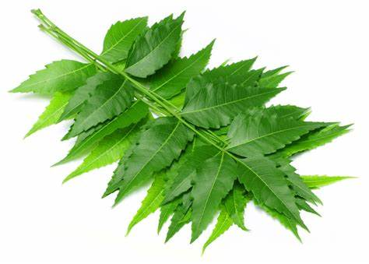
2.1 PLANT PROFILE
Botanical name : Azadirachta indica A.juss
Family : Meliaceae
Taxonomical classification
Kingdom : Plantae
(unranked) : Angiosperm

(unranked) :Eudicots
(unranked) :Rosids
Order : Sapindales
Family : Meliaceae
Genus : Azadirachta
Species : A. indica
Vernacular names
English - Margosa , neem tree
Bengali- Nim
Gujurat -Dhanujhada , limbda
Sanskrit - Arishta , parvakrita, Nimbaka
Telgu-Neem
Odiya - Neem
Marathi - Kadunimba
Habit and Habitat:
The neem is noted for its drought resistance . Normally it thrives in areas with sub arid to sub humid condition , with an annual rainfall of 400-1,200 milimeter (16-47). It can grow in region with annual rainfall below 400mm , but in such cases it depend largely on ground water level . Neem can grow in many different types of soil . It is typical tropical to subtropical tree and exist at annual mean temperature of 21-32 C (70-90F ). It can tolerate high to very high temperature below 4 degree celsius . Nem is one of a very few shade giving trees that thrives in drought prone areas e.g the dry coastal sourthern district of india and pakistan . The trees are not at all delicate about water quality and thrive on the merest tricle of water , whatever the quality. In india and tropical country where the indian diaspora has reached , it is very common to see neem trees used for shade lining streets around templates , school and such other public building or in most people back yard . In very dry areas the trees are planned on large tract of land .

COLLECTION OF PLANTS
The leaves of Azadirchta indica A.juss (family - meliaceae) were collected in the month of January from Centurion university of technology and management, Rayagada campus,Odisha,India and were authenticated by the botanist of dapartment of botany,centurian university of technology and management ,rayagada , odisha
Time of collection
The plants are collected in morning time .
Month of collection
The plants are collected in the month of september and october , 2016
2.3 AUTHENTICATION
The plants are authenticated by the botanist of department of botany , Centurian university of technology and management rayagada , odisha . The sample was identified to be Azardichta indica A.juss (meliaceae)
2.4 MACROSCOPY
Morphological study: Morphological observations were made from living plamts collected during seven field trips and procured from 18 herbal shops . Morphological studies (root, leaf , stem and flower ) were also based on examination of 20 herbarium specimen available at ISLQAU herbaium, islambad . Further information from taxonomical and floristic sources provided confirmation of morphological characteristics (hooker 1875 : Tutin & Hwywood 1972 nasir & Ali (1974-1975) . Morphological examination conducted using a binacular stereo zoom light microscope (model SZF kyoswa , japan , with eye piece WF 10 ×10/. Assesssment of floral morphology was aided by reconstitution of dried flower in hot water with detergent . All the field images presented was taken by the author using a sony digital camera (DSC-W50).
Organoleptography:
The organoleptic analysis was based on field collection and sample of crude herbal parts procuredfrom herbal shop . The crude herbal samples were cleaned were studied . The crude herbal samples were numbered and preserved in glass bottle and zipped plastic envelope . The macroscopic feature of the herbal parts were studied with a Olympus binocular light microscope .
Constant features
Shape Oblique , lanceolate
Size 3.9-5.1 cm in length and 1-1.4cm in wide
Color fresh leaves are green and 1-1.4cm in wide
Base Symmetric
Margin Serrate
Apex Acuminate
Vernation Pinnate type
Orientation Dorsiventral
Texture Thin papery
Taste Bitter
Odour Unpleasent
2.5 MICROSCOPY
Palynological study:
A palynological study of Azzaditachta indica and its adulterant melia azedarach was conducted using light microscopy (LM) and scanning electron microscopy (SEM). The pollen sample studied were obtained from fresh collection. Fully matured anthers were removed from specimen and prerpared by the standard procedure of acetolysis (Erdtman , 1960) , after which they were mounted in glycerine jelly and sealed with parrafin wax for light microscopy. The glycerine jelly was prepared according to modified method oif zafar et al. (2011) measurment and morphological obesrvation of pollen were fixed to alluminium stubs with double sided cellphone , tape , air dried at room temperature a d coated with a very thin layer of gold (JFC-1100). The specimens were examined using a scanning electron microscope(JEOL-JSM 5910) at 2000x , 5000x , and 10000x magnification . the b terminology used for sculputring is based on the work by Erdtman ( 1960), Barthlott(1984) and ronald (2000).
Anatomical study
For epidermal prerparation ,leaf sample of 1to 3 cm were cut from the mid portion of mature foliage leaves . Shultz s method ,with modification , was used (subrahmanyam , 1996 Zafar et al,2011).The peelings of leaves were washed with distilled water for 2-3 min. The leaf blades were placed with the adaxial side upward and then scarped gently with a sharp razor . The same procedure was followed to prepare the abaxial and adaxial side but the leaf was placed with the adaxial surface upward.The abaxial and daxial epidermiss peeling were placed on clean glass slides with 1-2 drops of 88% lactic acid ,covered with cpver slip and fixed with parafim wax . Prepared slides were observed under a meiji lighy microscope. The microphotographs of adaxial and abaxial surface were taken with a leica light microscope fitted with a CCD camera (DM-1000).The same procedure was adopted to peal of the leavesfrom adaxial surface for SEM study. The peelings were dried at room temperature and then affixed with double sided tape and coated with the same manner as the pollen .
Quantitative leaf microscopy
Quantitative leaf microscopy to determine palisade ratio , stomata number , stomata index , vein - islet number and vinlet termination number were carried out on epidermal strips.
Stomatal number :
Material:
- Fresh leaf peel
- Chloral hydrate solution
- Stage micrometer
- Drawing board
- Camera lucida
- Black tracing paper
Procedure :
The upper and lower epidermal layer of the leaf peel was cleared with chloral hydrate solution and mounted on a slide , with the help of camera lucida and stage micrometer one mm square was drawn on a paper . The stage micrometer one mm square was drawn on a paper. The stage micrometer was observed and their stomata were marked in that unit area . then the number of stomata present in that area was calculated . Five such reading were taken and the average number of stomatal number was calculated.
Stomatal index
It is the percentage which the number of stomata forms to the total number of epidermal cells , each stomata being counted as one cell.
Stomatal index (I) ={S/(E+S)} ×100
Where ‘s’ denotes the number of stomata per unit area . ‘E’ denotes the number of epidermal cells in the same unit area.
Material
- Fresh leaf peel
- Chloral hydrate solution
- Stage micrometer
- Camera lucida
- Drawing Board
- Black tracing paper
Procedure:
Pieces of upper and lower epidermal layers of their leaves were cleared by chloral hydrate sloution and mounted on a slide . A camera lucida and a driving board were arranged . A unit area covering the entire field of view was drawn on a paper . Then the preparation was observed ender high power . The epidermal cells and the stomata were counted .
Same process is followed for the determination of palisade ratio & vein -islei number .
MICROSCOPIC CHARACTERS OF AZADIRACHTA IDICA LEAVES
Parameter | Range | Average
Vein -islet number | 12-16 | 14.9
Palisade ratio | 3.2-3.6 | 3.4
Stomatal index | 9.1-9.8 | 9.4

Measurment of microscopic elements of the leaves
Names of the elements | Size range
Trichomes | 150-240
Upper epidermal cells | 17-31
Lower epidermal cells | 16-31
Upper pallisade cells | 16-38×5-13
Lowers pallisade cells | 18-21×6-11
Pith cells | 25-5

Leaf microscopy
The outer epidermal membranpus layer (in fragments) were cleared in chloral hydrate , mounted with glycerin and observed under a compound microscope . The presence / absence of the following was observed : epidermal cells stomata (type and distribution ) and epidermal hairs (types of trichomes and distribution , epidermis (upper and power ), hypodermis , spongy parenchyma , stomata number stomatal ,vein inslet and veinlet termination number were determination by using fresh leaves of the plant .15 xylem elemeny and ground tissue were also observed under microscope . The transverse section of the fresh leaves through the lamina and the midrib were also cleared , mount
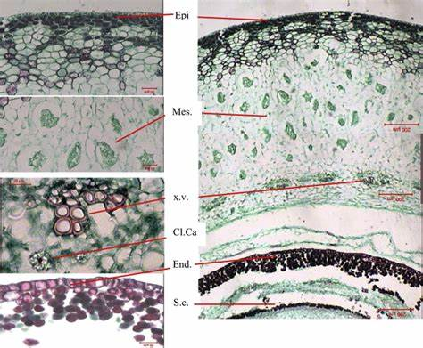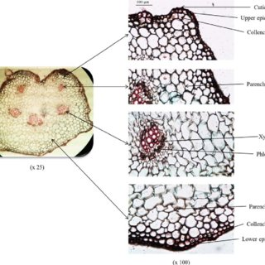
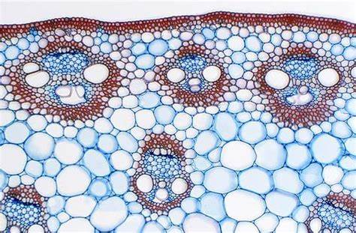
- Elongated , fusifoerm , tapering narrow at both end fibres are found with thick and watty walls .
- Prismatic crystals of calcium oxalate are found .
- Annular vessels inicellular covering trichomes , anisocytic stomata.
- Simple starch grain are found.
- Multicellular covering trichomes were found.

2.6 POWDER ANALYSIS :
2.6.1 Organoleptical properties
Color : Green
Odour : Characteristics
Taste : Characteristics
2.6.2 Powder Drug with chemical Reagents
The Powder drug with different chemical reagent show different color when seen on naked eye.
POWDER ANALYSIS WITH CHEMICAL AGENTS 4
Reagents | Colour observed
Powder as such | Greenish yellow
Powder + Concentrated HCL | Blackish green
Powder + Concentrated HNO3 | Deep brown
Powder + Concentrated H₂SO₄ | Black
Powder + 5% NaOH solution | Yellowish green
Powder + 5%KOH solution | Yellowish green
Powder +5% ferric chloride solution | Blackish green
Powder + Picric acid | Yellowish green
Powder + Ammonia | Brownish red

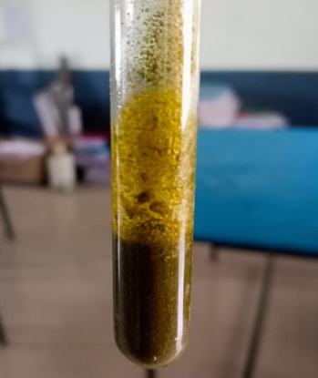
Powder + Picric Acid Powder + 5% of KOH solution Powder + 5% of NaOH solution
Yellowish Green Yellowish Green Yellowish Green

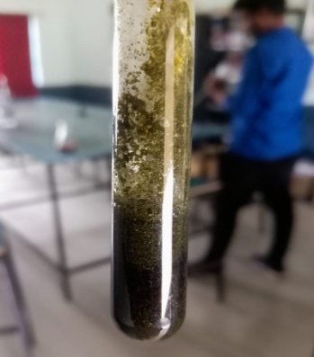

Powder+ Concentrated HCL Powder+ 5% of Ferric Chloride Sodium BlakishGreen Blackish Green
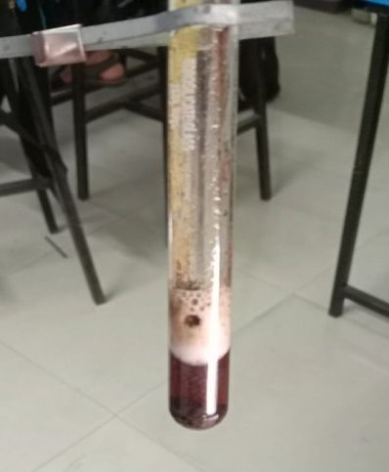

Powder+Concentrared HNO₃
Deep Brown

2.6.3 Fluorescence analysis:
Many drugs fluorescence when their powder is exposed to ultraviolet radiation . It is important to observe all ,material on reaction with different chemical reagents under U.V light . The flluroscence characteristics of Powdered drugs were studied under UV light after treating with different chemical reagents are reported .
FLUORESCENCE ANALYSIS OF POWDERED DRUG
FLUROSCENCE OBSERVED
REAGENT | SHORT WAVELENGTH | LONG WAVELENGTH
Powder as such | Greyish green | Brown
Powder +1N NaOH in methanol | Greenish black | Yellowish brown
Powder + 50% hydrochloric acid | Bluish black | Light orange
Powder + 50%sulphuric acid | Greenish grey | Black
Powder + 50% Nitric acid | Deep violet | Yellowish green
Powder + picric acid | Green | Greenish black
Powder + Glacial acetic acid | Green | Orange
Powder +5% KOH solution | Greenish red | Greenish brown
Powder + Nh3 | Green | Yellowish green

2.6.4 pH Determination
pH 1% solution
Material
- 1 gm powdered drug
- 100ml of distilled water
- Filter paper
- pH meter standard glass electrode
Procedure : 1 gm of the accurately weighed drug was treated with 100ml of distilled water and filtered .pH of the filtrate are checked with a pH meter (Elioco) having standardized glass electrode.
pH 10% solution :
Material
- 10 gm Powdered drug
- 100 ml of distilled water
- Filter paper
- pH meter with standardized glass electrode
Procedure: 10 gm of the accurately weighed drug was treated with 100ml of water and filtered .pH of the filtrate was checked with a pH meter (Elico) having standardized glass.
pH OF POWDERDED DRUG
pH OF 1% SOLUTION | pH 10% SOLUTION
7.76 | 7.57
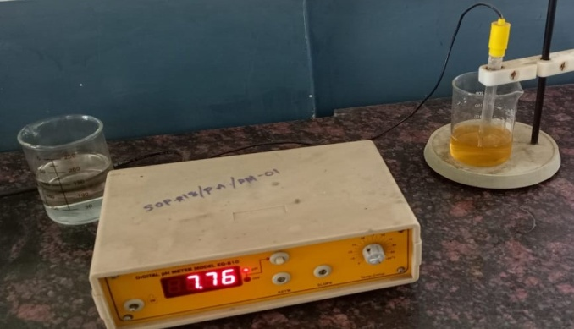
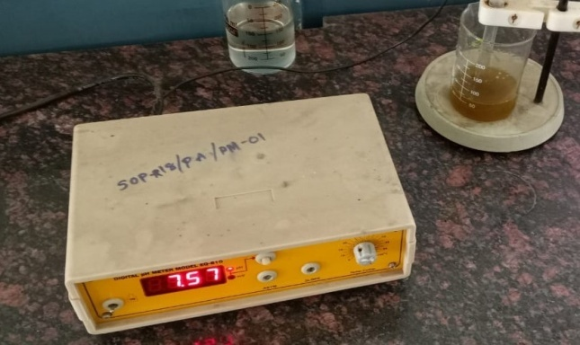

2.7 PHYSICAL EVALUATION
2.7.1 LOSS OF DRYING
MATERIALS:
- Powder drug (5 mg )
- Glass stoppered shallow weighting bottle
- Hot air oven
- Desiccators
Procedure:
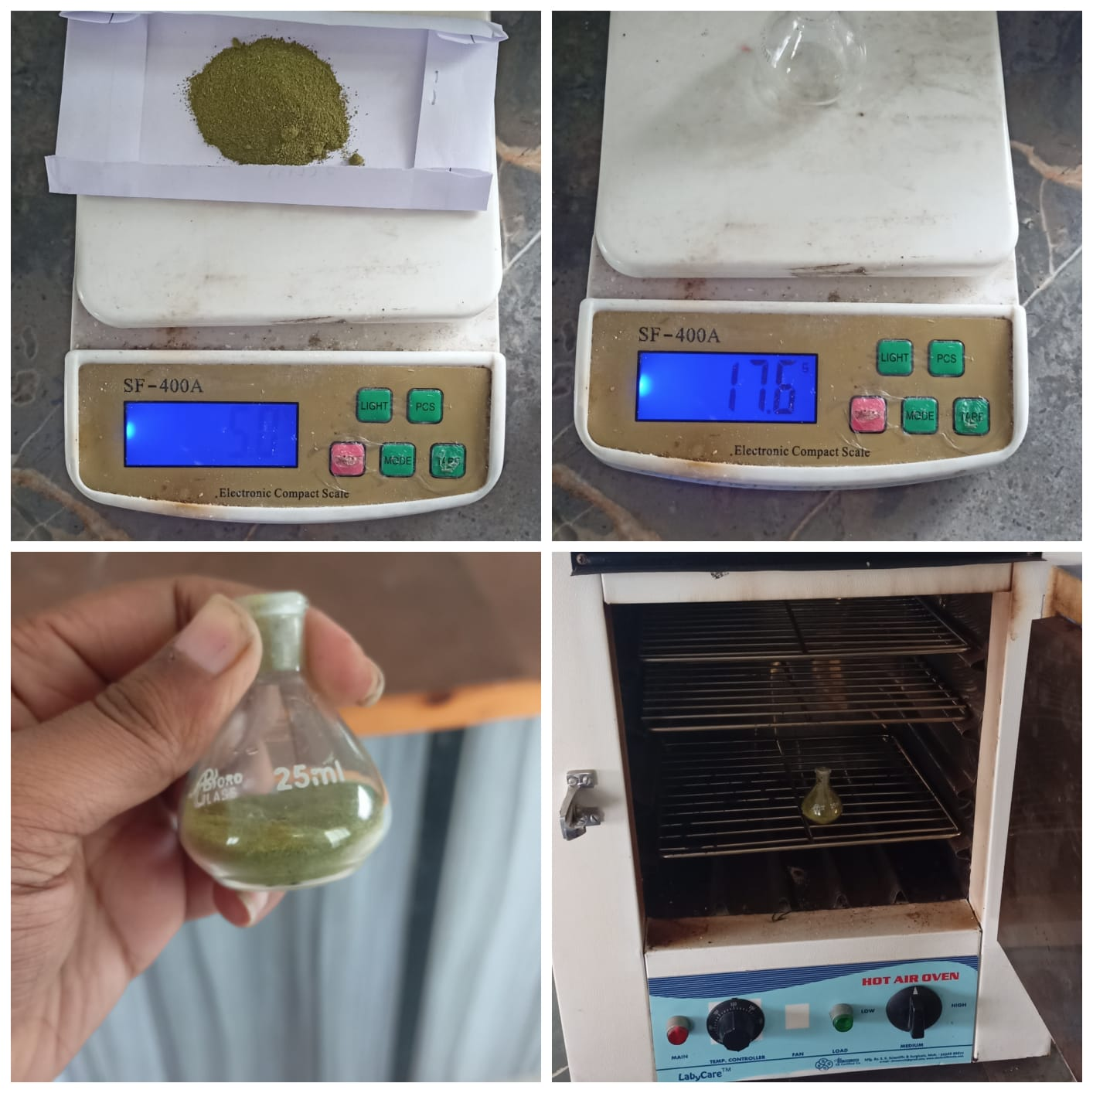
A glass stopped shallow weighing bottle was dried and weighed and 5 mg of the powdered drug was transferred to the bottle. The bottle was then covered and the bottle along with the content was weighted. The sample was then distributed as evenly as practicable by gentle side wise shaking to a depth not exceeding 10mm. The loaded bottle was then placed in the hot air oven; the stopper was removed and left it in the oven. The powdered drug was then dried to constant weight or for 30mm and at a temperature of 105 C. After drying is completed the hot air oven was opened and the bottle was closed promptly and allows cooling to room temperature in desiccators before weighting. The bottler and the content are then weight. The procedure was continued until a constant weight come
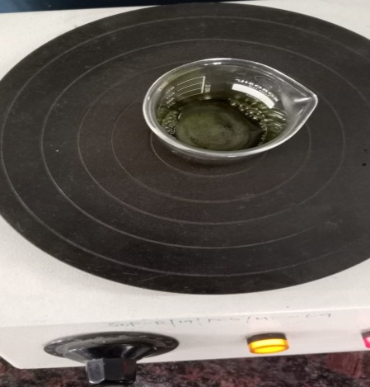
2.7.2 EXTRACTIVE VALUE
Ethanol soluble extractive
Material :
- Powder drug (5mg)
- Stopped conical flask (250ml)
- 90% Ethanol (bengal chemical and pharmaceutics Ltd)
- Flat bottomed shallow dish
Procedure:
5 gm of the air dried drug was coarsely powdered, taken in a stopped conical flask and macerated with 100ml of ethanol (90%) for 24 hrs .shaking frequently during the first 6hr and allowing standing for 18 hrs. Thereafter it was filtered rapidly taking precautions against loss of ethanol, and then 25ml of the filtrate rapidly taking precautions against loss of ethanol, and then 25ml of 105 c and weighed. The percentage of ethanol - soluble extractive was calculated with reference to the air dried drug.
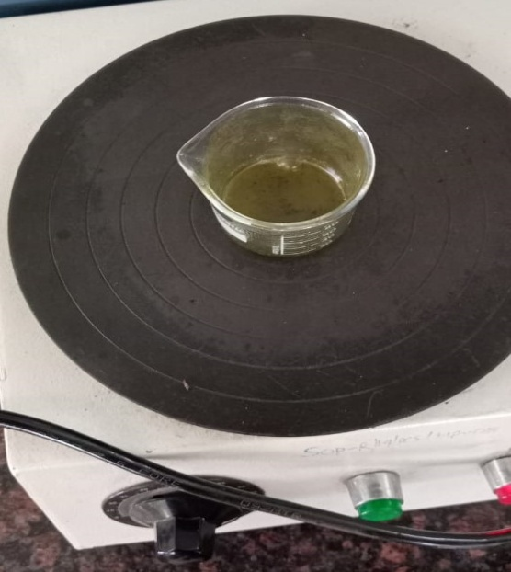
Water soluble Extractive
Material:
- powder drug (5mg)
- Stoppered conical flask (250ml)
- Triple Distilled water
- Chloroform (Merck)
- Flat bottomed shallow dish.
Procedure
5gm of the air dried drug was coarsely powdered, taken it stopped conical flask and macerated with 100ml of chloroform water for 24hrs, shaking frequently during the first 6hrs and allowing to stand for 18hrs .Thereafter it was filtered rapidly taking precaution against loss of chloroform water and then 25ml of the filtrate was evaporated to dryness in a tarred flat bottom shallow dish , dried at 105 C and weighed . The percentage of water soluble extractive was calculated with reference to the air dried drug.
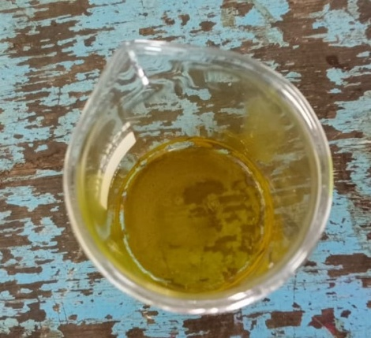
Ether Soluble Extractive:
Materials
- Powdered drug (5mg)
- Stoppered Conical Flask (250ml)
- Petroleum Ether (RFCL LIMITED)
- Flat bottomed Shallow dish
Procedure
5mg of air dried drug was coarsely powdered, taken in stoppered conical flask and macerated with 100ml of petroleum ether for 24hrs shaking frequently during the first 6hrs and allowing to stand for 18hrs. Thereafter, it was filtered rapidly taking precaution against loss of petroleum ether, and then 25ml.Of the filter was evaporated to dryness in a tarred flat bottomed shallow dish, divide at 105⁰C & weight. The percentage of petroleum Ether soluble extractive was calculated with reference to the air dried drug (Table No-6)
2.7.3 ASH VALUE
Total Ash
Materials
- Powder Drug ( 2mg)
- Tared Platinum or Silica dish
- Muffle furnace
- Ash less Filter Paper
Procedure
2gm. of air dried drug was weighed accurately in a tared platinum or silica dish and incinerated at a temperature not exceeding 450°C until free from carbon, cooled and weighed. If carbon free ask cannot be obtained in this way then the charred mass was exhausted with hot water. The residue was collected on ash less filter paper and the residue was incinerated with filter paper until the ash in white are nearly so. Then the filtrate was added,
evaporated to dryness and incinerated at a temperature not exceeding 450°C. The percentage of ash with reference to the air dried drug was calculated. (Table No.6).
Water soluble Ash
Materials
- Ash of powder Drug
- 25 ml of distilled water
- Silica Crucible
- Ash less Filter paper
- Muffle Furnace
Procedure
The ash was boiled for 5 minutes with 25ml of distilled water and the insoluble matter was collected on an ash less filter paper, washed with hot water, and incinerated for 15 minutes at a temperature not exceeding 450°C. The weight of the insoluble matter was subtracted from the weight of the ash; the difference in weight represents the water soluble ash. The percentage of water soluble ash with reference to the air dried drug was then calculated. (Table No.6)
Acid insoluble Ash
Materials
- Ash of powder drug
- 2(M) Hydrochloric Acid (25ml)
- Ash less Filter Paper
- Silica Crucible
- Muffle Furnace
- Desiccators
Procedure
The ash was boiled for 5 minutes with 25ml of 2M hydrochloric acid and the insoluble matter was collected in a Gooch crucible or on an ash less filter paper, washed with hot water, incinerated, cooled in a desiccator and weighed. The percentage of acid insoluble ash with reference to the air dried drug was then calculated. (Table No.6)
2.7.4 Swelling Index
Materials
- Glass Stoppered measuring cylinder
- 1gm Powder Drug
- 25ml Triple Distilled water

Procedure
1 gm of powdered drug was taken in a glass stoppered measuring cylinder having internal diameter of about 16mm, length of the graduated portion about 125mm, Then 25ml of distilled water was added and the mixture was shaked thoroughly every 10mins for 1hour, allowed to stand for 3hour at room temperature. The volume was then measured in ml occupied by the plant material, including any sticky mucilage. The mean value was calculated related to gram of plant materials. (Table no.6)
TABLE NO-6 PHYSICAL EVALUATION PARAMETERS
Sl No | Parameter | Value (%)(W/W)
1 | Loss of Drying | 1.20%
2 | Ash values
 | - Total Ash | 11.68%
 | - Acid in Soluble Ash | 10.60%
 | - Water Soluble Ash | 1.02%
3 | Extractive Values
 | - Water Soluble Extractive | 13.02%
 | - Alcohol soluble Extractive | 7.39%
 | - Ether soluble Extractive | 0.53%
4 | Swelling Index | 1.84%

CHAPTER-III
3.1 PHYTOCHEMICAL INVESTIGATION OF ETHANOLIC EXTRACT OF AZADIRACHTA INDICA A.JUSS. (MELIACEAE)
3.1.1 DRYING AND PULVERIZATION
The collected plant material was shade dried at room temperature, and then they are pulverized in mixer grinder to coarsely powdered drug and passed through mesh size 40 sieves.

3.1.2 PREPARATION OF EXTRACTS BY SOLVENT EXTRACTION
Materials:
(a) Soxhlet apparatus (JSGW)
(b) Ethanol
(c) Triple Distilled water
(d) Shade dried leaves of plant drug
Procedure:
The whole plant parts were dried in shade and powdered to get a course powder. About 800gm of dry coarse powder was extracted with ethanol by continuous hot percolation using Soxhlet apparatus. The extraction was continued for 72 hours. The hydro alcoholic extract was filtered and concentrated to a dry mass by using vacuum distillation. A deep green waxy residue obtained.
3.2 QUALITATIVE CHEMICAL EVALUATION
The ethanolic and powder were subjected to qualitative chemical tests.
(Table No. 7)

3.2.1. Detection of Carbohydrates:-
A little amount of extract was dissolved in distilled water separately and filtered. The filtrates were taken for various tests for detection of carbohydrates.

(i) Molish's Test:-
The filtrated was treated with 2-3 drops of 1% alcoholic alfa- napthol and 2ml of concentrated sulphuric acid was added along the sides of the test tube Formations of brown ring confirm the presence of sugar.
(ii) Small amount of the filtrates were treated with equal volume of Fehling's solution. A and B. Formation of brick rod precipitate confirm the reducing
(iii) Benedict's Test:-
Small portion of various filtrates were treated with equal volumes of Benedict's reagent. Formation of yellow precipitate confirms the presence of reducing sugar.
(iv) Barfoed's Test:-
Small portion of extract was treated with Barfood's reagent. Formation of red precipitate confirms the presence of carbohydrates.
(v) Test for Starch :-
A small amount of extract was treated with iodine solution. Formation of bluish black colour confirms the presence of starch
3.2.2. Test for Gum and Mucilage's:-
The extract was treated with absolute alcohol, stirred and filtered. The filtrated was dried and examined for its swelling properties.
3.2.3. Test for Proteins and Amino Acids:-
Small quantities of extract and decoction were dissolved in few ml of distilled water and subjected to Ninhydrin, Biuret, Millon, Xanthoproteic tests with tannic acid and heavy metals.
(i) Ninhydrin Test:-
The extract was treated with ninhydrin reagent (0.1% solution) and boiled. Formation of purple colour confirms the presence of protein.

(ii) Biuret Test:-
Extract was treated with equal volumes of 5%, sodium hydroxide then 4 drops of 1% W/V, copper sulphate solution was added. Formation of violet colour confirms the presence of protein.
(iii) Millon’s Test:-
Small amount of extract was treated with Millon’s reagent. Formation of white precipitate confirms the presence of protein.
(iv) Xanthoproteic Test:-
3ml of extract was treated with 1ml of concentrated nitric acid, boiled for 1 minute and then cooled. Concentrated ammonia was added until the solution was alkaline. Formation of orange colour confirms the presence of protein. (v)
(v)Test with Tannic Acid:-
To the above prepared extract, 10% tannic acid solution was added. Formation of white precipitate confirms the presence of protein.
(vi) Test with Heavy Metals:-
The above prepared extract was treated with different heavy metals.Formation of precipitate confirms the presence of protein.
3.2.4. Test for Fixed Oils and Fats:-
(i) Spot Test:-
A small quantity of extract was pressed between two filter papers. Oil stains were observed with petroleum ether extract indicating the presence of fixed
oils and fats.
(ii) Saponification Test:-
Few drops of 0.5N alcoholic potassium hydroxide were added to extract along with a few drops of phenolphthalein. The mixture was heated on a water bath for one hour. Soap was formed with extract indicating the presence of fixed oils and fats.

3.2.5. Test for Alkaloids:-
Small amount of solvent free extract was separately stirred with a few ml. of dilute hydrochloric acid and filtered. The filtrates were tested with various alkaloidal reagents such as Mayer's, Dragen Dorff's, Wagner's and Hager's reagent. phosphomolybdic acid and tannic acid. Formation of characteristic colour precipitated were preserved
3.2.6. Test for Glycosides:-
Small amount of the extract was dissolved separately in 5ml of distilled water and filtered. Another portion of the extract was hydrolyzed with hydrochloric acid for one hour on a water bath and hydrolysate was subjected to Legal's, Baljet's, Bontrager's, Keller-Kiliani's tests and for the presence of cyanogenetic glycosides.
- Legal's Test:-
To the hydrolysate, Iml of pyridine and a few drops of sodium nitroprusside solution was added and then made alkaline with sodium hydroxide solution. Formation of pink colour confirms the presence of glycosides.
(ii) Baljeet's Test:-
To a section of leaf sodiumpicrate solution was added. Observation of yellowish orange colour confirms the presence of glycoside.
(iii) Borntrager's Test:-
Hydrolysate was treated with chloroform and the chloroform layer was separated. To this equal volume of dilute ammonia solution was added. Formation of pink colour in ammoniacal layer confirms the presence of glycoside.

(iv) Test for Cardiac Glycosides [Keller - Kiliani Test]:-
To the extract, 10ml of 75% alcohol were added, boiled on water both, filtered. The filtrates were diluted with distilled water, Iml of strong lead acetate solution was added and filtered. The filtrates were extracted with an equal volume of chloroform. The chloroform layer was pipetted out and evaporated to dryness. The residue obtained was dissolved in 3ml of 3.5% of ferric chloride
in glacial acetic acid, it was left for 1 minute and then trams referred to a test tube. To the side of test tube 1.5ml of sulphuric acid was added carefully. Formation of brown colour at the interface and pale green colour in upper layer confirm the presence of digitoxose.
(v) Test for Cyanogenetic Glycoside:-
A small amount of extract was moistened with water, a piece of sodium picrate paper was kept above by the help of cork and kept for 30 minutes. Formation of brick red colour confirms the presence of cyanogenetic glycoside.
3.2.7. Test for Phytosterols:-
The extract was refluxed with 0.5N alcoholic potassium hydroxide until the saponification was complete. The saponification mixture was diluted with distilled water and extracted with petroleum ether. The ethereal extract was evaporated and unsaponifiable matter was subjected to Liebermann's, Liebermann's-Burchard's and Salkowski's test.
(i) Liebermann's Test:-
The residue was dissolved in concentrated sulphuric acid and a few drops of aqueous sodium nitrate were added. Formation of red colour on dilution and tumed to blue when made alkaline with aqueous sodium hydroxide confirm the presence of phytosterol.
(ii) Liebermann-Burchard's Test:-
The residue was dissolved in chloroform. To this Liebermann Burchard's reagent was added. Formation of green colour confirms the presence of phytosterol.

(iii) Salkowski's Test:-
A few drops of concentrated sulphuric acid were added to chloroform solution. Formation of brownish red colour in the lower layer confirms the presence of phyto chemical test.
3.2.8. Test for Flavonoids:-
Hydroalcoholic extract was separately dissolved in ethanol and then
subjected to the following tests.

(i) Ferric Chloride Test:
To a small quantity of the ethanol solution, few drops of neutral ferric chloride were added. Formation of blackish red color confirms the presence
of flavonoids.
(ii) Shinoda's Test:-
To the alcoholic solution a small piece of magnesium ribbon was added along with concentrated hydrochloric acid. Formation of magenta color confirms the presence of flavonoids.
(iii) Fluorescence Test:-
Alcoholic solutions were seen under UV light. Observation of green
Fluorescence was shown.
(iv) Reaction with Acid and Alkali:-
When alcoholic solutions were treated with alkali gave yellowish green color which on addition of acid become colors less.
3.2.9. Test for Tannins and Phenolic Compounds:-
The extract was dissolved in distilled water and filtered. The filtrates were treated with various reagents.
(i) Few ml of the filtrates were treated with 9% ferric chloride solution. Observation of bluish black colour confirms the presence of phenolic compound
(ii) Few ml. of the filtrates were treated with CuSo, solution. Formation of
precipitate confirms the presence of tannin.
(iii)Few ml of the filtrates were treated with lead acetate solution. Observation of white precipitate confirms the presence of tannins.
(iv) Few ml of the filtrates were treated with strong potassium dichromate solution. Formation of precipitate confirms the presence of tannins. (v)
(v) Few ml of the filtrates were treated with potassium ferricyanide followed by ammonia. Formation of deep red colour confirms the presence of phenolic compounds.
3.2.10. Test for Saponins:-
(i) Foam Test:-
The extract was diluted with 20ml. of distilled water and agitated in a graduated cylinder for 15mins. Formation of 1em layer foam confirms the presence of saponins.
(ii) Haemolysis Test:-
The extract was dissolved in distilled water and 2ml. of solutions were taken separately from the extract, 2ml. of 1.8%, sodium chloride solution to two test tubes, 2ml of the same sodium chloride solution was taken in another test tube (control tube), and 2ml. of distilled water was added to this test tube. 5drops of freshly drawn blood was added to these test tubes and kept for few minutes. Occurrence of hecmolysis confirms the presence of saponins.
3.2.11. Test for Volatile Oil:-50gms of coarsely powdered material was taken in a Clevenger apparatus and distilled for 6 hours. 0.1 ml. of volatile oil was separated out during this period, indicating the presence of volatile oil.
TABLE NO-7 QUALITATIVE CHEMICAL EVALUATION ON POWDER DRUG & ETHANOLIC EXTRACT OF AZADIRACHITA INDICA
Plant Constituents Test/Reagent Used | Powdered Drug | Ethanolic extract
TEST FOR CARBOHYDRATES
Molisch's Test | + | +
Fehling's Test | + | +
Benedict's Test | + | +
Barfoed's Test | + | +
Test for Starch | - | -
TEST FOR GUMS & MUCILAGE | - | +
TEST FOR PROTEINS & AMINO ACIDS
Ninhydrin Test | + | +
Biuret Test | - | -
Millon's Test | - | -
Xanthoproteic Test | + | +
Tannic Acid (10% W/V) | + | +
TEST FOR FIXED OILS & FATS
Spot Test | + | +
Saponification Test | + | +
TEST FOR ALKALOIDS
Dragendroff's Test | + | +
Mayer's Test | + | +
Wagner's Test | + | +
Hager's Test | + | +
Tannic Acid | - | +
Legal's Test | - | -
Baljet's Test | - | -
Bontrager's Test. | - | -
Keller-Killiani's Test | + | -
Liebermann’s Test | - | +
Salkowski’s test | - | -
Liebermann berchad’s Test | + | +

CHAPTER-IV
4.1 PHARMACOLOGICAL SCREENING
4.1.2 ANALGESIC ACTIVITY OF ETHANOLIC EXTRACT OF AZADIRACHTA IDICA AJUSS. (MELIACEAE).
Analgesia:
Analgesic drug is used to reduce pain. Pain is a disabling accompaniment of many medical conditions, and pain control is one of the most important therapeutic priorities. The classical analgesic drugs, notably opiates and NSAIDs have there origin in natural products that have been used for centuries. The original compounds typified by morphine and aspirin are still in wide spread use, but many synthetic compound that act by the same mechanism have been developed
NSAIDs are mainly affected against pain, associated inflammation or tissue damage because they decrease the production of the prostaglandins that sensitize nociceptors to inflammatory mediators such as bradykinin. Therefore, they are effective in arthritis, bursitis, pain of muscular and vascular origin, toothache, dysmenorrhoes, the pain of post partum states and pain of cancer metabolites in bone all conditions that are associated with increased prostaglandin synthesis. In combination with opoids, they decreased post operative pain and in some cases can reduce the requirement of opoids by as much as one third. Their ability to relieve headache may be related to the abrogation of the vasodilator effect of prostaglandins on the cerebral vasculature. There is some evidence that they have an action mainly in the spinal cord.
Animal test of analgesic drugs commonly measure nociception and involved testing the reaction of an animal to a mildly painful stimulus, often mechanical of thermal. Such measures include the tail flick test (measuring the time taken for a rat to withdraw its tail when a standard radiant heat stimulus is applied) or the paw pressure test (measuring the withdrawal threshold when a normal
or inflamed paw is pinched with increasing force) or tail immersion test (measuring the time taken for a rat to withdraw its tail when its tail is immersed in hot water of 55⁰ C).
Classification:
A. Non selective COX Inhibitors(Conventional NSAIDs)
1 Salicylates: Aspirin
2. Pyrazolone Derivatives: Oxyphenbutazone
3. Indole Derivatives: Indomethacin
4. Propionic acid derivative: Ibuprofen
5. Anthranilic acid derivative: Mefenamic acid derivative
6.Aryl acetic acid derivative: Diclofenac Sodium
7. Oxicam derivative: Tenoxicam
8. Pymolo-pyrole derivative: Ketorolac
B. Preferential COX 2 Inhibitor: Nimesulide
C. Selective COX 2 Inhibitor: Celecoxib
D. Analgesic-Antipyretics with poor Anti inflammatory action:
1.Para amino phenol derivative: Paracetamol.
2. Pyrazolone Derivative: Metamizole(Dipyrone)
3. Benzoxazocaine Derivative: Nefopam
Materials:
(a) Albino rats
(b) Thermometer
(c) Hydroalcoholic extract
(d) Diclofenac sodium
(e) Sodium lauryl sulphate 0.5% w/v solution
(D) Feeding niddle
Method:
Healthy Wister strain albino rats weighing about 150-200gm were taken. They were divided into 6 groups having 6 each numbered, and placed into individual restraining cages leaving the tail hanging out freely. The animals are then allowed to adapt in the cages for 30 minutes before testing. The lower Sem portion of the tail was immersed in a cup of freshly filled water of exactly 55°C. Within a few seconds the rut reacts by withdrawing the tail. The reaction time was recorded in 0.5 seconds by a stop watch. After each determination the tail was carefully dried. The reaction was determined before oral feeding of the drug and hydroalcoholic extract which was recorded as zero minutes reading. The control, standard and test substances were given to the animals by feeding niddle. After the drug was administered the reaction time was recorded at an interval of 30, 60,120,180,240 minutes. The mean reaction time was found out for each group and compared with the value of standard drug.
Control:
The animals marked group- I received orally Iml/100gm of body weight of 0.5%w/v solution of sodium lauryl sulphate and served as control
Standard:
The animals marked group-Il received orally 45mg/kg body weight of diclofenac sodium in 0.5%w/v suspension of sodium lauryl sulphate and served as standard
Test:
The animals marked test group - III to received 500mg/kg body weight of ethanol extracts Ethanolic extracts of the leaves of Azadirachta indica A. juss (Meliaceae) was screened for analgesic activity.
Result:
It was observed that ethanolic extracts at a dose of 500mg/kg body weight showed maximum analgesic activity amongst the other extracts (Table No 8). The result indicated that the major component responsible for analgesic activity may be present in this extracts.
Data was expressed as mean SEM and the statistical difference between the groups was analyzed by using Student's t-test. The value of p<0.05 was considered as statistically significant.

Sl No | Treatment | Reaction time (second) + SEM
 |  | 0 Min | 30 Min | 60 Min | 120 Min | 180 Min | 240 Min
1 | Control | 2.46 + 0.18 | 2.26 + 0.43 | 2.46 + 0.38 | 2.3 + 0.34 | 2.56 + 0.28 | 2.56 + 0.28
2 | Diclofenac sodium | 2.4 + 0.25 | 3.5 + 0.28 | 4.73 + 0.42 | 4.73 + 0.42 | 3.8 + 0.25 | 2.86 + 0.17
3 | Hydroalcoholic Extract | 2.37 + 0.39 | 3.30 + 0.47 | 3.32 + 0.68 | 4.03 + 0.49 | 3.28 + 0.23 | 3.01 + 0.23
TABLE NO.8. ANALGESIC EFFECT OF ETHANOLIC EXTRACT OF AZADIRACHTA INDICA LEAF.

Mean ± SEM, "*" indicates p<0.05.

CHAPTER-V
5.1 RESULT AND DISCUSSION:
The presence of these phytochemicals make the plant useful for treating different ailments and have a potential of providing useful drugs of human use. The quantitative determination of pharmacognostic parameters will help for setting standards for crude drugs. The total ash is particularly important in evaluating the purity of drugs. The pharmacognostic constants for the leaves of this plant, the diagnostic microscopic features and the numerical standards reported in this work could be useful for the compilation of a suitable monograph for it proper identification. And further work aiming towards tracing out of phytochemicals present in it and pharmacological activities are in progress.
The chemical tests on ethanolic extract and the powder material showed the presence of alkaloid carbohydrate, protein and amino acid, reducing sugars, flavonoids etc.
The ethanolic extract at a dose of 500mg/kg body weight were studied for their analgesic effect by tail immersion method and found that it was showing maximum effect, using diclofenac sodium as standard.

CHAPTER-VI
BIBLIOGRAPHY:
1 Kokale,CK,Parohit, A.P.& Gokhale, S.B.. Pharmacognosy, Nirali Prakashan. 41, Budhwar Peth, Jogeshwari Mandir Lane, Pune-411002, 35 Ede 2006, p. 2.
- Rangari, V. Pharmacognosy and Physochomistry. Career Publications Ghorpure Ghat. Nanik-422002. Part-1, 1" Reprint Edn 2004, pp.10-13.
- Rangari, V. Phomacognosy and Phytochemistry. Career Publications. Gharpure Ghat Nasik-422002, Part-1, 1" Reprint Edn. 2004, pp. 18-19.
- Rangari, V. Pharmacognosy and Phytochemistry, Career Publications. Gharpure Ghut, Nasik 422002, Part-1, 1" Reprint Edn. 2004, pp. 23-24.
- Rangari, V Pharmacognosy and Phytochemistry: Career Publications, Charpure Chat Nasik-422002, Part 1, 1" Reprint Edn. 2004, pp. 27-28.
- Rangari, V. Pharmacognosy and Phytochemistry. Career Publications. Gharpure Ghat, Nak-422002, Part-1,1" Reprint Edn. 2004, pp. 32-33.
- Plants.usda gov/java/profile?symbol-IPAQ.
- Kritikar.K.R.: Indian Medicinal Plants, Vol-Ill, 2 Edn.1933, p.1724.
9. Dr.Ansari, S.H. Essentials of Pharmacognosy, Birla Publications Pvt. Ltd.,Shahdara, Delhi-110032, 1" Edn. 2005-2006, p. 593.
10 Pharmacopoeia of India 1996, The Controller of Publications, Civil Lines.Delhi-110054, Vol-11, p 89.
11 Pharmacopoeia of India 1996, The Controller of Publications, Civil Lines.Delhi-110054, Vol-ll:p. A-53.
12 Dr.Ansari, S.H.: Essentials of Pharmacognosy, Birla Publications Pvt. Ltd.,Shahdora, Delhi-110032, 1" Edn. 2005-2006, pp. 592-593.
13 Pharmacopoeia of India 1996, The Controller of Publications, Civil Lines,Delhi-110054, Vol-II, p. A-54.
14 Dr. Mukherjee, P.K: Quality Control of Herbal Drugs, Business Horizons Pharmaceutical Publishers, G-59, Masjid Moth, GK-2, New Delhi-110048, 2nd Reprint Edn. 2007, p. 214.
15 Kokate, C.K. Practical Pharmacognosy, Vallabh Prakashan. Pitampura, Delhi-110034, 4 Reprint Edn, 2006, pp. 107-109.
16 Kokate, C.K., Purohit, A.P. & Gokhale, S.B.: Pharmacognosy. Nimili Prakashan, 41, Budhwar Peth, Jogeshwari Mandir Lane, Pune-411002, 35thEdn, 2006, pp. 593-597.
17 Dr.Ansari, S.H: Essentials of Pharmacognosy, Birla Publications Pvt. Ltd... Shahdora, Delhi-110032, 1" Edn. 2005-2006, pp. 588-590.
18 Rang, H.P., Dale, M.M., Ritter, J.M., Moore, P.K.: Pharmacology. Churchill Livingstone (Elsevier Science Ltd.), London, 5th Edn. 2003, pp. 246,562 & 567.
19 Tripathi, K.D. Essentials of Medical Pharmacology, Jaypee Brothers Medical Publishers Pvt. Ltd., EMCA House, Daryaganj, New Delhi-110002, 5 Edn. 2003, p. 167.
20 Vogel, H.G.: Drug Discovery and Evaluation Pharmacological Assays, Springer, New York, 2nd Edn. 2002, p. 697.

