DERMATOLOGICAL CLASSIFICATION OF SKIN IMAGE USING DEEP LEARNING TECHNIQUES
Pappu Kumar Rai¹ Waseem Ahmad Mir¹ Anwesha Banik¹ and Tawseef Ayoub Shaikh²
¹ GH Raisoni College of Engineering and Management
² National Institute of Technology, Srinagar

Skin disease is a significant public health problem and by far the most common type of cancer, especially in the region of North America. Fungal infections, bacteria, allergies, and viruses, among other things, are the most common causes of skin problems. Over the past few years, machine learning and deep learning have emerged in medicine Imaging has led to the creation of many image-based classification systems in the medical field and these systems outperform Compared with traditional image-processing classification methods. Deep learning technique for the classification of skin lesions has been effective in recent times. In this Chapter, we have discussed in detail about the dermatological classification of skin images using deep learning and have elaborated on the convolutional neural network as a technique for classification tasks.
Keywords: Skin disease, Image classification, Deep learning, CNN, InceptionV3.

Introduction
Dermatology is a branch of medicine in which the shape of various skin diseases plays an important part in diagnosis and therapy management. Skin is one of the most important and fastest-growing organs in the human body, and Skin infection is one of the most common health problems in the world. The largest organ of the human body is composed of the epidermis, dermis, subcutaneous tissue, blood vessels, lymphatic vessels, nerves, and muscles. The fluid can be used to inhibit the breakdown of lipids in the epidermis, thereby improving the appearance of the skin. Skin diseases can be caused by bacterial growth on the skin, hidden germs, allergic reactions, or microbes that destroy the skin’s texture. Ultraviolet radiation, tanning, family history, environmental variables, alcohol, and other factors can all contribute to skin diseases. Skin illnesses can lead to isolation, physical impairment, self-harm, body changes, interpersonal issues, unemployment, alcoholism, and even death in the case of malignant melanoma.

Several skin illnesses have symptoms that require a lot of work to address as the sufferers get older, as people get older, many skin diseases have symptoms that take a lot of effort to address. Skin illness is one of the diseases that affects almost everyone. In some states, the prevalence of skin disease is so high that more than half of the population is unaware of it. People from low-income communities are in poorer health and they cannot afford medical care. The technique of deep learning is beneficial for them, and it is not nearly as expensive as the medical industry.

In most cases, skin disease can be discovered by a painful biopsy procedure. because the procedure involves removing a portion of the skin tissue for histopathological evaluation under a microscope.
Dermatologists’ traditional dermatitis diagnosis is based on a combination of the patient’s medical history, clinical signs, dermoscopic images, and, on rare occasions, histological examination. However, becoming a competent der- dermatologist takes a long time to learn. Furthermore, skin disorders come in a wide range of types and might appear extremely similar to humans, making accurate and effective diagnosis challenging.

Recent developments in artificial intelligence (AI), notably convolutional neural networks (CNN) based deep learning algorithms, have enabled to identification of the most predictive aspects of diseases directly from medical photographs, given a big collection of categorized medical photos.

A visual indication, such as individual lesion shape, body size distribution, color, scaling, and arrangement of lesions, can be utilized to detect a skin condition. The recognition process becomes much more complex when the various components are examined separately, and the human-engineering feature extraction method is ineffective for its classification. On the other hand, using feature learning eliminates the need for feature engineering and allows the computer to choose which feature to utilize on its own, is one technique to overcome this challenge. Although numerous feature-learning-based classification systems have been developed, the majority of them are limited to dermoscopy or histopathology images. Image classification is a great achievement in computer science, this achievement helps a lot in many fields, some are given below:
    - Medical field.

    - Traffic control system.

    - Object detection in satellite images.

    - Video Processing

    - Machine vision.

Literature Survey

Several automated methods for detecting melanoma have been developed in the last decade as dermoscopy images have grown in popularity. Most earlier studies used handcrafted features-based skin cancer detection methods; however, in recent years, deep features derived using DL architectures, specifically CNNs, have been used. Kamarul Hawari and Mansor et al. [1] developed a CNN network with 3753 images and used the SVM algorithm as a classifier to obtain features by CNN to classify skin cancer, the used data set has four different classes, and the algorithm got 94.2 percent accuracy after training and testing. To classify diseases such as melanocytic nevus, seborrheic keratosis, basal cell carcinoma, and psoriasis, Xinyuan and Wang et al. [2] used an algorithm that is a combination of deep neural network and human knowledge. Their algorithm achieved 87.25 percent accuracy with 1067 images, and they also provide multi-class skin lesion classification; however, they

used domain expert knowledge, which is more expensive and difficult to obtain for people with limited resources. The Fine-Tuned Neural Network-based Skin Disease Classification Model developed by Lawson and J. Zhu et al. [3] achieved a reasonable accuracy of 89.90 percent for the validation set. However, to achieve the desired accuracy, the network components must be calibrated. Damon M. Chandler and Sheila S. Hemami et al. [4] developed a deep CNN ensemble model that produces excellent and highly accurate results. This ensemble model suffers from over-fitting. This ensemble model is also unsuitable for work with unknown discrepancies between the sample and population under consideration. Deep learning has the advantage of learning features directly from data without the assistance of a human expert for feature engineering and can outperform humans. Deep learning algorithms have recently achieved great success in a variety of computer vision problems. In 2012, Krizhevsky et al. [5] In the ImageNet Large Scale Visual Recognition Challenge 2010 (ILSVRC2010), developed a novel technique (AlexNet) using convolutional neural networks for the classification of a large data set (1.2 million images) containing 1000 object categories and achieved the best result, generating enormous interest among academics in the computer vision field. [6] Han et al. used a deep convolutional neural network to classify clinical images of 12 skin diseases. To the best of our knowledge, no previous studies have investigated the use of dermoscopy skin cancer datasets with sufficient diversity for multiclass classification of dermatoscopic skin cancer images. In [7] Esteva et al. used a pre-trained GoogleNet Inception v3 CNN model to classify 129,450 clinical skin cancer images, including 3,374 dermatoscopic images, to make a breakthrough in skin cancer classification. On the ISBI 2016 challenge dataset, Yu et al. [8] created a convolutional neural network with approximately 50 layers for malignant melanoma classification. Haenssle et al. [9] In 2018, a deep convolutional neural network was utilized to detect a binary diagnostic category of melanocytic dermoscopy images. Dorj et al. [8] developed ECOC SVM with a deep convolutional neural network approach for clinical skin cancer

image classification into four diagnostic categories. Skin disease classification using ensemble models [10] combines various prediction models to produce more accurate outcomes Overfitting arises in ensemble models, and the ensemble model fails to perform given unknown disparities between the studied sample and population. [11],[12]. Skin disease categorization using a Deep Neural Network model [13],[14] has done wonderfully in classifying skin diseases Despite this, experimental research has shown that the model is inappropriate for multi-lesion images. Deep Neural Network models require a considerable training level to obtain respectable accuracy, which requires additional computational effort. So many intriguing deep learning models can produce very impressive results in dermoscopy image classification and recognition. However, there are many areas where we can improve to build this future model for medical imaging and skin lesion discovery.

Theoretical Background

3.1 Convolutional Neural Network
A CNN, or convolutional neural network, is a type of artificial neural network used in deep learning for image or object recognition and classification. Deep Learning identifies objects in images using CNN architectures are used for image processing, computer vision tasks for localization and segmentation, video analysis, obstacle detection in self-driving cars, and natural language processing. CNNs are especially popular in deep learning because they play an important role in these rapidly expanding and new domains. CNNs are most commonly used for image processing, but they can also be used for data analysis and classification. As a result, they can be used to produce accurate results in a variety of industries, such as facial recognition, video classification, road/traffic signal recognition, galaxy classification, and medical image diagnosis/analysis.

CNN architecture has three layers.

      - Convolution layer
      - Pooling layer
      - Fully connected layer
Convolution layer: This is the first layer in CNN architecture, the convolution layer, performs a dot product between two matrices, one of which is the kernel and the other is a restricted portion of the receptive field. The kernel is smaller in space than an image but more detailed.

Pooling layer: "The pooling layer is used to minimize the spatial resolution of the feature maps and thus achieve spatial invariance to input distortions and translations," according to the research published in ’Neural Computation." Processing speeds up as the pooling layer reduces the number of parameters required to process the image while also lowering memory and computational costs.

Fully connected layer: In this layer, neurons are fully connected with all neurons; this layer aids in mapping the representation between input and output.

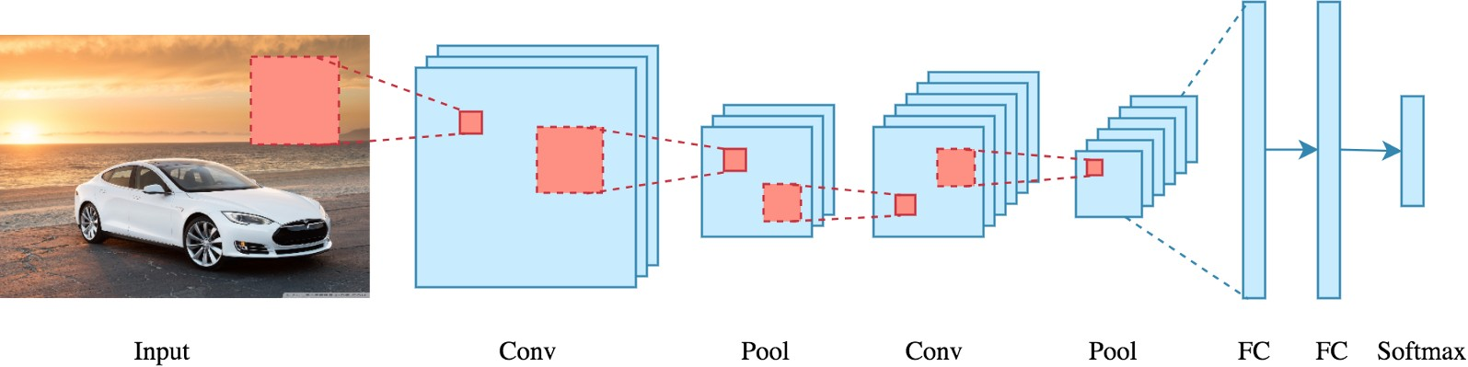

Figure 1: CNN

3.2 Deep Learning
Deep learning, which is essentially a three-layer neural network, is a subset of machine learning. There are three layers: the input layer, the hidden layer,

and the output layer. Deep neural networks are designed to mimic human brain activity, allowing it to "learn" from massive amounts of data, but they fall far short of its capabilities.

Hidden layers perform non-linear transformations on network inputs. Depending on the function of the neural network, the hidden layers differ; additional hidden layers can help optimize and improve accuracy.

Deep learning is used in many artificial intelligence applications and services to improve automation by performing analytical and physical tasks without the need for human intervention. Deep learning technology (such as self-driving cars) is used in everyday products and services as well as upcoming innovations (such as digital assistants, voice-enabled TV remotes, and credit card fraud detection).

Deep learning has more ability to learn as compared to machine learning because it has a few more layers than machine learning. Deep learning has a concept of transfer learning which has various pre-trained models, some models like ResNet 16, Mobile Net, Inception v3, VGG16, etc.

Deep learning is defined by industry leaders and professionals, and their specific and nuanced perspectives offer a great deal of insight into what deep learning is all about.
Deep learning is a machine learning field that focuses on artificial neural networks, which are algorithms inspired by the structure and function of the brain.

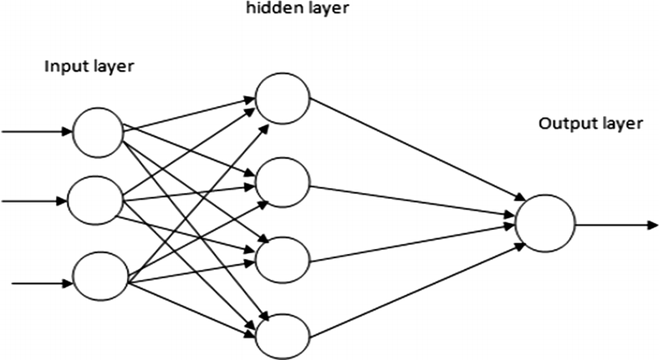

Figure 2: DNN Architecture

Some important points are very helpful for designing the model and also for understanding the concept of deep learning.
- Learning rate decay.

  - This process is based on the concept of learning rates; if the learning rate is too high, it may result in unstable training processes or the learning of a suboptimal set of weights. Furthermore, if the learning rates are too low, it may result in a lengthy training process that has the potential to become stuck.
- Transfer learning.

  - Transfer learning is a technique in which users enter new data into a trained model with an unknown classification. After adjusting the network, new tasks with more specialized classification skills can be performed. This method uses much less data than others, reducing computation time to minutes or even hours.
- Training from scratch.

  - This method requires the collection of a large labeled data set as well as the setup of a network architecture capable of learning the features and model. This method is especially useful for new applications with a large number of output categories. However, it is a less common strategy in general because it requires a large amount of data, which causes training to take days or weeks.
- Dropout.

  - This method attempts to alleviate the problem of over-fitting in the networks with a large number of parameters by deleting units and their connections at random during training. It has been demonstrated that the dropout strategy improves neural network performance on supervised learning tasks in domains such as speech recognition, document categorization, and computational biology.

Transfer learning
Transfer learning is a machine learning technique used to solve a problem re- related to model design. Transfer learning is also defined as the improvement of learning through the transfer of knowledge from an already learned related task to a new task.

In Transfer Learning we are solving the problems related to the solved problem, in other words solving others problems similar to the previous problem. For example, if you know how to ride a bicycle then you can get that knowledge to ride a bike, there are some pre-trained models in transfer learning concepts such as ResNet16, ResNet19, AlexNet, MobileNet, Inception V2, etc.

Transfer learning is applicable when you use what you have learned to solve problems and while problem solving we can use our learned skills to solve related problems. For example, the knowledge gained while solving the problem of the vehicle, the model learned and recognized from it and applied the same knowledge and tried to solve to some extent the problem of trucks.

Transfer learning is the process of applying a previously learned model to a new problem. It is particularly popular in deep learning right now due to its ability to train deep neural networks with small amounts of data. This is especially useful in data science, where most real-world situations do not necessitate millions of labeled data points to train complex models.

Transfer learning is used when a previously trained deep learning model is used to solve a separate but related problem. For example, if you trained a simple classifier to predict whether an image contains a backpack, you could use that knowledge to distinguish other objects such as sunglasses.

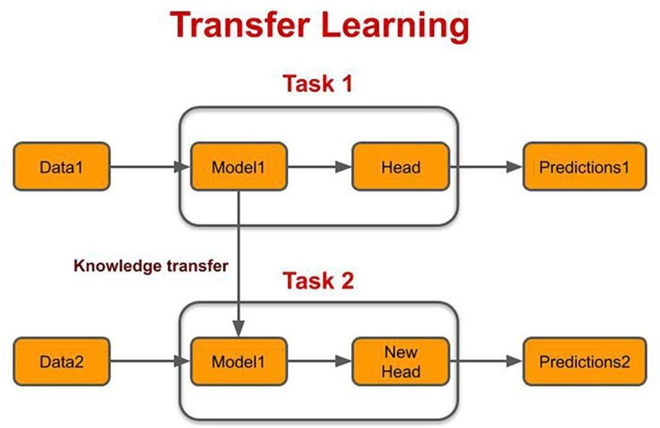

Figure.3: Transfer Learning

Fine Tuning
The deep neural network has already have trained model and it allows us to take ad- vantage of the model that has already been learned. We need not create a model from scratch.

For example, If we would like to identify different types of chair images and then provide consumers with purchase links. One way is to first identify 100 popular chairs, then take 1000 images of each chair from different perspectives and train a classification model on the resulting image dataset.

The solution for the given example is to collect more data. Data collection and labeling, on the other hand, might take a long time and cost a lot of money. Researchers, for example, paid millions of dollars in research funding to compile the ImageNet dataset. Even though the present cost of data collection has been greatly decreased, this expense cannot be overlooked.

Transfer learning is also another option for transferring knowledge from the source dataset to the target dataset. Although the majority of the photos in the ImageNet dataset have nothing to do with chairs, the model trained on it may be able to extract more generic image properties, such as edges, textures, forms, and object composition. These comparable characteristics may also be useful in recognizing chairs.

The concept of working with Fine Tune is to import the original pre-trained model, remove the classification layer (we can remove more than one layer from the top end), and then add one or more layers depending on your needs. Huh. The layer weights are then frozen so that they can be updated whenever the model is trained on new data for a new task. Only the weights in our newly created or modified layers should be updated. During this training phase, all the weights of the layers in our original model will remain the same, and only

the weights in our new layers will change.

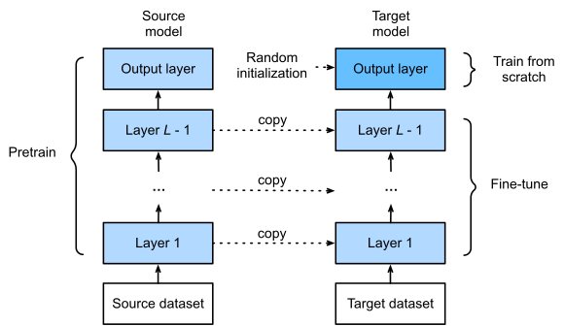

Figure 4: fine-tuning the model

- Conclusion
To diagnose dermatoscopic images, we focused on developing a mechanism to distinguish between skin lesions. We also created a deep learning model algorithm that works more accurately than current machine learning techniques. As is well known, unlike machine learning, deep learning does not require us to directly give the model features. Future studies on this subject can focus on how to introduce new models using new deep learning techniques as well as with different datasets. By varying feature extraction methods and classification strategies, we hope to improve the accuracy of new models. As another approach, we will investigate the model using a balancing dataset for new model categorization.

- References
    - K. H. Ghazali, M. F. Mansor, M. M. Mustafa, and A. Hussain, “Feature extraction technique using discrete wavelet transform for image classification,” in 2007 5th Student Conference on Research and Development. IEEE, 2007, pp. 1–4.
    - X. Zhang, S. Wang, J. Liu, and C. Tao, “Towards improving diagnosis of skin diseases by combining deep neural network and human knowledge,” BMC Medical Informatics and Decision Making, vol. 18, 07 2018.
    - Lawson and J. Zhu, “Image compression using wavelets and jpeg 2000: A tutorial,” 2003.
    - N. Ranganathan and A. Rani P, “A novel form based vector quantizer codebook design for image compression in the wavelet packet domain,” International Journal of Multimedia Its Applications, vol. 2, 02 2010.
    - A. Krizhevsky, I. Sutskever, and G. E. Hinton, “Imagenet classification with deep convolutional neural networks,” Advances in neural information processing systems, vol. 25, 2012.
    - S. S. Han, M. S. Kim, W. Lim, G. H. Park, I. Park, and S. E. Chang, “Classification of the clinical images for benign and malignant cutaneous tumors using a deep learning algorithm,” Journal of Investigative Dermatology, vol. 138, no. 7, pp. 1529–1538, 2018.
    - A. Esteva, B. Kuprel, R. A. Novoa, J. Ko, S. M. Swetter, H. M. Blau, and S. Thrun, “Dermatologist-level classification of skin cancer with deep neural networks,” Nature, vol. 542, no. 7639, pp. 115–118, 2017.

    - A. Rezvantalab, H. Safigholi, and S. Karimijeshni, “Dermatologist level dermoscopy skin cancer classification using different deep learning convolutional neural networks algorithms,” arXiv preprint arXiv:1810.10348, 2018.
    - H. A. Haenssle, C. Fink, R. Schneiderbauer, F. Toberer, T. Buhl, A. Blum,
A. Kalloo, A. B. H. Hassen, L. Thomas, A. Enk, et al., "Man against machine: diagnostic performance of a deep learning convolutional neural network for dermoscopic melanoma recognition in comparison to 58 der- dermatologists,” Annals of oncology, vol. 29, no. 8, pp. 1836–1842, 2018.
    - A. K. Verma, S. Pal, and S. Kumar, “Classification of skin disease using ensemble data mining techniques,” Asian Pacific Journal of Cancer prevention: APJCP, vol. 20, no. 6, p. 1887, 2019.
    - I. E. Livieris, L. Iliadis, and P. Pintelas, “On ensemble techniques of weight-constrained neural networks,” Evolving Systems, vol. 12, no. 1, pp. 155–167, 2021.
    - K. Roy, S. S. Chaudhuri, S. Ghosh, S. K. Dutta, P. Chakraborty, and
R. Sarkar, “Skin disease detection based on different segmentation techniques,” in 2019 International Conference on Opto-Electronics and Applied Optics (Optronix). IEEE, 2019, pp. 1–5.
    - X. Zhang, S. Wang, J. Liu, and C. Tao, “Towards improving diagnosis of skin diseases by combining deep neural network and human knowledge,” BMC medical informatics and decision making, vol. 18, no. 2, pp. 69–76, 2018.
    - S. S. Yadav and S. M. Jadhav, “Deep convolutional neural network based medical image classification for disease diagnosis,” Journal of Big Data, vol. 6, no. 1, pp. 1–18, 2019.
    - U.-O. Dorj, K.-K. Lee, J.-Y. Choi, and M. Lee, “The skin cancer classification using deep convolutional neural network,” Multimedia

Tools Appl., vol. 77, no. 8, p. 9909–9924, Apr 2018. [Online]. Available: https://doi.org/10.1007/s11042-018-5714-1
    - A. Esteva, B. Kuprel, R. A. Novoa, J. Ko, S. M. Swetter, H. M. Blau, and
S. Thrun, “Dermatologist-level classification of skin cancer with deep neural networks,” Nature, vol. 542, no. 7639, p. 115—118, February 2017. [Online]. Available: https://europepmc.org/articles/PMC8382232
    - F. Meyer, A. Averbuch, and J.-O. Stromberg, “Fast adaptive wavelet packet image compression,” IEEE Transactions on Image Processing, vol. 9, no. 5, pp. 792–800, 2000.

