Nanotechnology Applications In Various fields

1.Dr.B.VIJAYALAKSHMI, ECE Department AU GVP College Of Engineering for Women Visakhapatnam, Andhra Pradesh  bvl@gvpcew.ac | 2.S.PRAVEEN  ECE department ,GVPCEW,AU  GVP College Of Engineering for Women  Visakhapatnam, Andhra Pradesh ddychinnu655@gmail.com | 3.Dr..V.RADHIKA  ECE Department, Pragati Engineering College(A), Surampalem, Affiliated to JNTUK, Kakinada. Andhra Pradesh.  radhika.v@pagati.ac.in

ABSTRACT- There is an enormous growth in the way we have lived over the past 75 years. Furthermore, work was transformed by two miniature discoveries. One is that using semiconductor transistor and the other one miniaturisation of VLSI microchip have revolutionized modern inventions extremely since their development. In the 1939s, they have been getting smaller and smaller. In this paper introduces contemporary trends in nanotechnology then its applications besides future scope as well as addresses the progress of our country in this emerging field.

KEY WORDS-Nano technology ,biomedical,
Nano technogy application

1.INTRODUCTION

The globe is getting smaller. Beyond what the human eye can see, there is a vast and largely uncharted world. The tiny world is incredibly strange and enthralling. Nanotechnology is the result of going beyond the microscopic scale and investigating the possibilities of working at a nanoscopic level, which is a billion times smaller than the typical scale we work at now.

II.OVERVIEW OF NANOTECHNOLOGY

Any technology that operates on a nanoscale and has practical applications is referred to as nanotechnology. Today's science is yesterday's science fiction. We are now developing our skills in every branch of science, including physics, chemistry, biology, and engineering. Although the extremely small physical components of change known as "nanotechnologies" are largely what you cannot see and are catalyzing the revolution, they play a significant role in the rapid pace of technological progress. It is a developing science with promising prospects for the future.
Although it is difficult to foresee what will happen to nanotechnology over the next 100 years, we do know that it will be a significant science and technology tool in that time.

III.NANOTECHNOLOGY APPLICATIONS
Cancer-fighting invisible particles, more energy-efficient but quicker microprocessors, 10 times longer-lasting batteries, or solar panels that produce twice as much energy. These are only a few of the numerous uses for nanotechnology, a field that possesses all the necessary elements to usher in the next industrial revolution.
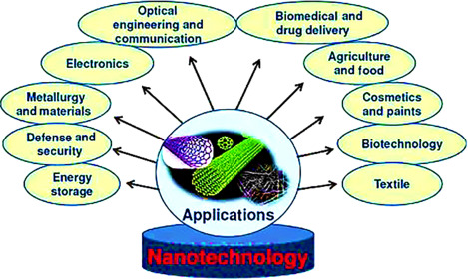
Fig 1.Applications of nanotechnology in various domains
A) SUSTAINABLEENERGY APPLICATION
The increasing need for environmental protection makes it more challenging to meet the world's energy needs. Many scientists are researching ways to create accessible, economical, and renewable energy sources, as well as strategies to lower energy use and alleviate the environmental impacts of toxicity. Future solar power is expected to be inexpensive because to prototype solar panels that use nanotechnology to convert sunlight more effectively than conventional designs. Numerous battery types that are less flammable, charge more quickly, are more efficient, weigh less, have a better power density, and retain electrical charge longer are already using nanotechnology.
B)BIO MEDICINE
The employment of medicines and medical instruments that use nanotechnology is already very common. The use of nanotechnology in medicine is known as nanomedicine. It is employed in the detection, diagnosis, and treatment of disease. Nanoparticles reduce the chance of harm to healthy tissue by encasing or otherwise assisting in the delivery of medication directly to cancer cells. This may finally alter cancer treatment and significantly lessen chemotherapy's damaging side effects. It's sufficient to remark that researchers are pursuing it. Increased success rates for numerous various medicines are also being made possible by the enhanced imaging diagnostic capabilities made possible by nanotechnology..
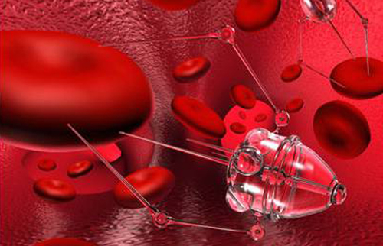
Fig 2. Application of nanotechnology in biomedicine
In reality, nanobots have the potential to treat a wide range of medical issues in addition to cancer, such as opening blood veins in difficult-to-reach places, performing biopsies, or detecting the presence of specific chemicals in otherwise inaccessible parts of the body. Nanorobotics shows great promise for furthering medical advancement in this area. Many contemporary medical and technical problems seem well-suited to nanotechnology as a solution.
C)POSSIBILITIES IN BIG DATA
The massive growth of electronic data in our information-technology era has created an urgent need to handle this data properly, identify trends, and warn us of issues without missing crucial information. For instance, leveraging big data from traffic sensors to regulate traffic and prevent accidents, preventing crimes by more wisely allocating police resources, and many more. Here, nanotechnology is crucial because it enables the development of extremely dense memory that can store vast quantities of this data. In addition, it inspires them to develop extremely efficient algorithms for managing, scrambling, and transmitting information without jeopardizing its dependability.
Fig 3. Application of nanotechnology in big data
D)WATER TREATMENT
The use of nanotechnology has the potential to significantly improve both human and planetary conservation. The supply of clean drinking water is a critical issue that is exacerbated by urban pollution, population increase, and the rapid consequences of climate change-related events. Nanotechnology has the potential and ability to filter and clean the magnetic interactions between incredibly small dust specks in addition to its ability to identify pollutants. Similar to this, there is significant potential in the development of nanoparticles that can clean water pollutants at a lower cost than the traditional method of pumping the water out of the ground and treating it. In general, getting clean water is a significant problem, and nanotechnology can greatly assist in solving it..
E) ELECTRONICS
Nanotechnology has played a crucial role in the development of electronics and computing, resulting in quicker, smaller, smarter, and more portable systems and products. Just 40 years ago, a computer that was infinitely slower was the size of a room. Today, it is entirely common to carry a computer in one hand. This is made possible by the shrinking of the microprocessor industry. For instance, transistors, the switches that power all modern computing, have dramatically shrunk in size over the shortest period of time, going from a size of about 250 nanometers in 2000 to barely one nanometer in 2016. This revolution in transistor size might soon make it possible to store all of a computer's memory on a single, tiny chip. Nanoscale magnetic tunnel junctions that can swiftly and effectively store data after a system shutdown have also enabled the development of ever-faster systems. These nanoscale junction computers are anticipated to soon be able to practically immediately flexible, bendable, foldable, and stretchable employing magnetic Random Access Memory (RAM). They are quite little and extremely flexible in everyday language. The focus on efficiency and reduction of size in the digital world has led to the development of nanotechnology.
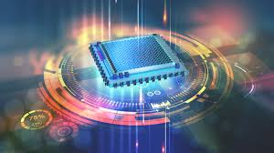

Fig 4.Application of nanotechnology in electronics

IV..DISTRIBUTION OF NANOTECHNOLOGY APPLICATIONS IN VARIOUS SECTORS

The beauty of nanotechnology is that it has a greater impact on our lives as things get smaller. However, if we can grasp this technology, we will have the chance to advance not only electronics but also many other facets of contemporary life.

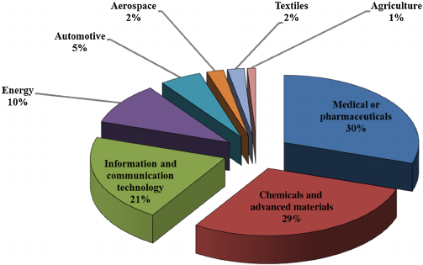
Fig 5.% Distribution of nanotechnology applications in various sectors
A )INDIA AND NANOTECHNOLGY
Early in the new millennium, initiatives to support nanotechnology research were launched in India. With a grant of Rs. 60 crores, the "Nanoscience and Technology Initiative" got off the ground. The government began the 5-year Nano Mission program in 2007 with more expansive goals and USD 250 million in additional funding. The financing covered a wide range of endeavors, including fundamental nanotechnology research, infrastructure development, human resource development, and international cooperation. Many organizations, including the Department of Biotechnology, Council of Scientific and Industrial Research, Department of Information Technology, and Defense Research and Development Organization, provided support for studies, projects, and researchers. At the Indian Institute of Science in Bangalore and the Indian Institute of Technology in Mumbai, national centers for nanofabrication and nanoelectronics have been established..
The work has been successful. In the last five years, India has published over 23,000 publications on nanoscience. India came in third place in terms of papers published in 2013 behind only China and the United States. There is, nevertheless, much space for development. India still only invests a small portion of what Japan, the United States, France, and China spend on research in this field.
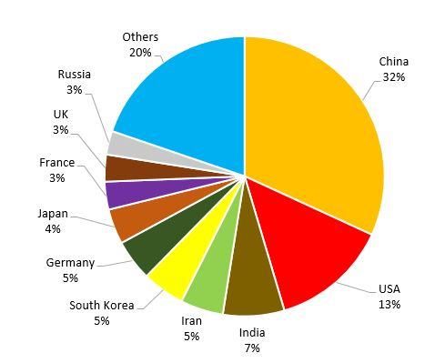
Fig 6. No of nanotechnology articles published by various countries
V.FUTURE OF NANOTECHNOLOGY
Today's nanotechnology is much more advanced than what is imagined in science fiction. Although the current focus of nanotechnology is primarily on material composition, their prospective applications are extremely broad. Nanotechnology has flourished; it is widely employed and could play a crucial role in the near future. It has had a good effect on life that could revolutionize our lives in the areas of medical, food, and energy, making it deserving of a science fiction novel. Nanotechnology is frequently described as "the future technology" that has many potential applications. Some even mention a revolution in nanotechnology. Nanotechnology undoubtedly has a lot of potential and benefits, but even the most recent technology contains risks that haven't been fully investigated.

VI.CONCLUSION
The use of nanotechnology could completely alter our way of life. This is due to the almost limitless potential it offers to bring about significant improvements in almost every area, including the food business, building, computer technology, medical, and new energy sources. Despite presenting many potential benefits in many areas, nanotechnology of today is still in its infancy as just a few projects have been commercialized. Many are yet to undergo full lifecycle assessment. The number of nanotechnology innovations continues to rise. However, the same cannot be said of research about their potential effects on environment and biological systems. As the world readily adapts to this new technology wave, concomitant effort should be directed to the understanding of their possible impacts. This is essential to ensure that nanomaterials do not become the new hazard of 21st century. The long-long term sustainability of this new technology may depend on the establishment of its risks.
VII.REFERENCES
[1] Pene F, Merlat A, Vabret A, et al. Coronavirus 229E-related pneumonia in immunocompromised patients. Clin Infect Dis.2003;37(7):929932.doi:10.1086
[2] Vijgen L, Keyaerts E, Moes E, Maes P, Duson G, Van Ranst M. Development of one-step, real-time, quantitative reverse transcriptase PCR assays for absolute quantitation of human coronaviruses OC43 and 229E. J Clin Microbiol. 2005;43(11):54525456.doi:10.1128/JCM.43.11.5452-5456.2005
[3] Arias LS, Pessan JP, Vieira APM, Lima TMT, Delbem ACB, Monteiro DR. Iron oxide nanoparticles for biomedical applications: a perspective on synthesis, drugs, antimicrobial activity, and toxicity. Antibiotics (Basel). 2018;7(2). doi:10.3390/antibiotics7020046
[4] Abo-Zeid Y, Williams GR. The potential anti-infective applications of metal oxide nanoparticles: a systematic review. Wiley Interdiscip Rev Nanomed Nanobiotechnol. 2020;12(2):e1592. doi:10.1002/wnan.1592
[5] Coyne DW. Ferumoxytol for treatment of iron deficiency anemia in patients with chronic kidney disease. Expert Opin Pharmacother. 2009;10(15):2563–2568. doi:10.1517/14656560903224998
[6] Ahamed M, Alhadlaq HA, Alam J, Khan MA, Ali D, Alarafi S. Iron oxide nanoparticle-induced oxidative stress and genotoxicity in human skin epithelial and lung epithelial cell lines. Curr Pharm Des. 2013;19(37):66816690.doi:10.2174/138161281131937001
[7] Ahamed M, Alhadlaq HA, Khan MAM, Akhtar MJ. Selective killing of cancer cells by iron oxide nanoparticles mediated through reactive oxygen species via p53 pathway. J Nanopart Res. 2013;15(1).doi:10.1007/s11051-012-12256
[8] Rab S, Afjal A, Javaid M, Haleem A, Vaishya R. An update on the global vaccine development for coronavirus. Diabetes2020;14(6):20532055.doi:10.1016/j.dsx.2020.10.023

