A Novel Approach To Drug Delivery Systems: Microsponges

Madhavi M.N ¹, Pankaj M Pimpalshende², Satish B.Kosalge³

1 Associate Professor, Department of Pharmaceutics  Hi-Tech College of Pharmacy, Chandrapur.  Maharashtra, India  Mail: madhumartha@gmail.com | 2. Professor, Department of Pharmaceutics, Hi-Tech College of Pharmacy, Chandrapur. | 3 Principal,  Hi-Tech College of Pharmacy, Chandrapur.

ABSTRACT
To maximize therapeutic efficacy and cost-effectiveness, innovative drug delivery technology has developed intensely competitive and is growing quickly. Microsponges are one of these cutting-edge developing techniques for precise, controlled, and target-specific medication administration. Microsponges are microscopic polymeric particles with porous surfaces resembling sponges, and pore ranges in size from 5 to 300 microns. The microsponge system can be made into gel, ointment, creams, liquids, or powders with good efficiency. More recently, it has been made into tablets and capsules for oral delivery. Lyophilization, ultrasonic assisted manufacturing, liquid-liquid suspension, and quasi-emulsion solvent diffusion can all be used for producing microsponges. Particle size, morphology, surface topography, loading efficiency, practical yield estimation, accurate density estimation, pore structure, compatibility tests, dissolution studies, and release kinetics will all be examined for these. The multifunctional microsponge technology is discussed in this review, along with its benefits, manufacturing processes, and applications..

Keywords: Microsponge, Porous surface, Control release, drug delivery system

I. INTRODUCTION

Novel drug delivery systems (NDDS) that can control drug release rates or target medications to a specific body site substantially impact the healthcare system. Carrier technology provides a cutting-edge approach to drug administration by affixing the medication to a carrier particle, such as microsponges, microspheres, nanoparticles, liposomes, etc., which regulates the release and absorption characteristics of the medicines. Microsponges are crucial DDS due to their small size and excellent carrier properties. [1]

Won created the microsponge technique in 1987, and Advanced Polymer Systems, Inc. obtained the initial patents. The Microsponge Delivery System(MDS) is a patented, polymeric, highly cross-linked system with porous microspheres. They consist of minuscule, spherical particles with a spongy-like texture, many empty spaces, and an impenetrable framework that connects them. This porous surface regulates the rate of release of the active substances. Microsponge sizes range from 5 to 300 μm in diameter, whereas a typical 25-μm sphere can have up to 250000 pores. (Figure 1). This Microsponge technology has numerous advantages, making it a versatile drug delivery vehicle. These characteristics enhance stability, reduce adverse effects, and favorably modify drug release. [1,2]

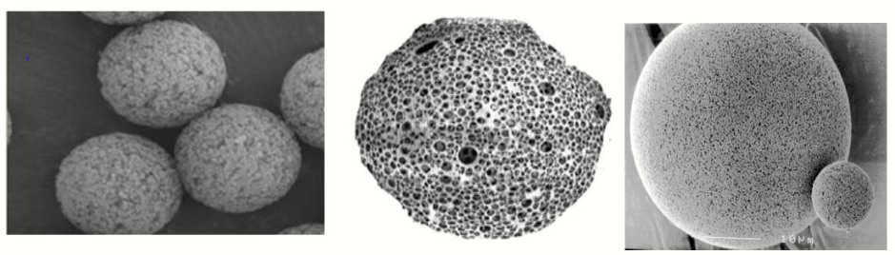
Figure 1: Highly Porous Nature Of A Microsponge.

Earlier, by overcoming the shortcomings of conventional dermatological formulations like uninhibited loss of active ingredients, disagreeable odour, interim overmedication followed by long-standing under medication, rashes, or more severe unwanted effects when active substances enter the skin, this system was employed to improve the performance of topically applied drugs.[3]
The oral route is the recommended way to administer therapeutic medications due to its low cost of therapy and ease of administration, which may lead to increased patient compliance. Some drugs are easily absorbed in the gastrointestinal tract, have a short half-life, and are quickly eliminated through blood circulation. Orally controlled release formulations, which release medication gradually into the digestive system and aid in maintaining steady medication concentration in the serum for extended periods, have been created to address these issues. The use of microsponge technology is unique because it allows for the regulated release of medications while also speeding up the rate at which drugs that are poorly soluble in water dissolve.[4]

A. Characterstics of microsponges [5]
- Retain their stability in the pH range of 1 to 11
- Maintain their stability up to 130ºC
- Companionable with most vehicles and ingredients;
- Since bacteria cannot pass through their 0.25 μm average pore size, they are self-sterilizing;
- carry a greater payload (50–60%), are still free-flowing, and are potentially economical.
B. Advantages [5,6]
- Up to six times, its weight can be absorbed without drying out to advanced oil control.
- Increased product elegance.
- Immiscible items may be incorporated using MDS
- Enhances thermal, physical, and chemical stability.
- Enhanced drug stability
- It enhances material processing; for instance, liquids can be turned into powder.
- Drug release that is controlled and extended for up to 12 hours.
- Site-specific action results for the target organ.
- Reduced irritability and improved tolerance lead to greater consumer acceptance.
- The flexibility to create new product forms.
II. MEHODS OF PREPARATION [4,5,6]

- Liquid-Liquid Suspension Polymerization Method
In liquid-liquid systems, suspension polymerization is a one-step method used to create microsponges. First, the monomers are dissolved in a suitable solvent solution containing the active components (non-polar drug), which are then dispersed in the phase of water with stirring. In order to aid in the preparation of suspension, aqueous phases frequently contain additives like surfactants and suspending agents, among others. Once separate droplets of the desired size have been produced in the suspension, polymerization is started by adding a catalyst, raising the temperature, or using radiation. The polymerization procedure produces a reservoir-like system with pores opening at the surface. In other instances, the pore network is created during the polymerization process using an inert solvent that is entirely miscible with the monomer but immiscible with water. Following the completion of the polymerization process, the liquid is removed, leaving the microsponges. These prefabricated microsponges are then permeated with a variety of active ingredients, including as antifungals, rubefacients, antiacne agents, and anti-inflammatory agents, and they serve as topical carriers. Solvents may occasionally be utilised to incorporate useful compounds more quickly and effectively. A two-step process is utilized if the drug can polymerize under certain conditions. Under moderate conditions, the drug is substituted by a functional component, and the polymerization is carried out using a different porogen. The steps of liquid-liquid suspension polymerization processes are summarised in Figure 2.
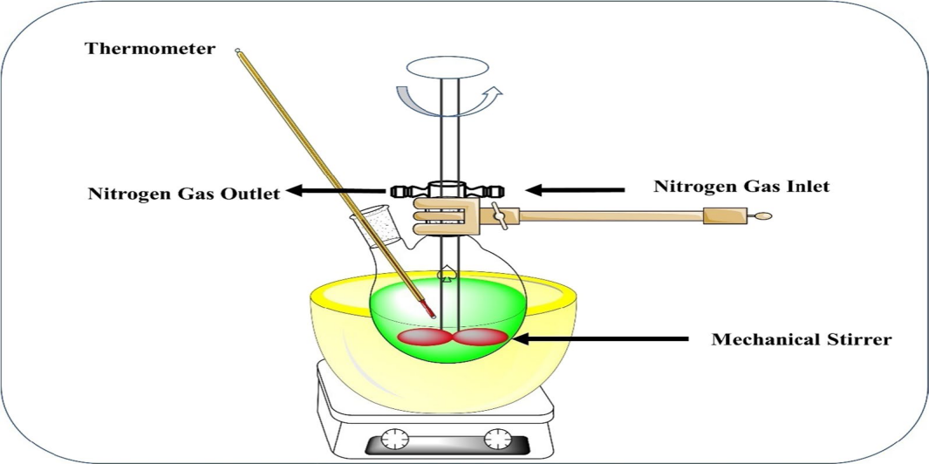
Figure 2 : Liquid-Liquid Suspension Polymerization Method

- Quasi-Emulsion Solvent Diffusion Method
This technique is frequently used to make oral and topical microsponges. This method entails the creation of two phases, the inner organic phase and the external aqueous phase. The internal organic phase is where the medicine is located. With the aid of a mechanical stirrer, the internal phase is added to the exterior phase drop by drop over the course of 60 minutes. Continuous stirring produces quasi-emulsion droplets, while organic solvent evaporation produces solid cages of microsponges. The microsponges were then separated by filtration and dried for 12 hours in the oven. Figure 3 highlights the procedures for producing microsponges using the quasi-emulsion solvent difusion method

.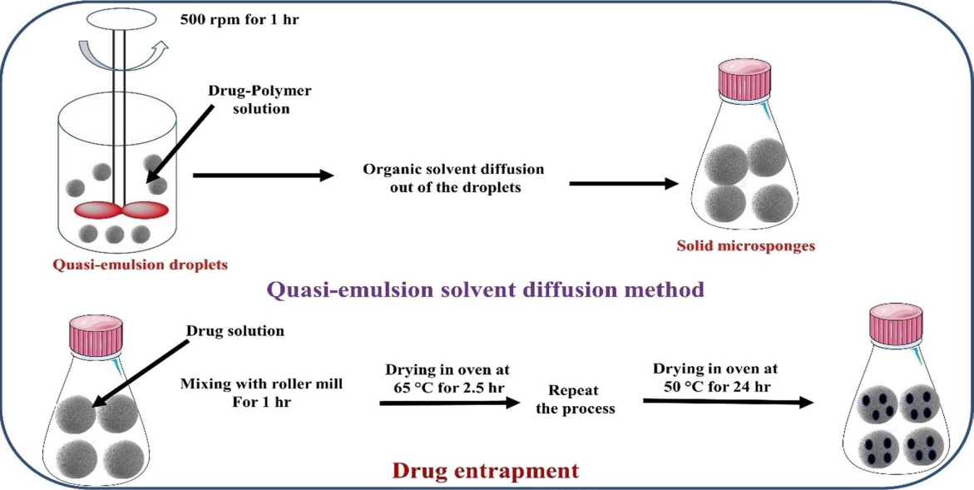
Figure 3: Quasi-Emulsion Solvent Diffusion Method

- Multiple emulsion solvent diffusion method
The technique was intended to create permeable, biodegradable microspheres. First w/o emulsion is prepared using suitable w/o emulsifier and then this w/o emulsion is subsequently dispersed once more in an aqueous phase with suitable o/w emulgent to create a (w/o/w) double emulsion. The use of capturing both soluble and insoluble drugs is made clear by this procedure. Using this technique, proteins and other thermolabile substances can be loaded.

- Addition of Porogen
In this method, the many emulsions were swapped out for porogen's like sodium bicarbonate or hydrogen peroxide. To accomplish this, a single-phase system was developed by combining the polymeric solution, which dissolved the porogen with an aqueous phase that included polyvinyl alcohol. Then an initiator was applied to produce many emulsions, then organic solvent was then withdrawn, leaving the particles alone to create microsponges, after which the particles were dried.
- Lyophilization
This method was used to create porous microspheres from the gelation procedure's generated microspheres. After being treated in chitosan hydrochloride solution, the microspheres were then stored for lyophilization. The fast solvent removal in this method results in microsphere holes. The lyophilization method for manufacturing MDS has the drawback of resulting in shrunken or otherwise fractured micro particles due to the fast elimination of solvent.
- Ultra sound aided production
This approach was developed by altering the procedure for MDS production known as liquid-liquid suspension polymerization. This method produces MDS by cross-linking diphenyl carbonate with beta-cyclodextrin monomer. The reaction mixture is heated and ultrasonicated to regulate the microparticles' size.. As shown in Fig. 4, the mixture was cooled and pulverized before being cleaned with ethanol and then distilled water. This production method has limitations, such as entrapping harmful cross-linking agent residue.

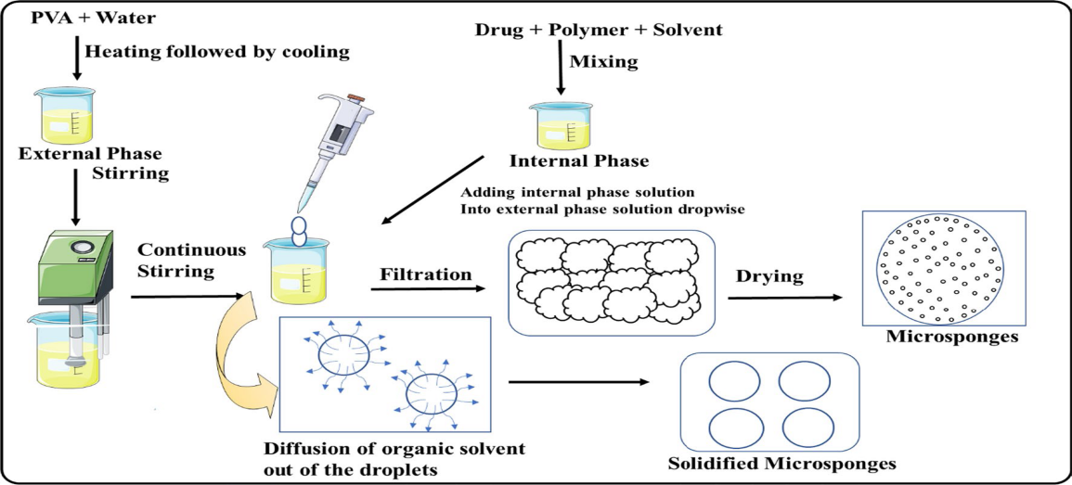
Figure 4: Ultrasound-assisted microsponge production method

III.EVALUATION OF MICROSPONGES [6,7]
Evaluation of microsponges by various methods which are given in table no. 1.

Table 1: Evaluation of Microsponges

S.NO | Parameters | Methods
1 | Particle size (Microscopy), size distribution and polydispersity | Diffractometry
2 | Morphology & surface  topography | Electron microscopy
3 | Density | Displacement method
4 | Pore structure | Mercury intrusion porosimetry
5 | Drug polymer interaction | FTIR
6 | Crystallinity | XRD studies
7 | Production Yield
8 | Loading efficiency | 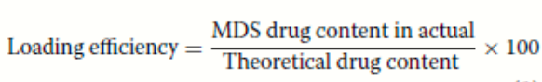

IV. MECHANISM OF DRUG RELEASE FROM MICROSPONGES [5]

In reaction to one or more of the following environmental triggers, such as pressure, temperature change, and solubility, which are described as follows, microsponges may gradually release a fixed amount of active components.
- Temperature change: A few encapsulated active compounds might be too viscous to flow swiftly from microsponges onto the skin at ambient temperature. Increased skin warmth also causes the flow rate to rise, which enhances release.
- Pressure: The active component in microsponges can be released onto the skin by rubbing or applying pressure.
- Solubility: Microsponges containing water-soluble compounds, such as antiseptics and deodorants, release their contents when water is around. Diffusion may cause the release to occur.

pH Triggered Systems: The active can be released based on pH by altering the microsponge's surface. This can be applied in a variety of ways for drug delivery.

V. PHARMACEUTICAL UTILIZATION OF MICROSPONGES

Different applications can be made use of micro sponges. It is usually used topically, though oral use has increased recently. Microsponge delivery techniques enhance the safety, effectiveness, and aesthetic value of topical prescription, over-the-counter, and personal care items. Due to its high loading capacity and capacity for prolonged release as an excipient, several patents have been reported.

To prevent local and systemic cutaneous side effects, microsponge drug delivery system (MDS) ensures drug localization in the epidermis and the skin's surface. By using a MDS, reducing the amount of drug that enters the percutaneous blood circulation is feasible. Table 2 displays microsponge-based formulations for dermatological uses.

Table 2: Drugs investigated for dermatological use using MDS.

S.N | Drug | Polymer | Dosage form | Method of preparation | Application
1 | Diclofenac diethylamine [8] | Eudragit RS-100 | Gel | Quasi-emulsion solvent diffusion | Prolonged release for proficient arthritis therapy
2 | Clobetasol propionate [9] | ----- do------ | Carbopol gel | ----- do------ | Maximum  therapeutic activity with minimum toxic effects due to Extended release.
3 | Diltiazem hydrochloride [10] | ----- do------ | Gel | ----- do------ | Sustained delivery system to overcome side effects
4 | Benzophenone‑3 [11] | Starch | Sunscreen cream | Emulsion gela-  tion method | The product is safe, effective, and aesthetically pleasing, with improved user compliance, decreased systemic absorption, and unwanted side effects.
5 | Benzoyl peroxide (BPO) [12] | Ethyl cellulose, | Cream | Quasi emulsion solvent  diffusion method | Reduced side effects by reducing percutaneous absorption
6 | Naringenin [13] | ----- do------ | Topical gel for | ----- do------ | three-fold more drug deposition in skin than plain gel.
7 | Oxybenzone[14] | ----- do------ | Gel | ----- do------ | A higher sun protection factor with less toxicity due to the drug’s-controlled release onto the skin over an extended period.
8 | Dithranol [15] | ----- do------ | Gel | ----- do------ | Increased patient compliance, prolonged release, and less irritation.
9 | Babchi essential oil [16] | ----- do------ | - | Quasi emulsion solvent evaporation | Enhanced photostability and stability, handling benefits, skin irritation problems overcome by Controlled release of drug.
10 | Silver sulfadiazine [17] | Ethyl cellulose, xanthan gum, | Gel | w/o/w emulsion solvent evaporation | Prolonged effect without skin irritation and low cytotoxicity with enhanced wound contraction.
11 | Betamethasone [18] | Eudragit RS100 | Microsponge based gel | Quasi emulsion solvent | Released of drug in a controlled manner.
12 | Oxiconazole nitrate [19] | Eudragit S-100 and Eudragit L-100. | Microsponge based gel | Quasi-emulsion solvent diffusion | Left on the skin for a prolonged period and gradually release their contents.
13 | Aceclofenac [20] | Ethyl cellulose and Eudragit ES100 | Topical Gel | ----- do------ | Sustain the medication release for eight hours.
14 | Sertaconazole [21] | Eudragit RS 100 | Corbopol gel for topical | ----- do------ | Control release
15 | Diclofenac Sodium [22] | Xanthan gum-facilitated ethyl cellulose | Carbopol gel | Double emulsification technique | Prolonged effect for effective treatment

It has been shown that the microsponge system accelerates the solubilization rate of weakly water-soluble medicines in oral applications by trapping them in its pores. As a result of the drug being effectively reduced to microscopic particles due to the tiny size of these pores, the solubilization rate is significantly accelerated by the significant increase in surface area. Controlled oral delivery of drugs and colon delivery drugs is achieved with microsponges technology using an acrylic polymer, Eudragit RS polymers. Table 3 lists research projects on microsponge drug delivery systems of different medications for various reasons other than topical treatment. Since significantly fewer severe regulatory restrictions exist, cosmetic items are developed, marketed, and supplied far more rapidly than dermatological products. Figure: 5 shows some examples of current cosmetics designed with microsponge technology.

Table: 3 List of MDS research projects that were undertaken for distinct objectives.
SNo | Drug | Polymer | Dosage form | Method of preparation | Application
1 | Albendazole [24] | Eudragit RS100 | Oral for colon delivery | Oil in Oil emulsion solvent diffusion | Sustained release
2 | Domperidone [25] | ----- do------ | Microsponges loaded in capsules | Quasi-emulsion solvent diffusion method | Sustained delivery, reduced frequency and side effects
3 | Meloxicam [26] | ----- do------ | Matrix tablet loaded with Microsponges | Modified Quassi-emulsion solvent diffusion | Colon-targeted
4 | Flurbiprofen [27] | ----- do------ | Microsponges are coated with pectin: HPMC mixture and then tableted. | Quasi-emulsion solvent diffusion method. | Colon specific drug delivery,
5 | Ketoprofen[28] | ----- do------ | Direct compressed tablets | ----- do------ | Tablets with much improved compressibility
6 | Miconazole [29] | ----- do------ | vaginal gel | ----- do------ | Improved vaginal retension with enhanced antifungal activity
7 | Sulpiride [30] | ----- do------ | Microsponges | ----- do------ | Improved sulpiride absorption and bioavailability by retaining MDS in the stomach for up to 8.0 hours after ingestion.
8 | Indomethacin [31] | ----- do------ | Microsponges | ----- do------ | Controlled release
9 | Diclofenac Sodium [32] | ----- do------ | Capsule | ----- do------ | Prolonged release
10 | Dicyclomine [33] | Eudragit S-100, | Pectin: hydroxypropyl methyl cellulose coated tablets | ----- do------ | Colon targeted  drug delivery.
11 | Cyclosporine [34] | Polyvinyl pyrrolidone, hydroxpropyl cellulose | Microsponges | Sequential wet-  milling and drop freeze-drying (DFD) process | Solubility Improved
12 | Curcumin [35] | Ethyl cellulose and Eudragit S 100 | Floating gastro retentive drug delivery system | Modified quasi emulsion solvent diffusion method | Increased the rate of solubilization and Gastro retentive drug delivery system
13 | Ranitidine HCl [37] | Eudragit S 100, Xanthan gum, | Sustained release  gastric buoyant microsponges | W/O/W emulsion - solvent evaporation method | Improved the anti-ulcer effect of Ranitidine
14 | Parecoxib [38] | Eudragit RS 100 and Ethyl cellulose, | Microsponge hydrogel sustained release tablets | Quasi emulsion solvent diffusion | For sustained release
15 | Ketoprofen [39] | Ethyl cellulose. HPMC, | Microsponges | ----- do------ | For controlled release
16 | Meloxicam [40] | Eudragit E100, Eudragit L100 | Transdermal gel | ----- do------ | Enhanced dissolution rate.
17 | Candesartan Cilexetil [41] | Eudragit RS100, RL100, and S100 | Powder | ----- do------ | Enhanced solubility and dissolution rate
18 | Curcumin [42] | Ethyl cellulose | Capsule and topical carbopol gel | ----- do------ | Prolonged release of drug
19 | Diclofenac [43] | Eudragit L100, Eudragit RS 100 and Eudragit EPO 100 | Microsponges | ----- do------ | Colon targeted Controlled release by predetermined rate.
20 | Diclofenac Sodium [44] | Ethyl cellulose | Microsponges | ----- do------ | Controlled release of drug
21 | Acetazolamide [45] | Ethyl cellulose polymer | Ophthalmic pluronic F-127 in situ gel | ----- do------ | enhanced effectiveness of therapy and fewer systemic side effects

Figure 5: Examples of current cosmetics designed with Microsponge technology [6, 23]

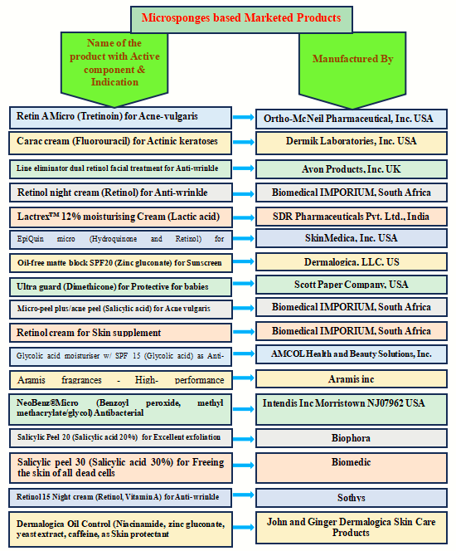

VI. CONCLUSION:

The market for unique and highly effective medicinal and cosmetic products makes microsponge technology and its adaptability promising. The highly controlled release drug of by loading in microsponges is a promising approach that reduces pharmacological adverse effects whereas retaining therapeutic efficacy. It also showed significant increases in formulation stability and more elegant and adaptable formulations. According to numerous studies, they are also said to be non-toxic, non-allergic, and non-mutagenic. Today, prescription drugs, cosmetics, sunscreens, and over-the-counter skincare products use this drug delivery system. It is an up-and-coming technology that will be thoroughly studied in the years ahead through several research projects because of its wide range of drug-administering options.

VII. REFERENCES:
- Joshi G, Kaur R, Kaur H. Microsponges: a novel drug delivery system. International Research Journal of Pharmaceutical and Biosciences. 2016 Jan;3(1), pp. 01-11.
- Ahmed A, Makram M, Sayed M, Louis D. An overview of microsponge as a novel tool in drug delivery. MADD. 2018 Dec;2(3). pp 1-7.
- Shelke PK, Gadhave MV, Gaikwad DD., Rajpure PB., Microsponge Drug Delivery system. International Journal of Universal Pharmacy and Life Sciences. ; 2013; 3(August), pp 1–17.
- Kar AK, Kar B, Parya H, Kundu S, Hirawat R. A novel approach on microsponge: multifunctional modern dosage form. Int J Pharm Sci Rev Res. 2018;51(2). pp 64-72.
- Tile MK, Pawar AY. Microsponges: a novel strategy for drug delivery. International Journal of Pure and Applied Bioscience. 2015;3(1). pp. 224-35.
- Tiwari A, Tiwari V, Palaria B, Kumar M, Kaushik D. Microsponges: a breakthrough tool in pharmaceutical research. Future Journal of Pharmaceutical Sciences. 2022 Jun 11;8(1):31.
- Verma NK, Alam G, Mishra JN. A review of dendrimer-based approach to novel drug delivery systems. Int J Pharm Sci Nanotechnol. 2015 Aug 30;8. Pp. 2906-18.
- Osmani RA, Aloorkar NH, Ingale DJ, Kulkarni PK, Hani U, Bhosale RR, Dev DJ. Microsponges based novel drug delivery system for augmented arthritis therapy. Saudi pharmaceutical journal. 2015 Oct 1;23(5). Pp. 562-72.
- Devi N, Kumar S, Prasad M, Rao R. Eudragit RS100 based microsponges for dermal delivery of clobetasol propionate in psoriasis management. Journal of drug delivery science and technology. 2020 Feb 1;55:101347.
- Ivanova NA, Trapani A, Di Franco C, Mandracchia D, Trapani G, Franchini C, Corbo F, Tripodo G, Kolev IN, Stoyanov GS, Bratoeva KZ. In vitro and ex vivo studies on diltiazem hydrochloride-loaded microsponges in rectal gels for chronic anal fissures treatment. International Journal of Pharmaceutics. 2019 Feb 25;557. pp.53-65.
- Bhuptani RS, Patravale VB. Starch microsponges for enhanced retention and efficacy of topical sunscreen. Materials Science and Engineering: C. 2019 Nov 1;104:109882.
- Jelvehgari M, Siahi-Shadbad MR, Azarmi S, Martin GP, Nokhodchi A. The microsponge delivery system of benzoyl peroxide: Preparation, characterization and release studies. International journal of pharmaceutics. 2006 Feb 3;308(1-2). pp.124-32.
- Nagula RL, Wairkar S. Cellulose microsponges based gel of naringenin for atopic dermatitis: design, optimization, in vitro and in vivo investigation. International Journal of Biological Macromolecules. 2020 Dec 1;164. pp. 717-25.
- Kumar PM, Ghosh A. Development and evaluation of silver sulfadiazine loaded microsponge based gel for partial thickness (second degree) burn wounds. European journal of pharmaceutical sciences. 2017 Jan 1;96. Pp.243-54.
- Pawar AP, Gholap AP, Kuchekar AB, Bothiraja C, Mali AJ. Formulation and evaluation of optimized oxybenzone microsponge gel for topical delivery. Journal of drug delivery. 2015;2015.
- Wadhwa G, Kumar S, Mittal V, Rao R. Encapsulation of babchi essential oil into microsponges: Physicochemical properties, cytotoxic evaluation and anti-microbial activity. Journal of Food and Drug analysis. 2019 Jan 1;27(1). pp.60-70.
- Tripathi PK, Gorain B, Choudhury H, Srivastava A, Kesharwani P. Dendrimer entrapped microsponge gel of dithranol for effective topical treatment. Heliyon. 2019 Mar 1;5(3).
- Mohanty D, Bakshi V, Rashaid MA, Reddy TV, Dholakia NA, Babu AM. Design and in-vitro characterization of betamethasone microsponge loaded topical gel. International journal of Pharma research and health sciences. 2016;4(2). pp.1124-9.
- Yadav V, Jadhav P, Dombe S, Bodhe A, Salunkhe P. Formulation and evaluation of microsponge gel for topical delivery of antifungal drug. International Journal of Applied Pharmaceutics. 2017 Jul 13. pp.30-7.
- Patel U, Code QR. Formulation and development of Aceclofenac loaded microsponges for topical delivery using quality by design approach. Int J Adv Pharm. 2018;7. pp.17-32.
- Pande VV, Kadnor NA, Kadam RN, Upadhye SA. Fabrication and characterization of sertaconazole nitrate microsponge as a topical drug delivery system. Indian journal of pharmaceutical sciences. 2015 Nov;77(6). pp.675-680.
- Maiti S, Kaity S, Ray S, Sa B. Development and evaluation of xanthan gum-facilitated ethyl cellulose microsponges for controlled percutaneous delivery of diclofenac sodium. Acta Pharmaceutica. 2011 Sep 1;61(3). pp.257-70..
- Nidhi K, Verma S, Kumar S. Microsponge: An advanced drug delivery system. Journal of Clinical and Scientific Research. 2021 Apr 1;10(2). pp.108-11.
- Abdellatif AA, Zayed GM, Kamel HH, Mohamed AG, Arafa WM, Khatib AM, Sayed OM. A novel controlled release microsponges containing Albendazole against Haemonchus contortus in experimentally infected goats. Journal of Drug Delivery Science and Technology. 2018 Feb 1;43. pp.469-76.
- Osmani RA, Aloorkar NH, Thaware BU, Kulkarni PK, Moin A, Hani U, Srivastava A, Bhosale RR. Microsponge based drug delivery system for augmented gastroparesis therapy: Formulation development and evaluation. Asian journal of pharmaceutical sciences. 2015 Oct 1;10(5). pp.442-51.
- Srivastava R, Kumar D, Pathak K. Colonic luminal surface retention of meloxicam microsponges delivered by erosion based colon-targeted matrix tablet. International journal of pharmaceutics. 2012 May 10;427(2). pp.153-62.
- Orlu M, Cevher E, Araman A. Design and evaluation of colon specific drug delivery system containing flurbiprofen microsponges. International journal of pharmaceutics. 2006 Aug 2;318(1-2). pp.103-17.
- Çomoglu T, Gönül N, Baykara T. The effects of pressure and direct compression on tabletting of microsponges. International journal of pharmaceutics. 2002 Aug 21;242(1-2). pp.191-5
- Salah S, Awad GE, Makhlouf AI. Improved vaginal retention and enhanced antifungal activity of miconazole microsponges gel: Formulation development and in vivo therapeutic efficacy in rats. European Journal of Pharmaceutical Sciences. 2018 Mar 1;114. pp.255-66.
- Younis MA, El-Zahry MR, Tallat MA, Tawfeek HM. Sulpiride gastro-retentive floating microsponges; analytical study, in vitro optimization and in vivo characterization. Journal of drug targeting. 2020 Apr 20;28(4). pp.386-97.
- Mahajan AG, Jagtap LS, Chaudhari AL, Swami SP, Mali PR. Formulation and evaluation of microsponge drug delivery system using indomethacin. International research journal of pharmacy. 2011 Oct;2(10). pp.64-9.
- Londhe K A, Sheetal B G , Ravindranath B S.,Preparation and characterization of Diclofenacfenac sodium loaded microsponges for capsules, American Journal of . PharmaTech Research. 2014; 4(6); pp.408-417.
- Jain V, Jain D, Singh R. Factors effecting the morphology of eudragit S-100 based microsponges bearing dicyclomine for colonic delivery. Journal of pharmaceutical sciences. 2011 Apr 1;100(4): pp.1545-52.
- Kobayashi M, Kondo K, Nakashima C, Kida Y, Niwa T. Design of self-dispersible microsponge containing cyclosporine through wet milling and drop freeze-drying processes to improve dissolution behavior. Journal of Drug Delivery Science and Technology. 2020 Jun 1;57:101577.
- Arya P, Pathak K. Assessing the viability of microsponges as gastro retentive drug delivery system of curcumin: optimization and pharmacokinetics. International journal of pharmaceutics. 2014 Jan 2;460(1-2). pp.1-2.
- Jafar M, Mohsin AA, Khalid MS, Alshahrani AM, Alkhateeb FS, Alqarni AS. Ranitidine hydrochloride stomach specific bouyant microsponge: preparation, in-vitro characterization, and in-vivo anti-ulcer activity. Journal of Drug Delivery Science and Technology. 2020 Feb 1;55:101453.
- Maruthi. N, Lakshmi Radhika G., Preparation And Evaluation Of Parecoxib Microsponge Hydrogel Sustained Released Tablet. Journal of Biomedical and Pharmaceutical Research. 2019, May 8;3. pp.79-89.
- Shahzad Y, Saeed S, Ghori MU, Mahmood T, Yousaf AM, Jamshaid M, Sheikh R, Rizvi SA. Influence of polymer ratio and surfactants on controlled drug release from cellulosic microsponges. International journal of biological macromolecules. 2018 Apr 1;109. pp.963-70.
- Nief RA, Hussein AA. Preparation and evaluation of meloxicam microsponges as transdermal delivery system. Iraqi Journal of Pharmaceutical Sciences (P-ISSN 1683-3597 E-ISSN 2521-3512). 2014;23(2). pp.62-74.
- Alhammid SN. Enhancement of the solubility and the dissolution rate of candesartan cilexetil using microsponge technology. Asian J. Pharm. Clin. Res. 2018;11. pp.385-90.
- Bhatia M, Saini M. Formulation and evaluation of curcumin microsponges for oral and topical drug delivery. Progress in biomaterials. 2018 Sep;7. pp.239-48.
- Janakidevi S, Ramanamurthy K. Design of a novel colon targeted microsponges loaded with diclofenac sodium using three different polymers. Int Res J Pharm. 2018;9(4). pp.9-10.
- Gadhve Manoj V, Bankar Priyanka P, Jadhav SL, Gaikwad DD. Formulation and evaluation of Microsponges of Diclofenac Sodium, World Journal of Pharmaceutical Research, 2017;6(11). pp.417-429.
- Obiedallah MM, Abdel-Mageed AM, Elfaham TH. Ocular administration of acetazolamide microsponges in situ gel formulations. Saudi Pharmaceutical Journal. 2018 Nov 1;26(7). pp.909-20.

