Mangrove Ecosystems and Their Conservation
Rayan Bhattacharya¹, Sayani Chanda², Anwesha Mondal², Animesh Ankuria².
Department of Fisheries Resource Management, Faculty of Fisheries Sciences, WBUAFS.
Department of Fisheries Engineering and Technology, Faculty of Fisheries Sciences, WBUAFS.

ABSTRACT
Mangrove ecosystems are arguably the most productive and diversified ecosystems present on the planet. Coastal ecosystems vary from the dense mangrove forests near the river mouth to the coastal dunes of the beach and the seagrass beds to the beautiful coral reefs just to name a few. Mangrove ecosystems are one of the most productive ecosystems in the planets, ecosystems like mangrove forests and seagrass beds are the best carbon sinks in the planets. Moreover, the high nutritive content in the mangrove areas makes the ecosystems coming under this banner the ideal site for breeding and nursery for many a marine finfish, shellfishes, reptiles and mammals. Also, the high biological productivity of the mangroves ecosystems also made these areas the center of human activities for millennia. Mangrove ecosystems provide an extensive spectrum of goods and services: they are primarily responsible for the production of fish, shellfish, and seaweed for both human and animal consumption; and they are a significant source of fertilizer, pharmaceuticals, cosmetics, household products, and construction supplies. Apart from diversity and productivity and services to human society, mangrove ecosystems are one the fastest depleting ecosystems of the globe at present. This chapter mainly focuses on the mangrove ecosystems, the threats they face and their conservation aspects.
Keywords – Coastal, Ecosystem, Mangroves, Productive, Seagrass, Corals, Dunes, Conservation, Threats
- INTRODUCTION
Coastal ecosystems, which are situated around continental perimeters, have outstanding biological productivity and are easily accessible. This has made them centers of human activity for millennia. Coastal ecosystems provide a diverse range of goods and services: they are the primary producers of fish, shellfish, and seaweed for both human and animal utilization; and they are a key supplier of fertilizer, drugs, cosmetics, household products, and building supplies. Coastal ecosystems, which include a diverse variety of habitat types and a wealth of species and genetic diversity, store and cycle nutrients, filter pollutants from inland freshwater systems, and serve to protect shorelines from erosion and storms. Oceans, on the other hand, play an important role in regulating planetary hydrology and climate, and they are a major carbon sink and oxygen supply due to the high productivity of phytoplankton. Coastal ecosystem services are more difficult to quantify in absolute terms, but they are nevertheless invaluable to human culture and life on Earth. These include coastal protection (buffering the coastline, shielding it from storms and wind and wave erosion), storing and cycling nutrients, sustaining biodiversity, maintaining water quality (by filtering and degrading pollutants), and functioning as recreation and tourism sites.
The coastal zone includes the intertidal and subtidal areas on and above the continental shelf (to a depth of 200 meters), as well as the lands immediately adjacent to it. As a result, this term encompasses places that are regularly inundated by saltwater. Because coastal ecosystems are defined based on physical characteristics (proximity to the coast) rather than a distinct set of biological features, they include a much broader range of habitats than other ecosystems in the Pilot Analysis of Global Ecosystems (PAGE), such as grasslands or forests. Coral reefs, mangroves, tidal wetlands, seagrass beds, barrier islands, estuaries, peat swamps, and other habitats each supply their own specific set of goods and services and face relatively distinct challenges.
In 1995, almost 2.2 billion people, or 39% of the world's population, lived within 100 kilometers of a shore, up from 2 billion in 1990. In comparison coastal areas make up only 20% of the total land area of the planet. With the exception of Antarctica, 19% of all lands within 100 km of the coast are categorized as altered, which means they are used for agriculture or urban purposes; 10% are semi altered and contain a mix of natural and altered vegetation; and 71% are classified as least modified. This least modified category contains a sizable portion of uninhabited areas in northern latitudes. According to Cohen et al. (1997) and Gommes et al. (1998), 20% of the world's population reside within 30 km of the sea, and over twice that amount do so within 100 km of the coast. By 2100, 600 million people are projected to live in coastal floodplains below the 1,000-year flood level, according to Nicholls and Mimura's estimates from 1998.Many crucial coastal habitats, including mangroves, wetlands, seagrass beds, and coral reefs, are rapidly vanishing. It is estimated that in different nations where such data are available, anything between 5 and 80 percent of the natural mangrove area has been lost. Significant losses have occurred, especially over the past 50 years. Natural coastal environments in India are extremely diverse. The entire Indian coast can be broadly classified into West Coast, East Coast and the islands. Backwaters and mudflats dot the western coastline, which has a larger continental shelf. The east coast on the other hand has a narrower continental shelf and is lined with lagoons, marshes, beaches and mangrove rich river deltas. Coral reefs are dominant in the small islands in the Gulf of Kutch in Gujarat, Gulf of Mannar in Tamil Nadu and in Lakshadweep and Andaman and Nicobar groups of islands
The world's coastal ecosystems depend heavily on mangroves. Mangroves are great friends in our fight to achieve net-zero carbon emissions by 2050 because they absorb carbon at up to four times the rate of terrestrial forests. They function as important nesting sites and provide a home for diverse array of fishes, crustaceans, shellfish, and wildlife. Additionally, they contribute to the stabilization of coastlines, offer protection to coastal communities from storm surges, and help mitigate erosion. This unit will deal with one of the most ecologically important coastal ecosystems, viz. mangroves; their diversity and distributions, the threats they face and the conservation efforts and a few case studies related to them.
- MANGROVES: THE SENTINELS OF THE SHORE
The term “mangrove” refers to tidally influenced wetland ecosystems within the intertidal zones of tropical and subtropical latitudes. Mangroves are coastal forests that grow in sheltered estuaries, river banks, and lagoons across the tropics and subtropics. The term ‘mangrove’ describes both the ecosystem and the plant families that have developed specialized adaptations (e.g., aerial roots, salt excretion glands and vivipary of seeds) to live in this tidal environment (Tomlinson, 1986). To avoid confusion, Macnae (1968) proposed that “mangal” should refer to the forest community while “mangroves” should refer to the individual plant species. The predominant ecosystem found along the subtropical and tropical coastlines of the planet is the mangrove. Mangroves are resilient. Mangrove trees live in hot, muddy, salty circumstances that would kill other plants rapidly because their roots are submerged in water. These plants have a number of adaptations that allow them to not only survive but also thrive in these environments. Two of these adaptations are a complex root system that maintains mangrove trees upright in shifting sediments at the point where land and water converge and a filtration system that keeps out much of the salt. Additionally, the mangrove environment is home to a staggering variety of organisms, some of which are specific to mangrove forests. Mangrove swamps are also crucial to both the health of the earth and our own well-being, as scientists are learning. Natural barriers between the land and the sea are provided by mangroves. Strong waves that have accumulated on open oceans are absorbed by mangroves. This is particularly crucial when there are tropical storms. Mangroves also prevent erosion that waves over time bring about. Mangroves are frequently referred to as carbon sinks because of the way they filter sediment runoff from both natural and human activity.
Snapper and grouper, among other juvenile fish from the surrounding coral reefs, congregate in the mangroves' tangled roots to seek safety. The baby fish may grow here with a lot less competition and predatory pressure. Mangrove lagoons can serve as nurseries for both estuary and reef fishes (Odum et al., 1982; Boulon, 1992) and are an essential habitat for young members of many fish species (Thayer et al., 1987; Cintron-Molero, 1992; Boulon, 1992). Shrimp, crabs, and lobster are just a few examples of the crustaceans that thrive in these settings. Some smaller fish species never leave the mangroves' complex root systems. Fish like tarpon, rays, and lemon sharks prefer to hunt in the area near the edges of mangroves (Wolf, 2012).
Mangrove forests play a vital role for both humanity and biodiversity. While extensive areas of these ecosystems have been lost, there is an evolving understanding of their multifaceted benefits. Increasing efforts are being made to preserve the remaining mangrove forests and initiate restoration projects. These ecosystems have a unique nature, straddling both land and water, and they have suffered substantial losses, potentially exceeding those experienced by many other ecosystems. These losses have had repercussions for both local communities and the global environment. Additionally, mangroves are unparalleled in their ability to capture and store carbon per unit of land. Consequently, the decline of mangroves and their associated soils has led to significantly higher emissions of greenhouse gases on a global scale. (SOWM, 2021).
- Status of Mangrove Cover Worldwide

- As in 2016 the mangroves cover 136000 km² area world-wide.
- South-east Asia is home to one third of all the mangroves, with Indonesia housing 20% of the world total.
- South Asia accounts for 8414 km² of the total mangroves, that is roughly 6.5% of the global mangrove cover.
- A net loss of 4.3% (6075 km²) of mangroves was seen for a duration of 20 years from 1996 to 2016 but the average rate of mangrove loss is slowing down worldwide as of now.
- 42% of the total world mangrove cover as of now is under protection.

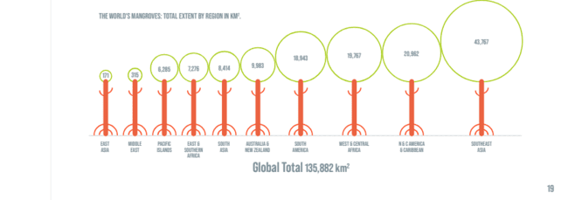

Figure 1: The world’s mangrove covers regionally in Km² (Source: The State of World Mangroves, 2021)
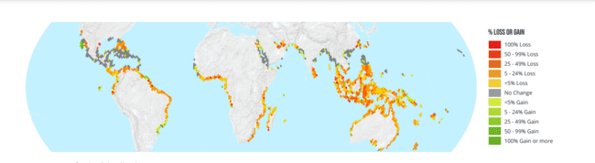
Figure 2: Percent gain or loss in mangroves worldwide from 1996-2016 (Source: The State of World Mangroves, 2021)

- Status of Mangrove Cover in India

- Mangroves in India are roughly 3.3% of the global mangrove cover.
- The Sundarbans in West Bengal holds half the total area under mangroves in India.
- The 2017 mangrove cover assessment carried by the Forest Survey of India showed that the mangrove cover in the country is 4921 Km² which accounts for 0.15% of India’s total area.
- There has been an increase of 181 km² in India’s mangrove cover as compared to the 2015 assessment.
- The mangroves in India have been classified into three types (IFSR, 2017): -
  - Very dense mangroves- Covers 1481 Km² area which roughly accounts for 30.1% of the total mangrove cover.
  - Moderately dense mangroves- Covers 1480 Km² area which roughly accounts for 30.07% of the total mangrove cover.
  - Open mangroves- Covers 1960 Km² area which roughly accounts for 39.83% of the total mangrove cover.

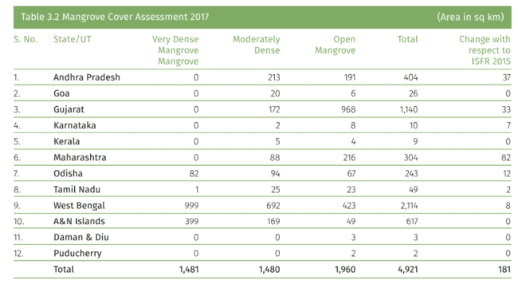
Figure 3: Mangrove area in India in accordance to state (Source: ISFR, 2017)
- Reason for Increase in Mangrove Cover in India: -
- Andhra Pradesh: Positive change of 37 km² is mainly due to afforestation and regeneration.
- Gujarat: Positive change of 33 km² in mangroves in mainly due to conservation efforts such as plantation and regeneration particularly in Bhavnagar, Jamnagar, Kutch and Junagarh.
- Maharashtra: Positive change of 82 km² mainly due to plantation and regeneration of mangroves.
- Odisha: A positive change of 12 km² in Bhadrak, Baleshwar and Kendrapara districts.
- West Bengal: A positive change of 8 km² in the mangroves of East Midnapore and South 24 Paraganas due to plantation and natural rejuvenation.

- Mangrove Zonation
Mangrove zonation refers to the categorization of specific sections within a mangrove forest that are predominantly populated by members of the same family, genus, or species. This phenomenon is observed in both natural and man-made mangrove forests. Mangrove zonation primarily manifests in four distinct types, determined by the prevalence of a particular family within that zone, namely the red mangrove, black mangrove, white mangrove, and buttonwoods. The variation in salinity tolerance among different plant species primarily drives this zonation. Additionally, tidal inundation and changes in land elevation play a role in shaping these patterns. Along the same stretch of coastline, you can find red, black, white mangrove trees, and buttonwoods coexisting, yet they are confined to specific sections of the tidal zone. This zonation is influenced by tidal fluctuations, land elevation, and variations in soil and water salinity.

- Red Mangroves
Red mangroves thrive at the water's edge, where they face the full impact of tidal fluctuations and prevailing winds. They have evolved to adapt to these challenging conditions, characterized by the emergence of prop roots extending from their trunk and branches. These intricate networks of roots not only enhance the tree's stability but also act as collectors of sediments from the surrounding water. What sets red mangroves apart are their distinctive aboveground prop roots, which facilitate the exchange of air with their submerged underground roots. These trees are classified as broad-leaved evergreens. In tropical regions, they can grow to heights exceeding 80 feet (approximately 24 meters). Often referred to as "walking trees," red mangroves create the illusion of moving atop the water due to their continually expanding prop roots. They are typically located closest to the ocean due to their remarkable salt tolerance.
E.g.: Plants belonging to the family Rhizophoraceae, the most popular of them all is Rhizophora mangale.

- Black Mangroves
The black mangrove is typically situated further inland, featuring pneumatophores that extend upward from the soil surrounding its trunk. These specialized root structures serve the purpose of delivering oxygen to the subterranean roots, which often reside in oxygen-deprived, anoxic sediments. These trees are named "black mangroves" due to the dark hue of their bark. Black mangroves primarily thrive along high-tide shores and have the remarkable ability to endure salinity levels of up to 60 parts per thousand (ppt) and extremely oxygen-deprived conditions.
E.g.- Plants belonging to the family avicenniaceae, the common example being Avicennia germinans.

- White Mangroves
White mangroves are found in the interior of the mangrove forest, where they lack particular root adaptations. They grow higher up than red and black mangroves. They do not have aerial roots in general. However, when oxygen is limited due to flooding, unusual growth of peg roots occurs. Their bark is pale white in hue and prefers low salinity environments.
E.g.: Plants belonging to the genus Laguncularia and Lumnitzera of family combretaceae.

- Button Woods
The Buttonwood mangrove is an associate mangrove; it is not a real mangrove, but it is common in regions where mangroves grow. Buttonwoods and white mangroves share the same habitat. Salt is discharged through the two red notches at the leaf's base. The salt is carried away from the plant when it rains.
E.g.: Conocarpus erectus
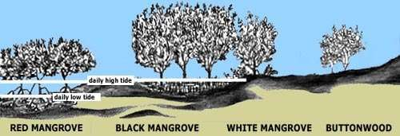

Figure 4: Mangrove Zonation (Source: https://www.floridamuseum.ufl.edu)

- MANGROVES- TRESAURE TROVES OF DIVERSITY
The mangrove environment plays a crucial role in the biology of its animal inhabitants. However, it's noteworthy that until recently, this unique ecosystem hadn't received the attention it rightfully deserved, especially concerning its faunal aspect. In contrast, the floral components of both Indian and Sundarbans mangrove forests have been extensively documented in various literature sources (Roxburgh, 1832; Mitra and Banerjee, 1979; Choudhury, 1979; Untawale, 1980; Naskar and Guhabakshi, 1982).
Previous research on the fauna of this region scarcely made any mention of the mangroves, despite the existence of around 700 publications on various aspects such as bioecology, systematics, and fisheries. Stoliczka (1869) stands out as one of the early researchers who explored the malacofauna of the brackish water systems in lower Bengal. Following this, Alcock (1896-1906) contributed to the understanding of crustaceans, Annandale (1907) explored Hydrozoa, Polyzoa, and Entoprocta, Kemp (1913) focused on crustaceans, and Hora (1955) delved into the realm of fishes. Their works significantly enhanced our knowledge of the estuarine fauna present in this part of the Sundarbans.
Floral Diversity
A total of 54 true mangroves (20 families); 60 associates from 46 genera. 25 of the 34 species that make up the primary components are members of just two families: Avicenniaceae and Rhizophoraceae.

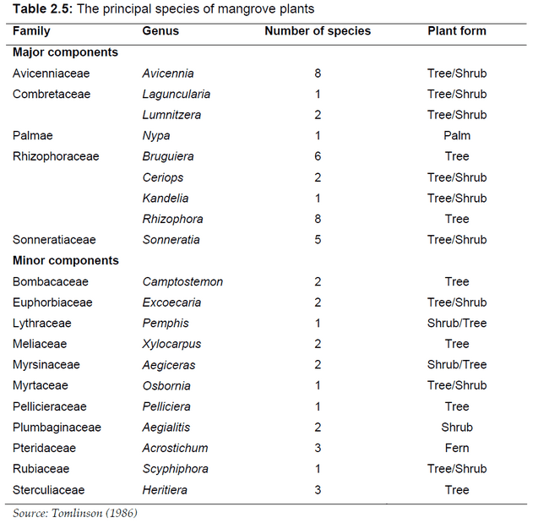
Figure 5: The Principal Species of Mangrove Vegetation

Figure 6: List of Mangrove (Exclusive) Plant Species Available in Sunderbans (Mandal and Nandi, 1989).

- Faunal Diversity

The primary faunal components within this ecosystem consist of terrestrial, brackish water, and marine species. Mangrove fauna can be found in three distinct biomes: the littoral or supra-littoral forests, intertidal mudflats, and estuaries. The littoral or supralittoral forest biome is essentially a terrestrial ecosystem encompassing both creatures that live in the air and on trees, as well as those residing in the soil. Arboreal animals and soil inhabitants can be categorized as epifauna and infauna, respectively. The intertidal mudflats serve as a semi-terrestrial or semi-aquatic habitat primarily supporting soil-dwelling organisms and benthic life forms. In contrast, the estuary is inhabited by aquatic organisms, including plankton and nekton. The distribution of animals within the mangrove ecosystem is influenced by various factors such as the type of substrate, salinity, tidal range, vegetation, light availability, temperature, and more (Mandal and Nandi, 1989).

Zooplankton can be categorized into three size groups: microzooplankton (organisms ranging from 20 to 199 micrometers), mesoplankton (organisms measuring between 200 micrometers and 2 millimeters), and macrozooplankton (organisms larger than 2 millimeters). Microzooplankton includes foraminiferans, ciliates, rotifers, copepod nauplii, barnacle nauplii, and veliger mollusks. Mesoplankton is primarily composed of copepods, while macrozooplankton, the largest group, features jellyfish as its most significant members. Additionally, various organisms such as sponges, hydroids, anemones, polychaetes, bivalves, barnacles, bryozoans, and ascidians are attracted to and inhabit the roots, trunks, and branches of mangrove trees.

A significant portion of the fish population consists of juveniles, indicating that the mangrove habitat serves as a nursery area for them. Fish play a crucial role as predators in the ecosystem, as they consume a diverse range of organisms, including amphipods, isopods, shrimp, nematodes, insects, gastropods, crabs, bivalves, other fish, and planktonic larvae (Sasekumar et al., 1992). Mullets (Liza spp.) are particularly effective at consuming a substantial amount of detritus. Similarly, mangrove red snappers (Lutjanus argentimaculatus) primarily feed on other fish and shellfish. Crocodiles, including both saltwater and mugger species, are integral members of the nekton community, occupying the role of top predators.
The mangrove fauna can be divided into 4 major categories according to Mandal and Nandi (1989) which are as follows:
- Littoral or supra-littoral forest fauna
- Intertidal mudflat fauna
- Estuarine fauna
- Parasite fauna

- THE IMPORTANCE OF MANGROVES

- Mangroves are Pillars of Diversity and Endemism

Mangrove trees and shrubs collaborate to establish and shape an environment that serves as a crucial habitat for a multitude of species. Within the drier regions of this ecosystem, terrestrial fauna find their home, encompassing a range from insects and reptiles to monkeys and tigers. Moreover, mangroves offer shelter to a diverse array of aquatic life, including fish, mollusks, crabs, and even larger inhabitants like sharks, crocodiles, and dugongs in the pools and channels surrounding their roots. Mangrove forests feature intricate, winding channels that not only channel water from inland rivers but also transmit tidal movements upstream. These channels create connections to numerous other ecosystems, allowing larger creatures to frequent them or utilize mangroves as essential nursery grounds. Mangrove forests, in essence, serve as hubs of exchange where minerals and particles from inland or coastal areas can be deposited, perpetuating a state of continual transformation in the land.
Furthermore, the remarkable productivity of mangroves contributes to the enrichment of surrounding waters. This enrichment occurs through the migration of fish and other animals and the constant export of organic matter from the mangrove forests themselves. Mangroves serve as a crucial habitat for a select group of species, either because they exclusively inhabit these environments or have sought refuge in mangroves when other habitats have become scarce or disappeared. Remarkably, a total of 341 species that depend on mangroves are recognized as threatened by the international community and IUCN, falling into categories such as vulnerable, endangered, or critically endangered. This diverse group includes a wide array of creatures, from tigers to seahorses, sawfish to sea eagles, orchids to sea cucumbers, and many more.

- Rich Natural Resources

Coastal communities have historically acknowledged the vital role of mangroves as an essential ecosystem due to the numerous advantages they offer. Besides the core topics of coastal protection and climate change mitigation discussed in this report, mangroves provide a wealth of other benefits. Given the escalating challenges posed by climate change, these benefits are becoming increasingly significant. The preservation of mangroves could prove pivotal in helping coastal communities adapt to the evolving landscape of change and uncertainty in our world.

- Food Supplies

Mangroves function as prolific sources of sustenance. Their elevated productivity sustains diverse and thriving food chains, which are frequently enriched by the nutrients carried by rivers and streams. The nature of the habitat itself fosters this abundance. The roots create a suitable surface for oysters and various mollusks to settle and thrive. Furthermore, the intricate layout of winding channels offers shelter for fish and provides a relatively secure environment where they can live during their early life stages, shielded from potential predators.
The primary species harvested from mangroves include shrimp, oysters, and various small fish. Fishing activities here are primarily conducted by small-scale or artisanal fishers, often for local consumption. Many of these fisheries operate independently of national government oversight, which makes them often overlooked but of critical importance. On the other hand, some fisheries are more well-known. Specific species like mud crabs, oysters, and prawns hold significant value and are marketed to regional or even international markets. According to a recent study supported by GMA (Global Mangrove Alliance), these forests provide livelihoods for more than one-third of small-scale fishers in countries with mangroves. In many nations, particularly in Central and West Africa, this percentage exceeds 80%. The global estimate of mangrove fishers stands at approximately 4.1 million individuals. For each of these fishers, there may be several others who depend on them, both for employment and as their primary source of protein. In addition to small-scale fishing, larger commercial fisheries also rely on mangroves. While adult prawns are abundant in offshore areas, their larvae depend on nutrient-rich estuaries dominated by mangroves for rapid growth and protection from predators. Mangroves also serve as crucial nursery grounds for species like banana prawns, which are potentially the most significant for trawl fishing in the Indo-West Pacific region.

- Timber and Fuel

In many regions, mangroves represent the sole source of accessible wood. Even in places where other tree varieties abound, mangrove wood is highly valued for its resistance to decay and termite infestation. It finds use as timber in construction, polewood for fencing, and in crafting fish traps. Additionally, it serves as a fuel source for cooking, and its dense wood is frequently transformed into high-quality charcoal. While the extraction of mangrove trees has contributed to the decline of mangrove ecosystems in many locations, there are areas where responsible and sustainable harvesting practices have been upheld for over a century.

- Filters

Mangrove woodlands play a dual role in sediment management. They capture sediments, bolstering coastal stability in certain areas, and they also act as a barrier that prevents these sediments from suffocating offshore coral reefs. Simultaneously, intricate ecological processes involving microbes and filter-feeding organisms around mangrove roots contribute to the purification of water passing through them. This purification process is vital for removing pollutants and excess nutrients, thereby providing significant ecological benefits to nearby ecosystems as well as to human populations.

- Tourist Hubs
Numerous mangrove areas are also sought-after destinations for tourists. Recent research conducted by GMA scientists involved an analysis of TripAdvisor data, which revealed the existence of nearly 4,000 mangrove "attractions" spread across 93 countries and territories. These destinations have garnered reviews from international travelers, underscoring the fact that mangroves are equally popular among local visitors. The activities available in these areas encompass everything from leisurely walks or guided hikes to aquatic pursuits like boating and specialized wildlife observation. Some rather unique experiences are on offer as well, such as witnessing nighttime firefly displays or experiencing in-water bioluminescence, for instance. Moreover, recreational fishing in mangrove regions is increasingly gaining value, with top fly-fishing locations attracting discerning clients willing to invest hundreds of dollars per day for the opportunity to enjoy sporting activities in undisturbed natural settings.
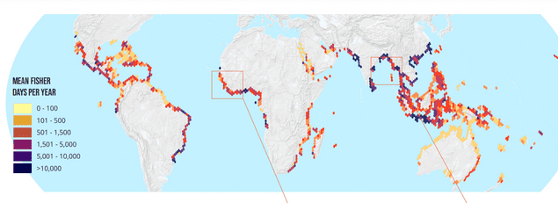
Figure 7: The numbers of fishers using mangroves, modelled as the total numbers of days individual fishers spend per km² of mangrove per year (Source: The State of World Mangroves, 2021)
- Defending Coasts

Mangroves flourish in the coastal areas where they straddle both land and sea. Coastal regions are constantly changing due to the shifting of sediments caused by storms, the impact of waves, surges, and winds. Mangroves play a crucial role in serving as natural defences along the coast, mitigating the impacts of storms. However, this role is multifaceted and intricate, and its importance can vary but is often quite significant.
In numerous tropical and subtropical regions, mangroves play a crucial role in diminishing the impact of waves and storm surges, serving as a primary defence against flooding. When waves encounter or penetrate a complex structure, they rapidly lose their energy, resulting in decreased speed and height. Mangrove forests are well-suited for this purpose, thanks to characteristics like their substantial bottom friction, considerable cross-shore width, high tree density, and intricate tree composition encompassing roots, trunks, and canopy. They form a rugged, three-dimensional barrier with intricate root systems, trunks, and canopies, which collectively attenuate the force of incoming wind and waves, thus reducing the risk of flooding. Studies have demonstrated that even when trees are relatively young or have recently been restored, a wave passing through just 100 meters of mangrove forest can lose up to two-thirds of its energy.
Mangroves' airborne roots serve to secure sediments and thwart erosion. They contribute to the settling of sediments and slow down the movement of water, thereby reducing the discharge of leaves and branches. This, in turn, facilitates the preservation or even the upward growth of mangrove soils. In certain locations, this vertical buildup can be substantial enough not only to sustain mangroves but also to match the rate of rising sea levels.
Many mangrove-rich countries frequently experience severe storms. However, even in these extreme circumstances, mangroves offer assistance by mitigating the effects of waves and physically stabilizing the land. These forests also serve as a safety barrier, capturing large debris like cars, boats, and parts of buildings, which often cause substantial damage once they enter coastal waters. Moreover, tropical storms can sometimes generate surges that elevate the sea surface by several meters. Mangroves act like porous dams, aiding in the containment and reduction of these surges, significantly diminishing inland flooding. Even though purpose-built and engineered sea defences can't guarantee absolute resilience against all impacts, one of the most valuable aspects of natural sea defences, like coastal mangroves, lies in their capacity to self-construct and regenerate if they suffer damage.

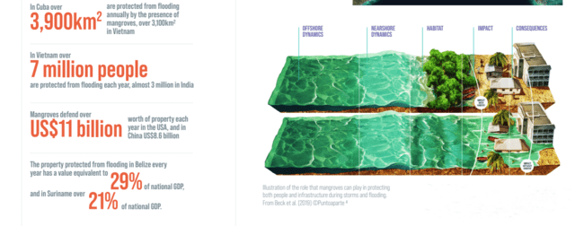
Figure 8 and 9: Protection of Property and People by Mangroves all over the Globe (Source: The State of World Mangroves, 2021)

- Storing Carbon

Mangrove forests function as carbon reservoirs, holding carbon within their living vegetation and their nutrient-rich peat-like soils. Like all forests, mangroves convert carbon dioxide, acquired through photosynthesis, into leaves, wood, and roots, thus increasing their carbon content in biomass as they grow. In fact, mangroves are among the most efficient carbon-capture ecosystems globally. They transform carbon dioxide into organic carbon at a remarkable pace, surpassing nearly all other environments on Earth in this regard. What sets mangroves apart is that the carbon they contribute to the soil through leaf litter and root growth decomposes very slowly due to the waterlogged conditions caused by tidal water. This gradual decomposition results in the accumulation of carbon-rich soil over hundreds to thousands of years.

Furthermore, many species of mangrove trees have above-ground roots that trap sediment and other organic material carried into the forest during tidal flooding, further contributing to the gradual buildup of carbon-rich soil over time. This high productivity makes mangroves excel not only in carbon storage but also as crucial elements in carbon dioxide sequestration initiatives. However, when mangroves are cleared or degraded, they release the stored carbon, primarily as CO2. This release can be substantial, especially in cases where soils are excavated, such as in the construction of shrimp aquaculture ponds.
Figure 10: A comparison of the carbon stored in various forest types (Mg/Ha), showing the contribution of aboveground plants, shallow and deep soil (Source: The State of World Mangroves, 2021).

- THREATS TO MANGROVES
Extensive mangrove loss occurred during the 20th century, and although the rate of mangrove conversion significantly declined in the 21st century, climatic factors have increasingly played a role in global mangrove losses. A comprehensive analysis, using over one million satellite images, has tracked the drivers of mangrove decline since 2000, revealing that more than 60% of the losses were primarily due to direct and indirect human activities.
The primary driver of mangrove loss (accounting for 47% of losses) is the conversion of mangrove areas for commodity production. This is strongly linked to the expansion of fish and shrimp aquaculture, as well as rice farming. The growth of oil palm cultivation is also becoming a significant contributor. The second major human cause of mangrove deforestation (responsible for 12% of losses) is nonproductive conversion, where mangrove areas are transformed into unused land. Additionally, the conversion of mangroves for infrastructure, urban development, and coastal tourism accommodations is a substantial factor, accounting for 3% of the total losses.
Nearly 80% of human-driven mangrove losses are concentrated in six countries: Indonesia, Myanmar, Malaysia, the Philippines, Thailand, and Vietnam. Natural events, such as erosion, sea level rise, hurricanes, and droughts - which are exacerbated by climate change - also contribute to mangrove die-off and loss. Shoreline erosion, the second leading cause of mangrove loss, accounts for 27% of global losses, while extreme weather events contribute to 11% of total losses. For instance, erosion is the primary cause of loss in Bangladesh, responsible for nearly 80% of the country's losses. Infrequent but catastrophic cyclones can also lead to substantial mangrove forest loss, as observed in Papua New Guinea after Cyclone Guba in 2007.
Despite their resilience in challenging environments, mangrove ecosystems have faced unprecedented challenges in the Anthropocene, endangering the survival of some species that constitute these forests. Species at the interface with human activities, such as those in the high intertidal zones like Heritiera spp, or those with small localized populations like Bruguiera hainsii and Sonneratia griffithii, are at the greatest risk of global extinction. Many species, including Camptostemon philippinense, Pelliciera rhizophorae, and Avicennia rumphiana, face long-term extinction due to limited distribution, patchy habitat, and factors like slow propagation rates. The IUCN Mangrove Specialist Group periodically assesses the global conservation status of all mangrove species to provide information for the IUCN Red List and the global community.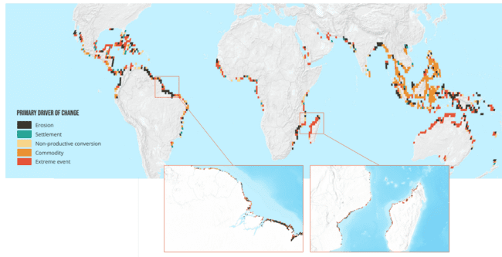Figure 11: Primary Drivers of Mangrove Loss all over The Globe (Source: The State of World Mangroves, 2021)

Figure 12: Threats to Mangroves (Source: The State of World Mangroves, 2021)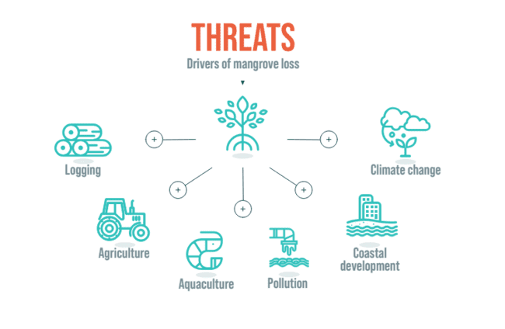
CASE STUDY: Mangrove loss due to shrimp aquaculture in Thailand: -
- Since 1975, it is estimated that the expansion of shrimp farms alone has caused the depletion of 50-65% of Thailand's mangrove forests. Thailand has played a significant role in shrimp farming to meet the demands of the United States, Japan, and Europe.
- This has resulted in numerous adverse effects on coastal communities, including land degradation, the loss of livelihoods dependent on natural resources, increased poverty, heightened susceptibility to natural disasters, and the decline of traditional fishing practices.
- Additionally, the long-term sustainability of prawn pond production tends to decrease, leading to the abandonment of many ponds and leaving extensive areas devoid of both mangroves and aquaculture.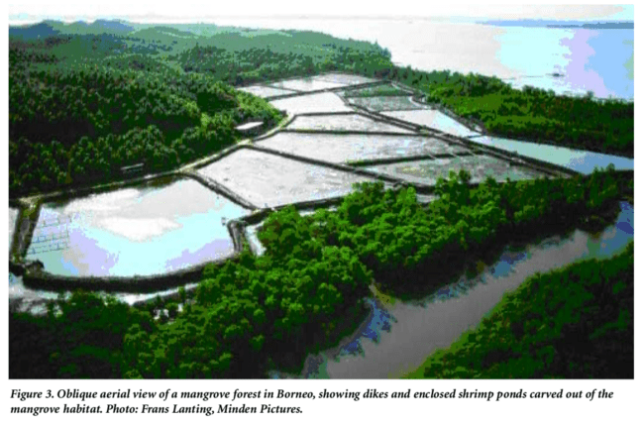

- SAVING AND CONSERVATION OF MANGROVES
Over the past two decades, mangrove forests have transitioned from being one of the fastest disappearing ecosystems on Earth to one of the most effectively preserved. Currently, around 42% of all remaining mangroves are situated within legally designated protected areas, although it's important to note that the degree of actual protection provided in these areas can vary significantly. These protected areas encompass a wide range, from small locally managed sites to extensive national forests, such as the Sundarbans, which are safeguarded across nearly their entire expanse in both Bangladesh and India. This conservation effort also extends to many of the unique species associated with mangroves, including tigers, proboscis monkeys, sawfish, and seahorses.
From a regional perspective, the most comprehensive coverage of protected areas for mangroves is found in South America, where over 74% of all mangroves are situated within them. In contrast, only 13% of East Asian mangroves and 9% of Pacific Island mangroves are protected. Notably, in some of the larger mangrove nations like Myanmar, Papua New Guinea, and Nigeria, there is notably low coverage, despite hosting nearly 10% of all mangroves, with only 3% to 5% of them falling within protected areas.
Among the leading mangrove nations, countries like Bangladesh (92%), Brazil (86%), and Mexico (75%) have some of the highest levels of mangrove coverage within protected areas. Even outside of designated protected areas, local or community ownership of mangroves often leads to sustainable management practices. Various regulatory measures are also employed to prevent mangrove loss, including coastal setback restrictions that prohibit construction within a specified distance from rivers and coastlines in different regions. Additionally, 'no net loss' regulations require that any clearance or loss of mangroves be compensated for by restoring an equal or larger area of equivalent habitat. When implemented effectively, these measures not only conserve mangroves but also protect human lives and livelihoods, ensuring a sustainable supply of fuelwood, supporting fishing, mitigating erosion, and improving water quality. Many protected mangroves also attract tourists, with sites like Can Gio in Vietnam, JN Ding Darling in Florida, USA, and the Nakama River in Iriomote, Japan, each receiving over half a million visitors annually.
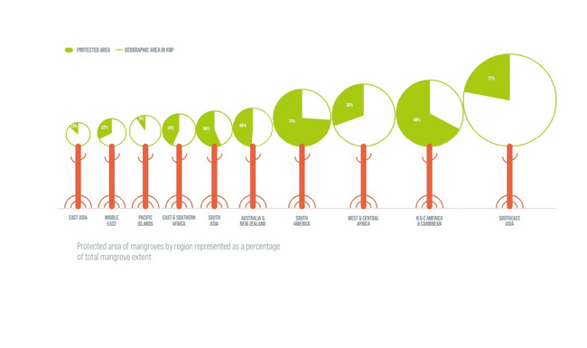
Figure 13: Percent of Mangroves under legal protection over the Globe (Source: The State of World Mangroves, 2021)

- Threats to Conservation

Regrettably, not all designated protected areas offer robust safeguards. Global change maps reveal that losses continue to occur within many of these areas, a fact confirmed by on-the-ground observations. Some of these losses may be natural, stemming from factors like erosion or storms. However, in other instances, these sites face challenges due to ineffective management or insufficient resources, hindering the proper enforcement of regulations. Furthermore, damage can also result from activities in neighbouring regions; alterations to water flows, for instance, might increase erosion or disrupt the supply of freshwater and sediment. In a few cases, governments may even downgrade or revoke protected status in favour of new activities and developments within these areas.
CASE STUDY: EXTERMINATION OF ALIEN MANGROVES IN SHENZEN WETLANDS, CHINA:
- The Shenzhen Mangrove Wetlands Conservation Foundation (MCF) in China is working to revive the natural mangrove species in response to the dominance of an introduced plant, Sonneratia.

- In 2017, the Shenzhen Mangrove Wetlands Conservation Foundation (MCF) initiated a project involving the removal of these non-native Sonneratia mangroves and replaced them with native species. This initiative aimed to restore a healthy mangrove ecosystem by 2020. Apart from clearing the Sonneratia plants, the restoration efforts include improving the hydrological conditions by reconstructing tidal streams, conducting experiments to optimize replanting techniques, and safeguarding mudflats as essential feeding grounds for migratory birds.

CASE STUDY: THE WESTERN INDIAN OCEAN MANGROVES:
- Mangroves play a critical role in both the environment and the livelihoods of millions of people in the Western Indian Ocean region. Kenya, Tanzania, Mozambique, and Madagascar collectively possess approximately 700,000 hectares of mangroves. However, in the past two decades, they have witnessed a loss of 30,000 hectares.

- Mozambique has experienced the most substantial mangrove losses, with over 6% of its mangrove cover being destroyed. To address this issue, partners within the GMA have initiated collaborative efforts. As part of the Save Our Mangroves Now campaign, they have set an ambitious target of achieving zero net loss in mangrove coverage by 2030, with the aim of establishing the region as a leader in mangrove conservation. Toward the conclusion of 2021, a separate report focusing specifically on the Western Indian Ocean region will be generated, and the findings will be shared with policymakers.

CASE STUDY: MANGROVE SILVICULTURE— THE EXAMPLE OF MATANG:
- The Matang Mangrove Forest Reserve, established in Peninsular Malaysia back in 1902, is currently under intense scrutiny due to having the most extensive documented management history among mangrove forests.

- The reserve employs a silvicultural approach to manage its Rhizophora mangrove trees in cycles spanning 30 years. This management strategy involves two rounds of thinning and one clear-cutting operation, followed by reafforestation. The primary objective is to optimize the yield of these monospecific stands, primarily for the production of charcoal. This 120-year history of silvicultural practices in the area is noteworthy and is undergoing thorough examination from various perspectives, including silviculture, ecology, socioeconomics, and public health.
- CONCLUSION
While there has been a reduction in the rates of mangrove loss and deterioration worldwide in recent years, numerous areas still confront substantial threats. These threats stem from coastal development, clearing for aquaculture and agriculture, pollution, overexploitation, and the compounding effects of climate change. The depletion of mangrove habitats anywhere results in a significant decline in the ecosystem services they offer, including fisheries support, water quality improvement, carbon sequestration, and coastal protection. Consequently, this jeopardizes coastal communities, employment, and food security.
Preserving all remaining mangrove cover is just one crucial aspect of the solution. We also need to enhance recovery by allowing natural regeneration and the afforestation of new sediments as coastlines shift and evolve. Additionally, restoring lost mangrove cover is essential. Achieving this requires community-led restoration efforts based on evidence, implemented on a large scale. It entails planning, funding, and executing science-backed restoration programs to start moving towards a global increase in mangrove cover. This entails addressing challenging issues like land ownership or use-rights, discontinuing unsustainable practices, and reducing associated costs.
The COVID-19 pandemic has underscored the urgency of rebalancing our relationship with nature. Our own recovery is intrinsically linked to nature's recovery.
REFERENCES
Alcock, A. 1896-1901. Materials for a carcinological fauna of India, (Nos. 1-6. The Brachyura, Oxyrhyncha, Oxystoma, Cyclometopa, Primigenia or Dromicea and Catemetopa or Grapsoidea). 1. Asia. Soc.Bengal 64: 157-291; 65: 134-296; ,67: 67-233; 68: 1-104; 68: 123-169; 69: 279-456. (Reprinted in 1984, International Books & Periodical Supply Service, New Delbi).
Alcock, A. 1902. A naturlist in the Indian Seas: Of four years with the Royal Indian Marine Ship Investigator. John Murry, London, 328 pp.
Alcock, A. 1905. Catalogue of the Indian Decapod Crustacea in the collection of the Indian Museum. Part 2. Fasciculus 1. Pagurides. The Trustees of the Indian Museum, Calcutta, 197 pp.
Alcock, A. 1906. Catalogue of the Indian Decapod Crustacea in the collection of the Indian Museum. Part 3. Macrura, Fasciculus 1. The prawns of the Penaeus group. The Trustees of the Indian Museum, Calcutta, 55 pp.
Annandale, N. 1907c. The fauna of brackish ponds at Port Canning, Lower Bengal. 4. Hydrozoa. Rec. Indian Mus., 1: 139-144.
Boulon Jr, R. H. (1992). Use of mangrove prop root habitats by fish in the northern US Virgin Islands.
Burke, L., Kura, Y., Kassem, K., Revenga, C., Spalding, M., & McAllister, D. (2000). Pilot analysis of global ecosystems: coastal ecosystems.
Choudhury, A. 1979. Mangrove environment of Sundar bans, West Bengal, India. Invited seminar paper in National Mangrove Workshop of Australia, 18-22. April, 1979.
Cintrón-Molero, G., & Schaeffer-Novelli, Y. (1992). Ecology and management of New World mangroves. In Coastal plant communities of Latin America (pp. 233-258). Academic Press.
Cohen, J.E., C. Small, A. Mellinger, J. Gallup, and J. Sachs. 1997. Estimates of coastal populations. Science 278: 1211–1212.
FSI, (2017) India State of Forest Report, Forest Survey of India, Dehradun.
Gommes, R., Du Guerny, J., Nachtergaele, F., & Brinkman, R. (1998). Potential impacts of sea-level rise on populations and agriculture. Food and Agriculture Organization of the United Nations, SD (Sustainable Development) Dimensions/Special, available online at http://www. fao. org/WAICENT/FAOINFO/SUSTDEV/Eldirect/Elre0045. htm.
Hora, S.L. 1955. Salinity in West Bengal rivers. - Effects on Pisciculture, Sci & Cult., 20 (9): 418-423.
Kathiresan, K. and Bingham B.L. (2001). [Advances in Marine Biology] Volume 40 || Biology of mangroves and mangrove Ecosystems. , (), 81–251. doi:10.1016/S0065-2881(01)40003-4
Kemp, S. 1913. An account of the Crustacea, Stomatopoda of the Indopacific region based on the collection of the Indian Museum. Mem Indian Mus., 4 (1): 1-217.
Macnae, W. (1968). A general account of the fauna and flora of mangrove swamps and forests in the Indo-Pacific region. Advances in Marine Biology 6, 73-270.
Mitra, R.L. and Banerjee, L.K. 1979. The genus Bruguiera Lamk. (Rhizophoraceae) in India. Bull bot. Surv. India, 21 (1-4): 142-150.
Naskar, K. and Guha Bakshi, D.N. 1982. Sundarbans - the World-famous mangrove forest of the district 24- Parganas in West Bengal (India). J. Econ. Tax. Bot., 3: 883-918.
Nicholls, R. J., & Mimura, N. (1998). Regional issues raised by sea-level rise and their policy implications. Climate research, 11(1), 5-18.
Odum, W. E., McIvor, C. C., & Smith, T. J. (1982). The ecology of the mangroves of south Florida: a community profile. The Service.
Roxburgh, W. 1832. Flora India: or description of Indian Plants. Repr. by Today and Tomorrow Co.
Spalding, Mark D and Leal, Maricé, (2021). The State of the World’s Mangroves 2021. Global Mangrove Alliance.
Stoliczka, F. 1869. The malacology of Lower Bengal and the adjoining provinces. I. On the genus Onchidium, J. Asiat. Soc. Bengal, 38: 86-111.
Thayer, G. W., Colby, D. R., & Hettler Jr, W. F. (1987). Utilization of the red mangrove prop root habitat. Mar Ecol Prog Ser, 35, 25-38.
Tomlinson, E B. (1986). "The Botany of Mangroves". Cambridge University Press, Cambridge, UK. 413 pp.
Untawale, A.G. 1980. Present status of mangroves along the west coast of India. Proc. Asian Symp. Mangrove Env. Res. management. Kuala Lumpur (In press).
Wolf, B. M. (2012). Ecosystem of the Mangroves. Wisconsin: University of Wisconsin-Stevens Point.

