Title: A STRATERGIC APPROACH TO ENDODONTIC DIAGNOSIS WITH BASIC AND ADVANCED TRENDS
Authors: Dr. ANSHU GUPTA¹, Dr. NAVNEET KUKREJA²,Anamika Thakur³
1.Consultant Conservative Dentist and Endodontist at Gupta Dental Professionals, Jammu.
2.Professor and Head, Department of Conservative Dentistry and Endodontics, Maharishi Markandeshwar College of dental sciences and research, Mullana, Haryana.
3.Reader, Department of Conservative Dentistry and Endodontics, Maharishi Markandeshwar College of dental sciences and research, Mullana, Haryana.

ABSTRACT
A careful evaluation of the patient’s clinical presentation and pathosis is a key to establish a sound endodontic diagnosis. The purpose of diagnosis is to determine what problem the patient is having and why the patient is having that problem. The diagnostic tests in endodontics are used to determine the condition of the pulp in teeth affected by caries, trauma or other types of insult. In this chapter a systematic diagnostic process involving history taking, clinical and radiographic examination, recent methods forestablishing pulp status, including electric or thermal pulp testing, or methods for measuring pulpal blood circulation are discussed. Correct treatment begins with a correct diagnosis.

key words: diagnosis, endodontics, dental pulp tests, caries, sensitivity, sensibility.
Introduction
Diagnosis can be defined as the art of identifying a disease from its signs and symptoms.¹ Diagnosis is basically a procedure of accepting a patient, recognizing his/her problem, determining the cause of problem and then developing a treatment plan that will solve the problem.² Diagnosis can also be defined as the correct determination, discriminative estimation & logical appraisal of conditions found during examination as evidenced by distinctive signs, marks & symptoms.³ The essential steps to be followed to arrive at correct diagnosis are summarized in fig 1.
Chief Complaint: It is a symptom or symptoms described by the patient in his own words relating to the presence of an abnormal condition.⁴
Medical history: To identify any risks that the patient may be exposed to during the dental treatment, to alert the clinician to any precautions that need to be taken and drug allergies or allergies to dental products.
Dental history: The chronological events that led up to the chief complaint is documented as the dental history.
It includes any past/present symptoms as well as any procedures or trauma that might have elicit the chief complaint.¹
History of present dental illness: include mode of onset (sudden/gradual), cause of onset, duration (since how many days complaint was present) and progress (increase or decrease in severity).
PAIN: The most common complaint that lead to dental treatment is pain. The history of pain should include the criteria in fig 2.⁵

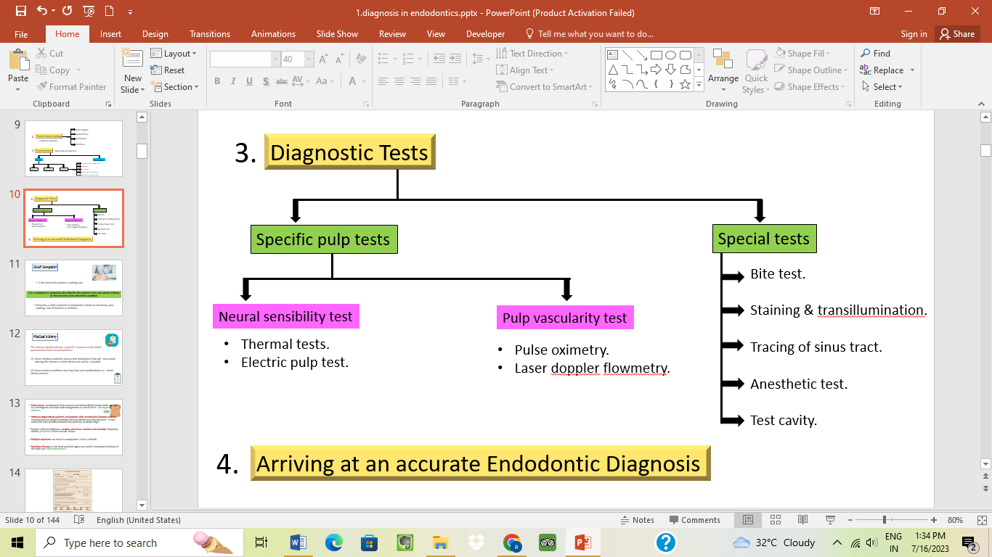

fig1: Steps to be followed to arrive at correct diagnosis

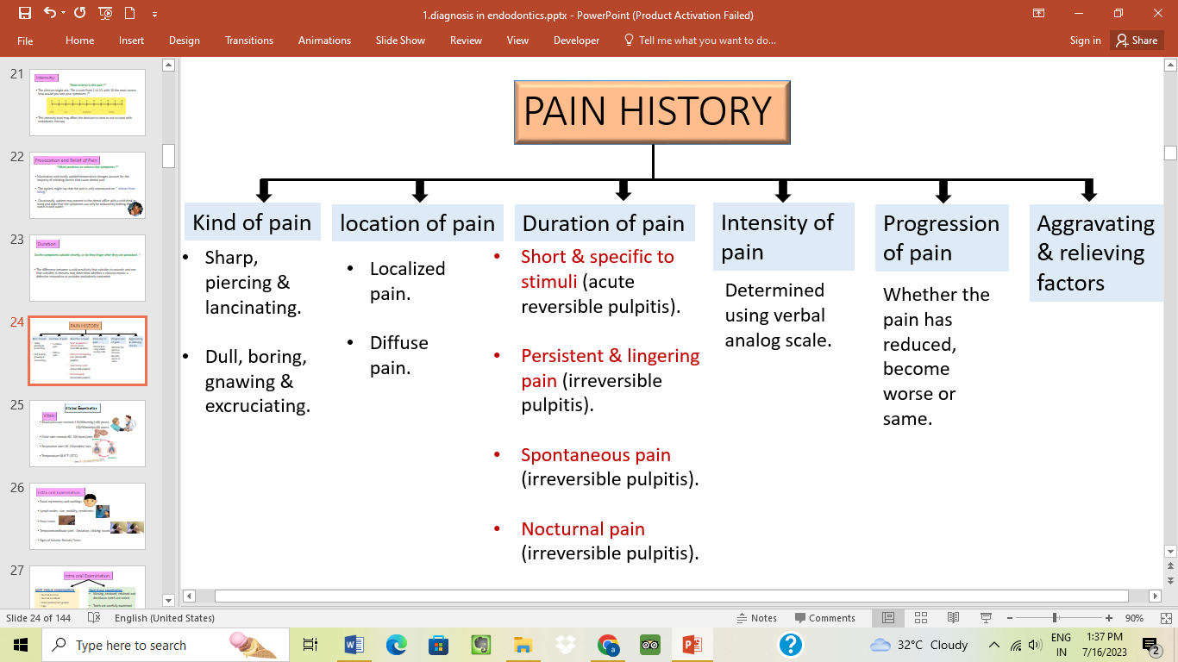

fig 2: Pain diagnosis

CLINICAL EXAMINATION & INVESTIGATIONS IN ENDODONTICS

- Visual and tactile inspection:
Soft tissue
- Color: Normal gingival color is coral pink, change from this is easily visualized in inflammatory conditions.
- Contour: change in normal contour (scalloped gingiva) occurs with swelling.
- Consistency: normal gingiva is healthy, firm, resilient while a soft, fluctuant or spongy tissue is indicative of a pathology.
Hard tissue
- Color: teeth with normal pulp show life like translucency and sparkle. Teeth that are discolored, opaque and less life-like in appearance are indicative of inflamed, degenerated or necrotic pulp.
- Contour: fractured teeth, wear facets, improperly contoured restorations or altered crown contours should be examined.
- Consistency: Caries, resorption.²
- PERCUSSION: Tooth is struck with a quick, moderate blow initially with low intensity by the finger, then with increasing intensity by using the handle of an instrument. Positive response to percussion occurs in case of:
- Rapid orthodontic movement.
- High points on restorations.
- Occlusal trauma.
- Lateral periodontal abscess.
- Apical periodontitis.
- Periapical abscess.^{1,2}

- PALPATION: Simple test done with fingertip using light pressure to examine tissue consistency & pain response.

- MOBILITY AND DEPRESSIBILITY TEST:
- Mobility test consists of moving a tooth in its socket using handles of two instruments or by using the fingers.
- Test for depressibility is performed by applying pressure in an apical direction on the occlusal/incisal aspect of tooth and observing vertical movement if any.
Grades of mobility
- +1 mobility: The first distinguishable sign of movement greater than normal.
- +2 mobility: Horizontal tooth movement no >1 mm.
- +3 mobility: Horizontal tooth movement >1 mm, with or without the visualization of rotation or vertical depressability.¹
- PERIODONTAL PROBING TEST
Periodontal probe is stepped around the long axis of the tooth, progressing in 1mm increments. Periodontal probing evaluates
- Health of periodontium.
- Furcation involvement.
- Pathological grooves.
- Differentiate disease of periodontal origin from pulpal origin.⁶

- BITE TEST/ OCCLUSAL PRESSURE TEST used for identification of a cracked tooth or fractured cusp. Devices used include tooth sloth, frac finder, orangewood stick, burlew rubber disk, wet cotton roll, cotton applicator.^{7,8}
- Pain on biting - apical periodontitis.
- Pain on release of biting force- cracked tooth.³

DIAGNOSTIC TESTS
Pulp testing involves attempting to make a determination of the responsiveness of pulpal sensory neurons. Various pulp tests used are summarized in fig 3.

fig 3: Pulp tests

- THERMAL TESTING:
Any thermal test, at best merely identifies the presence of pulp tissue that is capable of responding to a change in temperature.
Thermal tests activate hydrodynamic movement of ﬂuid within dentinal tubules, which excites the A-delta ﬁbres .⁹
- COLD TEST: Cold is the primary pulp testing method for many clinicians today. Various agents used are
- ICE STICK: (0˚C):
- Made by filling discarded anesthetic carpules or anesthetic needle cover with water & freezing them in an upright position in a refrigerator.¹⁰
DISADVANTAGES:
- Ice is not as cold another available material.
- Melted ice water can spread to either soft tissue or another tooth & cause a false +ve effect.
ADVANTAGES:
- Readily available
- Inexpensive

- ENDO ICE: Tetrafluoroethane (-50˚F) The material is sprayed onto a cotton pellet which is then applied to the middle third of the facial/labial surface of the crown. It should be kept in contact with the surface for 5 sec or until the patient begins to feel pain.³
- CO₂ SNOW: Dry ice (-78˚C)
‘Pencil’ or ‘stick’ of dry ice is applied to the middle third of the facial surface of the crown of the tooth and kept in contact for 2–5 s or until the patient feels pain.¹¹
ADVANTAGES:
- Accurate, reliable, consistent & fast.
- Complete dentition can be tested in 1–2 min without isolation of the teeth.
- Effective for testing teeth with full coverage crowns.
- DISADVANTAGES:
- Not effective with calciﬁed pulps or in elderly patients where there has been considerable secondary dentine formation.
- Apparatus is more expensive to purchase than ethyl chloride or ice sticks.
- Occupies large clinical space.
- May cause infarction lines in tooth because of very low temp.
- Burns of soft tissue can occur.^{1,3,12}
- ETHYL CHLORIDE/ SKIN REFRIGERANT (58.8˚F)
Tooth isolated with rubber dam & is sprayed with ethyl chloride or is applied with a cotton pellet saturated with ethyl chloride.
- COLD WATER/ DRINK: (69.2˚F)
A tooth or a group of teeth can be isolated with a rubber dam and iced water can be syringed onto each tooth.^{1,3}

- HEAT TEST

- Hot ball burnisher: was a traditional method used to apply heat, not used anymore due to uncontrolled temperature.
- Rubber wheal mounted on a mandrel: Heat can be generated by the friction created when a dry rubber-polishing wheel is run at a high speed against the dry surface of a tooth.
- Hot gutta percha stick: Gp stick is placed over the flame till it starts to sag but doesn’t produce any smoke and applied to Vaseline coated tooth.
- Hot water: Isolate the tooth with rubber dam, filling a syringe with hot water & apply the water to the tooth.
- Heating device (system B): The system B allows the dentist to set specific temperatures for warm thermal testing.
- After the surface of the tooth has been lubricated, a hot pulp test tip can be attached to the handle of the system B and the temperature set at 150°F.
- The tip is placed on the surface of the tooth and the patient’s response is evaluated.^{3,10}

- ELECTRIC PULP TESTING (EPT):
EPT is designed to stimulate a response of sensory fibers (A delta) within the pulp by electric excitation.

ADVANTAGES OF EPT
- The digital display provides instant, easy and reliable information.
- Gives a quantitative reading and can be compared with the normal reading of control tooth.

DISADVANTAGES OF EPT
- Recently traumatized teeth cannot be tested.
- Does not give any indication regarding the vascular supply.
- Readings from posterior teeth with partially vital pulps may be misleading (fig 4).^{10,13,14}
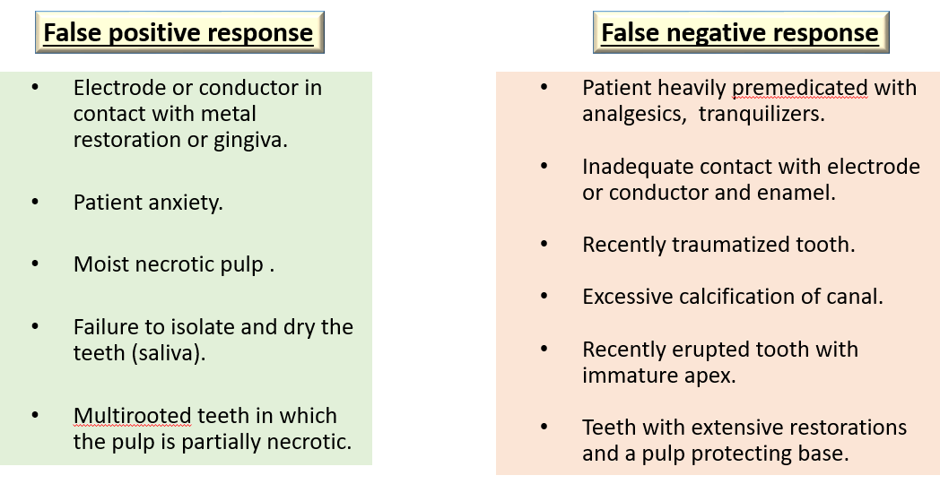

fig 4: False positive and false negative response of EPT

- ANESTHETIC TESTING
- Performed when usual tests have failed to enable one to identify the tooth.
- Either infiltration or intraligamentary injection is used, inject the most posterior tooth in the suspected area.
- If pain persists, anesthetize the next tooth mesial to it.^{1,3}

- TEST CAVITY: Performed when other diagnostic methods have failed.
- Test cavity is made by drilling through enamel dentin junction of unanaesthetized tooth.
- Sensitivity or pain felt is an indication of the presence of viable nerve fibres.¹⁰
- TRANSILLUMINATION TEST:

PRINCIPLE: caries, calculus, restorative material, sound tooth structure, inflammatory exudates and healthy periodontium have different indices of light transmission.
USES to diagnose crown & root fracture- light from fiber-optic placed at right angles to the fracture line, part of tooth proximal to light source-will absorb this light and glow and area beyond this fracture will be grey in comparison.^{1,15}
- GUTTA- PERCHA POINT TRACING WITH RADIOGRAPH:
- Can localize the endodontic lesion to the specific tooth.
- To locate the source of an infection, the sinus tract can be traced by threading the stoma with a gutta percha point.
- After tracing the sinus tract, the gutta percha is seen to be directed to the source of pathosis.
- LASER DOPPLER FLOWMETRY
It is a method used to assess blood flow in microvascular systems. A diode is used to project an infrared light beam through the crown and pulp chamber of a tooth. The infrared light beam is scattered as it passes through the pulp tissue.

Principle: The Doppler principle states that the light beam will be frequency-shifted by moving red blood cells but will remain unshifted as it passes through static tissue. The light enters the tooth and gets absorbed by the RBC’s which leads to a shift in the frequency of the scattered light. The proportion of doppler shifted light is detected with help of a photodetector. This principle is used to ascertain the presence of blood movement within the pulp space.
ADVANTAGES
- Reflects vascularity of pulp.
- Noninvasive procedure.
- Provides accurate reading in case of recently erupted teeth or traumatized teeth.
- Effectively monitor revascularization of replanted teeth.
DISADVANTAGES
- Systemic medication may alter blood flow in the pulp.
- Gingival blood vessels can give false reading.
- Need custom fabricated jig to hold sensor.
- Expensive.^{2,12,16}
- PULSE OXIMETRY: it is a noninvasive method to measure the oxygen saturation levels of circulating arterial blood. Pulse oximeter sensor consists of:
- Two light emitting diodes, one to transmit red light (660 nm) and other to transmit infrared light (940 nm).
- Photo detector on opposite side of vascular bed.
- Tooth is sandwiched between a photoelectric detector and an LED of red or infrared lights (fig 5).
- It measures the oxygen pressure of erythrocytes.
fig 5: Pulse oximeter parts

ADVANTAGES
- Effectively detects pulpal blood flow.
- Useful in traumatic injuries.
- Easy to reproduce readings.
- Pulp circulation can be detected independent of gingival circulation.
DISADVANTAGES
- Lower specificity in cases where coronal pulp is undergoing calcific changes.
- Pulp is insulated by enamel & dentin, difficult to detect pulsations by the probe.
- Background absorption associated with venous blood & tissue constituents.^{17,18}
- DUAL WAVELENGTH SPECTROPHOTOMETRY: Measures oxygenation changes in the capillary bed rather than in the supply vessels and hence does not depend on a pulsatile blood flow. It detects the presence or absence of oxygenated blood at 760 and 850nm.¹⁹

- TOOTH SURFACE TEMPERATURE CHANGES: Various methods for temperature measurement as a diagnostic procedure for human teeth, has been described with the use of thermistors, Hughes Probeye Camera, Infrared thermo-graphic imaging and Liquid Crystal testing.¹²

RECENT TRENDS:
- Digital subtraction radiography: is considered as a valuable tool to detect extremely small bone changes during or after root canal treatment with more accuracy. Introduced by Zeides Plantes and is almost twice as sensitive in the assessment of bone formation or resorption as conventional radiography.
uses:
- detection of lesion interproximal caries
- to view the progression of caries
- evaluation of bony changes or repair.
- Computed axial tomography scanners: especially used
- to determine buccolingual as well as mesiodistal widths of teeth
- to detect the presence or absence of root canal fillings and metal posts.
- CONE BEAM COMPUTED VOLUMETRIC TOMOGRAPHY:
CBCT uses a computer program cone-shaped beam rather than fan beam and provide a 3D volume image in single 360° rotations.
- ULTRASOUND: it is a noninvasive investigation procedure that uses a pulsed ultrasound beam having very high frequency (7.5–20 MHz) to produce a high-resolution image of more superficial structures. Color Doppler principle allows blood flow to be detected.²⁰

CONCLUSION: with the advent of newer diagnostic techniques, the diagnosis of exact pulpal status (vital or necrotic) has become a quicker, easier and precise task. However, the results of newer diagnostic tests cannot be relied upon individually, on the contrary, they should be combined with other diagnostic tests (patient history, clinical examination, pulse oximetry, LDF, radiovisiography) to arrive at a correct final diagnosis

REFERENCES
- Hargreaves M. Kenneth and Cohen Stephen. Diagnosis. Tenth edition; China: Eslevier:2011. Chapter:1 Diagnosis.1-39.
- Chandra S and Gopikrishna V. Grossman’s Endodontic Practice.13th edition; New Delhi, India: Wolters Kluwer 2014.Chapter: 3 Clinical Diagnostic Methods.53-78.
- Ingle I. John, Bakland K. Leif and Baumgartner J. Craig. sixth edition:Hamilton: BC Decker Inc:2008. Chapter14 Diagnosis of Endodontic Disease. 520-553.
- Roberson T, Heymann H, Swift ED. Sturdevant’s Art and Science of Operative Dentistry. Elsevier Health Sciences. 5th edition. Philadelphia. 2006.Cariology: The Lesion, Etiology, Prevention, and Control.65-134.
- Greenwood M. Essentials of medical history-taking in dental patients. Dental Update. 2015;42(4):308-315.
- Armitage GC. Diagnosis of periodontal diseases. J. Periodontol. 2003;74(8):1237-1247.
- Mathew S, Thangavel B, Mathew CA, Kailasam S, Kumaravadivel K and Das A. Diagnosis of cracked tooth syndrome. J Pharm Bioallied Sci. 2012;4(Suppl 2):S242-S244.
- Banerji S, Mehta SB and Millar BJ. Cracked tooth syndrome. Part 1: aetiology and diagnosis.Br. Dent. J. 2010;208(10):459-463.
- Jafarzadeh H and Abbott PV. Review of pulp sensibility tests. Part I: general information and thermal tests. Int. Endod. J. 2010;43(9):738-762.
- Chen E and Abbott PV. Dental pulp testing: a review.Int. J. Dent. 2009; 2009:1-12.
- Rickoff B, Trowbridge H, Baker J, Fuss Z and Bender IB. Effects of thermal vitality tests on human dental pulp. J. Endod. 1988;14(10):482-485.
- Gopikrishna V, Pradeep G and Venkateshbabu N. Assessment of pulp vitality: a review. Int. J. Paediatr. Dent. 2009;19(1):3-15.
- Lin J and Chandler NP. Electric pulp testing: a review. Int. Endod. J. 2008;41(5):365-374.
- Jafarzadeh H and Abbott PV. Review of pulp sensibility tests. Part ΙΙ: electric pulp tests and test cavities. Int. Endod. J. 2010;43(11):945-958.
- Marinova-Takorova M, Panov V and Anastasova R. Effectiveness of near-infrared transillumination in early caries diagnosis. Biotechnol. Biotechnol. Equip. 2016;30(6):1207-1211.
- Obeid AN, Barnett NJ, Dougherty G and Ward G. A critical review of laser Doppler flowmetry. J. Med. Eng. Technol. 1990;14(5):178-181.
- Almudever-Garcia A et al. Pulse oximetry as a diagnostic tool to determine pulp vitality: A systematic review. Applied Sciences. 2021;11(6):2747-2762.
- Gopikrishna V, Tinagupta K and Kandaswamy D. Evaluation of efficacy of a new custom-made pulse oximeter dental probe in comparison with the electrical and thermal tests for assessing pulp vitality. J. Endod. 2007 Apr 1;33(4):411-414.
- Chandi JK, Rajapandy S, Jahan N and Gill S. Advances in Endodontics: A Brief Review. J. MAR Dent Sci.2021:3(3):1-13.
- Jain V, Kumar BP, Krishna TS, Parakh S, Kiran PH and Tiwari A. Recent Advances in Endodontic Diagnosis: A Review. Int. J. Prev. Clin. Dent. Res. 2017;4(4):300-303.

