ARTIFICIAL INTELLIGENCE AND ITS GREY ZONES IN HEALTHCARE
Author 1 Author 2
Muskan Dilip Hinduja Vaishnavi Ashok Nidarkar
Undergraduate Undergraduate
KLE Vishwanath Katti Institute of Dental Sciences KLE Vishwanath Katti Institute of Dental Sciences
Belagavi, Karnataka, India Belagavi, Karnataka, India
muskanhinduja77200@gmail.com vaishnavi.nidarkar13@gmail.com

Author 3
Dr. Veena Benakatti
Master of Dental surgery (MDS)
Reader
KLE Vishwanath Katti Institute of Dental Sciences
Belagavi, Karnataka, India
veenak20021@rediffmail.com
Editor ID- IIPER1681478061

We have all entered a new world, the world of technologies. The end result is soon going to be that Artificial Intelligence(AI) will help us in all aspects of life. From imaging to diagnosis health apps are being introduced for every possible step that is being carried out in healthcare. Optimization of the facilities provided by the doctors is suspected to revolutionize AI in healthcare to a larger level. In the coming years AI can be predicted to help doctors provide better facilities and improve the treatment quality for patients. This tremendous growth of AI comes with a lot of challenges to be faced in the healthcare sector. These are nothing but the “GREY ZONES OF AI” that need to be analysed and overviewed for ease of implementation of artificial intelligence in healthcare market.
- ARTIFICIAL INTELLIGENCE: WHAT IS IT?
A computer program with artificial intelligence performs actions or thinks in ways that are normally associated with human intellect. Both academic writing and legal papers may use it. Data is a fuel for artificial intelligence.
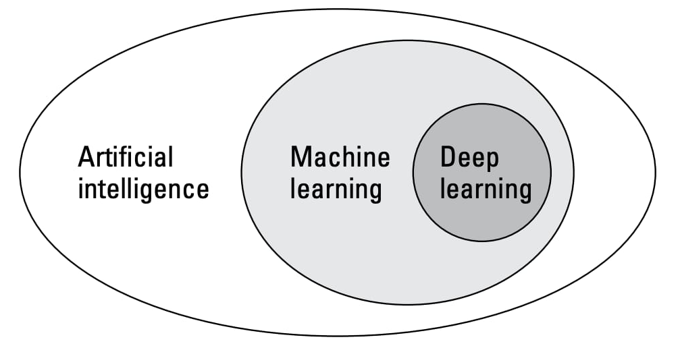
Figure 1: Subsets of AI

- DIVISIONS OF ARTIFICIAL INTELLIGENCE:
- MACHINE LEARNING
Machine Learning enables computational systems to gain knowledge from the supplied data.
Machine Learning can be:
- Supervised learning
It includes predicting a known output or target. This is task driven.
Example- undergraduate student who has been asked to check BP and is guided by the teacher.
- Unsupervised learning
It has no outputs to predict. It divides the data into a group of clusters, it requires to describe a structure and complex data look simpler in an organized form.
Example- Diagnosis of tumours which starts with the demographic details of patient, chief compliant, to past and present history taking, examination and ultimately to the diagnosis.
- Reinforcement learning
It is based on each data point where the algorithm chooses an action and changes its strategy to learn better after sometime. This learning is based on reward system and trial and error experimentation. Extensive amount of diverse data is provided to the AI system for such kind of learning.
Example- Patients in ICU. If the patient is recovered or discharged the system may receive a positive reward however a negative reward is received if the patient does not survive.

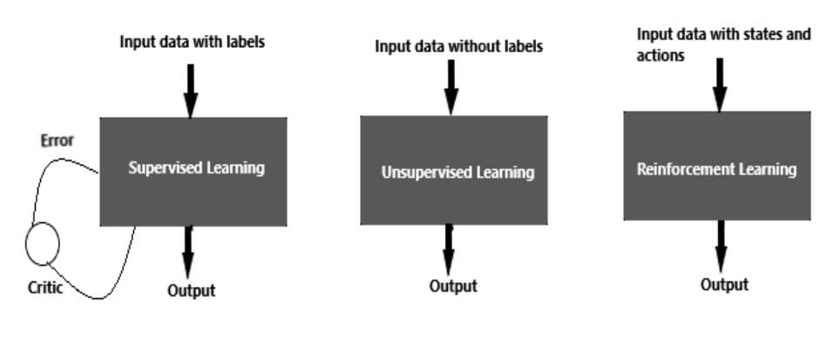
Figure 2: Different types of machine learning
- DEEP LEARNING
Deep Learning is a part of machine learning. This uses multiple-layer neural networking to find patterns in a vast database. It follows hierarchical learning and simulates the biological neurons in the brain. Any deep neural networking will have 3 layers an input layer, hidden layer and an output layer.
Example- interpretation of MRI scans. In these procedures previous images are being given as inputs. They are stored in the hidden layer and diagnosis is made in the output layer based on the information provided in the first two layers.

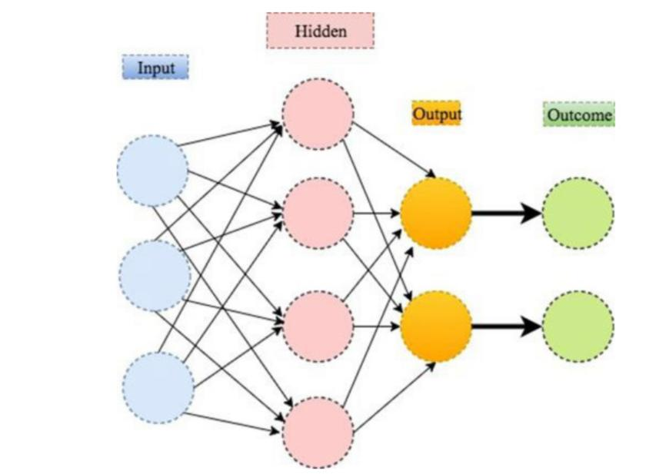
Figure 3: Illustration of deep learning with 2 hidden layers

Table 1: Difference between machine and deep learning
MACHINE LEARNING | DEEP LEARNING
Needs lesser data to be trained | Needs large data to be trained
Provides lesser accuracy | Provides higher accuracy
Takes lesser time to train | Takes longer time to train
Requires structure data | Does not require structure data
Requires few algorithms | Many algorithms required
Aims to make machine learn from the data provided to solve any problem | Aims to build network which discovers pattern for detection of features

- AIMS OF ARTIFICIAL INTELLIGENCE:
AI in healthcare seems to promise a “QUADRUPLE” aim namely,
- To provide better experience of care.
- To boost Health of populations.
- To refine work life of health care providers.
- To reduce per capita cost of healthcare.

- APPLICATIONS OF ARTIFICIAL INTELLIGENCE

- Diagnosis and treatment design
The data provided by previous patients can be used for treatment planning.

- Electronic health records
The likeliness of a condition or a disease can be predicted using electronic health records as they have patient’s information from the very past to the present.

- Drug interaction
Patients who are on multiple medications are prone to increased risk of drug interaction. AI algorithms make it possible to extract the information on the side effects of the drugs from the medical literature.

- Dermatology
Classification of various skin lesions or cancers.

- Radiology
MRI, CT SCANS, X-RAYS with more accuracy.

- Psychological conditions
Chat-bots that replicate human behaviour are being identifies for helping reduce depression and anxiety.

- Dental plaque and caries
Can be detected by AI software by previous images provided.

- POTENTIALS AND PROMISES OF ARTIFICAL INTELLIGENCE:
The increasing number of academic research studies are demonstrating various applications of AI in healthcare like interpretation of radiographs, detecting cancers, interpreting pathological lesions, improving genomics, etc. But is this immense volume of data that is being provided to the AI system in the form of electronic health records, that is not only helping to extract clinically relevant information but is also making diagnostic evaluation, reliable? Imagining a future hospital with AI machines and robots making accurate diagnosis, treatment planning reflects a question-
Can AI compete with human doctors in showing empathy, creativity and nonlinear thinking which are the superpowers of healthcare?
Despite the perception that actual machine learning deployments in clinical practices are uncommon and have several difficulties that are nothing more than the norm, AI may have a positive impact in the future.

- GREY ZONES OF ARTIFICIAL INTELLIGENCE:
The most prevalent issues with AI in healthcare, including getting informed consent, patient safety and transparency, algorithm bias and fairness, the privacy of the data provided to the systems, liability, cybersecurity, missteps and accidents, and data accessibility, are briefly discussed below.
- Informed consent
The interface of principles of informed consent and assistance for care of patients using AI is an immediate challenge in integrating AI into clinical practice. Under what circumstances the principles of informed consent should be deployed in the clinical AI space needs to be examined. It is the responsibility of clinicians to educate the patient to some extent around the complexities of AI. Some algorithms like the black box algorithm are non- interpretable and very difficult for the clinician to understand thus in such cases this lack of knowledge is worrisome and will also interfere with the so called Right to Explanation to the patient. In contrast to the traditional informed consent process in case of AI health app and chat-bots which are increasingly being used, user agreement is a contract that an individual agrees to without a face to face dialogue. How closely this user agreement resembles the informed consent document and understands the terms under which the clinician is going to provide the treatment is a tricky question to answer when information from patient facing AI health apps or chat-bots is fed back into clinical decision-making.

- Safety and transparency
AI algorithms used to assess information from patients medical records help the physicians to explore treatment options for their patients. However, such algorithms have been facing criticism for reportedly giving unsafe and incorrect recommendations for cancer treatment. Instead of using real patient data the software was only trained with a few synthetic cancer cases resulting in errors for treatment planning of the patient. This shows that it is of utmost importance that AI systems are safe and effective. Reliability, validity, transparency are the promises that the stakeholders or AI developers should ensure. The algorithms need to be defined in a such a way that the results generated are near to accuracy. Cases may require vast amount of data or very less amount of data depending on the AI system thus, data sharing is a big issue. The stakeholders of AI system should create a trust about the data provided by the ideal world in order to implement AI successfully into healthcare. According to the articles published, some examples of the AI systems developed show lack of transparency leading to an adjunct to intellectual property rights of the patients. Therefore, to avoid such misleads it is important to develop AI systems that are trustworthy and protect the patients information.

- Algorithmic fairness and biases
Capability of AI is to not only earn a high revenue but also to improve and expertise the healthcare facilities. This is all dependent on the data quality provide to the system. In healthcare AI there are dangers of prejudice and inequality. AI systems learn from information they have been provided but there may be issues if the data reflects inherent biases and disparities in the healthcare system. Any human trained algorithm will only be trustworthy, effective and fair if the data it is trained has minimal risk of biases. In healthcare sector where phenotype and genotype related information are involved biased AI cloud leads to false diagnosis rendering an ineffective treatment. Therefore, it is vital that the AI makers are aware of these risks and avoid potential biases at every stage of process and product development. Biases can be resolve by providing large amount of data variety that trains the computers for providing all possible diagnosis, treatments efficiently. More thought should be given to resource being provided to overcome algorithmic biases.
- Data privacy
The value of health data can be lakhs and lakhs of rupees. Evidences show that public is uncomfortable with private sectors or government organisations selling patient data for profit. It is fundamentally important to adequately inform the patients about the processing of their data. Fostering an open dialogue to promote trust because if patients and clinicians do not trust AI system their successful integration into clinical practice will practically fail. Reciprocity does not require ownership but those seeking to use patient data must promise that they are adding value to the health of the same patient whose data has been used. Some AI health apps share patient data not only with the doctor but also with the family and friends, this might deleteriously affect patients, such as impacts on health, insurance premiums, job opportunities or even personal relationships. Thus, it is imperative to protect patients data against its use outside the doctor patient relationship. Patients should also be able to request the deletion of data that they are not ok to share with. An oversight to software update and shortcomings at regular intervals is also needed in order to be transparent about the product discovered by the AI technology.

- Liability
Clinicians must treat patients with due expertise and care. Using advanced AI does not appear to be a part of standard care at this moment. If an AI based software gives an incorrect recommendation that is not one a non AI clinician would have arrived at, it is the clinician who would likely be liable for medical malpractice. At present it appears that clinicians could be held liable even though they are engaged in good reliance of AI based software as this software is considered as a tool under the control of health professional who is making the ultimate decision. It is the professional who remains the captain of the ship and is responsible for its course. Thus, to avoid medical malpractice liability clinicians can use AI as a confirmatory tool to assist with existing decision making process opposing the need to follow its recommendation out of fear of liability. Along with clinicians AI makers and hospitals that purchase and implement AI systems must also be considered liable as they should have similar responsibilities when they provide and hire an AI system respectively. Hence, a clear and predictable legal framework addressing the technological challenge is required to create clarity, transparency and trust.

- Cybersecurity
It is an issue that is needed to be considered when addressing legal challenges to the use of AI in healthcare. Healthcare related services, processes and products are all vulnerable to both cyber and physical threats and hazards. Hospital servers, diagnostic tools, wearables, wireless smart pills, medical devices may be considered as targets in health sector that can be infected with software virus that risk patients privacy and health. Corrupted data or infected algorithms can lead to incorrect and unsafe treatment recommendations. Hostile actors could get access to sensitive data or could threaten patient safety by misrepresenting their health. AI are in particular vulnerable to manipulation according to publications. This increases the need for cybersecurity as cyber attacks are often a global issue.

- Missteps and accidents
AI systems will occasionally be incorrect resulting in patient damage and other healthcare issues. If an AI system prescribes the wrong treatment, fails to detect a tumour or assigns a medical bed to one person over another a patient could be damaged. Injuries caused to the patient by AI may elect different reactions form patients and caregivers than injuries caused by human mistake. A flaw in one AI system might lead to thousands of patients being wounded rather than small number of patients injured by a single providers error.

- Data accessibility
Patient see different clinicians and change insurance carriers frequently that result in data being fragmented across multiple systems and formats. Healthcare data is frequently dispersed across multiple platforms. This raises the danger of inaccuracy, reduces comprehensiveness of data and raises the cost of data collection. All of which restricts the type of entities that might create successful healthcare AI.
- DISCUSSION:
All the discussed grey zones of artificial intelligence can be classified under the headings of Ethical and Legal challenges.
Ethical challenges: Healthcare sector is a complex filed that requires high standards of ethics. Ethics in healthcare are basic principle concerned with moral decision making by the clinician. Autonomy, justice and beneficence are the important parameters for healthcare professionals to follow ethics. Informed consent, safety and transparency, algorithmic fairness and biases, data privacy, missteps and accidents are all ethical challenges that AI faces.
Legal challenges: Challenges that require judicial review and come under the rule of law are legal challenges. A legal challenge is very time consuming exercise which is expensive for everyone. The decision made by the law is the final result. Every agency developing an AI system should fear a legal challenge in order to avoid challenges such as liability, cybersecurity and data accessibility.

Table 2: Difference between ethical and legal challenges
ETHICAL | LEGAL
Informed consent | Liability
Safety and transparency | Cybersecurity
Algorithmic fairness and bias | Data accessibility
Data privacy
Missteps and accidents

- CONCLUSION:
All these challenges can affect thousands of patient at once and if these challenges are taken care of healthcare delivery can become more effective with improved diagnosis, enhanced quality of treatment and all the goals of AI can be achieved. Hence, it is the clinician who should always remain the captain of the ship and use AI system to assist in decision making, to avoid malpractice liability.
- REFERENCES:
[1] Kelly, C.J., Karthikesalingam, A., Suleyman, M. et al. Key challenges for delivering clinical impact with artificial intelligence. BMC Med 17, 195 (2019).
[2] Mohammed Yousef Shaheen. AI in Healthcare: medical and socio-economic benefits and challenges. ScienceOpen Preprints. DOI: 10.14293/S2199-1006.1.SOR-.PPRQNI1.v1
[3] Gerke S, Minssen T, Cohen G. Ethical and legal challenges of artificial intelligence-driven healthcare. Artificial Intelligence in Healthcare. 2020;295-336. doi:10.1016/B978-0-12-818438-7.00012-5
[4] Deo RC. Machine learning in medicine. Circulation. 2015 Nov 17;132(20):1920-30.
[5] https://dzone.com/articles/comparison-between-deep-learning-vs-machine-learning
[6] Manne R, Kantheti SC. Application of artificial intelligence in healthcare: chances and challenges. Current Journal of Applied Science and Technology. 2021 Apr 24;40(6):78-89.
[7] https://www.deepinstinct.com/glossary/deep-learning
[8] Jiang F, Jiang Y, Zhi H, Dong Y, Li H, Ma S, Wang Y, Dong Q, Shen H, Wang Y. Artificial intelligence in healthcare: past, present and future. Stroke and vascular neurology. 2017 Dec 1;2(4).
[9] https://www.microsoft.com/en-us/research/blog/using-reinforcement-learning-to-identify-hispgh-risk-states-and-treatments-in-healthcare/

