Synthesis, characterisation and Performance Enhancement of materials using Nanotechnology based Nano Composite
Dipti Tiwari¹, Monaika yadav² Dr. Rajendra Bhadauria³,Santosh k singh⁴
1 Department of Applied sciences and Humanities Rama University Kanpur-India
2 Department of Applied sciences and Humanities Rama University Kanpur-India
3 Department of Applied sciences and Humanities Rama University Kanpur-India
4 Department of mechanical engineering GLA University Mathura-India

- Introduction
Nanostructures have attracted many researchers as one of the fastest-growing areas of research for many applications. several characterization methods are developed to find the shape, size crystalline structure and other physical properties of nanoparticles. the proposed idea of the current study is to develop a comparative characterizations technique for a synthesized cuo nano with a procured cuo nanoparticle. In the current study, cuo nanoparticle is synthesized using a wet chemical approach. Newly prepared nanofluid is characterized by FTIR, X-Ray diffraction (XRD) and compared with the parameters obtained from procured cuo from platonic India. The average particle size obtained from the above characterization technique was 28-64nm. Moreover, the Scanning electron microscope (SEM) and transmission electron microscope (TEM) were also used to validate the findings of XRD. Dynamic Light Scattering (DLS) was used to find the agglomerated size of nanofluids. The optical properties of the CuO nanofluids were evaluated using Ultraviolet-Visible absorption spectra. The KD2 Pro thermal property analyser was used to find the thermal conductivity of CuO nanofluids. And it was discovered that as particle loading increases, the thermal conductivity increases. However, the NEPCM samples are analysed using FTIR, TGA, and DSC techniques.

The introduction of nanofluids with improved thermal conductivity, thermal diffusivity, viscosity, and convective heat transfer coefficients allows them to replace conventional heat transfer fluids. Al₂O_{3,} CuO, SiO_{2,} TiO₂ are the potential metallic nanofluids capable of enhancing conductive and convective heat transfer even at low concentrations compared to conventional nanofluids. Among these metal oxides because of their unique size-dependent physical and chemical property has attracted the attention of many researchers S. Nallusamy et al [1] study the synthesis and characterization of CuO nanoparticles and found that as the particle loading increases the thermal conductivity of nanofluid also increases.[2] found that suspended nanoparticles can enhance the heat transfer characteristics of carbon nanotubes S.U.S Choi and J. A.Eastman [3] were the first to use the nanofluid term for the suspended particles in fluids. Z.G Zhang et al. [4] shows that the small addition of nanoparticles can enhance the thermal conductivity twice. Further research confirms that the addition of 1-5% nanofluids increases the thermal conductivity of the base fluid by 20%. Experiments at Argonne University show an enhancement of 60% in water’s thermal conductivity by adding CuO nanofluids[5–8]. S. Nallusamy et al.[9] performed X-ray diffraction and FESEM analysis of hybrid nanoparticles n heat transfer application and found that hybrid nanofluid significantly enhances the thermal conductivity of the base fluid J. A Eastman et al [10] explored that engines, engine Systems, microelectronics, transportation systems are just a few of the many applications for nanofluids. And nanofluid heat transfer is used in automobile radiators and chemical reactors, for example. Engineering and process industries include solar water heaters, refrigeration, and electronic device cooling. Further, Meenakshi et al. [11] found that the suspension of particles improves the thermal conductivity of ordinary fluids. Particles of various sizes, such as micrometres or centimetres, have been discovered for hundreds of years. It's a new type of heat transfer fluid composed primarily of nanofluids. They were carrying liquid-supported fibres or tubes that can be used for heat transmission, mass transfer, wetting and spreading. Generally used cooling base fluids cannot keep up with future expansion and demand in various fields. CuO PVA nanofluids were developed to explore the characteristics of the nanofluids. Furthermore, from the X-Ray diffraction pattern of CuO-NEPCM, it was clear that the synthesised samples were crystal clear and nanoscale in size. The TGA method studied CuO nanoparticles' thermal stability and weight loss. The result shows good thermal performance and stability of the nanofluid. Water-based Al2O3 and CuO nanofluids with particle sizes of 38.4mm and 28.6mm were studied, and it was found that as the temperature increases, the thermal conductivity of nanofluids also increases[12–13]. K.Rohini et al.[14] Formalised nanoparticles non-spherical in shape and discovered that the nanofluid has good thermal performance and excellent thermal stability. That it can withstand the 55ºC heating. Further, it was also found that the thermal conductivity ratio of the nanofluids is higher than the diffusivity ratio, which makes them suitable for the thermal management application. Carbon nanotubes were utilised by K.Rohini et al. [15], who found that even ultra Low quantities nanoparticles have a significant impact on thermal conductivity than those without. It was also found that the increase in heat conductivity in nanofluids is primarily affected by the particle volume. But several other factors are influencing the thermal conductivity, such as the amount, size, form, and chemical composition of the nanoparticles. Commercial nanoparticles are dispersed in a base using the scatter method, a two-step process. Fluid agitation by mechanical or ultrasonic means This approach has the advantage of large-scale production of nanofluids. It also provides more control over the nanofluids. And more. Stable nanofluids can be made by varying the particle size. This method is suitable for commercial nanofluids. Particle size is anticipated to be in the 8-10nm range, based on the sample's XRD pattern, which indicates it has a tetragonal structure of SnO₂[16-18]. According to Qiang Wu et al. [19], X-Ray Diffraction, Ultra Violet-Visible absorption, and a Scanning Microscope were used to characterise the materials. An essential industrial component, copper oxide nanoparticles, is employed in a wide range of applications, such as gas sensors, magnetic storage medium, solar energy conversion, and photovoltaics [20-23].
Although a literature survey establishes nanoparticles as potential catalysts or thermal conductivity enhancers, proper selection and testing of the nanomaterial still plays a critical role. The primary objective of this investigation is to assess the quality of the generated CuO nanofluids. It was put through plenty of other testings to see its suitability for the industry. SEM and a TEM are used in the current study to look into particle morphology and size. For measuring the dimensions of CuO nanofluids, DLS was used. Further, Researchers studied the CuO nanofluids' optical properties by looking at the absorption spectra in the UV-Visible range. It was found that as particle loading increases, CuO nanofluid thermal conductivity also increases, and this was confirmed by using the KD2 Pro Thermal conductivity analyser.
2. Characterization and Synthesis of Nano materials
2.1) Synthesis of CuO
0.2 M Copper acetate solution and 2 ml of glacial acetic acid were poured into a flask. The obtained blue colour is heated under vigorous stirring. Further, by adding an 8 M sodium hydroxide solution to the flask. The blue solution turned black in seconds, and a black suspension emerged in its place. The solution was stirred and heated for two hours. It was centrifuged to separate the liquid components when the combination was cool enough to handle. The final wet CuO precipitate was formed. Two rounds of washing with distilled water were performed to eliminate contaminating ions. Newly formed suspended nanoparticles tend to get agglomerated. To address this issue, CuO nanofluids were subjected to stirring and then ultrasonication for five hours, which eliminated agglomeration. Further, during physical observation, it was discovered that there was no particle settlement in the flask until four hours,. Figure 1 shows the synthesis process.
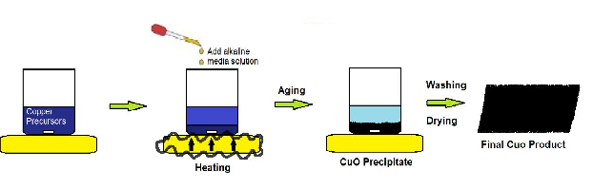

Figure 1 Synthesis of CuO
3.Composition, particle size of Nano materials
3.1 Energy Dispersive X-ray Analysis of CuO NPs (EDAX)
EDAX was used to examine the composition of CuO NPs. CuO NPs were approximately stoichiometric; as seen in Figure 1, EDAX determined the mass per cent of copper and oxide to be 52 and 48, respectively. As no other impurity was found, EDAX confirms the generation of pure CuO nanoparticles.

Figure 2 EDAX spectra of CuO

3.2 Calculation of the particle size of CuO nanoparticles (XRD )
X-ray diffraction is one of the most frequently used techniques for the characterization of nanoparticles. It is generally used for finding the crystalline structure, grain size phase lattice parameters of nanoparticles using Scherrer equation. in the current study the comparative XRD analysis of synthesized cuo and procured cuo nanoparticles is done. Burker diffractometer having 2θ ranging from 10⁰-60⁰ is used to plot the diffractogram and the average particle sixe is found using the Scherrer equation D = 0.9λ/β cosθ where λ is the wave length, β is (FWHM) Full width at half maximum of cuo nano powder. Results show that similar peak is developed in both analysis. Also these values are also in good agreement with the JCPDS. the average particle ranges between 28-64 nm. Results shows that three sharp peaks are absorbed having 2θ value at 33.5,38.8,48.2 for d spacing at .24,.22,.17 is noticed for both synthesized and procured nano cuo

S.No. | 2Θ OF SHARP PEAK | Θ Of SHARP PEAK | FWHM  OF SHARP PEAK | D dia (nm) | d spacing(nm)
Synthesize Nano Powder | 35.6 | 17.8 | .00245 | 58.56 | 0.0024
 | 38.8 | 19.4 | .00310 | 46.43 | 0.0022
 | 48.7 | 24.35 | .00230 | 64.23 | 0.0017
Procure Nano Powder | 35.8 | 17.6 | .00244 | 52.22 | 0.0024
 | 38.3 | 19.1 | .00311 | 51.21 | 0.0022
 | 48.6 | 24.2 | .00233 | 28.12 | 0.0017

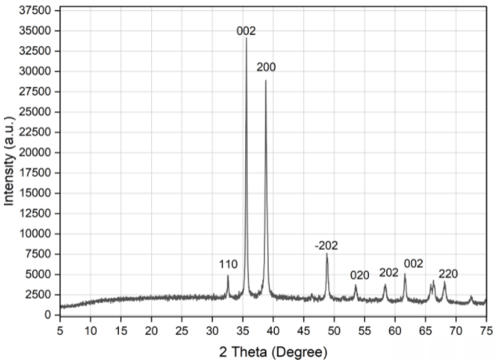

Figure 3 XRD Pattern for Synthesized cuo
Figure 4. XRD pattern of Procure CuO nanoparticles

3.3 SEM Analysis
SEM Analysis: SEM gave us a better understanding of the CuO nanofluids' shape, size, and surface morphology. It shows that spherical particles exist and are homogeneous in size. Furthermore, It was discovered that the average elementary particle size during scattering was in the 28-64 nm range, which is in line with the XRD results. as shown in Figure 3
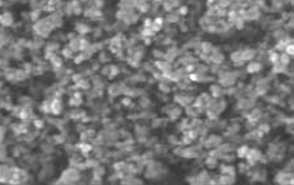

3.4 TEM Analysis
The TEM confirmed that the nanoparticle production was flawless and homogeneous. CuO nanoparticles with substantial phase separations or surface coatings are shown in TEM pictures. This is shown graphically in Figure 4. Also, further agglomerated CuO nanoparticles were analysed to determine their diameters. From a TEM picture. The Agglomerated chains of particles reveal that the grains have been clumped to form huge sizes ranging from 30nm to 50 nm depending on the flexural chain development. It was determined that the average particle size of agglomerated forms was 50 nm. As shown in Figure 4

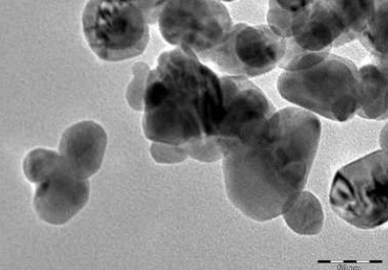
Figure 6 TEM Image of CuO
3.5 Dynamic Light Scattering (DLS)
Figure 7. Agglomerated Particle’s Distribution Size of CuO Nanofluids
DLS is an effective method for finding the size of the nano particle in a colloidal solution. DLS measures the light diffracted from the nano fluid in combination with Stokes Einstein law D=RT/N*1/6πµr where D is the diffusion constant, R is gas constant N is Avogadro number,µ is viscosity at temperature T and r is the radius to find the size of the nanoparticles.to avoid the multiple scattering low concentration nano fluid are preferred in case of DLS study and the results of DLS is validated comparing with TEM results[24]. In the current study Figure 5 .shows the distribution of agglomerated CuO particles in low concentration CuO nanofluids ranging between wavelengths from 20 to 140 nm. However, the proportion of Agglomerated CuO particles in the solution was deficient above a wavelength of 100nm. The solution shows the maximum concentration of CuO nanofluids, with an average dia of 53 nm. which is in line with the TEM findings the plot also demonstrated that the CuO nanofluids are in various sizes.
3.6 Optical Properties of Nano Fluids(UV-vis)
Figure 8 . CuO Nanofluids Absorption Spectrum
CuO nanofluids' optical properties were investigated using the UV–visible absorption spectrum. CuO nanofluid absorption spectra in the UV-visible range are given in Because of the agglutination and siltation that occurs as the produced nanofluid becomes saturated, reduced suspension scattering is obtained. It turned out that the 300-nm absorption peak was the most notable feature of the absorption spectra (3.2 eV). As the size of CuO decreases, the bandgap increases and the optical absorption shows a blue shift in the spectrum . as shown in Figure 6
4 Preparation of Nano phase Changing Material Composite
To establish the effect of nanoparticles on the thermophysical properties like thermal conductivity and viscosity of the PCM, CuO nanoparticles are added to the base PCM with a mass fraction of 0.1,0.3,0.5%. Further, to prepare the nano PCM sample, an ultrasonic vibrator is used, generating an ultrasonic pulse of 100w at 39 kHz and maintaining the homogeneity of the model; ultrasonication of the sample is done for 6 hrs. The prepared sample is stored in a microwave oven at 700 degrees Celsius to determine the nano PCM sample's stability, reliability, and thermal performance, and various tests are performed in varying weight percentages of nanoparticles.
4.1 Nano Composite Structure(FE-SEM).
Figure 8 (A) and (B) show the FE-SEM pictures of pure paraffin, whereas Figure (C) shows the micrograph of NPCM at 0.2% doping of CuO NPs in paraffin, which demonstrates the homogenous distribution of CuO NPs in paraffin.
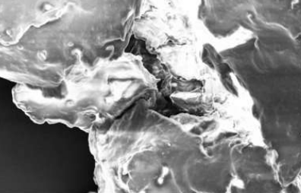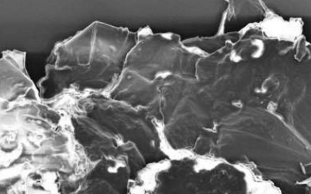
A
B
C
Figure 10 FE-SEM images of pure paraffin (A) and paraffin with CuO NPs (B), (C)
5. Application of Nano Composite

5.1 Stops Thermal Degradation (TGA Examination)
Using a Perkin Elmer Pyris 1 TGA, the boiling point, degradation point, and weight loss percentage were determined and recorded. In this experiment, a purge gas of continuous nitrogen is used to heat 5.5 mg of sample from 30 to 650 degrees Celsius at a rate of 10 degrees Celsius per minute at a flow rate of 20 ml/min and a pressure of 9 psi. Forced air cooling is used with an outside fan and an internal booster purge. TGA measurements at a 10°C/min temperature were used to compare the PCM nanocomposite. TGA results show that the degradation temperature of all the nano PCM samples is raised to a higher temperature compared to the base paraffin. It is evident from the results that the degradation of the pure paraffin starts at 157 and ends at 274. The temperature for further degradation of the.1,.3,.5,.7 wt% nano PCM samples begins at 176,182,184.186 and ends at 300,304.306. Results show that as the mass percentage increases, the thermal stability increases. This happens because as the CuO percentage increases, it enhances the physical bonding interaction between PW and the nanoparticle and improves the stability. As shown in Figure 9
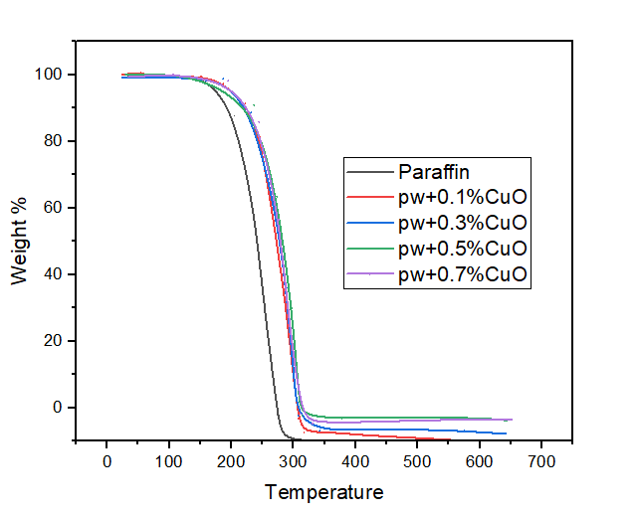
Figure 11.Thermal degradation of nano Cu–PCM composites as measured by TGA.

5.2 Improved Chemical Stability(FTIR Analysis)
Figure 12 FTIR Analysis of nano -PCM sample
are a chemical bonding, molecular structure, and degradation effect analysis technique known as Fourier transform infrared spectroscopy (FT-IR). Through infrared technology, researchers tracked how long a sample absorbed and emitted waves of light. The wavelength range covered by the FT-IR Perkin Elmer gadget is 660 cm⁻¹ to 4000 cm⁻¹
FT-IR tests are performed on the various NEPCM samples. It was found that there was no noticeable change in the wavelength of the NANOPCM samples. Paraffin wax C₂₈H₅₈ consists of CH2 and CH₃ bonds. They show sharp peaks. 2720 and 2630 cm⁻¹ and two weak peaks at 100 and 1000 cm^{-1.} All the peaks exhibit the bonding between the copper oxides and the paraffin. Similar peaks in all the samples at similar wavelengths show that the physical bonding of copper oxide and the paraffin does not disturb the chemical structure and stability of the NEPCMs samples. As shown in Figure 10
5.3 Reduced Melting and Solidification Temperature(DSC Analysis)
The figure shows the DSC analysis of paraffin and the added paraffin. A solid-to-solid phase transition causes the first small peak in the phase peak, whereas a solid-to-liquid phase transition causes the second large peak. During the solid-solid phase transition, the crystal structure changes. Cuo lowers the melting and solidification peaks of PCM samples by reducing thermal resistance; PW melts at 60.42°C and solidifies at 55.23°C; adding cuo lowers the melting and solidification peaks of PCM samples by reducing thermal resistance samples melt and solidify at a lower temperature than base paraffin. The lower melting and solidification temperature minimises melting and solidification time and improves the thermal performance of the NEPCM samples. The melting and solidification temperature differences for PW, Nano CuO–.1%PCM, CuO–.3%PCM, Nano CuO–.5%PCM, and Nano CuO–.7%PCM are reduced to 5.22 °C, 3.95 °C, 1.60 °C, 1.80 °C, and 1.32, respectively. By boosting PW nucleation, CuO reduced the impact of super-cooling during the melting and solidification stages. The nano CuO was used to speed up crystallisation and decrease the supercooling effect of paraffin wax. Furthermore, the CuO successfully stabilised the heated surface's temperature fluctuation during melting and solidification. As shown in Figure 11
Figure 13.DSC scanning of Cu–PCM nanocomposites.
5.4 Improved Thermal Conductivity:
A KD2 Pro was used to evaluate the thermal conductivity of CuO nanofluid. Nanofluid thermal conductivity is projected to be significantly improved by adding the suspended particles. Because of the volume fraction size and nanoparticle features, the thermal conductivity of nanofluid is highly dependent on it, as shown in Figure 7. According to the data, the thermal conductivity ratio rises with increasing particle volume fraction. As demonstrated by the new research, aggregation plays a critical role in thermal transport. CuO nanofluid thermal conductivity is being investigated as part of this study. In this study, CuO nanofluids were synthesised utilising a novel wet chemical process and then subjected to a battery of tests.
Figure 9.Thermal Conductivity of CuO nanofluid

6. CONCLUSION
The current study focuses on synthesising stable CuO using a wet chemical approach followed by characterisation using a series of tests to determine shape size, composition, surface morphology optical properties, etc. XRD analysis confirmed the production of CuO nanoparticles. According to theoretical calculations, CuO nanoparticles have an average elementary particle size of 11 nm. Using SEM, it was discovered that the produced samples had a spherical shape with an average elementary particle size of 9–11 nm. This agrees well with the XRD results. Further, It was reported that the agglomerated particle size distribution of CuO. Nanoparticles are in the 30-50 nm range using transmission electron microscopy (TEM); however, the DLS test revealed that The agglomerated particle distribution had an average size of 50 nm. Moreover, 53nm was the highest fraction of CuO. Ultraviolet absorption spectra were used to explore the visual properties of CuO nanofluids, and the results revealed maximum absorbance at 300 nm. Further, it was also found that an increase in the particle loading of CuO increases the thermal conductivity.

References
[1] S. Nallusamy 2016. Thermal Conductivity Analysis and Characterization of Copper Oxide Nanofluids through Different Techniques, Journal of Nano Research, vol. 40, pp. 105–112, https://doi: 10.4028/www.scientific.net/JNanoR.40.105.
[2] .S.Nallusamy A.,ManojBabu M,anikanda ,N.Manikanda, Prabhu and,N.Krishnamoorthi Balasubramanian 2015, Investigation on carbon nanotubes over review on other heat transfer nano fluids, International Journal of Applied Engineering Research, vol. Vol. 10 No.62
- S. U. S. Choi and J. A. Eastman 1995. Enhancing thermal conductivity of fluids with nanoparticles, Argonne National Lab. (ANL), Argonne, IL (United States), ANL/MSD/CP-84938, CONF-951135-29.
Z. G. Zhang, W. Yu, F. E. Lockwood and E. A. Grulke. 2001.Anomalous thermal conductivity enhancement in nanotube suspensions, Applied Physics Letters, Vol 79, 2252. https://doi.org/10.1063/1.1408272
H Masuda,A Ebata, K Teramae, N Hishinuma, and Y. Ebata 1993.Alteration of thermal conductivity and viscosity of liquid by dispersing ultra-fine particles, J-STAGE, Volume 7, Issue 4, Pages 227-233. https://doi.org/10.2963/jjtp.7.227
- S. Lee, S. U.-S. Choi, S. Li and J. A. Eastman 1999. Measuring Thermal Conductivity of Fluids Containing Oxide Nanoparticles, J. Heat Transfer, 121(2), 280-289. https://doi.org/10.1115/1.2825978
- A.M Hussein, R.A.Bakar, K.Kadirgama and K.V.Sharma 2014. Heat transfer enhancement using nanofluids in an automotive cooling system, International Journal of Heat and Mass Transfer, Volume53, Pages 195-202
- Y. Xuan and W. Roetzel 2000.Conceptions for heat transfer correlation of nanofluids, International Journal of Heat and Mass Transfer, vol. 43, no. 19, pp. 3701–3707. https://doi.org/10.1016/S0017-9310(99)00369-5
- S. Nallusamy and A. Manoj Babu, ‘X-Ray Differaction and FESEM Analysis for Mixture of Hybrid Nanoparticles in Heat Transfer Applications’, Journal of Nano Research, vol. 37, pp. 58–67, 2016, doi: 10.4028/www.scientific.net/JNanoR.37.58.
- Komarneni, Sridhar, Parker, C.John,Wollenberger,and J.Heinrich. 1996. Nanophase and Nanocomposite Materials II, MRS Online Proceedings Library, Volume 457, ADA329567, Symposium V .
- K.S. Meenakshi and P.J. Sudhan. 2015.Preparation and characterisation of copper oxide water-based nanofluids by one-step method for heat transfer applications Chemical Science Transactions, Vol. 4(1), pp. 127-132. doi: 10.7598/cst2015.976
- R.Manimaran, K.Palaniradja, N.Alagumurthi,S.Sendhilnathan and J.Hussain.2014.Preparation and characterisation of copper oxide nanofluid for heat transfer applications.AppliedNanoscience Volume 4, pages163–167. https://doi.org/10.1007/s13204-012-0184-7
- N.A.Sidik,H.A.Mohammed, A.Omer.Alawi and S.Samion. 2014.A review on preparation methods and challenges of nanofluids, International Communications in Heat and MassTransfer,Vol. 54,pp. 115-125 https://doi.org/10.1016/j.icheatmasstransfer.2014.03.002.
- K. Rohini Priya, K S Suganthi and K.S Rajan 2012. Transport properties of ultra-low concentration CuO–water nanofluids contain non-spherical nanoparticles. International Journal of Heat and Mass Transfer, Volume 55,Issue17–18,4734–4743. https://doi.org/10.1016/j.ijheatmasstransfer.2012.04.035.
- K. Rohini Priya, K.S. Suganthi and K.S. Rajan. 2012, Transport properties of ultra-low concentration CuO–water nanofluids containing non-spherical nanoparticles, International Journal of Heat Mass Transfer,
Volume. 55,Issue 17-18,4734-4743 https://doi.org/10.1016/j10.1016/j.ijheatmasstransfer.2012.04.035
- T. K. Hong, H. S. Yang and C. J. Choi. 2005. Study of the enhanced thermal conductivity of Fe nanofluids, Journal of AppliedPhysics,Vol.6,No.97,pp.1-4 https://doi.org/10.1063/1.1861145
- G.H. Ko, K Heo, K Lee, D.S Kim, C Kim, Y Shon and M Coi.2007. An experimental study on the pressure drop of nanofluids containing carbon nanotubes in a horizontal tube, International Journal of Heat Mass Transfer, Vol. 50(2324),pp.4749-4753 https://doi.org/10.1016/j.ijheatmasstransfer.2007.03.029.
- Q.Wu, Y.Meng, K.Concha, S.Wang,and Sequin 2013. Influence of temperature and humidity on nano-mechanical properties of cellulose nanocrystal films made from switchgrass and cotton, Industrial Crops and Products,Vol.48,pp.2835.https://doi.org/ 10.1016/j.indcrop.2013.03.032
- A.N Naje, A.S.Norry and A.M Suhail 2013. Preparation and characterisation of SnO2 nanoparticles, Int. Journal of InnovativeResearchinScience,Engg.AndTech.,Vol.2(12),pp.70687072.https://doi.org/10.1186/2228-5326-2-17.
- M.L. Zhong,D.C Zeng,Z.W Liu and H.Y Yu 2010.. Synthesis, growth mechanism and gas-sensing properties of largescale CuO nanowires, Acta Materialia, Vol. 58, Issue18,pp.5926-5932
https://doi.org/10.1016/j.actamat.2010.07.008
- P. Dai, H.A. Mook, G. Aeppli, S.M. Hayden and F. Dogan, 2000. Resonance as a measure of pairing correlations in the high-TC superconductor YBa2Cu3O6.6, Nature, Vol. 31(406), pp. 965-968 https://doi.org/10.1038/35023094
- S. Anandan, X. Wen and S. Yang. 2005.Room-temperature growth of CuO nanorod arrays on copper and their application as a cathode in dye-sensitized solar cells Materials Chemistry and Physics, Vol. 93, pp.35-39. https://doi.org/10.1016/j.matchemphys.2005.02.002
- J .W Zhu, H Q Chen, H Q Liu, X J Yang, L D Lu and X.Wang. 2004. Needle-shaped nanocrystalline CuO prepared by liquid hydrolysis of Cu(OAc)2, Journal of Material Science and Engineering. Vol. 384(1/2), pp. 172-176. https://doi.org/10.1016/j.msea.2004.06.011

[24] Stefanos Mourdikoudis , Roger M. Pallares and Nguyen T. K. Thanh 2018. Characterization techniques for : comparison and complementarity upon studying nanoparticle nanoscale

