A Survey on Various Recommendations
Techniques

Somen Roy Jyothi Pillai, Ani Thomas
Research Scholar Dept. of Computer Science & Engineering Dept. of Information Technology
CSVTU, Bhilai BIT, Durg (C.G) BIT, Durg (C.G)
somenroy2018@gmail.com jyothi.pillai@bitdurg.ac.in ani.thomas@bitdurg.ac.in

Abstract:

A recommender system is an efficient tool for filtering online information which has become ubiquitous due to changing computer user habits, personalization trends and new access to the Internet. Although the new recommender system is good at providing accurate recommendations, it still has various limitations and challenges such as scalability, cold start, and Sparsity. Because of the variety of techniques, the choice of technique when building an application makes a recommender system focused on complex tasks. Moreover, each technique has its characteristics, strengths and weaknesses and raises more questions that need to be clarified. The research paper aims to systematically review various recent contributions in the field of recommender systems, focusing on various applications such as recommending books, movies, and products. First, the different applications of each recommender system are analyzed and then an algorithmic analysis of various recommender systems is performed. Taxonomy is created that considers the various components required to develop an effective recommender system. Additionally, performance metrics focused on the datasets collected, the simulation platform and each post are evaluated and recorded. In conclusion, the paper provides a much-needed overview of the current state of research in this field and highlights the gaps and challenges that exist to help posterity develop efficient recommendation systems.

Keywords: Recommender system, Machine learning, Content-based filtering, Collaborative filtering, Hybrid filtering, deep learning,

1. Introduction:

A recommender framework (RS) could be a sort of data channel which points to proposing significant pieces of Data (budgetary news, item, motion picture, destination, etc.) Rating expression of users' intrigue may be a sort of explicit feedback which is the dynamic activity of the client, while certain criticism may be a detached activity of behaviour for audits of the page of item and so on. The exponential development of the information era by online stages is made a gigantic effect or change for genuine world individuals and related clients, this change appears that each individual's intrigued and choices are assorted on social organizing destinations expanding the alluring sessions with all kinds of space. So a framework that makes a difference in the clients selects reasonable alternatives for consideration and these frameworks are known as recommender frameworks.

RS frameworks are having a few sifting methods like content-based sifting, Collaborating sifting, and Knowledge-based. In RS, side data, Adaptable misfortune work, sequence-based representation and optimization issue with positioning misfortune, Arrange for that decipher a course framework factorization show into a neural arrangement shapes involvement with a few positioning misfortunes, switch out the factorization introduction for a sequence-based on Nearly all the recommender framework has been outlined for dealers item or service provider and all are like Amazon, Netflix, flip cart, etc. planned to draw in clients.

Presently, suggestion framework isn't restricted to business purpose, but they will have a more noteworthy impact on our way of life and this framework will become a basic device in every sphere of our life. It'll be an individual advisor who can help in each segment of living by giving vital proposals and direction the perfect recommender framework will be a necessary portion of the include look motor which can be able to offer personalized looks it is exceptionally difficult for the clients to figure out the method of reasoning and rationale behind the suggestion.

Content-based sifting – this procedure is based on chronicled information for the client and pertinent occasions where the user's past information is (content, sound, Video) but for the proposal and based on frameworks create a positioning list for expectation but strategies having cold begin issues where unused things and clients come to this interaction and their past data information is lost this may debase the execution of the framework H.Li,(2012)

Collaborating filtering – collaborating strategies are based on the similitude between clients and Things and for that, able to discover a few comparable strategies for clients and occasions be that as it may these strategies create the exceptionally common issue like Scanty, adaptability, and long-tail sense because of the need of criticism or evaluations by the client this procedure is based on network factorization and the issue can be taken care of by SVD but for the expansive and complex environment got to overcome the meagre issue for superior ratting Dutta, R. & Mukhopadhyay, D(2008)

Hybrid filtering – A cross-breed method is a conglomeration of two or more procedures utilized together for tending to the confinements of a person's recommender strategies. The joining of distinctive procedures can be performed in different ways. A half-breed calculation may consolidate the comes about accomplished from partitioned procedures, or it can utilize content-based sifting in a collaborative strategy or utilize a collaborative sifting strategy in a content-based strategy. This half-breed consolidation of diverse strategies by and large comes about in expanded execution and expanded exactness in numerous recommender applications. A few of the hybridization approaches are meta-level, feature-augmentation, highlight combination, blended hybridization, cascade hybridization, exchanging hybridization and weighted hybridization McAuley, J.(2016).
Traditional machine learning approach for recommendation system lies on classification and regression techniques based on dataset information, machine learning techniques are very efficient for generalization and interpretation of the RS model it is proved by recent research nowadays deep learning is very popular and more efficient than existing techniques, deep learning provides a new state of the art which can extract some information from pretend model and useful to automatic feature extraction with very handy for large datasets, the advantage of deep learning is very prominent for recent and future research in RS.

In the latter decade, a recommender framework has performed well in fathoming the issue of data over-burden and has become the more suitable apparatus for different ranges such as brain research, science, computer science, etc. any use case, and different domain recommender frameworks confront an assortment of challenges which are

I.1 Issues and Challenges in Recommendation Systems:

Sparse problem: Most users don’t rate most items, so the rating matrix is very sparse. This leads to the data Sparsity problem, which reduces the probability of finding a group of users who have similar ratings. It is the most obvious disadvantage of the CF technique. However, this problem can be reduced by using some extra domain information.

Cold-Start problem: The cold-start problem is a collective problem of new items and new users to RS. When a new item is introduced to the CF system without any ratings, it cannot be recommended at first. For example, Movie Lens cannot recommend any new movies until they have got some ratings. This problem is a bit difficult to solve because it is hard to find a group of similar users or create a CB profile without a user’s previous preferences.

Scalability Problem: One of the biggest problems with RS today is how well they can handle algorithms with big real-world data sets. It's getting harder and harder to handle huge, dynamic data sets made up of things like user preferences, ratings, and reviews. It's possible that when you use some recommendation algorithms on a small set of data, they'll give you good results, but if you use them on a lot of data, they might not give you the best results. That's why RSs need to use advanced, big-scale assessment methods to figure out how to use the data in the best way possible.
Privacy: RSs need to collect as much data as possible and make the most of it. But if they do this too much, it can leave users feeling like their privacy is being taken advantage of. That's why it's important to design techniques that can use the data sensibly, and carefully, and not give away too much.

Robustness: Another major issue with RS is its resilience to attacks. A robustness score is a measure of how resilient a system is to attacks. For example, an attacker can create fake user profiles according to some attack models (Push/Nuke attacks, etc.) to make certain target items more or less popular. These attacks are also known as shilling attacks, profile injection attacks, etc.

Diversity: Generally, a user will choose an item of interest from a recommended list as long as the list has some diversity in recommended items. Smooth recommendations for a limited type of product will not be valuable unless the user has a narrow set of preferences. In the early stages, when an RS is being used as a discovery tool, users may want to explore different and different options. To date, there has not been much research into this topic. However, the goal of this article is to design solutions that can achieve both diversity of items and accuracy of recommendation.

Various recommender calculations have been proposed on novel rising measurements, which centre on tending to the existing impediments of recommender frameworks. A great recommender framework must increment the suggestion quality based on client inclinations. Be that as it may, a particular recommender calculation isn't continuously ensured to perform similarly for diverse applications. This energizes the plausibility of utilizing distinctive recommender calculations for distinctive applications, which brings along a lot of challenges

Overview of Recommendation Models:

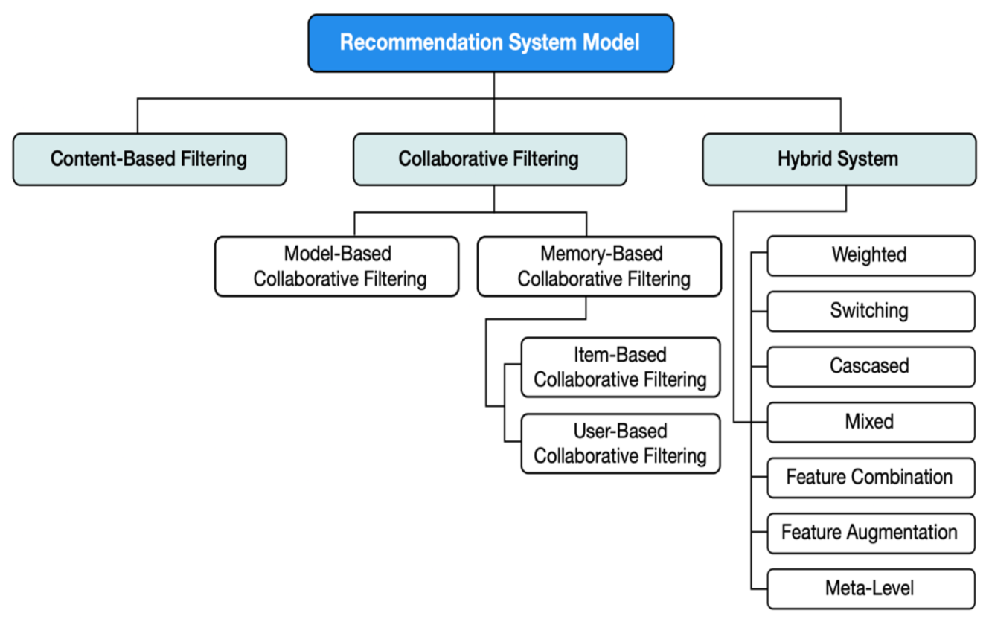

Figure 1 General architecture of the Recommendation model

There is a requirement for more investigation to reduce these challenges. Moreover, there's a huge scope of research in recommender applications that consolidate data from diverse intelligently online destinations like Facebook, Twitter, shopping locales, News domain etc. A few other regions for rising research may be within the areas of knowledge-based recommender frameworks, strategies for consistently handling understood client information and taking care of real-time client input to prescribe things in an energetic environment. It will help more about RS models with techniques by depicting figure2.

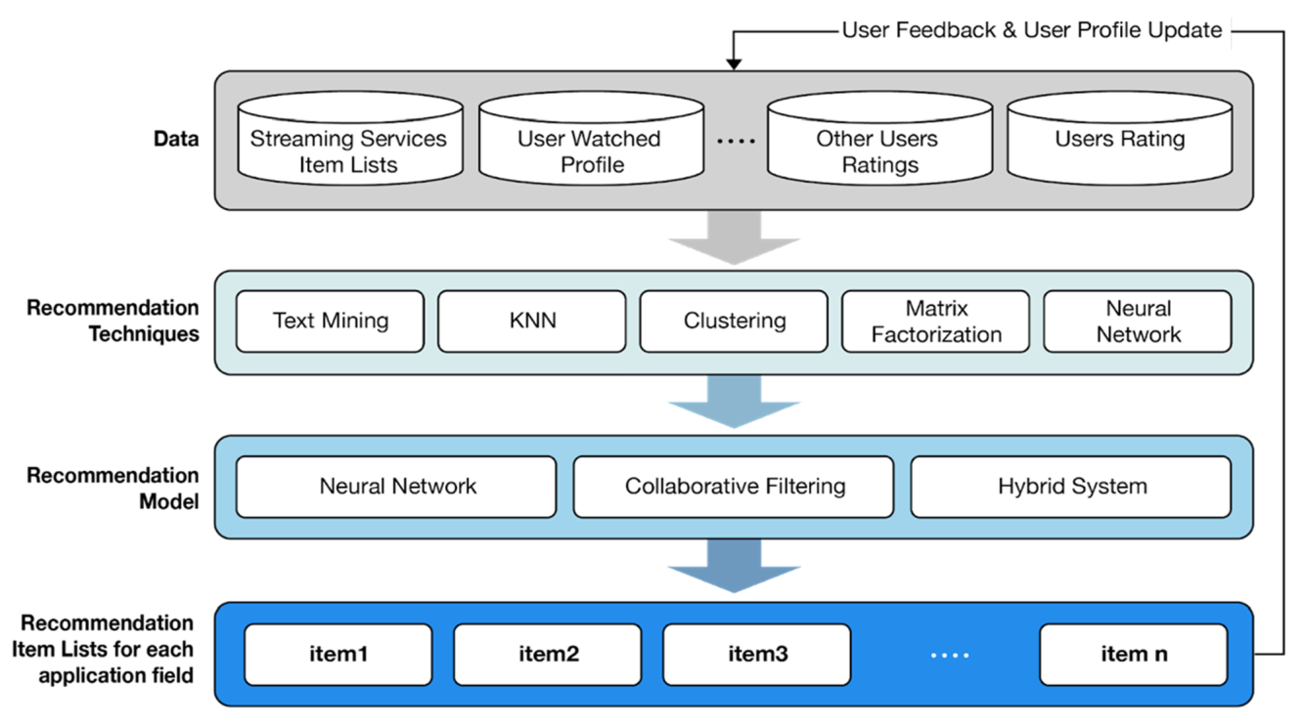

Figure 2. The overall flow of recommendation models and recommendation technique

II. Literature Review:

Dutta, R., & Mukhopadhyay, D [5] this work proposes to use valuable textual information for making recommendations. In addition, using the textual information, we can get ratings for products that have not been rated by enough consumers. This helps our system to overcome the problem of cold-start, which is a problem in collaborative filtering techniques. the system solves the problem of cold start and data. By contrasting the results of the scientific experiment and professional assessment, Xiang Liu's [2] study employs the appearance of weak characteristics to characterize consumers' degree of fashion and comes to the following conclusions: The writers of this study indicate feature priority and claim that the fashion level of customers may be correctly identified based on make-up, accessories, and hair color.

H.Li, F. Cai, and Z. Liao [3]. In general, recommendation algorithms are created and built to offer suggestions based on well-liked things. However, it shouldn't be limited to just that. Because the same and well-known commodities might dull customers, it should offer variety. Single, A, Srivastava J et al. [6] A system for dietary recommendations based on disorders, health conditions and other features of patients. The proposed design has been trained, tested and cross-validated. The results of training, testing and cross-validations show that the proposed solution has better accuracy and precision than the other solutions in the coming recommender systems. Singhal, A and R. KASTURI [7] outline the research challenges associated with the various applications of online recommender systems for e-commerce. These applications range from food ordering and online shopping to secure product delivery and customer tracking. Future experiments may also be conducted to assume and experiment with the results of the upcoming solutions of the recommender system.

Catcov Denis and Jari Veijalainen [16] found that the accuracy and diversity of a recommender system are not independent of one another. The growth of diversity can either reduce accuracy or increase it, depending on the magnitude of the increase in diversity. In the future, we plan to further explore the topic of randomness by designing algorithms that focus on randomness and testing them with real-world users. With a larger data set on randomness, insights into randomness may be gained. Deep learning appears to be a viable avenue for designing algorithms that prioritize randomness.

Kim, J., Choi, I et al. [18] recommendation algorithms are typically designed and developed to recommend popular items. However, it should not be limited to that. It should also provide diversity, as the same and well-known items can bore the customer. For example, more exactness can be used to identify books and fashion styling, while diversity can be more exact to detect books or fashion styling.

Venkatesan R, Sabari A et al. [15] Most of the current recommender systems of the e-commerce platforms use traditional algorithms (Item KNN, SVD) to recommend items that meet the customer's preferences. The accuracy of the recommendation can increase the customer's satisfaction. On the other hand, deep learning-based recommender systems (such as NCF algorithms) can increase sales volume by offering various items that match the customer's preferences because pursuing diversity can increase customer satisfaction while maintaining accuracy. Deep learning-based RS systems like NCF algorithms can increase sales volume by offering to pursue diversity.

Singh, P. K., and Dutta, Pramanik [19] This paper aims to track the trends in RS research. Here are some interesting findings: For example, most research in RS focuses on CF and a knowledge-based approach. China is the top contributing country to RS. The majority of papers in RS are published in IEEE. RS research peaked between 2013 and 2014. Most research in RS focus on CF with the DLL approach.

Hidasi, B, Karatzoglou, A et. al. [11] introduced a new set of loss functions. Combined with an enhanced sampling strategy, these new loss functions gave RNNs impressive top k gains for session-based recommendations. These techniques may offer similar benefits in Natural Language Processing domain, which shares significant similarities with the recommendation domain concerning machine learning (such as ranking, retrieval, and data structure). Improved sampling strategies have yielded impressive results.

Sharma, J, Kartikay Sharma et.al [17] Recommendation algorithms are typically designed and developed to provide recommendations based on the most popular items. However, recommendation algorithms should not be limited to that. They should provide diversity as the same and well-known items can bore the customer. Therefore, more exactness can be achieved by providing recommendations based on a diversity of items for the detection of books or fashion styling.

In this paper, Sahoo, A.K., Pradhan et al.[20] compare different privacy-preserving collaborative filtering methods as well as deep learning methodologies. The RBM- CNN shows better accuracy of health recommender systems as compared to other systems. This paper proposes a different approach using collaborative filtering using deep neural networks. This paper is useful for future research.

Leila Esmaeili and Shahla Mardani et al [25] .The commonly used technique next to CF is content-based filtering, but this technique also suffers from the same problem. Hence the hybrid approach, combining the other two techniques seems to produce a better result and it is becoming the most popular technique adopted in RS. Combining the other two techniques seem to produce a better result

Alamdari, P. M, Navimipour et. al [26] Furthermore, all selected mechanisms are compared based on some crucial metrics such as security, response time, scalability, accuracy, operation cost, diversity/novelty/serendipity, implicit/explicit data source, and independence. The author focused in this work on customer satisfaction more than accuracy. Y. K. Tan and X. Xu et al. [28] propose to improve recurrent model performance for session-based recommender systems by applying appropriate data augmentation techniques to account for temporal changes in user behaviour. Future work should explore the tradeoffs of embedding-based models for better results.

Manoharan, Samuel [14] The model is trained fast using the gated recurrent network. The developed design is trained, tested and cross-validated. The outcomes of the training, testing and cross-validating demonstrate that the proposed system has better precision and accuracy than the other ML and DL procedures such as the MLP, RNN Logistic Regression, and Navies’ Bayes respectively.

McAuley, He, R. [10] In this research, a novel approach called Fossil that predicts personalized sequential behaviour by combining similarity-based models with Markov Chains is suggested. We conducted comprehensive tests on several sizable real-world datasets and discovered that Fossil performs noticeably better than the state-of-the-art approaches. The writers of this article provide a few hybrid methods to get better outcomes

Murad, D, Heryadi, Y, et.al [21] It is clear from the overview of RS that research in this area is expanding exponentially. The most often used method for recommendation systems is collaborative filtering. The main disadvantage of this method is that it cannot address the cold start problem, but it may significantly improve in sparse data. Jie Lu et al., Qian Zhang, et al [24]. This article demonstrates how recommender systems may be improved using AI approaches and serve as a reference for recommender system researchers and practitioners. Utilizing a variety of ML and deep learning approaches in addition to other techniques.

SHOUJIN WANG and LONGBING CAO [38] The most noteworthy efforts on session-based recommender systems (SBRSs) to date have been reviewed in-depth and methodically in this study. To remove some uncertainty and inconsistencies in the field, the study proposed a uniform framework to divide the existing works in this field into three sub-areas and offered a unified problem statement for SBRS. It also examined the features of session data and the accompanying difficulties.

Noemi Mauro, Malte Ludewig, and et.al [29] In that respect, it is a widespread phenomenon that simpler methods and earlier non-neural approaches are frequently ignored in empirical evaluations and only neural methods are utilized as baselines despite their potentially ambiguous competitiveness.

Deqing Yang, Wenjing Meng, and et.al [31] In this research, we offer the MKM-SR, a unique session-based recommendation (SR) model that concurrently takes into account user micro-behaviors and item knowledge. Depending on the many intuitions about item and operation sequences present throughout a session,

Boi Faltings and Fei Mi [32] .In this research, a realistic incremental session-based recommendation scenario is used to suggest neural approaches. Demonstrates how current neural models may be utilized in this situation with minor changes and proposes a general technique called Memory Augmented Neural Recommender (MAN) that can be used to enhance a variety of existing neural models.

Zhang G., Zuo H., and Lu J [36] In this research, a brand-new framework called Res TL was put out. Res TL learns the target model for regression problems in a conditional shift scenario by maintaining the source data's distribution features in a model-neutral manner. By learning the residual between the two domains and reusing the antecedent parameters of the source fuzzy system, Res TL may create the target model

Quoc V Le and Tomas Mikolov [34] The potential of distributed representations for machine translation was shown in this article. We effectively learn meaningful translations for single words and short sentences from massive monolingual data sets and a modest beginning lexicon.

Eric Appiah and Longhua Zhou [39] this work suggest a safe deep learning-based recommender system that predicts and gives simple nutrition and treatment suggestions to patients with unique requirements without disclosing their private medical information. Based on their fundamental demographics, dietary habits, medical history, and other pertinent information, the system automatically generates precise suggestions for ill patients.
Sharma, S and V. Rana [40] The influence of related video recommendation systems on video views and likes is discussed in this study along with a personal recommendation system. Measuring ultimately necessitates taking this into account and analysing the intended consequence since recommend estimates and problems fundamental treatment and diet contributions are often employed for numerous extra purposes like user happiness or enhanced transactions.

Jesse, M, Bauer, C, and Jannach, D.[43], Overall, our research shows that the ILS measure may serve as a reliable substitute for views of human diversity. However, the specifics of how the measure is implemented might be important, therefore a particular metric has to be validated in a particular domain. Its application, for instance, before the use of algorithmic diversification approaches. With Our work closes a significant research gap in the literature as a result of these findings. Researchers frequently presume implicitly and without verification that the ILS metric they are using which is probably only developed via intuition would be an accurate substitute for human views on diversity.

A review of the use of machine learning algorithms in recommender systems has been proposed in [22]. The main goal of paper is to identify different ML algorithms being used in recommender systems and assist new researchers to do the research appropriately. The result confirms that a minimal research effort has been done focused on hybrid approaches, with plenty of room for research in semi-supervised and reinforcement learning for recommender systems. Neural Network and K-Means algorithms are not being researched enough for RSs development. Geetha et al. in [23] proposed a recommendation system for movies that overcome cold-start problems. It mainly follows collaborative filtering, content-based filtering, demographics-based filtering and hybrid approaches. This system attempts to overcome the drawbacks of each approach.

III. Popular Research Domain and techniques in RS:

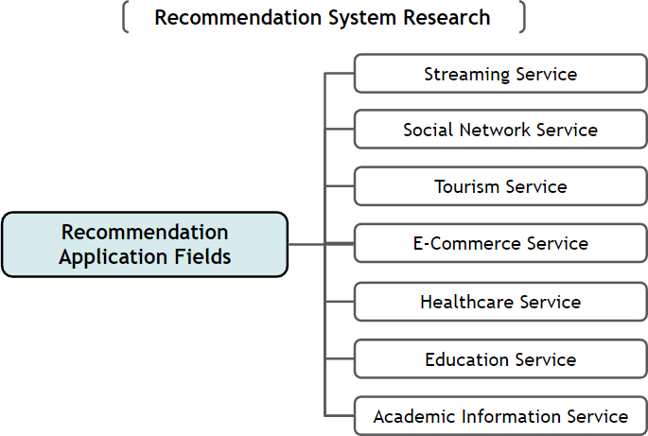

Summary of Research Trends:

Figure 3, visualizes the ratio of the total papers collected on seven service fields in this study from 2010 to 2022. The figure visualizes the trend of the ratio of the number of papers by year. Through these figures, it can be seen that a significant amount of research on recommendation systems was conducted from 2010 to 2022 in the following order: social network services, tourism, healthcare, e-commerce, and education. Furthermore, from the Figure, it can be seen that tourism, healthcare, and education have recently taken up a high proportion, and research is expanding. From the data, it can be seen that the interest in the field reflects the rapid increase in people’s interest in particular lifestyles and that the field of education enables effective alternatives to offline education. Now day’s customer of various domains is very much dependent on recommender systems and these systems are popular as intelligent agent for all kind of customers as the distribution suggests below chart.

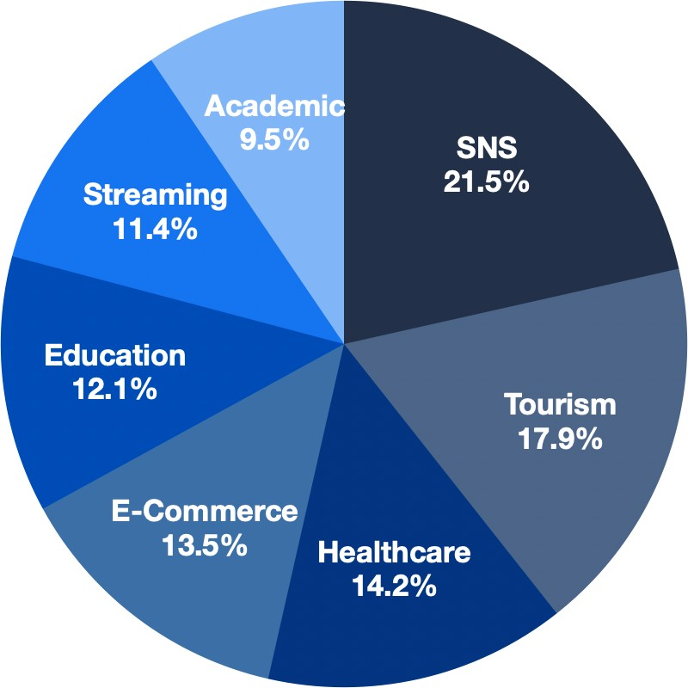

Figure 3 Distribution of seven recommendation system fields from 2010 to 2022

Popular Steps for RS Techniques:

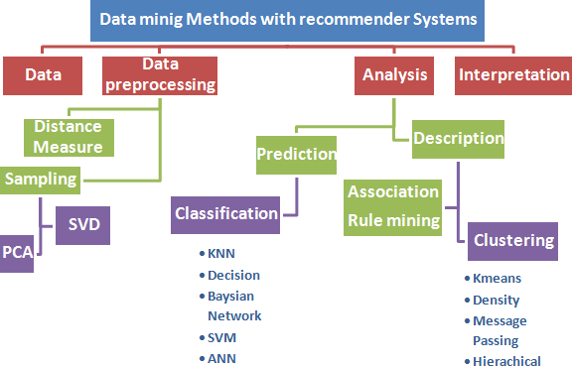

Figure 4 Technology mainly used in Recommender System

Table 1- Comparison of recommender systems techniques:

No | Techniques | Advantage | Disadvantage
1 | Content-Based recommendation Filtering | - The system didn’t use the user's data to recommend items.  - The system can recommend new items to the users based on the similarity between item specifications. | - We need to analyse and detect all item features to create a recommendation list  - The system didn't depend on the user's rate for this item so the evaluation of the product quality was not included.
2 | Collaborative recommendation Filtering | - The system didn’t use demographic information to recommend item | - The quality of the system depends on the highest rating item list.
 |  | - The system matches similar items between users.  3. The system can recommend to the user items outside their preferences and may like this item. | 2. There's a problem with how to recommend items to the new user (cold start  Problem).
3 | Demographic recommendation filtering | 1. It is not based on user-item ratings, it recommends before the user rated any item. | - 1. The gathering of demographic data leads to privacy issues.  - 2. Stability vs. plasticity problem.
4 | Hybrid Approaches | - 1. It combines all advantages of content-based and collaborative filtering.  - 2. It's based on Content Description and user evaluation.  - 3, Solve Overspecialization  - 4. Increase customer satisfaction rate. | - 1. Suffer from the cold start problem.  - 2. Early Rater problem for products.  - 3. Sparsity problem.

IV. Conclusion:

Recommender frameworks have been pulled into the consideration of analysts and academicians. In this paper, have distinguished and judiciously checked on investigated papers on recommender frameworks centering on different applications, which were distributed between 2011 and 2022. This survey has assembled differing points of interest like diverse application areas, methods utilized, recreation instruments utilized, assorted applications centered, execution measurements, datasets utilized, framework highlights, and challenges of distinctive recommender frameworks. Investigate holes and challenges were put forward to investigate long-term inquiries about point of view on recommender frameworks. By and large, this paper gives a comprehensive understanding of the slant of recommender systems-related investigations and to gives analysts with knowledge and future heading on recommender frameworks. The outcomes of this ponder have a few commonsense and significant suggestions

This survey will give a rule for future investigations within the space of recommender frameworks. In any case, this inquiry has a few confinements. Furthermore, we have looked into it as it was an English paper. Finally, Recommendation systems for News, E-Commerce, Movie Prescribe, Music Suggest, Personalized Recommend and Hybrid Prescribe various research papers on different domains that did not incorporate these catchphrases were not considered. Future inquiries can incorporate including a few extra descriptors and expanding the research motivation to cover more differing articles and news on recommender frameworks by applying deep learning techniques will be helpful in future research of RS.

V. References

[1]. Hu, X., Zhu, W., & Li, Q. (2014). HCRS: A hybrid clothes recommender system based on user ratings and product features. arXiv
preprint arXiv:1411.6754.
[2]. Xiang Liu, 2017. Fashion Evaluation Method for Clothing Recommendation Based on Weak Appearance Feature.

[3]. H.Li, F.Cai, and Z.Liao, “Content Based-Filtering Recommendation Algorithm Using”, in Proceedings of the HMM, pp. 275-277, 2012 View at Google Scholar

[4]. Driskill, R. & Riedl, J., 1999. Recommender Systems for E-Commerce: Challenges and Opportunities. American Association for

Artificial Intelligence, pp.73–76. Available at: http://aaaipress.org/Papers/Workshops/1999/WS-99-01/WS99-01-012.pdf.

[5]. Dutta, R. & Mukhopadhyay, D., 2008. Offering a Recommendation System in E-commerce. IEEE.
[6]. A. Singhal and J. Srivastava, “Research dataset discovery from research publications using web context,” Web Intell., vol. 15, no. 2,
pp. 81–99, 2017.
[7]. A. Singhal, R. Kasturi, and J. Srivastava, “DataGopher: Context-based search for research datasets,” in Proceedings of the 2014 IEEE
15th International Conference on Information Reuse and Integration, IEEE IRI 2014, 2014, pp. 749–756.
[8]. A. Singhal, “Leveraging open source web resources to improve retrieval of low text content items,” ProQuest Diss. Theses, p. 161,
2014.
[9]. S. Lakshmi and T. Lakshmi, “Recommendation Systems: Issues and Challenges,” Int. J. Comput. Sci. Inf. Technol., vol. 5, no. 4, pp
. 5771–5772, 2014.
[10]. He, R., McAuley, J.: Fusing similarity models with Markov chains for a sparse sequential recommendation. CoRR, abs/1609.09152
(2016)
[11]. Hidasi, B., Karatzoglou, A.: Recurrent neural networks with top-k gains for session-based recommendations. In: Proceedings of the
27th ACM International Conference on Information and Knowledge Management, CIKM ’18, pp. 843–852 (2018)
[12]. Hidasi, B., Karatzoglou, A., Baltrunas, L., Tikk, D.: Session-based recommendations with a recurrent neural network. In: Proceedings
International Conference on Learning Representations ICLR ’16 (2016)

[13]. Aciar, S. et al., 2007. Recommender System Based on Consumer Product Reviews.pdf.
[14]. Manoharan, Samuel. "Patient Diet Recommendation System Using K Clique and Deep Learning Classifiers."
Journal of Artificial Intelligence 2, no. 02 (2020): 121-130.
[15]. Venkatesan R and Sabari A 2020 Issues in various RS in E-commerce 2020 - A survey 2020 Journal of Critical Reviews 7(7) 604-
608
[16]. Cotcov, D, jari veijalainen “How does serendipity affect diversity in recommender system? A serendipity greedy algorithm”
computing (2020) 102:393- 411 published online 5 December 2018
[17] Sharma, J, Sharma, k, Kaustubh Garg: “Product Recommendation System a Comprehensive Review” ICCRDA 2020 IOP Conf.
Series: Materials Science and Engineering 1022 (2021) 012021
[18]. Kim, J.; Choi, I.; Li, Q. Customer Satisfaction of Recommender System: Examining Accuracy and Diversity in Several Types of
Recommendation Approaches. Sustainability 2021, 13, 6165. https://doi.org/10.3390/ su13116165
[19]. Singh, P. K, Dutta, P. K, Pramanik, A K D and Choudhury 2020 P RSS: An Overview, Research Trends, and Future Directions,
International Journal of Business and Systems Research · January 2021
[20]. Sahoo, A. K, Pradhan, C, Barik, R. K and Dubey H 2019 DeepReco: deep learning-based health RS using collaborative filtering.
Computation 7(2) 25
[21]. Murad, D. F, Heryadi, Y, Wijanarko, B. D, Isa, S. M and Budiharto 2018 Recommendation system for smart LMS using machine
learning: a literature review Proc. Int. Conf. on Computing, Engineering, and Design (ICCED) IEEE 113-118
[22]. I. Portugal, P. Alencar and D. Cowan, “The use of machine learning algorithms in recommender systems: A systematic review,”
Expert Systems with Applications, vol. 97, pp. 205-227, 2018.
[23]. G. G., S. M., F. C. and S. D., “A hybrid approach using collaborative filtering and content-based filtering for recommender system,”
Journal of Physics: Conference Series, vol. 1000, no. 1, p. 012101, 2018.
[24]. Qian Zhang, Jie Lu, Yaochu Jin: “Artiﬁcial intelligence in recommender systems” Complex & Intelligent Systems(2021)7:439–457
[25]. Leila Esmaeili and Shahla Mardani et al 2020 A novel tourism RS in the context of social commerce Expert Systems with
Applications Volume 149 ISSN 0957- 4174
[26]. Alamdari, P. M, Navimipour, N. J, Hosseinzadeh, M, Safaei, A and Darwesh A 2020 A Systematic Study on the RSS in the E-
Commerce IEEE Acces 8 115694-115716
[27]. P. Wang, J. Guo, Y. Lan, J. Xu, S. Wan, and X. Cheng, “Learning hierarchical representation model for next basket
recommendation,” in SIGIR, 2015, pp. 403–412.
[28]. Y. K. Tan, X. Xu, and Y. Liu, “Improved recurrent neural networks for session-based recommendations,” in DLRS, 2016, pp. 17–22.
[29]. Malte Ludewig, Noemi Mauro, and et al. 2019. Performance comparison of neural and non-neural approaches to the session-based
recommendation. In RecSys. 462–466.
[30]. Malte Ludewig, Noemi Mauro, Sara Latifi, and Dietmar Jannach. 2021. Empirical analysis of session-based recommendation
algorithms. UMUAI 31, 1 (2021), 149–181.
[31]. Wenjing Meng, Deqing Yang, and Yanghua Xiao. 2020. Incorporating user micro-behaviors and item knowledge into multi-task
learning for a session-based recommendation. In SIGIR.1–10.
[32]. Fei Mi and Boi Faltings. 2020. A memory-augmented neural model for an incremental session-based recommendation. In IJCAI. 1–7.
[33]. Fei Mi, Xiaoyu Lin, and Boi Faltings. 2020. Ader: Adaptively distilled exemplar replay towards continual learning for a session-based
recommendation. In RecSys. 408–413.
[34]. Tomas Mikolov, Quoc V Le, and Ilya Sutskever. 2013. Exploiting similarities among languages for machine translation.
[35]. Zhou J et al (2018) Graph neural networks: a review of methods and applications. arXiv Prepr.arXiv1812.08434 40
[36]. Lu J, Zuo H, Zhang G (2019) Fuzzy multiple-source transfer learning. IEEE Trans. Fuzzy Syst.
[37]. Zhitao Wang, Chengyao Chen, and et al. 2018. Variation recurrent model for a session-based recommendation. In CIKM. 1839–
1842.
[38]. SHOUJIN WANG, LONGBING CAO, “ A Survey on Session-based Recommender Systems” in ACM Computing Surveys · May
2021
[39]. Eric Appiah, Longhua Zhou(2021) Secured Recommender System for Special Need Patients Using Deep Learning Public Health,
20 September 2021 https://doi.org/10.3389/fpubh.2021.737269

[40]. Sharma, S, Rana, V (2021) Deep learning-based semantic personalized recommendation System International Journal of

Information management data insights, Volume 1
[41] Kumar, Vikas, et al. "Collaborative filtering using multiple binary maximum margin matrix factorizations." Information
Sciences 380 (2017): 1-11.
[42] Sharma, m and Mittal. Raman ’A Survey and Classification on Recommendation Systems’ January 2022 2nd International
Conference on Big Data, Machine Learning and Applications (BigDML 2021) 19-20, December 2021
[43] Jesse, M, Bauer, C, and Jannach, D.(2022), Intra list similarity and human diversity perceptions of recommendations the details
Matter. User model, user adapted interact: doi, 10.1007/s11257- 022-09351-w
[44] Panda, D.K, and Ray, S.(2022), Approaches and algorithms to mitigate cold start problems in recommender systems, a systematic
literature review. J. Intell. Inf. Syst. 59, 341-366. Doi 10.1007/s10844- 022- 00698-5

