**Four-Stage Data Science Framework Embedded With DSBNN for Line Trip Fault Prediction in Power Systems**

**1Dr. K. Kalyan Raj, 2Dr.B.MadhuKiran, 3Dr.B.Dasu, 4Dr.R.Srinivasa Rao**

*1Dr. K. Kalyan Raj, Assistant Professor, Dept of EEE, Seshadri Rao Gudlavalleru Engineering College, Gudlavalleru-521356,* [*kalyan20.kaniganti@gmail.com*](mailto:kalyan20.kaniganti@gmail.com)

*2Dr.B.MadhuKiran, Associate Professor, Dept of EEE, Seshadri Rao Gudlavalleru Engineering College, Gudlavalleru-521356, A.P*

*3Dr.B.Dasu, Professor, Dept of EEE, Seshadri Rao Gudlavalleru Engineering College, Gudlavalleru-521356, A.P*

*4Dr.R.Srinivasa Rao, Professor, Dept of EEE, JNTUK, Kakinada-533003, A. P*

**ABSTRACT**

Data science is a "concept to unify [statistics](https://en.wikipedia.org/wiki/Statistics), [data analysis](https://en.wikipedia.org/wiki/Data_analysis), [informatics](https://en.wikipedia.org/wiki/Informatics), and their related methods" to "understand and analyze actual phenomena" with data. Here we embedded four-stage data science framework for the detection of line trip fault prediction in power systems. In this work, we proposed the novelty of Embedding the DSBNN (Deep Sigmoid based Neural Network) with Data Science for predicting line trip fault in power systems. It involves four stages of the process it undergoes which include pre-processing, Variable Selection, Metrology Prediction, Process Control. Initially, the dataset features are pre-processed and it attains the variable selection stage in the manner of Random support-based AGWO. After those metrology predictions stage, the selected variables are applied to DSBNN is used. Finally, the stage of process control entropy is calculated and the threshold limit is set to predict whether the fault occurs or not. The experimental results revelations the dominance of presented method comparing with the existing methods.

**Keywords:** pre-processing, Adaptive Grey Wolf Optimization (AGWO),DSBNN (Deep Sigmoid based Neural Network), Data science, Power Systems.

**1. INTRODUCTION**

To simply stated, data science is the study of information. It is made up of various tools, methods, algorithms, and procedures. It also includes data storage, management, and analysis in order to extract meaningful information from both structured and unstructured data. It also employs machine learning methods to elicit insights from data. Nowadays, most businesses have an unusually large amount of data. It contributes to the effective use of this massive amount of data.Machine learning (ML), a basic aspect of "Artificial Intelligence" (AI), can play an important role in extracting insights from data, and data science (DS) is driving the transition.Data science is at the forefront of a new scientific paradigm [1], and machine learning has the potential to radically alter the cyber security landscape. The first goal is to ensure the facility system's dependability and stability as power grids grow and demand increases. In power systems, high-accuracy failure prediction enhances operational dependability and stability, potentially saving large losses from power outages. Fault prediction is the process of analyzing and mining prior data in order to predict whether or not there is a fault in the grid, allowing for the implementation of actions to prevent accidents and ensure system recovery [2].

Grid operators (PSOs) face a difficult task in providing end-users with uninterrupted power. Although human control over fault infiltration is impossible, it is critical to reliably identify, categories, and localize the fault location. The methods for detecting, classifying, and placing faults in power transmission systems have been thoroughly explored [3, 4].CPPS is more intelligent and stable than a traditional physical electrical power grid. However, because of cyberspace's weaknesses, particularly the complicated interacting process between electrical power and data flow, information security has become a critical issue affecting the facility system's safe and stable operation. As a result, the facility system is constantly vulnerable to network attacks. Unlike network attacks on the Internet, cyber-attacks against CPPS are more focused on disrupting the cyber layer's stability control over the physical layer, even paralyzing the facility system's functioning [5].

The concept of operating reliability was established in order to develop reliability models and assess failure rates and outage consequences in the data processing scale while accounting for various characteristics. Operating reliability theory, rather than classical planning reliability theory, is commonly utilised in real-time power system dispatching and can give a timely assessment to avert potential power grid outages or blackouts [6]. During the recent decade, electrical power systems have moved away from traditional energy systems and toward next-generation smart grid technology [7].

Researchers have discovered that small changes in operational data can help find leakage defects. Several leakage fault detection (LFD) approaches, such as the pressure gradient method, the negative pressure wave method, the inverse transient analysis method, and others, are presented to support this theory. The pressure gradient method works on the idea that when there is a leak, the leakage's upstream flow increases, generating an excessive pressure decrease. The downstream flow is unaffected, resulting in a steady pressure gradient. By comparing simulated pressures and flow rates to measured values at upstream, downstream, and various places along the pipe, the leak will be identified [8]. Many automated fault detection and diagnosis (FDD) approaches have been developed to detect these issues before they have an impact on the long-term functionality of the system [9, 10, 11].Determining the location of the fault is critical for both fault clearance and power restoration transmission. Single line to ground faults, line to line faults, triple line faults, transform faults, and multi-location faults are among the fault types that must be identified initially [12].

Many studies based on SCADA data have suggested that fault diagnosis and prognosis can be appreciated. To appreciate defect detection, machine learning models with domain knowledge have been presented. The detection of WT gearbox problems was suggested using a deep neural network (DNN)-based architecture [13, 14]. Many data-mining algorithms for alternative energy prediction were reviewed, and some of them might be used to detect faults [15]. In addition to the current situation, the majority of strategies fail to take into account all of the given factors. The unique method is suggested in light of these restrictions. The following are the primary contributions of this paper:

• The variable selection stage combines random support and AGWO (Adaptive grey wolf optimizer) to reduce redundant and unnecessary elements and choose the important variables to increase prediction accuracy and avoid the dimensionality curse.

• Using Data Science and the DSBNN (Deep Sigmoid based Neural Network) to predict power system line trip faults.

The manuscript's structure is organised in the following way: The second section examines the existing literature on the proposed technique. The suggested system is briefly discussed in section 3, the exploratory results are examined in section 4, and the paper is concluded in section 5.

**2. LITERATURE REVIEW**

N. Murugesan et.al. [16] Machine learning approaches for fault detection are delivered, and supported parameters such as PV arrays, current, irradiance, and temperature are suggested to handle this safety void. Current approaches, on the other hand, typically employ supervised learning techniques, which are conditioned by a variety of labelled data (so-called fault types) and thus have a number of identified drawbacks, such as being costly to implement, model simulation, and so on. For improved visualisation, the paper proposes an N-semi-regular Fuzzy Semi-Supervised Learning System supported by an N-semi graph and some labelled, normalised training data. To support network recovery, the proposed model not only describes the loss but also the likely fault structure. After building a model, PV systems can learn to monitor and identify PV failures on their own as the environment changes over time.

Lee Chia-Yen et al. [17] TFT-LCD panel processes rely on experimental design and technical experience for process monitoring and internal control across the production line, as demonstrated. This study proposes a three-phase data science framework embedded with several data processing and machine learning techniques to identify the variables influencing yield, predict photo spacer process metrology results, and suggest method control within the colour filter manufacturing process. An empirical investigation was conducted with Taiwan's leading TFT-LCD manufacturer to validate the proposed paradigm.

Maren David Dangut et.al [18] proposes a hybrid machine learning method that combines linguistic communication processing approaches with ensemble learning to predict highly rare aviation component failure. To validate the proposed approach, a real-world aviation central maintenance system log-based dataset is used. In this dataset, unscheduled component replacements are extremely rare. The results show that the proposed method outperforms existing imbalanced and ensemble learning methods in terms of precision, recall, and f1-score. It was also discovered that focusing solely on patterns found within the minority class could help to solve the problem of class imbalance.

Cheng He et al. [19] A new rolling bearing fault diagnosis method was proposed using a combined extreme-point symmetric mode decomposition (ESMD), composite multi-scale weighted permutation entropy (CMWPE), and gravitational search algorithm with multiple adaptive constraint strategy (MACGSA) optimised statistical procedure support vector machine (LSSVM). To address the issue of intrinsic mode function (IMF) modal aliasing and minor changes in fault characteristics, ESMD and CMWPE are known to obtain a more sensitive high-dimensional feature vector set. By fine-tuning LSSVM, MACGSA was able to improve fault detection accuracy. The ESMD model is used to generate a series of IMFs from rolling bearing data; the CMWPE values of the IMFs are then extracted to generate a high-dimensional feature vector set; and finally, the MACGSA-LSSVM model is used to perform fault classification.This approach has a higher diagnostic accuracy than previous methods.

Pengfei Liang et.al [20] A semi-supervised and high-accuracy adversarial learning system is built for the one-time and simultaneous defect identification of the gearbox using Generative Adversarial Nets and time-frequency imaging. The proposed strategy consists of two parts. The continuous wavelet transform is used in the first section to convert one-dimensional raw vibration data into two-dimensional time-frequency pictures. The labelled and unlabelled time-frequency images are fed into the constructed adversarial learning model in the second stage to grasp single and simultaneous gearbox failure diagnostics. Finally, the technique is put to the test with two case studies.The findings show that it achieves the best accuracy rate with higher accuracy and fewer training steps than other intelligent fault diagnostic methods currently available in the literature.

**3. PROPOSED SYSTEM**

This paper proposes a four-stage data science framework incorporating machine learning approaches for predicting data-based line trip faults in power systems. Pre-processing, variable selection, metrology prediction, and process management are all part of a four-stage data science framework. Remove factors having a large number of non-available (N/A) or identical values during the pre-processing stage. Also, see if the missing values are the result of parallel computers.The variable selection stage, which employs random support and the AGWO (Adaptive grey wolf optimizer), eliminates redundant and unnecessary variables while focusing on the important ones to improve prediction accuracy and avoid the dimensionality curse. The machine learning technique is used in the metrology prediction step to collect the chosen variables. Current, voltage, active power, and user reactive power are all electrical measures taken during the DSBNN (Deep Sigmoid based Neural Network) approach. The technique control stage tweaks the process for Entropy-based line trip fault prediction; the most important duty is determining whether or not a problem exists when the power system is operating. Figure 1 depicts a diagram of the methodology being described.Bottom of Form

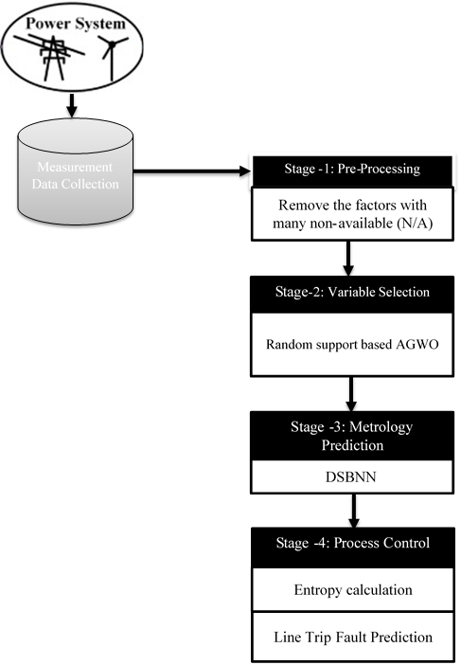

**Figure1:** Overall Proposed Trip Fault Prediction in Power Systems Methodology

**3.1 Pre-Processing**

In a stage-1 data science framework the Pre-processing is the important step to attain the dataset effectively. Let us consider is the Testbeddataset, where *n* is the number of records in the Testbeddataset. In the Set of features represented by. In Some places where the value is empty that case removes the factors with many non-available (N/A) and also eliminates the identical values.

**3.2 Random Support Based Adaptive Grey Wolf Optimization (AGWO)**

The stage-2 data science framework sorts the dataset input data based on the support value of features in this section. In this circumstance, the Random Support value evaluation is based on certain features.

****(1)

Where denotes the support value, denotes the chosen random optimal features set. We proceed to the Adaptive GWO, which is a swarm intelligence technique in a Four-stage data science framework that copies the organization of control of wolves, which is notable for its group hunting. Boarding a pack is often more valuable to grey wolves. They require a rigid socially dominant progressive system, with an Alpha (α) who can be either male or female. Usually, the alpha bears the brunt of the leadership responsibilities. The pack is required to follow the commands of most wolves.The Betas (β) are the alpha's subordinate wolves that assist him in basic leadership. The beta is the alpha's advisor and the pack's enforcer. When a wolf is neither a (or), it is referred to as a wolf. Omega wolves are led by delta (δ) wolves, who report to alpha and beta wolves. The fittest solution has been termed the alpha (α) in the mathematical model for the Random Support-based AGWO. Beta (β) and delta (δ) are the names for the second and third best solutions, respectively. Α,β,δ, and lead the hunt here. To boost AGWO and perform optimization, wolves' hunting style and social hierarchy of command are mathematically modelled. The Random Support-based Adaptive GWO method has a pseudo-code of given in algorithm1.

Bottom of Form

|  |
| --- |
| **Input:** *Initial grey wolfs, Random Support Value*  **Output:** *Selected Variable* |
| ***Begin***  *1: Establish the initial grey wolfs*  *2: Define the**,* *and*  *3: Find the fitness esteemusing condition (5) of every hunt agent*  *= The most effective hunt agent*  *= The second best hunting agent*  *=The third best hunting agent*  *4: Iteration*  *5:* ***repeat***  *6:* ***for***  *(grey wolf pack size)*  *Update the location of the present hunt agent utilizing*  *condition (9).*  ***End for***  *7: Find the fitness value of all hunt agents*  *9: renew the esteem of,*  *8: Update the vectors,  and*  *10:  until*  *11: output*  ***End*** |

**Algorithm 1:** Pseudo Code of the Random Support AGWO

**Step 1:**Search agents are used to initialise the GWO parameter (), vectors*,* and the maximumgreat number of iteration ().

** (2)

**(3)

The assessmentslinearly decrease from 2 to 0 over the time of iterations and*,*  are random vectors in [0, 1]. The parameter is linearly updated in each cycle to go from [2-0] as indicated by the condition (4),

 (4)

Where is the iteration number and is the total number of iteration took into consideration the optimization.

**Step 2:** Based on the size of the pack, generate wolves at random.

**Step 3:** Using the Random Support value as a criterion, evaluate each hunt agent's fitness esteem (5)

**(5)

Where is ascharacterized in (6) and🡪iteration amount,🡪coefficient matrix,🡪targetlocation, and 🡪 grey wolf location.

 (6)

**Step 4:** Find the finest hunt mediator (), second-preeminent hunt negotiator () and also the third finest hunt mediator () utilizethe circumstance(7),

, and  (7)

Where, and  (8)

**Step 5:**Using condition, update the current hunt agent's location (9)

**** (9)

**Step 6:**For all hunts, assess the fitness value.

**Step 7:**Renew the assessment of*,* and*.*

**Step 8:**If the iteration reaches a maximum, check for a halting condition; if so, offer the best estimate of the answer; otherwise, proceed to step 5.

The Adaptive grey wolf optimization algorithm outputs the ideal set of features. Here, features are randomly chosen for the dimensionality lessening of the dataset by utilizing aRandom Support-based AGWO algorithm that significantly decreases the computational cost and expands the classification accuracy of data.

**3.3 Deep Sigmoid Based Neural Network(DSBNN)**

A sigmoid function is a mathematical function that has a unique "S"-shaped curve, also known as a sigmoid curve. The sigmoid function is represented as follows:

 (10)

The input is (sig), and the output is (f). The output of a sigmoid function, the neural network must constantly learn to resolve tasks in a more qualified manner or to apply a variety of methods to achieve a better outcome. It learns how to respond to a replacement situation when it receives new information from the system. A deep neural network is a type of machine learning system that extracts high-level functions from input data by using multiple layers of nodes. It entails translating data into a more abstract and creative form.Convolution, Sigmoid-based normalization, pooling, and a connection layer are only a few of the layers of the proposed DSBNN, which solve the CNN problems. Figure 2 illustrates the construction of the Deep Sigmoid-based Neural Network (DSBNN).

Bottom of Form

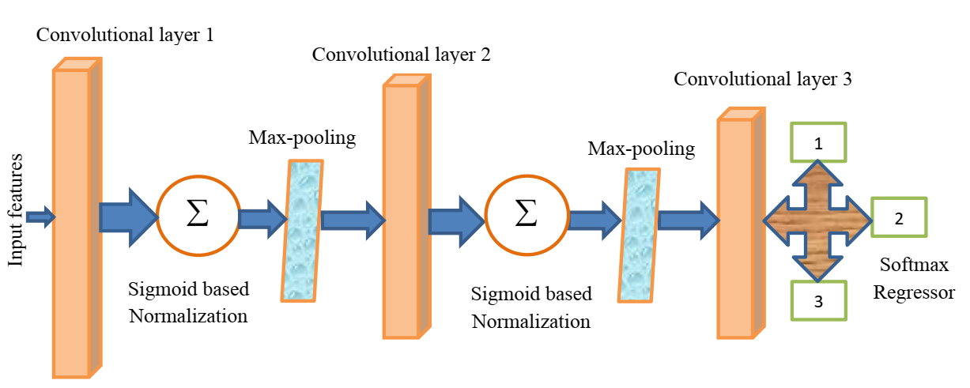

**Figure 2:** Architecture of the proposed DSBNN

|  |
| --- |
| **Input:** Features Selected from the Random Support AGWO  **Output:** fault occurs or not a prediction |
| 1. **Begin:** 2. Set all weights and biases using (11), (12). 3. **For all** input image If**do** 4. //Convolutional layer 5. **For**to *n* do 6. **For** layers =1 to **do** 8. **End for** 9. **End for** 10. //sigmoid-based normalization layer equation (14), 11. **For**to *n***do** 12. **For** layers =1 to **do** 13. **//** sigmoid     **End for**  **End for**  //Upgrade weights   1. **For**to 1 **do** 2. **For** to **do** 3. **If**!= max-pooling layer **then** 4. Upgrade weights and biases 5. **End if** 6. Upgrade the thresholds 7. **End for** 8. **End for** 9. **End** |

**Algorithm 2:**Pseudo code of the proposed DSBNN

The DSBNN classifier which finishing up conclusion that depends on the weight and biases of the earlier layers in the structure design. Subsequently, the model is upgraded with conditions (11) and (12) separately for all layers.

**** (11)

 (12)

Where means the weight,  means the bias,** means the layer number, ** means the regularization parameter, ** means the learning rate,  means the total amount of training sets,** means a momentum, **means the upgrading phase and means the cost function.

The DSBNN classifier contains various kinds of layers are according to the subsequent,

**Step 1: Convolutional layer**: This layer finishes the convolution of the input data with the kernel by using a condition (13).

 (13)

Where represents reproduced segmented images,  represents the filter, and represents the number of components in& the output vector is.

**Step 2: Sigmoid-based normalization layer**

The linear alteration of data to fit into a specific range is known as normalisation. For data standardisation, the Z-score normalisation method is used, which transforms data linearly. Equation (14) describes how to normalise Z-scores:

 (14)

Here, is the normalized output, f is that the sigmoid function value, is that the norm of the convolutional layer output image, and is that the variance of the values within the convolutional layer output image. The convolutional layer output image is normalized using the sigmoid function by using the equation (14). This layer leads to the Sigmoid-based normalized image and is given as input to the pooling layer. This layer brings about the support value-based normalized image and is anticipated to contribute to the pooling layer.

**Step 3: Pooling layer:**Down-sampling is another name for this layer. The pooling method decreases the size of output neurons from the convolution layer to reduce computational intensity and avoid overfitting. The max-pooling algorithm selects only the highest value in each feature map, resulting in fewer output neurons. Pooling layers are often used after convolution layers to simplify the data within the output of the convolution layer.

**Step 4: A completely connected layer:** The actuation work computes a probability distribution of the classes. Thus, the output layer uses the softmax function to search out a preceding layer outcome that matches the foremost normal or malignant or benign.

 (15)

Where, which represents the resultant image. Here, the DSBNN is adapted with the sigmoid function-based normalization to direct the over-fitting in layers and conclusions in the important classification of measurements include current, voltage, active power, and the reactive power of users during the process.

**3.4 Entropy Calculation**

Entropy is used to recognise the texture of measurements. The condition (16) calculates the entropy of the variables as follows:

  (16)

The main goal of Line Trip Fault Prediction Using Entropy is to determine whether or not there is a fault during the operation of a power system by forecasting whether or not the threshold value will reach a high level, indicating that a fault has occurred, otherwise it will not.

**4. RESULTS**

The results of the experiments will show that the strategy we've provided outperforms traditional methods. The findings of the implementation are based on Matlab2018a software running on Intel CoreTM i7 CPUs running at 1.6 GHz. Extensive experimental researches were conducted in order to determine the optimum feature subsets chosen by AGWO that provide the highest potential accuracy when utilising various classifiers.

**4.1 Dataset Description**

The Advanced Diagnostics and Prognostics Testbed (ADAPT) lab at the NASA Ames center expects to convey some way to judge the adequacy of symptomatic calculations at distinguishing deficiencies in power frameworks. The calculations are assessed utilizing information from the Power System (EPS),which recreates components of a standard aviation vehicle power framework. The EPS takes into consideration the controlled inclusion of flaws in repeatable disappointment situations to check if analytic calculations can recognize and detach these shortcomings. This dataset was created from the EPS within the ADAPT lab. Every information document relates to at least one test run of the work. During a test, an information procurement framework orders the work into various arrangements and records information from sensors that action framework factors like voltages, flows, temperatures and switch positions. Flaws were infused in an exceedingly portion of the exploratory runs.

Bottom of Form

.

**4.2 Performance Analysis**

Accuracy, Sensitivity, Specificity, Precision, Recall, and F-measure are statistical metrics that can be stated in TP, FP, FN, and TN esteem.

**4.2.1 Accuracy** is one of the statistical indicators used to assess the performance of our suggested work.The number of correct predictions divided by the total number of observations in the dataset is used to measure accuracy. It measures the precision with which power fault data is classified. The condition is used to check for accuracy (17),

 (17)

Where TN is a true negative, TP is the true positive, FP is the false positive, and FN is the false negative.

**4.2.2 Sensitivity**

The number of true positives that a classification test can effectively discriminate is referred to as sensitivity. It shows how effective the test is at categorising data. The conditional sensitivity is calculated (18).

 (18)

**4.2.3 Specificity**

A classification test's specificity is defined as the number of true negatives accurately detected. It expresses how well the test distinguishes between normal and abnormal data. Utilizing the condition, specificity is calculated (19).

 (19)

**4.2.4 Precision**

Precision is the proportion of the predicted positive instances that were correct text sizedata given by equation (20).

 (20)

**4.2.5 Recall**

The recall is the proportion of the quantity of ordinary information recognized to the general amount of information accessible in the dataset which is given in condition (21).

 (21)

**4.2.6 F-measure**

It's a metric for determining the precision of a test. The best value for the F-measure is 1 and the most uncomfortable one is 0. The equation is used to find it (22).

 (22)

WOSIG (without sigmoid) and existing techniques ANN (Artificial neural network), KNN (K-Nearest Neighbour), and NB (Nave Bayes) are compared in Figure 3 and Table 1. The proposed technique's accuracy is 98 percent, which is significantly higher than the previous techniques' 70, 77, and 61 percent accuracy. In addition, when compared to existing approaches, the other metrics of Sensitivity, Specificity, Precision, Recall, and F-measure have improved.

|  |  |
| --- | --- |
| **C:\mathumadev\praveen doc\Fw__pravin_results\fig1.jpg** | **C:\mathumadev\praveen doc\Fw__pravin_results\fig2.jpg** |

**Figure 3:**Performance measure for proposed and existing techniques.

|  |  |  |  |  |  |  |
| --- | --- | --- | --- | --- | --- | --- |
| **Techniques** | **Accuracy** | **Sensitivity** | **Specificity** | **Precision** | **Recall** | **F-measure** |
| Proposed | 0.989362 | 0.974533 | 0.998907 | 0.998261 | 0.974533 | 0.986254 |
| WOSIG | 0.978059 | 0.967742 | 0.984699 | 0.976027 | 0.967742 | 0.971867 |
| ANN | 0.703457 | 0.759036 | 0.69243 | 0.328696 | 0.759036 | 0.458738 |
| KNN | 0.771277 | 0.939163 | 0.735697 | 0.429565 | 0.939163 | 0.589499 |
| NB | 0.611702 | 0.390244 | 0.617908 | 0.027826 | 0.390244 | 0.051948 |

**Table 1:**Performance measure values for proposed and existing techniques.

|  |  |  |  |  |  |
| --- | --- | --- | --- | --- | --- |
| **Techniques** | **Human error** | **Equipment** | **Fire** | **Weather** | **Unknown** |
| Proposed | 276 | 107 | 209 | 302 | 21 |
| WOSIG | 265 | 102 | 198 | 294 | 18 |
| ANN | 210 | 82 | 162 | 243 | 12 |
| KNN | 238 | 90 | 179 | 255 | 16 |
| NB | 186 | 71 | 143 | 219 | 9 |

**Table 2:**Count of disturbances due to different causes values for existing and proposed techniques.

|  |  |  |
| --- | --- | --- |
| **Techniques** | **MW Loss** | **No of Customers Affected** |
| Proposed | 74.5872 | 929 |
| WOSIG | 69.2678 | 915 |
| ANN | 58.6574 | 609 |
| KNN | 61.1549 | 763 |
| NB | 55.3658 | 546 |

**Table 3:**Count of disturbances due to MW lost and affecting a

number of customers.

**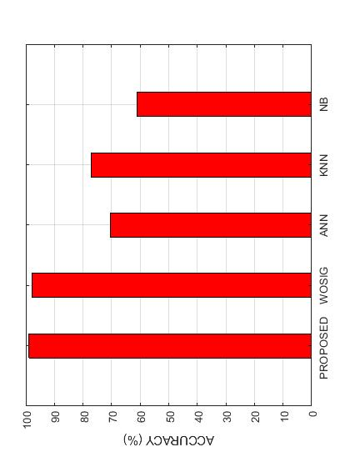**

**Figure 4:**The highest classification accuracy achieved by the proposed classifier.

Figure 4 shows how the proposed and current techniques WOSIG without sigmoid, ANN (Artificial neural network), KNN (K-Nearest Neighbor), and NB (Nave Bayes) perform in terms of classification accuracy. The most important features during a power outage, such as MW loss and the number of customers impacted, are employed by five classifiers to forecast the best accuracy. Following that, the Cause appears as an important informative feature, which is employed by two classifiers to achieve the best accuracy. The “MW lost” is the amount of active power lost in MW units when a particular type of disruption occurs. “No. of Affected Customers” is the second important When a specific type of disturbance happens, the power fault has an undesirable effect on the feature.

|  |  |  |
| --- | --- | --- |
| **C:\mathumadev\praveen doc\Fw__pravin_results\fig4.jpg** | **C:\mathumadev\praveen doc\Fw__pravin_results\fig5.jpg** | |
| **(a)** | | **(b)** |

**Figure 5:**Count of disturbances due to different causes and MW lost and affecting a

number of customers.

The examination of the types of disturbances that occur in count of cause is shown in Table 2 and Figure 5(a). Human error, equipment failure, fire, bad weather, and the unknown are all examples of disturbances. It is explained that the main sources of disturbances are Weather and Equipment Failure, with Weather and Equipment Failure causing the greatest amount of disruptions. Table 3 and Figure 6(b) show the number of disturbances that cause MW loss and affect a large number of consumers for each type of disturbance. Customer contacts are found to be the source of the greatest amount of disruptions, resulting in MW loss and affecting a huge number of customers.

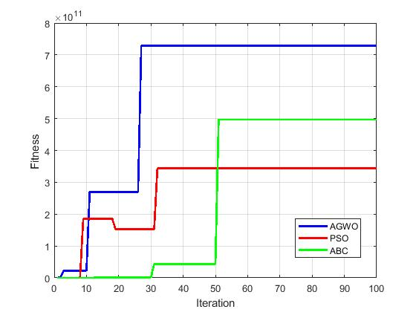

**Figure 6:** comparison of convergence graph proposed optimization with existing optimization

Figure 6 shows that the proposed calculation's components impact is better to the next existing PSO and ABC algorithms. In cycle 10, the introduced strategy achieves the global ideal incentive. However, the current methods for dealing with their ideal worth are more advanced than cycle 30.So in our work, we choose the proposed optimization.

**5.CONCLUSION**

In this paper, we precede the four-stage data science framework is embedded with DSBNNfor the detection of line trip fault prediction in power systems. Prediction of fault in power system includes data science undergoes the process of Four stages pre-processing, Variable Selection, Metrology Prediction, Process Control. At every stage, the process controls and detects the fault occurs or not by proceeding with enthalpy calculation in the Final stage. The proposed technique results attain better accuracy 98% when comparing with the existing techniques. The novel DSBNN proposed technique reaches far better accuracy and all other performance measures too when comparing with normal DNN.

**Declarations**

**Funding                      :**In this research article has not been funded by anyone.

**Conflict of interest    :**All authors do not have any conflict of interest.

**Data availability        :**Not applicable.

**Ethical Approval       :**This article does not contain any studies with human participants or animals performed by any of the authors.

**REFERENCES**

1. Sarker, Iqbal H., A. S. M. Kayes, ShahriarBadsha, HamedAlqahtani, Paul Watters, and Alex Ng. "Cybersecurity data science: an overview from a machine learning perspective." *Journal of Big Data* 7, no. 1 (2020): 1-29.
2. Zhang, Senlin, Yixing Wang, Meiqin Liu, and ZhejingBao. "Data-based line trip fault prediction in power systems using LSTM networks and SVM." *Ieee Access* 6 (2017): 7675-7686.
3. Raza, Ali, AbdeldjabarBenrabah, ThamerAlquthami, and Muhammad Akmal. "A review of fault diagnosing methods in power transmission systems." *Applied Sciences* 10, no. 4 (2020): 1312.
4. Abdelgayed, Tamer S., Walid G. Morsi, and Tarlochan S. Sidhu. "Fault detection and classification based on co-training of semisupervised machine learning." *IEEE Transactions on Industrial Electronics* 65, no. 2 (2017): 1595-1605.
5. Cao, J., Wang, D., Qu, Z., Cui, M., Xu, P., Xue, K. and Hu, K., 2020. A novel false data injection attack detection model of the cyber-physical power system. *IEEE Access*, *8*, pp.95109-95125.
6. Zhang, Guanglun, HaiwangZhong, Qiang Wang, and Xin Cao. "A Machine-Learning Based Method to Analyze the Correlation between Meteorological Data and Component Outages of Power System." In *2020 IEEE/IAS Industrial and Commercial Power System Asia (I&CPS Asia)*, pp. 352-357. IEEE, 2020.
7. Ibrahim, Muhammad Sohail, Wei Dong, and Qiang Yang. "Machine learning driven smart electric power systems: Current trends and new perspectives." *Applied Energy* 272 (2020): 115237.
8. Xue, Puning, Yi Jiang, Zhigang Zhou, Xin Chen, Xiumu Fang, and Jing Liu. "Machine learning-based leakage fault detection for district heating networks." *Energy and Buildings* 223 (2020): 110161.
9. Bode, Gerrit, Simon Thul, Marc Baranski, and Dirk Müller. "Real-world application of machine-learning-based fault detection trained with experimental data." *Energy* 198 (2020): 117323.
10. Fahim, Shahriar Rahman, YeahiaSarker, Subrata K. Sarker, MdRafiqul Islam Sheikh, and Sajal K. Das. "Self attention convolutional neural network with time series imaging based feature extraction for transmission line fault detection and classification." *Electric Power Systems Research* 187 (2020): 106437.
11. Gharsellaoui, Sondes, MajdiMansouri, Mohamed Trabelsi, Shady S. Refaat, and HassaniMessaoud. "Fault diagnosis of heating systems using multivariate feature extraction based machine learning classifiers." *Journal of Building Engineering* 30 (2020): 101221.
12. Rao, TC Srinivasa, SS Tulasi Ram, and J. B. V. Subrahmanyam. "Neural network with adaptive evolutionary learning and cascaded support vector machine for fault localization and diagnosis in power distribution system." *Evolutionary Intelligence* (2020): 1-12.
13. Dunderdale, Christopher, Warren Brettenny, Chantelle Clohessy, and E. Ernest van Dyk. "Photovoltaic defect classification through thermal infrared imaging using a machine learning approach." *Progress in Photovoltaics: Research and Applications* 28, no. 3 (2020): 177-188.
14. Lara-Benítez, Pedro, Manuel Carranza-García, Jorge García-Gutiérrez, and José C. Riquelme. "Asynchronous dual-pipeline deep learning framework for online data stream classification." *Integrated Computer-Aided Engineering* Preprint (2020): 1-19.
15. Qu, Fuming, Jinhai Liu, Hongfei Zhu, and Bowen Zhou. "Wind turbine fault detection based on expanded linguistic terms and rules using non-singleton fuzzy logic." *Applied Energy* 262 (2020): 114469.
16. Murugesan, Dr N., R. Anitha, and M. Ganesan. "N-Semi Regular Graph-Based Fuzzy Semi-supervised Learning Approach for Fault Detection and Classification in Photovoltaic Arrays." *International Journal of Advanced Research in Engineering and Technology* 11, no. 9 (2020).
17. Lee, Chia-Yen, and Tsung-Lun Tsai. "Data science framework for variable selection, metrology prediction, and process control in TFT-LCD manufacturing." *Robotics and Computer-Integrated Manufacturing* 55 (2019): 76-87.
18. Dangut, Maren David, ZakwanSkaf, and Ian K. Jennions. "An integrated machine learning model for aircraft components rare failure prognostics with log-based dataset." *ISA transactions* (2020).
19. He, Cheng, Tao Wu, Changchun Liu, and Tong Chen. "A novel method of composite multiscale weighted permutation entropy and machine learning for fault complex system fault diagnosis." *Measurement* 158 (2020): 107748.
20. Liang, Pengfei, Chao Deng, Jun Wu, Zhixin Yang, Jinxuan Zhu, and Zihan Zhang. "Single and simultaneous fault diagnosis of gearbox via a semi-supervised and high-accuracy adversarial learning framework." *Knowledge-Based Systems* 198 (2020): 105895.