NANOTECHNOLOGY MATERIAL SCIENCE : INSTUMENTETION AND WORKING

Author : Shivani C. Bedarkar , Neha S. Jagtap, Divya D. Gapat , Sneha G. Akoskar, Shraddha N. Deshmukh ,Nishat N. Kazi,Shrushti M, Salunkhe

Abstract:
Ellipsometric measurement of thickness and optical constants in thin film nanotechnology Nanotechnology in medicine raises important regulatory and ethical issues. Nanoparticles can be engineered to cross the blood-brain barrier into the brain. Nanotechnology has the potential to improve cancer treatment and other areas of medicine. Regulatory authorities should establish strict approval procedures for nanotechnology devices. Since the signal depends on thickness and material properties, ellipsometry can be a popular tool for non-contact determination of thickness and optical constant of various films. 3] By analyzing the change in polarization of light, ellipsometry can provide information about layers thinner than the wavelength of the probe light itself, even down to a single atomic layer. Elliptical measurement allows the investigation of the complex refractive index or tensor of the dielectric function, which gives access to fundamental physical parameters such as the above. It is commonly used to describe film thicknesses of individual layers or complex multilayer stacks ranging from a few angstroms or tenths of a nanometer to several micrometers with excellent accuracy.
Keywords:
Nanotechnology ,nanoscience ,instruments ,tools

Introduction :-
𝙣𝙖𝙣𝙤𝙥𝙖𝙧𝙩𝙞𝙘𝙡𝙚𝙨 𝙖𝙣𝙙 𝙣𝙖𝙣𝙤-𝙨𝙞𝙯𝙚𝙙 𝙢𝙖𝙩𝙚𝙧𝙞𝙖𝙡𝙨, 𝙧𝙚𝙨𝙚𝙖𝙧𝙘𝙝𝙚𝙧𝙨 𝙬𝙚𝙧𝙚 𝙖𝙗𝙡𝙚 𝙩𝙤 𝙘𝙧𝙚𝙖𝙩𝙚 𝙄𝙣𝙣𝙤𝙫𝙖𝙩𝙞𝙫𝙚 𝙢𝙚𝙙𝙞𝙘𝙖𝙡 𝙙𝙚𝙫𝙞𝙘𝙚 𝙘𝙖𝙥𝙖𝙗𝙡𝙚 𝙤𝙛 𝙣𝙖𝙫𝙞𝙜𝙖𝙩𝙞𝙣𝙜 𝙩𝙝𝙚 𝙗𝙤𝙙𝙮 𝙩𝙤 𝙖𝙘𝙝𝙞𝙚𝙫𝙚 𝙥𝙚𝙘𝙞𝙛𝙞𝙘 𝙡𝙤𝙘𝙖𝙩𝙞𝙤𝙣 𝙖𝙣𝙙 𝙥𝙧𝙤𝙫𝙞𝙙𝙚 𝙝𝙞𝙜𝙝 𝙥𝙧𝙚𝙘𝙞𝙨𝙞𝙤𝙣 𝙩𝙧𝙚𝙖𝙩𝙢𝙚𝙣𝙩. 𝙩𝙝𝙞𝙨 𝙤𝙣𝙚 𝙝𝙖𝙨 𝙂𝙧𝙚𝙖𝙩𝙡𝙮 𝙞𝙢𝙥𝙧𝙤𝙫𝙚 𝙩𝙝𝙚 𝙚𝙛𝙛𝙚𝙘𝙩𝙞𝙫𝙚𝙣𝙚𝙨𝙨 𝙤𝙛 𝙩𝙝𝙚 𝙩𝙝𝙚𝙧𝙖𝙥𝙮 𝙖𝙣𝙙 𝙧𝙚𝙙𝙪𝙘𝙚 𝙩𝙝𝙚 𝙙𝙖𝙢𝙖𝙜e 𝙝𝙚𝙖𝙡𝙩𝙝𝙮 𝙩𝙞𝙨𝙨𝙪𝙚𝙨.
One area where nanotechnology shines is cancer treatment. Nanoparticles can be engineered to deliver drugs directly to tumor sites, increase drug concentration in cancer cells while saving healthy cells against unnecessary exposure. In addition, nanoparticles can be designed to respond to specific triggers, such as pH levels or temperature at the tumor site, allowing controlled release of the drug. This approach, known as "smart drug delivery", with great potential to improve cancer treatment In addition, nanotechnology has made breakthroughs in treatment diseases related to the central nervous system, known as difficult to access conventional treatments. Nanoparticles can be designed to cross the blood-brain barrier, a limited protective barrier penetration of many substances into the brain, thus opening up new opportunities Treatment Despite significant advances and potential benefits, the adoption of Nanotechnology in medicine also raises important regulatory and ethical questions. consider. Since these nanomedical devices are relatively new and revolutionary products, it is essential to ensure their safety and effectiveness. Regulators should establish rigorous review processes for approval and monitor these devices before they are used in a clinical setting. addition, ethical issues must be carefully addressed to ensure responsible use of nanomedical devices. Patient privacy issues informed consent and a fair distribution of these advances Treatments should be carefully managed to avoid potential abuse ordisparities in access to nanotechnology-based medical interventions. In short, nanotechnology has revolutionized medicine by providing Innovative devices and applications that are very promising in treatment complex disease. By providing targeted and less toxic therapies, Nanomedical devices have the potential to significantly improve patient health result. However, it is essential to address regulatory and ethical concerns considerations to ensure the responsible and beneficial integration of nanotechnology in the medical field.
Material and methodology:
History:-
Nanoparticles and structures were used by humans in the 4th century AD, by the Romans. Nanotechnology derives its name from a name in 1974. It was introduced by Taniguchi¹ to describe the manufacturing process with finishes and tolerances in the nanometer region. He extrapolated the specifications of existing and former machine tools, such as lathes and grinders, to a new generation of machine tools. He correctly concluded that by the late 1980s and 1990s an accuracy between 0.1 um and 1 nm would be required to meet the needs of industries .
Scope:-
Nanotechnology in scientific terms is defined as the science that deals with processes occurring at the molecular and atomic or nanometer-scale levels. Nanomaterials have many applications in pharmaceutical science and technology. Some other dominant uses of nanotechnology are drug delivery, imaging, and biosensors. These nano-sized devices are called nanomedicine. Nanotechnology in scientific terms is defined as the science that deals with processes occurring at the molecular and atomic or nanometer-scale levels. Nanomaterials have many applications in pharmaceutical science and technology. Some other dominant uses of nanotechnology are drug delivery, imaging, and biosensors. These nano-sized devices are called nanomedicine. Nanoscale device systems, which are smaller in size than eukaryotic or prokaryotic cells, could eventually reach much larger numbers in normally inaccessible areas such as cancer cells. , inflamed tissue, etc. due to their permeability and retention (EPR)-enhancing effects and thus may reduce lymphatic drainage. can be used to deliver genes or proteins by mouth.
Instrumentation:
Cantilever:
Nanomechanical cantilevers are microscopically fabricated thin and small beams of silicon. They serve as extremely sensitive mechanical sensors (9). polymorphic detection of proteins and nucleic acids. A micro-machined cantilever platform that integrates microfabrication and nanoscience to detect biomolecules without labeling, enabling miniaturization. Molecular adsorption, when confined to only one side of the cantilever beam can deform, resulting in a measured deflection of the cantilever. This nanoscale deviation is caused by cantilever surface stress changes due to biomolecular interactions and can be measured by optical or electrical means, thus explaining the presence of particles. biological death. Biological specificity in detection (8). the fluctuations of highly sensitive atomic force microscope cantilevers can be used to detect low concentrations of bacteria, characterize their metabolism and quantitatively screen (within minutes) their response to antibiotics (10).
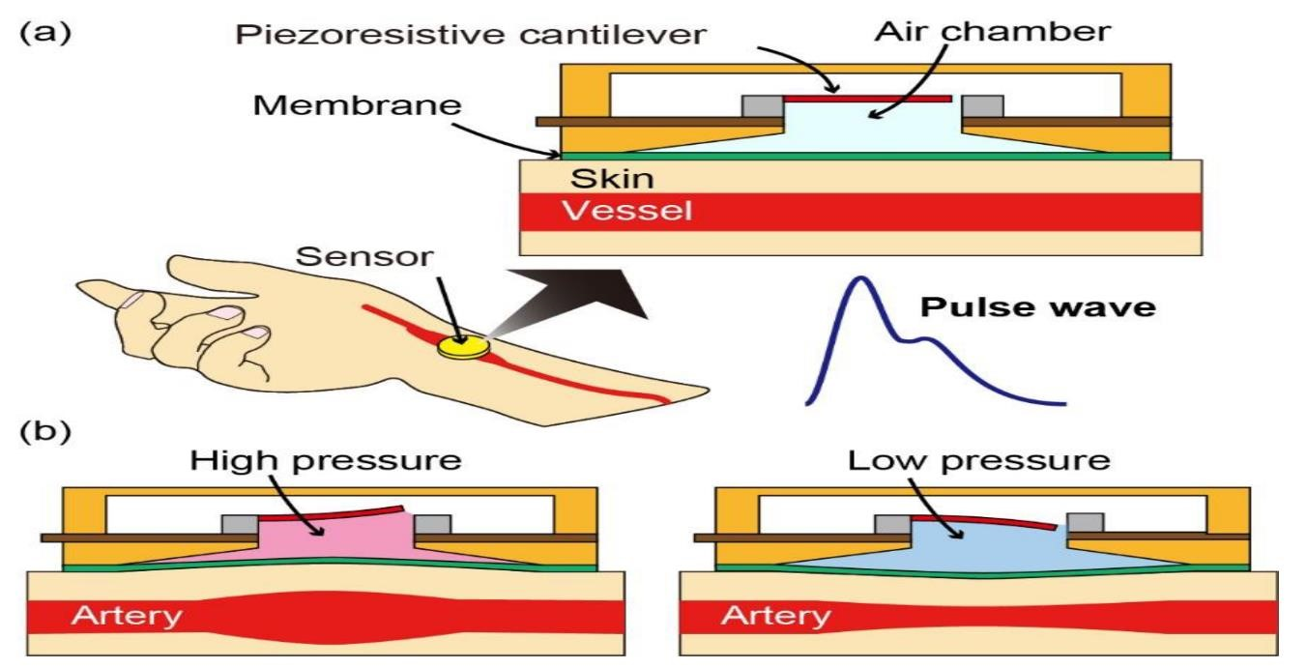
Fig. 1: (11)

working :-
using the cantilever as the sensor, neither the tip of the cantilever nor the sample surface is needed. The upper or lower surface of the cantilever beam acts as a sensing zone and allows the processes taking place on the cantilever beam to be monitored with unprecedented precision, especially the adsorption of molecules. The formation of molecular layers on the surface of the cantilever beam will result in a stress surface, which can lead to bending of the cantilever, provided that adsorption occurs better on one of the surfaces of the cantilever. Cantonese. Adsorption is controlled by coating one surface (usually the top surface) of the cantilever with a thin layer of material that exhibits affinity for molecules in the medium (sensor surface). This surface of the cantilever is called the functionalized surface. The other surface of the cantilever (usually the lower part) may be left uncoated or covered with a passivation layer, i.e,q that is, a chemical surface that does not show appreciable affinity for the molecules of the medium we wish to detect. To create functional surfaces, a metal layer is usually evaporated over the area used as the sensing surface. Metallic surfaces, e.g. gold, can be used for single-layer covalent bonding presenting a chemical surface sensitive to molecules detected from the environment. Usually, a monolayer of thiol molecules is used, which is covalently bonded to the gold surface. The gold layer is also advantageous to use as a reflector if the deflection of the cantilever is read through the optical beam deflection method.

Scanning electron microscope:
The scientist Smith (1 956) and later Thornley (1 960), and as suggested by the early simulation of SE imaging done by Catto and Smith (1973) (12) Electron microscopy of soft and biological materials, or "soft electron microscopy", is essential to the characterization of macromolecules. Soft microscopy was tuned by contrast enhancement while maintaining low electron dosage, and sample and image preparation methods were adjusted to the length scale of features of interest. While cryo-electron microscopy offers the highest resolution, larger structures can be characterized efficiently and with high contrast using low-voltage electron microscopy by performing scanning transmission electron microscopy in a scanning electron microscope (STEMin-SEM). Here, STEM-in-SEM is demonstrated for a four-lobed protein assembly where the arrangement of the proteins in the construct must be examined (13). The study focused on LM and SEM (light microscope and scanning electron microscopy) of Datura stramonium L. extract and evaluated its phytochemical, antibacterial and antioxidant activities (14).
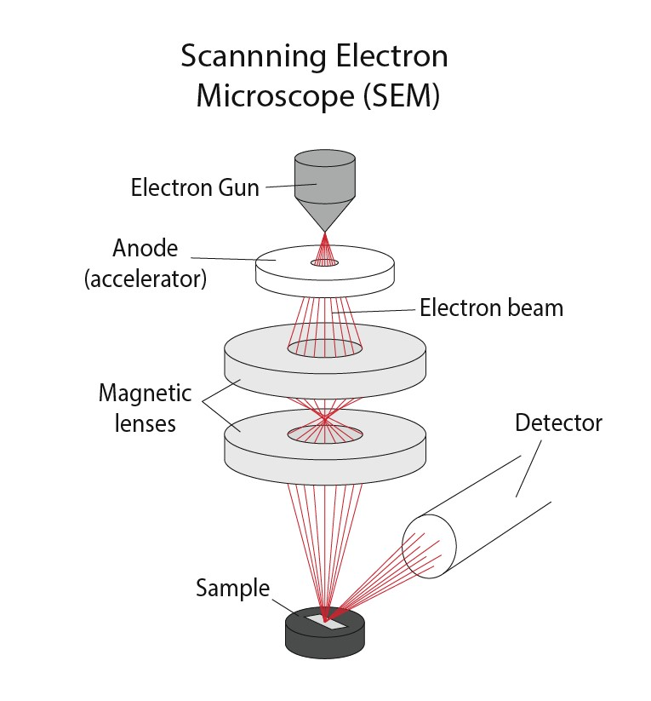
Figure 2

WORKING:-
The SEM is an instrument that produces a largely magnified image by using electrons instead of light to form an image. An electron beam is generated at the top of the microscope using an electron gun. The electron beam follows a vertical path through the microscope, which is held in a vacuum. The beam moves through the electromagnetic field and the lens focuses the beam onto the sample. When the beam hits the sample, electrons and X-rays are ejected from the sample.
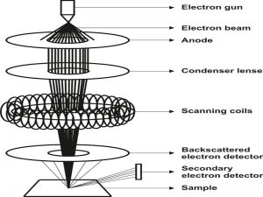

Fig.3: (15)
Scanning tunnelling microscope:-
scanning tunnelling microscopy (STM) has developed and advanced into a technique able to measure a variety of structural, functional, and spectroscopic properties and relationships at the single-molecule level (16). surface analytical technique capable of imaging individual atoms and molecules in real space, scanning tunnelling microscopy (17)
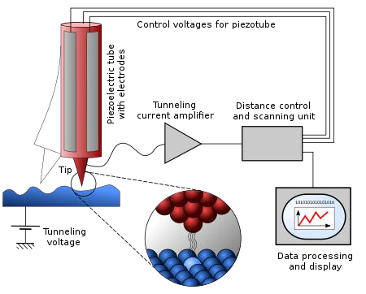
Fig 4: (18)
WORKING:-
Scanning tunneling microscope (STM) works by scanning a very sharp wire tip over a surface. By bringing the tip close to the surface and applying a voltage to the tip or sample, we can image the surface at microscopic scales - down to the resolution of individual atoms. STM is based on several principles. One is the quantum mechanical effect of the tunnel. It is this effect that allows us to “see” the surface. Another principle is the piezoelectric effect. It is this effect that allows us to precisely scan the tip with control at the angstrom level.
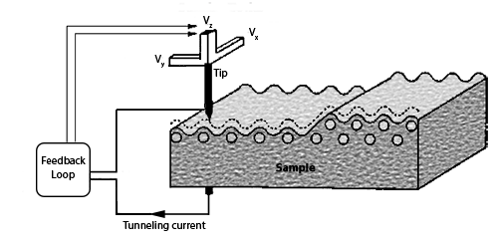
Figure 4

Atom probe:
Atom probes are microscopes used in materials science. Atom probes are closely related to this method
Field ion microscope. Atom probes differ from traditional optical and electron microscopes in the following ways:
The magnifying effect is not due to the magnifying caused by the highly curved electric field.
By manipulating the radiation path.

working :-
The atom probe is a combination of a time-of-flight mass spectrometer and a point projection microscope
Atomic scale imaging is possible13. Combining this with 3DAP position detection (Fig. 1) 2) allow.
Full 3D reconstruction capabilities of APT. Applying a high voltage (~10 kV) produces a high voltage.
A sudden high temperature peak produces an electric field (approximately 1010 V/m). Applying the voltage between the specimen and a local electrode14, 15, as in the local electrode atom probe (LEAP) in Fig. 2, allows the field to be applied selectively to a single specimen in an array of microtips. Atoms on the specimen apex are field evaporated as ions and accelerated toward the imaging detector. By pulsing the evaporation, e.g. by using subnanosecond voltage pulses in addition to the dc voltage, the flight time of each ion can be measured and used to calculate the mass-to-charge ratio and thus determine its chemical nature. A 100 nm diameter area on the chip is projected onto a detector with a diameter of approximately 100 mm, resulting in a magnification of 106. The original positions of the atoms on the sample tip are determined from the ion impact positions on the detector, and the order of evaporation events is used to provide depth information. This combination of data helps to reconstruct a three-dimensional image of the elemental distribution with near-atomic resolution.

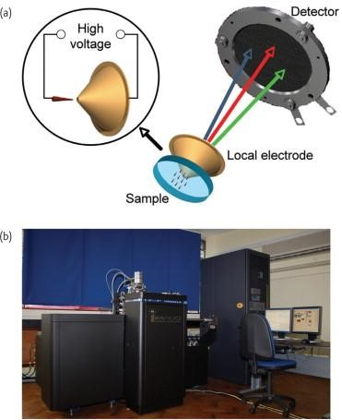
Figure 5
Ellipsometers :
Ellipsometers assesses a shift in the polarization of light reflected by or transmitted from a material structure. These devices are often used to discover the optical properties and thickness of a sample. However, they can also determine the chemical composition, crystallinity, roughness and other material properties involved in the displacement optical response. Ellipsometers were originally designed to provide the level of sensitivity needed to measure nanoscale layers used in electronics. Today, it is used in physical sciences, semiconductor research, and information storage. This widespread use is related to the growing reliance on thin films in technology and research.
WORKING:-
The measured signal is the change in polarization when incident radiation (in a known state) interacts with the material structure of interest (reflected, absorbed, scattered or transmitted). The change in polarization was quantified by the ratio of amplitude, Ψ, and phase difference, Δ (defined below). Since the signal depends on the thickness as well as the properties of the material, ellipse measurement can be a popular tool for non-contact determination of the thickness and optical constant of various films.[3] Upon the analysis of the change of polarization of light, ellipsometry can yield information about layers that are thinner than the wavelength of the probing light itself, even down to a single atomic layer. Elliptic measurement allows probing of the complex refractive index or tensor of the dielectric function, allowing access to basic physical parameters such as those listed above. It is commonly used to describe film thicknesses for single layers or complex multilayer stacks ranging from a few angstroms or tenths of a nanometer to several micrometers with excellent accuracy.

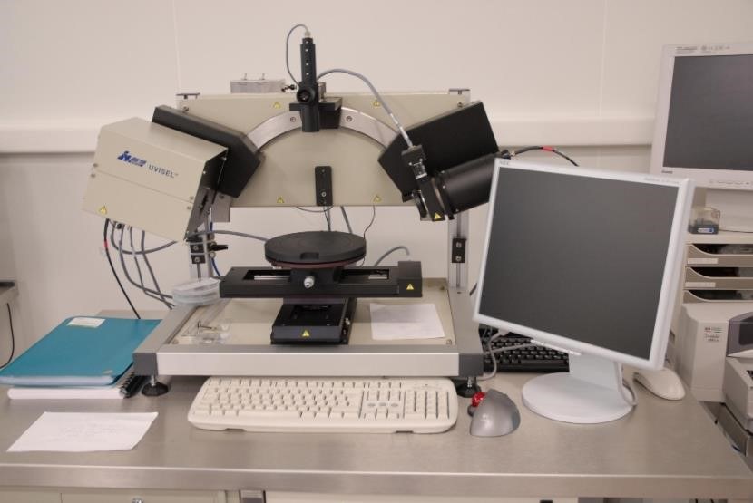
Figure 6

Conclusion :
To provide an overview of nanotechnology and material science in instrumentation and working to improve society. These tools increases effectiveness of drugs action on human body.

REFERANCE :-
1]Bayda S, Adeel M, Tuccinardi T, Cordani M, Rizzoli F. The History of Nanoscience and Nanotechnology: From Chemical-Physical Applications to Nanomedicine. Molecules. 2019 Dec 27;25(1):112. Doi: 10.3390/molecules25010112. PMID: 31892180; PMCID: PMC6982820. 22
2]https://www.azonano.com/article.aspx?ArticleID=6355
3]https://www.bccresearch.com/marketresearch/nanotechnology/NAN029A.html#:~:text=Nanotechnology%20tools%20and%20instruments%20are,these%20instruments%20unique%20to%20nanotechnologis
4]https://www.ncbi.nlm.nih.gov/pmc/articles/PMC3243873/
5]The British Museum. [(accessed on 22 July 2019)]; Available
online: www.britishmuseum.org/research/collection_online/collection_object_details.aspx?ob jobjec=61219&partId=1
6]https://books.google.co.in/books?hl=en&lr=&id=UFjlm-
DYV2IC&oi=fnd&pg=PR7&dq=info:IyZ1KTaK-
hMJ:scholar.google.com/&ots=WAFRlH4Oib&sig=NYK2pPiRUpp1OlBa0cg91070FA&redir_esc=y#v=onepage&q&f=false
7)https://scholar.google.com/scholar?hl=en&as_sdt=0%2C5&q=cantilever+sensors+nanomec hanical+tools&oq=can#d=gs_qabs&t=1690103200761&u=%23p%3DBgQeAjgAAJUJ
8) https://link.springer.com/article/10.1557/mrs2009.121
9)https://www.ingentaconnect.com/contentone/asp/jnn/2010/00000010/000 00004/art00045
10) https://www.nature.com/articles/nnano.2013.120
11)
https://mail.google.com/mail/u/0?ui=2&ik=fcc96f5400&attid=0.2&permms gid=msg-
f:1772203575207097867&th=189821c319e5760b&view=att&disp=safe
12)https://citeseerx.ist.psu.edu/document?repid=rep1&type=pdf&doi=91796d4f4167b66581d 038bb35084eb08285c47d
13]https://pubmed.ncbi.nlm.nih.gov/35881504/
14]https://pubmed.ncbi.nlm.nih.gov/35555838/
15]https://www.rrutc.msm.cam.ac.uk/outreach/articles/the-scanning-electron-microscope
16]https://www.annualreviews.org/doi/abs/10.1146/annurev-anchem-060908-155213
17) https://www.annualreviews.org/doi/abs/10.1146/annurev.anchem.1.031207. 112932
18 ]https://www.intechopen.com/chapters/46864

19]https://www.ncbi.nlm.nih.gov/pmc/articles/PMC7176243/
20]https://www.purdue.edu/ehps/rem/laboratory/equipment%20safety/Research%20Equipment/sem.html
21]https://www.nanoscience.com/techniques/scanning-tunnelin microscopy/#:~:text=The%20scanning%20tunneling%20microscope%20(STM,down%20to%20resolving%20individual%20atoms.
22]https://www.azonano.com/nanotechnology-eq uipment-index.aspx
23]https://en.wikipedia.org/wiki/Ellipsometry
24]https://www.sciencedirect.com/science/article/pii/S1369702107703061

