Artificial Intelligence and its application in Sleep Medicine
Anushree Rai¹, Aditi¹
¹Assistant Professor, SGT University Gurugram, Haryana
Introduction:
Sleep is fundamental to sustaining appropriate physical and psychological functions. A sleep problem is characterised by insufficient or poor sleep quality. Individuals suffering from sleep disorders may exhibit any of the following symptoms: difficulty going asleep, difficulty returning to sleep, difficulties awakening during the night, or premature awakening (Neylan et al., 2003).
The overall prevalence of sleep difficulties among persons aged 18 years in various countries, including India, was 7.5% (Vancampfort et al., 2018). Insomnia was reported to be 15.4% among urban Indians aged 16 to 65 years (Roy et al., 2015), whilst OSA and OSAS were reported to be 9.3% and 2.8% among Indians aged 30 to 65 years (Reddy et al., 2009). The evaluation and rehabilitation of sleep disorders is heavily reliant on the use of polysomnography (PSG), which generates massive volumes of labelled electrophysiological data.
Sleep monitoring provides massive amounts of data in both the laboratory and ambulatory settings. AI algorithms can examine large and complex datasets, that peculiarly positions the field of sleep medicine to benefit from Artificial Intelligence (Bandyopadhyay, A & Goldstein C., 2023). The healthcare is improved with improvement in care delivery, patient participation and decision- making with the advancement of AI in healthcare system (House of Lords, 2018). With the advancement of AI in computer systems it can solve human intelligence-related problems (Fogel and Kvedar, 2017). It also helps in performing tasks that were previously thought require human intelligence such as speech recognition, decision-making, and pattern and object recognition. While AI has gained recognition in the medicine branch such as radiology and oncology, AI has a significant impact in the field of sleep medicine (Bandyopadhyay, A & Goldstein C., 2023).

Artificial Intelligence and Sleep Rehabilitation:
Insufficient quantity and quality of sleep has been linked to variety of problems in human body, it has an effect on the endocrine, metabolic system, higher cortical function and neurological difficulties. Sleep deprivation has been related to a variety of problems in most body systems, including endocrine, metabolic, higher cortical function, and neurological difficulties. Insufficient sleep, excess of perceived sleep and abnormal leg movements are distinctive symptoms of sleep problems or disorders (Pavlova, M. K., & Latreille, V. 2019). Nocturnal polysomnography (PSG) is the gold standard for identifying sleep disorders such as INS, PLM, RBD, and nocturnal frontal-lobe epilepsy (NFE). The diagnosis of sleep disorders is done in sleep labs via sensors attached to the patient’s body to record physiological data (electroencephalogram (EEG), electrooculography, electromyography (EMG), and so on) (Douglas, N.J.; Thomas, S.; Jan, M.A.). Sleep disorders can be objectively detected by expert or certified sleep technicians based on physiological data acquired for the patient via PSG. However, there are several drawbacks to using PSG, such as the too expensive and inconvenient (for example, the time required to deploy many sensor attachments). Furthermore, sleep technicians must annotate and classify PSG recordings (which contain a large number of outcomes). However, there are several drawbacks to using PSG, such as the high cost and inconvenience (for example, the time required to deploy many sensor attachments). Furthermore, sleep technicians must annotate and classify PSG recordings (which contain a large number of outcomes).
With the rapidly emerging technologies such as Big data, artificial intelligence (AI), the Internet of Things (IoT), and cloud computing are altering the medical trend away from traditional healthcare towards digital medicine and health. In today’s clinical sleep medicine paradigm and basic research into sleep medicine supervised machine learning approaches have emerged as the most promising option for developing software systems capable of matching expert human intelligence on a wide range of data-intensive jobs and analytic functions (Benjamens, S.; Dhunnoo, P & Meskó, B., 2020; Watson, N. F., & Fernandez, C. R.,2021). AI can assist by exploiting existing clinical data to identify patients at high risk of sleep disorders Nathaniel F. Watson, Christopher R. Fe. The classification of four basic sleep disorders i.e., insomnia (INS), periodic leg movement (PLM), REM sleep behaviour disorder (RBD) and nocturnal frontal- lobe epilepsy (NFE) is done with the help of sleep disorder network (SDN) developed by AI. To extract and assess the complex and cyclic rhythms of sleep disorders that alter the ECG patterns the SDN was built using deep convolutional networks. The SDN is a valuable tool for sleep monitoring and screening, as well as an alternative screening strategy based on single-lead ECGs (Urtnasan, E., Joo, E. Y., & Lee, K. H. 2021).

MAJOR SLEEP DISORDERS
- Insomnia
Insomnia is a prevalent and often occurring condition in clinical practise, characterised by trouble falling asleep, easy awakening, and early awakening. According to epidemiological studies, between 25% and 30% of adults match the diagnostic criteria for insomnia L. Culpepper. Due to the high incidence in the literature and increased predictive accuracy in healthcare system, the XG Boost which is a machine- learning model is used to detect risk factors for insomnia. Machine- learning models may effectively predict risk for a sleep disorder and identify crucial risk variables using demographic, laboratory, physical exam, and lifestyle covariates. Depression, age, weight, and waist circumference are the biggest predictors of insomnia (Huang, A. A., & Huang, S. Y., 2023) . One way to improving sleep is to reduce hyperarousal, which is a prevalent causative and sustaining factor in the insomnia paradigm. The Somnox sleep robot looks like a bean-shaped pillow that users may snuggle and offers tactile and audio instructions to help them rest. The robot will go through its normal breathing pattern ("sleeping"). A control panel allows participants to manually adjust the breathing settings.
To standardise the intervention and comply with the General Data Protection Regulation (GDPR) in terms of storing data in a third country, the Somnox mobile app provides a personalised breathing experience with the option of playing soothing music, nature sounds, or white/pink noise (Store, S. J et al.,2021).

- Obstructive sleep Apnea:
The cessation of airflow due to upper airway obstruction and concomitant respirartory effort is defined as Obstructive sleep apnea (OSA). The gold standard for the treatment of OSAS is Nasal continuous positive airway pressure (CPAP) because it serves as a pneumatic splint to stabilise the upper airway and is effective when used correctly. Several factors such as socioeconomic, psychological factors, disease severity, and side effects challenges the adherence to CPAP treatment (Chang et al., 2020; Pavwoski et al., 2017; Mehrtash et al., 2019)
In order to overcome the challenges faced in the rehabilitation of OSAS patients to guide treatment selection, forecast treatment success, assess current treatment and compliance, and adherence to a more customised treatment approach AI is emerging in the rehabilitation.
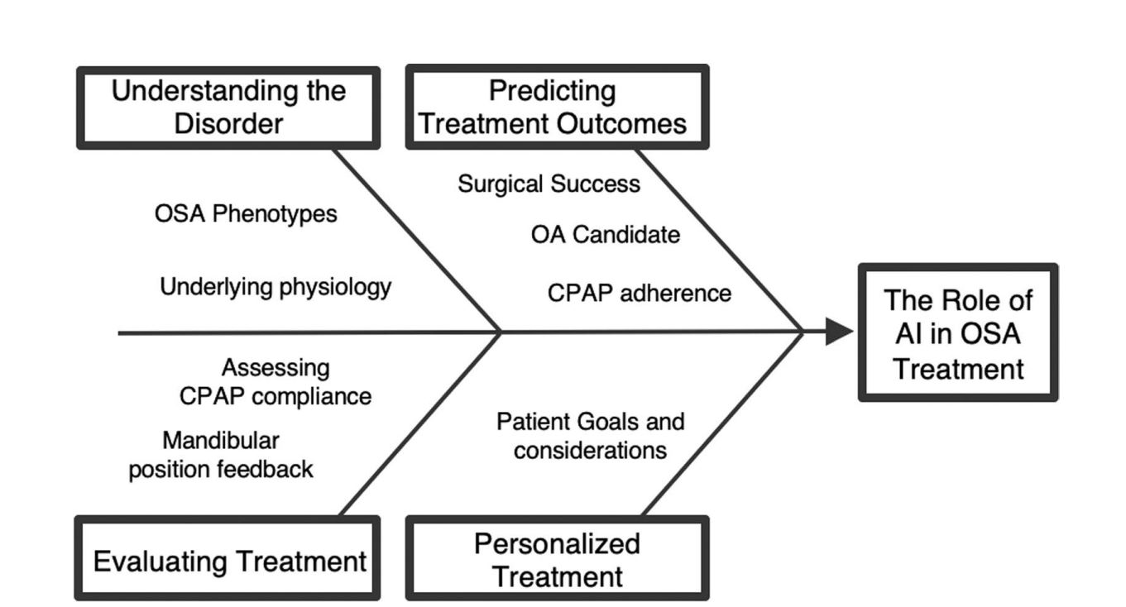
The role of AI in the management of Obstructive sleep apnea (Brennan, H. L., & Kirby, S. D..,2023)

With the emerging advancement in medical technology, positive pressure ventilator based on artificial intelligence processor is used in the management of obstructive sleep apnea syndrome. The smart positive pressure ventilator's information storage function is contained in the local medical terminal, which is displayed after signing in with the user authority, and it is mostly composed of data collection, data processing, and medical interface design. When the CPAP ventilator sends respiratory data packets to the local medical terminal, it is doing so in real time. Before being received and evaluated by the local medical terminal, each data packet is gathered and delivered in real time for predefined amount of time. Alarm message processing basically monitors the patient's breathing situation in real time, extracts information, and generates an alarm in the CPAP ventilator telemedicine system (Chen, Z., Zhao, Z., & Zhang, Z.,2021).

- Periodic Leg Movement:
Periodic limb movement disorder (PLMD) is a sleep disorder characterised by irregular leg movements occur on a regular basis during sleep and are characterised by quite stereotyped foot, leg, or arm movements. Symptoms of PLMD include excessive tiredness during the day, wakefulness during night, sleep cycle issues, frequent waking from sleep, and kicking your bed partner (Karadeniz, D., Ondze, B., Besset, A., & Billiard, M.,2000) PLMD is diagnosed using leg electromyography markers from PSG data. Leg movements can occur as a result of respiratory problems during sleeping. Leg movement can be detected near the end of an apnoea period as a reflexive response to hypoxia and awakening. Because of the numerous connections attached, the amount of channels employed for polysomnographic recording sometimes presents problems for individuals. It also raises the likelihood of problems during the recording process and the storage volume. For the examination of PSG records, new software is being created. Machine learning techniques, statistical methodologies, and Digital signal processing methods are all used by the software. Popular machine learning algorithms are used to classify Periodic leg movement (Umut, I., & Çentik, G. 2016). It is also important to analyse leg movement in sleep and microarousal as both occur close to each other. Microarousal require advanced movement analyses of leg movement in sleep from sensors placed on the leg. The RestEaZeTM leg band now includes advanced technology that blends gyroscope, accelerometer, and capacitance measures. It had a sensitivity of 76% and a specificity of 86% for identifying the leg movement in sleep with microarousal. The classifier identifies sleep zones with high vs low rates of leg movement in sleep with microarousal, indicating fragmented versus uninterrupted restful sleep. It scans leg motions using powerful machine learning to identify sleep fragmentation caused by arousals.

References:

Neylan, T. C., Reynolds, C. F. III, &amp; Kupfer, D. J. (2003). Sleep disorders. In R. E. Hales
& S. C. Yudofsky (Eds.), The American Psychiatric Publishing textbook of clinical
psychiatry (p. 975–1000). American Psychiatric Publishing, Inc.

Vancampfort, D., Stubbs, B., Smith, L., Hallgren, M., Firth, J., Herring, M. P., Probst, M., &
Koyanagi, A. (2018). Physical activity and sleep problems in 38 low- and middle-
income countries. Sleep Medicine, 48, 140–147. https://doi.org/10.1016/j.sleep.2018.04.013

Roy, S., Bhattacharjee, A., Chakraborti, C., &amp; Singh, R. (2015). Prevalence of insomnia in
urban population of West Bengal: A community-based cross-sectional study.
International Journal of Medicine and Public Health, 5(4), 293–293.

Reddy, E. V., Kadhiravan, T., Mishra, H. K., Sreenivas, V., Handa, K. K., Sinha, S., & Sharma,
S. K. (2009). Prevalence and risk factors of obstructive sleep apnea among middle-aged
urban Indians: A community-based study. Sleep Medicine, 10(8), 913–918.
https://doi.org/10.1016/j.sleep.2008.08.011

Bandyopadhyay, A., & Goldstein, C. (2023). Clinical applications of artificial intelligence in sleep medicine: a sleep clinician’s perspective. Sleep and Breathing, 27(1), 39-55.

House of Lords. House of Lords Select Committee on Artificial Intelligence. AI in the UK: ready, willing and able? (Report of Session 2017–19). London: The Stationery Office; 2018. https://publications.parliament.uk/pa/ld201719/ldselect/ldai/100/100.pdf (Retrieved May, 2, 2018)
Fogel AL & Kvedar JC. Artificial intelligence powers digital medicine. npj Digital Medicine. 2018; 1(5): 1-4. doi:10.1038/s41746-017-0012-2

Pavlova, M. K., & Latreille, V. (2019). Sleep disorders. The American journal of medicine, 132(3), 292-299.

Benjamens, S., Dhunnoo, P., & Meskó, B. (2020). The state of artificial intelligence-based FDA-approved medical devices and algorithms: an online database. NPJ digital medicine, 3(1), 118.
Watson, N. F., & Fernandez, C. R. (2021). Artificial intelligence and sleep: Advancing sleep medicine. Sleep medicine reviews, 59, 101512.
Urtnasan, E., Joo, E. Y., & Lee, K. H. (2021). Ai-enabled algorithm for automatic classification of sleep disorders based on single-lead electrocardiogram. Diagnostics, 11(11), 2054.
Huang, A. A., & Huang, S. Y. (2023). Use of machine learning to identify risk factors for insomnia. Plos one, 18(4), e0282622.

Støre, S. J., Tillfors, M., Wästlund, E., Angelhoff, C., Andersson, G., & Norell-Clarke, A. (2021). The effects of a sleep robot intervention on sleep, depression and anxiety in adults with insomnia–Study protocol of a randomized waitlist-controlled trial. Contemporary Clinical Trials, 110, 106588.
Chang, H. P., Chen, Y. F., & Du, J. K. (2020). Obstructive sleep apnea treatment in adults. The Kaohsiung journal of medical sciences, 36(1), 7-12.

Pavwoski, P., & Shelgikar, A. V. (2017). Treatment options for obstructive sleep apnea. Neurology: Clinical Practice, 7(1), 77-85.

Mehrtash, M., Bakker, J. P., & Ayas, N. (2019). Predictors of continuous positive airway pressure adherence in patients with obstructive sleep apnea. Lung, 197, 115-121.

Brennan, H. L., & Kirby, S. D. (2022). Barriers of artificial intelligence implementation in the diagnosis of obstructive sleep apnea. Journal of Otolaryngology-Head & Neck Surgery, 51(1), 1-9.

Chen, Z., Zhao, Z., & Zhang, Z. (2021). Obstructive sleep apnea syndrome treated using a positive pressure ventilator based on artificial intelligence processor. Journal of Healthcare Engineering, 2021, 1-10.

Karadeniz, D., Ondze, B., Besset, A., & Billiard, M. (2000). Are periodic leg movements during sleep (PLMS) responsible for sleep disruption in insomnia patients?. European Journal of Neurology, 7(3), 331-336.

Umut, I., & Çentik, G. (2016). Detection of periodic leg movements by machine learning methods using polysomnographic parameters other than leg electromyography. Computational and mathematical methods in medicine, 2016.

