An Overview of Circular Economy with an Emphasis on the Basel and Hong Kong Conventions of the IMO-Sustainability Approach

- Dr.A.Mathiazhagan, Professor, Department of Ship Technology, Cochin University of Science and Technology
- Aravind K.R., Assistant Professor, Department of Ship Technology, Cochin University of Science and Technology

Abstract:
The circular economy aims to change the paradigm in relation to the linear economy, by limiting the environmental impact and waste of resources, as well as increasing efficiency at all stages of the product economy. There an urgent need to redesign our extractive economy. The circular economy is a model of production and consumption, which involves sharing, leasing, reusing, repairing, refurbishing and recycling existing materials and products as long as possible. In this way, the life cycle of products is extended.Reusing and recycling products would slow down the use of natural resources, reduce landscape and habitat disruption and help to limit biodiversity loss. This paper provides a comprehensive overview of Sustainable Materials Management (SMM) through the lens of the Circular Economy (CE) paradigm, with a particular focus on the Basel and Hong Kong Conventions established by the International Maritime Organization (IMO). The paper highlights the significance of the circular economy in the marine industry and its role in addressing the challenges of waste management and resource depletion. It explores the principles of the circular economy, the relevance of the Basel and Hong Kong Conventions, and their contributions to achieving sustainable materials management in the maritime sector.

Keywords: Circular Economy; Sustainability, Sustainable Development, Life cycle model, Business strategy.

1. Introduction:
The concept of a circular economy involves maintaining a cycle where materials are never discarded as waste and the natural environment is continually rejuvenated. Within this framework, products and materials are continuously circulated through various processes such as maintenance, reuse, refurbishment, remanufacture, recycling, and composting. This approach to the economy not only addresses challenges like climate change, biodiversity loss, waste, and pollution but also severs the link between economic activities and the depletion of finite resources. In our existing economic model, resources are extracted from the Earth, transformed into products, and ultimately disposed of as waste in a linear progression. In contrast, a circular economy strives to prevent the generation of waste from the outset..Thecircular economy encompasses a wide range of elements, such as products, infrastructure, equipment, and services, and is relevant to all sectors of industry. This approach involves both "technical" resources like metals, minerals, and fossil fuels, as well as "biological" resources like food, fibers, and timber. Many perspectives endorse a transition from reliance on fossil fuels to the adoption of renewable energy sources, while also highlighting the significance of diversity as a fundamental trait within systems that are both resilient and sustainable.
The maritime industry, being an essential global trade facilitator, faces unique challenges in waste management and resource conservation. The Basel and Hong Kong Conventions, established by the International Maritime Organization (IMO), play a pivotal role in regulating waste management at sea. This paper aims to provide an overview of sustainable materials management through the circular economy framework, with a specific focus on the marine industry and the IMO conventions.

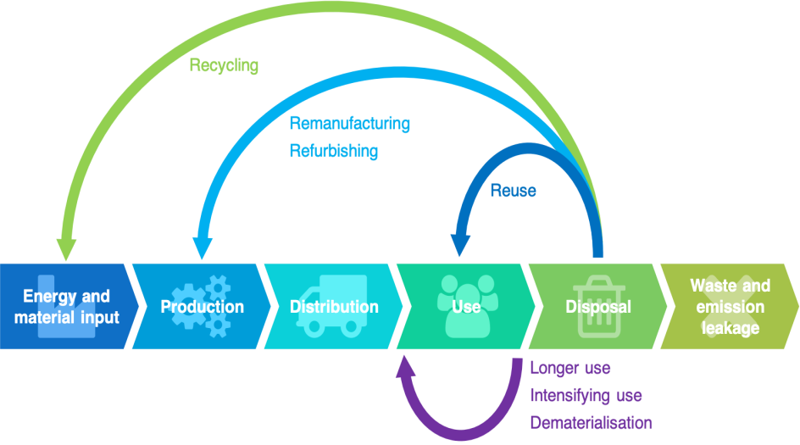

Fig. 1 Circular Economy Model (Source: ref.1)

2. Materials Life Cycle Model.

• Initially, raw materials are sourced from natural reserves using methods like drilling or mining.
• These materials then undergo purification and refining processes to transform them into substances such as metals, ceramics, rubber, and fuel.
• The resulting primary products undergo further transformations to yield engineered materials like metallic alloys, glass, plastics, and semi-conductors.
• Subsequently, these engineered materials are shaped and subjected to heat treatments to create components, which are later assembled into products and devices designed for societal use.
• Over time, during their period of service, products can either age, become obsolete, malfunction, or no longer fulfill their intended functions efficiently, leading to their eventual disposal. This marks the conclusion of their life cycle.

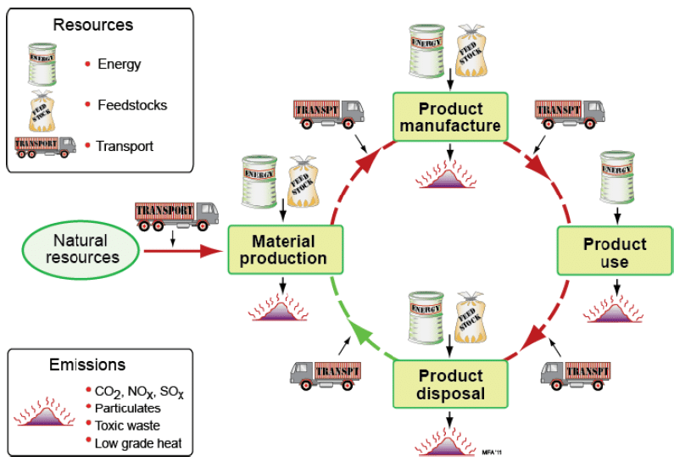

Fig.2 Life Cycle model of Materials(Source: ref.2)

The concept of a circular economy often pertains to the quantities of materials being recycled or waste being minimized. However, the Cradle to Cradle Design places its focus on the quality of products, emphasizing both human safety and environmental well-being. This approach gained popularity through the book "Cradle to Cradle: Remaking The Way We Make Things." Architect William McDonough played a significant role in its widespread adoption, earning recognition as the "pioneer of the circular economy." This acknowledgment came as he received the 2017 Fortune Award for Circular Economy Leadership at the World Economic Forum(3) in Davos. The Cradle to Cradle Design encompasses the entire lifecycle of materials, including their creation, product manufacturing, usage, and the various possibilities for end-of-life disposal. The stages are interconnected through transportation processes.
The Global Resources Outlook 2019 by UN Environment, meticulously prepared by the International Resource Panel, investigates the patterns of natural resource utilization and their corresponding consumption tendencies tracing back to the 1970s. The primary findings are highlighted below:
- Roughly fifty percent of the total worldwide greenhouse gas emissions and over ninety percent of instances of biodiversity loss and water stress can be attributed to the extraction and processing of materials, fuels, and food.
- Since 1970, the extraction of resources has more than tripled, encompassing a fivefold surge in non-metallic minerals usage and a forty-five percent rise in fossil fuel consumption.
- A projection suggests that by 2060, global material usage could double, reaching a staggering 190 billion tonnes from the current 92 billion tonnes, consequently leading to a forty-three percent upswing in greenhouse gas emissions.
In light of these findings, the UN Environment's Emissions Gap Report 2018(4) underscores that the present juncture necessitates unparalleled and immediate collaborative action from all nations to combat global warming. The report further urges countries to elevate their mitigation aspirations as a means to bridge the emissions gap by 2030 and establish a foundation for sustainable decarbonization. The circular economy, characterized by its principles of waste reduction, material circulation, and nature rejuvenation, proposes a fresh paradigm shift towards a resilient system that benefits business, humanity, and the ecosystem. The surge in circular economy momentum is unmistakable, with businesses and global leaders embarking on endeavors to eliminate waste and pollution, promote product and material circulation, and foster nature's regeneration. Nevertheless, the repercussions of our linear economic model are becoming apparent, and planetary thresholds are being crossed sooner than anticipated. This underscores the pressing need to transition from intent to action, aiming for positive outcomes but at an accelerated pace. Such a substantial transformation cannot take place without deliberate design and dedicated efforts.

3. Levels of circularity ("R" models)

During the 2010s, various frameworks for a circular economy emerged, characterized by a series of stages or degrees of circularity. These models commonly employed English terms beginning with the letter "r". The initial model, referred to as the "Three R principle" – "Reduce, Reuse, Recycle" – has roots dating as far back as the 1970s. Breteler (2022) highlights that out of the four models studied, the most comprehensive and expansive was the "10R principle." This principle was developed by Jacqueline Cramer(5), a professor in sustainable entrepreneurship and a former Dutch Environment Minister.

4. Circular economy principles

The idea of the circular economy spans a wide array of industries and can be deconstructed into seven interlinked models of production and consumption that synergize and reinforce one another:

Sustainable sourcing: the formulation and application of an ethical procurement strategy.

Ecodesign: the process of minimizing the environmental impact of a product or service across its entire lifecycle.

Industrial and territorial ecology: the exploration of eco-industrial synergies within a business region, where one company's waste can transform into another's resource.

Functional economics: a collaborative economic approach emphasizing usage over ownership, promoting services tied to products rather than the products themselves.

Responsible consumption: the practice of prudent consumption and selection of products based on social and ecological criteria.

Prolonging use duration: achieved through repair, reuse, and repurposing strategies.

Recycling: the management and reclamation of materials present in collected waste

Similar to automobiles, all ships eventually reach a juncture where continued operation becomes neither sustainable nor cost-effective. When their life cyclesends, which typically span 20-30 years, most vessels are either dismantled or repurposed. As the maritime sector strives for decarbonization and older ships lose their viability, ship recycling is being integrated into the industry's regulatory framework. The lion's share of ship recycling, approximately 90%, occurs in countries like Bangladesh, China, India, Pakistan, and Turkey. In India's Gujarat state, the Alang region, with all its yards operational, directly employs approximately 60,000 individuals and generates numerous indirect employment opportunities. During the announcement of its 2021 budget earlier this year, India's finance ministry outlined intentions to double the country's ship-recycling capacity by 2024.

The steel industry, ranking among the top three global CO2 producers, stands as a significant contributor to greenhouse gas emissions. Ship recycling serves as a substantial source of scrap metal for the steel and iron sectors, thereby reducing the necessity to manufacture virgin metals to fulfil demand. In 2009, a study commissioned by the World Bank unveiled that Bangladesh fulfilled half of its steel requirements through domestic ship recycling. This percentage stood at roughly 15% for Pakistan and ranged from 5% to 6% for India.

5. Regulating recycling
While ship recycling offers lifecycle advantages and generates numerous employment opportunities, the sector confronts significant hurdles in terms of both worker safety and ecological consequences. With the expansion of the global fleet, the demand for ship recycling is poised to increase, presenting substantial prospects for enhancing and elevating the ship-recycling industry in South Asia. This moment is opportune for proactive measures, sustained efforts, and an unwavering dedication to enhancing secure labour conditions and ecological sustainability.

6. Hong Kong Convention: Safe and Environmentally Sound Ship Recycling

The Hong Kong Convention, formally known as the "International Convention for the Safe and Environmentally Sound Recycling of Ships," is an important legal framework established by the International Maritime Organization (IMO) to address the challenges associated with ship recycling. This convention is designed to ensure that the recycling of ships is carried out in a safe, environmentally friendly, and socially responsible manner. Ship recycling is a complex process that involves dismantling ships at the end of their operational lives to recover valuable materials, such as steel, and to manage hazardous materials on board properly.

6.1 Objectives and Scope

The primary objective of the Hong Kong Convention is to provide a comprehensive set of guidelines and regulations to govern all aspects of ship recycling, from shipyard practices to the management of hazardous materials. The convention aims to prevent accidents, injuries, and environmental pollution during the ship recycling process. It applies to all ships, including large commercial vessels and smaller ships, that are being recycled, regardless of their flag state. This global approach ensures that ship recycling activities are conducted consistently and responsibly across international borders.

6.2 Inventory of Hazardous Materials (IHM)

Shipowners are required to develop and maintain an Inventory of Hazardous Materials (IHM) that lists all hazardous materials present on board the ship. This inventory helps ship recycling facilities identify potential risks and take necessary precautions to ensure the safety of workers and prevent environmental contamination.

7. Basel Convention: Regulating Transboundary Movements of Hazardous Waste

The Basel Convention on the Control of Transboundary Movements of Hazardous Wastes and Their Disposal is an international treaty established to address the management and control of hazardous waste, particularly when it crosses international borders. Administered by the International Maritime Organization (IMO), the convention aims to minimize the adverse environmental and health impacts associated with the generation, transportation, and disposal of hazardous wastes.

7.1 Definition of Hazardous Wastes

The convention defines hazardous wastes as wastes that are harmful to human health or the environment due to their physical, chemical, or biological properties. It includes a range of waste streams, such as industrial wastes, medical wastes, and certain types of electronic wastes

7.2 Prior Informed Consent (PIC) Procedure

The PIC procedure is a fundamental aspect of the Basel Convention. It requires that a country exporting hazardous waste obtain the prior informed consent of the country receiving the waste before the shipment takes place. This procedure ensures that the recipient country is aware of the nature of the waste, its potential risks, and its intended management methods

7.3 Environmentally Sound Management (ESM)

The Basel Convention emphasizes the importance of environmentally sound management of hazardous waste. It encourages countries to develop and implement strategies for the safe handling, transportation, treatment, and disposal of hazardous waste. ESM practices aim to minimize risks to human health and the environment.
7.4 Ban Amendment
One of the significant achievements of the Basel Convention is the Ban Amendment, which prohibits the export of hazardous waste from countries that are members of the Organization for Economic Cooperation and Development (OECD) to non-OECD countries. This amendment aims to prevent the transfer of hazardous waste to countries that might lack the infrastructure and capacity to manage it safely.

6. Shaping a sea-worthy circular economy
During the transitional period prior to the convention's enactment, it holds significance to utilize recycling yards that already adhere to the convention's stipulations. This interim phase offers the opportunity for more conscientious ship recycling as we await comprehensive global commitment from governments and nations to endorse the convention. In the interim, a considerable array of guidelines and agreements have been established to assist the industry. Diverse organizations, including the European Commission, OECD, International Maritime Organization, and associated entities like ILO, have developed extensive directives to facilitate responsible ship recycling. These guidelines encompass various aspects such as devising ship-recycling plans, facility authorization, hazardous material inventory, and labor conditions.

7. Circular Economy in the Marine Industry
Ship recycling has been a longstanding practice, driven by the inherent value of the materials used in their construction, which used to be wood in the past and now is predominantly steel. Within recycling, the shipping industry has set a precedent for other sectors like automobiles and aviation. Approximately 95–98% of ship materials, measured by weight, are subjected to recycling(8). However, a significant portion of ship dismantling occurs in what can only be described as appalling conditions in Asia, where ships are dragged onto muddy beaches, a practice known as "beaching"(9). This method of demolition is perilous, resulting in numerous fatalities and causing severe pollution.
The shipping industry is characterized by an "engineer-to-order" framework, where essential processes for delivering a product (such as design, engineering, manufacturing, assembly, etc.) unfold after receiving an order. This approach to ship construction and design yields distinctive, tailor-made ship models, rendering the industry less adaptable and prepared for future regulatory retrofitting. Introducing standardized and modular designs that can be easily retrofitted for new fuel types has the potential to reduce costs and confer a competitive edge. Additionally, remanufacturing used maritime components can curtail energy, water, and material consumption by up to 90%. When these components are remanufactured to match the reliability of new parts, it may lead to a reduction in overall component costs ranging from 50% to 80

8. Barriers in the maritime industry to the circular economy:

8.1 Low awareness, limited knowledge level and lack of technical expertise.
The circular economy concept remains relatively unfamiliar within the broader maritime industry, as indicated by the survey results indicating that a quarter (25%) of participants have not encountered the circular economy before. Additionally, self-assessment responses from those acquainted with the circular economy reflect a moderate level of familiarity on average. The limited awareness concerning shipyards and recycling facilities directly impact end-of-life practices for vessels, influencing disassembly techniques and the reverse supply chain. Currently, both repair and recycling yards lack awareness of the potential value of the items they dismantle. This disregard for quality standards is evident in equipment left for repair and reuse, which doesn't meet the technical benchmarks set by original equipment manufacturers (OEMs) in remanufacturing practices. A crucial requirement is enhancing the skills of ship repair and recycling facility workers to extract components from end-of-life ships without causing harm to core products. Ensuring the quality of disassembled items from vessels proves challenging, potentially escalating remanufacturing costs and process complexities (Matsumoto and Umeda, 2011). This challenge is closely linked to the technical capabilities and capacities of recycling yards.
Moreover, given the maritime industry's slower adoption rate in comparison to other sectors, the remanufacture and rebuilding capacities of maritime OEM manufacturers lag behind, excluding well-known engine remanufacturers who serve various industries. This gap, especially when juxtaposed with more advanced sectors like automotive, results in process-related challenges and an expanding knowledge gap, which can elevate costs and prolong lead times(10)

8.2. Regulation and certification related barriers (Classification societies, Flag authorities etc.)
The foremost obstacle to implementation is encountered within the realm of regulations. The maritime industry operates under stringent rules, regulations, and legislative frameworks designed to prevent environmental harm and ensure human well-being. Ships must be affiliated with a Classification society, an entity tasked with overseeing vessels on behalf of the flag state, ensuring adherence to structural requirements, and confirming compliance of shipyards involved in construction, repair, or refitting processes. Within the maritime circular economy paradigm, this is a pivotal aspect as it significantly influences the destiny of equipment. As part of their responsibilities, classification societies scrutinize the certification of all items onboard a vessel, encompassing new, used, or remanufactured items. At present, classification societies display a preference for new components over remanufactured ones during the retrofitting of ships, which has led to a challenge (10).
When it comes to new items, the certification process follows a standardized and straightforward procedure involving relevant stakeholders, typically devoid of complications. The scenario takes a different turn, however, when reusing or incorporating remanufactured equipment. Recertification becomes a necessity, and both the original equipment manufacturer and third-party remanufacturers are confronted with a conflict of interest in this process. Classification societies exhibit reluctance in re-certifying used or remanufactured products due to a dearth of knowledge and information.

8.3. Long lifecycle of maritime vessels.

The maritime industry boasts a distinctive characteristic in its notably extended vessel lifespan in comparison to other modes of transportation, averaging around 30 years of economic viability. The regulatory landscape of the maritime sector undergoes intermittent modifications to address evolving global developments, requirements, and trends. Consequently, what might have constituted an effective design a decade ago or a product in alignment with past regulations swiftly becomes outdated upon the emergence of new mandates? This transition renders previously utilized or remanufactured products inadequate to meet contemporary regulations. Furthermore, owing to their protracted lifecycle, ship owners are left with outdated components during the end-of-life phase that are unsuitable for continued utilization within the maritime domain. Even if suitability is established, these components could prove uneconomical in comparison to newer alternatives in terms of operational expenses. Regrettably, within the maritime industry, there is only a limited inclination toward embracing design for remanufacturing (DfRem) principles

8.4. Geographic barriers to reverse supply chain and asset tracking issues.
Asian shipbuilding yards overwhelmingly dominate the newly constructed vessel market, while the dismantling market is primarily controlled by other nations, notably Bangladesh, India, China, Pakistan, and Turkey. Consequently, there exists a substantial divergence between the locations of production and demolition, giving rise to a core challenge in terms of core collection. The extensive distances that need to be covered, coupled with the present underdeveloped state of the reverse supply chain, hinder the effective implementation of the 6R principles at this juncture. Given the prolonged lifespan of ships, coupled with inadequate industry standardization and the presence of a wide array of materials and equipment on board, the tracking of assets (including onboard equipment) emerges as a significant impediment. Milios et al. (2019) note an instance where a shipping company attempted to enhance the efficiency of reuse and recycling by mapping components; however, the intricate supply chain complexities rendered this endeavourunfeasible(10). Moreover, this expansive supply chain hampers efficient communication. Overcoming these challenges necessitates industry-wide adoption and collaborative efforts.
8.5. Perception and Industry Acceptance.

The significant obstacle within the maritime sector pertains to user perception or the establishment of trust in RRR (Reuse, Remanufacturing, Recycling) products among ship-owners and shipyards. There exists a reluctance among ship-owners and shipyards to incorporate remanufactured or pre-owned items, driven by various factors. Many ship-owners remain unaware of the extended warranty period that accompanies remanufactured products. This lack of awareness contributes to the limited demand for RRR products in the maritime industry. Often, identical components are solely employed as spare parts for sister vessels, and certain ship-owners opt to procure the same engines from end-of-life sources to dismantle and retain as spare parts.
9. Discussion:
The implementation of Circular Economy principles in the marine industry can lead to a paradigm shift that not only addresses environmental concerns but also drives economic growth. Circular practices can reduce the reliance on virgin resources, lowering production costs and reducing the sector's carbon footprint. Furthermore, adopting a Circular Economy approach can enhance the industry's resilience by decreasing its vulnerability to resource scarcity and price fluctuations.
The Basel and Hong Kong Conventions play a pivotal role in ensuring the safe and environmentally sound management of hazardous materials and waste. Their alignment with Circular Economy principles demonstrates a commitment to sustainable practices within the maritime sector. However, there is a need for increased global cooperation, capacity-building, and technology transfer to ensure effective implementation and enforcement of these conventions.
10. Future Works:
The integration of Circular Economy principles in the marine industry is an ongoing process that requires continued research and innovation. Future works in this field could focus on the following areas:
Technological Innovation: Develop advanced technologies for ship recycling, waste treatment, and materials recovery to enhance the efficiency and environmental sustainability of Circular Economy practices in the maritime sector.
Policy Frameworks: Advocate for stronger policy support and regulatory mechanisms that incentivize Circular Economy adoption in the marine industry, aligning with international conventions and agreements.
Capacity Building: Invest in training and capacity-building programs for industry professionals, policymakers, and local communities to ensure the effective implementation of Circular Economy practices and conventions.
Lifecycle Analysis: Conduct comprehensive lifecycle analyses to assess the environmental, economic, and social impacts of Circular Economy strategies in the marine industry, helping to inform decision-making and resource allocation.

11. Conclusion:

Sustainability involves proactive planning to secure the future's long-term mission viability. It represents an environmental management objective that transcends mere pollution prevention and regulatory adherence, instead focusing on the preservation of our resources. Comparatively, the circular economy seems to hold greater sustainability potential than the current linear economic model. Through reduced resource utilization and minimized waste generation, it conserves resources and aids in mitigating environmental pollution. However, critics contend that these assumptions oversimplify matters and overlook the intricate nature of existing systems along with potential trade-offs. Notably, the social facet of sustainability receives limited attention within the academic discourse surrounding the circular economy.

The integration of the Circular Economy into the maritime sector, facilitated by frameworks like the Basel and Hong Kong Conventions of the International Maritime Organization (IMO), presents a holistic avenue for responsible materials management. These conventions supply the necessary regulatory foundation to ensure the proper handling and disposal of waste within the maritime realm, aligning harmoniously with circular economy principles. The symbiosis between circular economy tenets and IMO conventions holds significant promise in fostering ecologically conscious and resource-efficient practices within the marine industry, making notable contributions to global sustainability endeavors.

Reference:

1.Geissdoerfer, M., Pieroni, M.P., Pigosso, D.C. and Soufani, K. "Circular business models: A review" ). Journal of Cleaner Production. 277: 12374(2020) .
2.André Canal Marques, “Sustainability Design of Products to Engineering”, International Journal of Performability Engineering 10(6):589-604, June (2014).
3.McDonough, William; Braungart, Michael , Cradle to Cradle: Remaking the Way We Make Things. New York: North Point Press. ISBN 0865475873(2002).
4. Hsu, A.; Widerberg, O.; Weinfurter, A.; Chan, S.; Roelfsema, M.; Lütkehermöller, K. and Bakhtiari, F, UN Environment Emissions Gap Report, Bridging the emissions gap - The role of non-state and subnational actors, . Nairobi (2018).
5.Jacqueline Cramer, Building a Circular Future, Amsterdam Economic Board, Vormgeving Counter Creatives(2022)

6. Kanu Priya Jain, Hans (J.J.) Hopman, Jfj Pruyn, Critical Analysis of the Hong Kong International Convention on Ship Recycling, International Journal of Environmental, Ecological, Geological and Mining Engineering Vol:7 No:10, 2013.

7. Amy E. Moen,Breaking Basel: The elements of the Basel Convention and its application to toxic ships, Marine Policy, Volume 32, Issue 6, Pages 1053-1062(2008).

8. Sabrina Chao, Ship recycling: building a circular economy for the high seas, Economist Impact, September 16 (2020).
9. Jansson, K.: Remanufacturing & Ship Repair Possibilities, Networking and Outlook. World Remanufacturing Summit, Shanghai (2013)
10. Milios, L., Beqiri, B., Whalen, K. A. & Jelonek, S. H., Sailing towards a circular economy: Conditions for increased reuse and remanufacturing in the Scandinavian maritime sector. Journal of Cleaner Production, 225, 227-235(2019).

