CRITICAL ASSESSMENT OF NEED FOR ENTREPRENEURIAL EDUCATION
(GOVERNMENT-INITIATED ENTREPRENEURIAL EDUCATION IN INDIA)

Dr G Jayanthi, Professor, School of Management, Kumaraguru College of Liberal arts and Science.
Coimbatore, Email : jayanthi.g.bba@kclas.ac.in

Abstract
Today, the majority of schools instruct students in business studies, economics, and commerce. The unfortunate reality is that while this subject does indeed focus on the details of starting and running a business, it fails to convey to our future business owners—aspiring kids and teens—what it truly means to be an entrepreneur: They do not learn about the experiences (and failures) of now-successful entrepreneurs. It does not teach them the personality traits and qualities they should be focusing on improving in order to evolve into successful entrepreneurs. Our educational system has been in charge of educating young people for successful adulthood. They should be prepared for the wide range of opportunities that lie ahead of them after they graduate from high school or college, including working for others, starting their own businesses, and giving back to their communities.

Each of these alternatives calls for a breadth of knowledge in their chosen field, as well as innovative problem-solving capabilities, leadership qualities, experience working on successful teams, and adaptability in a constantly changing environment. It's no coincidence that these are the same skills that businesses claim they look for in recent college and university graduates. These abilities are the cornerstones of entrepreneurship education because they explicitly train students to recognize and respond to opportunities and difficulties. Therefore, it's crucial that we teach children/ students to be entrepreneurial in addition to teaching them traditional topics like science, language, and history, which provide a foundation of knowledge. The chapter deals with Entrepreneurial Education, Government Initiatives and the assessment and finally deals with Relationship of Prevalence, Effectiveness and equal Accessibility for Entrepreneurial Education.
Key Words : Entrepreneurial Education, Entrepreneurial Mindset, Government initiatives

- INTRODUCTION - IMPORTANCE OF ENTREPRENEURSHIP
Entrepreneurship being an intangible factor is the moving force and development is the consequence. It has an important role in the context of a developing nation like India which is confronted with major socio-economic problems. Entrepreneurship can play an important role not only in the industrial sector of a country but in the farm and service sectors also. India is being attacked by baffling problems of over population, unemployment, under-employment, poverty and the like. Entrepreneurship is consistently equated with the establishment and management of small business enterprises and setting up these units is the solution to these baffling problems. Concentration of economic power, regional imbalances, exploitation by monopolists, and many other giant problems find their solutions in the development of small scale industry which is another name of entrepreneurship in the developing countries. Mahatma Gandhi also asserted the same, entrepreneur ship has not grown much in India but it is gaining importance fast.
The government has been taking significant steps to encourage entrepreneurship as entrepreneurship is the only solution to various problems of developing countries. Entrepreneurship caught strong waves during the last .
CAN ENTREPRENEURSHIP BE TAUGHT ?
There are many people who believe that entrepreneurship is an inborn trait which can’t be taught. This is just not true. As with any skill, from maths to music, learning to be entrepreneurial is built upon inborn traits.It is possible to teach entrepreneurship can be taught by building upon a human’s natural ability to imagine:
- Imagination is about envisioning things which don’t exist.
- Creativity is employing imagination in order to address a challenge.
- Innovation is harnessing creativity in order to generate bespoke solutions.
- Entrepreneurship involves applying innovations, scaling the ideas by encouraging others’ imagination.

By utilizing this framework, educators at all levels can help young people engage with their immediate environment and imagine how things might be different, test out innovative solutions to problems they encounter, hone their ability to reframe issues in order to generate novel ideas, and then work tirelessly to scale their ideas by rallying others to help them.

1.1 WHY ENTREPRENEURIAL EDUCATION TO THE SCHOOL STUDENTS ?

Quoting from the article written in India Today -New Delhi, UPDATED: Nov 6, 2022 14:10 IST

"formal education will make you a living; self-education will make you a fortune." The entrepreneur mindset is a blend of self-learning and formal education. It prepares the child to understand to sustain in the real world” - Jim Rhon

Decoding the importance of entrepreneurship curriculum in schools
Entrepreneurship has received extensive attention in India over the past decades as an academic discipline. In recent times, we have heard more about developing entrepreneurship among school students because of the changing trend.
1.1.1 THE ENTREPRENEURIAL MINDSET TO ENTREPRENEURIAL BEHAVIOUR

The entrepreneurship curriculum provides a unique way to develop a creative mindset to rethink and reimagine the world with innovative approaches. Here's why the entrepreneurship curriculum is needed for school students. The high demand for innovative solutions has created new opportunities for education institutes to initiate new curriculums for entrepreneurship.
An entrepreneurial mindset is most needed to enhance creativity and critical thinking more than that; it is an ability that creates consciousness in young minds so they can create opportunities that make their horizon broad, which is effective practice.
It has been realised that educational institutes offer knowledge, not a guarantee of employment once you graduate; they do make their space an informal market by walking the extra mile after years of schooling, which questions the nature of the education offered to students in a country An entrepreneurship mindset offers more than just making them think about innovation; every year, we see around 40 percent of the incubators involved in startups for their bright future in India.
An entrepreneurial mindset is as common as what we think, but as we say, the winners are no different, but they do things differently. Mindset involves conscious intellect in our belief system, where an individual processes information and acts accordingly. An entrepreneurial mindset is a specific set of beliefs that drives entrepreneurial behaviour. An entrepreneurial mindset starts with having the belief that the outcome will be a success and having the confidence to influence the outcome.

1.1.2 THE RATIONALE OF THE ENTREPRENEURIAL MINDSET:
According to the All India Survey on Higher Education, AISHE-2018-19, we have 993 Universities, 39,931 colleges, and 10,725 stand-alone institutions, with total enrolment estimated to be 37.4 million with 19.2 million males and 18.2 million females in higher education. The gross enrolment ratio has increased from 25.8 in 2017-18 to 26.3 in 2018, which affects not having job opportunities or if they get a job, whether it is underpaid or not efficient according to qualifications; If they are introduced to a self-sufficient idea, they won't struggle and will be sufficient to create job opportunities. Entrepreneurs are most needed in developing countries like India.
The entrepreneurial mindset is predominantly about the development of skills among the School Students. These skills come from that side of education which teaches and helps the student irrespective of their socio-economic status and drives them to contribute to the country's economy. We see many students graduating with a lack of advanced skills and innovative thinking, which is a setback for a more significant cause.
The government has even started recognising entrepreneurs and small businesses by introducing schemes and loans and introducing skill-based learning in the curriculum in NEP 2020. The state governments have already started workshops and training sessions for the students. So it's not only about learning inside the walls, but learning and practicing what you have learned and experimenting with creativity.
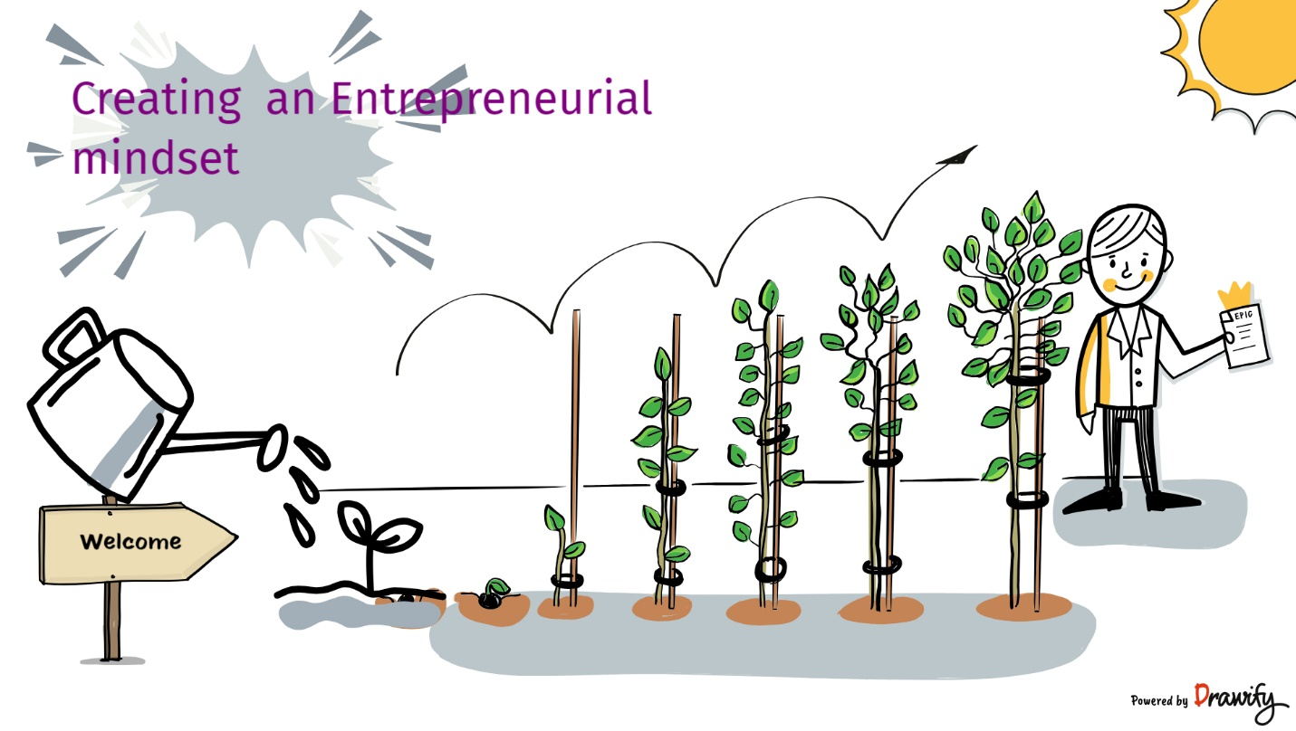

1.1.3 IMPLICATIONS OF ENTREPRENEURIAL MINDSET IN STUDENT'S LIFE:
This initiative can be implemented by introducing it into the curriculum and making it more practical for students. Focusing on the Critical basics of entrepreneurship can be taught to each student, creating interest in the subject. By making it participatory, for instance, students can interview and get involved with entrepreneurs and learn from their experiences and learning exposure that will not only introduce them to real-time experience but also inspire them to learn about business.
Another way to involve students in developing an entrepreneurial mindset can be to ask them to come up with a business idea or product. Involving other students to debate about the idea improves brainstorming. This practice will improve the critical thinking and innovative thinking of the student and increase their horizon to implement the learning in real life.
Adding these activities will develop research and other helpful valuables and help them identify their interests. Students can learn abilities such as critical thinking, identifying problems and opportunities, and understanding the fundamental nature of the market; after that, they can progress to a stage forward.

1.1.4 FUTURE OF ENTREPRENEURIAL MINDSET:

Change is the only constant, and the entrepreneurial mindset embraces change and uncertainty with surprises and offers more skills and abilities to individuals and society. Students need to look at the world differently and be more creative to bring the necessary change with value. Small practices add to the personality, which leads to a successful future.
The entrepreneurial mindset is a reform in education that is embraced globally. We can see examples like Japan and the United States. They are the most entrepreneurial countries and are known for the innovation they give to the world. It is essential for Indian students and is evident after the government embraced the idea and offered them help to grow.

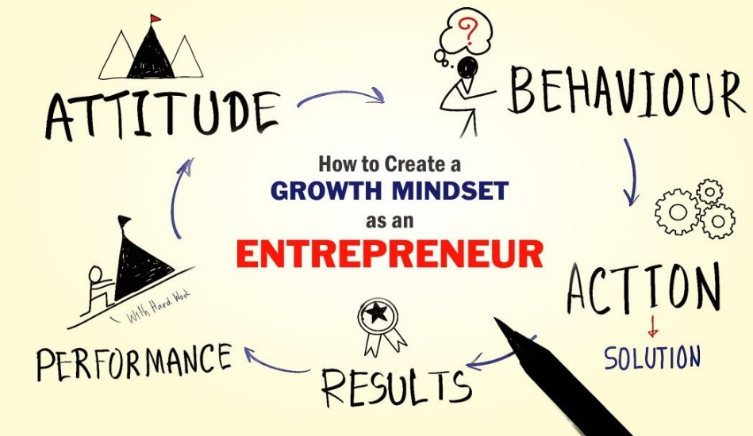

(https://businessconnectindia.in/wp-content/uploads/2019/06/How-to-Create-a-Growth-Mindset-as-an-Entrepreneur.jpg)

From the article, it is evident that the following skills are to be imparted to the school students and it has to be practiced among the school students : ((Report By Jagdish Bishnoi, Founder & CEO, SAFL India Foundation Research Scholar, University of Delhi)
Entrepreneurial Skill Sets | Offer Venture lab Programmes
Creating Entrepreneurial Mind set | - Teach Entrepreneurial topics – instructional ppts and videos, use a printable student work book  - Provide Entrepreneurial learning to the students as a part of a class, curriculum, hybrid and remote learning  - Venture Lab : Programs and assignments include idea pitch, Knowledge on Social Entrepreneurship and career exploration
Advanced Skills and Innovative thinking
Creative thinking
Problem solving Skills
Thinking differently
Critical thinking
Idea Generation
Business Knowledge
Analytical Skills

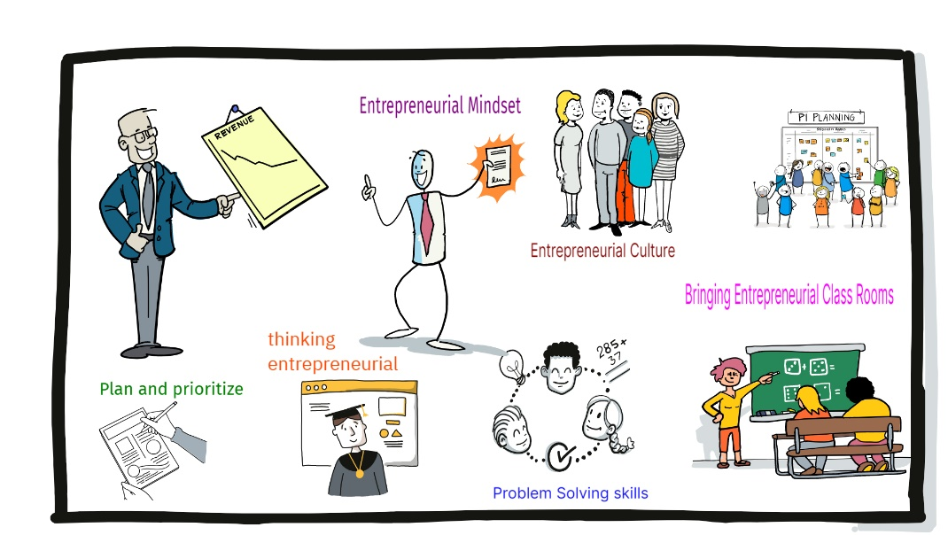
(image source : own)

- Government Initiatives - What is entrepreneurship program for students?

The objective of this chapter is to have an understanding about the government initiatives toward Entrepreneurial empowerment.

Entrepreneurship programs teach students basic life skills like problem-solving, innovative thinking, teamwork, etc. These programs also cater to enhance skills that adhere to contemporary situations. For example, students are taught skills to adapt to the unprecedented pandemic situation.

Young Entrepreneurs Classroom (YEC) is a 6-day certification programme that enables entrepreneurial skills in students. This short-term course introduces students to the core concepts of entrepreneurship and shows the way forward towards their entrepreneurial future.

The New Education Policy is laying emphasis on honing the spirit of entrepreneurship in students right from the school years. In a scenario where entrepreneurship is foreseen as the cornerstone of the economy, the future entrepreneurs should be nurtured from an early stage in their lives. In this context, Metamorphosis Edu, world’s first organisation that teaches entrepreneurship to the students (Grade VI - Grade XII) at school level, has come up with short courses that are tailor made for students to teach them the nuts & bolts about starting up your own businesses. (Refer Table 1 )
The recent changes in the National Education Policy (NEP) have the potential to significantly impact entrepreneurship education in India, not only at the higher education level but also at the secondary level through a greater emphasis on practical learning. With a notable focus on entrepreneurship, the NEP presents a great opportunity to enhance entrepreneurship education. The policy changes allowing foreign universities to establish campuses in India could facilitate knowledge transfer from countries with well-established entrepreneurship education programmes and ecosystems, benefiting Indian students pursuing tertiary education. Moreover, the NEP's introduction of a credit transfer system and increased flexibility in switching between universities and programmes could encourage more individuals to pursue entrepreneurship education, contributing directly to the growth of the country's entrepreneurial ecosystem. As a result, we may witness the emergence of a more vibrant and diverse pool of Indian entrepreneurs equipped with the necessary skills and knowledge to navigate the complexities of the modern entrepreneurial landscape.

Benefits of Entrepreneurial Education
Simply said, starting your own business is the finest way to change the way you work and live. Our students may always profit from and contribute to entrepreneurship. Their entrepreneurship education compels students to begin their professional careers prior to earning their degrees. So many successful businesspeople have launched their ventures even before earning their degrees.
Our students also benefit greatly from entrepreneurship education in that they start their own businesses at a young age. Instead of putting too much emphasis on their studies and extracurricular activities, they strive to concentrate on honing their abilities and put a lot of effort into doing so in order to make them a better source of income for themselves. The term for creativity and invention is entrepreneurship. One advantage of entrepreneurship for our students is that it motivates them to take risks and develop even greater creativity and innovation in their chosen fields.
The following are the benefits of Entrepreneurial education viz.,
- Knowledge of Business at early stage
- Thinking for a better future
- Entrepreneurial education is relevant to all fields
- Personal growth and development
- Creation of Job opportunities
- Prepares for future
- Help them to identify and solve problems .

Table – 1 Entrepreneurial Initiatives by the Government of India
MSE - Metamorphosis School of Entrepreneurship | Young Entrepreneur’s Class Room- YEC | Metamorphosis Entrepreneurship Olympiad (MEO) –MEO | Jump starter
Metamorphosis School of Entrepreneurship offers a two-year entrepreneurship course to students at the school level. The exclusively curated curriculum takes students on an entrepreneurial journey and gives them an end-to-end experience; right from ideation to developing a business model and taking the final product into the market.  It has a case study-based curriculum, with mentoring and live guest talks sessions. The alumni community is also made to participate in a lot of networking events and business -plan competition. | Young Entrepreneurs Classroom (YEC) is a 6-day certification programme that enables entrepreneurial skills in students. This short-term course introduces students to the core concepts of entrepreneurship and shows the way forward towards their entrepreneurial future. It has a Hybrid model of teaching with a recorder and live sessions.  On the successful completion of the programme, the students will be certified as Young Entrepreneurs by Metamorphosis in association with IIT Bhubaneswar. | A national-level competitive test conducted for school students. Through this test (which has expertly curated questions by real-time entrepreneurs and industry experts), students could assess their entrepreneurial quotient and take a step forward towards honing their skills which are crucial to possess in the upcoming age of automation.  The winners would be announced at the school level and also at the national level and would be certified by Metamorphosis in association with IIT Bhubaneswar. | To introduce students to entrepreneurship, Metamorphosis has curated an introductory session named “Jumpstarter”. This course will help students understand the why’s and what’s of entrepreneurship while enlightening them on the huge avenues that would be opened for young entrepreneurs. This course is subject to the availability of schools.  Topics that would be addressed: (one of the following topics would be selected for a session)  Importance Of entrepreneurship at an Early Age  21st Century Entrepreneurial Skillsets  How to become an entrepreneur before 20  The journey of Early Startups
Eligibility: Grade VI to Grade XII  Course Duration: 2 years  Fee: Rs 50,000  Link: https://www.metamorphosisedu.com/metamorphosis-school | Eligibility: Grade VI to Grade XII  Course Duration: 6 days  Session Duration: 1 hour  Fee: Rs 999 (as of now)  Link: https://www.metamorphosisedu.com/entrepreneursclassroom | Eligibility: Grade VI to Grade XII  Fee: None  Link: https://www.metamorphosisedu.com/meo | Eligibility: Grade VI to Grade XII  Course Duration: 1 Day  Session Duration: 1 hour  Fee: None

2.1 Institutionalizing the concept of a “Professor of Practice”:
The push by the University Grants Commission (UGC) is to institutionalize the concept of a “Professor of Practice” (PoP) in Indian higher education institutions. The UGC aims to enhance the quality of higher education by bringing practitioners, policymakers, skilled professionals, and others into the higher education system.
- The UGC's plan introduces a new class of positions called PoPs in an effort to close the gap between academics and industry. These people are specialists in their fields who have a lot of industry experience..
- Unlike traditional academic professors, PoPs may not be required to have a PhD or advanced research degree. They are appointed to faculty positions to share their practical knowledge, skills, and real-world experiences with students.
- The UGC's effort aims to increase faculty resources in higher education institutions and incorporate real-world practises and experiences into the classroom. The UGC aspires to provide graduates with the pertinent skills required by industry and society by incorporating industry and professional expertise into educational institutions..
The UGC’s initiative recognizes that universities, with the influx of bright minds every year, are well-positioned to foster innovation. By introducing PoPs, universities can offer courses focusing on practical applications, facilitate applied learning, mentor student projects, develop industry-aligned courses, collaborate on research projects, and provide insights on converting patents into commercial products
The presence of Professors of Practice (PoPs) in universities can contribute to fostering an innovative culture and reshaping the commercial thinking of academic institutions.
It highlights that in today’s post-knowledge societies, innovation has become the third pillar alongside teaching and research in universities. When an innovative culture is strongly established, it is believed that every academic within the university will have the ability to synthesise ideas and potentially create start-up enterprises.
These university-based start-ups would not only incubate ideas but also transform them into patents and eventually into commercial products.
The growth of such innovative ideas contributes to the development of an entrepreneurial university, where research, industry work, and academia converge. This entrepreneurial culture strengthens, the role of PoPs may evolve, potentially leading to a new generation of “entrepreneurs in residence” within universities.
These individuals would serve as role models and mentors, guiding bright students in creating ground breaking ventures, similar to the creation of Google on a university campus. All India Survey on Higher Education (AISHE): The main objectives of the survey are to identify and capture all the institutions of higher learning in the country; and collect the data from all the higher education institutions on various aspects of higher education.
2.2.1 Key findings of All India Survey on Higher Education (AISHE) 2020-2021
Specification | 2020-21 | Trend w.r.t 2014-15.
Total student enrolment: UP, Maharashtra, TN, MP, Karnataka and Rajasthan are top 6 States in terms of number of students enrolled. | 4.14 crore. | 21%
Female Enrolment | 2.01Crore | 28%
Percentage of female enrolment to total enrolment... | 49% | 4
Gross Enrolment Ratio (GER): Percentage of students belonging to eligible age group (18-23 years) enrolled in Higher Education. | 27.3 | 3 point raise
Gender Parity Index (GPI): Ratio of female GER to male GER | Increased from 1 in 2017-18 to 1.05 | ---
Institutes of National Importance (INIs)... |  | Almost doubled 75
Enrolment in INIs | 149 | increased
Female per 100 male faculty | 61% | Increased (63)

From the above table of comparison (Aishe), it is opined that there is a rise in enrollment and other aspects demands that the learning environment has to be changed. Female enrolment has increased to 28 % when it is compared to 2014-15 data.
2.4 Entrepreneurial Initiatives for women
In order to enable and inspire women entrepreneurs to launch and expand their enterprises, the Indian government has established a number of entrepreneurial education and assistance programmes for women. These programmes seek to give women the information, abilities, resources, and networks of support they need to succeed as business owners. The following are some significant government programmes for women's entrepreneurship education in India.
These federal initiatives, in addition to other state-specific initiatives, are essential in promoting entrepreneurial education for women in India. In order for women to start and build their enterprises, contribute to the economy, and attain financial independence, they want to foster an environment that is encouraging. These programmes offer networking opportunities, financial aid, and training for women who are interested in starting their own businesses.
Exhibit – 1
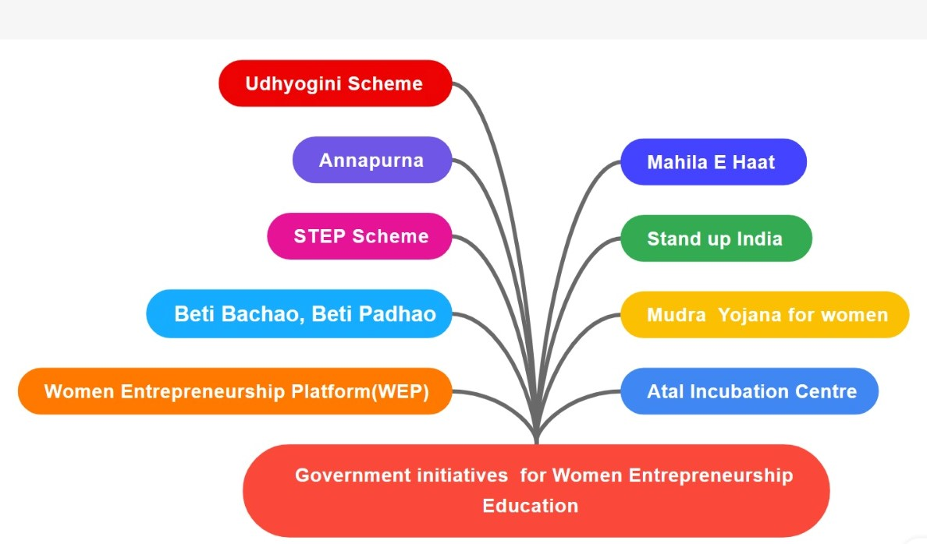

Table- 3- Government Initiatives for Women Entrepreneurial Education
S.No | Scheme | Details of the Scheme
1 | MUDRA Yojana for Women | - The Pradhan Mantri MUDRA Yojana (Micro Units Development and Refinance Agency) provides loans to women entrepreneurs at affordable interest rates.  - It offers three categories of loans: Shishu, Kishor, and Tarun, with increasing loan amounts based on the business's stage of development.
2 | Stand-Up India | - This initiative aims to promote entrepreneurship among women and marginalized communities by providing bank loans between ₹10 lakh and ₹1 crore to set up greenfield enterprises.  - At least one woman entrepreneur and one individual from a Scheduled Caste (SC) or Scheduled Tribe (ST) is eligible for this scheme.
3 | Beti Bachao, Beti Padhao: | - While not directly an entrepreneurship program, this initiative by the Indian government promotes the education and welfare of the girl child, which indirectly contributes to their empowerment and potential as future entrepreneurs.
4 | Annapurna Scheme | - This scheme offers working capital to women entrepreneurs who run food catering businesses, canteens, and food stalls.  - It helps women expand their food-related businesses.
5 | Mahila e-Haat: | - Launched by the Ministry of Women and Child Development, Mahila e-Haat is an online platform that enables women entrepreneurs to showcase and sell their products and services.  It provides a digital marketplace for women to reach a wider audience.
6 | Udyogini Scheme | This scheme by the Rajasthan government offers financial assistance and training to women entrepreneurs in the state.  It aims to encourage women to start and manage small-scale businesses.
7 | STEP Scheme | The Support to Training and Employment Program for Women (STEP) is a government initiative that provides skill development and training to women to enhance their employability and entrepreneurial abilities.
8 | Women Entrepreneurship Platform (WEP): | Although not a government initiative, the WEP was launched by NITI Aayog to promote and support women entrepreneurs in India. It offers various programs, resources, and opportunities for women to connect, learn, and grow as entrepreneurs.
9 | Atal Incubation Centres (AICs): | These centers, supported by NITI Aayog, provide incubation and mentoring support to startups, including those led by women. AICs help women entrepreneurs develop their business ideas and access resources.
1(Government of India Initiatives )
STEP Scheme
A Doorway to an Entrepreneurial University Background- Higher Education in India
The term ‘higher education’ with respect to India denotes the tertiary level education that is imparted after 12 years of schooling (10 years of primary education and 2 years of secondary education). India’s higher education system is the third largest in the world, next to the United States and China.
India’s Higher Education sector has witnessed a tremendous increase in the number of Universities/University level Institutions & Colleges since independence.
As per the All-India Survey of Higher Education (AISHE), there are 1,043 universities, 42,343 colleges and 11,779 standalone institutions. Out of these, almost 78.6% are in the private sector– aided or unaided colleges and only about 21% are in the Government.
The article discusses the value of collaborations between academia and industry in driving economic and intellectual growth.
Entrepreneurial University:
The statement is discussing the concept of the “entrepreneurial university” as the next phase in the evolution of universities. It acknowledges that there are differing views on whether universities should focus solely on being the source of new knowledge and research, or if they should also engage in commercialising their intellectual output.
III. Relationship of Prevalence, Effectiveness and equal Accessibility for Entrepreneurial Education.
1. Prevalence: Recent years have seen a considerable increase in the popularity of entrepreneurship education as more people want to acquire the skills and information required to launch and run their own firms. At several levels, including elementary and secondary schools, colleges, universities, and institutions of higher learning, entrepreneurship education is provided. The prevalence of entrepreneurship education varies by region, with some places emphasising the integration of entrepreneurial concepts into their curricula more than others, while others are currently creating such programmes.
2. Effectiveness: The influence entrepreneurship education has on students' entrepreneurship-related knowledge, skills, attitudes, and behaviours can be used to assess its efficacy. Effective entrepreneurship education emphasises practical skills like ideation, company planning, market research, financial management, and networking in addition to theoretical understanding. Additionally, it ought to promote an innovative, resilient, and adaptable mindset. The success of graduates who go on to found and run prosperous enterprises, contribute to economic growth, and spur innovation demonstrates the long-term efficacy of entrepreneurship education.
3. Equal Accessibility: To ensure that people from all backgrounds have equal access to high-quality entrepreneurship education, ensure equal accessibility in the field of entrepreneurship education. This includes removing obstacles that could exclude some groups from participating:
- Gender Equality: Providing equal opportunities for both genders to access entrepreneurship education and ensuring that curriculum materials and classroom environments are inclusive.
- Socioeconomic Inclusion: Ensuring that individuals from different socioeconomic backgrounds have access to entrepreneurship education, regardless of their financial means.
- Racial and Ethnic Diversity: Creating inclusive environments that cater to the needs of diverse racial and ethnic groups, and promoting diverse role models and mentors in entrepreneurship education.
- Geographical Accessibility: Offering entrepreneurship education in both urban and rural areas to ensure that students from all geographic locations can participate.
- Accessibility for People with Disabilities: Designing education materials and physical spaces that are accessible to people with disabilities.

Offering scholarships and financial aid, collaborating with neighbourhood organisations, creating curriculum materials that are culturally relevant, and utilising online learning platforms to reach a larger audience are all ways that equal accessibility in entrepreneurship education is promoted.
In general, entrepreneurship education is essential for giving people the abilities and outlook required to thrive in an entrepreneurial setting. We can encourage a broad and dynamic ecosystem of future entrepreneurs who contribute to economic growth and innovation by assuring its ubiquity, efficacy, and equal accessibility.

Conclusion
The popularity and availability of informal learning channels for entrepreneurship education have been emphasised by this study, but more research is required to determine their prevalence, efficiency, and equality of access. Understanding the degree to which aspiring businesspeople in India rely on informal channels, including networks, independent coaches, and expertise passed down through families, can be helpful in determining their impact and any potential drawbacks. The study ought to look into what influences how well potential entrepreneurs can make up for a lack of formal education possibilities. In order to better understand entrepreneurial education in India, future studies should aim to explore and address these crucial topics. Through thorough research using larger and more varied sample sizes, we can gain insights into the challenges, opportunities, and potential impacting factors in accessing entrepreneurship education. This knowledge will guide the development of more open, accessible and comprehensive entrepreneurship education, fostering a thriving entrepreneurial ecosystem in India.
References
- https://www.studyiq.com/articles/a-doorway-to-an-entrepreneurial-university/
- India Today -New Delhi, UPDATED: Nov 6, 2022 14:10 IST
- https://www.forbes.com/sites/robynshulman/2018/04/08/5-ways-teachers-can-introduce-entrepreneurship-skills-in-their-classrooms/?sh=2b9ab0e67293
- Report By Jagdish Bishnoi, Founder & CEO, SAFL India Foundation Research Scholar, University of Delhi.
- https://techbaji.com/entrepreneurship/entrepreneurship-for-students/

