Municipal Waste Management System in Urban Areas

Ravi Kumar B N Anand K Joshi
Assistant Professor, Mechanical Engineering Department, Dept. of Mechanical Engg., Presidency
J N N College of Engineering, Presidency University
Shivamogga, Karnataka, India Bengaluru
ravidhoddal@jnnce.ac.in anandjoshi.mech@gmail.com

ABSTRACT
Rapid increase in different types of hazardous waste due to continuous economic growth, industrialization and urbanization is becoming a major problem for government to ensure effective and sustainable waste management. The transport, separation, handling and discarding of wastes needs to be properly managed without affecting the environmental health.
At present, there is no such system of separation of dry, wet and metallic wastes. This process proposes an Automated Waste Separator (AWS) which is a simple and economical separation system for domestic purpose in the most economical and effective method. This report proposes implementation of an advanced waste separator. The waste has to be separated and monitored properly so as to gain the golden property of the waste by recycling. Also if the waste is handled manually then there is a chance of spread of diseases and various infections. If the waste is handled with fast working separator machine and a data of separated waste then it reduces the chances of various diseases by keeping it far away from workers and helps industries to make a great profit by recycling them at their required pace.
The separated dry materials like plastic glass can be further recycled, the metallic waste can be melted and re-used. The wood waste can be converted into briquette and wet waste is converted into manure. This work proposes an Automatic Waste Separator (AWS) which is a cheap, easy to use solution.

Keywords—Waste Separator, Land fill, Waste Disposal.

INTRODUCTION

In this modern era, sorting and disposal of waste is a major problem to the whole world. Also the huge amount of wastes has an adverse impact on the environment. At this present time, we are totally unaware of the golden value of wastes i.e. the energy required to make a product by recycling is much less as compared to the raw material. Also it impacts on the cost of the product as well as less carbon emission. The general method of disposal of waste is by uncontrolled and unplanned open dumping at landfill sites. This system is very injurious to human health, animal life and plants. Hence proper waste management system is required.

II. LITERATURE SURVEY
Wolfgang Muller et. al. [1] have investigated that the diverse characteristics of MSW is categorized into different categories like plastic, paper, glass and biowaste, which is garden and coversorganic kitchen waste. Further, the collection system could be the outcome of impurity in the biowaste.
J.S. Bajaj et. al.[2] states several up gradations can be done to the existing project, namely: Advanced processing techniques can be incorporated once the waste has been separated, methods for individual material feeding for local use so that the separated can be performed continuously once the waste is dumped, image sensing can be used to segregate materials through Image processing technology.
Ananth et al., [3] have done study on Belt conveyor which is the transportation of waste from one location to another. This study provides to design the conveyor system used for which includes belt speed, belt width, motor selection, belt specification, shaft diameter, pulley, gear box selection, with the help of standard model calculation.
Garrett C. Fitzgerald et al.,[4] have investigated the process of producing power from waste energy which can be called as Waste to wealth Technologies. Also, they find that carbon emission and Land filling can be reduced in this research.
Ashish R. Mishra et al., [5] have investigated that the era of globalization characterized by swift technological change, fast urbanization and population increases in developing countries, new problems have emerged. For instance, a sharp rise in solid waste has accompanied urbanization which has presented public policy challenges Efficient solid waste management is critical for the health and well-being of urban population Solid waste management consists in the control of the generation, collection, storage, transfer, processing and disposal of the solid waste.
Kavya Balakrishnan, Rosmi et, al. [6] have developed the system of separating wastes in to different categories in most economic and effective method.

III. OBJECTIVES AND METHODOLOGY

A. OBJECTIVES
- To fabricate the automated waste separator
- To separate wastes at primary stage so that most of wastes get recycled easily and keeps our surrounding’s clean.
- To solve the social issue of waste disposal, the waste separator identifies the kind of material being thrown inside it and separates it.
- Reduction of waste from sources and the reuse of waste through recycling
- To decrease the amount of hazardous waste bound for energy recovery, treatment, and disposal facilities.

B. METHODOLOGY

Here the waste management system is designed and developed in such a way that it sorts the wastes into three categories namely dry waste, wet waste and metallic waste. The whole flow diagram along with its description is explained below.
Initially the mixed waste is dumped into the shredder. The shredder shreds the waste or garbage into smaller pieces to reduce the size of the garbage. Next, the shredded waste is shifted to the magnetic Roller with the help of the conveyor belt. The magnetic Roller attracts the metallic waste or particle present in the garbage or waste and separates it. Later the remaining waste moves to the Blower section where the Paper and Plastics are transferred to the heated roller hopper. The Paper and the Plastics are made to fall on the rotating heated roller so the plastic will stick on to the heated roller, so the plastic is separated from the roller fall on the Plastic Bin, remaining papers are falls on the waste paper bin.
The metallic, plastic and Paper wastes are separated and the remaining wet waste is transferred to the wet waste bin through conveyor belt. Figure 1, 2, 3, 4 and 5 shows Flow diagram of automated waste separator, Diagram of waste separator, 3D Diagram of waste separator, 2D Diagram of Conveyor Belt and 2D Diagram of Shredder respectively.

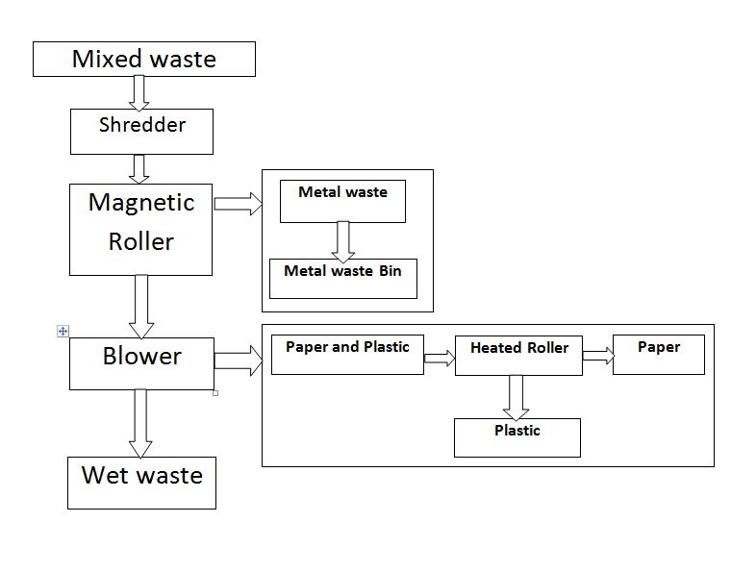

Figure 1: Flow Chart of automated waste separator

Magnetic Roller
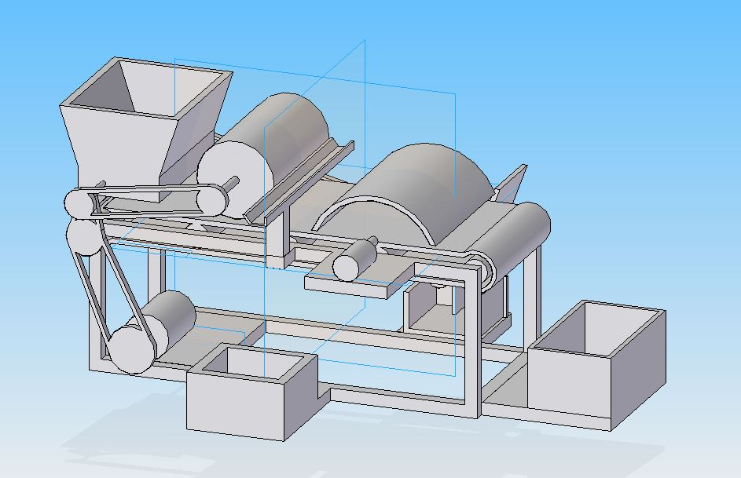

Shredder

Blower

AC Motor

Metal waste Bin
Wet Waste Bin

2: 3D Diagram of automated waste separator
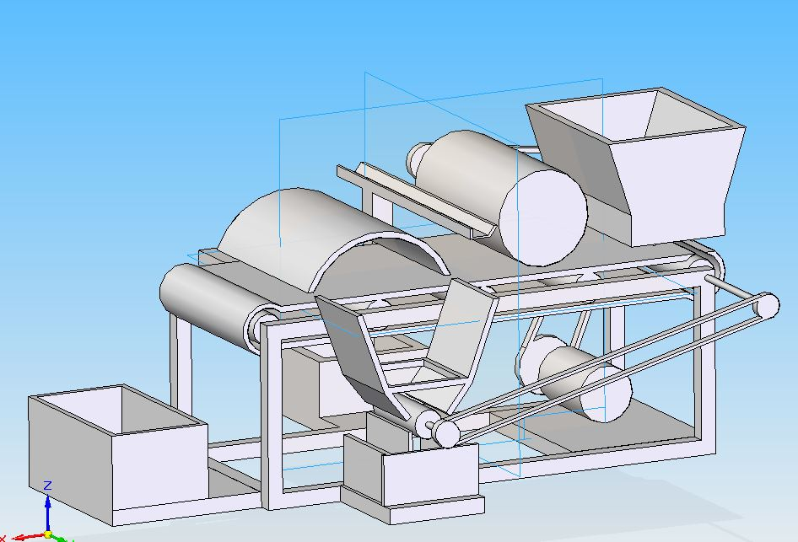
Heated Roller
Conveyor Belt

Figure 3: 3D Diagram of waste separator

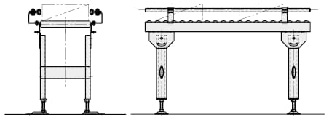
Figure 4: 2D Diagram of Conveyor Belt

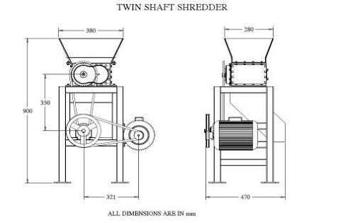

Figure 5: 2D Diagram of Shredder

C. DESIGN AND CALUCLATIONS:
Speed calculation:
Motor Speed =1440 RPM
Gear Box Ratio = 14.211:1
Gear Box output Shaft Speed = Motor speed/ Gear box ratio= 1440/14.211
= 101.329 RPM

Shredder Speed:
Let,
$D_{1}$= Pulley Diameter of Gear box output shaft = 2 Inches
$D_{2}$= Pulley Diameter of Shredder = 14 Inches
$N_{1}$= Speed gear box output shaft = 101.329 =102 RPM
${ N}_{2}$= Speed shredder shaft = ?

$\frac{N_{1}}{N_{2}}$= $\frac{D_{2}}{D_{1}}$
$$N_{2}= \frac{D_{1} ×{ N}_{1}}{D_{2}}$$

$$N_{2}=\frac{2 ×102}{14}$$

$$N_{2}=14.571RPM$$

Conveyor Speed
let,
D = conveyor roller Diameter =80 mm = 0.08 m
Roller speed = 15 RPM
Conveyor speed = circumference × Input speed
= πD×15
= π(0.080)×15
=3.769 m/min
= 0.06283 m/sec
Torque at Shredder:
Let,
d = Shredder shaft diameter =25.4 mm = 0.025 m
Torque at Shredder = Mass acting on bearing × Circumference
= (8×9.81)×πd
= (8*9.81)×(π*0.025)
= 6.16 N-m

Torque at conveyor:
Let,
$$d_{1}=Conveyor Shaft diameter=25.4 mm=0.025 m$$
Torque at conveyor = Mass acting on bearing × Circumference
= (4*9.81) ×π$d_{1}$
= (4*9.81) ×(π*0.025)
= 3.08 N-m
Torque at motor:
Let assume,
P = 2 HP
Torque at motor = $\frac{P×5252}{1350}$

$T_{lb-ft}$= $\frac{2×5252}{1350}$

$T_{lb-ft}$= 7.78 lb-ft

(Note = 1lb-ft =1.36 N-m)

T =7.78 *1.36= 10.58 N-m
Torque of the motor is greater than required, so 2HP motor is sufficient

Power calculation:
For Induction motor:
P= V I Cos¢
Where V = 220 v
cos¢ = Power factor = 0.85
P= 2HP = 1492 w = 1.4 KW (Note 1 HP= 746 W)

I = $\frac{P}{vcos¢}$

I =$\frac{1492}{220X0.85}$

I = 7.97 Ampere = 8 Amps

IV.CONCLUSION

AWS (Automated Waste Separator) is effectively implemented for the segregation of waste into dry, wet & metallic waste at domestic level which in turn helps in the solving the garbage problem and to utilize them for recycling process. The separated dry materials like plastic glass can be further recycled; the metallic waste can be melted and re-used. The wood waste can be converted into briquette and wet waste is converted into manure.

V. REFERENCES
[1]Anna jank, Wolfgang Muller, Irene Schneider, Frederic Gerke, Anke Brokreis, “National Library of Medicine”, Waste Separation Press(WSP): a mechanical pretreatment option for organic waste from source separation, DOI: 10.1016/j.wasman.2015.02.024, mar 9, 2015.
[2] J.S. Bajaj, Urban Solid Waste management in India, Planning Commission Government of India, New Delhi,1995.
[3] Ananth, Vaitla Rakesh, Pothamsetty Kasi Visweswarao, “International Journa for Research in Applied Science and Engineering Technology”, Design and Selecting the Proper Conveyor Belt, Vol8, Issue 3, 2020.
[4] Garrett C. Fitzgerald, Nickolas J. Themelis, Department of Earth and Environmental Engineering, Foundation of Engineering and Applied Science,Technical and Economic Analysis of Pre-Shredding Municipal Solid Wastes Prior to Disposal Columbia University September 2009.
[5]R. Mishra Shwetha, Anurag V Tiwari, Dept. of Civil Engg, “Solid Waste Management - Case Study” PRMITR, Badnera, Maharashtra, India.
[6] Kavya Balakrishnan, Aleena V.J., Rosmi T.B., Swathy Krishna K.J., Sreejith S “Journal of Microcontroller Engineering and Applications”, Automatic Waste Seggregator system, Vol 3, Issue 2, ISSN 2455-195, pp1-7.

