Application of Molecular Markers in Genetic Diversity analysis
Navendra Uniyal¹*
¹Department of Agriculture, Doon Group of Institutions,
Shyampur, Rishikesh, Uttarakhand
*Corresponding author: navendraunniyal121@gmail.com

Abstract
Many plant species were exterminated or had their geographic ranges severely restricted due to habitat changes brought on by climate change and human activity. In recent years, the distribution of certain plant species that once had a vast range has substantially decreased, leading to their position as endangered and threatened species. The ability of a population to adapt to a changing environment is influenced by genetic diversity, which is a crucial factor in species conservation. The amount of genetic variation among individuals in a variety, or population, of a species, is commonly known as genetic diversity. It results from the numerous genetic variations between individuals and may appear as differences in DNA, biochemical traits (such as protein structure), physiological traits (such as abiotic stress resistance or growth rate), or morphological traits (such as plant height). Genetic diversity is examined by using morphological markers and biochemical markers. The exact level of genetic diversity cannot be defined by morphological and biochemical markers because environmental factors influence morphological and biochemical parameters. Molecular markers have shown to be very effective tools in the study of genetic diversity because of their highly polymorphic character and inability to be influenced by the environment. Molecular markers also known as DNA markers or genetic markers analyzed the diversity on the level of the DNA. Molecular markers give a chance to characterize genotypes more exactly than other markers and to evaluate genetic relationships.
Keywords: Biochemical, Environment, Genetic diversity, Molecular markers, Morphological

Introduction
Genetic diversity is defined as the amount of variability between individuals, or populations of a species that depict the balance between genetic variety loss and mutation (Hughes et al., 2008, Carvalho et al., 2019). Genetic diversity is a significant factor in the conservation of species because it influences a population's ability to adapt to a changing environment (figure 1) (Kirk and Freeland 2011, Szczecińska et al., 2016). For understanding any species evolutionary past and determining potential threats to variety in the future, knowledge of genetic diversity patterns is very helpful (Neel and Ellstrand 2003). More genetically diverse populations are more suitable because genetic diversity is frequently linked to plant fitness (Ilves et al, 2013). Diversity is traditionally investigated by assessing variations in morphological and biochemical parameters. These two methods are helpful in the detection of diversity but these methods have some drawbacks. The expression of morphological and biochemical parameters is influenced by environmental factors. Analysis of genetic diversity based on molecular markers is a helpful complement to the morphological and biochemical characterization of plants as they are abundant, unaffected by tissue or environmental effects, and enables the identification of plants in the early phases of development. Molecular marker analysis was discovered with the development of biotechnology to efficiently analyze genetic diversity (Thomas et al., 2006).
Molecular markers are recognizable DNA sequences that are located at a known, genome-specific location on the chromosome. They are useful tools in genetic studies and by minimizing potential environmental impacts give information on genetic variability (Soares et al., 2016). Molecular markers are significant tools for genetic diversity study, which is the initial stage in breeding initiatives and genetic resource protection. In the fields of taxonomy, ecology, diversity, plant breeding, conservation, and genetic engineering, molecular markers have a wide range of applications. Numerous molecular markers such as Random Amplified Polymorphic DNA (RAPD), Amplified Fragment Length Polymorphism (AFLP), Start codon targeted (SCoT), Simple sequence repeats (SSRs), Inter-simple sequence repeat (ISSR), Restriction Fragment Length Polymorphism (RFLP), Single Nucleotide Polymorphisms (SNPs) and Sequence characterized amplified regions (SCARs) are widely used in the assessment of genetic diversity (Table 1). In this study, we discussed about genetic diversity and molecular markers used in genetic diversity analysis.
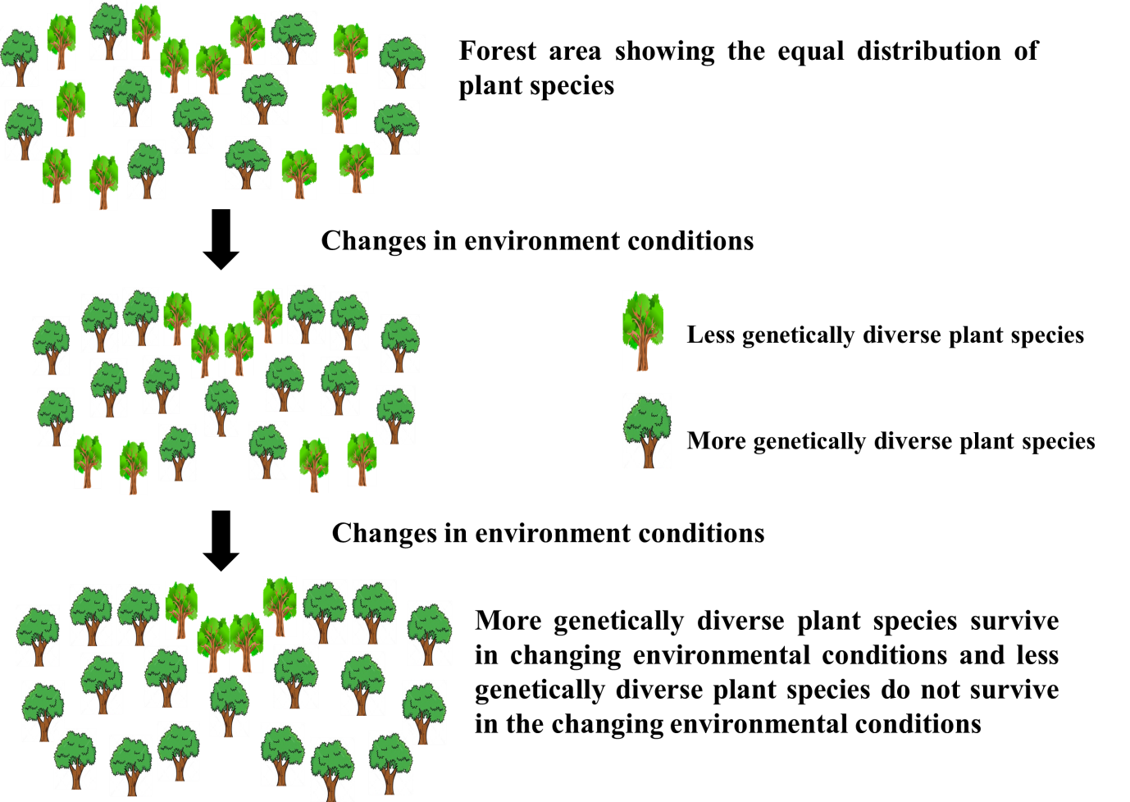
Figure1. Impact of changing environmental conditions on plant species

Simple sequence repeats (SSRs)
Simple sequence repeats (SSRs) also known as microsatellites are one of the key molecular marker applied in genetic diversity studies. SSR markers are 1-6 nucleotide tandem repeats and 1–4 nucleotides DNA sequences long found in most taxa's nuclear genomes at high frequency (Idrees and Irshad 2014, Beckmann and Weber 1992). Due to their high mutation rate and co-dominant nature (distinguish heterozygotes from homozygotes), SSRs markers are able to detect polymorphisms within and between populations and genetic admixture between populations, even if they are strongly linked. (Naceur et al., 2012). SSRs markers are abundant, random distribution in the entire genome, highly reproducible, highly polymorphic, high information content, and easy to assay.
Random amplified polymorphic DNA (RAPD)
Randomly amplified polymorphic DNA (RAPD) markers usually consist of the use of 8-15 base pairs length oligonucleotide primers of the arbitrary sequence which bind to the nonspecific sites on the DNA and produce band profiles (fig 2). Primers randomly bind on the DNA under low annealing temperature. RAPD markers can detect polymorphism even with small amounts of genomic DNA available. As the primers can bind anywhere in the genomic DNA sequence, RAPD is a simple and quick technique that does not require genomic knowledge to characterize organisms but where it's not entirely clear. (Mkada–Driss et al., 2014, Kumar et al., 2011). The RAPD markers are useful because of its simplicity, effectiveness, and easy performance.
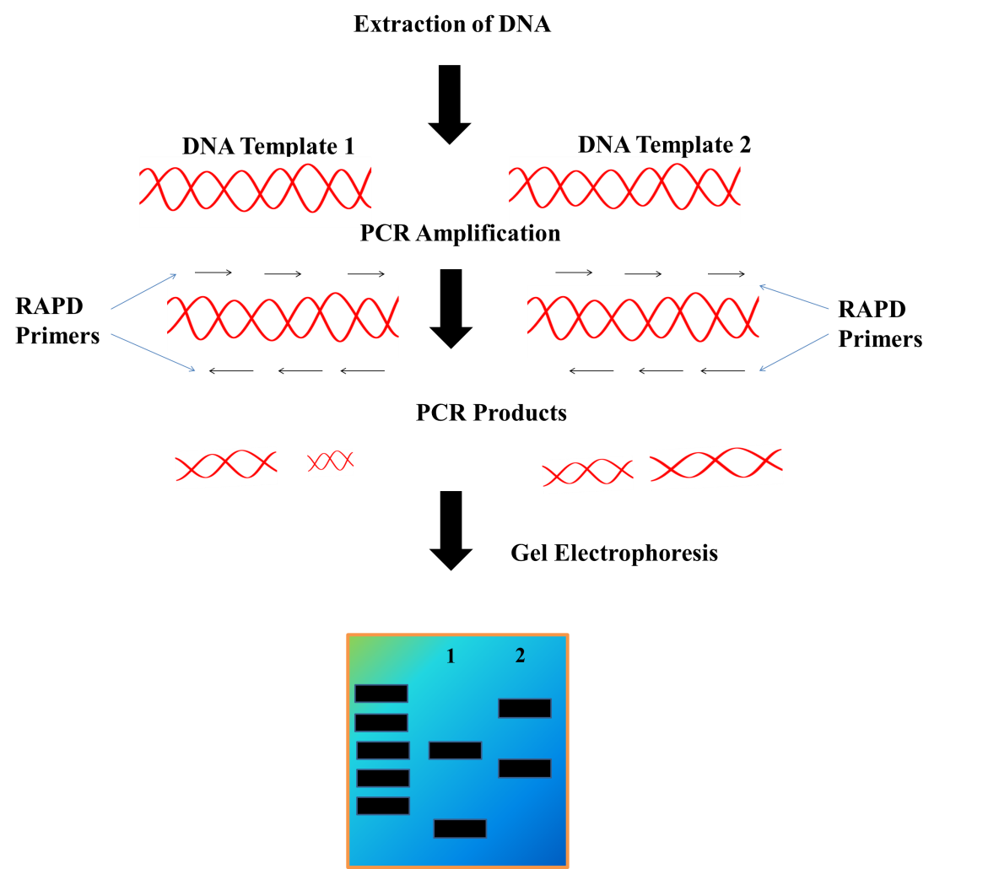
Figure2. The principle of RAPD

Inter simple sequence repeats (ISSRs)
Inter simple sequence repeat (ISSR) is the region which is present between two microsatellites (SSR). It is a multi-locus marker and in this technique region between two microsatellites (SSR) amplified using polymerase chain reaction. Inter Simple Sequence Repeats (ISSRs) are dominant in nature (does not distinguish heterozygotes from homozygotes) and used in genetic diversity, cultivar identification, evolutionary biology, gene tagging phylogeny and genome mapping studies (Pradeep et al., 2002). Compared to other dominant markers, such as RAPD, ISSR markers yield more polymorphic and repeatable bands and can produce results quickly and cost-effectively. (Wang et al., 1994, Borba et al., 2005). The universality and simplicity of the ISSR marker's development (without prior sequence knowledge) are its key advantages (Agostini et al., 2008, Jabbarzadeh et al., 2010). Design based on the microsatellite areas and high annealing temperature is the main reason why the ISSR marker is reproducible (Sandes et al., 2016).

Single nucleotide polymorphisms (SNPs)
Single nucleotide polymorphisms (SNPs) are also known as minisatellite are co-dominant markers, and these are molecular markers of the new generation and most often associated with genes, making them the most useful genetic markers in genetic studies (eg. genetic diversity analysis) (Jiang 2013). SNPs detect polymorphisms among individuals because of single nucleotide position changes. SNPs markers are abundant, co-dominant, locus-specific, and much more stable than other genetic markers. SNPs have recently received considerable attention because these markers are bi-allelic and occur much more frequently in the genome than other molecular markers. (Ren et al., 2013).
Restriction fragment length polymorphisms (RFLPs)
Genetic fingerprinting, profiling, and testing are other names for restriction fragment length polymorphisms (RFLPs), were the first developed molecular markers technique and now it is not widely used. It is a co-dominant marker and hybridization-based marker that use DNA fragments generated from genomic DNA by a specific restriction endonuclease. During the 1980s, RFLP markers were first created in the human genetic study and subsequently used in plant studies (Botstein et al., 1980, Weber and Helentjaris 1989). Compared to morphological or biochemical markers, RFLPs offer the opportunity to assess genetic diversity between individuals more precisely. The benefits of using RFLPs in crop breeding and linkage analysis include the ability to detect an infinite number of loci, co-dominant markers that are extremely reliable, but the drawbacks include labor-intensive, expensive, time-consuming, large amounts of DNA required for restriction, and limited polymorphism, especially in closely related lines. (Collard et al., 2005).
Start codon targeted (SCoT)
Start codon targeted (SCoT) is an important, simple, and helpful gene-targeted marker based on the short conserved plant gene region around the ATG translation initiation codon (Collard and Mackill 2009). SCoT markers use longer primers (18-mer) and can produce reproducible polymorphisms. SCoT markers are a dominant marker, do not require sequence data and are associated with functional genes and corresponding characteristics (Mulpuri et al., 2013). The concept of the SCoT marker is identical to ISSR and RAPD molecular markers because it uses forward and reverse primer (Nair et al., 2016). SCoT primers generate more polymorphisms compared to other dominant markers (RAPDs and ISR). SCoT markers are used for genetic diversity research, phylogenetic analysis, structural analysis, cultivars identification, quantitative trait loci (QTL), fingerprinting, variation and differentiation (Shekhawat et al., 2018, Feng et al., 2015, Gorji et al., 2012). Simple, quick, highly polymorphic, easy to use, universal primers, low cost, and gene-targeted markers are the advantages of SCoT markers. (Yang et al., 2019).
Sequence-characterized amplified region (SCAR)
It is a DNA fragment recognized by PCR amplification using two specific oligonucleotide primers. The two ends of RAPD markers are cloned and sequenced to create useful SCAR markers which are longer than RAPD primers. It has 18–25 bases in primers and in RAPD 10 bases in primers (Rajesh et al., 2013, Premkrishnan and Arunachalam 2016). When compare to RAPD, SCAR markers are more precise, and repeatable, only detect one locus and their amplification is less sensitive to reaction conditions. SCAR markers are species-specific techniques that may be used for molecular identification. These markers are co-dominant and PCR-based markers and can also be useful in the physical mapping (Bhagyawant 2016). The basic idea is to convert RAPD (dominant markers) into SCAR (co-dominant) because the use of RAPD markers has some limitations and disadvantages. (Yang et al., 2013).
Amplified fragment length polymorphism (AFLP)
Amplified fragment length polymorphism (AFLP) is also a DNA fingerprinting technique that employs DNA digestion by restriction enzyme followed by amplifying the subsets of genomic fragments in the special polymerase chain reaction and separation by electrophoresis on a polyacrylamide gel. (Vos et al., 1995). AFLP markers are dominant markers. AFLP markers are very helpful due to their robust, secure, highly reproducible, low price and detection of high polymorphism. For examine gene flow, population structure, evolution, genetic mapping, ploidy level, plant conservation research, hybridization, and introgression research, and to track herbicide-resistant biotypes, AFLPs is used (Slotta 2008).
Table1: Genetic diversity analysis by using Molecular markers
Molecular Marker | Plant | Observation / Results | References
AFLP Markers | Amaranthus palmeri | High levels of genetic diversity detected | Chandi et al., 2013
AFLP Markers | Croton antisyphiliticus | Polymorphism and genetic diversity was found | Oliveira et al., 2016
ISSR markers | Croton tetradenius | The markers were effective and showed polymorphism | Almeida-Pereira et al., 2017
ISSR markers | Melocanna baccifera (Roxb.) Kurz | Genetic diversity detected | Alansi et al.,2016
RAPD markers | Xylocarpus sp. | The markers provide an efficient tool for accessing and designing the conservation strategy of current interspecific genetic polymorphism in mangrove species | Pawar et al., 2013
RAPD markers | Caesalpinia pulcherrima (L.) Sw. | RAPD markers are not effective for detecting plymorphisms | Rodrigues et al., 2012
SSR Markers | Dalbergia odorifera | Genetic diversity detected | Liu et al., 2019
SSR Markers | Alnus cremastogyne | 14 Populations of A. cremastogyneare have a relatively high level of genetic diversity | Guo et al., 2019
SNP markers | Cowpea | The markers were efficient in the study of the diversity | Souleymane et al., 2018
SNP markers | Mimulus guttatus | A small number of SNPs can detect clonality patterns and wide-ranging relationships between native and introduced populations | Pantoja et al., 2017
RFLP markers | Brassica juncea | The markers showed high polymorphism levels | Mir et al., 2015
RFLP markers | Vigna radiata | A high level of polymorphism was found | Shahidul et al. 2015
SCoT markers | Durum wheat | Genetic variation detected | Etminan et al., 2016
SCoT markers | Rose | High degree of variation detected | Agarwal et al., 2019

Application of genetic diversity
In the last three decades, efforts have been created to detect genetic diversity of plants using molecular marker techniques. Genetic diversity is important for the development of improved recombinants is a key goal of any crop improvement strategy (Naik et al., 2006). Plant breeders have the chance to develop new and improved cultivars with desirable characteristics, including preferred traits of both farmers such as high yield potential, big seed, etc., and preferred traits of breeders such as resistance to pests and diseases, photosensitivity, etc. (Bhandari et al., 2017). Molecular markers are important in genetic diversity because they are highly informative and have helped to classify agronomic characteristics in wild, traditional and enhanced germplasm by dissecting quantitative traits (Lefebvre 2004).
Forests give a wide range of timber goods, panels, posts, poles, pulp and paper that are used in everyday life. Genetic and phenotypic diversity have been identified using molecular DNA-based techniques over the past 20 year (Tereba et al. 2017). Endangered tree species genetic diversity knowledge in any region of the globe can lead to the development of efficient conservation and future use policies (Gudeta 2018). Genetic diversity serves several important purposes, including as a resource for tree breeding and improvement programs for the development of well-adapted tree species and the improvement of genetic gain for many helpful characteristics, ensuring the health of trees as a whole by demonstrating their resilience to a variety of biotic and abiotic stressors under changing and unpredictable environmental and societal conditions (Porth et al., 2014).

Conclusion

The majority of conservation initiatives to date whether in situ or ex situ, have moved forward with little knowledge of the genetic diversity that was being saved, and it is vital to change this condition. Conservation of important plant species is important but without the knowledge of genetic diversity conservation is not effective. Traditionally, Genetic diversity is examined by using morphological markers and biochemical markers. These markers cannot define the exact level of genetic diversity because environmental variables affect morphological and biochemical parameter expression. On the other hand, genetic diversity at the DNA level is defined by molecular markers that are unaffected by environmental factors. Compared to other markers, molecular markers are quick, efficient, and reliable in that they clearly delineate genetic differences.
References

- Hughes AR, Inouye BD, Johnson MT, Underwood N, Vellend M. Ecological consequences of genetic diversity. Ecology letters. 2008 Jun;11(6):609-23.
- Carvalho YG, Vitorino LC, Souza UJ, Bessa LA. Recent trends in research on the genetic diversity of plants: implications for conservation. Diversity. 2019 Apr 18;11(4):62. doi:10.3390/d11040062.

- Kirk H, Freeland JR. Applications and implications of neutral versus non-neutral markers in molecular ecology. International journal of molecular sciences. 2011 Jun 14;12(6):3966-88.
- Szczecińska M, Sramko G, Wołosz K, Sawicki J. Genetic diversity and population structure of the rare and endangered plant species Pulsatilla patens (L.) Mill in East Central Europe. PloS one. 2016 Mar 22;11(3):e0151730.
- Ilves A, Lanno K, Sammul M, Tali K. Genetic variability, population size and reproduction potential in Ligularia sibirica (L.) populations in Estonia. Conservation Genetics. 2013 Jun;14:661-9.
- Thomas J, Vijayan D, Joshi SD, Lopez SJ, Kumar RR. Genetic integrity of somaclonal variants in tea (Camellia sinensis (L.) O Kuntze) as revealed by inter simple sequence repeats. Journal of Biotechnology. 2006 May 17;123(2):149-54.
- Neel MC, Ellstrand NC. Conservation of genetic diversity in the endangered plant Eriogonum ovalifolium var. vineum (Polygonaceae). Conservation Genetics. 2003 May;4:337-52.
- Soares AN, Vitória MF, Nascimento AL, Ledo AD, Rabbani AR, Silva AV. Genetic diversity in natural populations of mangaba in Sergipe, the largest producer State in Brazil. Genet. Mol. Res. 2016 Aug 19;15(3):1503-8624.

- Idrees MU, Irshad MU. Molecular markers in plants for analysis of genetic diversity: a review. European academic research. 2014;2(1):1513-40.
- Beckmann JS, Weber JL. Survey of human and rat microsatellites. Genomics. 1992 Apr 1;12(4):627-31.
- Naceur AB, Chaabane R, El-Faleh M, Abdelly C, Ramla D, Nada A, Sakr M. Genetic diversity analysis of North Africa’s barley using SSR markers. Journal of Genetic Engineering and Biotechnology. 2012 Jun 1;10(1):13-21.
- Pradeep Reddy M, Sarla N, Siddiq EA. Inter simple sequence repeat (ISSR) polymorphism and its application in plant breeding. euphytica. 2002 Nov;128:9-17.
- Wang Z, Weber JL, Zhong G, Tanksley SD. Survey of plant short tandem DNA repeats. Theoretical and applied genetics. 1994 Apr;88:1-6.
- Borba RD, Garcia MS, Kovaleski A, Oliveira AC, Zimmer PD, Castelo Branco JS, Malone G. Dissimilaridade genética de linhagens de Trichogramma Westwood (Hymenoptera: Trichogrammatidae) através de marcadores moleculares ISSR. Neotropical Entomology. 2005;34:565-9.
- Agostini G, Echeverrigaray S, Souza-Chies TT. Genetic relationships among South American species of Cunila D. Royen ex L. based on ISSR. Plant Systematics and Evolution. 2008 Sep;274:135-41.
- Jabbarzadeh Z, Khosh-Khui M, Salehi H, Saberivand A. Inter simple sequence repeat (ISSR) markers as reproducible and specific tools for genetic diversity analysis of rose species. African Journal of Biotechnology. 2010;9(37):6091-5.
- Sandes SS, Zucchi MI, Pinheiro JB, Bajay MM, Batista CE, Brito FD, Arrigoni-Blank MD, Carvalho SV, Silva-Mann R, Blank AF. Molecular characterization of patchouli (Pogostemon spp) germplasm. Genetics and Molecular Research. 2016.
- Molecular Markers in Plants for Analysis of Genetic Diversity: A Review. EUROPEAN ACADEMIC RESEARCH Vol. II, Issue 1/ April 2014.
- Mkada–Driss I, Lahmadi R, Chakroun AS, Talbi C, Guerbouj S, Driss M, Elamine EM, Cupolillo E, Mukhtar MM, Guizani I. Screening and characterization of RAPD markers in viscerotropic Leishmania parasites. PLoS One. 2014 Oct 14;9(10):e109773.
- Kumar NS, Gurusubramanian G. Random amplified polymorphic DNA (RAPD) markers and its applications. Sci Vis. 2011 Jul;11(3):116-24.

- Jiang GL. Molecular markers and marker-assisted breeding in plants. Plant breeding from laboratories to fields. 2013 May 22;3:45-83.

- Ren J, Sun D, Chen L, You FM, Wang J, Peng Y, Nevo E, Sun D, Luo MC, Peng J. Genetic diversity revealed by single nucleotide polymorphism markers in a worldwide germplasm collection of durum wheat. International journal of molecular sciences. 2013 Mar 28;14(4):7061-88.

- Botstein D, White RL, Skolnick M, Davis RW. Construction of a genetic linkage map in man using restriction fragment length polymorphisms. American journal of human genetics. 1980 May;32(3):314.
- Weber D, Helentjaris T. Mapping RFLP loci in maize using BA translocations. Genetics. 1989 Mar 1;121(3):583-90.

- Collard BC, Jahufer MZ, Brouwer JB, Pang EC. An introduction to markers, quantitative trait loci (QTL) mapping and marker-assisted selection for crop improvement: the basic concepts. Euphytica. 2005 Jan;142:169-96.

- Collard BC, Mackill DJ. Start codon targeted (SCoT) polymorphism: a simple, novel DNA marker technique for generating gene-targeted markers in plants. Plant molecular biology reporter. 2009 Mar;27:86-93.

- Mulpuri S, Muddanuru T, Francis G. Start codon targeted (SCoT) polymorphism in toxic and non-toxic accessions of Jatropha curcas L. and development of a codominant SCAR marker. Plant science. 2013 Jun 1;207:117-27.

- Nair AG, Vidya P, Mohan C. Analysis of genetic variability in sweet potato accessions using Start Codon Targeted (SCoT) polymorphism. International Journal of Biotechnology and Biochemistry. 2016;12(2):111-21.

- Shekhawat JK, Rai MK, Shekhawat NS, Kataria V. Start codon targeted (SCoT) polymorphism for evaluation of genetic diversity of wild population of Maytenus emarginata. Industrial Crops and Products. 2018 Oct 15;122:202-8.

- Feng S, He R, Yang S, Chen Z, Jiang M, Lu J, Wang H. Start codon targeted (SCoT) and target region amplification polymorphism (TRAP) for evaluating the genetic relationship of Dendrobium species. Gene. 2015 Aug 10;567(2):182-8.

- Gorji AM, Matyas KK, Dublecz Z, Decsi K, Cernak I, Hoffmann B, Taller J, Polgar Z. In vitro osmotic stress tolerance in potato and identification of major QTLs. American journal of potato research. 2012 Dec;89:453-6

- Yang S, Xue S, Kang W, Qian Z, Yi Z. Genetic diversity and population structure of Miscanthus lutarioriparius, an endemic plant of China. PloS one. 2019 Feb 1;14(2):e0211471.
- Rajesh MK, Jerard BA, Preethi P, Thomas RJ, Fayas TP, Rachana KE, Karun A. Development of a RAPD-derived SCAR marker associated with tall-type palm trait in coconut. Scientia Horticulturae. 2013 Feb 4;150:312-6.
- Premkrishnan BV, Arunachalam V. Database of predicted SCAR markers in five fruit and three vegetable crops. Journal of genetics. 2016 Mar;95(1):171-5.

- Bhagyawant SS. RAPD-SCAR markers: an interface tool for authentication of traits. Journal of Biosciences and Medicines. 2016;4(01):1.
- Yang L, Fu S, Khan MA, Zeng W, Fu J. Molecular cloning and development of RAPD-SCAR markers for Dimocarpus longan variety authentication. SpringerPlus. 2013 Dec;2:1-8.
- Vos P, Hogers R, Bleeker M, Reijans M, Lee TV, Hornes M, Friters A, Pot J, Paleman J, Kuiper M, Zabeau M. AFLP: a new technique for DNA fingerprinting. Nucleic acids research. 1995 Jan 1;23(21):4407-14.
- Slotta TA. What we know about weeds: insights from genetic markers. Weed science. 2008 Apr;56(2):322-6.
- Tereba A, Konecka A, Nowakowska JA. Application of selected molecular markers in studies on forest trees. Folia Forestalia Polonica. Series A. Forestry. 2017;59(2).
- Gudeta TB. Molecular marker based genetic diversity in forest tree populations. Forestry Research and Engineering: International Journal. 2018;2(4):176-82.
- Porth I, El-Kassaby YA. Assessment of the genetic diversity in forest tree populations using molecular markers. Diversity. 2014 Apr 4;6(2):283-95.
- Naik D, Sao A, Sarawgi AK, Singh P. Genetic divergence studies in some indigenous scented rice (Oryza sativa L.) accessions of Central India. Asian Journal of Plant Sciences. 2006.
- Bhandari HR, Bhanu AN, Srivastava K, Singh MN, Shreya HA. Assessment of genetic diversity in crop plants-an overview. Adv. Plants Agric. Res. 2017;7(3):279-86.
- Lefebvre V. Molecular markers for genetics and breeding: development and use in pepper (Capsicum spp.). InMolecular marker systems in plant breeding and crop improvement 2004 (pp. 189-214). Berlin, Heidelberg: Springer Berlin Heidelberg.
- Chandi A, Milla-Lewis SR, Jordan DL, York AC, Burton JD, Zuleta MC, Whitaker JR, Culpepper AS. Use of AFLP markers to assess genetic diversity in Palmer amaranth (Amaranthus palmeri) populations from North Carolina and Georgia. Weed Science. 2013 Mar;61(1):136-45.
- Oliveira TG, Pereira AM, Coppede JS, França SC, Ming LC, Bertoni BW. Genetic diversity analysis of Croton antisyphiliticus Mart. using AFLP molecular markers. Genet Mol Res. 2016 Jan 1;15(1):1-8.
- Almeida-Pereira CS, Muniz AV, Alves RP, Feitosa-Alcantara RB, Arrigoni-Blank MD, Carvalho SV, Costa TS, White LA, Pinto VD, Sampaio TS, Blank AF. Genetic diversity of native populations of Croton tetradenius Baill. using ISSR markers. Genetics and Molecular Research. 2017.
- Alansi S, Tarroum M, Al-Qurainy F, Khan S, Nadeem M. Use of ISSR markers to assess the genetic diversity in wild medicinal Ziziphus spina-christi (L.) Willd. collected from different regions of Saudi Arabia. Biotechnology & Biotechnological Equipment. 2016 Sep 2;30(5):942-7.
- Pawar UR, Baskaran J, Ajithkumar IP, Panneerselvam R. Genetic variation between xylocarpus spp.(meliaceae) as revealed byrandom amplified polymorphic DNA (RAPD) markers. Emirates Journal of Food and Agriculture. 2013:597-604.
- Rodrigues MG, Mazzini RB, Pivetta KF, Alves MD, Desidério JA. Characterization of the genetic variability among Caesalpinia pulcherrima (L.) Sw.(Fabaceae) plants using RAPD molecular markers. Acta Scientiarum. Agronomy. 2012;34:259-63.
- Liu F, Hong Z, Xu D, Jia H, Zhang N, Liu X, Yang Z, Lu M. Genetic diversity of the endangered Dalbergia odorifera revealed by SSR markers. Forests. 2019 Mar 3;10(3):225..
- Guo HY, Wang ZL, Huang Z, Chen Z, Yang HB, Kang XY. Genetic diversity and population structure of Alnus cremastogyne as revealed by microsatellite markers. Forests. 2019 Mar 21;10(3):278.
- Souleymane O, Jean-Baptiste T, Bao-Lam H, Kusi F, Poda SL, Timothy J, Philip R, Danquah E, Ofori K, Tinga Jeremy O. Single nucleotide polymorphism (SNP)-based genetic diversity in a set of Burkina Faso cowpea germplasm. African Journal of Agricultural Research. 2018 May 10;13(19):978-87.
- Pantoja PO, Simón-Porcar VI, Puzey JR, Vallejo-Marín M. Genetic variation and clonal diversity in introduced populations of Mimulus guttatus assessed by genotyping at 62 single nucleotide polymorphism loci. Plant Ecology & Diversity. 2017 Jan 2;10(1):5-15.
- Mir JI, Shahidul I, Rajdeep K. Evaluation of genetic diversity in Brassica juncea (L.) using protein profiling and molecular marker (RFLP). International Journal of Plant Breeding and Genetics. 2015;9(2):77-85.
- Shahidul I, Mir JI, Rajdeep K. Evaluation of genetic diversity in Vigna radiata (L.) using protein profiling and molecular marker (RFLP). International Journal of Plant Breeding and Genetics. 2015;9(4):238-46.
- Etminan A, Pour-Aboughadareh A, Mohammadi R, Ahmadi-Rad A, Noori A, Mahdavian Z, Moradi Z. Applicability of start codon targeted (SCoT) and inter-simple sequence repeat (ISSR) markers for genetic diversity analysis in durum wheat genotypes. Biotechnology & Biotechnological Equipment. 2016 Nov 1;30(6):1075-81.
- Agarwal A, Gupta V, Haq SU, Jatav PK, Kothari SL, Kachhwaha S. Assessment of genetic diversity in 29 rose germplasms using SCoT marker. Journal of King Saud University-Science. 2019 Oct 1;31(4):780-8.

