“USE OF PLASTIC IN BITUMEN FOR CONSTRUCTION OF ROAD”

Prof.Mrs.A.P.Chougule.
Faculty of Civil Engineering Department Dr J.J.Magdum College of Engineering, Jaysingpur.
Kolhapur , Tal - Shirol
Email- arati.chougule@jjmcoe.ac.in

Prof. Mahendra Umare
Faculty of Civil Engineering Department
KDK College of engineering, Nagpur.
Dist – Nagpur.
Email- mnu72@rediffmail.com

Abstract: The use of plastic in bitumen will allow for the utilization of waste plastic materials it increases the quality of the road in this case plastic bitumen can reduce the overall cost of the project since plastic bitumen can increase the life of the road & reduce the long term maintenance requirement it should provide long term cost saving to the agency when the proper use of plastic bitumen in construction of a road.
In this project, we have to increase the concentration of plastic & decrease the concentration of bitumen by taking different concentration ratios of plastic & bitumen. We have to design the module of plastic bitumen blend which have all the standard properties of the regular bitumen by taking a different test like flash fire point, penetration etc, on plastic bitumen blend.
Keywords: - plastic, bitumen, plastic bitumen blend
1. INTRODUCTION
Plastic is everywhere in the world. In every industry plastic is used as a main component like packing material in building construction, in making toys etc. Also in the automobile industry plastic materials are widely used all over the world. Nowadays plastic is widely used in plastic bottles, used for mineral water packing, cold rinks storage, detergent storage etc. After use of that bottle for a one-time purpose they are thrown here and there. And that creates pollution. By using these plastic bottles in bitumen we can increase the strength of the road. If the plastic is added in proper proportion to the bitumen the life span of the road would be increased. It can save money and also protects the environment. In various countries, the plastic is used in road construction.
The proper use of these materials can help to build an economical road. The maximum proportion of plastic in plastic bitumen blend can help strong and durable roads.
II. OBJECTIVES
1. To reduce the quantity of bituminous and to increase the quantity of plastic in the construction of flexible pavement.
2. To increase the life span of the road.
3. To reduce the overall cost of the road.
4. To test the bitumen and modified bind.

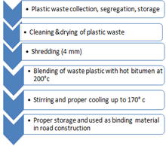
III. LITERATURE REVIEW
1. Dr R. Vasudevan (2007) In his research article, he concluded that a polymer bitumen blend surpasses regular bitumen in terms of binding. Blend reduces bitumen penetration while raising softening point. It boosts the temperature of the road when used in road construction. Plastic coating improves soundness by reducing porosity and moisture absorption. The use of waste plastic on the road has a number of advantages, including garbage disposal, improved road conditions, and pollution presentation, to name a few.
2: "Plastic Waste in Pavement Construction," Anzar Hamid Mir (2015). He notes that the complicated modulus phases of binder angles, which must be evaluated at various temperatures, loading rates that are similar to weather, and climatic variables are all part of the binder's viscous elastic nature.
3: "Economics and Viability of Plastic Road" by Amit P. Gowanda (2013). Polymer modified bitumen is employed in that research report because it performs better, although a higher percentage of polymer bitumen blend results in more polymer dispersion in bitumen, which separates on cooling and may damage the qualities and quality of the road.
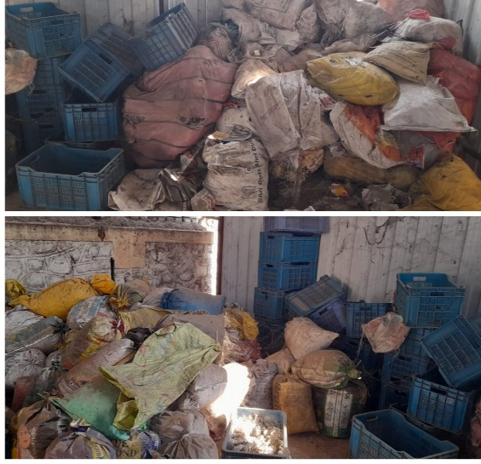
4: S.S. Verma (2008) Plastic has been shown to raise the melting point of bitumen. This technique not only hardens the road but also extends its life.
5: S. Vasudevan and S. Rajasekaran (2006) investigate the polymer bituminous blend as a superior binder than plain bitumen. The combination raised bitumen softening point while decreasing penetration value with appropriate ductility.
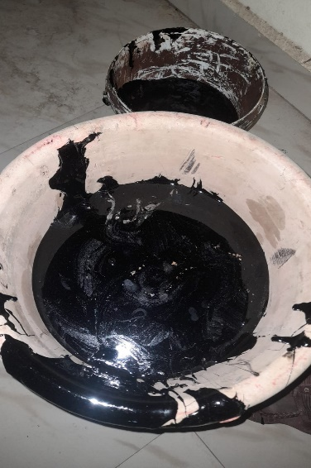
IV. MATERIAL USED AND COLLECTION OF MATERIAL
The following materials are used in the manufacturing of plastic bitumen blends. Waste poly bags, waste plastic bottles, and bitumen are the main materials used for making plastic bitumen blend.
A: POLY BAGS &WASTE PLASTIC BOTTLES: Low-density polyethene bags or plastic bags, as well as waste plastic bottles, are examples of waste that can be found in the environment. People frequently use these types of bags to transport items and daily necessities. Because they are lightweight, they can carry a sufficient amount of objects with adequate strength. The researchers had put in a lot of effort to include plastic into the construction material. This polybasic waste of low-density polyethene is discovered at the dumping area and the region where large plastic bags are gathered. Because of the environmental issues caused by these waste LDPE poly bags, they must be appropriately disposed of utilising plastic management procedures or recycled.
B: BITUMEN: Bitumen is a crude oil of low grade that is composed of complicated, heavy hydrocarbons. A thick, viscous fluid called bitumen needs to be extracted from the ground in an oil reserve. To get rid of it and transform it into a better product requires a lot of heat and work. Bitumen can spontaneously bubble to the surface of the Earth in petroleum spills, despite the fact that it is difficult to remove from the ground. Instead of being imprisoned deep inside the Earth, fossil fuels and petroleum products escape from the planet through these seeps. In these seeps, bitumen, asphalt, and tar bubble up into pools. In addition, the main fossil fuel component of oil sands is bitumen. When bitumen and asphalt combine, a solid that can be used to pave roadways is generated.
V. TESTS ON MATERIALS

1. Penetration
2. Flash & Fire point test
3. Viscosity

RESULTS
- For 15% plastic in the blend
TEST | RESULT | RANGE
PENETRATION | 23 | 60-70
FLASH & FIRE POINT. | 305  320 | 250-300
VISCOSITY | 601 | 550-600

2. For 20% plastic in the blend
TEST | RESULT | RANGE
PENETRATION | 23 | 60-70
FLASH & FIRE POINT. | 305  320 | 250-300
VISCOSITY | 640 | 550-600

4. For 30 % plastic in the blend
TEST | RESULT | RANGE
PENETRATION | 23 | 60-70
FLASH & FIRE POINT. | 305  320 | 250-300
VISCOSITY | 701 | 550-600

VI. CONCLUSION
- When the plastic is replaced by bitumen using 30%, the standard range exceeds. Hence, we conclude that plastic bitumen blend with 30% plastic is not suitable for road construction purposes.
- Now the plastic is replaced by bitumen using 20%, and the results of the test exceed the permissible range by a small percentage.
- Lastly, the plastic is replaced by bitumen using 15%, and the results of the test are found in between the permissible range

Hence our conclusion is the replacement of plastic with bitumen using 15% is suitable for road construction purposes.
REFERENCES
- Amit Gawande, G.S Zaire, V.C Range G.R Bharsakalea and Saurabh Tayde, utilization of waste plastic in the asphalt of roads, scientific reviews and chemical communication
- Dr S.S. Verma, “Road from Plastic State. Science Tech Entrepreneur, March 2008 Gianni A.K. Mode, A.J., “Bio Enzymatic Soil Stabilizers for Construction of Rural Roads”, International Seminar on Sustainable Development in Road Transport, New Delhi-India 8-10November 2001
- Dr Salish Chandra, Shiv Kumar & Rajesh Kumar An ad, “Soil Stabilization with Rice Husk Ash and line Sludge”, India Highways, Indian Roads Congress, vol. 33 No. 5, May 2005, pp.87-98
- Dr. Vasudevan and S. Rajasekaran, (2007). ‘Utilization of Waste Plastics in Construction of Flexible Pavements (Reuse of waste plastics – a path-breaking initiative)’
- Use of waste Plastic in Construction of bituminous road.”( Vol. 4 No.05 May 2012) (International Journal of Engineering Science and Technology (IJEST)
- Vasudevan, Rajasekaran, S.Saravanavel, “Reuse of Waste Plastics for Road Laying” Indian Highways, (Journal of Indian Roads Congress) Vol. 34. Issue 7, Page No: 5 – 20 July 2006.
- Vera S.S. (I.C.J.), (2008). ‘Roads from plastic waste

