**R SOFTWARE UTILIZED FOR STATISTICAL ANALYSIS OF DIETARY FIBER DETERMINATION OF NANOCRYSTALS AND ANALYTICAL SIGNIFICANCE OF SHAPIRO-WiIK TEST.**

**CHAYA G\***

**Department of Chemistry, Bharathi College Post Graduate & Research Centre, Bharathinagara, Mandya District – 571422, Affiliated to University of Mysore, Mysuru, Karnataka, India**

**Tel: + 91 9740140864. E-mail address:** [**chayaguruswamy97@gmail.com**](mailto:chayaguruswamy97@gmail.com) **(Chaya G)**

**CHAYA G: ORCID :** https://orcid.org/0000-0002-9426-743X

**ABSTRACT**

The potential use of agro based nutraceuticals of Coriander sativum seed synthesised enzymatically to obtained a nanocrystals. The potential use of agro based nutraceuticals nanomaterials for drug delivery, nanofillers, as agro-foods and biomedical applications. The raw materials of agro based nutraceutical principal active component of coriander seed fabrication of amorphous nanocrystal powder obtained by processing under optimized condition. Statistical data done by using ‘R software Packages CRAN. R software is an integrated suite for calculation, data analysis, graphical display functions of input and output operators ;user -defined functions with simple and effective programming language. The normality distribution done using Shapiro-wilk test.

Keywords: R software, nanocrystals, nutraceuticals, shapiro-wilk test.

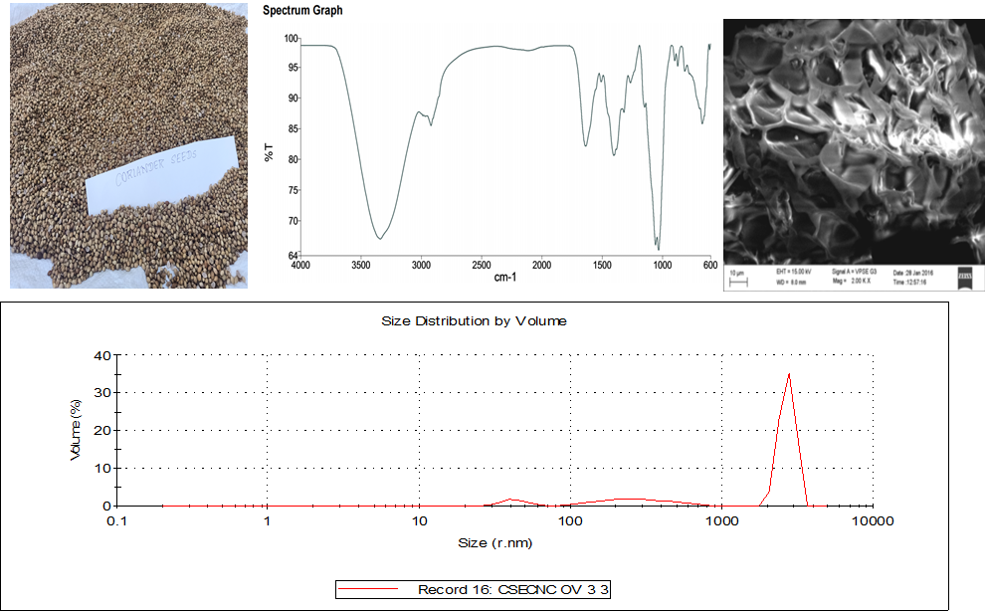

Graphical Abstract

**INTRODUCTION**

New Statistical Procedure for testing a complete sample for Normality. (**Shapiro and wilk 1965**) test statistic obtained by dividing the square of an appropriate linear combination of the sample order statistics by the usual symmetric estimate of variance. The W test for normality indication of Probability plots. In a Probability plot the regression of the observations on the expected values of order statistics from a Standardized of the hypothesized distribution plot tending to be linear if the hypothesis is true (**Shapiro and wilk 1965**).

To perform a shapiro-wilk test on a dataset with sample size n=100 in which the Poisson distribution values were obtained. Shapiro – Wilk’s test is a normality test. Suppose a sample attained a1, a2, a3…..an from normally distributed population. the p value ranges indicate equal to P or below 0.05 rejected in the hypothesis for the normality.

Shapio –wilk’s test null hypothesis test equations 1 & 2 **( Baris Guner et.al Vol.X,No.X, Month XXXX)** :

W= ……(1)

m 1= 1/N

**STATISTICAL METHOD FOR ANALYSING THE DATA**

Syntax: **Sample t-test/ Welch test:**

R code for t-test

t.test(x, y=NULL, alternative= c(“ two.sided”, “less”,”greater”), mu=0, paired=FALSE, var.equal=FALSE, conf.level = 0.95,…..)

Running t-test for the data set:

t.test(nano_data, y=NULL, alternative=c(“greater”),mu=4.1,paired=FALSE, var.equal=FALSE,conf.level=0.95)

Kruskal.test(): used to perform Kruskal- Wallis test as alternative to ANOVA.

Similarly, the same function can be used to test other hypotheses. As per the standard procedure, one has to check the assumption of normality before using t-test. The following code is used to test the assumption of normality. We use Shapiro-wilk test for normality. Here the null hypothesis we test the variable follows normal distribution.

library(readxl)

> nano_data <- read_excel("C:/Users/lenovo/Desktop/nano.data.xlsx")

> View(nano_data)

> nano_data=runif(100)

> nano_data=rnorm(100)

> qqnorm(nano_data);qqline (nano_data)

> shapiro.test(nano_data)

Shapiro-Wilk normality test

data: nano_data

W = 0.98911, p-value = 0.5936

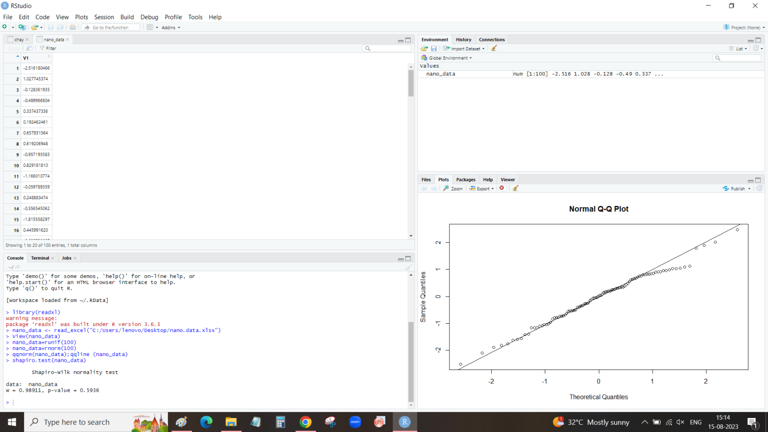

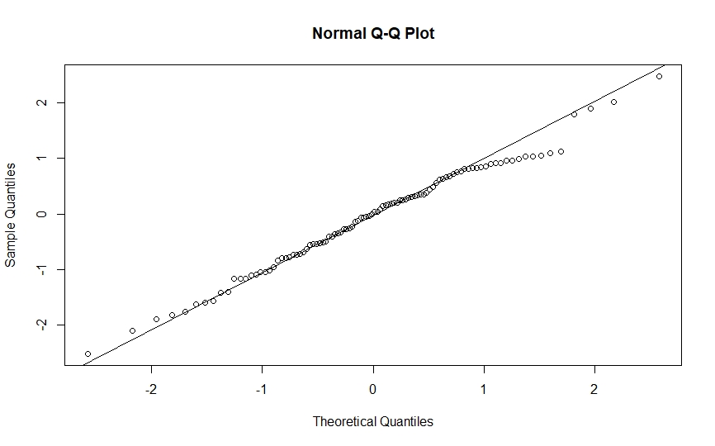

Agro- based Nutraceutical nanocrystal Q-Q plot using R studio Programme software.

Based on the F-test , we conclude that the equality of variances is satisfied by the data.

**RESULTS AND DISCUSSION**

Mathematical Operation: equation 2 A polynomial equation in coded term (**Mitali et.al 2021);**

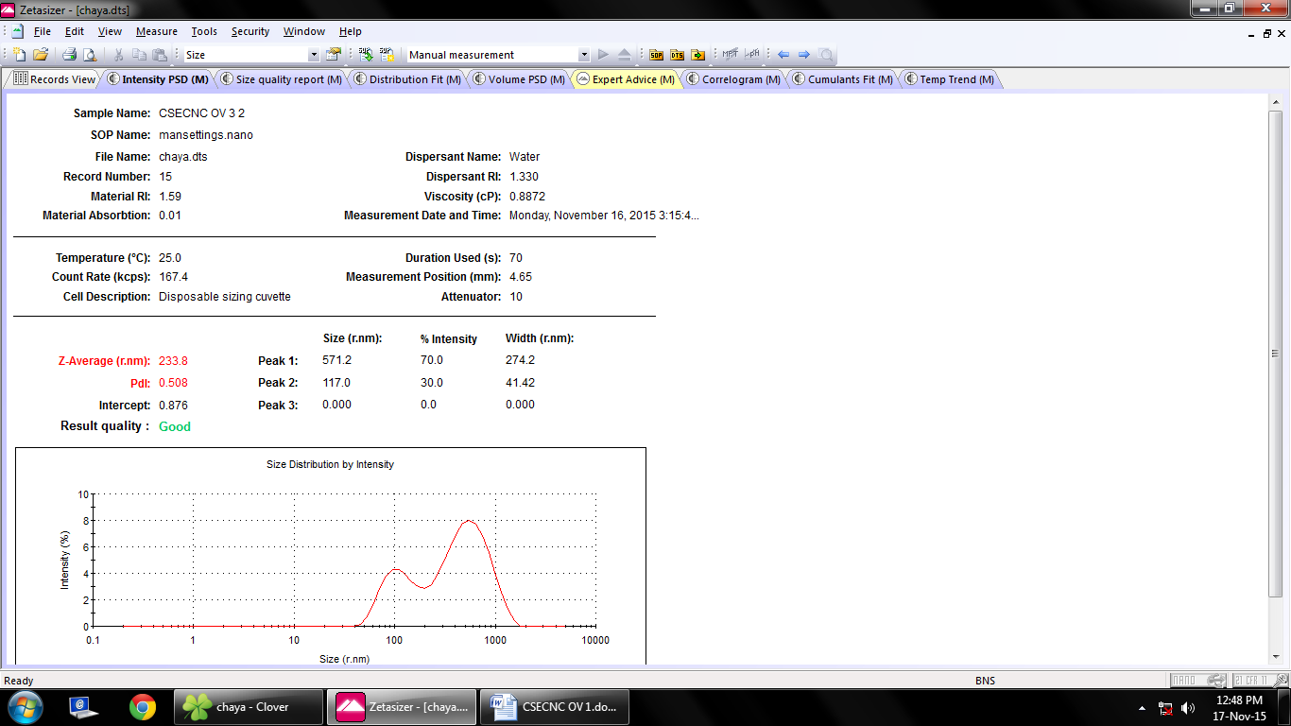

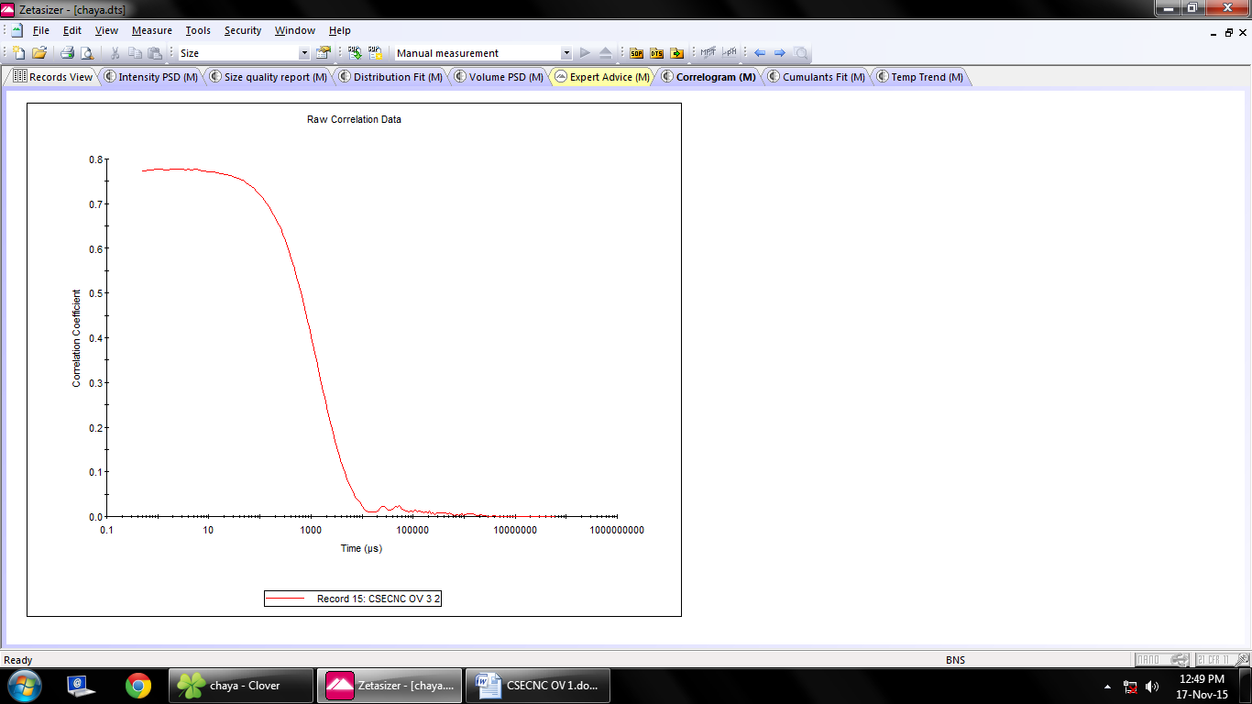

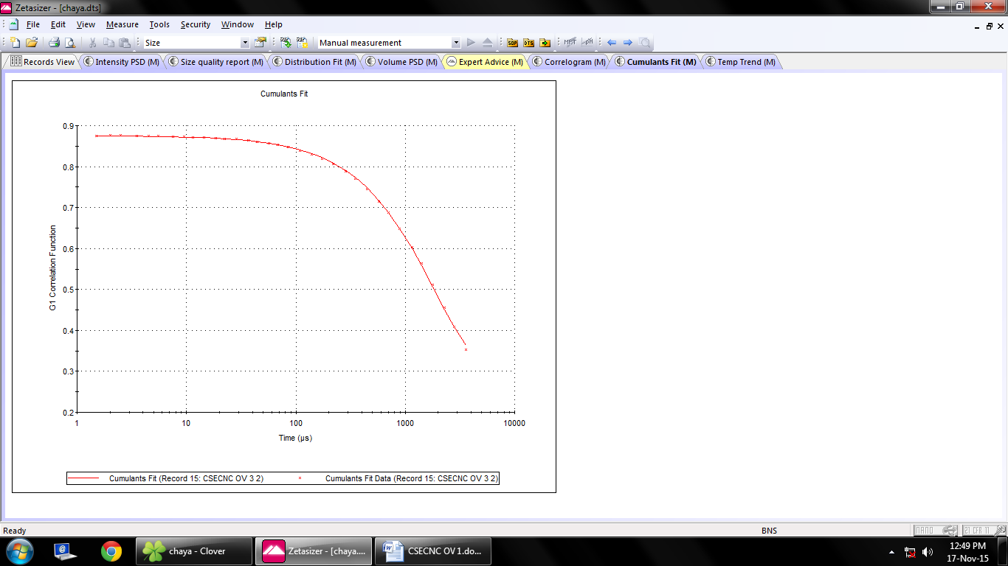



**Intensity PSD [M]**





Distribution Fit [M]



**Volume PSD [M]**



**Correlogram [M]**



**Cumulant Fit [M]**

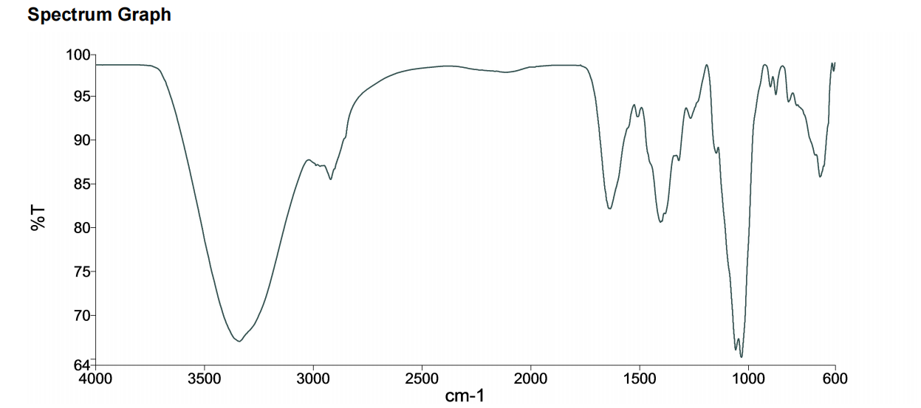

**ATR-FTIR Agro-based Nutraceutical Nanocrystal FTIR Spectrum**

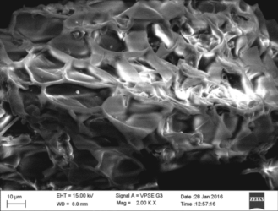

**SEM image of Agro-based Nutraceutical Nanocrystal**

**CONCLUSION**

The R built in function used various test for normality using Shapiro-Wilk test , F-test conclude equality of variances, used t-test followed by Welch -test; further like to conclude that in statistical data analysis if variable normality not satisfied then Mann-Whitney U test had been useful. The non-parametric test by Wilcoxon-signed rank sum test.

REFERENCES

1. Mitali sarkar,shanku Denrah, manisha das, Mahadeb Das (2021)Statistical optimization of bio-mediated silver nanoparticles synthesis for use in catalytic degradation of some azo dyes, Chemical physics impact, volume3, December 2021.
2. Vancha Harish , Devesh Tewari , Manish Gaur , Awadh Bihari Yadav ,* , Shiv Swaroop , Mikhael Bechelany ,* and Ahmed Barhoum ,*(2022), Review on nanoparticles and nanostructured materials: bioimaging, biosensing,drug delivery,tissue engineering,antimicrobial,and Agro-food applications. Nanomaterials 2022
3. Nikolay Sirotkin and Anna Khlyustova *(2023), plasma synthesis and characterization of PANI + WO3 Nanocomposites and their supercapacitor applications, Journal of composite Science, 7,174.
4. S. S. Shapiro; M. B. Wilk (Dec., 1965), An Analysis of Variance Test for Normality (Complete Samples)*Biometrika*, Vol. 52, No. 3/4. (Dec., 1965), pp. 591-611.
5. Baris Guner, Mark T. Frankford ,and Joel T.Johnson,IEEE TRANSACTIONS ON GEOSCIENCE AND REMOTE SENSING, VOL. X, NO. X, MONTH XXXX , A Study of the Shapiro-Wilk Test for the Detection of pulsed sinusoidal Radio Frequency Interference.
6. J. Uttley (2019) Power Analysis, Sample Size, and Assessment of Statistical Assumptions—Improving the Evidential Value of Lighting Research, LEUKOS, 15:2-3, 143-162,
7. Juris Meija1, Michael Bushell1, Martin Couillard1, Stephanie Beck2, John Bonevich3, Kai Cui4, Johan Foster5, John Will5, Douglas Fox6, Whirang Cho6, Markus Heidelmann7, Byong Chon Park8, Yun Chang Park9, Lingling Ren10, Li Xu10, Aleksandr B. Stefaniak11, Alycia K. Knepp11, Ralf Theissmann12, Horst Purwin12, Ziqiu Wang13, Natalia de Val13, Linda J. Johnston1,* (2020), Particle size distributions for cellulose Nanocrystals measured by Transmission electron Microscopy: an interlaboratory comparison, *Anal Chem*. 2020 October 06; 92(19): 13434–13442.

1. Byoungsang Lee, Seokyoung Yoon, Jin Woong Lee, Yunchul Kim, Junhyuck Chang, Jaesub Yun, Jae Chul Ro, Jong-Seok Lee, and Jung Heon Lee* (2020), Statistical Characterization of the morphologies of Nanoparticles through Machine learning based Electron Microscopy image Analysis, ACS Nano 2020,14,17125-17133.
2. Emily M. Williamson, Zhaohong Sun, Lucía Mora-Tamez, and Richard L. Brutchey* (2022), Design of Experiments for Nanocrystal syntheses: A How-to Guide for Proper Implementation, *Chem. Mater.* 2022, 34, 9823−9835.
3. Justine Rochon* , Matthias Gondan and Meinhard Kieser (2012), To test or not to test: Preliminary assessment of normality when comparing two independent samples,BMC Medical Research Methodology 2012, 12:81