**Concept of fermentation process**

Devanshi Trivedi1 and Hiral Shah2

Department of microbiology1, Ananya Institute of Science, KIRC campus, Kalol-382721

Department of microbiology2, Ananya Institute of Science, KIRC campus, Kalol-382721

**An introduction to fermentation**

Fermentation is a technology that has been around for as long as human history. The Latin word 'fervere', which means 'boiling',is the origin of the term 'fermentation'.Fermentation occurs when certain substances are broken down into simpler compounds with the help of microorganism. The French chemist Louis Pasteur discovered term fermentation technology and it is known as zymology. Initially, humans developed fermentation technology as a means of preserving food materials like fruit, vegetables, and meat during shortage of food. Over time, humans have empirically demonstrated that fermentation is not only a way to preserve food but also a way to transform food into food and beverages with sensory characteristics. Furthermore, researcher also find bioactive compounds like antibiotics, pigments, antioxidants, antitumor agents, and biosurfactants have been produced by this technique at an industrial level. Fermentation is another way to make chemical products, such as acetic acid, citric acid, and ethanol.The main process of fermentation depends on the concentration of microorganisms, cells, cellular components, enzymes as well as temperature, pH and oxygen for aerobic fermentation.The vast majority of commercially available enzymes, including lipases, invertases and rennet are also produced by fermentation with a GMO microorganism.

**Chronological development of fermentation technology**

The history of fermentation technology in India dates back more than 3,000 years, according to the literary texts. In India, Soma juice is the first product of fermentation made by Vedic Aryans**.**. Another beverage known as Sura (wine/beer), made through fermentation, is also available. Therefore, it is thought that India has known about fermentation since ancient times. In Rigveda, mention that Curd is another popular product of fermentation.Initially, fermentation was mainly associated with the preparation of spiritual drinks, but later it began to be used for other purposes as well.

Louis Pasteur showed that fermentation is introduced by living organisms in a series of experiments during the 1850s and 1860s. In 1857, He find out living organisms plays vital role for formation of lactic acid fermentation. Additionally, he found that bacteria cause milk to soured, and his understanding of the role of microorganisms in food spoilage resulted in the development of pasteurization process in 1860. He also working in brewing industry and published his paper “Studies on fermentation” in 1879. Pasture perform different types of experiments and noticed that particular microorganisms cause specific end-products in fermentation process.

Microorganisms that could undergo physical and chemical changes to become higher-yielding, faster-growing, tolerant of less oxygen, and able to use and increase medium concentration were discovered in the 1970s. Selection of bacterial strain is useful for food fermentation. However, advance research in fermentation industry has been done by biotechnology company name as BioTork which develops technique to improve fermentation processes with the help of microorganisms.

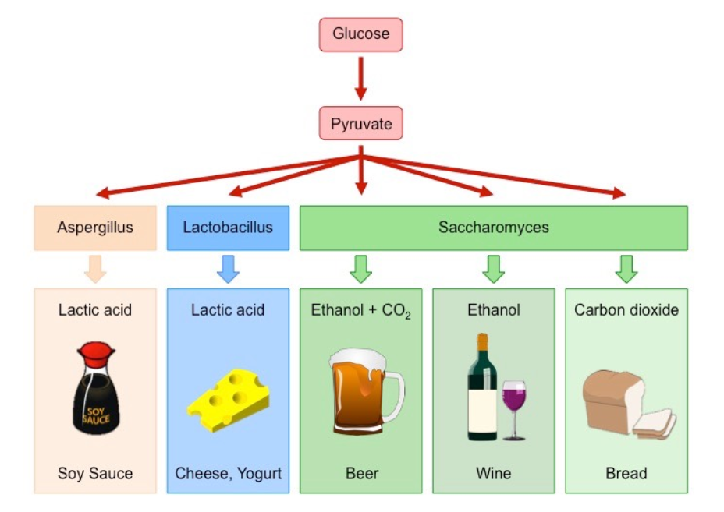

**Figure: 1.1** Production of Fermented Foods by Bacteria and Yeast (*Saccharomyces*)

(yeast fermentation – Bioninja)

**Screening of Industrially important Microbes:**

To find and isolate metabolite-producing microorganisms from a large microbial population, screening is a highly selective procedure.

**Primary Screening:**

Detection and Isolation of industrial important microorganism is known as Primary screening. Secondary screening, which may take a qualitative or quantitative approach, comes after primary screening. Perform secondary screening in flasks, agar plates, small fermenters with liquid media, or by combining these methods. However, the quantitative analysis revealed that yields of antibiotic could be anticipated when the microorganism is grown in different media, whereas the qualitative analysis focused on the ability of microorganisms that are sensitive to a recently discovered antibiotic.

**Secondary Screening:**

Secondary screening should provide the information necessary to assess the true potential for industrial use of a microorganism. It should establish whether the microbes are really generating novel chemical substances that haven't been identified before. Secondary screening should provide information as to whether a particular microorganism possesses pH, aeration, or other critical requirements for both microbial growth and chemical product formation. Secondary screening aims to show whether the product resulting from microbial fermentation is present in multiple chemical forms in the culture medium and whether it is an optically or biologically active substance. The ability of microorganisms to chemically alter or destroy their own fermentation products is another thing we need to investigate.

**Design of Industrial Fermenters (Bioreactors)**

A bioreactor, also known as a fermenter, is essentially a sizable container with a thick stainless steel body used for the culture of microorganisms. A fermenter's primary purpose is to offer a controlled environment for the growth of a microorganism in order to produce a desired product. An ideal feature of bioreactors is the provision and control of various operations such as temperature, pH, aeration and agitation system, lower evaporation rate, minimum power consumption, suitable sampling facilities, use of the cheapest material, aseptic operation or restricted by the containment for a long period during the entire operation, small and larger ships, ships with minimal labor in maintenance, cleaning, operation and harvesting operations, etc.

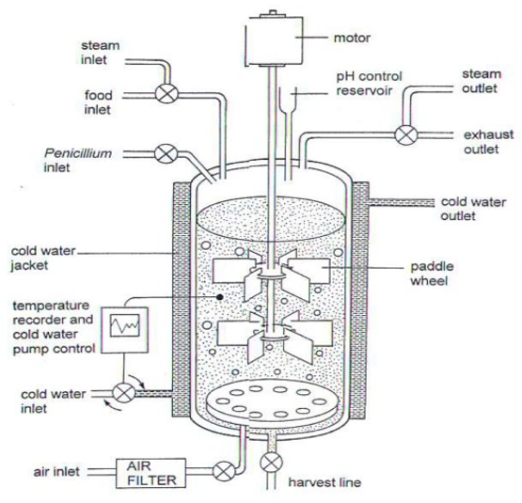

**Fig. 1.2: A typical bioreactor** **(https://wiki2.org/en/Bioreactor)**

Figure 1.2 A show the different part of Bioreactor.

A bioreactor is a large container, usually made of a thick stainless steel body, to contain large amounts of culture broth and the pressure that can sometimes be produced during gas production. During fermentation process, the fermentation medium, air, and equipment are sterilized to avoid biological contamination. Design of bioreactor should be completely free from leakages; otherwise long-term operations will be difficult and contaminations will occur. Anti-foam agents are also added during the procedure to control of foam. It also makes it easier to monitor and control dissolved oxygen. Bioreactors ensure proper aeration and agitation of the fermentation broth so that microbial metabolism occurs at optimal levels. Recently developed fermenters are usually connected to computers to enable efficient processes such as monitoring and data collection.

**Fermentation Process:**

**Downstream processing**

**Upstream processing**

Fermentation Process

Fermentation Raw Material

Production microorganism

Fermentation

Product

Product purification

Effluent wastes

**Figure 1.3: Schematic diagram of fermentation process (www.kaliganjgovtcollege.ac.in)**

**Fermentation process can be divided in three stages.**

**Stage I:** Stage 1 is referred to as the Upstream Process and involves the preparation of a liquid medium, the removal of particulate matter and chemical inhibitors from the medium, sterilization, the purification of the air, etc.

**Stage II:** Fermentation which involves the substrates are transformed into the desired product during fermentation. with the help of microorganisms.

**Stage III:** The downstream process takes place in stage three. cells are removed from the fermentation broth or media, the desired product is purified and concentrated, and waste is disposed of or recycled.

A fermenter is necessary for the fermentation process because it gives the organism growing inside of it the ideal pH, temperature, oxygen, and other environmental conditions that are required for successful production

**Fermentation and its types**

Fermentation is the chemical transformation of organic substances into simplex compounds under the influence of microorganisms like bacteria, yeast, or mold. fermentation process defines in two ways. One is aerobic and another is anaerobic. Aerobic fermentation means intentionally mixing air into the medium. Microaerobic means that air is initially present but is then consumed or replaced by microbial growth. Anaerobic fermentation, on the other hand, sees oxygen being removed and intentionally excluded from the fermentation medium, as it is toxic to cells. Various microorganisms have the property of producing certain compounds and synthesizing metabolites in the culture medium as a result of the oxidation of monosaccharides, mainly glucose, under both aerobic and anaerobic conditions.

**Two broad fermentation techniques have emerged as a result of this rapid**

**development:**

Fermentation is classified into two types based on the substrate used as follows

Solid State Fermentation (SSF).

Submerged Fermentation (SmF).

**Solid State Fermentation (SSF).**

Solid-state fermentation (SSF) is a Fermentation technique in which substrate as a solid material or the inert support of microorganisms growing on it. The SSF technique was created to manufacture conventional foods and alcoholic beverages, but it has since expanded to include the pharmaceutical and biochemical sectors.

Solid substrates for SSF are made from primary raw materials like cereal grains, wheat bran, sawdust, wood shavings, and various other plant and animal materials. The best raw materials for SSF are fungi and actinomycetes because they produce more biomass and reach to hyphae. Later, numerous bacterial and yeast species were employed to carry out such fermentation.

This method has recently been used to produce extracellular enzymes, some useful chemicals, fungal toxins, and fungal spores. In solid substrate fermentation, the surface of the solid is where the majority of the microbial growth and product formation takes place The SSF's microbiological components can exist as isolated, pure cultures, mixed, distinguishable cultures, or completely mixed native microorganisms. Faster development of specific mold, yeast, or bacteria cultures, whether in pure or mixed cultures, should be possible in solid state fermentation when there is a solid or gas interface. Small, fibrous or granular particles that do not break easily or stick together are essential for the solid matrix's main characteristic.

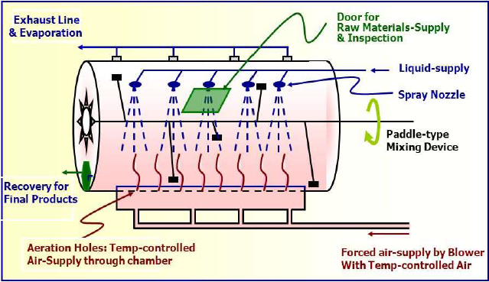

**Figure 1.4: Design of Solid-state fermentation** **(www.mlsu.ac.in)**

* The SSF involves a number of steps, including the following ones:
* Raw materials are pretreated using a variety of methods, including mechanical, chemical, and biochemical ones, to increase the availability of the bound nutrients and also to reduce the size of the components
* Hydrolysis of primarily polymeric substrates,
* Utilization (fermentation) of hydrolysis products.
* Separation and purification of end products.
* However, serious problems arise with respect to mixing, heat exchange, oxygen transfer, moisture control and gradients of pH, nutrient and product as a consequence of the heterogeneity of the culture.

The second disadvantage of SSF is that it makes it difficult, laborious, and often inaccurate to measure and control the parameters mentioned above, which limits the industrial applications of this technology. Because of these issues, the microorganisms that have been chosen for SSF are better able to tolerate a wide variety of growing conditions.

Tray fermenters without any agitation, drum fermentors with continuous or staggered slow agitation, and column fermentors with forced aeration are the bioreactors used in SSF. The trays used in tray-style fermentors can be made of plastic, metal, or wood and have perforated bottoms. The first step in a tray fermenter is to sterilize the trays, fill them with a substrate mixed with inoculum, and prepare the surface with a slime layer. To a practical height, the trays are stacked one on top of the other. For better growth, a humid environment is created inside the chamber, and cool or warm air is used to regulate the temperature. The trays are taken out after the process is finished, and the fermented mash is combined for further processing to recover the product. The more expensive column fermentor is made of glass or plastic and has a jacket for water circulation and is typically aerated using forced air.

**Submerged fermentation**

**Batch fermentation:**

In a batch culture, the fermenting organism grows in a closed system. A bacterium continues to thrive in the medium until either the nutrients are depleted or the poisonous by products it secretes reach an inhibiting threshold. The bacteria use significant resources supplied to them for growth and the build-up of metabolic products. Because of this, the conditions in which the cell wall composition and concentrations of a variety of cytoplastic factors change as the microorganisms continue to grow in the culture.

When bacteria are inoculating in fresh medium under the best physiological condition, they show characteristic pattern of growth.



**Figure 1.5: Bacterial Growth curve (Christine case, Biology 230)**

Following inoculation, culture enter in a lag phase, there is no visible increase in cell number. During this period, bacteria leading up to active growth that means it is the period of adaptation to new environment and go through initially log phase. In this phase culture are active and start diving and logarithmic increase in cell number. Under the favourable condition bacteria will show maximum rate of growth and minimum generation time. When bacteria are continuously grow in same medium for prolong time, condition in medium become more and more unfavourable for growth in stationary phase due to depletion of nutrients from the medium due to utilization in log phase. It also increase the cell density can cause limiting space available for the organisms and increased viscosity. In the last phase of growth curve is death phase or decline phase. here, bacteria still continued grow in same medium and condition are more and more unfavourable due to excess amount of reduced of nutrients in medium and accumulation of toxic waste metabolite. So, bacteria are stop growing. Their death rate exceeds growth rate and number of living cell decreased in the medium.

**Fed-batch fermentation :**

Fed-batch culture system is modifying version of batch culture system. It is also called as semi-closed system of cultivation. Fresh growth medium added to continuously during fermentation without removing the growing microbial culture at the end of the process. The continuous addition of fresh medium in prolongs both log phase and stationary phase there by increase in biomass and the amount of metabolite. A fed batch fermentation increases the yield compared to batch fermentation. Fed-batch fermentation is mainly employed in Production of Thiostrepton by *Streptomyces laurentii*, Production of industrial enzymes, histidine, glutathione (*Brevibacterium flavum*), Lysine (*Corynebacterium glutamicum*) Production of baker’s yeast, Production of antibiotic like Penicillin

**Continuous fermentation**

Continuous fermentation is an open system, run for indefinite period. It is used for production of some primary metabolites like ethanol and organic acids, fermented foods and the production of monoclonal antibodies and recombinant proteins by animal cell cultures. Continuous fermentation is a system that is open and operates forever. It is used to make fermented foods, some primary metabolites like ethanol and organic acids, as well as recombinant proteins and monoclonal antibodies in animal cell cultures.This method involves continuously or intermittently adding new nutrient medium to the fermenter while same as a withdrawing an equivalent amount of used medium containing microorganisms in order to recover cells or fermentation products. As a result, the volume of the medium and the concentration of nutrients are kept at their ideal levels. This system has been run entirely automatically. The continuous fermenter is used to its maximum capacity and lowers operating costs while achieving high productivity over a long period of time.

**Types of continuous Bioreactor**

1. **Chemostat Method:**

In this method, the growth rate is regulated by the availability of only one part of the medium. In this method, the nutrient feed rate and the harvest culture withdrawal rate remain constant. Control the growth rate of a microorganism by varying the concentration of any of the chemicals present in the medium, such as carbon, nitrogen, salts, oxygen etc. which act as a growth retarder. This method is used more frequently than the turbidostat approach due to fewer mechanical issues and the presence of less unused media in the harvested culture

**2. Tubidostat** :

By measuring the culture turbidity at regular intervals throughout the fermentation process, the turbidostat technique maintains a constant total cell population. Both the rate at which nutrients are fed into the fermenter and the rate at which the culture is removed can be controlled and managed by the fermenter by measuring turbidity. This method of fermentation necessitates a low maximum cell population, which results in the use of less substrate and the waste of more substrate as unused and leftover medium, which is removed from the fermenter with the harvested culture..

**References:**

1. E.M.T. El-Mansi , C.F.A. Bryce , B. Dahhou, S. Sanchez , A.L. Demain , A.R. Allman (2012). Fermentation Microbiology and Biotechnology: An Historical Perspective Taylor & Francis Group, LLC 3rd edition, pp .1-519

2. M.J.Waites, N.L.Morgon, J.S. Rokky (2001). Industrial Microbiology: An Introduction, Wiley, pp.1-304

3. P.B. Kishor., A. M. Rao., I. S. Kumar (2011). Pharmaceutical biotechnology, Himalaya Publishing House Pvt. Ltd. Girgaon, Mumbai, pp. 1-48.

4. P.Stanbury, A. Whittaker, S. Hall (1999). Principle Fermentation technology 2nd edition ,pp.1-351

**Sources/ Url link**

1. http://ib.bioninja.com.au (yeast fermentation – Bioninja)

2. (<https://wiki2.org/en/Bioreactor>)

3.[**www.kaliganjgovtcollege.ac.in**](http://www.kaliganjgovtcollege.ac.in)

4.[**www.mlsu.ac.in**](http://www.mlsu.ac.in)

5.Christine L case, Biology 230. Determination of a Bacterial Growth Curve, skyline college