INTRODUCTION OF E-BANKING

INTRODUCTION
The first electronic banking or Online banking was started in the USA in 1996 such as Citi bank and other banks next in Fargo etc., Singapore – DPS Bank started the internet banking services in 1997.
In India, ICICI was the first bank to launch Internet banking to its clients in 1996. The bank offered lower internet costs and increased awareness of online banking. Now a day’s offering the Internet banking towards the development economy plays a pivotal role in developing countries like India. Now banks are no longer confined to traditional banking instead it is shifted to the appropriate banking system. The banks give appropriate information technologies- authorize tools and techniques for banking operations which improve in offering the best quality bank services to the clients. In traditional banking, clients must visit the bank branches to assist of any banking services. But now there are many services given by banks like ATMs, Online banking, and Mobile banking is also an information technology-authorized services which are replacing the traditional method of assistance. In today’s modern banking not only glance for new ways to attract but also to hold to customers and gain a merciless advantage over their competitors. 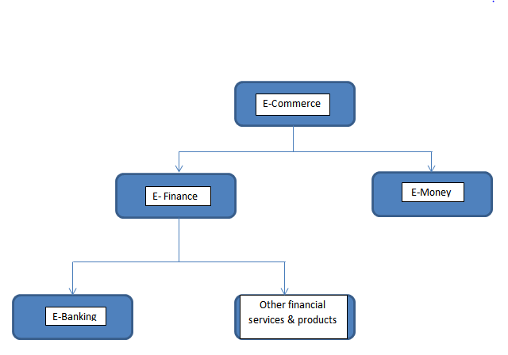
Meaning of E-Banking
E-banking is also called as electronic banking, online banking, or Internet banking. E-banking helps in the using of electronic and telecommunications networks, convey various banking products and services. The clients can access his / her account and perform numerous transactions using computers, mobile phones, or any gadgets, etc., In other words, Internet banking is a system allowing individuals to perform backing activities anywhere, anytime via the Internet. E-banking protects many facilities like fund transfer, checking account statements, utility bill payments, opening of bank account, applying for loans, track the nearest ATM, obtaining information on financial products and services, etc., using a smartphone, personal computer, laptop, or personal digital assistant.
Table shows the kinds of digital payments
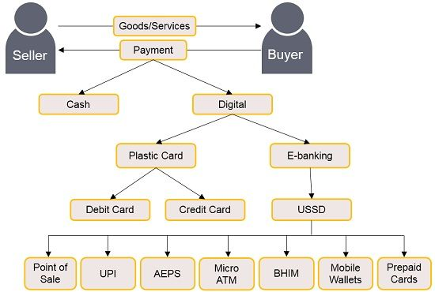

Characteristics of E-banking
1. Provides 24x7 facility: It is one of the important characteristics of E-banking. E-Banking provides customers with an all-time access service to their bank accounts. Customers can very easily access their accounts anytime, anywhere without any limitations. E-banking also provides convenience to customers as they can do transactions as per their wish.
2. Quick transactions: E-banking provides the quick transfer of funds to its customers, which saves the time for customers, and money gets transferred very speed from one account to another account. The whole system of E-banking is electric and works over the Internet.
3. Develops loyalty in customers: E-banking also helps the banks to develop a large number of loyalties to customers. E-banking services are able to serve their customers well at any time. E-banking is able to provide fast and better services to customers.
4. Lower transaction cost: E-Banking is one of the characteristics which reduces the cost when the customer is involved in doing the financial transactions. Electronic transactions are the lowest medium of doing transactions. The manpower work has been because of online banking.
5. Provides better production: E-banking has a systematic role in increasing the inventiveness of businesses. The whole monetary transaction system is supported by electronic software systems. These systems are specially designed for doing this kinds of transactions funds.
6. Reduce frauds in transactions: Another important characteristic of e-banking which helps in continuously monitoring customers’ accounts. Customers can easily track each & every transaction of their accounts. The customers can easily track if any of the fraud is done by anyone in financial transactions.

Kinds of E-banking
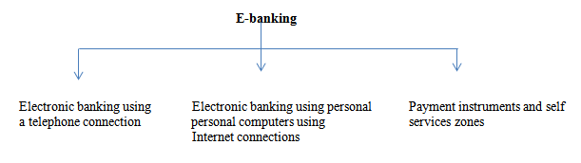
1. Electronic banking using a telephone connection: This is one of the types of E-banking where customers can do E-banking using the telephones by taking instructions. There are two types of telephone connections which are as follows:
• Automated telephone system: Automated telephone Banking System means any device, capable of providing voice response to a Cardholder's request or any banking information for banking services.
• Handset banking: Handset banking is also called as mobile banking is also one of the types of services provided by banks and many financial institutions which allows the customers to conduct transactions using a handset device such as a tablet, smartphone etc.,
2. Electronic banking using personal computers using an internet connection
• Home banking: Home banking or Web banking, is a system that enables the customers of a bank or any other financial institution to perform a range of financial transactions through the financial institution's websites or mobile app.
• Internet banking: Online banking, also known as virtual banking, is an electronic system that empowers customers to make a payment to a bank or other financial institution to conduct a financial transaction through the financial institution's websites.
• Mail banking: Mail banking is a service provided by a financial institution to customers which allows them to deposit cheques into their accounts through mail. It is primarily used by branchless banks and customers who live too far from a branch use mail banking.
3. Payment instruments and self-services
• Self-service zone: It is also one of the types of E-banking. Self-service banking is a service where customers can conduct activities and financial transactions using channels and devices without going to a branch.
• Payment card: It is one of the types of E-banking where the customers can make transactions through cards in shops, malls hotels, etc.,
• Electronic wallet: E-wallet is a type of pre-paid account in which a customer can store the money for any future online transaction. An E-wallet is protected with a password, with the help of an E-wallet in payment instruments, in this one can make payments for groceries, flight tickets, and online purchases, among others, etc.,
Services covered under the Internet banking
1. Handset banking: Handset banking is also called as M-banking which is utilized to perform the account interchanges or any transaction activities, credit applications, invoice payments, other financial exchanges, remaining amount checks in account, etc., through mobile phones/ personal digital assistants.
2. Plastic cards: A key card or plastic card is a card which stores the data on microchip or microprocessor or memory chip in the magnetic stripe which found on the credit cards, debit cards, etc., Plastic cards not exploit for transfer, financial moving monetary data, a smart card can be encrypted to interchange the data from one party to another.
3. Electric fund transfer (EFT): EFT is the electronic exchange of money from one account of bank to another either with a one monetary institution or across many institutions through computer-based systems without the direct interference of bank staff.
4. Electronic clearing services (ECS): ECS is a technique of transferring funds digitally and is normally used for bulk transfers. This technique is used for funds that are both tedious and regular in nature.
5. Internet banking: It is a support that is services given by banks that allow account holders to get their recorded information by means of Internet or the web. Internet banking is also called as web banking.
6. Home banks: It is the most common way to exchange money where customers from home can use without going to a bank’s branch. It embodies making account requests, bills covering, cash moving, and applying for credit cards, direct deposits etc.,
7. Telephone banking: It is another kind of service given by a bank to customers that is to the customer holders to get their information of account or any other kinds of information from banks through telephone.
Advantages of E-banking
1. Convenience: It is very easy for the account holder of banks to do pecuniary activities. Customers no need to go to the banks to approach their bank accounts, customers conveniently can use financial activities any time, where sitting in their homes through the internet.
2. Faster services: Nowadays customers no need to wait in que to pay their any bills or transmit money, which offers quick services, but money transfers are possible only if there is internet.
3. Services quality: Online banking has increased the range of customers' services utilize online banking to make fast, secured, and easy payments, by utilizing Internet banking software, the clients can track all their accounts and related transactions.
4. 24/7 services: Clients can easily access the online banking services at any time, anyway. Clients can also access banking services anytime, anywhere in any location.
5. Liquidity: E-banking provides client to access more reluctantly available pecuniary matters. Customers can draw cash from any ATMs at any location.
6. Discounts: The banks give discounts on credit cards, debit cards, etc., by doing online transactions and get numerous discounts from banks through online banking.
7. Transfer auxiliary: The effective bank systems gives a customer’s a single to fetch money to any person for 365 days a year.
8. Paying bills online: E-banking offers to pay any sort of bills like water supply, electricity bill, telephone, and other facilities instead of standing in queues.
9. Surveillance services: internet banking has access to update pass book at anywhere and anytime to control their financial plans and can track of their transactions.
10. Systematic rules: In E-banking there is a systematic rule each and every person should follow the same rules, and there is no bifurcation between the rich, middle, and poor classes, for each and every customer same rules should be followed.
Disadvantage
1. More start–up cost: Internet banking priced a lot to set up different types of computers, software, hardware a modern and networks. Banking company should make remarkable investments to set in motion Internet banking services.
2. Security problems: Hacking of E-banking systems has led to several security problems. Clients could suffer will get financial loss if they lose their login information while making payments.
3. Transaction issues: Sometimes banking servers frequently go down which causes transactions to fail, in emergency cases if we want to do a transaction if the server is slow this will be issued to customers.
4. Long process to use E-banking: In some of the government banks offer E-banking through the completion of an application which is then approved before allowing access to a security password to log in and sometimes takes up a long process too.
5. No cash deposit platform: There are fewer platforms to deposit cash, especially in rural areas, and more people in rural areas don’t know how to deposit cash.
6. Awareness of E-banking: Many people don’t have awareness of E-banking and they are scared to use E-banking because of hacking the account. The banks should take the initiatives to guide the customers.
7. Challengers for beginners: It will be very difficult for customers who newly start to do online banking transactions and it will be very difficult to do and they are worried about losing money too.
References
- Agarwal, R., & Karahanna, E. (2000). Time flies when you’re having fun: Cognitive absorption and beliefs about information technology usage. MIS Quarterly, 24(4), 665–694

- Bass, F. M. (1969). A new product growth for model consumer durables Management Science, 15(5), 215–227.
- Cunningham, L. F., Gerlach, J., & Harper, M. D. (2005). Perceived risk and e-banking services: An analysis from the perspective of the consumer. Journal of Financial Services Marketing, 10(2), 165–179.
- Daniel, E. (1999). Provision of electronic banking in the UK and the republic of Ireland. International Journal of Bank Marketing, 17(2), 72–82.
- Lassar, W. M., Manolis, C., & Lassar, S. S. (2005). The relationship between consumer innovativeness, personal characteristics, and online banking adoption. International Journal of Bank Marketing, 23(2), 176–200.
- Srivastava, R. K. (2007). Customer‟s perception on usage of internet banking. Innovative Marketing, 3(4), 67-73. [2] Haq, S., Khan, M. (2013).
- E-banking challenges and opportunities in the Indian banking sector. Innovative Journal of Business and Management, 2(4), 56-59. [3] Gupta, P., Mishra, C. M. (2012).
- E-banking- New emerging trends in Indian banking industry. Research Journal of Economics and Business Studies, 1(10), 1-3.

