Research Article
Use of CHATGPT in Higher Education to assist Administrative staff: A Review
Apoorv Bhiwandkar, Dr. Pranjal Muley
¹ Vivekanand Business School; apoorv.bhiwandkar2123p@ves.ac.in
² Vivekanand Business School; Pranjal.muley@ves.ac.in
Abstract: ChatGPT is an AI-powered natural language processing tool, you may converse with a chatbot in a way that is similar to that of a human being while also doing a lot more. The language model may help you with things like writing emails, essays, and code as well as provide answers to your inquiries. All institutions consist of non-teaching which carry out menial jobs but with the help of this technology they can be trained in such a manner that they can take up jobs like writing circulars, emails, notices, MOU’s etc covering all administrative work in a professional manner and with sophisticated language. The purpose of the research is to analyze the role of ChatGPT in administrative activities such as drafting circulars, emails, notices in professional and decent way. This research is based on secondary data and exploring new prospects for administrative staff of Higher education.
Keywords: ChatGPT, Users, Administrative activities, Summary, Write, Explain

1. Introduction to ChatGPT
Technology is constantly evolving in the digital age and offers convenience for a variety of tasks, including learning (Ausat, 2022); (Cahyono et al., 2023). Chatbots are one piece of technology that can be used to boost administrative task productivity especially in Higher education. ChatGPT is a chatbot which makes use of GPT-3(Generative Pretrained Transformer), the most recent language generation model created by OpenAI. Because GPT-3 can produce text that sounds like human speech, ChatGPT can hold discussions with users that are authentic and interesting. The flexibility of ChatGPT to handle a variety of jobs and themes is one of its main advantages. ChatGPT can handle all of your chatbot needs, whether you need one for product recommendations, customer support questions, or general information requests. It can also be taught to manage certain jobs or sectors, like banking or e-commerce.

The usage of ChatGPT in India seems to tend to have increased over a period of time. Following figure (Figure 1) is the Data from Google Trend.

Figure-1

2. Literature Review

Since Chat GPT is a newly emerging tool and therefore its scope in all possible domain is currently being explored through various research projects. Although there exist research articles in the field of education but mostly are done for students’ productivity, teachers, and as self-learning tool. No research is found as a supporting tool for non-teaching staff for administrative work. Education changes and transforms in response to technological advancements. Education and technology are related and have an impact on one another (Potasheva, O. V., 2019); (Mhlanga, D., 2023) ;(Baidoo-Anu D et al, 2023). Teachers, academics, and authorities are paying more and more attention to how artificial intelligence language models, such Chat GPT, might enhance independent learning in higher education (Baskara FX., R, 2023). ChatGPT is regarded as a platform or instrument for locating fresh knowledge and concepts (Bishop, L., 2023). ChatGPT's potential to increase productivity and efficiency in the educational process is quite promising (Firaina R et al, 2023). Miriam Sullivan (2023) in her article said that although the release of ChatGPT and its implications for higher education have generated a lot of debate, there are evident opportunities to improve access and learning for students. ChatGPT can significantly raise the level of student productivity in the current digital era. It can benefit students in a variety of ways, including by giving them access to relevant information and tools, enhancing their language abilities, promoting teamwork, increasing their productivity and effectiveness, and motivating them. However, the function of ChatGPT should be seen as an addition to interpersonal interaction and academic effort, not as a replacement for it (Fauzi et al, 2023).

3. Discussion

3.1 Top Keywords for ChatGPT

When a question is asked or a statement is made to ChatGPT, it uses a process called "contextual language modeling" to generate a response. This means that it looks at the words which are used and tries to understand the context in which they are used. Then it uses this understanding to generate a response that's appropriate to the context.

3.1.1 Write

Chat GPT assists in writing. It; as the tool; can provide proofread like Grammarly and write creative responses when prompted. This facility would help administrative staff of higher education in writing scripts of letters, circulars, notices and MOUs.

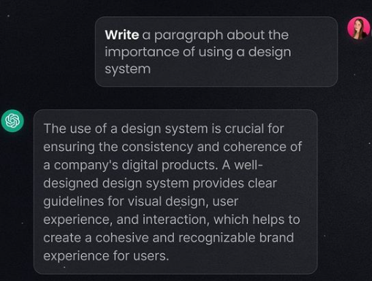

3.1.2 Explain

Explain keyword in Chat GPT can be used whenever a user wants to request an explanation or clarification of a topic or a concept. This facility of Chat GPT would assist administrative staff of higher education for self-training or understanding academic terminologies and functions.

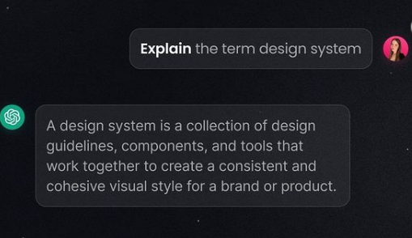

3.1.3 Analyze

Chat GPT can also look for keywords and do an analysis of a specific topic or data. It also provides insights into the data and can provide proper explanation of each part of the analysis. This facility of Chat GPT would assist administrative staff of higher education for analyzing students’ performance, comparative analysis of semester results/ batch results across the years.

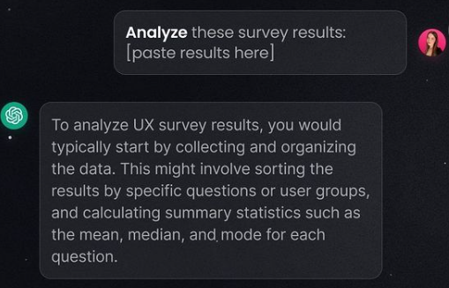

3.5 Design

Chat GPT is currently limited to text responses but is still very creative. Users can ask it to generate wireframes, SVG’s and programming codes for multiple languages.

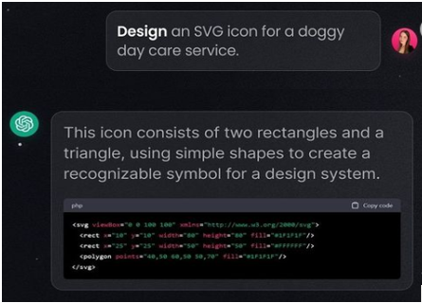

4. ChatGPT usecases

A use case is a description of a particular action or interaction a user might have with a piece of software. It describes the actions a user takes, the anticipated results, and any potential problems that might occur. Following are a few usecases of ChatGPT

4.1 Write Emails

Email is a potent communication tool that has revolutionized how to interact with one another on a personal and professional level. It is to note that the AI model's recommendations are based on the patterns and trends in the data it was trained on when utilising ChatGPT to compose emails. Even though emails can be a useful tool for generating ideas or suggestions, it is ultimately owner’s responsibility to ensure that they are clear, professional, and effective. However, This facility would help administrative staff of higher education in writing new scripts of letters, circulars, notices and proofreading and editing current contents.

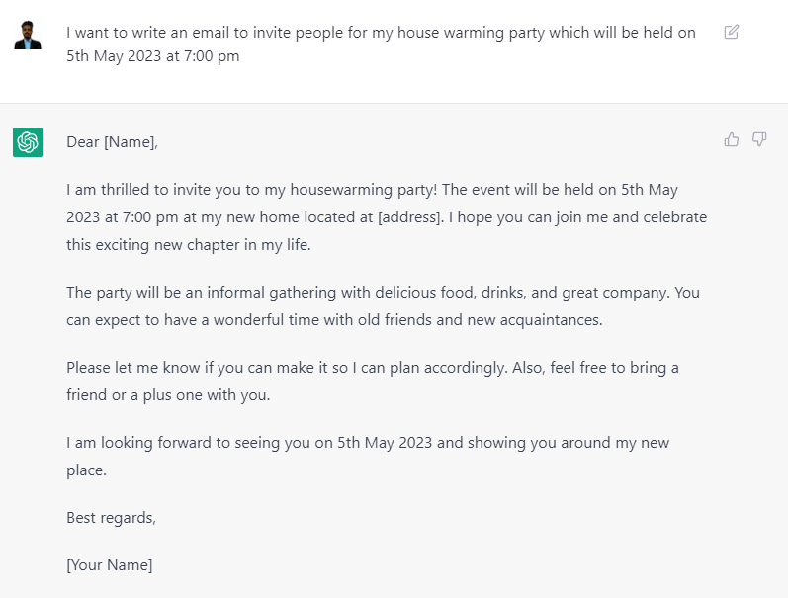

4.2 Write a Summary

A summary is a shortened version of a lengthy text or document that focuses on the most important details or primary concepts. It is typically intended to provide a quick overview of the content for readers who may not have time to read the entire document. This facility would help administrative staff of higher education in writing shortnote on a big event reports, highlights of major discussion, minutes of the various committee and cell meeting and action taken reports.

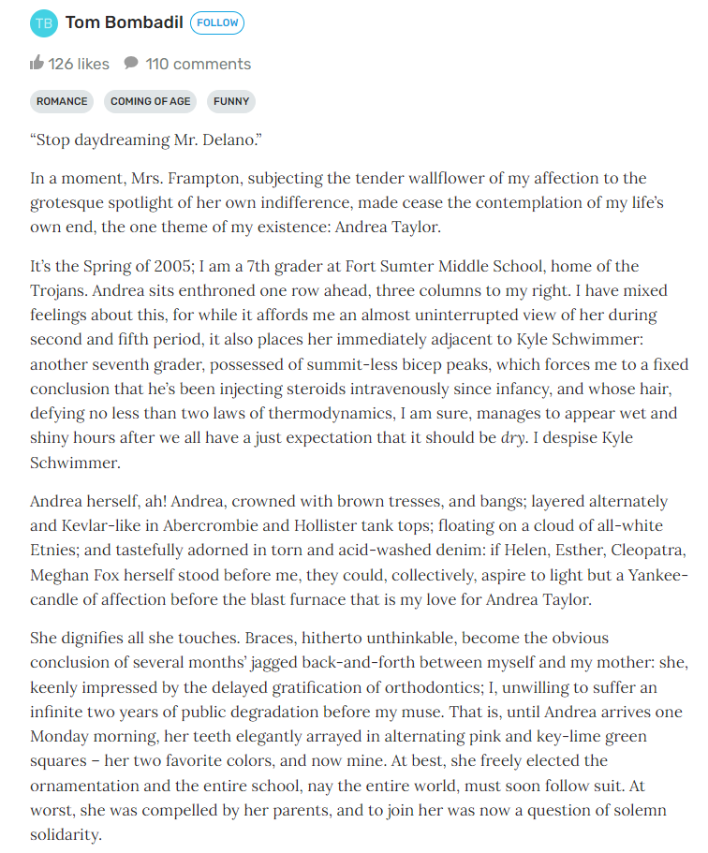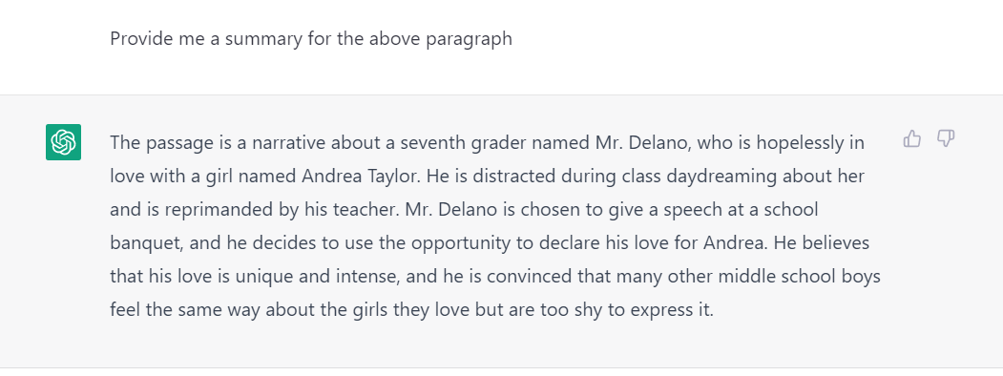

8. Conclusion
ChatGPT is an AI-powered natural language processing tool that has the potential to revolutionize the way institutions support their staff. By using GPT as a system-facing tool in higher education, administrative activities can be streamlined, saving time and lightening the pressure on managerial and administrative staff. By providing support with writing emails, essays, and administrative work in a professional and sophisticated manner, ChatGPT can help institutions improve their efficiency and productivity. Moreover, ChatGPT's flexibility in handling a variety of tasks and themes makes it an asset for supporting staff in any industry.

References:
- Ausat, A. M. A. (2022). Positive Impact of The Covid-19 Pandemic on The World of Education. Jurnal Pendidikan, 23(2), 107–117. https://doi.org/10.33830/JP.V23I2.3048.2022
- Baidoo-Anu, D., & Owusu Ansah, L. (2023). Education in the Era of Generative Artificial Intelligence (AI): Understanding the Potential Benefits of ChatGPT in Promoting Teaching and Learning. Available at SSRN 4337484.
- Baskara, FX. Risang. (2023). The Promises and Pitfalls of Using Chat GPT for Self-Determined Learning in Higher Education: An Argumentative Review. SENTIKJAR, PROSIDING Vol.2 2023.
Behavior, 134, 107329.
- Bishop, L. (2023). A computer wrote this paper: What chatgpt means for education, research, and writing. Research, and Writing (January 26, 2023).
- Cahyono, A. S., Tuhuteru, L., Julina, S., Suherlan, S., & Ausat, A. M. A. (2023). Building a Generation of Qualified Leaders: Leadership Education Strategies in Schools. Journal on Education, 5(4), 12974–12979. https://jonedu.org/index.php/joe/article/view/2289
Dialogic interactions, satisfaction, engagement, and customer behavior. Computers in Human
- Fauzi, Tuhuteru L, Sampe F, Ausat A M Al, Hatta H R. Analysing the Role of ChatGPT in Improving Student Productivity in Higher Education. Journal on Education, Volume 05, No. 04, Mei-Agustus 2023, pp. 14886-14891.
- Firaina R, Sulisworo D (2023). Exploring the Usage of ChatGPT in Higher Education: Frequency and Impact on Productivity. Buletin Edukasi Indonesia (BEI) by IISTR, Vol. 2, No. 01, April 2023, pp. 39-46
- Jiang, H., Cheng, Y., Yang, J., & Gao, S. (2022). AI-powered chatbot communication with customers:
Lifelong Learning. Education, the Responsible and Ethical Use of Chat GPT Towards Lifelong Learning (February 11, 2023).
- Luan, L., Lin, X., & Li, W. (2023). Exploring the Cognitive Dynamics of Artificial Intelligence in the
- Mendoza, S., Sánchez-Adame, L. M., Urquiza-Yllescas, J. F., González-Beltrán, B. A., & Decouchant, D. (2022). A Model to Develop Chatbots for Assisting the Teaching and Learning Process. Sensors, 22(15), 5532. https://doi.org/10.3390/s22155532
- Mhlanga, D. (2023). Open AI in Education, the Responsible and Ethical Use of ChatGPT Towards Lifelong Learning. Education, the Responsible and Ethical Use of ChatGPT Towards Lifelong Learning (February 11, 2023).
- Mhlanga, D. (2023). Open AI in Education, the Responsible and Ethical Use of Chat GPT Towards
Post-COVID-19 and Learning 3.0 Era: A Case Study of ChatGPT. arXiv preprint arXiv:2302.04818.
- Potasheva, O. V., Kuzmenko, M. V., & Plutova, M. I. (2019, May). The effective use of digital technologies in education: positive experience of regional innovation platforms. In 1st International Scientific Conference" Modern Management Trends and the Digital Economy: from Regional Development to Global Economic Growth"(MTDE 2019) (pp. 687-692). Atlantis Press.
- Sullivan M et al (2023). ChatGPT in higher education: Considerations for academic integrity and student learning. Journal of Applied Learning & Teaching, Vol.6 No.1 (2023).
- Zhuo, T. Y., Huang, Y., Chen, C., & Xing, Z. (2023). Exploring ai ethics of chatgpt: A diagnosticanalysis. arXiv preprint arXiv:2301.12867.

