Bridging the Digital Divide to leverage Socio-Economic empowerment: Conceptualization of JEEVIKA's In-house Applications from Management Information System.

Arpan Mukherjee,
Young Professional – Knowledge Management & Communication,
JEEVIKA, Department of Rural Development, Government of Bihar
Contact Information: arpanmukherjee.3582@gmail.com, +91-8945903602
Abstract:
In today's digital age, access to technology and the internet is no longer a luxury, but a necessity. Inadequate accessibility to technology and the internet creates a digital divide that exacerbates socio-economic inequalities. This research paper aims to explore the issue of the digital divide in India's context and discuss the importance of bridging the gap through technology access. The digital divide is a term used to describe the gap between those who have access to digital technologies, such as computers and the internet, and those who do not (Joshi et al., 2020). The digital divide not only creates disparities in access to information but also limits opportunities for education, employment, healthcare, and civic participation (Pitaud & Deschamps, 2020). This research paper explores how JEEVIKA's in-house applications from the Management Information System (MIS) is contributing to reducing the digital divide in the context of socio-economic development. The paper examines the impact of the applications in promoting digital literacy, enhancing access to information, and fostering inclusivity in marginalized communities.
Introduction:
Table-I: % age usage of internet in urban and rural areas
Year | Urban | Rural
2018 | 85 | 25
2019 | 153 | 32
2020 | 171 | 68
2021 | 262 | 109
Source: IAMAI, Feb 2022
In an era characterized by the pervasive influence of digital technology, access to the internet and advanced devices has transcended its status as a mere convenience and has emerged as a fundamental necessity However, as societies progressively embrace the digital age, an alarming chasm has materialized, commonly referred to as the "digital divide". According to India Statistical Report 2022 only 39% of the internet users are female. This divide, manifesting as the uneven distribution of technological resources, not only perpetuates but amplifies socio-economic disparities. This research paper delves into the intricate dynamics of the digital divide within the unique context of India, a nation that encapsulates immense diversity across its vast landscapes. As digital technology becomes ever more integrated into facets of daily life, the inaccessibility to this digital realm assumes a critical role in shaping an individual's opportunities and quality of life. The digital divide is a multifaceted issue, encapsulating disparities in technological access, digital literacy, and the ability to leverage digital tools effectively. Such disparities extend beyond technological limitations, infiltrating education, employment, healthcare, and civic engagement, thus impeding the equitable growth of socio-economically marginalized communities.

Figure-1: Internet Penetration rate in India
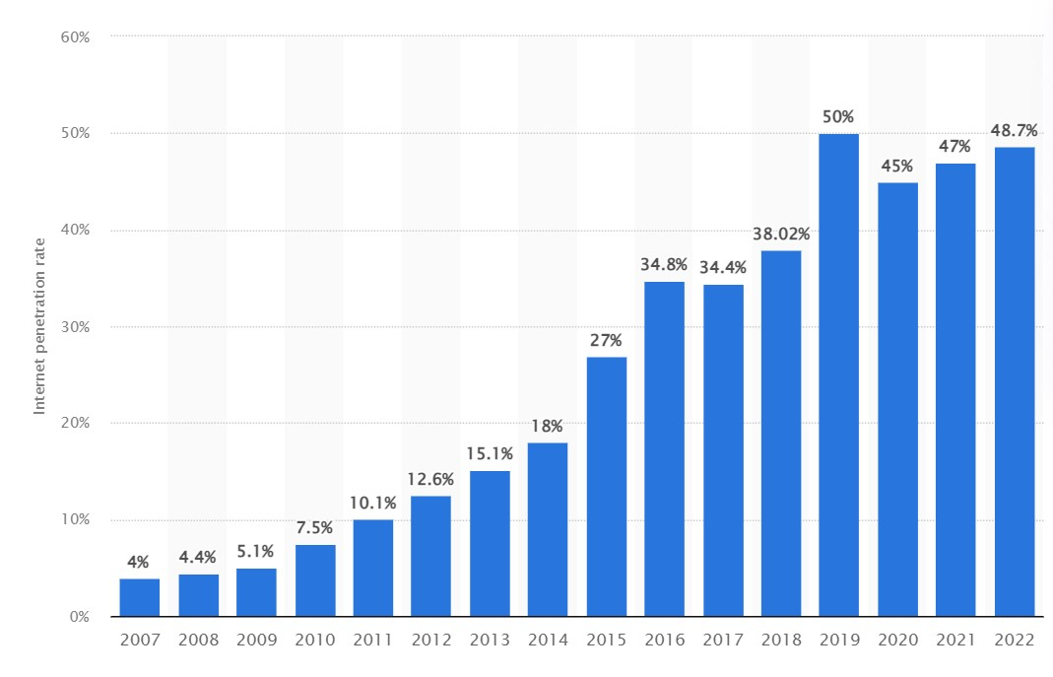Source: Statista 2023
Table – II: Internet Penetration in India with respect to the population growth
Year | Population in India | Internet Users | %age internet users in total population
2018 | 1279498874 | 486209572 | 38.02
2019 | 1295291543 | 647645771 | 50
2020 | 1311050527 | 592594838 | 45.2
2021 | 1326801576 | 631557550 | 47.6
Source: Various reports of UN Population Division and International Telecommunication Union

About JEEVIKA
JEEViKA is India’s largest state level women’s socio-economic empowerment program, working directly with 13 million families in rural Bihar and is one of the flagship programs for poverty alleviation of the Govt. of Bihar. The program entails promotion of a three-tier community architecture with “Self-Help Group” as the primary, “Village Organisation” as secondary and “Cluster-Level Federations” at the tertiary level institutions. JEEViKA has till date promoted 1.046 million SHGs, 72584 Village Organisations and 1520 Cluster Level Federations. These community institutions enable collective capacity building, improved access to finance and public services and direct linkage to markets. JEEViKA has successfully amplified the reach of rural bank branches in Bihar by developing SHG women as credible borrowers. JEEViKA groups have thus far leveraged more than $ 4.25 billion of bank credit, stimulating investments into productive livelihoods JEEViKA SHG women have collectively mobilized nearly $ 220.76 million in small savings, highlighting the immense inherent potential of rural women. Today, there are more than 150,000 JEEViKA women entrepreneurs in rural Bihar, who have successfully established small businesses. More than 5000 Bank Sakhis (Banking Correspondents) operating in the panchayats are providing banking services and 5.36 million women have been insured under PMSBY and 5.89 million under PMJJBY. JEEViKA has promoted System of Crop Intensification (SCI), nutrition gardens among small farmers and landless and development of Farmer Producer Organizations. 26 all Women Farmer Producer Companies have been promoted by JEEViKA for collective marketing of the agri-produce of the SHG members. Till date 50,121 MT of agri-produce have been sold and a total transaction of $ 12 million has been made yielding $ 505,589 of net profit. Similarly, large scale programs around livestock including backyard poultry and Goat rearing, dairy and fisheries have been implemented with more than 323,000 families, leading to improved incomes and nutrition at the household level. SHG members have set up canteens- Didi Ki Rasois in 77 hospitals, 14 SC/ST residential schools and in 10 other institutions. These Didi Ki Rasois has a cumulative turnover of $ 2.6 million. JEEViKA is leveraging its massive outreach to deliver large scale behavior change communication (BCC) on improved nutrition and sanitation practices. JEEViKA groups are playing a vital role in the sanitation value chain by triggering demand for improved sanitation through BCC, facilitating ready availability of finance and materials for toilet construction and ensuring sustainability by participatory monitoring of toilet usage and maintenance. Today, the sight of JEEViKA women huddled together in a rural neighborhood, discussing and resolving their social and economic issues without any external assistance is a ubiquitous one. JEEViKA continues to strive for empowering and enabling every rural household to have greater social and financial freedom, improved access to nutrition and sanitation services and access to key public services. Considering the journey of the program thus far, this massive outreach is well poised to result in massive transformation in rural Bihar.
Objectives
This study is dedicated to examining the landscape of the digital divide within the intricate weave of Indian society, an arena where socio-economic stratifications often parallel regional, cultural, and educational disparities. With a burgeoning population and diverse demographics, India stands as a paradigmatic example of the digital divide's intricate entwinement with socio-economic dynamics. The significance of this paper transcends theoretical exploration; it seeks to spotlight a transformative initiative that endeavors to bridge this divide and catalyze socio-economic progress: JEEVIKA's in-house applications, a pivotal component of its Management Information System (MIS). Major objectives of the paper are as follows:
- Evaluate JEEVIKA's In-house Applications from MIS: Exploring the features and functionalities of JEEVIKA's in-house applications designed to address the digital divide and assessing the applications’ usability, accessibility, and relevance for marginalized communities.
- Assess the Impact of JEEVIKA's Applications on Digital Literacy: Measuring the effectiveness of the applications in enhancing digital literacy among users and studying the applications’ contribution in improving users' skills to navigate the digital landscape.
- Analyze the Applications' Role in Enhancing Access to Information: Examining how the applications facilitates access to information related to agriculture, education, healthcare, and government schemes and determining whether the applications provides valuable information that was previously inaccessible to marginalized communities.
- Investigate the Applications’ Contribution to Fostering Inclusivity: Exploring how the applications promotes inclusivity by bridging gaps between privileged and marginalized populations and analyzing the applications’ role in empowering marginalized communities and providing a platform for their voices to be heard.
- Examine Challenges and Limitations in Bridging the Digital Divide and Gauge Community Perceptions and User Experiences: Gathering qualitative insights from users to understand their perceptions of the applications’ effectiveness and determine whether users feel more connected, empowered, and informed through their interactions with the applications.
Literature Review
The concept of the digital divide has evolved over time, encompassing multiple dimensions. Norris (2001) categorizes it into three levels: the global divide (between countries), the social divide (within countries), and the democratic divide (related to political participation). DiMaggio and Hargittai (2001) emphasize the skill-based divide, highlighting how digital literacy influences people's ability to navigate the digital landscape effectively. Research by Warschauer (2003) emphasizes that access to digital technology is influenced by socio-economic factors, creating a vicious cycle where limited access perpetuates inequalities. Studies by Van Dijk (2005) and Selwyn (2004) show that low-income households, rural areas, and marginalized communities often face barriers such as lack of infrastructure, affordability, and digital literacy.
Hargittai and Walejko (2008) explore the intersection between digital inequality and education, suggesting that digital skills and technology access influence educational attainment. Research by Warschauer and Matuchniak (2010) underscores the importance of integrating technology into education to bridge gaps and enhance learning outcomes. Hafkin and Huyer (2007) draw attention to the gendered nature of the digital divide, highlighting how women often have reduced access and usage due to socio-cultural norms and biases. Studies by Molla and Licker (2001) and Huyer et al. (2005) shed light on the need to empower women through digital literacy initiatives.
Policies and interventions play a pivotal role in addressing the digital divide. The "Digital India" initiative in India, as outlined by Government of India (2015), is a notable example. Research by Heeks and Molla (2009) suggests that successful interventions require a multi-dimensional approach encompassing infrastructure development, digital literacy programs, and content localization. As access alone does not guarantee digital inclusion, research by van Deursen and van Dijk (2014) emphasizes the importance of digital literacy and digital skills. Insights from DiMaggio et al. (2004) and Robinson et al. (2015) reveal that active use of digital technologies, such as online collaboration and critical information evaluation, contributes to reduced inequalities.
Granovetter's "strength of weak ties" theory (1973) finds relevance in the context of the digital divide. Research by Hampton et al. (2011) demonstrates that individuals with diverse online networks are more likely to access information and resources that may not be available within their immediate offline communities. Mobile phones have played a significant role in bridging the digital divide, especially in developing countries (Donner, 2008; Tacchi et al., 2012). These studies highlight the democratizing potential of mobile technology, which requires lower infrastructure investment and provides access to information and services even in remote areas. Gurstein (2003) introduces the concept of "effective use" alongside access, suggesting that meaningful engagement with technology is crucial for digital inclusion. Research by van Dijk (2006) explores how digital inclusion contributes to broader social development goals such as empowerment and participation.
Methodology
- Research Design: This study employs a mixed-methods research design that combines quantitative and qualitative approaches to comprehensively explore the impact of JEEVIKA's in-house application on bridging the digital divide.
- Data Collection
- Quantitative Data Collection (Survey Questionnaires): Develop structured questionnaires targeting users of JEEVIKA's application. The questionnaire will encompass aspects such as demographic information, digital literacy levels, frequency of application use, and perceived impact on digital inclusion.
- Qualitative Data Collection: In-depth Interviews: Conduct semi-structured interviews with a diverse sample of application users. These interviews will provide insights into their experiences, challenges, and perceptions related to the application's effectiveness.
- Sampling:
- Quantitative Sampling- Random Sampling: Use random sampling to select a representative sample of application users from different regions and socio-economic backgrounds.
- Qualitative Sampling - Purposeful Sampling: Employ purposeful sampling to select participants who can provide rich insights into the impact of the application. Ensure diversity in terms of age, gender, education, and geographical location.
- Data Analysis:
- Quantitative Data Analysis (Descriptive Analysis): Employ descriptive statistics to summarize the demographic characteristics of the respondents and their digital literacy levels.
- Qualitative Data Analysis (Thematic Analysis): Conduct thematic analysis of the interview transcripts to identify recurring themes related to the application's impact, challenges, and user experiences.
- Ethical Considerations:
- Obtain Informed Consent: Prior to data collection, obtain informed consent from participants, ensuring they understand the purpose of the study and their rights as participants.
- Confidentiality: Ensure participant anonymity and confidentiality by assigning pseudonyms to interviewees and storing data securely.
- Limitations: Acknowledge potential limitations, such as selection bias due to the sampling strategy, and address these limitations transparently in the discussion section.
- Contribution to the Field: Through a comprehensive analysis of both quantitative and qualitative data, this methodology aims to provide a nuanced understanding of how JEEVIKA's in-house application contributes to bridging the digital divide.
- Ethical Considerations (Obtain Informed Consent): Prior to data collection, obtain informed consent from participants, ensuring they understand the purpose of the study and their rights as participants. Confidentiality: Ensure participant anonymity and confidentiality by assigning pseudonyms to interviewees and storing data securely.

Unveiling India's Digital Divide and its Socio-Economic Implications
India, being the second most populous country in the world, is home to a diverse population with varying levels of socio-economic status. This diversity creates a significant digital divide in the country. According to a study by Singh, the digital divide in India can be categorized into two levels. The first level of the digital divide in India is between disadvantaged caste groups and other people. This divide is rooted in historical socio-economic deprivation, where disadvantaged caste groups have been marginalized and face barriers in accessing technology and the internet.
Inadequate access to technology and the internet limits opportunities for marginalized populations to uplift themselves and escape the cycle of poverty. Disadvantaged individuals who lack technology access are unable to access crucial information, educational resources, and employment opportunities that can improve their socio-economic status. As a result, they continue to face barriers in accessing quality healthcare, education, and even basic services. For example, the COVID-19 pandemic has highlighted the impact of the digital divide on healthcare access.
Patients from disadvantaged communities with limited access to technology and the internet struggled to access telehealth services, leading to a further exacerbation of their health inequalities.
Management Information System in JEEVIKA
In the pursuit of empowering marginalized communities and fostering sustainable rural development, JEEVIKA has harnessed the potential of technology through its innovative Management Information System (MIS) and a suite of purpose-driven mobile applications. This integrated approach exemplifies JEEVIKA's commitment to leveraging digital tools to bridge gaps, enhance access, and drive positive change in the lives of rural populations.
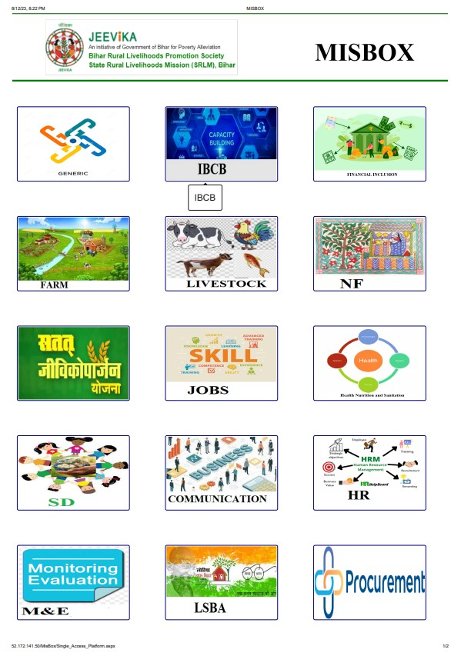
At the core of JEEVIKA's digital transformation lies its Management Information System (MIS), a comprehensive framework that acts as the nerve center of data collection, analysis, and decision-making. The MIS serves as a centralized repository for critical information, enabling JEEVIKA to efficiently manage its multifaceted interventions and engage with stakeholders across diverse geographies. There are more than 100 in-house mobile/web applications monitored by Management Information System of JEEVIKA, which includes Masik Prativedan (Monthly grading), digital finance, Pashu Sakhi Information, Training Modules, Farmer Producer Organizational overview, Health Help Desk Application and so on.
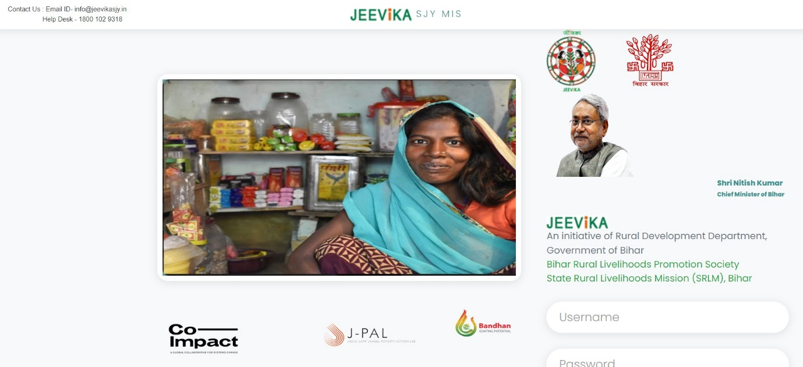
JEEVIKA's suite of mobile applications has been meticulously designed to ensure user-friendliness, accessibility, and relevance in addressing the unique challenges of digital access in rural and marginalized areas. These applications incorporate a range of features that cater to the needs and limitations of users while fostering inclusivity and empowerment.
Salient Features
- User-Friendly Interface: The mobile applications boast an intuitive and user-friendly interface that caters to users with varying levels of digital literacy. The design prioritizes simplicity, making navigation and interaction effortless, even for individuals who might be new to technology.
- Local Language Support: Recognizing the linguistic diversity across India, JEEVIKA's applications offer content in a range of local languages. This language support ensures that users can engage with the applications in a language they are comfortable with, making information and resources more accessible and comprehensible.
- Offline Access: Understanding that reliable internet connectivity can be a challenge in rural areas, JEEVIKA's applications offer offline access to selected content. Users can download resources when connected to the internet and access them later without the need for continuous connectivity. This feature bridges the gap posed by limited internet availability.
- Interactive Learning Modules: JEEVIKA's applications employ interactive learning modules that engage users through quizzes, assessments, and simulations. These modules transform learning into an engaging experience, promoting active participation and enhancing retention of information.
- Localized Content: The applications curate content that is contextually relevant to the target communities. Whether it's agriculture practices specific to a region, government schemes applicable locally, or culturally sensitive content, the applications ensure that information resonates with users' immediate needs and realities.
Addressing Digital Access Challenges: Empowering Rural and Marginalized Communities
To address the challenges faced by the community institution, JEEVIKA have focused on 4 major components:
- Overcoming Connectivity Barriers: Limited internet connectivity is a significant challenge in rural and marginalized areas. By offering offline access, JEEVIKA's applications ensure that users can access crucial information and resources even when offline. This feature bypasses the connectivity barrier, empowering users with uninterrupted access to learning and resources.
- Community’s Participation in Digitization: JEEVIKA have trained 115,235 Community Professionals to digitize the data entry process. Community Mobilizer have been equipped with the mobile phone, provided by JEEVIKA across 6 districts of Bihar for the digitization and information dissemination.
- Digital Literacy Enhancement: Many individuals in rural areas might lack familiarity with digital devices. JEEVIKA's user-friendly interface and interactive modules cater to users with varying degrees of digital literacy. This approach not only enhances their digital skills but also boosts their confidence in engaging with technology.
- Local Language Engagement: Language can be a formidable barrier to digital access. By providing content in local languages, JEEVIKA's applications ensure that users can engage with technology in a language they understand. This localization fosters comfort, inclusivity, and engagement, facilitating meaningful interactions.
- Tailored Information: Rural and marginalized communities often have unique challenges and needs. JEEVIKA's applications address this by providing localized and tailored content. Whether it's agriculture guidance, healthcare information, or government schemes, the applications ensure that users receive information that directly impacts their lives.
Challenges
JEEVIKA's journey towards digital transformation, while marked with significant achievements, has also encountered a range of challenges that underscore the complexities of bridging the digital divide. One of the primary hurdles is the variance in digital literacy levels within the target communities. The diversity in educational backgrounds and familiarity with technology among the beneficiaries poses a challenge in ensuring uniform adoption and effective utilization of digital tools. Infrastructure limitations, particularly in rural and remote areas, present another obstacle. Inadequate internet connectivity and inconsistent electricity supply hinder seamless access to online platforms. This disparity amplifies the digital divide, as those in urban centers enjoy superior access compared to their rural counterparts. The cost of digital devices and data plans can also be prohibitive for marginalized communities, further hindering their ability to benefit from digital initiatives.
Cultural and linguistic diversity adds another layer of complexity. JEEViKA's interventions span regions with varying languages and cultural practices. Tailoring digital content to cater to these diversities demands meticulous effort, as generic approaches might not resonate with all segments equally. Moreover, cultural norms and social barriers can impede the participation of certain demographic groups, particularly women, in digital initiatives. Data security and privacy concerns are also pertinent in the digital realm. Many beneficiaries might be apprehensive about sharing personal information online due to fears of misuse or breaches. Building trust and assuring the security of their data becomes crucial in encouraging engagement.
The rapid pace of technological advancement demands continuous upskilling and training for both beneficiaries and JEEViKA staff. Keeping up with evolving platforms, tools, and strategies is a constant challenge, necessitating dedicated resources and efforts.
Strategies adopted to overcome challenges
Infrastructure Development: Lack of access to reliable internet connectivity and technological devices remains a significant barrier. JEEVIKA has collaborated with reliance JIO to provide Closed User Group (CUG) sim cards with sufficient data packs to its employees to disseminate the information into underserved areas, making internet access more accessible and affordable.
IVR technology: JEEVIKA Mobile Vaani - An IVR-based interactive platform, accessible free of charge to users even through basic phones, forms a cornerstone of this initiative. This innovative platform amalgamates both in-house and user-generated content, thereby infusing it with contextual richness and holistic insight to enhance user engagement. A key element of the approach involves training JEEViKA cadres in utilizing and advocating for the platform as an integral facet of their routine Self-Help Group (SHG) activities. This strategic community mobilization transcends mere dissemination, fostering a robust content exposure and open discussions on pertinent subjects like Health and Nutrition Services (HNS) and other priority matters. Consequently, this engenders the adoption of improved health behaviors and bolsters the self-efficacy of women in the targeted communities. A notable facet of this endeavor lies in its ability to engage with specific, well-defined target groups on a one-to-one basis, showcasing the potential to facilitate tailored interactions. Remarkably, this initiative has been successfully implemented across five blocks in Muzaffarpur and fifteen blocks in the Nalanda district of Bihar, underlining its tangible impact and scalability.
Digital Literacy Programs: Promoting digital literacy is vital to ensure that all individuals can effectively use technology. JEEVIKA conducts digitization orientation programs that teach basic digital skills, including using computers, navigating the internet, and utilizing relevant applications and data entry. In collaboration with major digital players like Google, Microsoft, Amazon web services, JEEVIKA has conducted State Level Digital Transformation Conclave to inculcate Artificial Intelligence and Machine Learning in the MIS system. This has also enhanced the public-private partnership to eradicate digital divide.
Localized Content and Applications: Developing applications and content in local languages and contexts enhances accessibility and relevance. JEEVIKA's in-house applications are user-friendly and culturally sensitive, addressing the unique challenges and opportunities of the targeted communities. Regular feedback loops and usability testing should be implemented to continually improve the applications' usability and effectiveness.
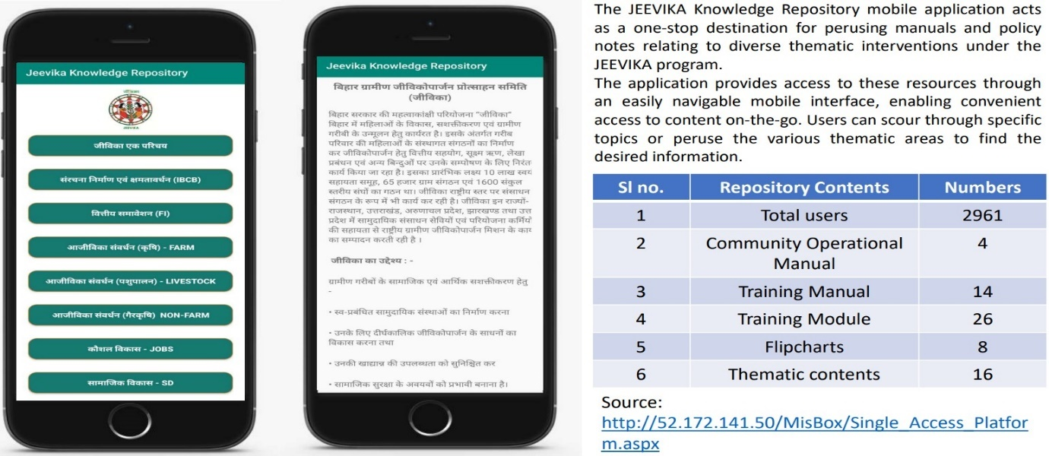
Community Engagement: Engaging local communities is crucial to the success of digital empowerment initiatives. JEEVIKA has involved community members in the design, implementation, and evaluation of their in-house applications. This participatory approach ensures that the solutions truly reflect the needs and aspirations of the people they aim to serve.
Partnerships and Collaborations: Collaboration between JEEVIKA and NGOs, private sector entities, and educational institutions was essential. By pooling resources and expertise, a comprehensive approach have been developed to tackle the multifaceted challenges of the digital divide. JEEVIKA has formed partnerships with tech companies, universities, and local organizations to leverage their strengths in infrastructure, expertise, and digitization.
Continuous Adaptation: Technology evolves rapidly, requiring a dynamic approach. JEEVIKA allocates a section of its budget and resources for regular updates and improvements to their applications to ensure they remain relevant and effective. Continuous adaptation also involves staying informed about emerging technologies that could further empower marginalized communities. JEEVIKA has also developed a clear financial plan to ensure the long-term viability of their initiatives. This may involve diversifying sources, exploring public-private partnerships, and integrating the costs into broader development budgets.
Monitoring and Evaluation: Establishing metrics to assess the impact of digital empowerment initiatives is crucial. JEEVIKA has implemented robust monitoring and evaluation systems to track the progress of their applications in enhancing socio-economic empowerment. Regular assessments help identify areas for improvement and demonstrate the positive outcomes to stakeholders. Collaboration with the external agencies to have impact analysis and audit of the ongoing interventions ensuring transparency and efficiency of the organization.
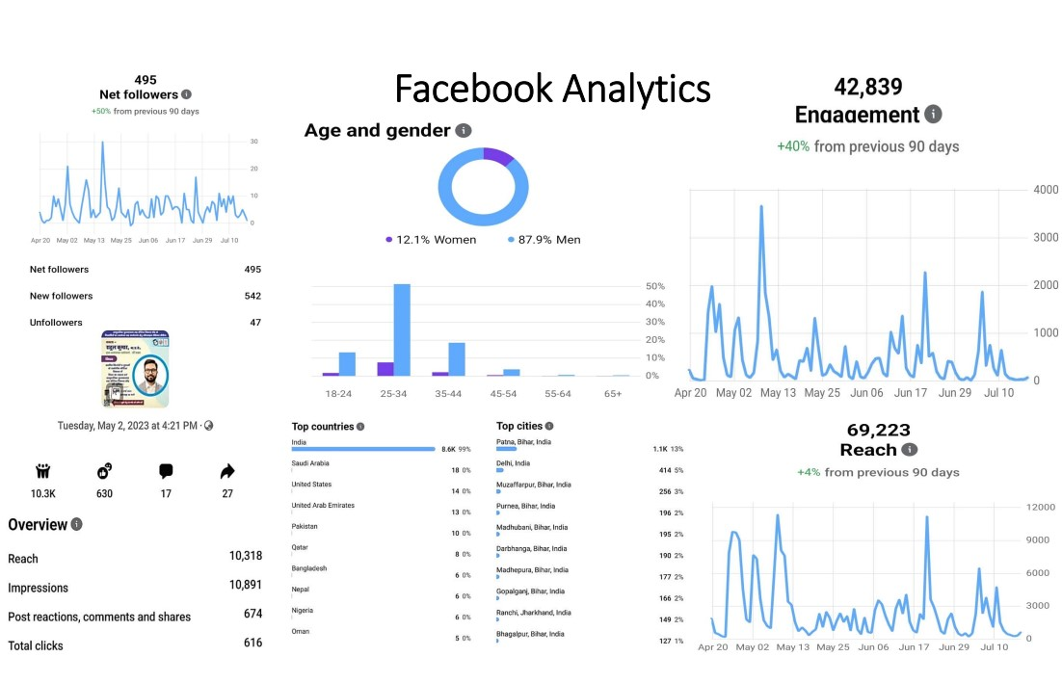
Extensive use of Social-Media: JEEVIKA’s social media presence have been a game changer to bridge the gap of digital divide. By strategically leveraging the reach and accessibility of social media channels, JEEViKA has harnessed a dynamic means to bridge information gaps and empower marginalized communities. Through engaging content, informative posts, and interactive discussions, JEEViKA has effectively democratized access to essential knowledge, resources, and opportunities. This digital outreach has not only dismantled geographical barriers but has also empowered individuals with the tools to navigate the digital landscape confidently. The impact is profound – enabling users, who were once on the fringes of digital connectivity, to become active participants in discussions, decision-making, and socio-economic progress. JEEViKA's foray into social media isn't merely virtual; it's a tangible manifestation of technology's transformative potential, combating the digital divide by empowering the underserved and fostering a more inclusive digital future.

Case Study
A Journey of Triumph: Seema's Path to Empowerment
In the eloquent words of Seema, the story of her ascent began in 1999, when she stepped into her husband's home after marriage. Greeted by the stark reality of two cramped rooms housing a family of six, along with four goats and a solitary cow, Seema confronted the challenge of limited resources. Her husband's daily wage work in a Delhi-based shop and meagre agricultural income from a small patch of land adjacent to their house barely sufficed for daily sustenance. Armed with a 12th-grade education, Seema resolved to explore alternative income avenues, but societal norms and familial constraints kept her confined within the domestic realm until 2014.
In a pivotal discussion with her spouse, Seema expressed her aspirations of contributing to the family's well-being. With the support of a Community Mobilizer, she forged a connection with an existing Community-Based Organization (CBO) under the aegis of JEEVIKA program in her Gram Panchayat. By March 2014, Seema had seamlessly transitioned into the role of a Community Mobilizer (CM), fostering the creation of multiple CBOs within her Gram Panchayat. These associations were intricately linked to banking institutions and other initiatives administered by JEEVIKA. Her educational background became a cornerstone in meticulously documenting CBO meetings and financial reports, capturing the attention of a DPCU official in Patna. This recognition propelled her ascent to becoming a Bank Mitra of the Bank of Baroda in 2016. With unwavering dedication, Seema embarked on regular visits to the BoB branch in GP Belchhi, facilitating banking transactions spanning deposits, withdrawals, account openings, Aadhaar seeding, loan applications, and meticulous banking documentation. Her diligence upheld loan recovery protocols, a testament to her commitment to financial inclusivity.
The journey took a pivotal turn when an opportunity arose to become a Bank Sakhi for Fino Payment Bank. Seema embraced the challenge, applying as a Business Correspondent (BC). This marked the inception of an arduous yet transformative process. The path led her to a rigorous screening procedure at BPIU, Belchhi, followed by a comprehensive six-day training regimen at RSETI Patna in 2020, culminating in her certification by the Indian Institute of Banking and Finance (IIBF).
Within a mere span of 28 months since her induction, she successfully facilitated the opening of saving bank accounts for a remarkable count of 1100 customers, who now remain loyal patrons of her Customer Service Point (CSP). In addition, she effectively orchestrated an impressive total of 9082 financial transactions, collectively amassing a substantial volume exceeding Rs. 2,55,95,768/-. As of the present, her daily transaction activity oscillates between 3.5 to 4.25 lakhs, catering to a customer base ranging from 80 to 115 on an average.
A Digital Odyssey: Seema's Empowerment through JEEVIKA's Technological Enablers
Seema's journey, punctuated by fortitude and determination, found an unexpected ally in the form of digital technology and JEEVIKA's application. This technological synergy acted as a catalyst, amplifying her productivity and propelling her on a mission to disseminate digital knowledge to the unreached corners of her community.
As Seema's trajectory intersected with JEEVIKA’s digital platforms, a transformative shift ensued. With the digital tool at her disposal, her efforts as a Community Mobilizer gained a new dimension. JEEVIKA’s Digital Applications became her virtual toolkit, empowering her to streamline the documentation of CBO meetings and financial reports. Her proficiency in utilizing technology to organize and record data not only improved the efficiency of her tasks but also impressed the higher echelons of the program. This proficiency culminated in her appointment as a Bank Mitra for the Bank of Baroda in 2016, a role that demanded precision and competence in digital transactions and documentation.
Her business approach strategically targets diverse segments including MANREGA job card holders, school-going children, elderly pensioners, Persons with Disabilities (PwD), beneficiaries of Indira Awas Yojana, and the Kisan Samman Nidhi scheme, amongst others, at the panchayat level. This astute strategy has catapulted her into becoming a recognizable figure synonymous with banking transactions within her community. Engaging in discussions with her customers during their regular visits to her CSP, instead of the alternative five CSPs, her prudent approach towards banking transactions is often noted as the driving factor behind their loyalty and commendation.
JEEVIKA's application proved to be an invaluable companion in her routine visits to the BoB branch in Gram Panchayat Belchhi, Patna. Seema seamlessly navigated through banking transactions, including deposits, withdrawals, account openings, and loan applications. She used digital tools to meticulously document banking processes, ensuring that financial inclusivity adhered to established protocols. This digital acumen not only streamlined her responsibilities but also added a layer of professionalism to her role as a bridge between the bank and the community. Seema's journey wasn't limited to personal growth; it encompassed a commitment to uplift her community through digital enlightenment. Armed with the knowledge garnered from her interactions with JEEVIKA's application, Seema embarked on a mission to disseminate digital literacy in areas previously untouched by modern technology. Her advocacy for digital inclusion traversed the landscape, reaching the farthest corners of her Gram Panchayat. Through workshops, discussions, and demonstrations, Seema infused her community with the empowerment that digital literacy bestows.
In a journey marked by personal evolution and community empowerment, Seema's narrative symbolizes the intersection of determination, technology, and social transformation. JEEVIKA's application, acting as a conduit of progress, not only elevated Seema's productivity but also amplified her ability to sow the seeds of digital knowledge among the unreached. Through her, digital empowerment became more than just a concept; it became a tangible force that reshaped lives and nurtured a new wave of possibilities in the uncharted terrain of her community.
In Seema's narrative, her journey from the confinements of societal norms to the corridors of financial empowerment exemplifies resilience, tenacity, and an unyielding spirit. Her tale stands as a testament to the profound impact of initiatives like JEEViKA, which not only empower women but also catalyze an entire community's progress through empowerment, education, and economic upliftment.
Conclusion
JEEVIKA's innovative approach, demonstrated through their MIS applications, showcases the potential to uplift marginalized communities by providing them with tools and resources that empower their socio-economic growth. By focusing on developing user-friendly applications tailored to the unique needs and challenges of these communities, JEEVIKA has taken a significant step towards democratizing access to information, education, and services. The impact of bridging the digital divide extends far beyond just technological accessibility. It enables individuals and communities to tap into opportunities that were once out of reach, fostering economic self-sufficiency, enhancing education, and promoting informed decision-making. This holistic approach aligns with the United Nations' Sustainable Development Goals, particularly in eradicating poverty, promoting decent work, and fostering inclusive growth.
Nevertheless, challenges remain, including infrastructural limitations, digital literacy disparities, and the need for continuous adaptation to rapidly evolving technology. Addressing these challenges demands a collaborative effort involving governments, non-governmental organizations, businesses, and academia. By synergizing resources and expertise, a more comprehensive and sustainable approach can be forged, ensuring the benefits of digital empowerment reach every corner of society. In essence, JEEVIKA's journey to conceptualize and implement in-house applications within their MIS exemplifies the immense potential of technology as an enabler of socio-economic empowerment. As we move forward, it is crucial to continue nurturing such initiatives, learning from their successes and challenges, and replicating their models to create a more equitable and prosperous world for all. The path to a digitally inclusive society is not just a technological journey; it is a testament to our commitment to humanity's progress, where every individual's potential can be unlocked, and no one is left behind.
References
- DiMaggio, P., & Hargittai, E. (2001). From the "Digital Divide" to "Digital Inequality": Studying Internet Use as Penetration Increases. Princeton University Center for Arts and Cultural Policy Studies.
- Donner, J. (2008). Research Approaches to Mobile Use in the Developing World: A Review of the Literature. The Information Society, 24(3), 140-159. doi:10.1080/01972240802019970
- Government of India. (2015). Digital India. https://www.digitalindia.gov.in/
- Hafkin, N., & Huyer, S. (2007). Cinderella or Cyberella? Empowering Women in the Knowledge Society. Kumarian Press.
- Hargittai, E., & Walejko, G. (2008). The Participation Divide: Content Creation and Sharing in the Digital Age. Information, Communication & Society, 11(2), 239-256. doi:10.1080/13691180801946150
- Hampton, K. N., Goulet, L. S., Marlow, C., & Rainie, L. (2011). Social Networking Sites and Our Lives: How People's Trust, Personal Relationships, and Civic and Political Involvement are Connected to Their Use of Social Networking Sites and Other Technologies. Pew Research Center.
- Huyer, S., Sikoska, T., & Hafkin, N. (2005). Gender Mainstreaming in Information and Communication Policies: A Toolkit. Commonwealth Secretariat.
- Norris, P. (2001). Digital Divide: Civic Engagement, Information Poverty, and the Internet Worldwide. Cambridge University Press.
- Selwyn, N. (2004). Reconsidering Political and Popular Understandings of the Digital Divide. New Media & Society, 6(3), 341-362. doi:10.1177/1461444804042519
- Tacchi, J., Watkins, J., & Kiran, M. S. (2012). Rural eServices and the Potential for Transformation: Findings from a Study of Community Multimedia Centers in India. Information Technologies & International Development, 8(3), 1-17.
- Van Deursen, A. J., & Van Dijk, J. A. (2014). The Digital Divide Shifts to Differences in Usage. New Media & Society, 16(3), 507-526. doi:10.1177/1461444813487959
- Warschauer, M. (2003). Technology and Social Inclusion: Rethinking the Digital Divide. MIT Press.
- Warschauer, M., & Matuchniak, T. (2010). New Technology and Digital Worlds: Analyzing Evidence of Equity in Access, Use, and Outcomes. Review of Research in Education, 34(1), 179-225. doi:10.3102/0091732X09349791

Appendix
Questionnaires for Data Collection
Certainly, here's a sample questionnaire that you can use for your research paper on bridging the digital divide through JEEVIKA's in-house application from the Management Information System (MIS). Please customize the questions as needed to align with your specific research objectives and the context of your study:
Participant Information:
- Gender: [ ] Male [ ] Female [ ] Other
- Age: ________
- Education Level: [ ] No formal education [ ] Primary [ ] Secondary [ ] Higher Secondary [ ] Graduation [ ] Post-Graduation [ ] Others (please specify) ____________
- Occupation: ____________
Usage and Access to JEEVIKA's Application:
- Are you aware of JEEVIKA's in-house application from the MIS? [ ] Yes [ ] No
- How frequently do you use the JEEVIKA application?
  - Daily
  - Weekly
  - Monthly
  - Rarely
  - Never used
- What type of device do you use to access the application?
  - Smartphone
  - Feature phone
  - Tablet
  - Computer
- What motivates you to use the JEEVIKA application? (Select all that apply)
  - Access to information
  - Skill enhancement
  - Job opportunities
  - Health information
  - Government schemes
  - Social interaction
  - Other (please specify) ____________
Digital Literacy and Skill Enhancement:
- How confident do you feel in using digital devices and applications?
  - Very confident
  - Somewhat confident
  - Neutral
  - Not very confident
  - Not at all confident
- Has using the JEEVIKA application improved your digital literacy skills?
- Significantly
- Moderately
- Slightly
- Not at all
Access to Information and Empowerment:
- Have you gained new knowledge or insights through the JEEVIKA application?
- Yes, frequently
- Yes, occasionally
- No
- How has the JEEVIKA application influenced your decision-making in areas like agriculture, education, healthcare, or livelihoods?
Challenges and Impact:
- What challenges do you face while using the JEEVIKA application, if any? (Open-ended)
- In what ways has the JEEVIKA application positively impacted your life or community? (Open-ended)
Community Engagement:
- Have you participated in any community forums or discussions within the JEEVIKA application?
- Yes, frequently
- Yes, occasionally
- No
- How do you perceive the role of community engagement features in the application in fostering interaction and collaboration among users?
Recommendations:
- How can JEEVIKA further enhance the effectiveness of its application in bridging the digital divide?
- What additional features or content would you like to see in the JEEVIKA application to better serve your needs?
Final Thoughts:
- Do you believe that the JEEVIKA application has contributed to reducing the digital divide in your community? Please explain your answer.
- Is there anything else you would like to share about your experience with the JEEVIKA application and its impact on digital access and empowerment?

