COMPARISON OF LOAD V/S DEFROMATION OF SHORT COLUMN BY USING MATLAB SOFTWARE

Prasad K N¹
¹Amruta Institute of Engineering and Management Science, Bidadi
Email: prasadnagaraj144@gmail.com

Vidya.B.R²
²Amruta Institute of Engineering and Management Science, Bidadi
Email: vidyapari17@gmail.com

ABSTRACT
The purpose of the project work is to comparison of load v/s deformation of short column made by reinforced cement concrete when they are subjected to concentric compression. The analysis of the reinforced cement concrete column is done by a Finite Element Software known as MATLAB in that ANN Tool (Artificial neural network). The input data for the software were collected from the experiments conducted on columns and the lateral ties are provided according to IS:456-2000 at clause number 26.5.3.2(c). As the studies are made limited on this comparison of load v/s deformation of short column, we are affordable with limited number of literatures. comparison of load v/s deformation of short column are depending upon wrong assumptions on model used for the analysis, and the results are very much conservative, and the empirical conservative rules are essential for the technical codes. In this research, the analysis is done through MATLAB software. The analysis is done for Normal strength concrete Column (NSC) of mix proportion of M- 20, M-30, M-40grade concrete. The analysis of physical model and deformation values are obtained very accurately with minimized errors. Finally, it shows the MATLAB software displaying the deformation results specifically.
Keywords—MATLAB; Artificial neural network; concentric.

INTRODUCTION
A reinforced concrete column is defined as a structural member with a steel frame [Reinforcement’s] composed of concrete that is been designed to carry the compressive loads. Stiffness of building frames. Main reinforcement in columns is longitudinal,parallel to the direction of the axial load, and bars are arranged in square, circular or circular pattern. Design of columns consists of compression and bending moments about one or both axes of the cross section. Generally, columns are the supporting elements for every kind of structural bodies. Column carry the load from beams from the superstructure’s and it will transfer the load to the sub-structure. Steel rebars are embedded into column to be as reinforcement. It may be provided in the tied form or the helical form. Column characteristics are depending upon the factors like slenderness ratio, stiffness, young’s modulus, characteristic compressive strength.Generally, the compressive strength of Normal Strength Concrete is below 50 N/mm². The other name for NSC are namely Conventional Concrete or Ordinary Portland Concrete or Traditional Vibrated Concrete. The main constituents used in manufacturing NSC are ordinary Portland cement, water, fine and coarse aggregate. The proportioning of concrete is done with guidelines given by IS:10262-2009. De-Bonding takes place in cement paste from the aggregates particles due to compression failure.MATLAB stands for MATrix laboratory. It provides easy access for the matrix developed through LINPACK (Linear system package) & EISPACK (Eigen system package) projects. It’s a computing language. For the technical computing this is one of the high computing language.it mainly includes the techniques like computation, visualization and programming. This is one of the modern programming language used in prediction. It supports the object-oriented programming, debugging tools and built-in editing options. MATLAB is well versed for the research work and even for teaching also. The data which is required for the MATLAB doesn’t required any dimensioning system. If we see the history it was launched in the ear 1984 and later on it became an effective tool around the world. Its built-in advancement also provides the variety of computational technique. Its graphic design is such effective, it helps in generation of results immediately and effectively visible.

MATERIALS AND METHODS

MATERIALS

1. Cement: OPC: Ordinary Portland Cement of 53 grade.
2. Fine Aggregate: M. Sand of Zone II.
3. Coarse Aggregate: 20mm downsize Aggregates.
4. Water: Portable water.
5. Steel: 8mm,10mm,12mm & 16mm TMT bars were used

Table:1 Specific Gravity of constituents.
Sl. No | Material | Specific gravity | IS codal limits | Related IS code
1. | Cement | 3.15 | 3.15 | IS:2720 Part - 3
2. | Fine aggregate | 2.57 | 2.5 – 2.9 | IS:2386(Part-3):1963
3. | Coarse aggregate | 2.65 | 2.6 - 3 | IS:2386(Part-3):1963
Table: 2 Mix Proportion for NSC M-20,M-30,M-40.

Materials | Proportion-M-20 | Proportion-M-30 | Proportion-M-40
Cement (kg/m³) | 358.47 | 383.16 | 465
Fine aggregates (kg/m³) | 690.68 | 670.72 | 650.80
Coarse aggregates (kg/m³) | 1113.93 | 1128.41 | 1094.89
Water (lit/m³⁾ | 197.16 | 191.58 | 186
Water cement ratio | 0.55 | 0.5 | 0.40
Cube compressive strength (28 days) N/mm² | 27.23 | 36.28 | 49.61

B.Methodology
- Collecting the experimental data and using it as inputs for MATLAB
- Importing the input and results into the MATLAB to perform Artificial Neural Network (ANN) techniques.
- Compare the MATLAB results using experimental results. 4. Finally compare the experimental results to know the shear behavior.

RESULT AND DISCUSSION

This Chapter includes the experimental data’s of column casted for different concrete mixes like NSC(Normal Strength Concrete), of mix proportion M-20, M-30 & M40. With Main bar reinforcements 8mm, 10mm,12mm and 16mm diameter with 8mm diameter Lateral ties and results compared with the MATLAB/ANN results.
Table:3 Experimental Result Data’s of NSC Columns

CriticalloadPcr(kN) | CriticaldeformationΔcr(mm) | LoadPy(kN) | DeformationΔy(mm) | UltimateloadPu(kN) | UltimatedeformationΔu(mm)
301.50 | 4.50 | 351.75 | 6.05 | 502.50 | 10.68
317.92 | 4.88 | 370.90 | 6.34 | 529.86 | 10.36
333.27 | 5.32 | 388.82 | 6.4 | 555.45 | 9.72
255.42 | 3.97 | 297.99 | 5.4 | 425.70 | 11.32
270.27 | 4.42 | 315.32 | 6.19 | 450.45 | 10.60
284.85 | 4.96 | 332.33 | 6.4 | 474.75 | 9.91
221.88 | 6.06 | 258.86 | 7.2 | 369.80 | 12.54
234.96 | 5.77 | 274.12 | 6.6 | 391.60 | 11.00
247.43 | 6.12 | 288.67 | 7.1 | 412.39 | 10.54
310.76 | 4.40 | 362.56 | 5.29 | 517.94 | 9.20
330.81 | 4.96 | 385.95 | 5.4 | 551.35 | 8.80
348.45 | 5.14 | 406.53 | 5.9 | 580.75 | 8.21
269.28 | 4.21 | 314.16 | 6.1 | 448.80 | 9.68
284.52 | 4.62 | 331.94 | 5.1 | 474.20 | 9.24
300.30 | 4.76 | 350.35 | 5.6 | 500.50 | 8.68
234.90 | 4.26 | 274.05 | 7.7 | 391.50 | 10.20
248.70 | 4.71 | 290.15 | 5.6 | 414.50 | 9.46
262.02 | 5.17 | 305.69 | 6.18 | 436.70 | 8.90
320.76 | 3.80 | 374.22 | 4.4 | 534.60 | 6.84
338.88 | 4.30 | 395.36 | 4.51 | 564.80 | 6.54
357.42 | 4.22 | 416.99 | 4.62 | 595.70 | 6.04
273.24 | 4.21 | 318.78 | 4.5 | 455.40 | 7.20
288.12 | 4.10 | 336.14 | 4.9 | 480.20 | 7.10
304.50 | 3.91 | 355.25 | 4.5 | 507.50 | 6.23
239.10 | 3.58 | 278.95 | 4.17 | 398.50 | 7.45
255.30 | 3.89 | 297.85 | 4.32 | 425.50 | 7.30
267.12 | 4.05 | 311.64 | 4.5 | 445.20 | 6.78
340.68 | 3.06 | 397.46 | 3.38 | 567.80 | 5.20
362.70 | 3.30 | 423.15 | 3.55 | 604.50 | 4.80
383.88 | 2.98 | 447.86 | 3.21 | 639.80 | 4.56
294.48 | 2.76 | 343.56 | 3.42 | 490.80 | 5.64
312.90 | 3.27 | 365.05 | 3.48 | 521.50 | 5.10
329.76 | 3.30 | 384.72 | 3.56 | 549.60 | 4.69
256.50 | 3.29 | 299.25 | 4 | 427.50 | 6.30
273.75 | 3.00 | 319.38 | 3.48 | 456.25 | 5.65
288.12 | 2.91 | 336.14 | 3.65 | 480.20 | 5.20

Table:4 MATLAB Result Data’s of NSC columns

CriticalloadPcr(kN) | CriticaldeformationΔcr(mm) | LoadPy(kN) | DeformationΔy(mm) | UltimateloadPu(kN) | UltimatedeformationΔu(mm)
303.19 | 4.78 | 353.63 | 6.12 | 505.24 | 10.33
319.90 | 5.05 | 373.11 | 5.96 | 533.07 | 9.81
335.61 | 5.21 | 391.42 | 6.14 | 559.24 | 9.29
260.80 | 4.86 | 304.18 | 6.35 | 434.60 | 10.76
277.51 | 5.13 | 323.66 | 6.19 | 462.43 | 10.24
293.22 | 5.29 | 341.97 | 6.37 | 488.60 | 9.72
218.41 | 4.94 | 254.73 | 6.58 | 363.96 | 11.19
235.12 | 5.21 | 274.21 | 6.42 | 391.79 | 10.67
250.83 | 5.37 | 292.52 | 6.60 | 417.96 | 10.15
310.57 | 4.41 | 362.24 | 5.58 | 517.54 | 9.33
327.28 | 4.68 | 381.72 | 5.41 | 545.37 | 8.82
342.99 | 4.83 | 400.03 | 5.60 | 571.54 | 8.30
268.18 | 4.49 | 312.79 | 5.81 | 446.90 | 9.76
284.89 | 4.76 | 332.27 | 5.64 | 474.73 | 9.25
300.60 | 4.91 | 350.58 | 5.83 | 500.90 | 8.73
225.79 | 4.57 | 263.34 | 6.04 | 376.26 | 10.19
242.50 | 4.84 | 282.82 | 5.87 | 404.09 | 9.68
258.21 | 4.99 | 301.13 | 6.06 | 430.26 | 9.16
319.59 | 3.95 | 372.76 | 4.92 | 532.58 | 8.12
336.29 | 4.22 | 392.24 | 4.75 | 560.41 | 7.60
352.01 | 4.37 | 410.55 | 4.94 | 586.58 | 7.08
277.20 | 4.03 | 323.31 | 5.15 | 461.94 | 8.55
293.90 | 4.30 | 342.79 | 4.98 | 489.77 | 8.03
309.62 | 4.45 | 361.10 | 5.17 | 515.94 | 7.51
234.81 | 4.11 | 273.86 | 5.38 | 391.30 | 8.98
251.51 | 4.38 | 293.34 | 5.21 | 419.13 | 8.46
267.23 | 4.53 | 311.65 | 5.40 | 445.30 | 7.94
342.75 | 2.78 | 399.78 | 3.22 | 571.18 | 4.99
359.46 | 3.05 | 419.27 | 3.05 | 599.01 | 4.48
375.17 | 3.20 | 437.58 | 3.24 | 625.18 | 3.96
300.36 | 2.86 | 350.33 | 3.45 | 500.54 | 5.42
317.07 | 3.13 | 369.82 | 3.28 | 528.37 | 4.91
332.78 | 3.28 | 388.13 | 3.47 | 554.54 | 4.39
257.97 | 2.94 | 300.88 | 3.68 | 429.90 | 5.85
274.68 | 3.21 | 320.37 | 3.51 | 457.73 | 5.34
290.39 | 3.36 | 338.68 | 3.70 | 483.90 | 4.82

- With reference to above table we can identify the error of maximum 8.37kN of Pcr b/w Experimental and MATLAB results.
- With reference to above table we can identify the error of maximum 0.89mm of Δcr
b/w Experimental and MATLAB results.
- With reference to above table we can identify the error of maximum 9.64kN of Py b/w Experimental and MATLAB results.
- With reference to above table we can identify the error of maximum 1.21mm of Δy
b/w Experimental and MATLAB results.
- With reference to above table we can identify the error of maximum 13.85kN of Pu b/w Experimental and MATLAB results.
- With reference to above table we can identify the error of maximum1.52mm Δu b/w Experimental and MATLAB results.

COMPARISON OF NS CCOLUMNS EXPERIMENTAL RESULTS WITH MATLAB RESULTS
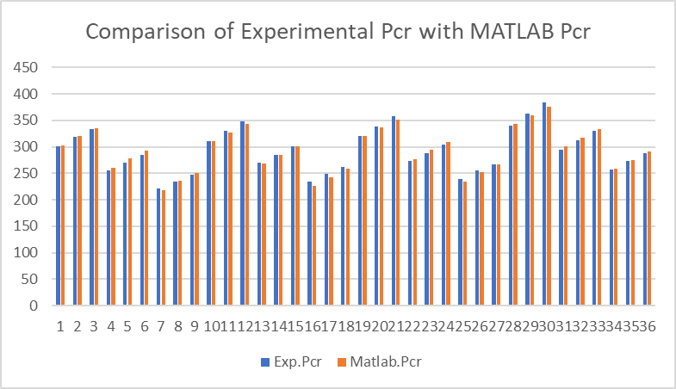  Graph.1Comparison of Experimental Pcr with MATLAB Pcr.  From the above graph it is observed that the variation in the critical  Load of Experiment is almost nearer to the critical load obtained from MATLAB | 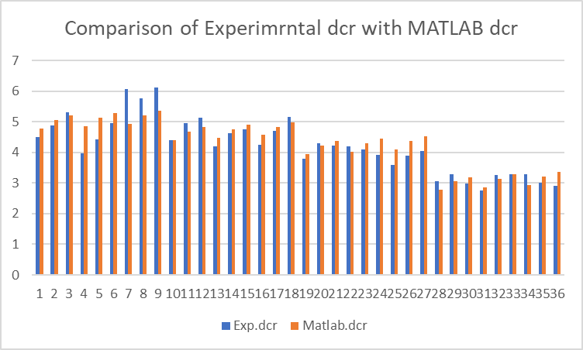  Graph.2 Comparison of Experimental Δcr with MATLAB Δcr.  From the above graph it is observed that the variation in the critical deformation of Experiment and MATLAB are varied in high extent due to variation in network training.
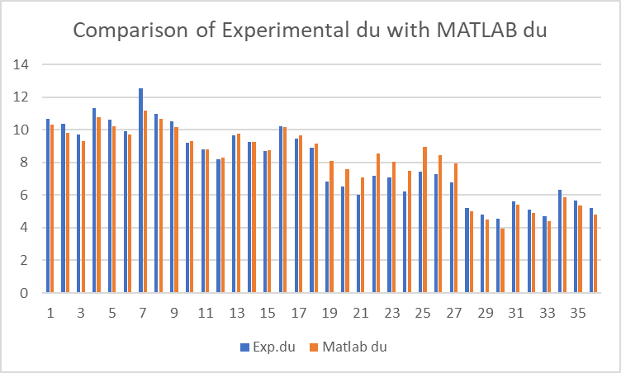  Graph.3 Comparison of Experimental Δu with MATLAB Δu.  From the above graph it is observed that the variation in the ultimate deformation in Experiment is comparatively higher than the MATLAB due to variation in network training | 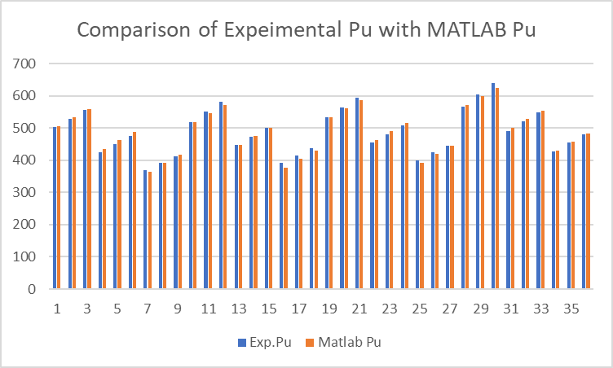  Graph.4 Comparison of Experimental Pu with MATLAB Pu.  From the above graph it is observed that the variation in the ultimate load of Experiment is almost nearer to the ultimate load obtained from MATLAB.

COMPARISONOFLOADV/SDEFORMATIONGRAPHFROMEXPERIMENTATLABOFNSCCOLUMN
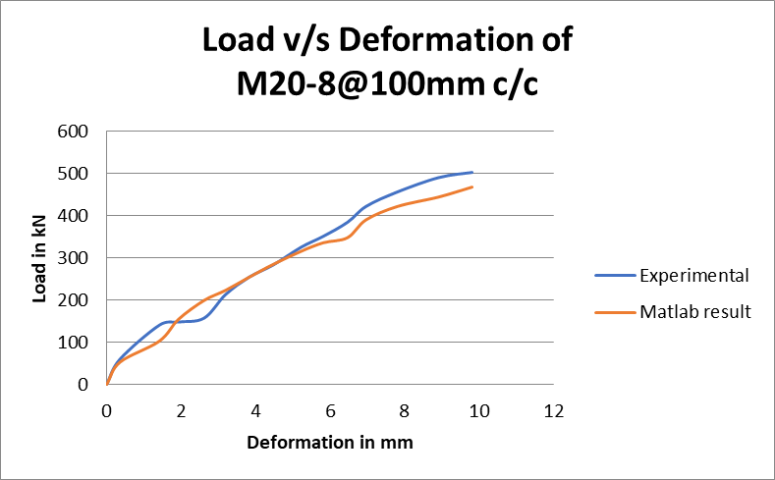

Graph.5 Comparison of Load v/s Deformation graph from Experimental with MATLAB of NSC M20 Column.
- FromtheabovegraphitisobservedthatMATALBcurveissimilartoExperimentalcurve.
- In experiment, load values are taken for regular intervals of deformation and in MATLAB the deformations and critical, yield load are obtained for ultimate 567.8kN axial load.

COMPARISON OF LOAD V/S DEFORMATION GRAPH FROM EXPERIMENTAL WITH MATLAB OF NSC COLUMN
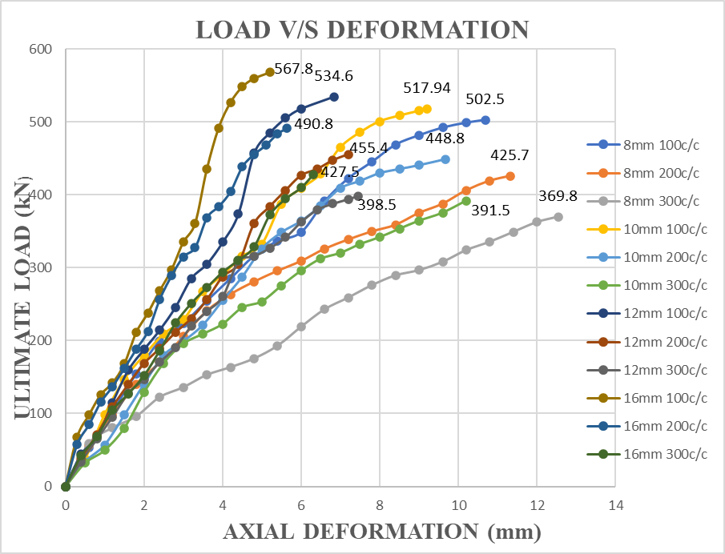

Graph.6 Comparison of Load v/s Deformation graph from Experimental with MATLAB of NSCM-20 Column.

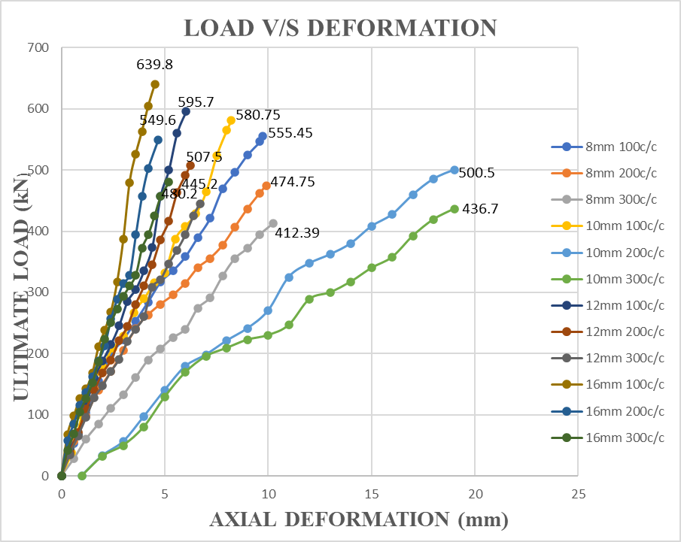

Graph.7 Comparison of Load v/s Deformation graph from Experimental with MATLAB of NSC M -30Column.
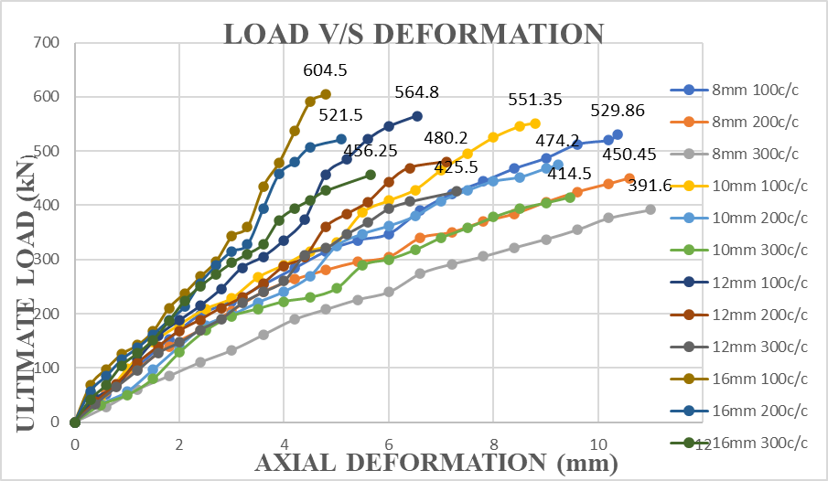
Graph.8 Comparison of Load v/s Deformation graph from Experimental with MATLAB of NSCM-40Column.

IV.CONCLUSION
This investigation was conducted to find the shear behavior of various concrete mix columns like NSC[NORMAL STRENGTH CONCRETE]M-20,M-30,M-40.The Reinforcement of column with main bar 8mm,10mm,16mm dia meter with lateral ties of 8mm diameter spaced at100mm,200mm,300mm c/c bought to know the shear behavior r of different concrete mix columns.
- COMPARISONOFNSC-20COLUMNEXPERIMENTALRESULTSWITHMATLAB RESULTS:
The total deformation of NSC-20 increases as the application of axial load increases.

    - TheabovegraphshowsthesimilarityinthenatureofcurveofbothMATLABcurve andexperimentalcurve.
    - Theultimateloadof567.8KNwasfoundduringexperimentandsameappliedasthe axialloadinMATLAB.
    - Theultimatedeformationobtainedfromtheexperimentwasrecordedas12.54mmwhereasMATLABprovided 11.19mmas result.
- COMPARISONOFNSC-30COLUMNEXPERIMENTALRESULTSWITHMATLAB RESULTS:
The total deformation of NSC-20 increases as the application of axial load increases.

- TheabovegraphshowsthesimilarityinthenatureofcurveofbothMATLABcurve andexperimentalcurve.
- Theultimateloadof604.5KNwasfoundduringexperimentandsameappliedasthe axial load in MATLAB.
- Theultimatedeformationobtainedfromtheexperimentwasrecordedas10.20mmwhereasMATL.ABprovided10.19mmas result.
- COMPARISONOF NSC-40 COLUMN EXPERIMENTAL RESULTSWITHMATLAB RESULTS:
The total deformation of NSC-40increases as the application of axial load increases.

- TheabovegraphshowsthesimilarityinthenatureofcurveofbothMATLABcurve andexperimentalcurve.
- Theultimateloadof639.8KNwasfoundduringexperimentandsameappliedasthe axialloadinMATLAB.
- Theultimatedeformationobtainedfromtheexperimentwasrecordedas7.45mmwhereasMATLABprovided8.98mmasresult.

REFERENCES
- Saifullah, M.A. Hossain, S.M.K. Uddin, M.R.A. Khan and M.A. Amin, (2011),“Nonlinear analysis of RCbeam for differentShear Reinforcement Patterns byFiniteElementAnalysis”.
- M.S Marefat (2017), In his study, before 1970 the concrete structures which werebuiltweconsistingofreinforcementwithplainbarswithoutanygripindentationson the rebar. His study was helped to conduct the experimenton numericalmodelofa columnwhichwasmade ofplain bars.
- Hamid Eskandari (2016), He studied different views with respect to retrofitting acolumnforaparticularbendingmomentandaxialloadforcolumnsdeterioratedby corrosion, especially those in a salt factory where they are exposed to chlorideions.
- M. S. Kachi (2014), This paper proposes a simple method for calculating circularsections subjected to axial force (compression or tension) and bending moment. Itoffersmanypossibilitiesofcalculationandverificationofcircularsections.
- H.AkbarzadehBengar(2010),H.AkbarzadehBengarfoundthattheprestressedconcrete solid members, nowadays possible to make use of the advantage of HPC(fc'>60 MPa) as well as replacing the solid section with a PSC thin-walled sectionforcertainmemberssuchascircularand boxcolumns.
- Fumio(1995), He combined uses of both high &ordinarystrength longitudinalbars for his study. When column subjected to bending moment ordinary strengthlongitudinalbarswillyieldfirstthenthehighstrengthbarswillyield.
- Yong(1988),Experimentwasconductedtoasquarecolumnmadebynormalstrength concrete. An improved stress strain relationship is obtained by providingmoreshearreinforcement.
- YongYook-kong,MalakahGNour,EdwardGNawy(1988)“Experimentalstudiesonsquarecolumnusingnormalstrengthconcreteanddeterminingofstress-strainrelationship”
- Abrams (1987), His study was to obtain the effect of column when subjected toaxial loading. If the spacing of stirrups is more then we can observe the largerdeflection.
- Saatcioglu, M., &Razvi, S. R (1987) “Study ofHigh-strength concretecolumnswithsquaresectionsunderconcentriccompression. JournalofStructuralEngineering,124(12),1438-1447.
- Abrams,D.P,ArturoTena,(1987),“Influenceofaxialforcevariationsonflexuralbehaviourofreinforcedconcretecolumns”.StructuralJournal,84(3),246-254.

