Agricultural Drones

Vaani Sri.S, Sai Durga.C , M. Maheswaran, K. Kokila
Department of Agronomy, Faculty of Agriculture, Annamalai University, Annamalai Nagar, Chidambaram, Cuddalore dist. – 608002 , Tamil Nadu

Abstract
India now has 1.408 billion people, and it will probably surpass China in population size in the near future. 16.3% of Indians, according to the Global Food Security Index 2022, are underweight. In addition, 3.8% of Indian children are obese, 33.9% of them are stunted, and 33.4% of them are underweight. India has a 0.65 human development index. To secure the security of the nation's food supply, agriculture is crucial. Agriculture is the foundation of India's economy because it employs more than 70% of the country's population. Providing food for the world's expanding population is the primary challenge facing agriculture. Indian small-scale farmers fall within this category. Additionally, less than 5 acres make up roughly 80% of India's cultivable land. Upgrading farm mechanization and bolstering farm practices can both contribute to national food security. Therefore, as a contemporary technology, drones have the potential to lessen issues related to farming methods and promote sustainability in the agricultural sector of the future.
Keywords : Unmanned aerial vehicle, Agriculture, Spraying, Monitoring, Quadcopter.
Introduction:
An unmanned aerial vehicle (UAV) is another name for a drone. It is an aircraft with no human passengers, crew, or pilot. Drones are used in farming to help with crop yield and crop growth, two tasks that can both be aided by their use. Farmers can employ these drones to assist them in gathering high-resolution photos of their fields thanks to the usage of sophisticated sensors and digital photography capabilities. Such equipment provides information that is extremely helpful in increasing crop yields and farm productivity. The use of agricultural drones today relieves farmers. Drone technology can reduce the need for labor and the consumption of resources. Drones are additionally utilized by farmers to get aerial views of their land.
Drone categories:
1. Fixed-wing drones: Fixed-wing drones have a rigid (non-movable) wing, a fuselage (the aircraft's primary body), and tails that serve as their propulsion system. They can fly longer at faster speeds. They carry the drawback of needing a runway or launcher for take-off and landing, which limits their ability to cover a wide range of terrain, including jungle, desert, mountain, and ocean locations.
2. Rotary wing drones: Also referred to as rotatory wing drones, these drones use propeller- or rotary blade-based propulsion systems. These drones can fly both horizontally and vertically, unlike fixed-wing variants. These can be used to survey sites that are typically challenging to survey (pipelines, bridges, etc.). The continual rotation of the rotor blades gives them a lift similar to that of helicopters. However, low speed and short flight range have drawbacks.
3. LTA & tethered systems drones: These are hardly utilized in agriculture and have challenging management.

Major Components of Drones:
The following are major parts of drones.
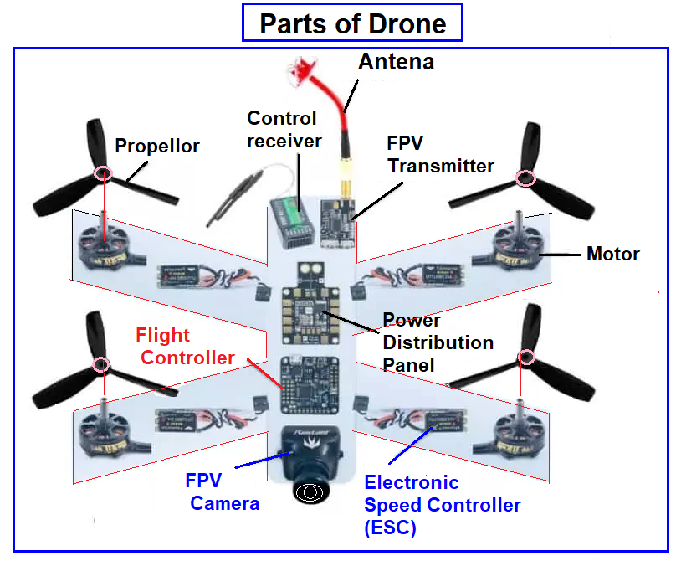
Fig.1 Components of drone
1. Frame:
The framework needs to be sturdy enough to hold the added weight of the motors and cameras as well as the propeller motion.
• It ought to offer minimal aerodynamic resistance and be durable.
2. Propellers:
- Long propellers produce enormous torque to carry heavy loads at a low speed (RPM) and are less sensitive to changing the speed of rotation.
- Short propellers carry less loads.
- A drone's speed and its capacity to lift loads depend on the shape, size, and number of its propellers. They require a high speed to generate more thrust and frequently change rotational speeds.
3. Drone motors: Motor Drones can use both brushless and brushed motors.
- Brushed motors are more reasonably priced and suitable for small-scale drones.
- Brushless motors of this sort are strong and extremely energy-efficient. But in order to regulate their speed, they require an electronic speed controller.
- Drones used for aerial photography, traffic studies, and freestyle drone
all make use of these brushless motors.

4. Electronic Speed Controller (ESC):
The drone's four motors are each equipped with an ESC, which is used to connect the battery to the electric motor for power supply and translate the flight controller's signal to the motor's revolutions per minute (RPM).
5. Flight Controller (FC):
- The Flight Controller is a computer processor that controls balance and telecommunications utilizing various transmitters.
- This device contains accelerometer, barometer, magnetometer, gyroscope, and GPS sensors.
- An ultrasonic sensor may execute the distance measurement.
6. The radio signal from the radio transmitter is sent to the ESC by the pilot to control the motor speed.
7. Radio Receiver: Captured the pilot's signal. The quadcopter is equipped with this gadget.
8. Battery: The majority of drones use high-power Lithium Polymer (LiPo) batteries. Battery configurations include 3S (3 cells) and 4S (4 cells).
9. Drones can be set to fly on their own or be manually piloted using a remote controller. Autonomous drones can fly to a destination, carry out an operation—such as taking pictures or delivering a package—and then fly back to their starting position using sensors and preprogrammed instructions.
Drone applications in agriculture:
Analysis of field soil:
Crop soil quality has a direct impact on how productive a farmer is. Farmers must perform a soil analysis as a critical phase in the crop-cycle. One can identify problems with soil quality, fertilizer management, or dead soil zones using precision agriculture. This information aids farmers in identifying the best practices for planting, crop management, and soil management. Accurate 3-D maps created by drones can be utilized for early analyses of the soil's properties, moisture content, and soil erosion.
Pesticide spraying:
Spraying insecticides is essential for preserving crop health since it kills pests and unwelcome plants like weeds. In comparison to hand spraying, drones equipped with pesticide spraying equipment operate more effectively and at a lower cost. They can accurately and evenly spray the necessary volume of liquid in real time thanks to their capacity to monitor and control their distance from the ground. As a result, there is an increase in efficiency and a decrease in the amount of chemicals that seep into the groundwater. By drastically reducing labor and time expenditures, as well as by shielding farmers from harmful pesticides, we are able to achieve precision agriculture.
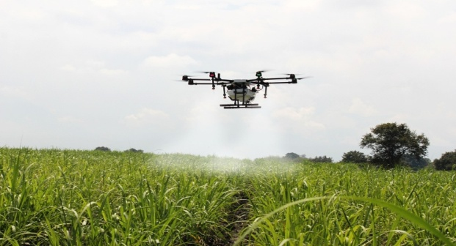
Fig.2 Drone used for spraying

Irrigation:
Drones with Thermal Cameras and Remote Sensing capabilities can detect irrigation problems or regions with insufficient or excessive moisture. With the use of RGB Imagery, farmers may position and separate their crops in fields to enhance drainage, follow natural land flow patterns, and prevent water logging. Farmers will be able to adapt to various surroundings with ease thanks to the use of drone technology. Drones can also be used to depict a crop's heat signature, or the amount of energy or heat it emits once it has started to grow, as well as to calculate the vegetation index, which represents the crop's relative density and health.
Monitoring Field Conditions:
Drone field monitoring is used to keep an eye on the state of the field and the soil. Drones can precisely map the field and provide elevation data, allowing farmers to see any field anomalies. Knowledge of field elevation makes it easier to identify drainage patterns and wet/dry regions, which facilitates the use of more efficient watering techniques. Utilizing more modern sensors, a number of agricultural drone suppliers and service providers also provide soil nitrogen level monitoring services. This makes it possible to apply fertilizer precisely, removing troublesome growth zones and enhancing soil health for years in the future.
Health evaluation:
It's important to evaluate the health of the crops and look for bacterial or fungal infestations on trees. Using both visible and near-infrared light to scan a crop, drone-borne technology can identify which plants reflect different amounts of both green and NIR light. Multispectral images made from this data can be used to follow changes in plants and assess their health. An entire orchard can be saved with quick action. Farmers can also more accurately apply and monitor treatments once a disease is identified.

Mid-field weed identification:
Mid-field weed identification: Using NDVI sensor data and post flight picture data, we can produce weed maps that will make it simple for farmers to distinguish between areas with a lot of weed growth and nearby, healthy crop areas.

Cattle herd monitoring:
Drones equipped with thermal sensors are a reliable choice for keeping an eye on cattle herds from above. They are capable of identifying animals that are missing, hurt, or giving birth. Therefore, drones allow livestock farmers a new way of constantly tracking their livestock, which leads to higher profitability.

Benefits associated with drones for agriculture:
Benefits of drones in the agriculture sector include the ability to map crops, analyze soil, control pests, and more. Drones can be utilized for a variety of jobs in the agriculture sector. The following are a few of the major advantages of employing drones in agriculture:
Increased crop yields

Lower price of commodities
Enhanced accuracy

Increased effectiveness

1. Increased effectiveness: Drones can swiftly and efficiently cover huge amounts of land, enabling farmers to collect information and monitor crops more successfully. This can help identify problems early, leading to speedier and more effective solutions.
2. Enhanced accuracy: Drones can collect precise data and high-resolution photographs, giving farmers a clearer picture of their crops. This can help identify areas of concern and make sure that solutions are successful and focused.
3. Increased crop yields: Farmers can spot problem regions by using drones to collect information on the health of their crops. Farmers can raise their agricultural yields and revenues by solving these problems.
4. Lower prices: By identifying farm areas that need attention, lowering the demand for human labor, and lowering the usage of pesticides and other chemicals, drones can assist to lower costs.

Obstacles to drone technology adoption in the agricultural sector:
Despite the benefits that drones provide, a number of obstacles prevent farmers from implementing the technology. Here are a few of the main difficulties:
1. Fear of job loss: Since fewer people will be required to undertake manual labor on farms as a result of the use of drone technology, many farmers worry that this will result in job losses.
2. Lack of knowledge and training: Farmers may lack the skills or background required to operate drones safely. If they lack the confidence to use the technology, it could be challenging for them to adopt it.
3. Price: Many farmers might not have the funds to invest in this technology because drones can be expensive.
4. Regulatory obstacles: Farmers may find it challenging to use this technology if there are legal obstacles to the usage of drones in agriculture.

Conclusion:
In summary, new technologies are emerging that allow for the detailed collection of data. Wide-ranging service opportunities are made possible by UAV technology. For the first time, PwC claims that UAS will turn agriculture into a high-tech industry, with decisions based on actual data collection and processing and a potential boost in productivity and yields.
Farmers in the agricultural industry can profit from drones in a variety of ways, including higher productivity, better yields, and lower expenses. Farmers may be hesitant to accept this technology due to worries about job loss, a lack of expertise, and inadequate training. In order to solve the difficulties in deploying drones while promoting their use, efforts are being made in rural areas wherein the adoption of UAV is still gaining traction. The farmer must be aware of the potential benefits offered by this technology and obtain the appropriate training to support the effectiveness of the machinery. Drone technology usage in the agricultural industry has the potential to change how farmers manage their crops and increase yields.

References:
Surya Rathore, Vijayalakshmi B, V V Sumanth kumar. Digital technologies in agriculture. Drones in Agriculture. Pg 171-182
AdityaS. Natu, Kulkarni S.C. Adoption and Utilization of Drones for Advanced Precision Farming: A Review., International Journal on Recent and Innovation Trends in Computing and Communication (2016) published in, ISSN: 2321-8169 Volume: 4 Issue: 5 PP.563 – 565

Everaerts J. The use of unmanned aerial vehicles (UAVs) for remote sensing and mapping.
The International Archives of the Photogrammetry, Remote Sensing and Spatial Information Sciences, 37 (2008) (2008), pp. 1187-1192

Herwitz S.R., Johnson L.F., Dunagan S.E., Higgins R.G., Sullivan D.V., Zheng J., Slye R.E.
Imaging from an unmanned aerial vehicle: agricultural surveillance and decision support.
Computers and electronics in agriculture, 44 (1) (2004), pp. 49-61

Meivel S., Maguteeswarn R., Gandhiraj N., Srinivasan G.
Quad copter UAV based Fertilizer and Pesticide Spraying System.
International Academic Research Journal of Engineering Sciences, 1 (1) (2016), pp. 8-12
Vol issue, February, Page No.2016
https://www.financialexpress.com/opinion/food-security-and-national-security-of-india/3023836/
https://www.fao.org/documents/card/fr/c/I8494EN/
https://en.wikipedia.org/wiki/Unmanned_aerial_vehicle
https://cfdflowengineering.com/working-principle-and-components-of-drone/
file:///C:/Users/COOL/Desktop/timeline-of-drones-and-exploration-of-drone-based-applications-v2.webp
https://timesofindia.indiatimes.com/blogs/voices/drone-technology-in-agriculture-benefits-and-challenges-for-rural-india/

https://nahep.vnmkv.org.in/media/2020/05/AgriDrones.pdf
file:///C:/Users/COOL/Downloads/Drones%20in%20Agriculture%20(1).pdf

