**Chemical Derivatization of Phytochemicals: A Constant Source of New Drug Molecules**

Prafulla Sabale1, Manish Kamble*1, Kamlesh Machewar1,Mahendra Gunde2, Tejaswini Selwate2, Kalyani Dongarwar.

1.University Department of Pharmaceutical Sciences, R. T. M. N. U. Nagpur-440033 (India)

**Abstract:**An overview of the well-known function of phytochemicals as a source of fresh drug leads is provided. Combinatorial chemistry has raised hopes for the discovery of novel chemical entities with considerable molecular activity and desirable pharmacological characteristics. Phytochemicals and their analogues demonstrate great chemical variety, maximal biological specificity, and therapeutic efficacy in addition to being employed as precursor materials for analogue design and synthesis as semisynthetic novel pharmacological entities with better therapeutic efficacy. For the beginning or design of novel phytochemical entities, it is necessary to identify the optimal candidate phytomedicine via bioassay-guided fractionation and isolation of desirable phytoconstituents. In many instances, structural alteration of phytomedicines is necessary to improve the physic-chemical and pharmacokinetic activities of plant-derived compounds, which results in altered therapeutic action and increased selectivity. Exploring the novel derivatized chemical entities is encouraged by semisynthetic derivatives' overall favourable preeminence. The goal of the current review is to provide an overview of phytochemical chemical derivatization.

**Keywords:** Phytochemicals, Semisynthetic derivatives, Synthetic drugs.

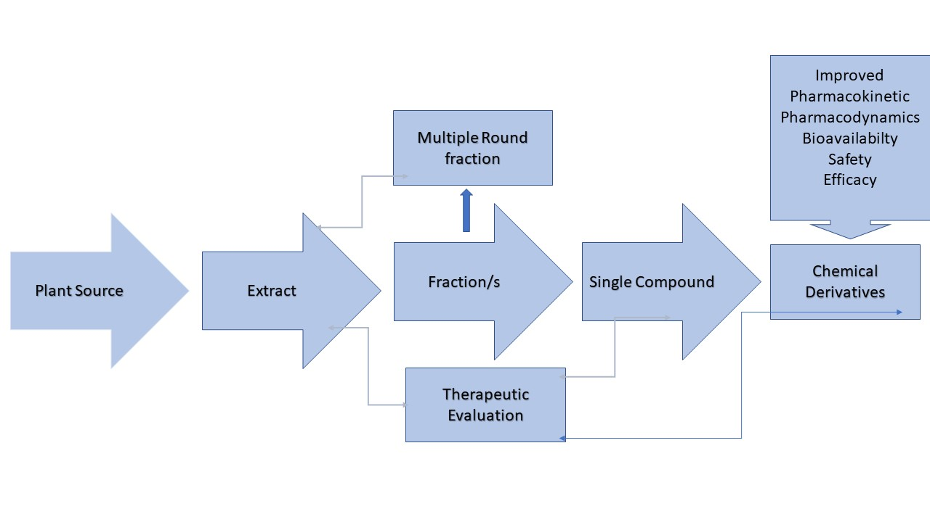

**Graphical Abstract:** Phytochemicals in the drug development

**Introduction:** People have always relied on plants to provide fundamental requirements including food, clothing, shelter, and a variety of disease treatments. Since the beginning of time, man has relied on nature to meet his fundamental requirements and has also investigated its riches and employed them to treat illnesses. Ancient civilizations used traditional medicine, with knowledge transferring from one generation to the next. Traditional medical practises based on plants continue to be crucial to healthcare, and usage across cultures has been well-documented [1-2]. Plant-derived traditional medicines were the primary source of healthcare for almost 65% of the world's population, hence they play a significant role in the healthcare system [3]. Plant-derived remedies originally originated in modern medicine through the use of plant material as an indigenous therapy in folklore or traditional systems of medicine. Photochemicals are often viewed as safer than synthetic medications due to their increased chemical variety and preference over synthetic combinatorial molecules. Additionally, the metabolites from plants have more stereogenic centres, heteroatoms in a variety of ratios, favoured core ring scaffolds, and therapeutic efficacy [4-5]. Isolated compounds from well-known plant sources were used as excellent starting points for the design and synthesis of analogues. Although the valuable lead compounds are made of natural materials, it is uncommon for these materials to be used directly in clinical settings [6]. Because natural products and their semi-synthetic derivatives are valuable sources of new drug candidates with a variety of biological and pharmacological activities, structural modifications of isolated compounds are therefore necessary in many situations [7-8]. It's fascinating to see that the majority (21%) of the total medical contribution is made up of semi-synthetic derivatives. Excellent examples of changes that improved biological activity are increasing lipophilicity and adding halogen atoms to natural compounds [9].

**Fig 1:** Utilization of Plant derived medicines, Semisynthetic medicines and other systems of medicine

The structural change is used in accordance with standard medicinal chemistry principles to improve therapeutic efficacy, selectivity, pharmacokinetics, and physicochemical properties. The current drug discovery paradigm used by large pharmaceutical corporations and technical constraints on finding novel compounds with desirable activity present hurdles for the development of new semi-synthetic drugs. Structures must be changed when creating an analogue in order to increase efficacy, decrease toxicity, or improve absorption. This is frequently done by adding or removing particular functional groups. The parent natural compounds' design, chemical alterations, and natural sources are summarized in the current review. This article also aims to present a summary of the biological functions of their equivalents.

**Chemical Derivatization of Natural Products:**

**Alkaloids**

Alkaloids are secondary metabolites that include nitrogen and are very common in nature all over the world. They have a variety of biological actions. The first alkaloid, morphine, was extracted from opium in 1805 and it is still a significant therapeutic compound [10]. There are currently more than 20000 alkaloids known, and many of these have been used in medicinal settings. At least 60 plant-derived alkaloids have currently received drug approval in a number of nations [11]. The few purine alkaloids that are regularly ingested are mostly found in tea, cocoa, and coffee. Most alkaloids are pharmacologically active or dangerous when taken in large quantities; they demonstrate a wide range of biological properties, including anticancer, antibacterial, anticholinergic, antihypertensive, antidepressant, anti-inflammatory, and antiulcer [12].

**Table 1: Few alkaloids used in marketed medicines**

|  |  |  |
| --- | --- | --- |
| **Alkaloid name** | **Applications** | **Example product** |
| Ajmaline | Antiarrhythmic agent | AritminaTM, GilurytmalTM, RauwopurTM, RitmosTM |
| Caffeine | Neonatal apnea, atopic dermatitis | AgevisTM, AnlagenTM, ThomapyrineTM, Vomex ATM |
| Codeine (Methylmorphine) | Antitussive, analgesic | AntitussTM, CodicapsTM, TussipaxTM |
| Lobeline | Anti-smoking, asthma, cough | CitotalTM, LobatoxTM, RefraneTM, StopsmokeTM |
| Morphine | Pain relief, diarrhea | DiastatTM, DuromorphTM, OramprphTM, SpasmofenTM |
| Quinine | myotonic disorders | AdaquinTM, BiquinateTM, QuinoctalTM, Zynedo-BTM |
| Taxol (Paclitaxel) | ovary carcinoma | TaxolTM |
| Vinblastine | Hodgkin’s disease, testicular cancer, blood disorders | PeriblastineTM, VelbanTM, VelbeTM, VelsarTM |
| Vincristine | Burkitt’s lymphoma | NorcristineTM, OncovinTM, VincrisulTM |

**Ajmalin:** Ajmalin and ajmalicine are the medicinally important terpenoid indole alkaloids. The most important indole alkaloid is clinically useful anticancer agent. Ajmalicine is used in the treatment of circulatory disease. A[jmalicine](https://www.sciencedirect.com/topics/chemistry/ajmalicine) was found to occur in [*Uncaria*](https://www.sciencedirect.com/topics/biochemistry-genetics-and-molecular-biology/uncaria) elliptica and Petchiaceylanica , whereas its 10,11-dimethoxy derivative, [reserpiline](https://www.sciencedirect.com/topics/chemistry/reserpiline) , and the C-20 [epimer](https://www.sciencedirect.com/topics/chemistry/epimer) of [reserpiline](https://www.sciencedirect.com/topics/chemistry/reserpiline), isoreserpiline, have been isolated from Neiosospermaoppositifolia .

R=h, 20β-H Ajmalicine

R=, 20β-H Reserpiline

R=OMe, 20α-HIsoresserpiline

R=H, 20α-HTetrahydroajmalicine



**Fig 2:** Chemical derivatives of Ajmalin

**Caffeine:**Understanding the mechanism and molecular effects of oxidative damage to purine bases, which occurs mostly at C-8, requires a special interest in the oxidation of purines. Caffeine and its equivalents involve the embedded purine ring structure being oxidised at C-8. No other oxidation products were seen during the extremely selective reaction, which was thought to be caused by the production and rearrangement of the 8,9- or 7,8-oxaziridines [13].

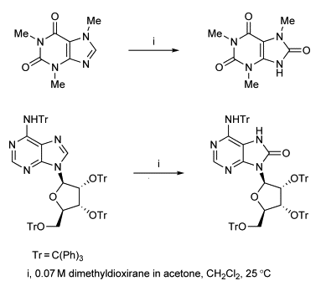

**Fig 3:**Different chemical derivatives of Purine Bases

**Morphine:** The opium poppy, or Papaver somniferum, is a plant that naturally contains morphine, a potent narcotic. Although it is commonly used recreationally or used to make other illicit opioids, its primary purpose is the treatment of pain. Other opioids like hydromorphone, oxymorphone, and heroin are all made from morphine [14].

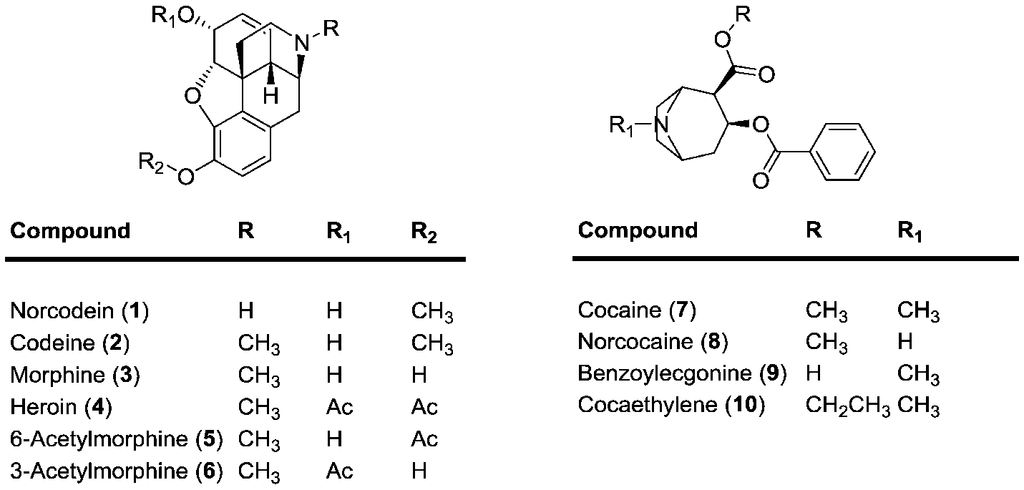

**Fig 4:**Various semisynthetic derivatives of Morphine

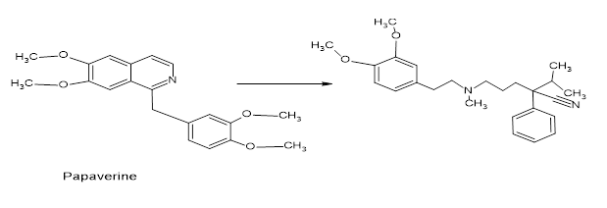

**Fig 5:**Semisynthetic modification of some alkaloids

**Quinine:** One of the biggest health problems that the human race still faces is malaria, thus finding more affordable and effective medications is crucial for world health. Indigenous communities in the Amazon region had long employed the bark of cinchona species to treat fevers; this practise was later brought to Europe to treat malaria. Quinine, an antimalarial medicine, was extracted from the bark of various Cinchona species, including C. officinalis. The antimalarial medications chloroquine and mefloquine, which essentially supplanted quinine, were synthesised from quinine. With the emergence of resistance to both of these medications in many tropical places, another plant long used in Traditional Chinese medicine (TCM) to treat fevers, Artemisia annua (Quinhaosu), gained prominence[15]. A promising new natural product lead compound, known as artemisinin, was offered by traditional Chinese medicine. In many nations now, artemisinin analogues are used to treat malaria [16]. In an effort to increase the activity and utility of artemisinin, many analogues have been created. The completely synthetic analogue OZ277 (Fig. 7) [17] and the dimeric analogue are two of the more promising of these.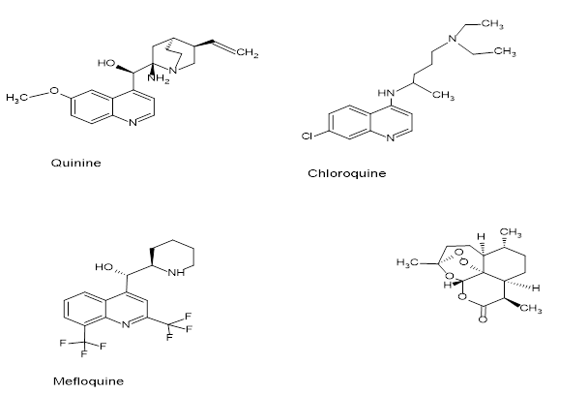

**Fig6:**semisynthetic analogue of antimalarial Quinine

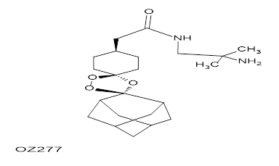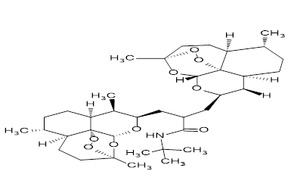

**Fig7:** semisynthetic analogue of antimalarial Artemisin

Plants have been used to cure cancer for a very long time [18], but many of the claims made for their effectiveness should be considered with some scepticism because cancer is probably not well defined in terms of folklore and traditional medicine [19]. The so-called vinca alkaloids vinblastine and vincristine, as well as the two clinically-active drugs etoposide and teniposide, which are semi-synthetic derivatives of the naturally occurring substance epipodophyllotoxin, are some of the best known [20–22]. They were discovered in the Madagascar periwinkle, Catharanthus roseus.

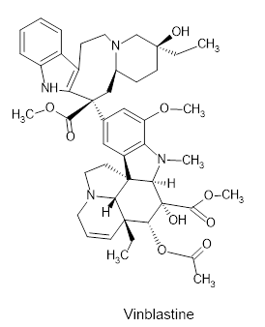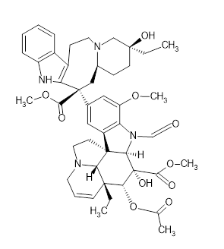

Etoposide

**Fig 8:** Chemical Modification in anticancer phytochemicals from Vinca & Taxol

**Flavone:** An essential subclass of flavonoids with a 2-phenyl-1-benzopyran-4-one structure are known as flavones. In complicated diseases like cancer, inflammation, cardiovascular disease, diabetes, and different neurological disorders, the scaffold has been frequently employed for multitargeting. Flavones have a wide spectrum of biological functions, which has sparked interest in the structure-activity connections among medicinal chemists. Low molecular weight polyphenolic phytochemicals called flavonoids are produced by plants' secondary metabolism [23]. The following flavonoids would be categorised as such: There are several different types of flavonoids, including flavonols (such as kaempferol, myricetin, quercetin, and fisetin), flavones (such as apigenin and luteolin), flavonoid glycosides (such as rutin and astragaline), flavanones (such as hesperetin and naringenin) flavonolignans (such as silibinin), flavan (Fig.9). The medicinal potential of numerous natural, semisynthetic, and synthetic flavone derivatives has been investigated. Due of flavones' beneficial effects on oxidative stress-related disorders like cancer and Alzheimer's disease, which are significant metabolic diseases caused by oxidative stress. Flavones can undergo a variety of structural modifications to produce products with the high yield, purity, and desirable quality. Reduction processes, base-induced degradation, oxidation, rearrangement, substitution, addition, condensation, and interactions with organometallic reagents are a few of the structural alterations that might occur.

**Fig 9:** Different Flavones with vast therapeutic activity

**Lignans:** Higher plants often include the large class of phenylpropane derivatives known as lignans, which play a key role in both food and medicine. They have received a lot of attention for their diverse structures (dimers, trimers, or tetramers) and pharmacological properties, including their anti-tumor, antiviral, antimitotic, antihypertensive, and anti-oxidant properties. Due to the many forms of bonding between the C6 and C3 units and the oxidation of the interesting structures, lignans were chosen as the starting material to make semi-synthetic derivatives[24–25].

**Fig 10:** Lignans and Semisynthetic analogue

**Phenolic compounds:** Polyphenols and phenolic compounds are secondary metabolites that have a variety of uses. owing to their widespread occurrence, variety of chemical makeup, and alluring pharmacological characteristics. Functional foods are a rich source of these phytochemicals. The therapeutic effectiveness of phenolic substances includes antioxidant, antibacterial, cancer prevention, ascorbic acid stabilisation, etc. [26–28].

**Fig 11:** Commonly used Polyphenols for synthesizing analogues

**Steroid:** The metabolism of cholesterol produces steroids, which have a distinctive cyclo-pentanoperhydrophenanthrene ring motif. The creation of pharmaceuticals, medicinal chemistry, and chemical biology all depend on steroids. A variety of medical diseases, such as inflammation, heart disease, cancer, and allergic reaction, are treated using a number of FDA-approved drugs containing steroid bases. They also play a significant role in other crucial areas of health-related behaviour, such as fitness and contraception [29–31].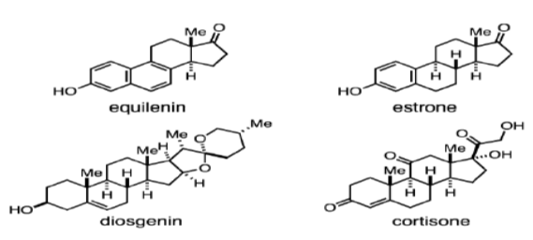

**Fig 12:** Plant derived steroids and analogue

**Conclusion:**The use of natural materials and their semi-synthetic derivatives as sources of innovative medication candidates with a variety of therapeutic effects is exceptional. Resources for developing novel therapeutic compounds are already available or are being developed quickly. Numerous altered semisynthetic drug compounds are produced thanks to the development of synthetic biology technologies. The importance of a semisynthesis as a strategy for boosting the biological activity of starting natural products has been well researched. Numerous promising natural and/or semi-synthetic phytochemicals fit the bill to be considered as possibilities for use in drug discovery. The active chemicals are being isolated from the species that displayed high biological activity during screening using bioassay-guided fractionation. various scientific studies might be used to develop medicines for various illnesses. In order to derive the compounds with the appropriate pharmacokinetics, pharmacodynamics, and therapeutic efficacy, more research is required. These compounds could then be used as leads and scaffolds for the creation of novel medications.

**References:**

1. T. Johnson, CRC ethnobotany desk reference, CRC Press, Boca Raton, FL, 1999.
2. N.R. Farnsworth, R.O. Akerele, A.S. Bingel, D.D. Soejarto, Z. Guo, Medicinal plants in therapy, Bull. World Health Organ. 63 (1985) 965–981.
3. G. Samuelsson, Drugs of Natural Origin: A Textbook of Pharmacognosy, fifth ed., Swedish Pharmaceutical Press, Stockholm, 2004.
4. K. Grabowski, K.-H. Baringhaus, G. Schneider, Nat. Prod. Rep. 25 (2008) 892
5. Z. Guo, Acta Pharm. Sin. B. 7 (2017) 119.
6. D.J. Newman, G.M. Cragg, J. Nat. Prod. 79 (2016) 629.
7. E.C. Barnes, R. Kumar, R.A. Davis, Nat. Prod. Rep. 33 (2016) 372.
8. S.N. Dupuis, A.W. Robertson, T. Veinot, S.M.A. Monro, S.E. Douglas, R.T. Syvitski, K.B. Goralski, S.A. McFarlandc, D.L. Jakeman, Chem. Sci. 3 (2012) 1640.
9. A.M. Lourenco, L.M. Ferreira, P.S. Branco, Curr. Pharmaceut. Des. 18 (2012) 3979.
10. Devereaux, A.L.; Mercer, S.L.; Cunningham, C.W. DARK classics in chemical neuroscience: Morphine. ACS Chem. Neurosci. 2018, 9, 2395–2407.
11. Cordell, G.A.; Quinn-Beattie, M.L.; Farnsworth, N.R. The potential of alkaloids in drug discovery. Phytother. Res. 2001, 15, 183–205.
12. Falcao de Sousa, J.A. Leite, J.M. Barbosa-Filho, P.F. de Athayde-Filho, M.C. de Oliveira Chaves, M.D. Moura, A. Luiz Ferreira, A.B. Albino de Almeida, A.R.M. Souza-Brito, M. de Fatima Formiga Melo Diniz, L.M. Batista, Molecules 13 (2008) 3198.
13. I. Collins, J.J. Caldwell, in [Comprehensive Heterocyclic Chemistry III](https://www.sciencedirect.com/referencework/9780080449920/comprehensive-heterocyclic-chemistry-iii), 2008.
14. David H. Chestnut MD, in Chestnut's Obstetric Anesthesia, 2020.
15. D.L. Klayman, A.J. Lin, N. Acton, J.P. Scovill, J.M. Hoch, W.K. Milhous, A.D. Theoharides, Isolation of artemisinin (qinghaosu) from artemisia annua growing in the United States, J. Nat. Prod. 47 (1985) 715–717.
16. P.M. O'Neill, G.H. Posner, A medicinal chemistry perspective on artemisinin and related endoperoxides, J. Med. Chem. 47 (2004) 2945–2964.
17. J.L. Vennerstrom, S. Arbe-Barnes, R. Brun, S.A. Charman, F.C.K. Chiu, J. Chollet, Y. Dong, A. Dorn, D. Hunziker, H. Matile, K. McIntosh, M. Padmanilayam, J. Santo Tomas, C. Scheurer, B. Scorneaux, Y. Tang, H. Urwyler, W. Sergio, W.N. Charman, Identification of an antimalarial synthetic trioxolane drug development candidate, Nature 430 (2004) 900–904.
18. J.L. Hartwell, Plants used against cancer, Quarterman, Lawrence, MA, 1982.
19. G.M. Cragg, M.R. Boyd, J.H. Cardellina II, D.J. Newman, K.M. Snader, T.G. McCloud, Ethnobotany and drug discovery: The experience of the US National Cancer Institute, in: D.J. Chadwick, J. Marsh (Eds.), Ethnobotany and the search for new drugs, ciba foundation symposium, vol, vol. 185, John Wiley & Sons, Inc., New York, NY, 1994, pp. 178–196.
20. F. Gueritte, J. Fahy, The vinca alkaloids, in: G.M. Cragg, D.G.I. Kingston, D.J. Newman (Eds.), Anticancer agents from natural products, Taylor and Francis, Boca Raton, FL, 2005, pp. 123–135.
21. F. Roussi, F. Gueritte, J. Fahy, The vinca alkaloids, in: G.M. Cragg, D.G.I. Kingston, D.J. Newman (Eds.), Anticancer agents from natural products, 2nd ed., Taylor and Francis, Boca Raton, FL, 2012, pp. 177–198.
22. K.-H. Lee, Z. Xiao, Podophyllotoxin and analogs, in: G.M. Cragg, D.G.I. Kingston, D.J. Newman (Eds.), Anticancer agents from natural products, 2nd ed., Taylor and Francis, Boca Raton, FL, 2012, pp. 95–122.
23. Singh, M., &Silakari, O. (2018). *Flavone. Key Heterocycle Cores for Designing Multitargeting Molecules, 133–174.*
24. T. Sugahara, S. Yamauchi, S. Nishimoto, A. Kondo, F. Ohno, S. Tominaga, Y. Nakashima, T. Kishida, K. Akiyama, M. Maruyama, Y. Kakinuma, Interdiscipl. Stud. Environ. Chem. 2 (2008) 263.
25. M. Gordaliza, P.A. Garca, J.M. Miguel del Corral, M.A. Castro, M.A. Gomez- Zurita, Toxicon 44 (2004) 441.
26. R. Tsao, Nutrients 2 (2010) 1231.
27. C. Tanase, I. Boz, A. Stingu, I. Volf, V.I. Popa, Ind. Crop. Prod. 60 (2014) 160.
28. M. Naczk, F. Shahidi, J. Pharmaceut. Biomed. Anal. 41 (2006) 1523.
29. M. Adamczyk, D.D. Johnson, R.E. Reddy, Steroids 62 (1997) 771.
30. Y. Xu, S. Gao, D.P. Bunting, A.A.L. Gunatilaka, Phytochemistry 72 (2011) 518.
31. P.H.J. Batista, K.S.B. de Lima, F. Pinto, C.L. das, J.L. Tavares, D.E. Uchoa, D.E.de A. Uchoa, L.V. Costa-Lotufo, D.D. Rocha, E.R. Silveira, A.M.E. Bezerra, K.M. Canuto, O.D.L. Pessoa, Phytochemistry 130 (2016) 321.