IOT Alcohol Sensing Alert with Engine Locking

Dr.K.Ramakrishna Reddy ^{1,} ² Ms. Divya sai leela amrutha
Professor¹, ² UG Student
^{1, 2} Department of Computer Science and Engineering (AI & ML)
Vignan Institute of Technology and Science, Deshmukhi, Hyderabad.
ramakrishnareddy524@gmail.com

Abstract - The purpose of this research aim to improve human driving safety and lower the number of accidents caused by drunken driving. It has injured and damaged Individuals. Drivers who have been drinking alcohol endanger themselves and others. As a result, we are presenting a unique and novel solution to prevent accidents caused by intoxicated driving. So, we developed platform like a Detection System to reduce drunk driving as much as possible. If a motorist has been drinking, the alcohol breath analyzer sensor will identify the level of alcohol in the driver's breath and detain the driver if it exceeds a certain threshold. When a threshold is crossed, a warning is delivered then vehicle's engine is turned off instantly. The goal of this article is to keep passengers safe both within and without the vehicle.

Keywords: The Engine Locking, the control system automatic, and the Internet of Things.

- INTRODUCTION

Road accidents are become a serious problem all over the world. Every year as a result of problems such as speeding, intoxicated driving, and other factors. Drunken driving is a major contributor to the growth in traffic fatalities. Drunken driving not only that puts others in risk on the road, but it also jeopardizes his own safety. The majority of accidents occur outside of cities as a result of drunken driving and no testing approach has to be implemented in order to prevent these road fatalities. Every year road accidents caused by drunken driving result in 3000 deaths and more than 6000 injuries. In MQ3 Sensor, a microcontroller (), an Internet of things device, and an LED are all used. The Technology is attempting to create a safe life setting within the car and among the surrounding individuals many people have been injured or killed as a result of drunk driving. When you drink and drive, you endanger not just yourself, but also you’re passengers, pedestrians, and other road users. Someone's life is cut short every thirty minutes, and families are devastated. According to our method, the automobile cannot be driven after the driver has consumed alcohol, hence preventing drunk driving. [1] Suicides, unattended railway crossings, and major metropolitan traffic are also common causes of drunken deaths. The "The "Alcohol Detector Project" can be installed in a number of automobiles to assess whether the driver has ingested alcohol or not. This project can also be used in many businesses or organizations to track employee alcohol use. It is benefits this project include cheap cost and automated operation, lower power consumption, and the provision of a System of Automobiles and other vehicles with automatic safety features. The detection of alcohol and engine lockout technology can be extremely beneficial to police officers. The alcohol detection and engine lockout system exemplifies a self-driving auto and other vehicle safety system.

RELATED WORK

Nowadays, almost everyone has a cell phone, and almost everyone uses the internet. In these mobile phones also serve as a communication platform. There are numerous causes of car accidents, including driver intoxication, tiredness, and unconsciousness. There are also certain systems in place to prevent accidents, but they do not provide a sufficient answer to adopt in a car to prevent the different accidents that occur on a regular basis. For example, if a driver is traveling at 80 km/h and suddenly stops, the ignition system may malfunction.

In [2,] an infrared sensor was utilized to detect an obstruction in front of the sensor (a car), and the vehicle was stopped when an impediment was discovered. It was also monitoring harmful chemicals such as alcohol from the vehicle's interior. If there is a high concentration of gases, only the authorized person is told.

It describes a real-time online prototype driver-fatigue monitor in [3]. It uses charge coupled device cameras with active infrared illuminators that are placed remotely to record footage of the driver. Various visual clues that generally characterize a person's state of awareness are extracted in real time and methodically blended to evaluate the driver's fatigue level. Eyelid movement, gaze movement, head movement, and facial expression are all distinguished by visual clues. If the driver's eye closes repeatedly [4], it indicates that the eye-blink frequency has beyond the normal range, and the ignition system will be turned off immediately.

[5] Outlines how the MQ303A Sensor estimates concentration in the driver's exhaled wind. Sensor MQ303A converts sensor output voltage signal to MCU.

IMPLEMENTATION

Road accidents are become a serious problem all over the world. The vehicle detects alcohol and has an automatic engine lockout system. Accidents are becoming more common as a result of people drinking and driving. This fast rising problem could be solved by our system. We are developing a system to prevent drunken driving accidents by utilizing sensors, microcontrollers, relay circuitry, and Internet of things devices. There are other MQ-X [6] sensors on the market for various uses, but we will utilize MQ3 because it is the most effective at detecting alcohol. The great majority of MQ3 sensors function in the same manner. They are all supplied with a heating element that heats a layer of conducting material, the resistance of which is constantly monitored. Its resistance shifts.

Power supply:

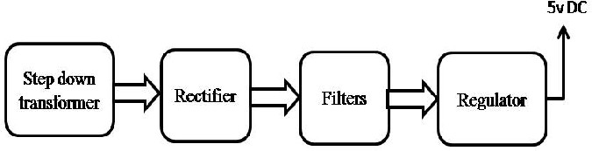

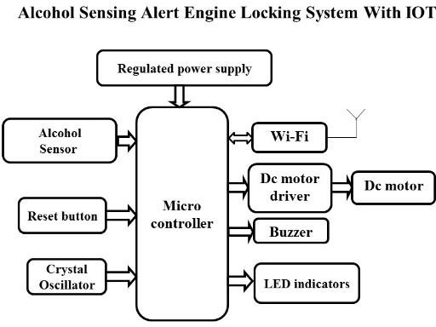

RESULTS AND DISCUSSION

Components:

1. MQ3 (4-pin) sensor

2. 9V DC motor

3. THE BUZZER

4. ENGINE STOP

5. RELAY

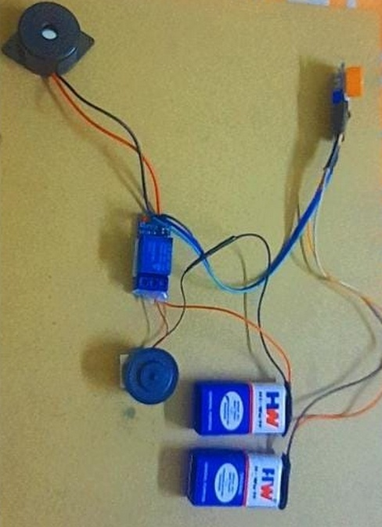

1. Driver starts the vehicle. Check the vehicle's speed.

2. If it is zero, begin detecting with various sensors and alert detection [7]. In this scenario, alcohol is primarily tested, and if it is identified, the ignition is turned off.

3. If the speed exceeds 2 kmph, the sensing process is restarted. The detection [8] of various parameters by the sensor will be detected and reported.

4. The gasoline supply will be switched off if alcohol is found [9].

5. The vehicle will come to a complete stop, and the discovery will be reported to a relative and the police station.

CONCLUSION & FUTURE SCOPE

We created a real-time model that can automatically lock the engine when an intoxicated driver attempts to drive a car in this project. Nowadays, car accidents are getting more common. We can protect both the driver and the remaining passengers by placing this alcohol sensor in the car. It is a relatively simple application. The project will last a long time. It requires little to no upkeep and, of course, uses little power. This is a well-thought-out concept for detecting drunk driving. This design allows for a safe car travel while minimizing the accident rate associated with alcohol. This concept can be used to control drunk drivers and accidents caused by drunk driving. The government must implement legislation requiring such circuits to be installed in all automobiles, as well as requiring all automobile manufacturers to include such devices in the design of the vehicle. If this target is fulfilled, the number of fatalities caused by intoxicated drivers will be drastically decreased. Future scope can be securely landing of car aside without disturbing other vehicles with this type of device.

REFERENCES

[1] NCRB: Accidental Deaths and Suicides in India in 2015

[2] Mohd Amin, M.H. Mohamad Mohd Hafizzie Bin Ramli, Bin Hasanuddin "Vehicle Accident"
Alcohol Detector Embedded Prevention System",

[3] "Embedded Controller for Vehicle Obstacle Detection and Cabin Alert System". "Accident Prevention Using Eye-Blinking and Head Movement", ETCSIT2012, IJCA

[4] Wang dong, Cheng quan cheng, China "The automatic control system of anti-drunk-driving" IEEE -2011

[5] Lee, Evaluating the Suitability of Vehicle-Based Sensors for Detecting Alcohol Impairment. Washington, DC: National Highway Traffic Safety Administration, 2010.
[6] Paul Baskett, Yi Shang, Michael V. Patterson, and Timothy Trull, 2013 IEEE, Towards A System for
Body-Area Sensing and Detection of Alcohol Craving and Mood Dvsregulation.
[7] Dhivya M and Kathiravan S, Department of Electrical and Computer Engineering, Kalaignar Karunanidhi Institute of Technology- Driver Authentication and Accident Avoidance System for Vehicles [Smart Computing Review, vol. 5, no. 1, February 2015].
[8] Mugila.g, Muthulakshmi.M, Santhiya.K, Prof.dhivya.P- smart helmet system for vehicle protection employing alcohol detection ISSN: 2395-5619, Volume 2, Issue 7, July 2016.].
[9]"Design of Alcohol Detection System for Car Users Using Iris Recognition Pattern Using Wavelet Transform," 2016 7th International Conference on Intelligent Systems, Modeling and Simulation (ISMS), Bangkok, 2016, pp. 15-19. L. A. Navarro, M. A. Dio, E. Joson, R. Anacan, and R. D. Cruz.

