Advancing Primary Healthcare in India: Challenges, Recommendations, and Innovations

Dr. Ambarish Das Dr. Ismail Zabiulla Rifai Dr. Mahadevan. D
Senior Resident Junior Resident Junior Resident
Dept. of Preventive & Social Medicine Dept. of Preventive & Social Medicine Dept. of Preventive & Social Medicine
JIPMER JIPMER JIPMER
Puducherry, India Puducherry, India Puducherry, India

Dr. Abdul Basith K M Dr. Viswanath Narendiran
Junior Resident Junior Resident
Dept. of Preventive & Social Medicine Dept. of Preventive & Social Medicine
JIPMER JIPMER
Puducherry, India Puducherry, India

ABSTRACT

In developing countries like India, strengthening the primary healthcare system is crucial to bring about substantial change in the health of the community without subjecting individuals to the burden of financial toxicity. Well-equipped health system at the community level is essential to maintain subsidiarity across health systems and avoid undue overcrowding at secondary, and tertiary health systems. In this regard, certain changes need to be incorporated in the existing structure and functioning mechanism of the primary healthcare system of the country. This chapter attempts to reveal some possible scope for improvement in the current functioning mechanism of the primary healthcare system of India.

Keywords: Primary healthcare, Developing countries, Health system, Sustainable development goals, Health infrastructure, Technology integration, Artificial intelligence.

I. INTRODUCTION

The concept of primary health care was given by the Bhore committee [1]. Primary healthcare plays a vital role in promoting health, preventing diseases, and delivering comprehensive healthcare services to the community. The traditional model of primary healthcare has gone through many reforms to address the health issues of the society in late nineties and early twenties [2]. The introduction of the Universal immunization program, national vector-borne disease control program, National Health Mission, National Tuberculosis Elimination program, etc were the major breakthroughs in primary healthcare of the country [3]. India has achieved many milestones in the field of primary healthcare [4]. Many diseases have been conquered on a program basis and many more are on the verge of being conquered soon. The infant mortality rate and maternal mortality rate of India though show a declining trend [5], still, there is a lot to do to reach the targets of sustainable development goals. Availability, affordability, and accessibility are the key factors for any kind of healthcare in a country like India where a vast number of people are below the poverty line and most of them are residing in rural areas [6].

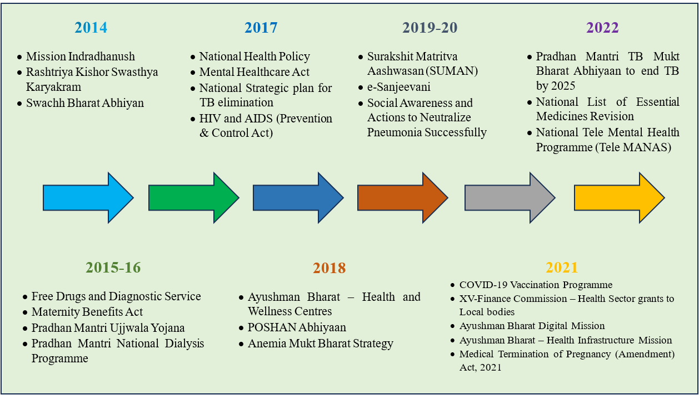
Figure 1: Major Initiatives from 2014 to 2022 for better overall health [7]

II. CHALLENGES
Besides all achievements in primary healthcare, there are certain challenges that need to be overcome to meet the targets of sustainable development goals and to provide quality healthcare service to everyone in this country.
A. POOR IMMUNIZATION COVERAGE
Given the facts above, the healthcare system of India should be interlinked and not fragmented. Minimum basic healthcare should be available in hard-to-reach areas and hilly areas. The immunization coverage of India is yet to reach the target of a hundred percent. Though India has attained remarkable achievements in eliminating some vaccine-preventable diseases, there are still certain states where immunization rates have not reached one hundred percent, and diseases like Japanese encephalitis remain prevalent in those areas.
B. THE GROWING BURDEN OF CHRONIC DISEASES
There is a growing burden of chronic diseases in this country and India is soon going to be the diabetes capital of the world. Population-based screening and early diagnosis and treatment are great initiatives so far but unless huge emphasis is not given to health-promoting measures and policy-level changes, the burden of chronic diseases will continue rising. Together, NCDs such as cancer, diabetes, respiratory conditions, and cardiovascular illnesses cause 80% of premature deaths worldwide [8]. In 2016 cardiovascular illnesses were the biggest cause of death globally [9]. Similar patterns may be observed in India, where NCDs have surpassed communicable illnesses to become the main cause of mortality during the past ten years [10]. The management of the condition depends on continuity of care, both in terms of knowledge about medications and tests as well as relationships with service providers [11]. The team members at PHCs must divide and distribute various duties, including information gathering, counseling, and examination, to ensure treatment for chronic illnesses.
C. TRUST BETWEEN HEALTHCARE PROVIDERS AND PATIENTS
All social interactions are said to be based on the fundamental underlying concept of trust. The foundation of the connection between healthcare practitioners and patients is trust. A patient's voluntary acceptance of vulnerability in the hope that the healthcare professional would act in his best interests has been characterized as trust [12]. As a result, people often prefer private healthcare services over public ones due to long waiting times and limited availability of medicines and tests [13]. The lack of emphasis on primary health care has led to the unchecked growth of the private sector, characterized by unethical practices and a lack of transparency [14]. This erosion of trust between providers and patients poses significant challenges to the healthcare system.
D. FRONT-LINE WORKERS
Front-line healthcare workers are the backbone of service delivery at the community level. Most of the national and state health programs are being implemented by these frontline workers. In the year 2022, the world health organization gave tribute to ASHAs of India for their remarkable contribution to service delivery in the community. Similarly, the Auxiliary nurse midwives and Anganwadi workers are giving service in the community. Any new health initiative is being implemented by these front-line workers after giving formal training. But their income is not getting upgraded in that manner and they are being overburdened by multiple works, which is demotivating to work wholeheartedly in those services. Besides, many front-line workers lack the necessary skills in technology and hence find it difficult in sending reports in portals. These challenges need to be addressed for the smooth implementation of health programs in the community.
E. INADEQUATE MANPOWER
The doctor-to-patient ratio and nurse-to-patient ratio of India are much lower than those recommended by the world health organization. This is reflected in the quality of services, and poor people are forced to go to private health facilities for their health issues, which further results in increased out-of-pocket expenditure. Apart from this, healthcare professionals suffer from different mental issues due to increased workload. In some areas, ASHAs are doing more than they are supposed to do. In some villages, there are not even any ASHA. Studies have shown the inequality in manpower in different areas of the country.
F. INADEQUATE INFRASTRUCTURE
Whereas some states are doing exceptionally well in service delivery, some states are still lacking basic infrastructure for the primary healthcare system. There is no sub-center for some hard-to-reach villages, where people are travelling long distances to get drugs for fever or to get their babies delivered.
III. RECOMMENDATIONS TO TRANSFORM PRIMARY HEALTHCARE
Primary healthcare in India has gone through different reforms in due course of time and is still going through all possible upgrades to provide basic comprehensive healthcare in the community. But to have uniform quality in healthcare, to prevent vaccine-preventable diseases, to prevent premature deaths due to chronic diseases, and to attain a significant reduction in infant mortality and maternal mortality, some modifications need to be done.
A. STRENGTHENING PRIMARY HEALTHCARE INFRASTRUCTURE
Investing in the infrastructure of primary healthcare facilities, including manpower, equipment, and technology is very important. The Ayushman Bharat Project by the government of India is a welcome step in this regard. Ayushman Bharat Health and Wellness Centre are there in all states. Pradhan Mantri Jan Arogya Yojana or PM-JAY was launched with the aim of providing health insurance coverage to vulnerable populations. It facilitates the access and utilization of services in secondary and tertiary healthcare systems [15].
B. TECHNOLOGY INTEGRATION
Tele-consultation and remote monitoring technologies can be a boon for people living in underserved and hard-to-reach areas. Not only virtual consultations but remote diagnosis and monitoring of patients can also be done with the help of these technologies [16]. Electronic health records help secure the storage and retrieval of patient information. Adopting the smart city concept in the integration of health through innovative, cost-effective, sustainable solutions under the smart city mission is a way forward for the healthcare system in India [17].
C. MORE EMPHASIS ON HEALTH PROMOTION AND PREVENTION
There is a need for more investment in health-promotive and preventive measures to reduce the burden of preventable diseases [18]. The focus should be on community-based initiatives, health education, early warning systems, hygiene, and sanitation. Vaccination and population-based screening of non-communicable diseases should be done religiously. One health approach should be taken as the basic requirement of the health of any society.
D. IMPROVING SOCIAL CAPITAL
Strong social networks and community engagement impart a positive impact on the health of individuals and society [19]. Social trust within the community is to be built with enforcement in standard health education materials with sharing experiences from those who gained from the health care system. There are different social organizations, and NGOs working in the country in the field of health, alcohol de-addiction, women empowerment, prevention of child trafficking, and many more.
E. EDUCATION AND TRAINING OF HEALTH WORKERS
There should be periodic training of frontline workers and healthcare workers working at hospitals, to keep them well accustomed to the programmatic guidelines of different health programs. Besides, there should be regular hands-on training in all relevant technological skills [20]. The devices given for data entry should be periodically checked and should be replaced on detection of any fault [21].
F. ADEQUATE COMPENSATION AND INCENTIVES FOR FRONTLINE WORKERS
It is imperative to invest in providing steady wages and performance incentives for frontline health workers, like ASHAs and Anganwadi workers, as an indispensable strategy to upgrade the Indian health system. By implementing this, we can boost their motivation and dedication to deliver superior health services in their respective areas of responsibility. Besides, there should be new recruitments of health workers if necessary to prevent overburdening of the existing health force and subsequent burn-out [22].
G. ROLE OF ARTIFICIAL INTELLIGENCE
Artificial intelligence (AI) shows promising results in diagnosis, treatment, and public health management. Integration of artificial intelligence will not only save time but will also improve the quality of care in the community. However, integration of AI in public health requires addressing challenges like poor data integration, outdated analytic infrastructure, and difficulties in accessing personal health data. Judicial use of artificial intelligence in public health will be a revolutionary step in tracking the health status of a vast number of people [23].
H. POLICY LEVEL CHANGES
Policy level changes are necessary to prioritize health in government policies and budgets in India. The government should invest in strengthening the public healthcare system, increasing access and availability of healthcare services, and reducing out-of-pocket expenses for healthcare. The COVID-19 pandemic has highlighted the need for increased government expenditure on health to address challenges in healthcare delivery. To tackle major health issues such as tuberculosis, anemia, hypertension, and diabetes, the government needs to invest in similar war-scale efforts that were made during the COVID-19 pandemic [24,25].
I. ADOPTING BEST PRACTICES AND INNOVATIVE SOLUTIONS FROM OTHER STATES AND COUNTRIES
Adopting innovative solutions and initiatives from other settings can help in increasing the efficiency of our healthcare system. The Makkalai Thedi Maruthuvam (MTM) initiative by the government of Tamilnadu is a welcome step in this regard, where dedicated health workers do house-to-house visits for investigation and drug delivery to patients with chronic diseases [26].
J. UPGRADING HEALTH MANAGEMENT INFORMATION SYSTEM
HMIS will be the portal to a large collection of data regarding the health indicators of India. This data will be collected from the States/ UTs and compiled to give valuable indicators [27]. This is vulnerable to hacking and phishing. Adopting hack-proof solutions like dynamic cybersecurity systems like blockchain technology could be a boon [28].
IV. CONCLUSION
India has immense potential to attain a shining future in primary healthcare. By addressing the existing challenges, adopting innovative approaches, and implementing evidence-based policies, India can build a robust primary healthcare system that caters to the needs of its diverse population. With collaborative efforts from policymakers, healthcare providers, and communities, India can achieve equitable access, high-quality care, and improved health outcomes for all, and hence can meet the targets of sustainable development goals.

REFERENCES
- CodeHunk. National institute of health & family welfare [Internet]. Nihfw.org. [cited 2023 Jul 30]. Available from: http://www.nihfw.org/ReportsOfNCC.html
- Gov.in. [cited 2023 Jul 30]. Available from: https://main.mohfw.gov.in/sites/default/files/7_CH_III_Reforms_Measures_Poli.pdf
- Selvaraj SK, Karan KA, Srivastava S, Bhan N, Mukhopadhyay I, World Health Organization. India: health system review. Health Systems in Transition. 2022;11(1).
- [Internet]. [cited 2023 Jul 30]. Available from: https://pib.gov.in/PressReleaseIframePage.aspx?PRID=1706381%2C+https%3A%2F%2Fdghs.gov.in%2Fcontent%2F5_1_MajorAchievements.aspx
- Health an integral component of social welfare, leitmotif for the Government [Internet]. [cited 2023 Jul 30]. Available from: https://www.pib.gov.in/PressReleseDetailm.aspx?PRID=1894904
- [Internet]. [cited 2023 Jul 30]. Available from: https://rural.nic.in/sites/default/files/WorkingPaper_Poverty_DoRD_Sept_2020.pdf
- Health an integral component of social welfare, leitmotif for the Government [Internet]. [cited 2023 Jul 30]. Available from: https://www.pib.gov.in/PressReleseDetailm.aspx?PRID=1894904
- Non communicable diseases [Internet]. World Health Organization; [cited 2023 Jul 30]. Available from: https://www.who.int/news-room/fact-sheets/detail/noncommunicable-diseases
- Naghavi M, Abajobir AA, Abbafati C, Abbas KM, Abd-Allah F, Abera SF, et al. Global, regional, and national age-sex specific mortality for 264 causes of death, 1980–2016: A systematic analysis for the global burden of disease study 2016. The Lancet. 2017;390(10100):1151–210. doi:10.1016/s0140-6736(17)32152-9
- Dandona L, Dandona R, Kumar GA, Shukla DK, Paul VK, Balakrishnan K, Prabhakaran D, Tandon N, Salvi S, Dash AP, Nandakumar A. Nations within a nation: variations in epidemiological transition across the states of India, 1990–2016 in the Global Burden of Disease Study. The Lancet. 2017 Dec 2;390(10111):2437-60.
- Wagner EH, Austin BT, Davis C, Hindmarsh M, Schaefer J, Bonomi A. Improving chronic illness care: translating evidence into action. Health affairs. 2001 Nov;20(6):64-78.
- Gopichandran V. Trust in healthcare: an evolving concept. Indian J Med Ethics. 2013.
- Kane S, Calnan M. Erosion of trust in the medical profession in India: time for doctors to act. International journal of health policy and management. 2017 Jan;6(1):5.
- Sengupta A, Nundy S. The private health sector in India. Bmj. 2005 Nov 17;331(7526):1157-8.
- Lahariya C. ‘Ayushman Bharat’program and universal health coverage in India. Indian pediatrics. 2018 Jun;55(6):495-506.
- Carrillo de Albornoz S, Sia KL, Harris A. The effectiveness of teleconsultations in primary care: systematic review. Family Practice. 2022 Feb 1;39(1):168-82.
- Smart Cities Mission: A step towards Smart India [Internet]. Gov.in. [cited 2023 Jul 29]. Available from: https://www.india.gov.in/spotlight/smart-cities-mission-step-towards-smart-india
- Pati S, Sharma K, Zodpey S, Chauhan K, Dobe M. Health promotion education in India: present landscape and future vistas. Global journal of health science. 2012 Jul;4(4):159.
- Hu F, Hu B, Chen R, Ma Y, Niu L, Qin X, et al. A systematic review of social capital and chronic non-communicable diseases. Biosci Trends. 2014;8(6):290–6.
- Joshi HS, Joshi MC, Ranjan P, Misra S, Verma P, Rana MS, Agarvanshi G. Refresher training on maternal and child health for urban community health volunteers: assessing knowledge and skills. Internet Journal of Medical Update. 2006 Jul 1;1(2).
- Jones DW, Appel LJ, Sheps SG, Roccella EJ, Lenfant C. Measuring blood pressure accurately: new and persistent challenges. Jama. 2003 Feb 26;289(8):1027-30.
- Colvin CJ, Hodgins S, Perry HB. Community health workers at the dawn of a new era: 8. Incentives and remuneration. Health Research Policy and Systems. 2021;19:106.
- Fisher S, Rosella LC. Priorities for successful use of artificial intelligence by public health organizations: a literature review. BMC Public Health. 2022;22:1–14
- Chauhan V, Dumka N, Hannah E, Ahmed T, Kotwal A. Recent initiatives for transforming healthcare in India: A political economy of health framework analysis. Journal of Global Health Economics and Policy. 2022;2:e2022002.
- Garg S, Bhatnagar N, Singh MM, Borle A, Raina SK, Kumar R, et al. Strengthening public healthcare systems in India; Learning lessons in COVID-19 pandemic. J Family Med Prim Care. 2020;9:5853–7.
- Chennai: Health services at your doorstep [Internet]. [cited 2023 Jul 29]. Available from: https://www.who.int/india/news/feature-stories/detail/chennai--health-services-at-your-doorstep
- Health Management Information System. [cited 2023 Jul 29]. Available from: https://hmis.mohfw.gov.in/#!/
- Haleem A, Javaid M, Singh RP, Suman R, Rab S. Blockchain technology applications in healthcare: An overview. International Journal of Intelligent Networks. 2021 Jan 1;2:130-9.

