Cost Effective Solar Energy Generation and Its Various Applications

Lipika Nanda
Professor,School of Electrical Engineering
KIIT Deemed to be University
Bhubaneswar, Odisha, India

Sourav Kabisatpathy
U.G.Student,School of Electronics Engineering KIIT Deemed to be University
Bhubaneswar, Odisha, India
Sruti Mishra
U.G.Student,School of Electronics Engineering KIIT Deemed to be University
Bhubaneswar, Odisha, India

Bidhu Bhusan Mohanty
U.G.Student,School of Electronics Engineering KIIT Deemed to be University
Bhubaneswar, Odisha, India

ABSTRACT
The most important energy source is Solar energy, which is gaining popularity on a global scale. Over 940 Gigawatt of Solar PV have been installed as of 2021. The existence of reliable energy supply networks is one of the fundamental requirements for socioeconomic development in any country on Earth.Numerous African nations, such as South Africa, Egypt, and Algeria, have witnessed a remarkable surge in solar electricity availability. This significant development has had a profound impact on reducing the number of people worldwide who lack access to energy. The annual growth of solar energy continues to be robust, with Asia leading the way with a staggering capacity of 486 GW by the end of 2021. In contrast, Central America has approximately 1.8 GW of installed capacity, and the Caribbean lags behind with the lowest capacity of 694 MW. With the rising demand for uninterrupted power supply in various regions, forward-thinking developers are increasingly embracing solar Photovoltaics (PV) renewable energy as an attractive option for their customers.This report examines the global status of solar energy capacity and makes important recommendations for improving its usability, affordability, and dependability as well as a critical approach that future governments may adopt.

Keywords—Solar energy; Solar PV; Renewable energy; Capacity

INTRODUCTION

Over the past decade, the expense associated with solar energy equipment per watt has witnessed a steady rise due to the diminishing accessibility of renewable energy resources. It will surely grow more inexpensive in the next years and progress as a better technology in terms of both cost and usability. Each passing day, Earth receives a generous supply of sunlight, showering the planet with an abundant and free energy source, totaling approximately 1366 watts[1]-[3]. What makes solar energy particularly advantageous when compared to conventional power sources is its remarkable ability to harness this energy using compact photovoltaic (PV) solar cells. These small wonders enable the direct conversion of sunlight into usable solar power, marking a significant departure from the norm. A lot of study has been done to combine the Sun's energy process by creating solar cells, panels, and modules with high converting efficiency.Solar energy systems harness the power of sunlight, transforming it into electricity by means of photovoltaic (PV) panels or through the innovative utilization of concentrated solar power (CSP)[4]-[5]The best feature of solar energy is that it is easily accessible and free to the general people, unlike the price of various fossil fuels and oils during the last 10 years. Additionally, solar energy takes a lot less labour than conventional energy generation methods.

SOLAR ENERGY

Sun energy, which is energy that originates from the sun and manifests as heat and radiation. Utilizing the sun's radiant light and heat as a renewable energy source involves a range of rapidly developing and expanding technologies, such as solar thermal energy, solar architecture, solar heating, molten salt power plants, and artificial photosynthesis.A extremely attractive source of electricity, solar energy is available in huge quantities. The ocean, clouds, and land absorb the remaining solar energy, reflecting around 30% of it back to space.
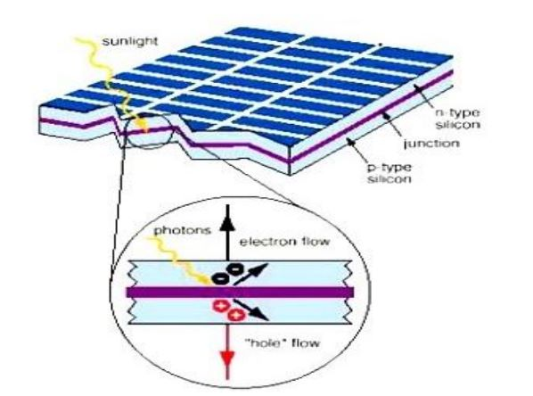
Figure 1: Harnessing solar energy

Advantages of Solar Energy
Solar energy has a number of benefits, including:
g) Real estate with extra value
h) More advanced technologies
i) Improved economy
j) Creation of jobs.

a) Low operating costs
b) No monthly bills
c) Renewable energy
d) Low maintenance costs
e) Environmental friendliness
f) A source of income

Drawbacks of Solar Energy
Solar energy has a number of drawbacks, including:
a) High setup costs
b) Intermittent use in overcast weather
c) Lower efficiencies
d) Increased area requirements
e) Dependence on latitude

- Methods of utilizing solar energy
There are three primary methods for harnessing and utilizing solar energy: photovoltaics (PV), concentrating solar power (CSP), and solar heating and cooling (SHC). PV involves the direct conversion of light into electricity, while CSP employs solar thermal energy to drive large-scale electrical turbines. On the other hand, SHC utilizes solar thermal energy to heat or cool water and air[6]-[7]. These three approaches serve as the main avenues for storing and effectively utilizing the abundant power of the sun. But more predominantly we use Photovoltaic Arrays in industries to harness solar power as they are more technically feasible and can generate electricity directly. The Photovoltaic array, which consists of the PV panels and supporting structures, and the balance of system (B.O.S.) components, which are made up of storage batteries, charge controllers, inverters, and wiring, are the two main components of a photovoltaic system.

WORKING OF SOLAR ENERGY

Solar power is generated by harnessing solar energy using solar panels. Solar panels are generally made of silicon and installed on a metal panel frame covered with glass. When photons, which are individual units of light, make contact with a thin layer of silicon situated on the surface of a solar panel, they cause electrons in the silicon atoms to be displaced. This displacement results in the generation of a particular type of electric current known as direct current (DC), which is then harnessed by the wiring incorporated within the solar panels[8]-[10]. The power is then changed from direct current (DC) to alternating current (AC) via an inverter. Regular wall sockets used for plugging in appliances use AC electrical electricity.

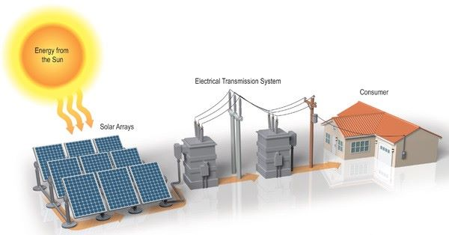
Figure 2: Working of solar energy

MODELLING OF PV PANEL

- Solar Photovoltaic Cell
The solar panels transform solar energy into DC power, which is then sent through an inverter to create AC electricity.The inverter is connected to our consumer unit (fuse board), allowing power to be utilized in your home. Solar photovoltaic (PV) systems harness the power of sunlight to convert it into usable electrical energy. These systems employ specially designed cells that facilitate the transformation of solar energy into electricity. Each PV cell typically consists of one or two layers composed of silicon or alternative semi-conducting materials. Upon exposure to light, the PV cell facilitates the flow of electricity through its layers, resulting in the creation of an electric field. As light intensity rises, electricity flows more freely. The amount of energy that PV cells produce while exposed to direct sunlight is measured in kWp, or kilowatt peak.
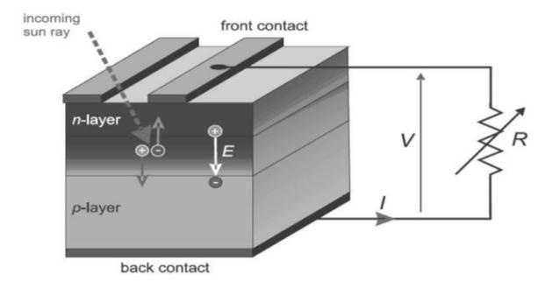
Figure 3: Mechanism of solar PV

- Photovoltaic Module
A PV module or PV solar module is an assembly of photovoltaic (PV) or solar cells. Generating the necessary voltage and current for a solar photovoltaic (PV) system involves connecting multiple PV modules, commonly known as PV panels, to create a large array called the PV array. Each PV module plays a vital role in the overall PV system by transforming sunlight into direct current (DC) electricity. PV modules can be connected in parallel or in series to provide the required voltage and current for a given system.
- Photovoltaic Array
The photovoltaic module on the right is an example of a photovoltaic module that makes up a solar array.A number of PV cells that are linked together make up each photovoltaic (PV) module. Direct-current electricity is produced by the cells using solar energy. PV modules are commonly referred to as solar panels, however the term is actually more accurate for solar-thermal water heating or air conditioning panels.
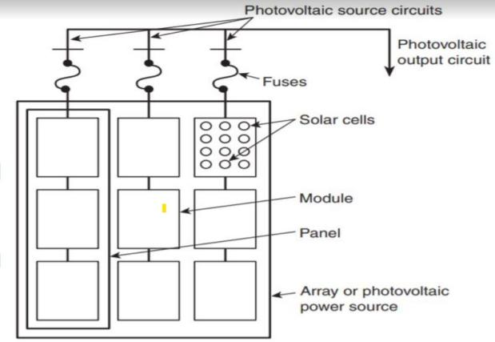
.

Figure 4: PV Module and PV array

SOLAR COLLECTORS

- Fresnel
This type of collector uses a Fresnel lens, which is flat on one side and fine, linear grooves on the surface of a refracting substance (often optical grade plastic). Each groove's angle is intended to provide optical performance that resembles that of a spherical lens[13]. The beam radiation, which is incident usually, condenses on the focal line and is absorbed by a receiver tube. Temperatures between 150 and 300 °C may be achieved with a concentration ratio of 10 to 30.

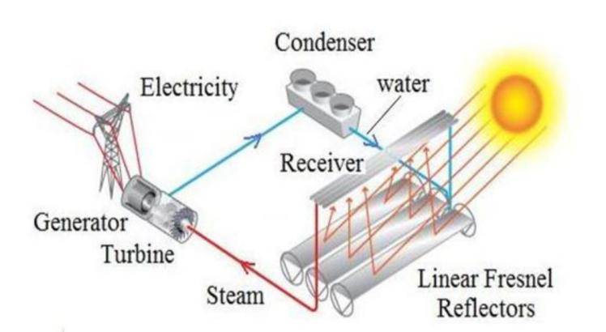

Figure 5: Fresnel reflector

- Parabolic Dish
A solar reflector dish, a solar receiver, and a mounting structure make up the solar parabolic dish. The dish is permanently fastened to a dual-axis solar tracker, making sure it is pointed directly at the sun at all times.The central receiver, which is located at the focal point of the solar parabolic dish, is where the solar radiation is focused after being reflected by the dish. The Stirling engine installed at the centre receiver is where the solar parabolic dish's main use is found—to generate power. Stirling engines are more efficient in converting solar energy into electricity than other concentrated solar systems, with a claimed 30% efficiency.

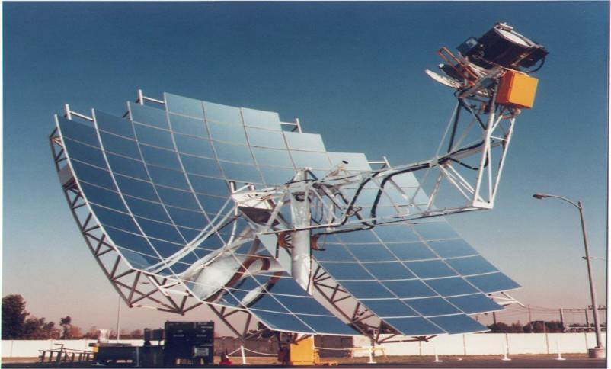
Figure 6: Parabolic Dish

- Parabolic Trough
A group of concave mirrors known as a parabolic trough concentrates solar light onto the receiving tube that is located in the focus. These troughs may follow the Sun along a single axis, which is often aligned north-south, to ensure optimal efficiency. A fluid runs through this tube while absorbing heat from concentrated solar light.
A linear Fresnel system resembles a parabolic trough. These collectors use lengthy flat Fresnel mirrors and resemble parabolic troughs. Although it costs significantly less to install, this technology is less effective. Only a few plants are included as examples.Synthetic oil or a molten salt combination is commonly used to flow through the heat exchanger tubes and absorb the heat concentrated by the mirrors. This fluid typically operates between 400 and 600 C. The tubes then supply this oil to the procedure.
.

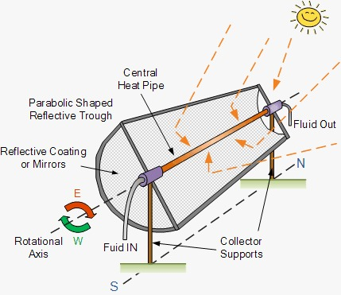
Figure 7: Parabolic Trough

- Parabolic Trough
One of the most promising methods for using solar energy to generate electricity on a wide scale is the use of central receivers. In essence, heliostats, or reflective surfaces, are placed all around a central tower, reflecting solar irradiance to a receiver at the top of the tower. The radiation that the receiver has absorbed is subsequently used to generate electricity[11]-[12].
A circular array of heliostats (large mirrors with dual axis sun-tracking motion) focuses DNI on a central receiver at the top of a tower. In this central receiver, a heat-transfer medium absorbs the highly concentrated radiation reflected by the heliostats, converting it into thermal energy that is utilized to produce superheated steam for the turbine. So far, demonstrations have used molten salts, liquid sodium, steam, water, and air as heat transfer media. A pressurized gas or air can directly replace natural gas in a gas turbine if it is utilized as a heat transfer medium at extremely high temperatures of up to 1000°C. This application makes use of the great efficiency (≥ 60%) of contemporary gas and steam combination cycles.
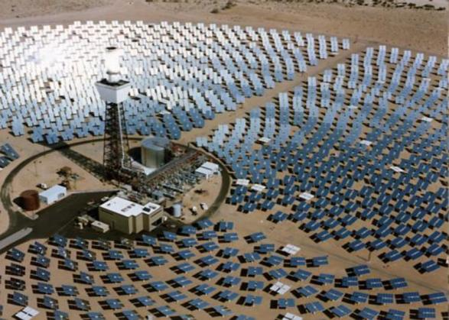

Figure 8: Central Receiver Plant

APPLICATIONS

- Solar Water Heating
Heater using solar passive energy. Solar energy may be used to heat water rather cheaply. It is inexpensive to run because it doesn't need pumps. The water can be circulated while being heated using the thermosyphon method. Because a cold fluid is denser than a warm fluid, the thermosyphon operates. As a result, there is a pressure differential between the system's two legs. This pressure differential helps to keep the water flowing continuously.On the colder, denser side, the water sinks, while on the warmer, less dense side, it rises.Because they can be constructed for incredibly little money utilizing 55-gallon drums and plastic piping, thermosyphon water systems are fantastic for underdeveloped countries. There must be a one-way valve. The solar collector switches to its thermal radiator mode at night. When it is nighttime, it emits heat into space..

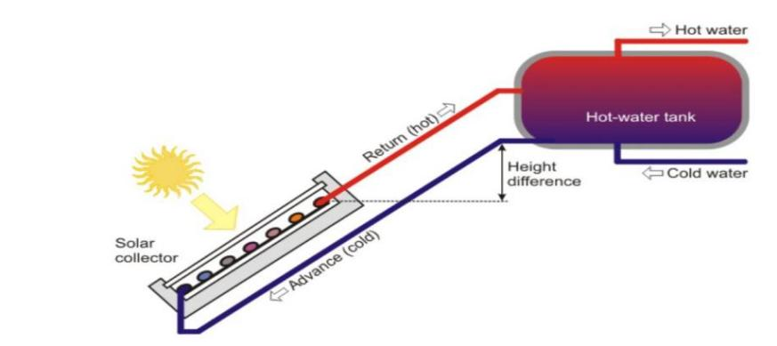

Figure 9: Solar water heater

- Solar Refrigeration
It has been demonstrated that solar energy is the best source for low-temperature heating applications.There are three established methods for providing refrigeration at temperatures below zero degrees using solar energy. operated by photovoltaic (PV), mechanical solar, and absorption-based cooling[7]. Vapor compression refrigeration is a key component in solar mechanical cycles as well as PV- operated cycles, whereas absorption refrigeration relies mostly on thermal energy.The photovoltaic system is the most practical and suitable option among these three strategies for tiny portable systems positioned far from traditional energy sources.
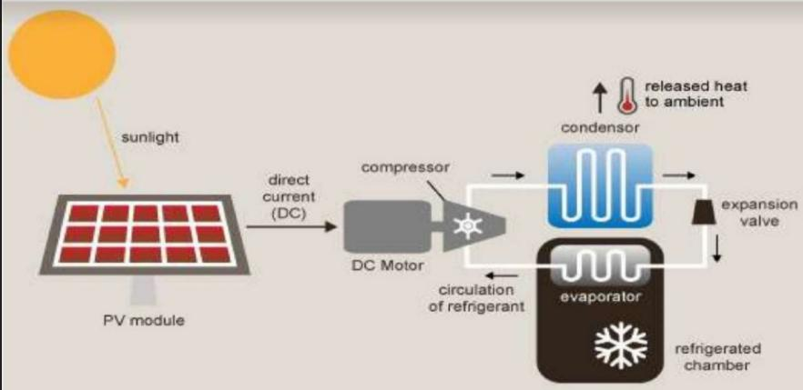

Figure 10: Solar refrigeration

- Generation of electricity using Solar Panel
With photovoltaic cells, it is possible to generate electricity directly from sun energy. The photovoltaic cell is an energy conversion tool that uses sunlight's photons to generate electricity. It is made of semi-conductors, which collect photons from the sun and release them as free, highly energetic electrons.

- Solar Cooker
A simple sort of solar cooker is the flat plate box type.It consists of a well-insulated metal or wooden box with a black interior stain. Sunlight with short wavelengths is permitted into the container[6]. Because higher wave­length radiations cannot pass through the two glass coverings, the heat loss from the box's blackened interior to its exterior is lessened. When the box is exposed to sunlight, the temperature within the box rises because the solar rays penetrate the glass coverings and are absorbed by the blackened surface. There are cooking pots with charred exteriors in the sun box.

- Solar Distillation
In dry, semiarid, and/or coastal regions, potable water is in short supply. Due to the abundance of sunshine in these locations, solar distillation is a method that may be utilized to transform salt water into drinkable distilled water. In a process where a sealed, transparent glass lid allows sunlight to enter, a small basin is enclosed and devoid of light. Within this basin, salt water is filled utilizing the following technique. Due to the penetration of solar radiation through the lid, absorption takes place, leading to the conversion of light energy into heat upon interaction with a darkened surface. Consequently, the heat generated facilitates the evaporation of water from the brine, which denotes impure salt water. The inside of the cool roof is where the created vapour are condensed into pure water. Condensed water gathers in the lowest troughs of the sloped roof where it is transported to a storage tank to create drinking distilled water.

CONCLUSION
The majority of people are well acquainted with conventional energy sources that are non-renewable. However, there is a growing awareness and utilization of solar energy due to its economic advantages. By incorporating a battery backup system, solar energy can generate electricity consistently, even during overcast days and at night. Additionally, it can be seamlessly integrated with the existing power grid, ensuring uninterrupted power supply. Compared to traditional fossil fuels and petroleum resources, solar energy offers numerous benefits. It provides reliability and shows great potential in addressing the escalating energy demands. Ongoing research in solar cells and solar energy indicates a promising future for this sustainable technology.

ACKNOWLEDGEMENT

We would like to express our sincere gratitude to our mentor Dr. Lipika Nanda who guided and encouraged us to write this Review Paper on the topic "Solar Energy and It's Applications", which helped us in doing a lot of research about Solar Energy and how to harness it and it's different applications in various fields and we are really thankful for the chance.

REFERENCES

[1] Shruti Sharma, Kamlesh Kumar Jain, Ashutosh Sharma a review on “Solar Cells: In Research and Applications”,Materials Sciences and Applications, 2015, 6, 1145-1155 Published December 2015 http://dx.doi.org/10.4236/msa.2015.612113
[2] Askari Mohammad Bagher, Mirzaei Mahmoud Abadi Vahid, Mirhabibi Mohsen. “Types of Solar Cells and Application”. American Journal of Optics and Photonics.Vol. 3, No. 5, 2015, pp.94-113. doi: 10.11648/j.ajop.20150305.17
[3] Book of “Non conventional energy resources” by B.H Khan, McGraw Hill
[4] Book of “Solar Energy” by Dr. S. P. Sukhatme. Tata McGraw Hill Publication.
[5] Gaurav A. Madhugiri, S. R. Karale, “High solar energy concentration with a Fresnel lens: A Review”Vol.2, Issue.3, May-June 2012 pp-1381-1385 ISSN: 2249-6645.
[6] REN21, “Renewables 2019 Global Status Report,” (Paris: REN21 Secretariat). 2019.
[7]Nanda, Lipika, A. Dasgupta, and U. K. Rout. "Smart solar tracking system for optimal power generation." 2017 3rd International Conference on Computational Intelligence & Communication Technology (CICT). IEEE, 2017.
[8]L. Nanda, S. Mandal, A. Priya, A. Pradhan, C. Jena and B. Panda, "Solar Photo Voltaic Panel Interfaced Boost Converter with MPPT Algorithm at Various Climatic Conditions," 2023 International Conference on Power Electronics and Energy (ICPEE), Bhubaneswar, India, 2023, pp. 1-6, doi: 10.1109/ICPEE54198.2023.10060750.
[9]Nanda, L., Acharya, A.: Evaluation on various DC–DC non-isolated maximized voltage gain converter topology. In: 11th International Conference on advances in computing, control and telecommunication technologies, ACT, 2020, pp. 173–178 (2020)
[10]A. Pradhan, B. Panda and S. Mohapatra, "Performance analysis of proposed MPPT method with the conventional methods," 2020 IEEE International Symposium on Sustainable Energy, Signal Processing and Cyber Security (iSSSC), Gunupur Odisha, India, 2020, pp. 1-5, doi: 10.1109/iSSSC50941.2020.9358820.
[11]A. Pradhan, B. Panda, L. Nanda, C. Jena and S. Sahoo, "Analysis of requirement of load matching for photovoltaic-maximum power tracking system," 2022 International Conference on Smart Technologies and Systems for Next Generation Computing (ICSTSN), Villupuram, India, 2022, pp. 1-5, doi: 10.1109/ICSTSN53084.2022.9761345.
[12]S. Panda, R. K. Dhaka, B. Panda, A. Pradhan, C. Jena and L. Nanda, "A review on application of Machine Learning in Solar Energy & Photovoltaic Generation Prediction," 2022 International Conference on Electronics and Renewable Systems (ICEARS), Tuticorin, India, 2022, pp. 1180-1184, doi: 10.1109/ICEARS53579.2022.9752404.
13]A. Pradhan, B. Panda, L. Nanda, C. Jena and S. Sahoo, "Analysis of Various Types of Reflectors on The Performance of PV Panel," 2022 International Conference for Advancement in Technology (ICONAT), Goa, India, 2022, pp. 1-6, doi: 10.1109/ICONAT53423.2022.9725825.

