Functional Nano Biosensors Materials for Food Safety Applications
K. Girija^{a*}, S. Thirumalairajan^{b*}, V.M. Hariharanª
ª Department of Physics, Dr. N.G.P. Arts and Science College, Coimbatore - 641 048, India
^{b} Centre for Agricultural Nanotechnology, Tamilnadu Agricultural University, Coimbatore -641 003, India

Abstract
Biosensors in food safety and quality have become indispensable in current sensoria due to the requirement of food safety and security for human health and nutrition. This chapter covers the fundamental, historical background of biosensors, functional nanostructures, food safety applications and various types of biosensors that can be used for food safety and food quality monitoring, but these are not limited to conventional sensors, such as temperature sensors, optical sensors, electrochemical sensors, calorimetric sensors, and pH sensors. The chapters are framed in a way that readers can experience an overview of food safety and quality analysis for different segments of the food industry, particularly for food science and agricultural applications. This chapter serves as a reference for scientific investigators who work on the assurance of food safety and security using biosensing principles as well as researchers developing biosensors for food analysis.

Keywords: Biosensor, Nanomaterials, Food safety, Analytics,
*Corresponding author: Phone: +9384534689. Fax: +55 (16) 33739824
E-mail address: kgirja.ngp@gmail.com, sthirumalairajan@gmail.com

1. Introduction
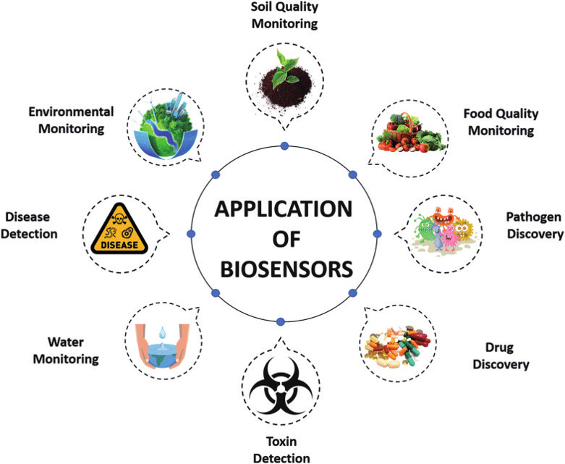
In recent years, the field of biosensors has witnessed significant advancements, particularly in the realm of food safety applications. As the demand for safe and quality food continues to grow, the need for sensitive, rapid, and reliable detection methods becomes imperative. Biosensors, with their ability to detect and quantify specific analytes, have emerged as a promising solution to address food safety challenges. Moreover, the integration of functional nanostructured materials into biosensor design has propelled this technology to new heights, offering enhanced sensitivity and selectivity [1]. Biosensors, in essence, are analytical devices that combine a biological recognition element with a transducer to convert the interaction between the analyte and the recognition element into a measurable signal. They have a rich history that can be traced back to the early 1960s when the first enzyme-based biosensor was developed. Over the decades, biosensors have found numerous applications in various fields, including clinical diagnostics, environmental monitoring, and food safety. However, their use in food safety applications holds particular importance due to the potential risks associated with contaminated or adulterated food products.

Figure 1.1: Image of the different biosensor application
In food safety applications, biosensors offer numerous advantages over traditional methods. They provide rapid and real-time monitoring capabilities, enabling quick detection of contaminants, pathogens, allergens, and spoilage indicators. Additionally, biosensors can be designed to be portable and user-friendly, allowing for on-site testing and reducing the need for centralized laboratory analysis. This aspect is particularly valuable in scenarios where time is of the essence, such as during food transportation and distribution [2].
Recent advancements in functional nanostructured biosensors have further revolutionized food safety monitoring. Nanomaterials, such as quantum dots, and functional nanostructures metal nanoparticles, have been integrated into biosensors to improve signal transduction and increase sensitivity. The use of nanomaterials has also facilitated multiplexing, enabling the simultaneous detection of multiple analytes, which is essential for comprehensive food safety assessment.

1.2 Historical background of the biosensor
The history of biosensors in the context of food safety applications traces back to the early developments of this innovative technology. The emergence of biosensors can be attributed to the efforts of various researchers and scientists who sought to bridge the gap between biology and electronics. The roots of biosensors can be found in the work of biochemist Leland C. Clark Jr., who, in the early 1960s, pioneered the concept of enzyme-based biosensors. Clark's groundbreaking work led to the invention of the first practical enzyme electrode, the Clark electrode, which measured the concentration of oxygen in the blood. This seminal development marked the birth of biosensor technology and laid the foundation for subsequent advancements [3].

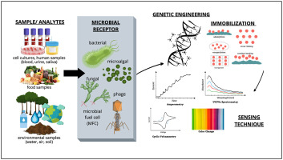

Figure 1.2: Photograph image of Leland C. Clark Jr and schematic illustration of biosensor working principle
As the potential of biosensors became evident, researchers from diverse fields started exploring their applications in different domains, including food safety. The late 1970s witnessed the introduction of glucose biosensors, which utilized glucose oxidase to measure glucose levels in the blood. These early glucose biosensors set the stage for the future application of biosensors in food safety, where the detection of specific analytes became crucial for ensuring the quality and safety of food products. During the 1980s and 1990s, the miniaturization of electronics and the advancement of nanotechnology paved the way for significant progress in biosensor development. This period saw the integration of various transduction principles, such as optical, electrochemical, and piezoelectric, into biosensor designs. The use of microfabrication techniques also enabled the production of miniaturized and portable biosensors, further expanding their potential for on-site food safety testing.
In the context of food safety, biosensors offered distinct advantages over traditional analytical methods. Conventional approaches, such as chromatography and immunoassays, were time-consuming, labour-intensive, and often required specialized facilities and trained personnel. In contrast, biosensors provided rapid and real-time monitoring capabilities, making them highly suitable for the detection of foodborne pathogens, toxins, allergens, and chemical contaminants.
As biosensor technology continued to mature, research efforts focused on enhancing their performance and specificity. One critical area of advancement was the exploration of alternative recognition elements beyond enzymes, such as antibodies, aptamers, and molecularly imprinted polymers. These recognition elements provided a broader range of targets for biosensors, enabling the detection of a wide array of analytes with high sensitivity and selectivity. The 21st century witnessed a surge in research and development in the field of biosensors, with a particular emphasis on incorporating nanotechnology to enhance their capabilities. Nanostructured materials, due to their unique properties, emerged as promising candidates for biosensor design. Nanoparticles, nanowires, and nanocomposites were utilized to improve signal transduction and increase the surface area available for analyte binding, leading to unprecedented sensitivity levels [4]. In the context of food safety, nanostructured biosensors exhibited remarkable potential. They offered the ability to detect even trace amounts of contaminants, ensuring the safety of food products and mitigating the risk of foodborne illnesses. Moreover, the use of nanomaterials facilitated multiplexing, enabling simultaneous detection of multiple analytes, which was essential for comprehensive food safety assessment. Overall, the history of biosensors for food and safety applications spans several decades of innovative research and technological advancements. From the early enzyme-based biosensors to the integration of nanotechnology, this field has evolved significantly, revolutionizing food safety monitoring. The historical journey of biosensors has led to the development of highly sensitive, rapid, and reliable detection methods, enabling timely intervention and ensuring the quality and safety of food products. As research continues to push the boundaries of biosensor technology, it is evident that these devices will continue to play a crucial role in safeguarding public health and enhancing food safety practices in the years to come.

1.3 Overview of Biosensor
The origin of biosensors can be traced back to the mid-20th century when scientific minds began to explore the possibilities of interfacing biology with electronics. The concept of biosensors evolved from the need to develop innovative and efficient ways to detect and measure biological substances or analytes in various applications. The roots of biosensor technology can be attributed to the pioneering work of biochemist Leland C. Clark Jr. and his colleague Champ Lyons in the early 1960s. Clark, while researching ways to measure blood oxygen levels, invented the first practical enzyme electrode, known as the Clark electrode or the "Clark Oxygen Electrode." The device utilized an enzyme, glucose oxidase, immobilized on an oxygen-permeable membrane, which catalyzed the conversion of glucose and oxygen into gluconic acid and hydrogen peroxide. The reduction of oxygen at the electrode's surface produced a measurable electrical signal, which was proportional to the concentration of glucose in the blood. This groundbreaking work marked the advent of enzyme-based biosensors and laid the groundwork for future developments in the field.
The 1970s saw further progress in biosensor research, particularly with the introduction of glucose biosensors for diabetes management. In 1975, Adam Heller and his team developed the first wearable glucose biosensor, which revolutionized diabetes monitoring by providing individuals with real-time glucose readings. This glucose biosensor utilized a thin, flexible needle coated with glucose oxidase and a second enzyme, peroxidase, along with a platinum electrode. When the needle was inserted into the skin, glucose in the interstitial fluid reacted with the enzymes, generating a current proportional to the glucose concentration. The biosensor connected to an external device, displayed the glucose levels, empowering diabetic patients to manage their condition more effectively [5]. The 1980s and 1990s witnessed significant diversification in biosensor development, with researchers exploring various transduction principles and recognition elements. Enzymes, due to their specificity and catalytic properties, remained widely used as recognition elements in biosensors, but other recognition elements, such as antibodies and DNA, were also investigated. The late 1990s and early 2000s saw exponential growth in biosensor research, driven by advancements in nanotechnology. Nanomaterials, such as nanoparticles and nanotubes, exhibited unique properties that made them suitable for biosensor applications. These materials provided increased surface area and enhanced signal transduction, leading to improved sensitivity and selectivity of biosensors. Furthermore, the miniaturization of biosensor components allowed for the development of portable and handheld devices, enabling on-site and point-of-care testing.
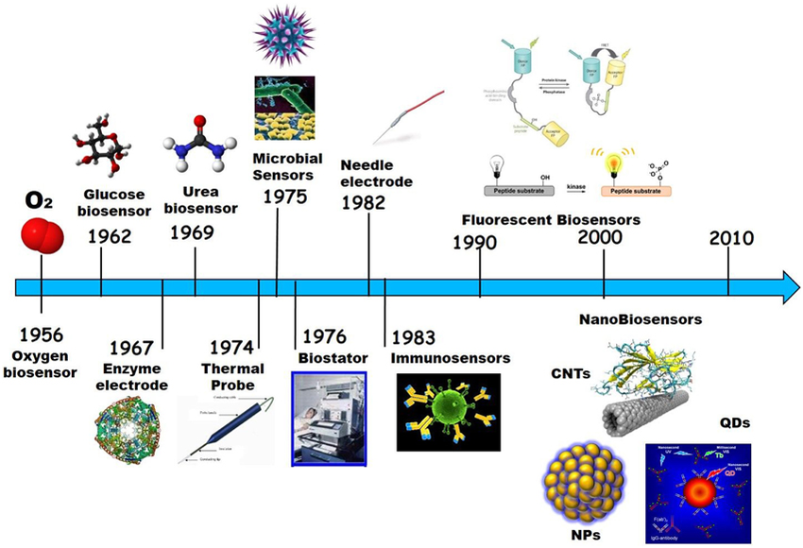
Figure 1.3 Schematic illustration of Biosensor development
Over the years, biosensors have undergone significant advancements, from the introduction of wearable glucose biosensors to the integration of nanotechnology and functional materials. The continuous evolution of biosensors holds promising prospects for revolutionizing various industries, contributing to enhanced disease management, environmental monitoring, and ensuring food safety. As researchers continue to push the boundaries of biosensor technology, it is evident that these remarkable devices will play an ever-increasing role in shaping the future of science and technology.

1.4 Functional Materials
The development and progress of biosensor technology have been significantly influenced by the choice and integration of functional materials. Functional materials play a crucial role in biosensors, as they directly impact the device's performance, sensitivity, and selectivity. Over the years, researchers have explored and incorporated a wide range of functional materials to enhance biosensor capabilities, especially in food and safety applications [6].
- Enzymes: Enzymes are among the most widely used recognition elements in biosensors. These biologically active molecules possess high specificity for their target analytes, making them ideal for detecting various substances in complex samples. Enzyme-based biosensors are commonly employed in food safety applications to detect specific analytes, such as glucose, lactate, and certain foodborne pathogens. The immobilization of enzymes on transducer surfaces allows for repeated and stable measurements.
- Antibodies: Antibodies, or immunosensors, have also found extensive use in biosensors. These proteins bind specifically to antigens, enabling the detection of various pathogens, allergens, and contaminants in food samples. Immunobiosensors have proven effective in identifying foodborne pathogens like E. coli, Salmonella, and Listeria monocytogenes. The sensitivity and specificity of antibody-based biosensors make them invaluable tools in food safety monitoring.
- Aptamers: Aptamers are short single-stranded DNA or RNA sequences that can bind to target molecules with high affinity and specificity. They offer advantages over antibodies, such as easier synthesis, higher stability, and cost-effectiveness. Aptamer-based biosensors have demonstrated success in detecting toxins, pesticides, and allergens in food samples, making them valuable alternatives in food safety applications.
- Molecularly Imprinted Polymers (MIPs): MIPs are synthetic polymers designed to recognize and bind to specific target molecules with high selectivity. These materials are created through a process known as molecular imprinting, where the target molecule is used as a template to shape the polymer's structure. MIP-based biosensors have been applied in food safety to detect contaminants and toxins, offering stability and reusability in comparison to natural recognition elements.
- Nanomaterials: Nanotechnology has significantly impacted biosensor development, with various nanomaterials being incorporated to improve sensor performance. Nanoparticles, such as gold, silver, and quantum dots, are utilized as labels or signal amplifiers to enhance sensitivity. Nanowires and nanotubes provide increased surface area for analyte binding, enabling more efficient detection. Nanocomposites, combining with different nanomaterials, offer synergistic effects, leading to improved biosensor functionality.
- Carbon-based Materials: Carbon nanotubes and graphene have garnered considerable interest in biosensor research due to their exceptional electrical and mechanical properties. These carbon-based materials are highly sensitive to changes in their electronic properties when interacting with analytes, making them ideal for transducing signals in biosensors. They have been employed in detecting various analytes, including DNA, proteins, and heavy metals in food samples.
The integration of these functional materials into biosensor designs has revolutionized the field of food safety and quality monitoring. Functional nanostructured materials, in particular, have played a crucial role in advancing biosensor technology, enabling rapid, sensitive, and specific detection of contaminants and pathogens in food samples. These biosensors have the potential to transform food safety practices, enabling real-time monitoring and reducing the risk of foodborne illnesses.

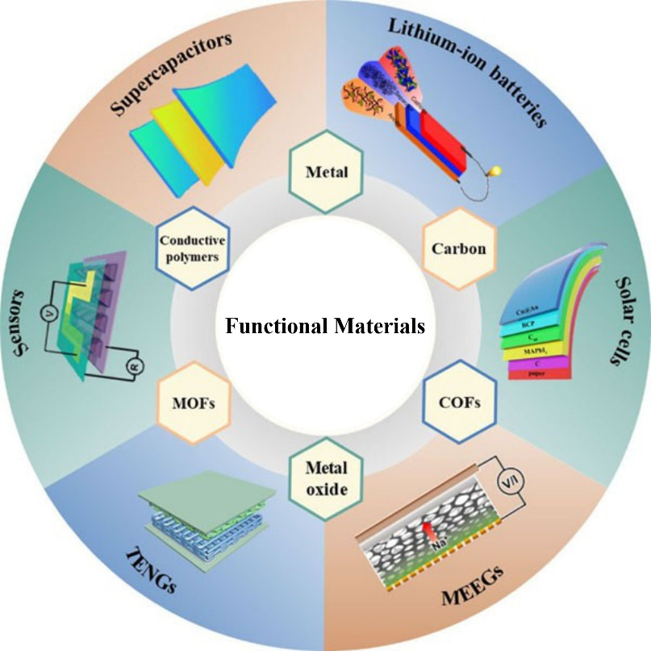

Figure 1.4: Schematic illustration of various functional materials for biosensor applications.
In conclusion, functional materials are the heart of biosensor technology, determining the sensitivity and selectivity of these devices. Enzymes, antibodies, aptamers, MIPs, nanomaterials, and carbon-based materials are among the key functional materials employed in biosensor design. Their successful integration has led to significant advancements in food safety applications, offering rapid and reliable detection of contaminants and pathogens. As research in materials science and nanotechnology continues to progress, it is anticipated that biosensors will further evolve, paving the way for safer food products and ensuring the well-being of consumers worldwide.

1.5 Food and Safety Applications
Food safety is a paramount concern for consumers, food producers, and regulatory authorities worldwide. Contaminated or adulterated food products can pose serious health risks, leading to foodborne illnesses and outbreaks. To address these challenges, biosensors have emerged as powerful tools for rapid, sensitive, and specific detection of various analytes in food samples. The unique capabilities of biosensors make them invaluable in ensuring the safety and quality of food products throughout the entire food supply chain.
Biosensors find diverse applications in the field of food safety, and some of the key areas of their use include:
- Detection of Pathogens: Pathogenic bacteria, such as Salmonella, Escherichia coli (E. coli), Listeria monocytogenes, and Campylobacter, are among the leading causes of foodborne illnesses. Traditional methods for pathogen detection often involve time-consuming culture-based techniques. Biosensors, however, offer a rapid and reliable alternative. They can identify and quantify specific pathogenic bacteria within minutes, facilitating quicker response time and enabling timely interventions to prevent widespread outbreaks.
- Allergen Monitoring: Food allergens can trigger severe allergic reactions in sensitive individuals. Cross-contamination or mislabelling of food products can lead to inadvertent exposure to allergens. Biosensors equipped with specific antibodies or aptamers can detect allergenic proteins at trace levels, enhancing allergen monitoring in food processing facilities and helping to ensure accurate product labelling.
- Contaminant Detection: Food products can be exposed to various contaminants during production, storage, and transportation. These contaminants include heavy metals, pesticides, mycotoxins, and chemical residues. Biosensors enable the rapid screening of food samples for these contaminants, helping to identify and remove contaminated batches from the market, thereby safeguarding consumer health.
- Quality Assessment: The freshness and quality of food products play a significant role in consumer satisfaction and safety. Biosensors can be used to monitor the levels of freshness indicators, such as volatile organic compounds or biogenic amines, in perishable foods. Additionally, biosensors can assess the ripeness and maturity of fruits, ensuring that consumers receive products with optimal taste and nutritional value.
- Monitoring Food Spoilage: Spoilage of food products can occur due to microbial growth or chemical changes. Biosensors equipped with specific recognition elements can detect spoilage indicators, such as volatile organic compounds and microbial metabolites, allowing early detection of spoilage and preventing the consumption of deteriorated food items.
- Detection of Food Adulteration: Food fraud, including the adulteration of food products with inferior or unauthorized substances, is a global concern. Biosensors can identify the presence of adulterants or contaminants in food samples, ensuring product authenticity and protecting consumers from potentially harmful substances.
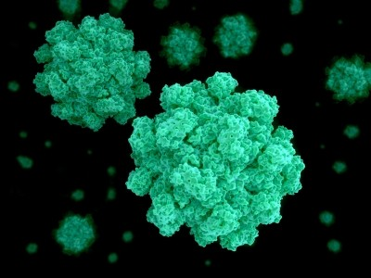
The advantages of biosensors in food safety applications are manifold. Their rapid response time allows for real-time monitoring and on-site testing, reducing the need for laborious and time-consuming laboratory analyses. Biosensors are also highly specific and sensitive, enabling the detection of target analytes even at low concentrations. Furthermore, their miniaturization and portability make them suitable for field deployment and remote areas where access to sophisticated laboratory facilities may be limited.

Figure 1.5: (a) Printing paper-based biosensors for food safety (Form Web)
However, some challenges persist in the widespread adoption of biosensors in the food industry. The complexity of food matrices, the potential interference of food components, and the need for sample preparation are some of the issues that researchers continue to address. Moreover, while biosensors offer rapid detection, their results may not always correlate with conventional reference methods, raising concerns about standardization and validation [8].

Figure 1.5: (b) Biosensor that identifies spoiled meat
In conclusion, biosensors play a pivotal role in ensuring food safety and quality by enabling rapid and accurate detection of contaminants, pathogens, allergens, and spoilage indicators. The ongoing advancements in biosensor technology, particularly the integration of functional nanostructured materials, hold tremendous promise for enhancing their performance and applicability in food safety applications. As biosensor research continues to progress, these devices are expected to become increasingly integral to food safety protocols, protecting public health and supporting the production of safe and wholesome food products.

1.6 Recent Advancements
In recent years, there have been significant advancements in biosensor technology, particularly with the integration of functional nanostructured materials. Nanostructured biosensors have shown remarkable potential in revolutionizing food safety applications, offering enhanced sensitivity, selectivity, and multiplexing capabilities. These cutting-edge devices hold promise in addressing the ever-increasing demands for fast, accurate, and reliable detection of contaminants and pathogens in food products. One of the key areas of recent advancement in nanostructured biosensors is the use of nanoparticles as labels or signal amplifiers. Metal nanoparticles, such as gold and silver nanoparticles, have unique optical and electrical properties that can be harnessed for sensitive and rapid detection. When functionalized with specific recognition elements, such as antibodies or aptamers, these nanoparticles can bind to target analytes and generate measurable signals, enabling the detection of pathogens, allergens, and chemical contaminants in food samples.
Quantum dots, another type of nanoparticle, have also gained attention in biosensor research. Quantum dots exhibit size-dependent fluorescence properties, making them highly sensitive probes for detecting biological analytes. Their broad absorption spectra and narrow emission peaks allow for multiplexing, enabling the simultaneous detection of multiple analytes in a single assay. In food safety applications, quantum dot-based biosensors have the potential to revolutionize the detection of various contaminants and pathogens, offering a comprehensive assessment of food quality and safety. Nanomaterials, such as nanowires and nanotubes, have been integrated into biosensor design to increase the surface area available for analyte binding. These materials provide a larger interface for molecular interactions, leading to improved sensitivity and a lower limit of detection. Additionally, functionalization of nanowires and nanotubes with specific recognition elements enables selective detection of target analytes, making them valuable components in biosensors for food safety [9].
Another recent advancement in functional nanostructured biosensors is the incorporation of nanocomposites. Nanocomposites combine different nanomaterials to take advantage of their individual properties and synergistic effects. These hybrid materials offer enhanced stability, signal amplification, and reproducibility, contributing to improved sensor performance. In food safety applications, nanocomposite-based biosensors have been utilized to detect various contaminants and pathogens, offering reliable and rapid analysis of food samples. Furthermore, the miniaturization and integration of functional nanostructured biosensors with microfluidics have enabled the development of lab-on-a-chip systems. These compact and portable devices allow for rapid, on-site testing, reducing the need for expensive and time-consuming laboratory analyses. Lab-on-a-chip biosensors have demonstrated the potential to revolutionize food safety monitoring by providing real-time results and facilitating immediate interventions when necessary.
Functional nanostructured biosensors have also been explored for continuous monitoring and real-time tracking of food products throughout the supply chain. This technology can be integrated into smart packaging systems, ensuring the safety and quality of food during transportation and storage. By providing information on temperature, freshness, and the presence of contaminants, smart biosensor-enabled packaging enhances traceability and reduces food wastage. Despite these significant advancements, challenges remain in the practical implementation of functional nanostructured biosensors. The complexity of food matrices, potential interference from food components, and the need for sample preparation continue to be areas of concern. Additionally, issues related to biosensor reproducibility, standardization, and validation must be addressed to ensure the reliability of results.
Overall, recent advancements in functional nanostructured biosensors have propelled the field of food safety applications to new heights. Nanoparticles, nanowires, quantum dots, and nanocomposites have demonstrated their potential in enhancing sensitivity, selectivity, and multiplexing capabilities. These cutting-edge biosensors hold promise in transforming food safety practices by offering rapid, sensitive, and specific detection of contaminants and pathogens. As researchers continue to innovate and address challenges, functional nanostructured biosensors are poised to play a crucial role in ensuring the safety and quality of food products, thereby safeguarding public health and strengthening consumer confidence.
1.7 Future of Functional Nanostructured Biosensors for Food and Safety Applications
The future of functional nanostructured biosensors holds tremendous promise for revolutionizing food safety applications and shaping the landscape of the food industry. As advancements in nanotechnology and materials science continue, biosensors are expected to play an increasingly critical role in ensuring the safety and quality of food products. Several key trends and developments are likely to drive the future of functional nanostructured biosensors in food safety applications.
- Enhanced Sensitivity and Selectivity: One of the primary goals of future biosensor development is to achieve even higher levels of sensitivity and selectivity. Functional nanostructured materials, with their unique properties, offer the potential to improve the recognition and transduction capabilities of biosensors. Researchers are actively exploring novel nanomaterials and surface modifications to enhance the interactions between recognition elements and target analytes, leading to improved detection limits and reduced false positives.
- Multiplexing Capabilities: Future biosensors are expected to enable simultaneous detection of multiple analytes, thereby enhancing their capabilities in food safety assessment. Functional nanostructured materials, such as quantum dots and nanocomposites, allow for multiplexing by providing distinct signal responses for different targets. This feature will enable comprehensive analyses of food samples, ensuring the detection of a wide range of contaminants and pathogens in a single assay.
- Integration with Artificial Intelligence (AI) and Big Data Analytics: The integration of biosensors with AI and big data analytics holds the potential to revolutionize food safety monitoring. AI algorithms can process complex data from biosensors rapidly and accurately, enabling real-time analysis and decision-making. Big data analytics can provide valuable insights into trends, patterns, and correlations in food safety data, aiding in the identification of emerging risks and proactive risk management strategies.
- Internet of Things (IoT) and Wireless Connectivity: Future biosensors are likely to be integrated into IoT devices, enabling seamless connectivity and communication. Wireless biosensors can transmit data in real-time to central databases, allowing for continuous monitoring of food products throughout the supply chain. IoT-enabled biosensors will facilitate the implementation of smart food safety systems, offering real-time traceability and timely interventions when potential hazards are detected.
- Portable and Point-of-Care Devices: Miniaturization of biosensors will continue to be a focus in the future. Portable and point-of-care biosensors will become more prevalent, empowering consumers, food producers, and regulatory authorities to conduct on-site testing. These user-friendly devices will reduce dependence on centralized laboratories and enable timely decision-making, especially in remote areas or during food transportation.
- Integration with Smart Packaging: The future of functional nanostructured biosensors lies in their integration with smart packaging systems. Biosensor-enabled smart packaging can provide real-time information about the quality and safety of food products during storage and transportation. Smart packaging equipped with biosensors can detect changes in temperature, humidity, and gas composition, offering consumers and stakeholders valuable insights into food product freshness and integrity.
- Environmental Monitoring and Quality Assurance: Beyond food safety, functional nanostructured biosensors hold potential in environmental monitoring and quality assurance. Biosensors can be employed to assess environmental parameters in food production facilities, ensuring compliance with hygiene and sanitation standards. They can also aid in monitoring water quality, air pollutants, and soil contaminants, contributing to sustainable and responsible food production practices.

Figure 1.7: Growth of biosensors market in future (www.grandviewresearch.com)
Overall, the future of functional nanostructured biosensors for food and safety applications is bright and promising. Advancements in nanotechnology, AI, IoT, and smart packaging will revolutionize how we monitor and ensure the safety and quality of our food. The integration of functional nanostructured materials in biosensor design will enhance sensitivity, selectivity, and multiplexing capabilities, empowering stakeholders with rapid and reliable detection tools. As research and innovation continue, functional nanostructured biosensors are poised to become indispensable tools in safeguarding public health, promoting food safety, and transforming the food industry towards a safer and more sustainable future [10].

1.8 Conclusions
Functional nanostructured biosensors have emerged as powerful tools in the field of food safety applications, offering rapid, sensitive, and specific detection of contaminants, pathogens, and allergens in food products. The journey of biosensor technology, from its origin in the early 1960s to the recent advancements in nanotechnology, has been marked by remarkable progress and innovation. The introduction of functional nanostructured materials, such as nanoparticles, nanowires, quantum dots, and nanocomposites, has significantly enhanced biosensor performance. These materials provide unique physicochemical properties, including high surface area-to-volume ratio, tunable surface chemistry, and quantum effects, which are instrumental in boosting sensitivity and selectivity. The integration of these materials into biosensor design has opened new possibilities for addressing the challenges of food safety monitoring.
Biosensors play a critical role in the detection of foodborne pathogens, allergens, chemical contaminants, and spoilage indicators. Their rapid response time, portability, and real-time monitoring capabilities make them invaluable for on-site testing and continuous surveillance throughout the food supply chain. By providing timely and accurate data, biosensors enable swift interventions to prevent the distribution of contaminated food products, safeguarding public health and minimizing the economic impact of foodborne outbreaks. The recent advancements in biosensor technology have paved the way for multiplexing capabilities, allowing for the simultaneous detection of multiple analytes in a single assay. This feature stands instrumental in comprehensive food safety assessment, offering a holistic approach to ensure the safety and quality of food products. Moreover, the integration of biosensors with AI, big data analytics, IoT, and smart packaging is expected to revolutionize food safety monitoring, providing stakeholders with valuable insights and actionable information in real-time.
Despite the promising developments, challenges remain in the practical implementation of functional nanostructured biosensors in the food industry. The complexity of food matrices, potential interference from food components, and the need for standardized protocols and validation continue to be areas of focus for researchers and regulatory authorities. As we look to the future, the potential of functional nanostructured biosensors in food safety applications is vast. Their integration into smart food safety systems and the adoption of portable and point-of-care devices will empower stakeholders with enhanced decision-making capabilities. Continuous research and collaboration between academia, industry, and regulatory bodies will be essential to address challenges, drive innovation, and ensure the widespread adoption of functional nanostructured biosensors in the food industry [11].
The application of functional nanostructured biosensors extends beyond food safety and into other domains, such as environmental monitoring, medical diagnostics, and industrial process control. The versatility and potential of biosensor technology make it a transformative force in various sectors, contributing to a safer, healthier, and more sustainable future. The journey of functional nanostructured biosensors in food and safety applications has been characterized by significant advancements and promising prospects. With continued research and technological innovation, these biosensors are poised to play a pivotal role in shaping the future of food safety, improving public health, and supporting the global effort to provide safe and high-quality food for all. As the world embraces the potential of functional nanostructured biosensors, we can look forward to a safer, more secure, and more transparent food supply chain, benefiting both consumers and the food industry alike.

References
- Naresh, Varnakavi., and Nohyun Lee. “A Review on Biosensors and Recent Development of Nanostructured Materials-Enabled Biosensors.” Sensors, vol. 21, Feb. 2021, p. 1109.
- Majer-Baranyi, Krisztina, et al. “Application of Electrochemical Biosensors for Determination of Food Spoilage.” Biosensors, vol. 13, no. 4, Apr. 2023, p. 456. Crossref, https://doi.org/10.3390/bios13040456.
- William R. Heineman, William B. Jensen, Leland C. Clark Jr. (1918–2005), Biosensors and Bioelectronics, Volume 21, Issue 8, 2006, Pages 1403-1404, ISSN 0956-5663. https://doi.org/10.1016/j.bios.2005.12.005
- Ramesh, Manickam, et al. “Nanotechnology-Enabled Biosensors: A Review of Fundamentals, Design Principles, Materials, and Applications.” Biosensors, vol. 13, no. 1, Dec. 2022, p. 40. Crossref, https://doi.org/10.3390/bios13010040.
- Pullano, S.A., Greco, M., Bianco, M.G., Foti, D., Brunetti, A., Fiorillo, A.S. (2022). Glucose biosensors in clinical practice: principles, limits and perspectives of currently used devices. Theranostics, 12(2), 493-511. https://doi.org/10.7150/thno.64035.
- Utkarsh Chadha, Preetam Bhardwaj, Rushali Agarwal, Priyanshi Rawat, Rishika Agarwal, Ishi Gupta, Mahek Panjwani, Shambhavi Singh, Recent progress and growth in biosensors technology: A critical review, Journal of Industrial and Engineering Chemistry, Volume 109, 2022, Pages 21-51, ISSN 1226-086X, https://doi.org/10.1016/j.jiec.2022.02.010.
- Chen, L., Abdalkarim, S.Y.H., Yu, H. et al. Nanocellulose-based functional materials for advanced energy and sensor applications. Nano Res. 15, 7432–7452 (2022). https://doi.org/10.1007/s12274-022-4374-7
- Curulli, Antonella. “Electrochemical Biosensors in Food Safety: Challenges and Perspectives.” Molecules, vol. 26, no. 10, May 2021, p. 2940. Crossref, https://doi.org/10.3390/molecules26102940.
- Parth Malik, Rachna Gupta, Vibhuti Malik, Rakesh Kumar Ameta, Emerging nanomaterials for improved biosensing, Measurement: Sensors, Volume 16, 2021, 100050, ISSN 2665-9174, https://doi.org/10.1016/j.measen.2021.100050.
- Hamad, Alshammari Fanar, et al. "The intertwine of nanotechnology with the food industry." Saudi journal of biological sciences 25.1 (2018): 27-30.
- Manikandan, Venkatesh S., BalRam Adhikari, and Aicheng Chen. "Nanomaterial based electrochemical sensors for the safety and quality control of food and beverages." Analyst 143.19 (2018): 4537-4554.

