NETWORK COMMUCATION
Communication:-
Communication is the process or sharing of information like data, picture, audio , video or any combination form, from one device to another device.
Communication between the devices may be local, i.e. restricted to a geographical area.
Communication between two devices is remote, if the devices are located apart from each other through a long distance.
Communication can be within one building, one city, across cities, across countries or across continents.
In data communication, two or more devices get connected for exchanging information between them by using the communication medium like wires.
The major characteristic of data communication are- Data must be delivered from source to destination connect accurately and in timely manner
The major components of data communication are- Message, sender, receiver, transmission medium, transmission protocol etc.
Message:- It is the data or information that you need to transmit.
Sender:- It is the device or computer that sends message.
Receiver:- It is the device or computer that receive message.
Transmission medium:- It consists of wire, coaxial cable, optic fiber cable, wireless media like
Satellite communication.
Protocol:- It is the rule for communicating between devices.
Communication is of two types:- Broadcasting and Point-to-Point
Broadcasting:- In this communication channel, the message is sent by one device in the form of packets with destination address is received by all other devices in the same network.
Point-to-Point:- This network consists of many connection between individual pair of devices. When the packet is sent from source to destination, the packet is routed between many devices to reach the destination.
Characteristics of Data Communication;-
- Delivery:- The system must deliver the data to connect destination.
- Accuracy:- The system must deliver the data accurately.
- Timeliness:- The system must deliver the data in a timely manner.
Advantage of Data Communication:-
- It protects program files from unauthorized users.
- It gives security to the program.
- It used to share the data.
- It is used to access the outside resources.
- It shares the resources with other peripheral devices.
- It can be used to access the databases from all over the world.
- It is easy to maintain.
Types of Data Communication: - Parallel and Serial.
Serial data communication is two types:- Synchronous and Asynchronous
Parallel Mode of Communication:-
The data consists of group of binary bits and are sent from sender to receiver in parallel communication lines. Each line or wire carries one bit of data at a time.
Receiver
Sender

The advantage if speed of communication and the disadvantage is its cost.
Serial Mode of Communication:-
The data is sent from sender to receiver one bit after another.
Receiver
Sender

The advantage is it requires one communication channel. It reduces the cost of communication. But it is not fast.
Synchronous Communication: - in this communication, the block of characters or bytes are sent on communication channel without start or stop bit.
Asynchronous Communication:- In this communication the data is transmitted character by character.
Mode of Transmission:- Transmission mode defines the direction of signal flow between two linked devices. The modes are:- Simplex, Half Duplex and Full Duplex.
Simplex:- In simplex mode , the information travels in one direction only from sender to receiver.
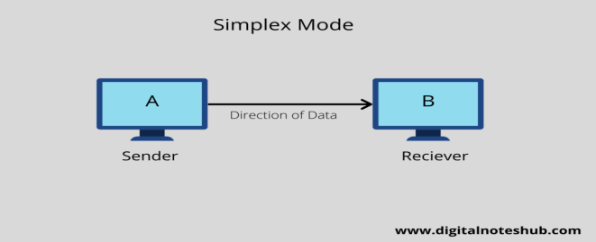
Half-Duplex:- In half-duplex mode the information travels in both directions, but alternately. That is, one device sends another receives and vice-versa.
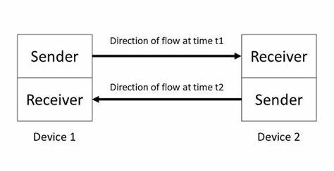
Full-Duplex:- In full- duplex mode the data transmitted in both the directions simultaneously.
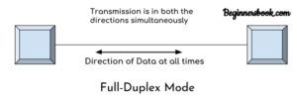
Network:- The term network is defined as it is the collection of independent computers connected with network cables for the purpose of exchange and sharing of resources.
Network is divided into three types based on size, distance and ownership:-
- Local Area Network
- Metropolitan Area Network
- Wide Area Network.
Local Area Network (LAN):- in LAN, the data transmitted between the computers connected into a local areas like within a building, office, within a campus within the area covered up to 5 KM.
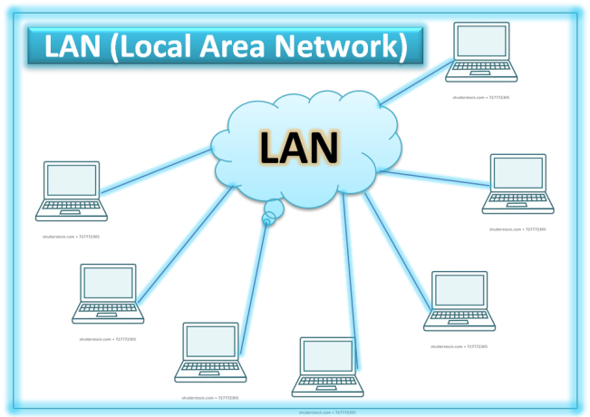
Metropolitan Area Network (MAN):- The data transmitted within a city comes under MAN. It uses the Optic fiber cable, covers the distance up to 50 KM.
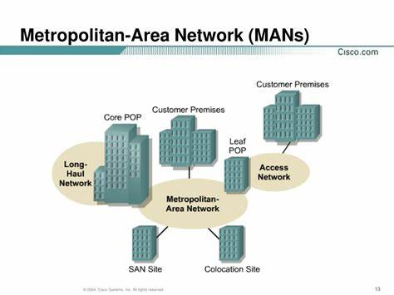
Wide Area Network (WAN):- The data like text, audio, video are transmitted over a long geographical area covered a country, a continent or the whole world. It uses the Public Switch Telephone Network (PSTN).
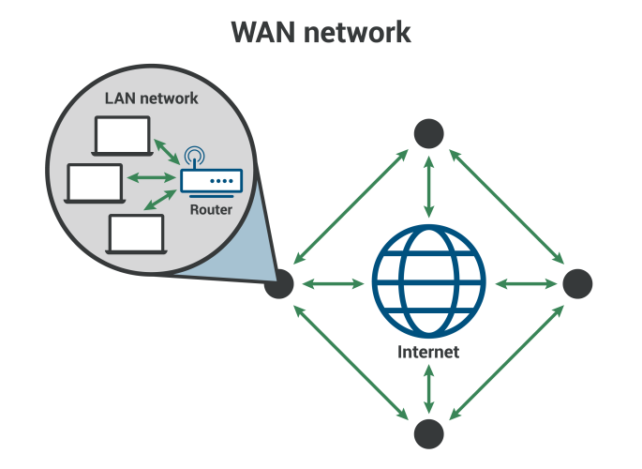
Communication Media:- for transmitting data between the systems, a communication media is required. There are various types of media depends on type of media, cost of media, transfer rate and efficiency.
The different types of communication media are:-
- Two wire open line
- Twisted pair cable
- Coaxial cable
- Optical fiber cable
- Radio and microwave communication channels
Two wire open line:- It is the simplest communication channel, consists of two insulated copper wires. The thickness of this wire is 0.4 to 1 mm and used for shorter distance. The data communication rate is 19200 bps.
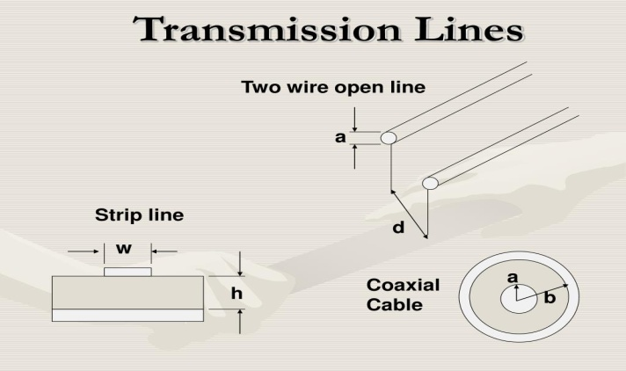

Twisted pair cable:- It consists of two insulated copper wires twisted together. It reduces the noise signals. The distance covered by this media is up to 1 KM. The data communication rate of this cable is 1 Mbps to 7 Mbps.
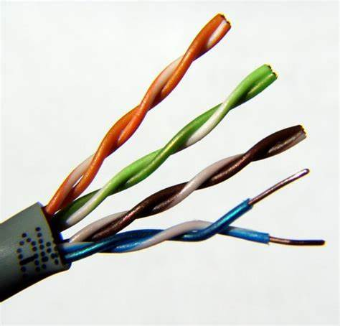
Coaxial cable:- In this cable, one solid conductor runs coaxially inside a mesh of outer conductor. The space between two conductors filled with insulator. It covers the distance up to 1 KM. The data transfer rate is up to 100 Mbps.
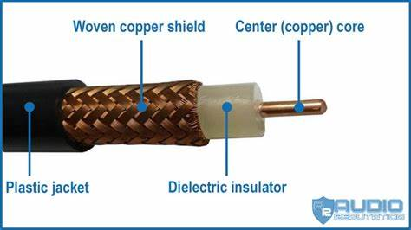
Optical fiber cable:- Optical fiber cable consists of a plastic or glass core covered by a cladding of lower refractive index. The cable carries the signals in the form of light. The glass core transmits the light when refractive index changes. There is a minimum loss of light in the internal reflections.
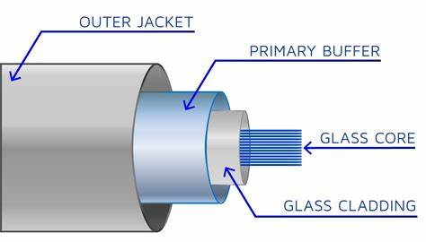
Radio and Microwave channels:- These channels transmit the data without using cables. These channels cover the large geographical areas and also cost effective. The data transmit rate of radio is 100 KBps to 400 KBps and its frequency is 1000 MHz. The data transmit rate of Microwave channel is 1000 MBps. It is basically used for broadcasting. It covers the distance 50 to 60 KMs. The example of microwave transmission is satellite communication.
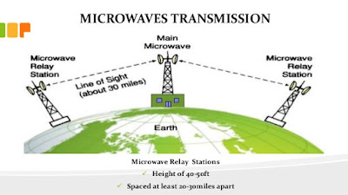
Network Topology:- The network topology is a physical layout of the network in which the network devices are connected. The stations are connected at a point is known as link station. Topologies are determined the complexity of the inner connections. The performance of the network is determined by the network topology.
The different types of network topologies are:-
- Bus Topology
- Star Topology
- Ring Topology
- Tree Topology
Bus Topology:- In bus topology all the devices or nodes are connected with a single common cable called as bus. When a signal addressed to any node, the other nodes in the network examines the signal whether that signal meant for one of them or not. In this system only one node can transmit the data at any given time. In this case, the protocol determines which node has right to transmit the data.
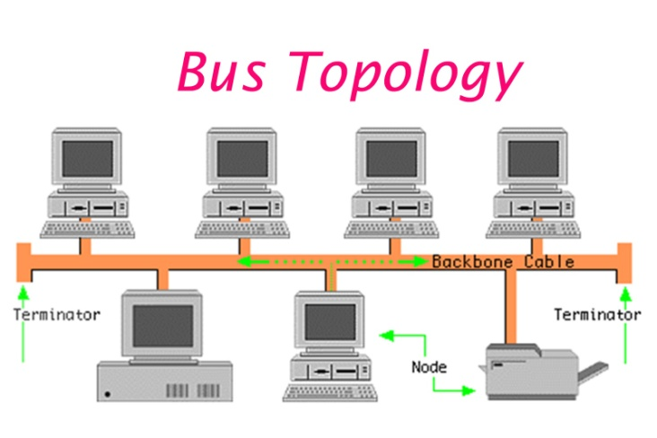
Star Topology:- In star topology the number of nodes are connected to a central controller known as hub. Here any node transmits the data to the controller. Then the controller exchange the data between the destination node connected to it. In this case, the network failure can be easily detected and remove that node from network. But, it controller fails, then the whole network is disable.
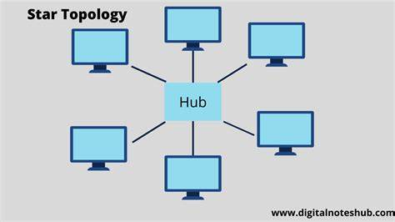
Ring Topology:- In ring topology the devices are connected in circular path. Here, each node is physically connected to only two nodes on its both sides. When any node transmits the data, the data passes to its neighboring nodes. If the neighboring node is not the destination node then, it passes to next node until it reaches at the destination. If any node is failure then, the data transmits in one direction only.
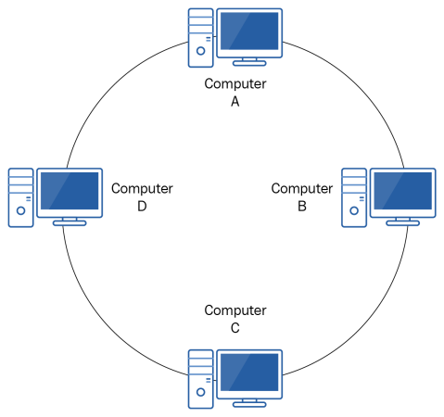
Tree Topology:- In the tree topology, the nodes are connected to a central hub, which controls all the traffic in the network. The devices are connected to secondary hub, which is connected to the central hub. This topology gives the flexibility to increase the number of nodes in a network. The different LANs can be connected with WAN using this topology.
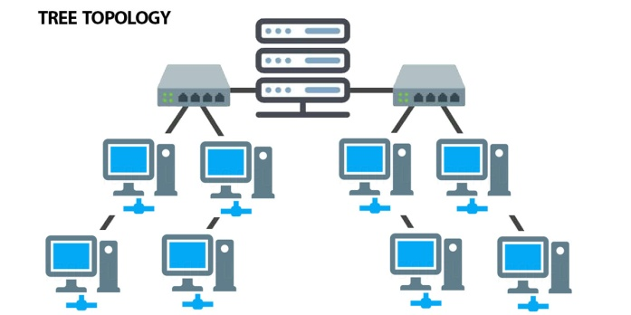
Network devices:- Network devices are used to increase the operation range of data communication. Some networking devices are:-
- Repeater
- Hub
- Switch
- Bridge
- Router
- Gateway.
Repeater:- It amplifies the signal that can travel father by increasing the size of the network.
It functions at the physical layer of OSI layer. The functions of repeater are:-
- Transmit the signal on to the next segment.
- Receives the signal which it cleans up.
- Retimes the signal to avoid collisions.
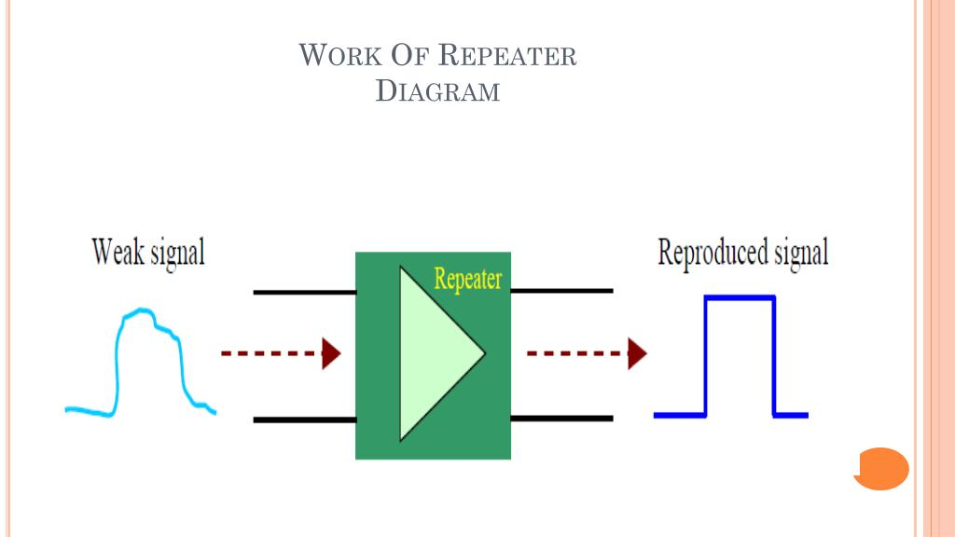
Hub:- A hub is the network device, that where data arrives from one or more nodes forwarded to one or more other nodes. It is 4 to 8 RJ-45 port. It also amplify the signals before transmitting to other nodes. So it is known as multiport repeater. It works in physical layer of OSI model. Hub is two types:- Active hub and Passive hub. Active hub amplifies the signal where as passive hub does not amplify the signals.
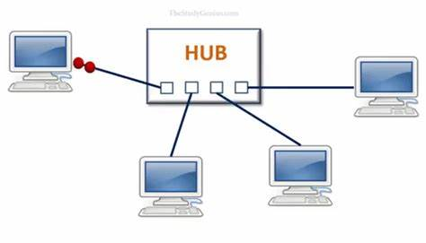
Switch:- A switch is a network device selects a path for sending a data units to its destination. It determines what adjacent network point the data should be sent. The purpose of switch is to select the best path. Data is grouped into packets. Eack packet has logical network address. The functions of switch are:-
- Get data packet from a computer connected to a port.
- Read the destination address of the data packet.
- Determine the port number to which the destination node is connected.
- Establish a temporary connection between the source and destination ports.
- Send the data packet in the port of destination node.
- Terminates the connection.

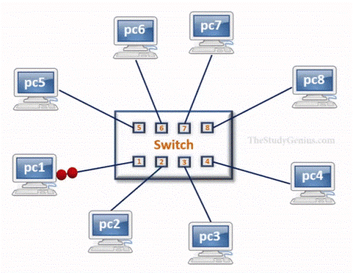
Bridge:- Bridges are devices that can transmit data between two heterogeneous LANS. It divides a large network into smaller segments. It filters the data and keep the traffic separate for each segment. When it finds a match the destination address , then tranmits the packet to the destination segment. It works in data link layer. The functions of bridge are;-
- It receives all signals from both segment A & B.
- Signals from segment A address to a node on segment B.
The bridge uses the MAC(Media Access Control) address to make decisions. It works in data link layer of OSI model.
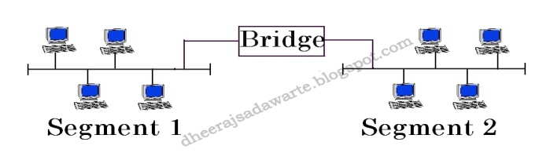
Router:- Router determines the best path out of the available paths for a particular transmission. It is consists of hardware and software. The hardware includes the physical interfaces where as the software is the operating system and the routing protocol. It connects two or more logically separate networks. It directs traffics to prevent collisions and congestion. The routing table store the address of different networks, the path of transmit data , the rules of filtering traffic in a table.
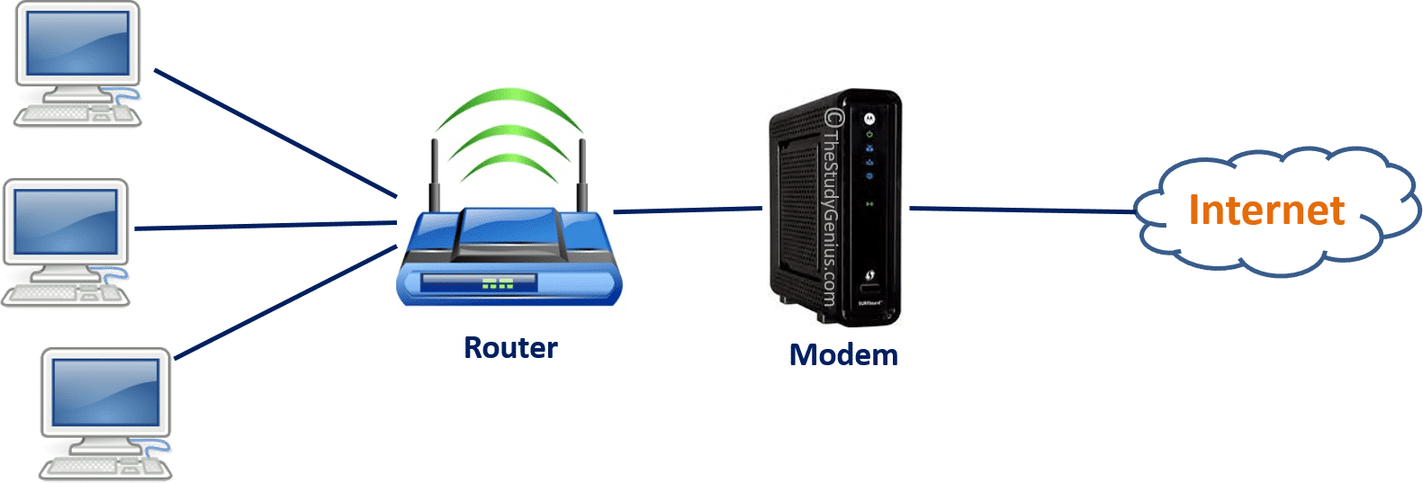
Gateway:- Gateway network device is used to connect the dissimilar networks. It performs protocol conversions for all seven layers of OSI model. It handles messages, address and protocol conversion necessary to transmit a message from one network to another network.
