Chitosan-Based Coating for Corrosion Protection of Copper

Beena Kumari K.S^{*, a}
^{*, a} Department of Chemistry, All Saints’ College, University of Kerala, Thiruvananthapuram, Kerala, India –695007
*beenagireesh@yahoo.co.uk

Nayana Senan V^{b}, Lekshmy O^{b}
^{b}Post Graduate & Research Department of Chemistry, Mahatma Gandhi College, Kesavadasapuram, Trivandrum 695 004, Kerala, India

Abstract
Chitosan has attracted a lot of attention in many fields due to its characteristics and potential uses. This polymer is the target of an increasing number of articles and patents each year. Chitosan's application is limited in neutral and basic media due to its weak solubility. In this work, Chitosan/PVP based coatings were investigated for the protection of copper substrates in neutral media. The corrosion resistance of chitosan-based coatings is improved by introducing polyvinyl pyrrolidone (PVP) as binder. Coated and uncoated copper substrates were characterized before and after corrosion treatments by scanning electron microscopy, Fourier transform infrared spectroscopy. Coating on copper substrate was performed by spin coating technique. Potentiodynamic polarization measurements shows that the chitosan/PVP acts as a good inhibitor for corrosion. It is found that upon crosslinking the chitosan coatings, a higher corrosion resistance could be achieved and the highest inhibition efficiency for chitosan/PVP coatings is calculated as 98%. The investigated inhibitor has shown good inhibition efficiency in 3.5% NaCl solution.
Keywords- Copper; SEM; PVP; NaCl; FT-IR
- Introduction
The exceptional electrical and thermal conductivity properties, corrosion resistance, and mechanical workability, copper and its alloys are widely used in piping, wiring, and cladding in the electrical, refrigeration, construction, petroleum refining, and transportation industries [1]. However, copper is prone to corrosion in hostile settings, particularly when corrosive species including oxygen, water, chloride, and sulphate ions are present. Sulphate-containing solutions are the most active corrosive species for anodic dissolution of copper. The stability and cost-effectiveness of polymers as anticorrosive materials have attracted significant interest. Polymers can be efficiently adsorbed on the surface of metals owing to their several adsorption locations (functional groups) displaying a considerable protection behaviour against corrosion. Extensive research on different dissolution mechanism has been performed and a general agreement is that the dissolution of copper is mainly through Cu⁺ ions and Cu(I) species. Environmental risks arise from the use of volatile organic compounds (VOC) or high pigment volume concentrations (PVC) in organic coatings [2]. Since chitin is a natural polysaccharide and is a major component of the exoskeleton of crustaceans like crabs and shrimp, chitosan (CS), the deacetylated form of chitin, has recently received more focus in the field of waterborne and environmentally friendly coatings. Because of its sustainability, biodegradability, and chemical and pathogen resistance properties, chitosan is an excellent candidate for the creation of protective coatings. There are several alternative deposition processes available to generate thin films of molecule-based compounds on various surfaces. Polymer films are frequently produced using the spin coating process [3]. For the purpose of spreading the fluid using centrifugal force, a second polymer solution is poured on a substrate and is then typically rotated at 1000 to 5000 rpm. Later, the coating will thin as a result of solvent evaporation. This method is applied to the creation of CDs and electrical microchips. The final thickness can be significantly altered by even the smallest modification in the coating spin speed or solution concentration. In this approach, it is possible to manage and link the dynamics of film formation to the ultimate structure of the movie. The "greener" supercapacitor binders polyvinylidene difluoride (PVDF) and polytetrafluoroethylene (PTFE) are being replaced by polyvinylpyrrolidone (PVP). The fact that PVP is non-toxic and soluble in ethanol is one of its main benefits [4]. PVP can also be regarded as one of the top polymers used in the production of micro and ultra-filtration membranes due to its outstanding resistance to corrosion and wear, mechanical characteristics, film-forming qualities, and thermal stability. By delaying the diffusion of corrosive species through the coating and preventing the transfer of charge between nearby anodic and cathodic sites, chitosan coatings serve as a physical barrier and prevent corrosion. The focus of this work is on developing Chitosan/PVP coatings on copper substrate using the spin coating technique because of the significance of polymer-based coating.
- Materials and Methods
A. Preparation of Copper Samples
The working electrodes were prepared by the pure copper. The copper specimens were mechanically cut into 1cm × 1cm× 1cm dimensions, embedded in epoxy resin, and only 1cm² was exposed to the air. The samples were abraded with a range of emery papers (800 to 3000 grade) before all of the trials. They were then cleaned using an ultrasonic cleaner, ethanol and acetone, followed by room-temperature drying. Chitosan (Mol.wt. = 5000) was purchased from Sigma–Aldrich Co. Ltd., deacetylation content = 78%. All other chemicals and reagents used were of analytical grade and were used without further purification. Sodium Chloride (3.5%) solutions were prepared by dilution of AR NaCl with deionized water.
B. Coating of copper samples with chitosan/PVP
The polished copper substrates were dried and tested for corrosion studies. The chitosan and PVP were dissolved separately in ethanol. Each solution was spin-coated onto the copper surface and then dried at room temperature for 24 h. The coated samples were cured at 100 ⁰C and then dried at room temperature for 2 h. The dried samples were kept in desiccator for corrosion analysis.
C. Electrochemical measurements
The electrochemical measurements were performed in a typical three-compartment glass cell consisted of a copper electrode as the working electrode (WE), a platinum foil as the counter electrode (PE) and a saturated calomel electrode (SCE) as the reference electrode (RE). The electrochemical experiments were performed using a CHI6041E electrochemical system at 30 ⁰C. The cathodic and anodic Tafel curves were recorded with respect to the OCP value with a scanning rate of 1 mV/S⁻¹. All potentials are presented in mV (SCE).
D. Surface characterization
The copper substrates were immersed in a 100 mL of 3.5% NaCl solution without and with chitosan/PVP coating for 3 days. The surface morphologies of these copper specimens were investigated by using a scanning electron microscope (FEI Nova Nano SEM 450). The FT-IR spectra measurements used to obtain the bonding information of chitosan on the surface of copper were carried out using Perkin Elmer Spectrum 100 FTIR spectrophotometer. The spectral range was from 4000 to 500 cm⁻¹. For comparison, FT-IR spectrum of the pure chitosan powder was obtained in the KBr pallets.
- RESULTS AND DISCUSSION
E. FT-IR Spectra of chitosan

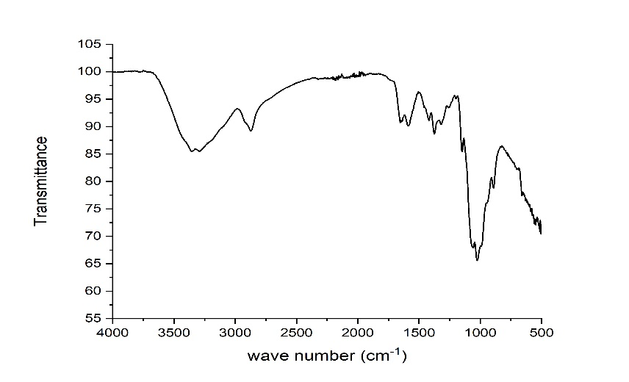
Figure 1: FT-IR Spectra of chitosan

In the chitosan spectrum, the O-H stretching band is wide and appears above 3500 to 3000 cm-1 and two small overlapped peaks at 3354 and 3296 cm-1 may correspond to N-H stretching of amines band. The C-H stretching band is observed at 2868 cm-1. The N-H bending vibration was observed at 1575cm-1 while the symmetric methyl bending vibration is observed at 1373 cm-1 and the symmetric and asymmetric stretching vibrations of C-O are observed at 1145 and 1025 cm-1.
The coated copper surface was characterised by IR spectrum. All the bands were shifted and it confirms the coating on copper surface. The figure 2 shows the vibrational bands of coated copper surface.
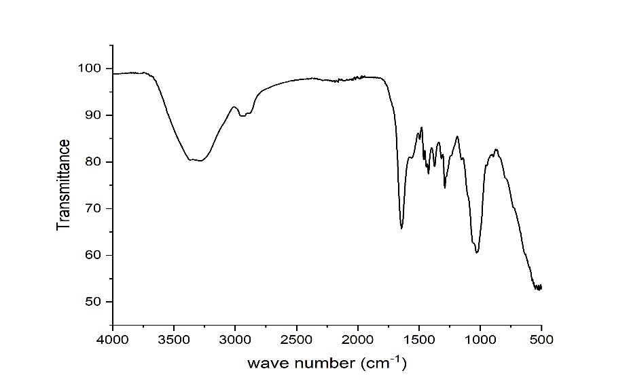
Figure 2: FT-IR Spectra of coated chitosan

F. Potentiodynamic polarization study
Tafel curves of copper electrode in 3.5% NaCl solution in the absence and presence of chitosan/PVP coating are shown in figure 3 which shows that the cathodic and anodic curves were different in the case of with and without coating. The E_{corr}, i_{corr}, ƞ, 𝛽c and 𝛽a values, were obtained from Tafel curves. These parameters are given in Table 1. It was clear that the value of i_{corr} decreased substantially in the presence of coating [5]. This indicates the protective effect of coating on copper which reduced the anodic dissolution. The corrosion inhibition efficiency attained a maximum of 98%.

Figure 3: Tafel plot of coated and uncoated copper surfaces at 30 ⁰C in 3.5% NaCl media.

Table 1. Electrochemical parameters from polarization study in 3.5% NaCl solution with and without coating
C  (mg/L⁻¹) | -E_{corr}  (mV) | i_{corr}  (mA/cm²) | β_{a}  (mv/dec⁻¹) | β_{c}  (mV/dec⁻¹) | Ƞ%
0 | 1046 | 0.182 | 239 | 212 | -
50 | 1054 | 0.102 | 286 | 183 | 43
150 | 972 | 0.002 | 281 | 195 | 98

G. SEM analysis
The surface study of copper after 3 days of immersion was analysed by scanning electron microscopy. The SEM micrographs of copper surface after 3 days of immersion in 3.5% NaCl in the absence and presence of chitosan/PVP coating are shown in figure 4. The figure 4 (a) is the polished copper sample before immersion, found smooth and showed some abrading scratches. Figure 4 (b) represents the damaged copper surface due to the corrosion after the 3 days immersion in 3.5% NaCl solution. SEM images of copper surface after 3 days of immersion in neutral solution with 150mg chitosan/PVP complex is shown in figure 4 (c). Figure 4 (c) shows the formation of protective coating in the surface. The cracking and pitting of copper surface reduced to a considerable extent in the presence of coating. From this it can be confirmed that the chitosan/PVP coating has better ability to act as an inhibitor for corrosion in 3.5% NaCl.
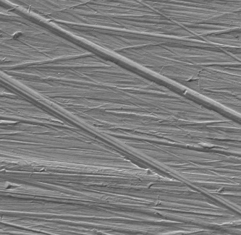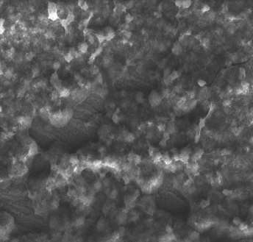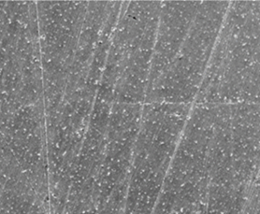
Figure 4: SEM micrographs of (a) polished copper, (b) after immersion without coating (c) coated with 150 mg chitosan/PVP in 3.5% NaCl.

- CONCLUSION
The protective efficacy of chitosan-based coatings to hinder degradation processes in copper substrates was investigated in 3.5% NaCl solution for 3 days. The results of the image analysis, exploited to quantify the protective efficacy, confirm that the developed chitosan coatings with PVP are effective in the corrosion inhibition. All these findings make chitosan-based coatings very promising for their application in the sustainable, long lasting, and safe protection of copper in neutral medium. Moreover, the incorporation of PVP in chitosan-based coatings improves their quality, anticorrosion properties and removability, due to a synergic effect between the polymer matrix and the corrosion inhibitors.

REFERENCES

C. Shiqiang, and Z. Dun, “Study of corrosion behavior of copper in 3.5 wt.% NaCl solution containing extracellular polymeric substances of an aerotolerant sulphate-reducing bacteria”, Corros. Sci, vol.136, pp. 275-284, May 2018.

R. Zaiema, Y.D Idrees, J. Maheen, D. M Mohmad, and A. Jehangir, “Volatile Organic Compounds Emission from Building Sector and Its Adverse Effects on Human Health,” in Ecological and Health Effects of Building Materials, vol. 33, J.A. Malik and S. Marathe, Eds. Switzerland: Springer, Cham, 2021, pp.67-86.

F. Jingguo, L. Meng, L. Gengshuo Liu, and M. Shenglin Ma “Robust ceramic based self-lubricating coating on Al–Si alloys prepared via PEO and spin-coating methods”, Wear, vol.458-459 (8), October 2020.

M. Aslan, D. Weingarth, N. Jäckel, J.S. Atchison, I. Grobelsek , and V. Presser “Polyvinylpyrrolidone as binder for castable supercapacitor electrodes with high electrochemical performance in organic electrolytes”, J. Power .Sources, vol. 266, pp. 374-383,October 2014.

M. Lian, Q Yujie, and Z. Wenjie, “Designing novel organic inhibitor loaded MgAl-LDHs nanocontainer for enhanced corrosion resistance,” J.Chem. Eng, vol.408, March 2021.

