Prediction of Decay in Coconut Trees Using Machine Learning and CNN
Chethan Rª, S Nithine Balajeeª, Kartik Parmarª, Sharan Rª, Niranjan Hiremath^{b}
ª Student, Department of Mechatronics Engineering REVA University, Bangalore, 560064, India

^{b}Associate Professor, Department of Mechatronics Engineering REVA University, Bangalore, 560064, India
Abstract
This paper discusses the coconut disease finding drone, a small unmanned aerial vehicle (UAV) that is designed to detect and identify diseases in coconut trees. The drone is equipped with various sensors, including a high-resolution camera and a GPS module, which allows it to capture detailed images of coconut trees and their surrounding areas. The drone is programmed to fly over coconut plantations and capture images of the trees from different angles and elevations. The images are then processed using machine learning algorithms that are trained to detect and identify common diseases that affect coconut trees, such as lethal yellowing, coconut bud rot, and stem bleeding. Once a disease is detected, the drone can alert farmers and other stakeholders in real time, providing them with early warning of potential outbreaks and enabling them to take proactive measures to prevent the spread of the disease.
Keywords: Smart disease monitoring robot, Coconut trees, Agriculture robots.
- INTRODUCTION
Coconut trees are an important crop in many tropical regions of the world, providing food, fiber, and various other products. The coconut industry plays a significant role in many countries economies, providing millions of people with income and employment opportunities. However, coconut trees are vulnerable to a variety of diseases that can have a significant impact on crop yields and quality. Diseases such as lethal yellowing, coconut bud rot, stem bleeding, and crown rot can cause severe damage to coconut plantations, leading to reduced yields and economic losses. Managing and preventing coconut diseases can be challenging, as many of these diseases are difficult to diagnose and treat. Traditional disease monitoring and management methods, such as manual inspections and chemical treatments, can be time-consuming and expensive and may not be effective in preventing the spread of diseases.

New technologies, such as drones equipped with sensors and machine learning algorithms, are being developed to help monitor and detect diseases in coconut plantations. These technologies offer a more efficient and cost-effective approach to disease management, providing farmers with real-time data and early warning systems that enable them to take proactive measures to prevent the spread of diseases. Overall, the paper presents a smart drone that replaces the archaic traditional disease monitoring and management methods with a time-efficient solution.
- METHODS AND COMPONENTS
2.1 Material Selection and sample preparation
This robot is designed to operate wirelessly making it virtually a machine, drone is operated using a pilot and is manually flown to the affected coconut tree. The image processing camera captures and processes the image to provide a live feed and details about the disease.

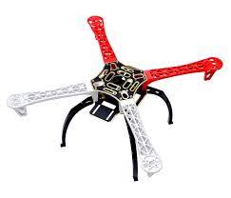
- MAIN FRAME

Figure 1: F450 Quadcopter Frame

The main frame is made up of F450 as it is the best suitable material for this project.

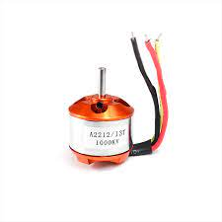
- DRIVE MOTORS

Figure 2: 1000KV BLDC Motor

4 1000KV BLDC Motor is being used for this Project.
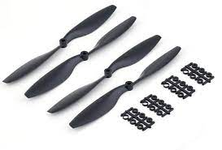
- PROPELLERS

Figure 3: 1045 Propeller

4 1045 Propellers are being used here as they are cheap and durable.

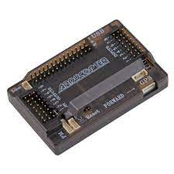
- APM2.8 + ESC 30A

Figure 4: APM 2.8 Flight Controller

APM 2.8 and ESC 30A are used for the flight and control of the drone. APM 2.8 is preferred as it is open-source and can be
Modified for our needs

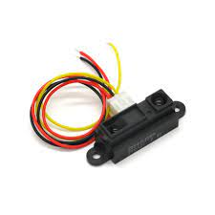
- SENSORS
Figure 5: Sharp Distance sensor

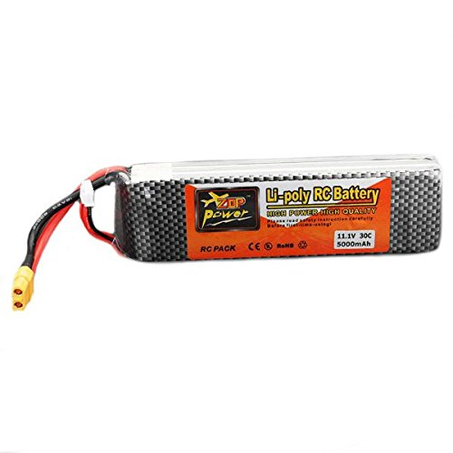
- BATTERY

Figure 6: Battery 12v, 5000mah

The battery used for this project is a 5500Mah 11.1V 3S Li-Po Battery which is a pouch-based battery.

- CAMERA
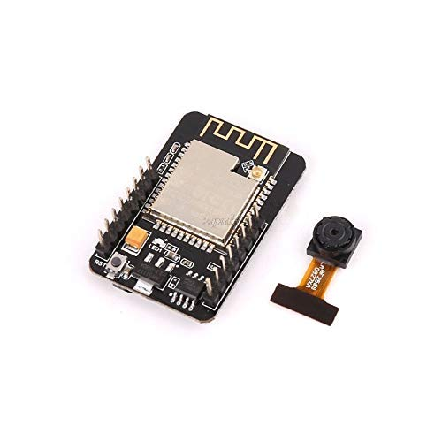
Figure 7: Camera

The camera used in this project is an ESP32 Camera module. This is preferred as it is open source and it is a low power
Camera module.

2.2 Methodology Phase 1
MODEL VIEW OF A DRONE
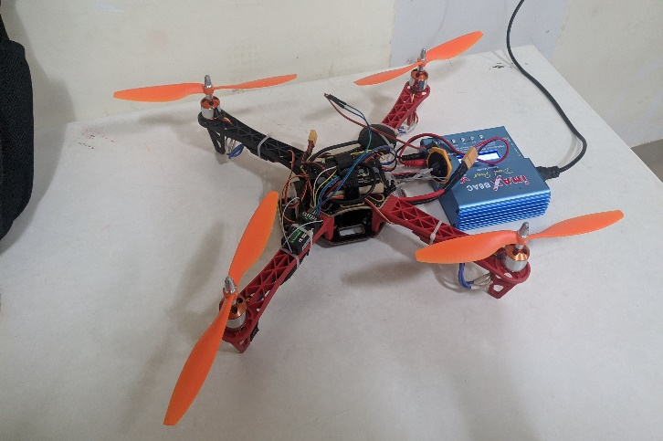
.
Figure 8: Drone Structure

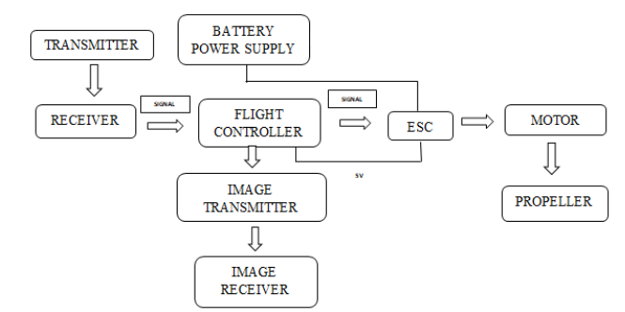
BLOCK DIAGRAMS

Figure 9: Drone Network
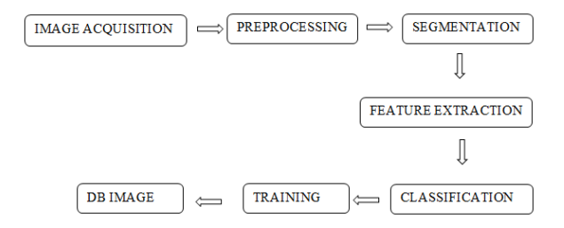
Figure 10: Image Processing
.

- Image Acquisition – Diseases images are captured using the camera. The captured images are uploaded to the system

- Pre-Processing – Pre-Processing is done to increase accuracy and reduce the complexity of the dataset. While converting the colour image to grayscale is an accepted pre-processing technique.

- Segmentation – Segmentation is the process of identifying the objects in the image. Segmentation can be done by using K- Means Clustering, Edge detection methods.

- Feature selection – This process is to extract the important information from the input image is the process, where we transform the input data into a set of features.

- Training – Here the datasets and split into two subsets.

- DB Image – This stage is where the Deployment of the finished machine learning model into a live environment.

2.3 Models Used for Image Processing

- Support Vector Mechanism (SVM) - Support Vector Machine (SVM) is a popular supervised learning algorithm that can be used for both classification and regression tasks. The main idea behind SVM is to find the optimal hyperplane that separates the different classes of data points in a high-dimensional feature space.

- Convolutional Neural Network (CNN) - A Convolutional Neural Network (CNN) is a type of deep learning neural network commonly used in image and video recognition and processing. It is specifically designed to automatically detect and extract meaningful features or patterns from input images, such as edges, corners, shapes, textures, or colors, by using a series of convolutional layers.

The basic building block of a CNN is a convolutional layer, which applies a set of learnable filters or kernels to an input image, resulting in a feature map that highlights the presence of certain features in different regions of the image. The filters are trained during the backpropagation process to maximize the accuracy of the network's predictions.

After several convolutional layers, a CNN typically includes one or more pooling layers, which reduce the spatial resolution of the feature maps by subsampling or averaging, to decrease the computational cost and prevent overfitting. Finally, the output of the last convolutional or pooling layer is typically flattened and connected to one or more fully connected layers, which perform the classification or regression tasks based on the learned features.

They are based on the idea of applying convolutional filters to an input image to extract features that are relevant to the given task. These filters can be thought of as sliding windows that move over the image, performing a dot product operation at each position, and producing a feature map that highlights certain patterns in the input image. The filters used in convolutional layers of CNNs are learnable parameters that are optimized during the training process using backpropagation. This allows the network to automatically learn the most relevant features from the input image for the given task.
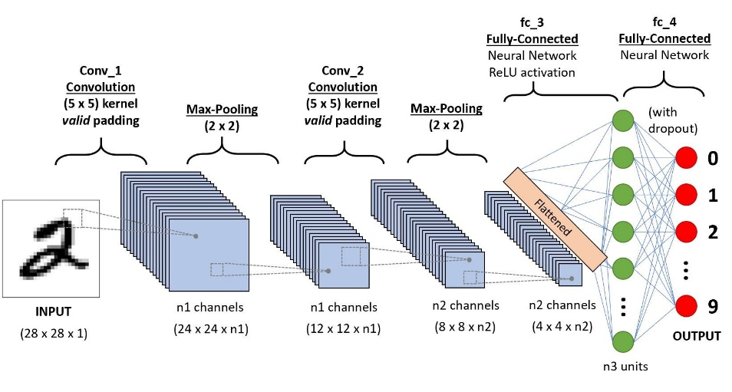
Figure 11 – Convolutional Neural Network

2.4 Methodology Phase 2
In this phase, we identify the stages in each disease category
- Stage 1 – Initial (Low Risk).
- Stage 2 – Medium Risk.
- Stage 3 – High Risk.
For each stage, we will identify the preventive measure that can be taken, the percentage of recovery from that stage.
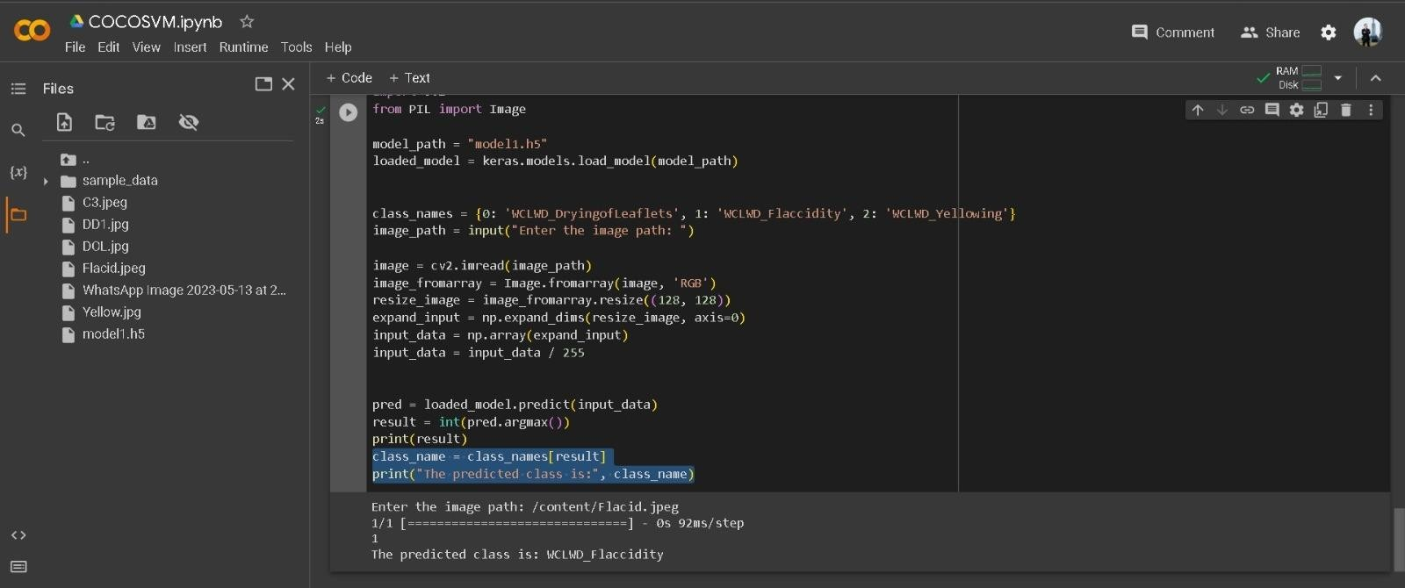
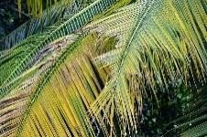
- RESULT
Fig 12- Identification of Flaccidity Disease using RGB colour Module
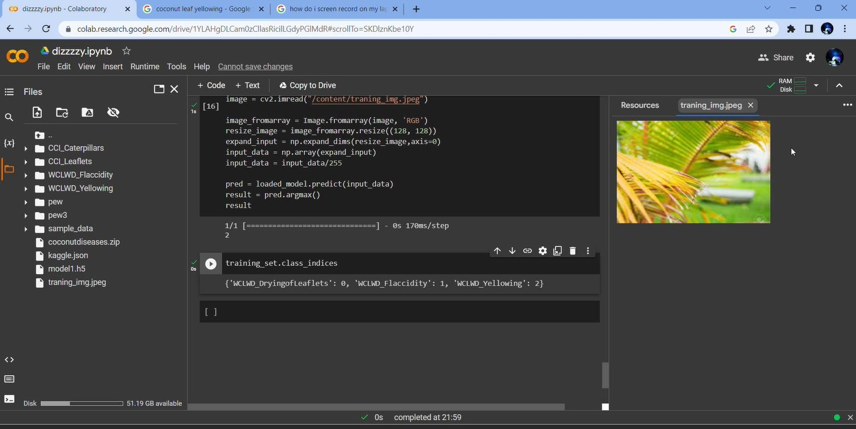
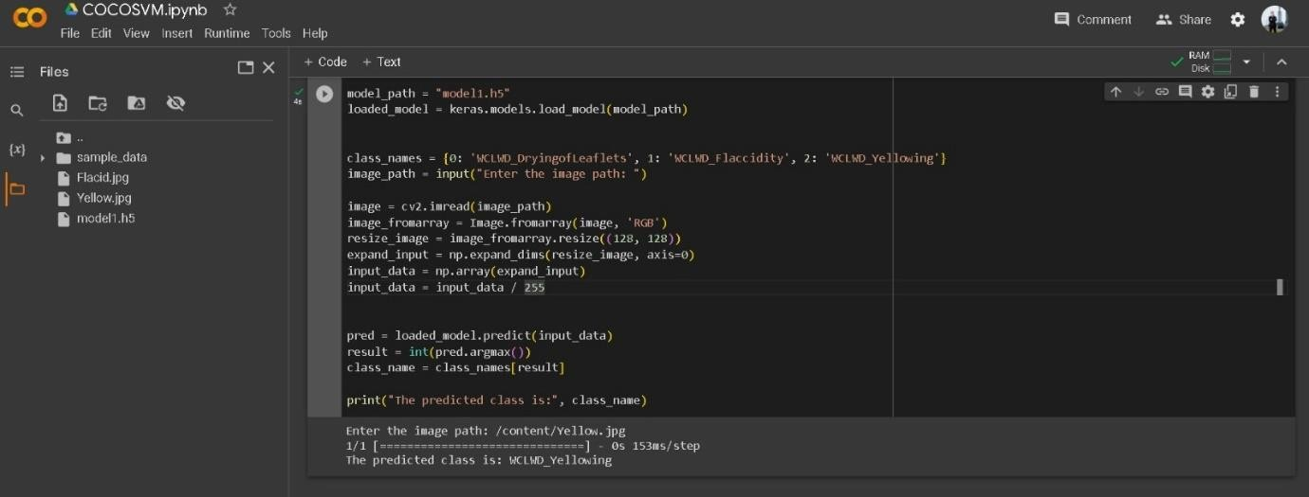
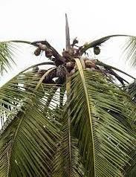
Fig 13 - Data sets of diseases with the help of the RGB Colour module
Fig 14 - Identification of Yellowing disease with the help of RGB Colour module

- CONCLUSION
In this project the drone is designed, developed and tested for the prediction of decay in coconut trees. Two models have been deployed for Image Processing and after comparing both the models our results show that Convolutional neural network [CNN] is more accurate in Detection of the Decay.
In Conclusion, the future scope of coconut disease drones is likely to involve the integration of advanced sensors, AI algorithms and autonomous operations, enabling more efficient and effective disease monitoring and management. These technologies have the potential to transform the coconut industry, making it more sustainable, resilient, and productive. Physical techniques for Coconut disease detection are time-consuming and dangerous. By using automated devices with human interference, we can reduce the risk of injuries and detect disease quickly and take action to reduce or eliminate it.

Acknowledgment
We would like to thank staff, faculty members of Department of Mechatronics Engineering, REVA University for their support extended during the project.
References
[1] Suryawanshi, Vikrant Krishna, J. Ashok, Sumit Ashok Rajmane, and Snehal Shivaji Mali. "Design & development of agricultural fertilizer spraying drone with remote controller and autonomous control with low weight aluminum alloy frame structure." Journal of Remote Sensing GIS & Technology 5, no. 2 (2019).
[2] Shaw, Karan Kumar, and R. Vimalkumar. "Design and development of a drone for spraying pesticides, fertilizers, and disinfectants." Engineering Research & Technology (IJERT) (2020).
[3] Sharma, Varun, Patchigolla Vignan, Nayab Suman, and Sayantan Bhattacharya. "DESIGN AND FABRICATION OF A AGRICULTURAL DRONE." Journal of Engineering Sciences 1, no. 1 (2016).
[4] Chandy, Abraham. "Pest infestation identification in coconut trees using deep learning." Journal of Artificial Intelligence 1, no. 01 (2019): 10-18.
[5] Giles, D., and R. Billing. "Deployment and performance of a UAV for crop spraying." Chemical engineering transactions 44 (2015): 307-312.
[6] Suryawanshi, Vikrant Krishna, J. Ashok, Sumit Ashok Rajmane, and Snehal Shivaji Mali. "Design & development of agricultural fertilizer spraying drone with remote controller and autonomous control with low weight aluminum alloy frame structure." Journal of Remote Sensing GIS & Technology 5, no. 2 (2019).
[7] Tzec-Simá, Miguel, Jean Wildort Félix, María Granados-Alegría, Mónica Aparicio-Ortiz, Dilery JuárezMonroy, Damian Mayo-Ruiz, Saraí Vivas-López, et al. "Potential of Omics to Control Diseases and Pests in the Coconut Tree." Agronomy 12, no. 12 (2022): 3164.
[8] Lever, Robert J. Pests of the coconut palm. No. 7. Food & Agriculture Org., 1969.
[9] Sadakathulla, S., and T. K. Ramachandran. "Efficacy of naphthalene balls in the control of rhinoceros beetle attacks in coconut." In Cocos, vol. 8, pp. 23-25. 1990

