SMART HELMET FOR COAL MINERS

R. Mounitha
Department of Electronics and Communication Engineering,
Karpagam Institute of Technology,
Coimbatore, Tamil Nadu, India.

K. Nijandhan
Department of Electronics and Communication Engineering,
Karpagam Institute of Technology,
Coimbatore, Tamil Nadu,India.
S. Varunika
Department of Electronics and Communication Engineering,
Karpagam Institute of Technology,
Coimbatore,TamilNadu,India.

S. Rohith Sai Kumar
Department of Electronics and Communication Engineering,
Karpagam Institute of Technology,
Coimbatore, Tamil Nadu,India.

S. Pragadeswaran*
Department of Electronics and Communication Engineering,
Karpagam Institute of Technology,
Coimbatore, Tamil Nadu, India.
Praga1994@gmail.com

ABSTRACT
The smart helmet concept designed for enhancing coal miners' safety demonstrates a well-considered approach. It integrates a variety of sensors and cutting-edge communication technologies to ensur components: The environmental conditions within the mine are monitored by sensors such as the DHT11, which tracks temperature and humidity, and the MQ-02, which detects harmful gas concentrations like methane and carbon monoxide. A vibration sensor is also utilized to identify any unusual movements or shifts that might indicate potential structural instability. The device's communication system is notably robust. LoRa technology, known for its extensive range and low power consumption, is used to transmit data over significant distances, especiall e the well-being of miners working in coal mines. The device functions through a combination of several key y in areas where conventional communication methods like Zigbee might fall short. Additionally, GSM technology serves as a backup communication channel in case LoRa connectivity is compromised. The core data processing unit is an Arduino microcontroller. It collects data from the various sensors, processes it into a suitable format, and then facilitates its transmission through the chosen communication methods (LoRa and GSM). The microcontroller can also execute predefined algorithms to locally analyze the sensor data against established safety thresholds. Received data is then sent to a control room, where safety personnel analyze the information. Based on the sensor readings, the control room staff can make informed decisions regarding miner safety. This could involve actions such as initiating evacuations or implementing measures to rectify working conditions. By thoughtfully integrating both LoRa and GSM, the design ensures effective communication across extended distances while maintaining a contingency option. The sensors chosen cover a comprehensive range of potential risks, spanning from environmental factors to gas concentrations and structural integrity. To enhance the system's functionality, potential additions might encompass real-time data visualization, predictive analytics for hazard anticipation, and wearables to track miner locations for efficient evacuation procedures. It's imperative to uphold regular maintenance and sensor calibration to guarantee the accuracy of collected data.
Key words: Smart helmet, coal miners' safety, working conditions, sensors, LoRa communication technology

I. INTRODUCTION
In earlier times, coal miners used helmets with limited protection and small lights for visibility while working underground. However, the occurrence of accidents, such as the notable Upper Big Branch Mine disaster in the US on April 5, 2010, prompted a re-evaluation of safety measures. The Mine Safety and Health Administration (MSHA) investigation revealed that a breach of safety protocols and exposure to harmful gases were key factors leading to the disaster. It was evident that timely detection could have mitigated the impact. Fortunately, technological progress in the modern era offers viable solutions to these challenges. In response, a smart helmet concept was developed to provide enhanced safety measures while maintaining lightweight design and heightened security. [1] The study by C. J. Behr, A. Kumar, and G. P. Hancke introduces a smart helmet incorporating features such as air quality monitoring, helmet removal detection, collision sensing, and communication through Zigbee technology. [2] Another investigation by Prof. Deepali Shinkar et al. presents an IoT-based smart helmet for coal mining tracking. Their approach integrates sensors for temperature, humidity, light, and air quality, alongside WIFI and GSM modules. Unlike earlier methods that relied on Zigbee and WiFi, this solution effectively covers medium to long communication ranges. The smart device is equipped with four sensors that trigger alerts upon identifying potential threats. The data is processed by an Arduino system, which compares it against predefined ranges. Any deviations from these ranges activate a buzzer, send alerts to authorized personnel, and display the status in a control room. Various components such as the DHT11 sensor for temperature and humidity assessment, obstacle detection, and vibration sensors for hazard and falling object identification work together to ensure miner safety. Detection of harmful gases like SO2, CO2, NO2, and NH3 is achieved through the MQ2 sensor. The gathered data is analyzed and transmitted efficiently using LoRa communication, known for its low power consumption. The comprehensive integration of these technologies significantly enhances the safety and monitoring of coal miners.

II. LITERATURE SURVEY
Yongping Wu and Guo Feng presented an innovative coal mine monitoring system that leverages Bluetooth wireless transmission technology. This advancement facilitates standardized short-range wireless communication, known for its low-power and cost-effective nature. Through the integration of well-established CAN bus technology, this system effectively merges both wired and wireless data transfer techniques [1].
Addressing the challenge of cable usage, Bluetooth's short-range wireless capabilities are harnessed. In a similar vein, Jingiiang Song and Yingli Zhu devised an automatic coal mine safety monitoring system using wireless sensor networks. This system utilizes a microcontroller to relay measurements from sensor groups, such as temperature and humidity, to a wireless communication module. The subsequent transmission of data is facilitated through a cable to a designated remote monitoring site [2].
Furthermore, Pranjal Hzarika emphasized the necessity of safety helmets embedded with gas sensors for coal miners. These helmets incorporate wireless Zigbee modules to detect gases like carbon monoxide and methane, with the collected data being remotely transmitted to a central control center [3].
Similarly, Mustafa Abro et al. and Abid et al. introduced an IoT-based wearable jacket tailored for coal miners' protection. This advanced wearable senses hazardous chemicals, monitors heart rate, assesses environmental conditions, and tracks miner location using GPS technology. The collated information is securely transmitted via Wi-Fi to an encrypted internet protocol [4].
D. Kock et al. devised an automation system that significantly benefits coal miners, particularly in South Africa. This system, developed for coal port detection, combines the analysis of gamma radiation and the natural vibrations present in the environment [5].
Meanwhile, Gaidhane et al. proposed a robust safety system for mine employees based on Zigbee technology. This system actively monitors gas levels, offering timely alerts by illuminating LEDs and sending Zigbee warnings when hazardous gas concentrations exceed predefined thresholds. Such precautions are paramount in reducing mine-related fatalities [6].
Lastly, Cheng Qiang et al. introduced an inventive wireless IoT-based communication system tailored for coal miners. This comprehensive system not only monitors crucial parameters like temperature, humidity, and methane levels but also communicates vital alerts through voice communication channels, enhancing miner safety [7].

III. PROPOSED SYSTEM
The intelligent helmet offers real-time monitoring capabilities for critical parameters, including hazardous gas levels, suitable light levels, humidity, helmet usage, and the miner's positioning. The utilization of IoT-based wireless networks proves to be the most efficient mode of communication between underground mines and base stations. Whenever any sensor readings surpass predefined threshold values, an alert is activated through a buzzer device to promptly inform either the supervisor or the personnel stationed at the base. The core focus of the proposed study revolves around an IoT-driven smart helmet designed to substantially assist underground workers. Specifically tailored to cater to the unique requirements of coal miners, this helmet incorporates gas sensors, temperature and humidity sensors, and other indispensable safety features. The helmet integrates detectors and a microcontroller within the transmitter section, receiving inputs from distinct sections like helmet removal sensors, collision sensors, and gas detectors. In the event of a hazardous incident, the helmet transmits alerts to designated applications placed across various zones within the coal mine. Sensors such as helmet removal detectors, gas sensors, and collision sensors capture pertinent parameters. The software design phase aligns with the study's operational workflow, divided into segments for sequence programming and interface programming. Successful attainment of the project's envisioned objective hinges on the seamless interplay of both software segments, working harmoniously in tandem. The stages of testing, fine-tuning, and addressing issues hold critical significance within the design process. These stages unfold subsequent to the integration of hardware and software components. Even minor design discrepancies could result in time-intensive setbacks, necessitating retracing steps back to earlier phases for thorough validation.

IV. HARDWARE AND DESCRIPTION
The Arduino Uno stands as a prominent open-source platform, widely recognized for its versatility in constructing electronics projects. It combines a physical programmable circuit board, often referred to as a microcontroller, with an Integrated Development Environment (IDE) software. This IDE, operating on a computer, facilitates the creation and uploading of computer code onto the physical board. Distinguished by its appeal to electronics beginners, the Arduino platform has gained popularity for several compelling reasons. It eliminates the need for an additional hardware component (programmer) to load new code onto the board, relying solely on a USB cable for this purpose. Furthermore, the Arduino IDE employs a simplified version of the C++ programming language, making programming more accessible to newcomers.
A cutting-edge autonomous robot system designed for mine disaster detection integrates advanced sensors, real-time data processing, and AI algorithms. By continuously monitoring environmental parameters such as gas levels, temperature, and seismic activity, it swiftly identifies potential hazards. This innovative technology offers a crucial lifeline for miners, enabling rapid responses and potentially saving lives during emergencies [8].
The platform's adherence to a standard form factor enhances accessibility by consolidating the microcontroller's functions into a cohesive layout. Based on the ATmega8 microcontroller, the Arduino board integrates 14 digital input/output pins (with six supporting PWM outputs), six analog inputs, a 16 MHz ceramic resonator, USB connectivity, a power jack, an ICSP header, and a reset button. These components collectively provide the necessary support for the microcontroller's operations. Connecting the board to a computer via a USB cable or powering it with an AC-to-DC adapter or battery initiates the project setup [14].
The Uno distinguishes itself from its predecessors by deviating from the conventional use of the FTDI USB-to-serial driver chip. Instead, it incorporates the Atmega16U2 (Atmega8U2 for versions up to R2) preprogrammed as a USB-to-serial converter. A unique feature of Revision 2 of the Uno board involves a resistor that grounds the 8U2HWB line, streamlining the process of transitioning the board into DFU mode.
Presenting a groundbreaking Dynamic Mobile Wheel Slip Detector designed for outdoor terrain. This innovative system combines mobile robotics with advanced sensors to accurately gauge wheel slip in real-time, enhancing traction control and maneuverability. Its adaptability to varying terrains marks a significant advancement, ensuring optimal performance and safety for mobile robots in diverse environments [9].
The MQ2 gas sensor plays a crucial role in electronic gas detection by accurately gauging gas concentrations in the air. This sensor effectively detects a range of gases, including LPG, propane, methane, hydrogen, alcohol, smoke, and carbon monoxide. Operating as a chemiresistor, the MQ2 sensor integrates a specialized sensing material that exhibits variations in resistance upon exposure to specific gases. These alterations in resistance serve as the basis for gas detection, enabling the sensor to reliably identify the presence of targeted gases in its surroundings.
By subjecting carbon fibers to FC-72 fluid, a precise method emerges for determining heat transfer coefficients, unveiling valuable insights into thermal properties. This approach facilitates accurate characterization of heat dissipation capabilities in various applications [11].
The DHT11 represents a fundamental and highly economical digital sensor designed to measure both temperature and humidity levels. This sensor utilizes a combination of a capacitive humidity sensor and a thermistor to capture environmental data. Through its data pin, it generates a digital signal that requires precise timing for effective data retrieval. It's worth noting that the sensor has a limitation of producing new data only once every 2 seconds, resulting in potential delays of up to 2 seconds when utilizing the associated library. RFID readers can be broadly categorized into two main types: handheld and fixed. Fixed readers are generally installed in specific locations such as warehouses or production lines, whereas handheld readers offer portability and can be carried to different locations. RFID systems operate across multiple frequency bands, including low frequency (LF), high frequency (HF), ultra-high frequency (UHF), and microwave frequencies. The choice of frequency is determined by various factors, including the intended application and the distance between the RFID reader and the tag it's interacting with.
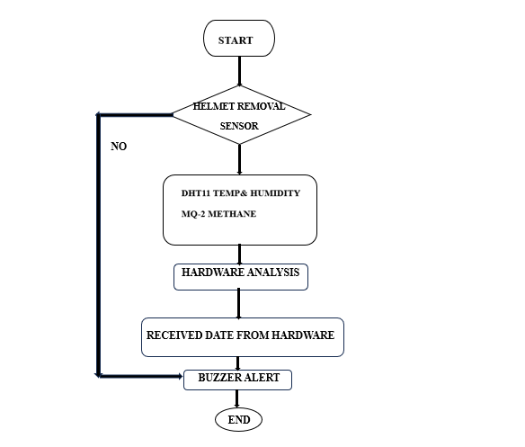FIGURE 1.1: Mine Gas, Humidity and Temperature Monitoring

Tangent Bug introduces an innovative navigation algorithm reliant on range sensors, enabling robots to intelligently traverse environments. This approach optimizes pathfinding by leveraging real-time data for efficient obstacle avoidance and route planning [12].
Liquid Crystal Display (LCD) screens have become integral to our daily environment, finding application in computers, calculators, TVs, mobile phones, and digital watches for time and information display. An LCD screen operates by utilizing liquid crystals to create visible images electronically. The 16x2 LCD display module holds a prominent place in DIY projects and electronic setups. The "16x2" specification denotes its capability to exhibit 16 characters distributed across 2 lines. Within this LCD module, each character is portrayed through a 5x7 pixel matrix, ensuring a crisp and clear presentation of textual content.
A GSM modem serves as a specialized device designed to operate using a SIM card and a mobile operator subscription, akin to the functioning of a mobile phone. This device presents itself to mobile operators just like a regular mobile device does. When linked to a computer, the GSM modem empowers the computer to establish communication via the mobile network [13].
While its primary role often involves providing mobile internet connectivity, these modems are also capable of sending and receiving SMS and MMS messages. Effective SMS communication necessitates the GSM modem's support for an "extended AT command set." A notable advantage of utilizing GSM modems for SMS initiation is the absence of a dedicated SMS service subscription requirement. Across various regions globally, GSM modems offer a cost-efficient solution for receiving SMS messages, with the message sender bearing the delivery cost. To initiate usage, a GSM SIM card is inserted into the modem, which is then connected to an available USB port on the computer.

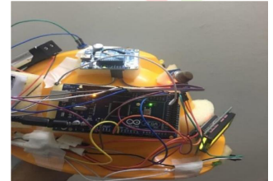
FIGURE 1.2: Smart Helmet for Coal Mining Industry

A buzzer is a commonly used device that emits a strong and frequently jarring sound. This sound is often loud and can be perceived as discomforting. Buzzer devices are commonly employed to serve as alarms or warning signals, finding particular utility in industrial settings and emergency scenarios. The terms "buzzer" and "beeper" are often used interchangeably, though their specific connotations can vary based on the context in which they are used.
The method of serial communication it employs relies on a UART interface. This characteristic makes it easily adaptable to a variety of microcontrollers. To function optimally, it requires a DC input ranging between 3.3 and 5 volts, facilitated by its built-in voltage regulator. Its design incorporates a "patch antenna" style, which makes it most effective at a baud rate of 9600. It's crucial to consider that this system demands a clear line of sight to satellites for optimal performance, necessitating ample open space.
The ESP8266 WiFi module stands as an economical and independent wireless transceiver that finds utility in developing endpoint IoT solutions. Serving as a conduit for internet connectivity within embedded applications, the ESP8266 module utilizes TCP/UDP communication protocols to establish connections with both servers and clients, enhancing its versatility and functionality.

V. SOFTWARE AND DESCRIPTION
The Arduino Integrated Development Environment, known as the Arduino IDE or Arduino Software, encompasses a comprehensive toolkit. It includes a dedicated text editor for coding, a message area for informative prompts, a text console for interaction, a user-friendly toolbar housing shortcuts to common functions, and an assortment of menus that provide access to a range of functionalities and tools.
The R/C Combat Vehicles' track systems offer agile maneuvering and robust traction, enhancing performance in simulated battle environments. Their advanced design ensures stability and versatility for effective tactical movements [10].
Blynk serves as a dedicated Internet of Things (IoT) Platform with the primary goal of streamlining the process of developing mobile and web applications that cater to the intricacies of the Internet of Things landscape.
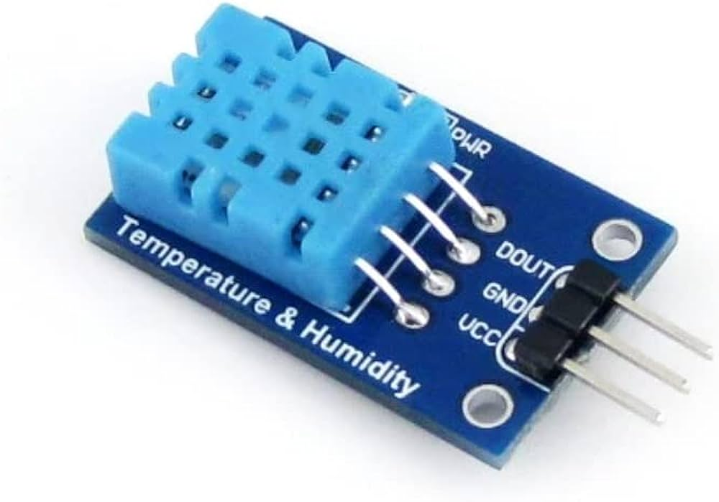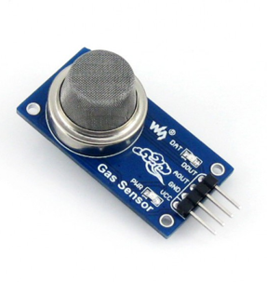
FIGURE 1.3: TEMPERATURE,HUMIDITY AND GAS SENSORS

VI. RESULTS
This segment presents the outcomes achieved through the proposed system implementation. The assortment of sensors employed effectively detects and monitors the environmental conditions in which underground miners operate. The real-time data acquired from these sensors is not only visually represented using LEDs but also transmitted to the web through IoT integration, utilizing Thing Speak. When any of the environmental parameters surpass their predetermined thresholds, an immediate alert is conveyed to the miner, co-workers, the supervisor, and the control station through the activation of a buzzer. In the unfortunate occurrence of a hazardous event within the mine, the control station is empowered to promptly mobilize a rescue team. The pivotal connection between the Arduino and the computer underpins the entire system. Leveraging open-source solutions, the integration of components like the MQ-2 Gas Sensor, ESP32, DHT11, and more, with the Arduino platform, is seamless and user-friendly, thus contributing to the system's efficiency and effectiveness.

VII. CONCLUSION AND FUTURE SCOPE
To culminate, the smart helmet developed for miners stands as a testament to cutting-edge technological integration, harnessing a diverse array of sensors and communication modules to enhance safety within hazardous work environments. This advanced helmet boasts a MQ2 gas sensor to swiftly detect noxious gases, a DHT11 temperature and humidity sensor for continuous environmental monitoring, an emergency switch for instant assistance requests, a 16x2 LCD display for information presentation, a buzzer for imminent danger alerts, a GSM modem for prompt SMS emergency notifications, GPS location tracking for accurate worker positioning, an ESP8266 wifi module facilitating seamless IoT communication, and a Blynk app for clear data visualization. The MQ2 gas sensor diligently identifies harmful gases, while the DHT11 sensor proficiently tracks temperature and humidity levels. The emergency switch empowers workers to promptly summon aid as required. Data collected by various sensors is efficiently exhibited on the 16x2 LCD, while the buzzer acts as an audible alert mechanism for potential hazards. The GSM modem ensures rapid transmission of SMS notifications to designated contacts, and GPS location tracking guarantees swift worker location in emergencies. The ESP8266 wifi module facilitates robust IoT communication, synergizing effectively with the Blynk app's data visualization features. In the horizon, potential expansions could involve the integration of additional sensors into the Arduino board of the smart helmet. For example, the inclusion of a heart rate or alcohol sensor could offer comprehensive worker monitoring. Furthermore, augmenting the helmet with temperature, humidity, methane gas, and carbon monoxide sensors would enable real-time oversight of mine environments. Upon detecting elevated levels of harmful gases, the helmet could proactively alert workers, enabling them to take immediate safety measures.

REFERENCES

- Liu Xiaoli, Guo Liwen, and Zhang Zhiye, "Statistics Analysis of Death Accidents in Coal Mines from January 2005 to 2009," IEEE, 2010.
- Zhou, Xin-quan, and Chen Guo-xin, "The Probability Analysis of Occurrence Causes of Extraordinarily Serious Gas Explosion Accidents and Its Revelation," Journal of China Coal Society, 2008, 33 (1): 42-46.
- Gao Junyao, Gao Xueshan, Zhu Wei, Zhu Jianguo, Wei Boyu, "Coal Mine Detect and Rescue Robot Design and Research," IEEE, 2008.
- Jong C. Wang, Yan Ting Lin, Huei Teng Jheng, Jyun Sian Wu, and Ruei Jhe Li, "Object Tracking for Autonomous Biped Robot," IEEE, 2010.
- Gao Junyao, Gao Xueshan, Zhu Jianguo, Zhu Wei, Wei Boyu, Wang Shilin, "Coal Mine Detect and Rescue Robot Technique Research," IEEE Proceedings, International Conference on Information and Automation, June 2009.
- M. Thamrin N., Rosman R., and Sarmawi D. S., "Design and Analysis of Wireless Controller Panel using RF Module’s for Robotic Wheelchair," IEEE, 2011.
- Heng Huang, Fillia Makedona, Dan Popa, and Harry Stephanou, "A Feature Extraction Method for Multimedia Data Analysis in Robot Wireless Sensor Networks," IEEE, 2007.
- Shan Cai, Zhao-long, Xu Jie Yang, and Xiao-zhi Liu, "Detecting Robot System for Mine Disasters," ICEEE, 2010.
- Ward C., Iagnemma C. K., "A Dynamic Mobile Based Wheel Slip Detector for Mobile Robots on Outdoor Terrain," IEEE Transactions on Robotics, Volume 24, Issue 4, Pages: 821-831, Aug 2008.
- Derek Engelhaupt Experiment with the Intelligent Robotics Institute of Beijing, "R/C Combat Vehicles Track Systems," 2009.
- Gandikota, Jones, and Fleischer, "Determining the Range of Heat Transfer Coefficients from the Carbon Fibers using FC-72," Experiment with the Pennsylvania Infrastructure Technology Alliance.
- Ishay Knmon, Elon Rimon, Ehud Rivilin, "Tangent Bug: A Range-Sensor-Based Navigation Algorithm," The International Journal of Robotics Research, Vol. 17, No. 9, Pages: 934-953, September 1998.
- Vladimir J. Lumelsky, Alexander A., "Path Planning Strategies for a Point Mobile Automation Moving Amidst Unknown Obstacles of Arbitrary Shape," Algorithmica, 2(1): 403-430, March 1987.
- K. A. Unnikrishna Menon, Deepa Maria, Hemalatha Thirugnanam, "Power Optimization Strategies for Wireless Sensor Networks in Coal Mines," IEEE, 2012.

