A brief overview on the recent progress in drop impact studies
Devranjan Samanta¹
Department of Mechanical Engineering, Indian Institute of Technology, Ropar, Punjab, 140001, India
- Introduction:
Drop impact studies in recent years have garnered interest among fluid dynamics researchers due to rapid progress in high-speed imaging and computational resources [1]. Drop impact on solid surfaces at ambient temperature has multiple applications in inkjet printing, forensics, spray coating or painting, crop spraying etc. In addition, at higher temperatures above boiling point, drop impact have implications on spray quenching, annealing of aluminum alloys, IC engines etc [2]. In addition, the dynamics of drop impacts at Leidenfrost state is another area of interest [3].
The present article will initially introduce the basic terminologies used in the drop impact research studies in section II. Subsequently, in section III, I will discuss the recent progresses in the area of drop impact research on solid surfaces at (i) ambient conditions and (ii) Leidenfrost state. The modulation in drop impact behaviour due to various additives like flexible chained polymers, surfactants, nanobubbles etc and application of external electric or magnetic fields are discussed in the results section.
- Basic terminologies:
In the context of drop impact studies on solid surfaces, the role of surfaces is very important. Surfaces can be categorized based on wetting [4]. Depending upon the equilibrium contact angle of the liquid surface with the solids, there are three types of solid surfaces i.e. (i) Hydrophilic (ii) Hydrophobic and (iii) Superhydrophobic (SH) surface (refer fig. 1). On hydrophobic surfaces, drops will spread easily upon impact at moderate impact velocities. Hydrophobic surfaces are known to bounce off the liquid droplets. In nature, lotus leaves are known to repel water droplets and its repelling capacity is known as “Lotus effect” [5]. The commercially available non-sticky utensils of Teflon coating are also having the hydrophobic surfaces. In recent years, surface engineering at the micron level has enabled researchers to increase the contact angle greater than 150º. Superhydrophobic surfaces have lower contact angle hysteresis than hydrodynamic surfaces [6]. The contact angle hysteresis is the difference between advancing contact angle and receding contact angle. In addition, SH surfaces have also lower sliding angle than hydrophobic surfaces. The minimum angle of an inclined surface at which drops starts to move along the surface is known as sliding angle. Generally the hydrophobic surfaces having higher adhesion with the water drops have higher sliding angle. The superhydrophobic (SH) surfaces have various applications such as anti-fogging, self-cleaning, anti-icing, oil-water separation etc. [7].
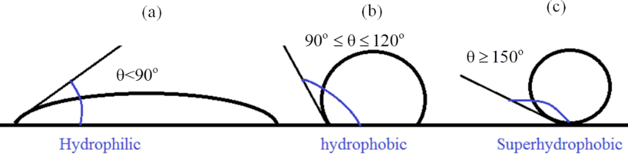
Fig. 1: Types of surfaces based on wetting (a) hydrophilic (b) hydrophobic and (c) Superhydrophobic surfaces.
Occasionally the drops upon impact on SH surfaces gets stuck on the SH surfaces, commonly known as impalement or Cassie to Wenzel transition (CWT) [8]. The individual state of Cassie-Baxter and Wenzel states are illustrated in fig. 2. In general, the CWT process is an irreversible process and decreases the effectiveness of the SH surfaces.

Fig. 2: Drops sitting on micro-textured superhydrophobic surfaces (a) Cassie-Baxter State and (b) Wenzel state
- Leidenfrost state : At sufficiently high temperatures above boiling point of a fluid, the drops of that fluid will levitate upon the heated substrate when they are released gently upon the substrate (fig. 3). As soon as the drop touches the substrate, due to rapid formation of vapor, a stable layer is formed between the substrate and the drop. This stable vapor layer provides the cushioning effect to the levitating drop. This effect first reported by J.G. Leidenfrost [3] was named in his honor. Leidenfrost effect is undesirable as the air layer formed in between the drop and the surface acts as an insulator and hampers the heat transfer process [8]. Subsequently the cooling performance of the impinging droplets during spray cooling or annealing will deteriorate.
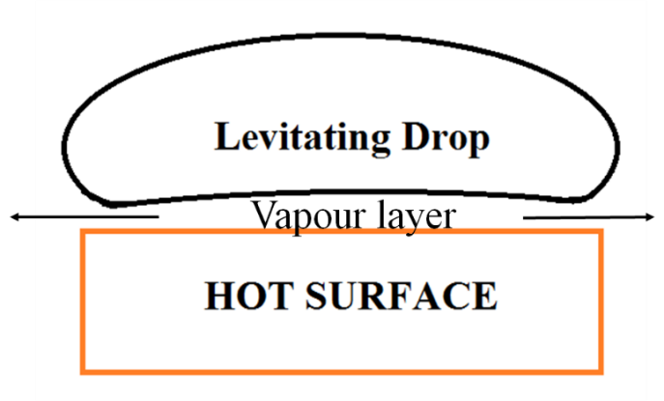
Fig. 3 Schematic of a drop levitating upon a heated surface: Leidenfrost effect
In the context of drop impact dynamics, the relevant non-dimensional numbers are formulated as follows:
Table I: List of non-dimensional numbers
Name of the non-dimensional number | Formula | Significance
Weber number (We) | $$We=\frac{ρDV^{2}}{σ}$$ | Ratio of inertial force to interfacial force
Bond number (Bo) | $$Bo=\frac{ρgD^{2}}{σ}$$ | Ratio of gravitational force to interfacial force
Reynolds number (Re) | $$Re=\frac{ρVD}{μ}$$ | Ratio of inertial force to viscous force
Capillary number (Ca) | $$Ca=\frac{Vμ}{σ}$$ | Ratio of viscous force to interfacial force
Ohnesorge number (Oh) | $$Oh=\frac{μ}{√ρσD}=\frac{√We}{Re}$$ | Ratio of viscous force to combined effect of inertial and interfacial force
Magnetic Bond Number (${Bo}_{m})$ | $${Bo}_{m}=\frac{B^{2}D}{μ_{o}σ}$$ | Ratio of magnetic force to interfacial force
Electro-capillary Number(${Ca}_{e}$) | $${Ca}_{e}=\frac{ε_{o}ε_{r}E^{2}D}{σ}$$ | Ratio of electrostatic force to interfacial force.
Weissenberg Number (Wi) | $$Wi=λ\dot{γ}$$ | Ratio of polymer relaxation time to shear stress

The significance of the symbols are as follows: (i)ρ: Fluid density (ii) D: Initial Droplet diameter (iii)V: Velocity at the moment of impact (iv) σ: surface tension (v)g: acceleration due to gravity (vi) μ: Fluid viscosity (vii) B: magnetic flux density (viii) $μ_{o}$:magnetic permeability of space (ix) $ε_{o}$: permittivity of the free space (x)$ε_{r}$:dielectric constant of the dielectric fluid (xi) E: electric field strength (xii) λ: relaxation time and (xiii) $\dot{γ}$: rate of shear.
Weber number (We) is useful in determining the outcome of drop impacts. At low We, drops spread on hydrophilic surfaces. On the contrary at low We on hydrophobic and SH surfaces, drops spread initially and then retract and rebound off the surfaces. At too high We, drops breakup into secondary droplets. Occasionally, at high impact We, there may be impalement or CWT on SH surfaces. The role of magnetic Bond number ${Bo}_{m}$ and electro-capillary number ${Ca}_{e}$will be discussed in the context of drop impact dynamics in presence of magnetic and electric field responsibility. Weissenberg number (Wi) is important in the context of non-Newtonian fluids. It reflects the ratio of the time scale of the polymer chain dynamics (λ) to the time scale of the flow i.e. ($\dot{γ}$)⁻¹. Higher Wi values denote the dominance of non-Newtonian effects.
- Recent progress in various aspects of drop impact research
In this section I have summarized the recent progress in few sub domains of droplet research. The summary is definitely not complete. However, I believe this will be useful in triggering interest on drop impact dynamics among fluid dynamics researchers.
a. Drop Impact research with polymer additives
Water drops generally rebound off hydrophobic surfaces. In nature, most of the crop leaves are of hydrophobic nature. As a result, a lot of insecticide spray drops rebounded off the surface. Non-Newtonian drops were observed to suppress rebound on hydrophobic surfaces [9]. Bergeron et al [9] for the first time showed that non-Newtonian drops suppress rebound on hydrophobic substrates. Different factors like extensional viscosity [9], normal stress due to stretching of polymer chains [10,11] were found to be responsible for slowing down the drop retraction dynamics on hydrophobic substrates. A few studies have suggested the role of adsorption of the polymer molecules [12] on the surfaces are also responsible for Dhar et al reported the role of critical impact velocity for a fixed polymer concentration and role of a critical polymer concentration for a given impact velocity to trigger the onset of rebound suppression on superhydrophobic surfaces prepared using commercial sprays. Based on the shear rate at the start of retraction, they showed that the onset of rebound suppression happens at Weissenberg number exceeding one. Fig. 4 illustrates that for the same polymer concentration of 1500 ppm of PAAM, different impact velocities result in different impact outcomes. At lower impact velocity of 0.75 m/sec (fig. 4(i)), 1500 ppm drop rebounds off the surface. However, at a higher impact velocity of 2.25 m/sec, drops of the same polymer concentration exhibited rebound suppression. Polymer drops also delays the onset of Rayleigh Taylor instability and thereby delays the breakup of capillary filaments (fig. 4 ii-d&e). At high impact velocities where the water drops fragmented into many smaller drops, polymer drops exhibited beads on a string (BOAS) like structures at the droplet rim during spreading. These filaments stayed intact during the retraction process and prevented the breakup of the drops.
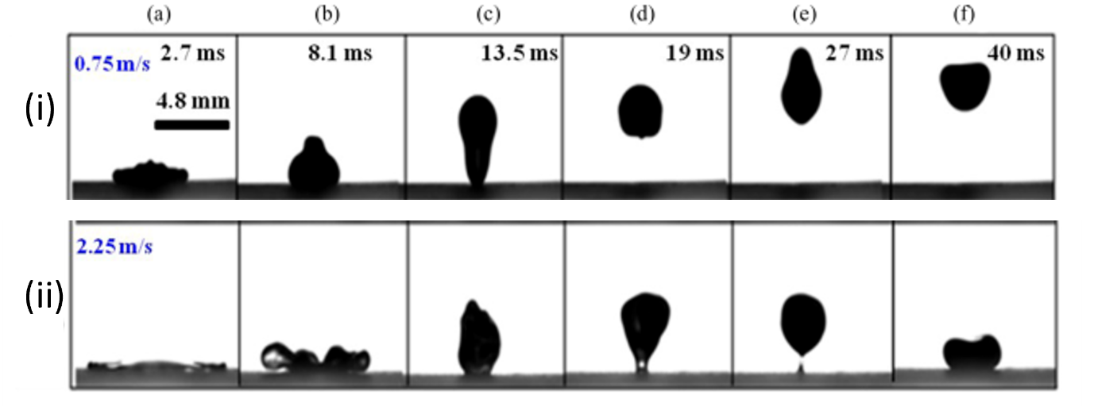
Fig. 4. Influence of impact velocity: (i) 0.75 m/s and (ii) 2.25 m/s on droplet dynamics of 1500 ppm PAAM solution. Left to right shows the temporal evolution [13].
b. Drop impact dynamics on soft deformable surfaces
Drop impact dynamics on soft deformable substrates is different from that on solid surfaces due to combine effect of bulk elasticity and surface effects [14,15]. The combined effect of bulk elasticity and capillarity together coined as elastocapillarity has been documented in a recent review by Bico et al. Surfaces made of PDMS (polydimethylsiloxane) gels, soft biological surfaces like skin, foodstuff, gels and emulsions are the type of soft compliant surfaces where elastocapillarity comes into play [16]. New phenomena like slowing down of contact line on soft substrates termed as “viscoelastic braking” and “dynamical depinning” were observed.
Often splashing is undesirable in many drop-based printing due to hygiene or safety conditions. Soft substrates are useful in eliminating drop splashing. Howland et al [16] showed that the kinetic energy threshold for splash formation on soft substrates is significantly higher compared to rigid substrates. With decrease in stiffness, the critical kinetic energy as well as Weber number required to trigger the splashing increases. Fig. 5 illustrates that with the reduction in substrate thickness, droplet splashing is inhibited. In addition, the role of substrate thickness was also discussed. For the same material, substrates of low thickness in the order of microns will act similar to the solid substrates, whereas the substrate of higher thickness in the order of mm will display different splashing behaviour. With decrease in stiffness, the substrate deformations at initial stages of impact contribute to the reduction in the speed of the ejecta sheet.
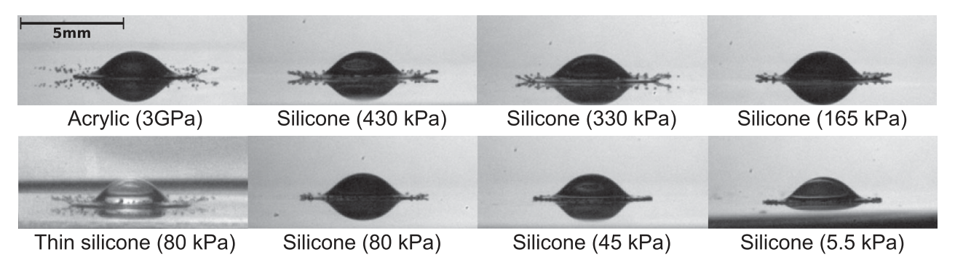
Fig.5: Splashing dynamics of ethanol droplet (0.88 mm dia) on substrates of different stiffness at same impact velocity of 2.61+/0.02m/sec. Except the left hand bottom image (3 micorn thick) , all substrates are of 10 mm thickness [16].
Snoeijer and his coworkers showed that macroscopic contact angle is lesser on soft substrates and the equilibrium drop shapes are dictated by drop size, molecular length scale and elastocapillary length (surface tension by elasticity) [17-20]. Snoeijer et al [19] developed an elastocapillary model for contact angles on soft solids. They showed that as the limiting case when elastic modulus E tends to infinity for a rigid solid, the elastocapillary model approaches the classical Young’s law for a rigid substrate. On the other hand, for E tending towards zero for the liquid surfaces, the elastocapillary model approaches Neumann’s law. Amirfazli and his coworkers [21] measured the micron order deformation of soft PDMS substrates during drop impact and compared the experimentally measured impact force with existing analytical models.
c. Drop impact on vibrating surfaces
Drop motion on inclined planes or in micro channels may be hampered due to contact angle hysteresis. Vibration induced oscillation modes is one effective technique to trigger the drop movement. This method doesn’t require any external forcing or any special surface treatment. When a drop is subjected to vibration at small frequencies, it behaves like a spring and undergoes significant drop deformation. The local contact angle may be higher or lower than the advancing or receding contact angles. Brunet et al prepared a phase diagram of the movement of the drops in the parameter space of angular frequency and amplitude of the vertical vibration [22]. They identified the operating regimes of these two parameters where the drop climbs up along the inclined plane instead of sliding down. Subsequently they showed that beyond a critical Capillary number Ca, the drops start to climb upward. Greater acceleration in the vertical direction overpowers the gravitational effects acting in downward direction resulting in a net upward movement of the drop. They also reported that contrary to the usual observation of advancing contact angle (θ_{a}) being greater than the receding contact angle (θ_{r}) along an inclined plane, at certain phases of an oscillation cycle the contact angle in the upper portion is greater than the contact angle in the lower portion (fig. 6). Subsequently Celestini et al [23] showed that simultaneous vibration of the solid substrate in both horizontal and vertical direction at same frequency but varying phase difference and amplitude exhibit a controlled directed motion. Bradshaw et al developed numerical simulation and showed that for sufficiently small amplitudes, movements of drops can be decomposed into odd and even modes [24]. The nonlinear interaction of these modes is the decisive factor of upward or downward movement of the droplets along the substrate.
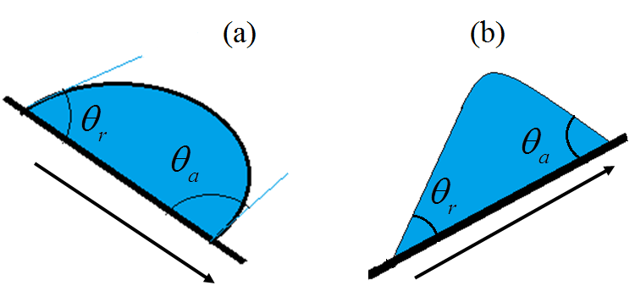
Fig. 6 (a) The usual scenario of a drop sliding down an inclined plane where θ_{a}> θ_{r} (b) Drop climbing up along the inclined plane due to vertical vibration where contact angle in the upper portion is greater than the contact angle in the lower portion of the drop [22].
d. Drop impact on granular beds
Drop impact on granular beds is studied by researchers to understand the raindrop impact on beaches [25] and crater morphologies due to asteroid impact [26,27]. It is also relevant in various applications such as drip irrigation, dispersal of microorganisms in soil and spray coating. This phenomenon is influenced by a large number of parameters such as droplet size, viscosity, surface tension, impact velocity as well as the grain size, shape and volume fraction. An exhaustive coverage of solid drop impacts on granular beds was recently provided in a review article by Van der Meer [28]. In this subsection, I will restrict to a brief coverage of drop impacts on granular beds.
Delon et al showed that the ratio of maximum spreading diameter (D_{max}) to the initial drop diameter (D) follows the scaling of We^{1/4}. This scaling was similar to the maximum diameter of water drops on solids. The spreading dynamics is governed by the time scale $τ_{γ }=\sqrt{\frac{ρΩ}{γ}}$ where ρ,Ω and $γ$ denotes density, drop volume and surface tension respectively. During the retraction phase, also termed as recession, granular particles are trapped by the droplet. This process is called impregnation. During the recession phase, water is pushed into granular bed. The time scale which dictates this phase is similar to the Darcy’s law of porous media i.e. $τ_{d}=\frac{Ωη}{KρgD_{max}^{2}}$. $K$ is the permeability of the granular bed.
Cheng and his coworkers [26] showed that the impact craters formed by liquid droplets form the same energy scaling as the craters formed due to asteroid impact. The scaling relevant to the asteroid impacts is known as the Schmidt- Holsapple scaling law. This is a remarkable observation as the energy involved during asteroid impacts (E~10¹⁵) Joules are 18 orders orders of magnitude higher than the energy involved in small water drop impacts (E~10⁻³). The length scales of the asteroid craters are also seven orders of magnitude higher than that of liquid drop impact craters. The same scaling also encapsulates the dynamics of solid spheres impact on granular beds. By using laser profilometry technique, they also showed that liquid drop impact craters have similar shapes as craters formed due to asteroid impacts.
e. Drop impact in presence of electric and magnetic field
Drop impact dynamics can be influenced due to external forcing like application of electric [29-30] and magnetic field [31-33]. Droplet suppression on SH surfaces can be achieved in presence of electric field [34]. Drop impact behaviour in presence of electric field may have potential applications in electrohydrodynamic (EHD) inkjet printing [35] or spray atomization [36]. Drop impact studies in presence of magnetic field may have potential applications in magnetic 3-D printing of metal objects [37, 38].
Previous study by Sahoo et al [29] showed that with the increase in Ca_{e}, droplet retraction dynamics is slowed down due to non-uniform spreading. It has also been observed that with the increase in Ca_{e} (increase in electric field strength if all other relevant physical parameters stay constant), the drops elongate along the electric field direction with the emergence of rim instability along the drop circumference. Due to this extension along the field direction, the droplet suffered non-uniform retraction. As a result, during the retraction, the capillary forces can’t impart it sufficient kinetic energy to avoid rebound suppression on SH surfaces. With the increase in electro-capillary number Ca_{e}, drops having same size and initial impact velocity exhibited rebound suppression. Subsequently, Varaprasad et al [30] showed that the rebound dynamics is arrested at even lower electro-capillary number in presence of polymer additives.
Contrary to the drop impact behaviour in electric field studies, drops spread orthogonally to the direction of magnetic field applied horizontally [31]. The emergence of Lorentz force in orthogonal direction is responsible for predominant spreading in orthogonal direction. In this study it was shown that with increase in ${Bo}_{m}$rebound suppression was observed. The asymmetric spreading instead of uniform spreading leads to slower retraction dynamics like the electric field scenario and eventually prevents the droplet rebound off the SH surface. In this case also, addition of polymers triggers the rebound suppression at lower magnetic Bond numbers ${Bo}_{m}$.
f. Recent developments in Leidenfrost effect
As the onset of Leidenfrost effect marks the deterioration in the heat transfer rate, researchers have adopted various ways to enhance the Leidenfrost point (LFP). LFP can be enhanced by using minute amounts of additives like flexible chained polymers like PAAM or PEO [39,40], surfactants [41,42], nanoparticles [43,44] and nano-bubbles [45]. These types of studies focused on finding out an optimum concentration of the additives. As a framework to future researchers, the scaling relationships of LFP with We and Oh were formulated. In cases of polymer drops, secondary atomization at temperatures much higher than boiling point at ambient pressure was observed to be lesser than water droplets [39]. In addition, due to fluid elasticity, the filament like structures pinned to the substrate helps in pulling down the bulk of the droplet downwards [40].
Without compromising the working fluid, another effective way to enhance the LFP is micro-texturing of the heating surface. The goal of micro-texturing is to hamper the stable liquid vapor interface or evacuating the vapor phase to reduce the envelope of film boiling phase. The common methods of surface texturing is the fabrication of micropillars [46,47] and porous structures [48,49]. The array of micropillars (fig. 8) fabricated using lithography technique or femtosecond laser processing prevents the formation of continuous stretch of stable vapor layers. The drop liquid encounters the solid surface of the micropillars intermittently and delays the onset of LFP. Often the micropillars are surface treated chemically to induce superhydrophobicity or superhydrophilicity. Optimum spacing of micropillars is vital as too dense micropillar arrays can impede the draining out of the vapor layer and aid in the occurrence of Leidenfrost phenomenon. Recently Z. Wang and his coworkers devised a special surface which can prevent LFP as high as 1100º C.
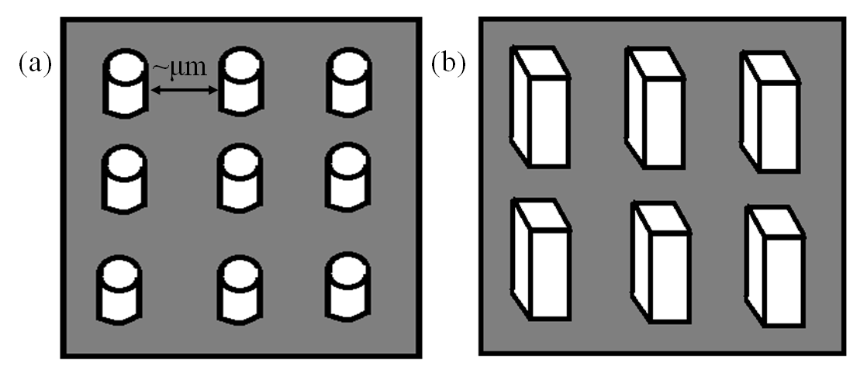
Fig. 8: Schematic of the array of micro-pillars in the form of (a) cylinders or (b) square pillars on a surface. Spacing between each pillar is in the order of microns
Another area of research in Leidenfrost phenomenon is the investigations of the drop mobility in the levitated states. Linke et al [51] observed self propelled motion of drops in Leidenfrost state on ratcheted surfaces. Subsequently Quere et al [52], further performed PIV and interferometry measurements to study the vapor beneath the droplets and velocity field within the droplet. On the other hand, surfaces can be modified in a way to stop the levitating drops from wandering away in undesirable direction [53]. Quere and his co-workers reported interesting phenomena about the mobility of the drops in Leidenfrost state [54]. When they just released a drop in the order of Bond number Bo<1, the drops propelled in all directions whereas slightly larger droplets with Bo>1 moved in a particular direction. Subsequently, using PIV measurement technique they showed the existence of one vortex within a small drop and two counter-rotating vortices in a larger drop at their respective central vertical planes. Poulikakos and his co-workers [55] reported that a drop just released gently on a substrate at temperatures well above LFP undergoes self-sustained spontaneous oscillations. The drop initially at rest undergoes repeated bouncing with heights increasing over the time. They showed that the vapor layer continuously drains out sideways and creates ripples on the droplet bottom surface. The resultant pressure oscillations contribute to the self-sustained trampolining like behaviour.
g. Drop impact research in the context of communicable disease e.g. Covid-19 transmission
Drop impact studies were utilized in the context of air-borne transmission of the global pandemic of Covid-19 disease in recent times [56]. Droplet splashing on different surfaces such as porous surfaces, soft compliant surfaces, superhydrophobic surfaces or porous structures and its subsequent fragmentation into secondary droplets were studied by many researchers. In a recent study [57], drop impact studies were performed on front and back of masks with and without superhydrophobic coatings. They observed that upon impact on a mask with superhydrophobic coating, many small secondary droplets may linger in the air , thereby increasing the chances of disease transmission. The fragmentation and aerosolization of drops impacting on solid surfaces through flush in toilets or splashes during hand washing can be a source of disease transmission [56]. They observed that larger droplets may quickly settle on the surface whereas small droplets fragment and get advected in the air.
Drop impact dynamics is also important in the context of crop disease transmission through rain drop impacts on contaminated leaves [58]. The droplet fragmentation on leaves of different morphology were classified into two categories: (a) crescent moon fragmentation, where one drop directly impacts vertically on another already sessile droplet and resulting in splash (b) inertial detachment fragmentation, where a drop impacts on another part of the leaf and fluid fragmentation is due to the momentum imparted to the leaf upon raindrop impact.
Conclusion: The current article is a brief overview on few aspects of drop impact research at ambient and Leidenfrost conditions. I have mentioned few exhaustive review papers which are solely focused on a single sub domain. I believe this article and the references within will spark interest in fluid dynamics researchers to delve deep into these areas of research.
Acknowledgement: The author would like to express his sincere thanks to IIT Ropar internal seed grant which helped him to explore the research area of drop impact dynamics and Leidenfrost phenomenon.
References:
- C. Josserand and S.T. Thoroddsen, “Drop impact on Solid surface”, Annual Review of Fluid Mechanics, 2016, 365-391
- A.L. Yarin, “Drop impact dynamics: Spreading, splashing, Receding, Bouncing….” Annual Review of Fluid Mechanics, 2006, 159-192
- D. Quere, “Leidenfrost Dynamics”, Annual Review of Fluid Mechanics, 2013, 197-215
- PG Dennes, FB Wyart and D. Quere,“Capillarity and wetting phenomena: Drops, Bubbles, pearls and waves” , Springer
- W. Barthlott and C. Neinhuis, “Purity of the sacred lotus, or escape from contamination in biological surfaces”, Planta, 1997, 202,1-8
- M. Nosonovsky and B. Bhushan, “Biomimetic superhydrophobic surfaces: Multiscale approach” Nano Letters, 2007, Vol. 7, No. 9
- S. Parvate, P. Dixit and S.Chattopadhyay, “Superhydrophobic surfaces: Insights from theory and experiment” , J. Phys. Chem. B 2020, 124, 1323-1360
- G. Liang and I. Mudawar, “Review of drop impact on heated walls”, International Journal of Heat and Mass transfer, 2017, vol. 106, 103-126
- V. Bergeron, D. Bonn, J. Y. Martin, and L. Vovelle, Controlling droplet deposition with polymer additives, Nature (London) 405, 772 (2000)
- D. Bartolo, A. Boudaoud, G. Narcy, and D. Bonn, Dynamics of Non-Newtonian Droplets, Phys. Rev. Lett. 99, 174502 (2007)
- M. I. Smith and V. Bertola, Effect of Polymer Additives on the Wetting of Impacting Droplets, Phys. Rev. Lett. 104, 154502, (2010)
- E. Lee, H. K. Chilukoti, and F. Müller-Plathe, “Suppressing the rebound of impacting droplets from solvophobic surfaces by polymer additives: polymer adsorption and molecular mechanisms,” Soft Matter, vol. 17, no. 29, pp. 6952–6963, 2021
- P. Dhar, S. R. Mishra, and D. Samanta, “Onset of rebound suppression in non-Newtonian droplets post-impact on superhydrophobic surfaces,” Phys Rev Fluids, vol. 4, no. 10, p. 103303, 2019, doi: 10.1103/PhysRevFluids.4.103303
- B. Andreotti and J. Snoeijer, Statics and dynamics of soft wetting, Annual review of fluid mechanics, 2020,52:285-308
- Bico J, Reyssat É, Roman B. 2018. Elastocapillarity: when surface tension deforms elastic solids. Annu. Rev. Fluid Mech. 50:629–59
- C. J. Howland, A. Antkowiak, J. Castrejón-Pita, S. Howison, J. Oliver, R. Style, A. A. Castrejón-Pita, It’s Harder to Splash on Soft Solids, PRL 117, 184502 (2016)
- JH Snoeijer et al, Drops on soft solids: free energy and double transition of contact angles. J. Fluid Mech., 2014
- JH Snoeijer et al, Capillary pressure and contact line force on a soft solid, Physical Review Letters, 2012a
- JH Snoeijer et al, Capillary angle on a soft solid: from Young’s law to Neumann’s law, Physical Review Letters 2012b
- JH Snoeijer et al, Paradox of contact angle selection on stretched soft solids. Phys. Rev. Lett., 2018,121
- A. Amirfazli et al, Understanding the drop impact phenomenon on soft PDMS substrates, Soft Matter, 2012, 8, 1045
- P. Brunet, J. Eggers and R. Deegan, Vibration-Induced climbing of drops, Phys. Rev. Lett., 2007, 99, 144501
- X. Noblin, R. Kofman and F. Celestini, Ratchet like motion of a shaken drop, Phys. Rev. Lett. , 2009, 102, 194504
- J.T. Bradshaw and J. Billingham, Thick drops climbing uphill on an oscillating substrate, J. Fluid Mech., 2018, 840, 131-153.
- G. Delon et al, “Impact of liquid droplets on granular media”, Phys. Rev. E, 2011, 84, 046320
- X. Cheng et al, “Granular impact cratering by liquid drops: Understanding raindrop imprints through an analogy to asteroid strikes”, PNAS, 2015, vol. 112, no. 2, 342-347
- H Kasturagi, “Physics of soft impact and cratering”, Springer
- Devaraj van der Meer, “Impact on Granular Beds”, Annual Review of Fluid Mechanics, 2017
- N Sahoo Mishra, D. Samanta and P Dhar “Electrohydrodynamics of dielectric droplet collision on different wettability surfaces”, Physics of Fluids,Vol. 33, Issue 11, 2021
- GVVS Vara Prasad, P Dhar and D Samanta “Triggering of electro-elastic anti-superhydrophobicity during non-Newtonian droplet collision”,Proceedings of Royal Society A, 2023
- N Sahoo, P. Dhar and D. Samanta “Vertical magnetic field aided droplet-impact- magnetohydrodynamics of ferrofluid”, Colloids and Surfaces A,2021
- N. Sahoo, G. Khurana, D. Samanta, and P. Dhar “Collisional ferrohydrodynamics of magnetic fluid droplets on superhydrophobic surfaces ", Physics of Fluids Volume 33, Issue 1, 2021
- GVVS Vara Prasad, P Dhar and D. Samanta “Magneto-elastic effect in nonNewtonian ferrofluid droplets impacting on superhydrophobic surfaces”, Langmuir,2021
- S. Yun, J. Hong, and K. H. Kang, “Suppressing drop rebound by electrically
driven shape distortion,” Phys. Rev. E 87, 033010 (2013)
- J. Xie, J. Jiang, P. Davoodi, M. P. Srinivasan, and C. Wang, “Electrohydrodynamic atomization: A two-decade effort to produce and process micro-nanoparticulate materials,” Chem. Eng. Sci. 125, 32–57 (2014).
- J. Park et al., “High-resolution electrohydrodynamic jet printing,” Nat. Mater. 6, 782–789 (2007)
- C. W. Visser, R. Pohl, C. Sun, G.-W. Römer, B. Huis in ‘t Veld, and D. Lohse,“Toward 3D printing of pure metals by laser-induced forward transfer,” Adv. Mater. 27, 4087–4092 (2015)
- A. Ahmed, B. A. Fleck, and P. R. Waghmare, “Maximum spreading of a ferrofluid droplet under the effect of magnetic field,” Phys. Fluids 30, 077102-1–077102-11 (2018).
- P. Dhar, S. Mishra, A Gairola, and D. Samanta,” Delayed Leidenfrost phenomenon during impact of elastic fluid droplets”, Proceedings of Royal Society A ,2020
- V. Bertola“An experimental study of bouncing Leidenfrost drops: comparison between Newtonian and viscoelastic liquids.”, 2009, Int. J. Heat Mass Transf. 52, 1786–1793; Corrigendum, Int. J. Heat Mass Transf. , 2013, 58,652-653,2013
- GVVS Vara Prasad, P Dhar and D. Samanta “Postponement of dynamic Leidenfrost phenomenon during droplet impact of surfactant solutions”, International Journal of Heat and Mass transfer,2022
- P. Zhang, B. Peng, X. Yang, J. Wang, L. Jiang, “Regulating droplet dynamic wetting behaviours using surfactant additives on high-temperature surfaces”, Adv. Mater. Interfaces, 2020, 7(14) 1-8
- GVVS Vara Prasad, P Dhar and D. Samanta “Morphed inception of dynamic Leidenfrost regime in colloidal dispersion droplets”, Physics of Fluids,2022
- G. Paul, P. K. Das, and I. Manna, “Nanoparticle deposition from nanofluid droplets during Leidenfrost phenomenon and consequent rise in transition temperature,” Int. J. Heat Mass Transfer 148, 119110 (2020).
- GVVS Vara Prasad,H Sharma, N Nirmalkar, P Dhar and D Samanta “Augmenting the Leidenfrost temperature of droplets via nanobubble dispersion”, Langmuir, 2022
- Kruse, C. et al. “Extraordinary shifts of the Leidenfrost temperature from multiscale micro/nanostructured surfaces” Langmuir 29, 9798–9806 (2013)
- H. Kim et al, “On the effect of surface roughness height, wettability, and nanoporosity on Leidenfrost phenomena.”, Applied Physics Letters, 2011, 98(8): 08312
- N. Farokhnia et al, H. Decoupled hierarchical structures for suppression of Leidenfrost phenomenon. Langmuir 33, 2541–2550 (2017)
- Weickgenannt, C. M. et al. Inverse-Leidenfrost phenomenon on nanofiber mats on hotsurfaces. Phys. Rev. E 84, 036310 (2011).
- Z. Wang et al, “Inhibiting the Leidenfrost above 100º C for sustained thermal cooling”, Nature, 2022, January
- H. Linke et al.,” Self-propelled Leidenfrost droplets”. Phys. Rev. Lett., 2006, 96, 154502
- G. Lagubeau, M. Merrer, C. Clanet & D. Quere, “Leidenfrost on a ratchet”, Nature Physics, 2011, 7, 395-98
- D. Quere et al, “Trapping Leidenfrost drop with crenelations”, Phys. Rev. Lett., 2011, 107,114503
- A. Bouillant et al, “Leidenfrost Wheels”, Nature Physics, 2018, vol 14,1188-1192
- D. Poulikakos et al, Spontaneous droplet trampolining on rigid superhydrophobic surfaces, Nature, 527,2015
- L. Bourouiba, “The fluid dynamics of disease transmission”, Annual Review of Fluid Mechanics, 2021, 53:473–508
- K R Melayil and S K Mitra, “Wetting, Adhesion, and Droplet Impact on Face Masks”, Langmuir, 37, 2810-2815
- T. Gilet and L. Bourouiba,” Fluid fragmentation shapes rain-induced foliar disease transmission”J. R. Soc.Interface 2015.12:20141092

