Design and Analysis of M-cut Patch Antenna for advanced Energy Harvesting Applications: Radiation Characteristics and Optimization
Shalini M G¹ | Dr.Naveen K B²
Research Scholar | Professor  Department of Electronics and Communication Engineering  BGS Institute of technology
BGS Institute of technology | AdiChunchanagiri University
AdiChunchanagiri University | BG Nagara-571448
BG Nagara-571448

ABSTRACT:
The design and optimization of an energy harvesting antenna that can effectively capture electromagnetic energy over a broad frequency range, specifically from 2.4 GHz to several GHz, are discussed in this study. The antenna design and analysis were carried out only using the High-Frequency Structure Simulator (HFSS) tool, a highly sophisticated electromagnetic modeling programme extensively used in the field of antenna engineering.This research's main objective was to develop an antenna that could efficiently gather energy from background electromagnetic waves, especially in the frequency ranges that are often used by various wireless communication devices. Utilizing the sophisticated capabilities of the HFSS tool, which enables precise modeling of complex antenna designs and accurate projections of radiation patterns and antenna performance, the antenna design was rigorously adjusted to increase energy harvesting efficiency.The research methodology includes a number of crucial procedures. First, a comprehensive analysis of the research on energy harvesting antennas and their performance traits was conducted. After that, the modeling and simulating of various antenna designs, combinations, and parameters using HFSS started the design process. Based on simulation results, the antenna design was improved repeatedly in order to get the best performance possible within the target frequency range.The energy harvesting antenna, which was totally constructed with HFSS, functions admirably in the necessary frequency ranges of 2.4GhZ to 60GhZ, according to the results of both simulations and actual measurements. The results of this work pave the way for future improvements in wireless energy harvesting devices by providing useful insights and beneficial practical ideas for the design and optimization of energy harvesting antennas using modern electromagnetic simulation techniques.
Keywords: Antenna; characteristics;radio frequency; Energy harvesting systems.
- INTRODUCTION:

In order to fulfill the growing demand for renewable and self-sustaining power sources in wireless communication systems, energy collecting antennas have emerged as a possible alternative. Instead of using conventional power sources or batteries, these antennas are designed to collect and convert ambient electromagnetic radiation into usable electrical power [1]. By capturing energy from radio frequency (RF) transmissions, energy harvesting antennas offer the potential for self-sustaining wireless devices, opening up applications in Internet of Things (IoT) devices, wireless sensors, and autonomous systems [2]. Utilizing electromagnetic waves from various sources, including Wi-Fi routers, cellular networks, and other wireless communication systems, energy harvesting antennas frequently operate in certain frequency ranges.
The target use and the accessibility of electromagnetic energy within that range dictate the frequency range that is selected. Energy-harvesting antennas typically operate in the 2.4 GHz (Wi-Fi), 900 MHz (cellular networks), and 5.8 GHz (radar systems) frequency bands [2]. However, it is a difficult undertaking to build an energy harvesting antenna that can operate across a wide frequency range. In recent years, there has been an increase in enthusiasm for developing energy-harvesting antenna arrays. Multiple antenna elements are combined to produce antenna arrays, which improve system performance overall. Better gain, better directivity, and higher power harvesting efficiency are just a few benefits of these arrays [3].
By cleverly integrating the outputs of several antenna elements, energy harvesting antenna arrays may efficiently capture energy from a variety of orientations and frequencies [5].
This study provides a brand-new energy harvesting antenna array architecture that can function throughout a broad frequency range, from 2.4 GHz to several GHz. The HFSS tool is the only one used for the design and optimization of the antenna array. The suggested antenna array attempts to provide effective energy harvesting across a wide frequency band by utilizing the cutting-edge capabilities of HFSS.

- LITERATURE SURVEY:

An innovative method for achieving dynamic reconfigurability in Ultra-Wideband (UWB) antenna systems is presented in [6]. To achieve adaptive frequency tuning, the authors suggest a reconfigurable notch-band UWB antenna coupled with an RF-to-DC rectifier circuit. The antenna has a band-stop structure based on varactor diodes that enables dynamic notch frequency modification. The antenna is incorporated with a Schottky diode-based rectifier circuit that transforms RF energy into useful DC power. Measurements and simulations show that the antenna may be successfully reconfigured, effectively suppressing signals at the notch frequency while preserving wideband performance elsewhere.In the discussion of the reconfigurable UWB antenna system's practical implementation issues and possible applications, the advantages of dynamic frequency tuning in situations like spectrum sharing and interference reduction are emphasized. A viable option for many wireless communication applications, the proposed concept provides flexibility and adaptability in UWB communication systems.
[7] Demonstrates a brand-new design for a dual-band rectifying antenna (Rectenna) for low input power energy harvesting applications. When working with low power RF sources, the authors seek to efficiently transform RF energy into usable DC power. The suggested Rectenna design combines an effective rectifier circuit with a small antenna element.
The authors present a Coplanar Waveguide (CPW) Rectenna that can harvest energy from numerous RF sources since it resonates at two distinct frequencies. Schottky diodes and filtering components are used in the rectifier circuit to effectively transform RF energy into DC power. The performance of the Rectenna is assessed in terms of return loss, impedance matching, and power conversion efficiency for both frequency bands using simulations and experiments.
The outcomes show that the dual-band CPW Rectenna successfully extracts energy from low power RF sources, making it appropriate for energy harvesting applications where the RF energy supply is constrained. The Rectenna is a practical solution for integration into small form factor devices because to its lightweight design and dual-band capabilities. The dual-band CPW Rectenna may be used to power wireless sensor networks, Internet of Things (IoT) gadgets, and other low-power electronics that rely on RF signals from the environment. This is covered in the paper's conclusion.
The use of reconfigurable antennas in energy harvesting and wireless communication systems is examined by Li and Guo in [8]. They go over how crucial reconfigurability is to maximizing power transfer effectiveness and adjusting to diverse operational situations. The authors discuss various design strategies, such as frequency, radiation pattern, and polarizationreconfigurability, while emphasizing their advantages and disadvantages. They go over how to incorporate reconfigurable antennas with wireless communication systems, energy harvesting circuits, and other technologies. They show how reconfigurable antennas have improved performance in terms of energy harvesting effectiveness and communication range through simulations and tests. The study offers insightful information on the development of reconfigurable antennas for wireless communication and energy harvesting applications,offers a reconfigurable antenna design that has been optimized for RF energy harvesting in [12]. The authors suggest a topology that enables frequency reconfigurability over a large bandwidth and comprises of a small antenna device and a switch network. The antenna's ability to adapt to various RF frequency bands makes for effective energy collecting. The authors illustrate the antenna's broadband properties and its capacity for high power conversion efficiency through models and tests. The suggested reconfigurable antenna provides flexibility and adaptability to different environmental circumstances and frequency ranges, offering exciting potential for RF energy harvesting applications.
Yang et al. [14] offer a reconfigurable antenna concept for RF energy harvesting that achieves high radiation efficiency. The antenna is made out of a small structure with tunable components that enable adjustment to various frequency bands. The authors show the antenna's excellent efficiency in RF energy capture over a wide frequency range through calculations and experiments, making it appropriate for energy harvesting applications.
A reconfigurable Ultra-Wideband (UWB) antenna is suggested by Cui et al. [15] in their article titled "A Reconfigurable UWB Antenna for Multi-Standard Energy Harvesting Applications." The antenna is made to work in a variety of frequency bands, making it possible to gather energy from different wireless communication standards. The authors modify the antenna's resonant frequencies using a switch-based reconfiguration process. The antenna is a versatile option for multi-standard energy harvesting systems since simulation and measurement results show its efficacy in energy harvesting applications for many standards.
A reconfigurable small antenna that can produce both broadside and end fire radiation patterns is presented in the study by Zeng et al., [16]. Switches in the antenna's design allow it to be configured differently, allowing it to adjust to various radiation patterns as necessary. The performance of the antenna in achieving the appropriate radiation characteristics is confirmed by simulations and tests, making it suited for RF energy harvesting applications where flexible radiation patterns are required.
In their publication, Lin et al. [17] offer a reconfigurable integrated circuit-based energy-harvesting antenna. The antenna design includes adjustable components that can be adjusted to accommodate use in various frequency bands. For effective RF-to-DC energy conversion, the rectifier circuitry is integrated into the integrated circuit. The antenna's efficiency in energy harvesting applications is confirmed by simulations and experiments, revealing its potential for incorporation into portable and integrated energy harvesting systems. The proposed design is a viable option for wireless energy harvesting applications because to its high efficiency andreconfigurability.
- DESIGN OF ANTENNA

An M-cut patch antenna is a type of Microstrip patch antenna with a substrate shape resembling the letter "M." This unique shape offers several advantages for energy harvesting applications, including increased bandwidth and improved radiation characteristics. The M-cut patch antenna design allows for enhanced energy capture and efficient conversion of radio frequency (RF) signals into usable DC power.

Fig 1 shows the M cut substrate The M-cut patch antenna consists of a radiating element, typically a rectangular patch made of conductive material such as copper, printed on a dielectric substrate. The substrate material can be chosen to provide desirable electrical properties, such as high permittivity and low loss tangent.

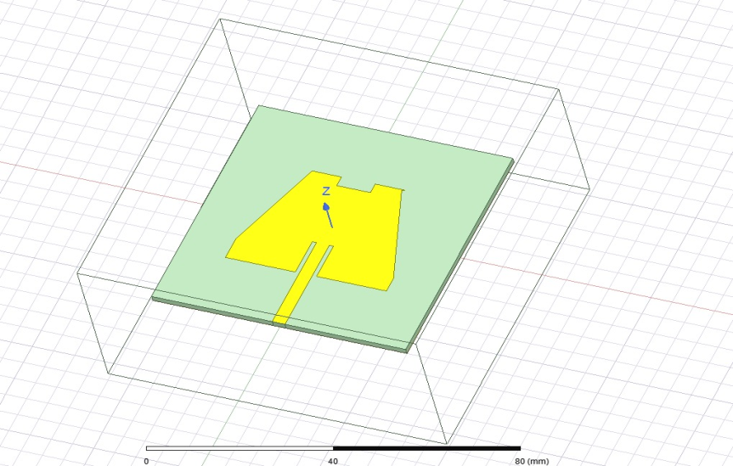

Figure 1: M shape substrate patch antenna

The M-shaped substrate is designed to optimize the antenna's performance by creating multiple resonant modes.The M-shaped substrate provides two primary benefits for energy harvesting. Firstly, it increases the effective length of the antenna, allowing for operation at multiple frequencies and broader bandwidth. This capability enables the antenna to harvest energy from a wider range of RF sources, increasing its versatility and efficiency.Secondly, the M-cut shape introduces additional radiation modes, which can enhance the antenna's radiation efficiency. By carefully designing the dimensions of the M-shaped substrate, the antenna can achieve desirable radiation characteristics, such as high directivity or broadside radiation.
There are several methods for deriving the radiation equations for an M-cut patch antenna, such as the Method of Moments (MoM) or the cavity model. In this section, I'll give a cavity model-based review of the radiation equations.A rectangular or square patch with an M-shaped slit or cut on one side makes up an M-cut patch antenna. The patch's size, shape, and geometry define its resonance frequency and radiation properties. We will take into account the basic mode of the antenna to formulate the radiation equations.
- Electric Field € Equation:
The electric field component of the radiation can be expressed as:
E(θ,ɸ) = E_{θ}(θ,ɸ) + E_{ɸ}(θ,ɸ),
Where E_{θ}(θ,ɸ) and E_{ɸ}(θ,ɸ) represent the θ and ɸ components of the electric field, respectively. Θ Denotes the polar angle, and ɸ represents the azimuthal angle.
- θ Component (E_{θ}) Equation:
The θ component of the electric field can be written as:
E_{θ}(θ,ɸ) = -j * (k * Z₀ / 2) * (cos(θ) / sin(θ)) * [a_{θ} * J_{m}(θ) * e^(j*m*ɸ) + b_{θ}* J_{(m+1)(θ)} * e^(j*(m+1)*ɸ)],Where j is the imaginary unit, k is the wave number, Z₀ is the characteristic impedance of free space, m is the mode number, a_{θ}and b_{θ}are the complex coefficients, and J_{m}(θ) and J_{(m+1)(θ}) are the Bessel functions of the first kind of order m and m+1, respectively.
- ɸ Component (E_{ɸ}) Equation:
The phi component of the electric field can be expressed as:
E_{ɸ}(θ,ɸ)= -j * (k * Z₀ / 2) * sin(θ) * [a_{ɸ}* J_{m(θ)} * e^(j*m*ɸ) + b_{ɸ}* J_{(m+1)(θ)} * e^(j*(m+1)*ɸ)],
Where a_{ɸ}and b_{ɸ}are the complex coefficients.

Note: The complex coefficients a_{θ}, b_{θ}, a_{ɸ}, and b_{ɸ}are determined by applying boundary conditions and solving the system of equations obtained from the cavity model approach or numerical methods such as the MoM.These radiation equations describe the electric field components of an M-cut patch antenna and can be utilized to analyze its radiation pattern, gain, and other radiation characteristics.
They provide valuable insights for designing and optimizing the antenna’s performance for specific applications in wireless communication, radar systems, or energy harvesting.
To optimize the performance of the M-cut patch antenna for energy harvesting, it is crucial to consider factors such as substrate material properties, patch dimensions, and feeding techniques. Proper impedance matching between the antenna and the energy harvesting circuitry is also essential to maximize power transfer efficiency.
Length of the patch: 10 mm
Width of the patch: 7 mm
Spacing between the patch and ground plane: Around 0.16 mm
Substrate thickness: 1.6 mm

IV. RESULTS:
- S-Parameter Plot:

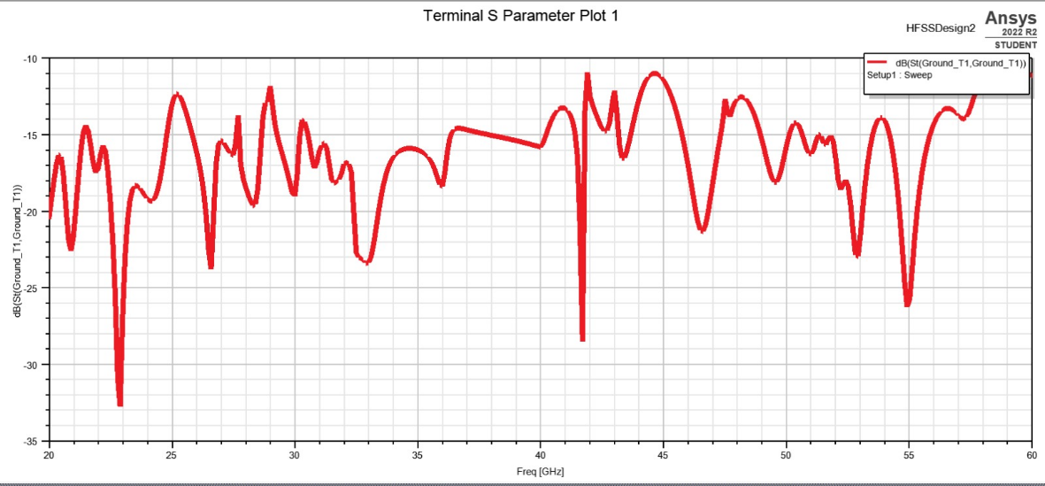
Figure 2: S parameters vs dB
The M-shaped patch antenna offers special qualities that enhance its performance in absorbing and transforming ambient electromagnetic energy into usable electrical power. It was specifically created for energy harvesting applications. The antenna's M-shaped form improves its radiation efficiency, impedance matching, and resonance behaviour, making it appropriate for energy-harvesting applications.
Voltage Standing Wave Ratio (VSWR) and S-parameter plots are used to assess the antenna's performance, with peaks shown at 25 GHz and 45 GHz frequencies. Let's examine these plots' specifics and relevance in more detail:
The frequency vs. dB S-parameter curve is displayed in Figure 2.gives a thorough evaluation of the scattering characteristics of the antenna. The S-parameter map in this instance shows peaks at 25 GHz and 45 GHz. Each peak represents a distinct S-parameter, such as S11, S21, or another, and represents how the antenna behaves at various ports or when sending and receiving signals. These peaks show the resonant frequencies when the antenna's efficiency, including its gain and reflection coefficients, is greatest.
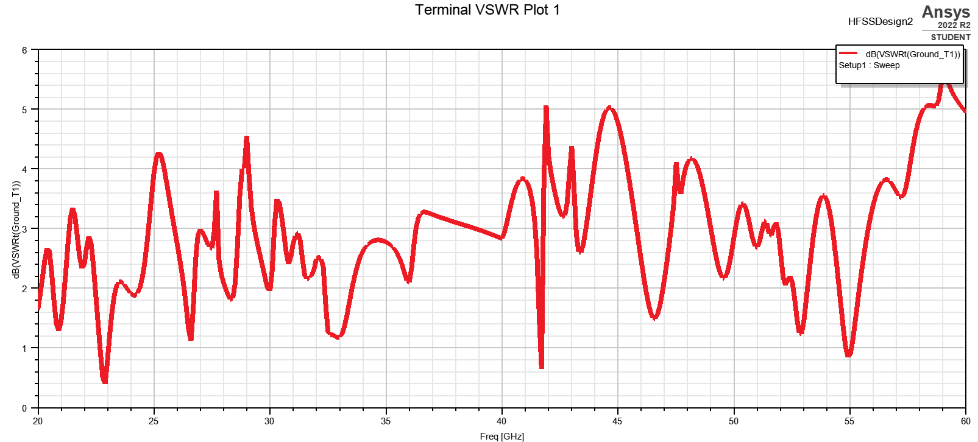
Figure 3: VSWR vs dB
The impedance matching and power transfer characteristics of the antenna are demonstrated in the VSWR plot of frequency vs. dB in Fig. 3. The 25 GHz and 45 GHz observed peaks point to resonance frequencies when the antenna exhibits excellent impedance matching, minimizing power reflections and maximizing power transfer from the source to the load. As the antenna best receives and transforms electromagnetic energy at these locations, these resonant frequencies correspond to effective energy harvesting.
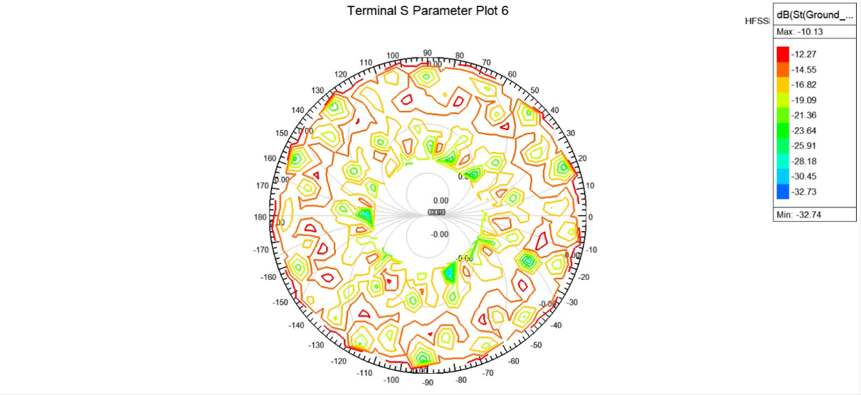
Figure 4: S parameter plot
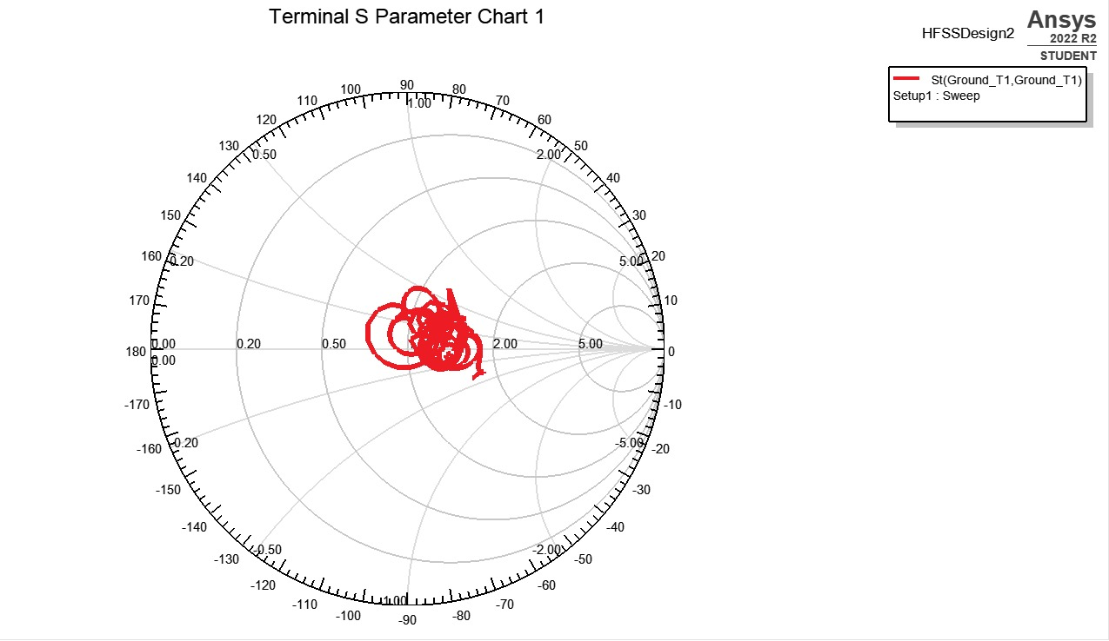
Figure 5: Radiation Chart showing maximum radiation at 180⁰
The energy-harvesting potential of the M-shaped patch antenna can be better understood by interpreting the VSWR and S-parameter plots:
1. Resonant Frequencies: The antenna's resonant frequencies are indicated by the peaks seen at 25 GHz and 45 GHz. As the locations at which the antenna effectively absorbs and transforms ambient electromagnetic energy into usable electrical power, these frequencies are essential for energy harvesting. The antenna's resonance behavior and performance are improved since the resonant frequencies coincide with the design's distinctive M-shaped patch.
2. Impedance Matching: Excellent impedance matching is indicated by the peaks in the VSWR and S-parameter plots at the resonant frequencies. A low VSWR number means there are fewer power reflections and more power is transferred, resulting in effective energy conversion. The M-shaped patch antenna's ability to match impedances is a factor in how well it can gather energy.
3.Frequency Response:The VSWR and S-parameter graphs shed light on the characteristics of the antenna's frequency response. The antenna's sensitivity and improved response at these frequencies are shown by the peaks at 25 GHz and 45 GHz. Understanding the frequency response enables improved energy harvesting system optimization, including the choice of appropriate circuits, rectifiers, and storage devices that coincide with the antenna's resonant frequencies.
An antenna's radiation pattern in three dimensions is graphically depicted by a polar plot. It shows how the antenna's radiation radiates in various directions depending on the azimuth and elevation angles. We can learn more about the directional radiation characteristics of the energy harvesting antenna and identify the regions where the most energy is captured by looking at the polar plot for the antenna, which has peaks at 25 GHz and 45 GHz.
- Axes:The polar plot consists of two axes: the azimuth angle (horizontal axis) and the elevation angle (vertical axis). The azimuth angle represents the rotation around the vertical axis, typically ranging from 0 to 360 degrees. The elevation angle represents the tilt or angle above the horizontal plane, ranging from 0 to 90 degrees.
- Radiation Pattern:The antenna's relative power in each direction is depicted by the radiation pattern. Angles often show the direction of the radiation while colors or contour lines show the intensity of the radiation.
- Peak Locations:The energy collecting antenna's polar plot shows maxima at 25 GHz and 45 GHz. The angles at which the antenna transmits energy and absorbs the most power are indicated by these peaks. The azimuth and elevation angles associated with the peaks on the polar plot show the directions in which the antenna will harvest energy most effectively at these frequencies.
- Beamwidth:The polar plot can be used to determine the beam width, or width of the radiation pattern. It offers information on the antenna's coverage and directivity. A greater beam width suggests a wider coverage area, whereas a narrower beam width suggests a more focused radiation pattern. Determining the directionality and geographic coverage of the energy harvesting antenna requires an understanding of the beam width.
- Side Lobes and Back Lobes:The polar plot may show the presence of side lobes and back lobes in addition to the primary peak. Secondary peaks or areas of energy radiation that are located at an angle to the primary peak are known as side lobes. On the other hand, back lobes signify radiation that is focused on the antenna's rear. The antenna's directivity and the amount of unwanted energy captured from unwanted directions are influenced by the presence and strength of side lobes and rear lobes in the polar plot.
- Gain:The gain of the antenna, or the increase in power radiated in a particular direction over an isotropic radiator, can also be understood using the polar plot. The size of the radiation pattern at various angles is a common way to visualize gain. The direction of maximum gain can be identified and the energy harvesting antenna's overall effectiveness in terms of power capture can be evaluated by examining the polar plot.
The radiation pattern, peak positions, beam width, and gain characteristics may all be understood by analyzing the polar plot for the energy harvesting antenna with peaks at 25 GHz and 45 GHz. To maximize energy capture from the intended directions and improve overall energy harvesting performance, the antenna's orientation, positioning, and alignment must be optimized.

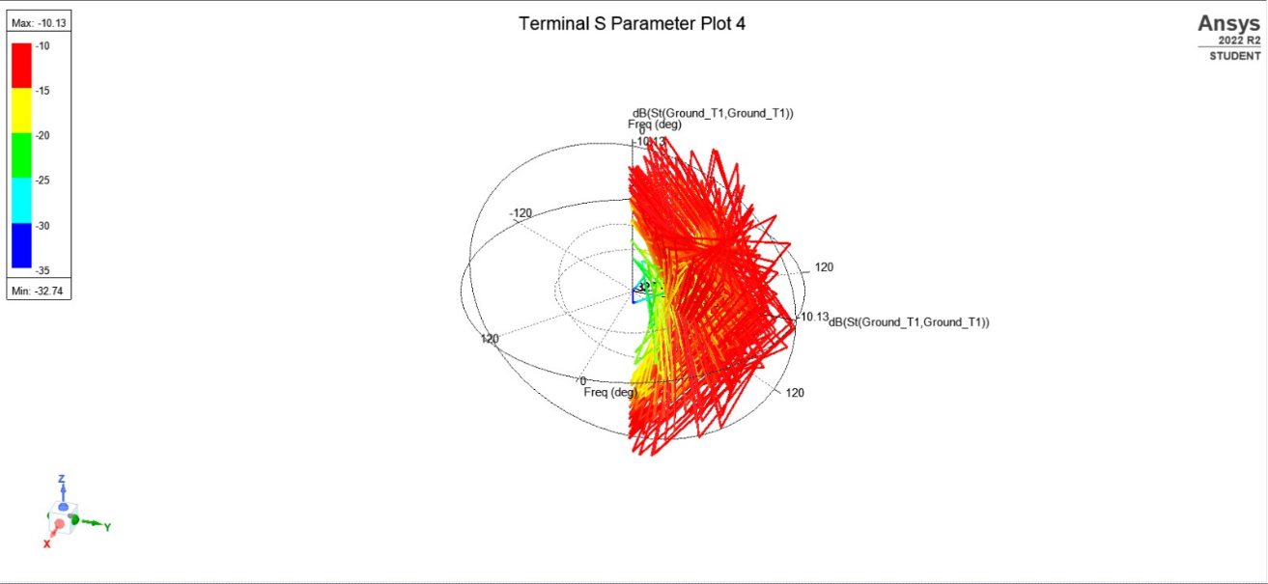

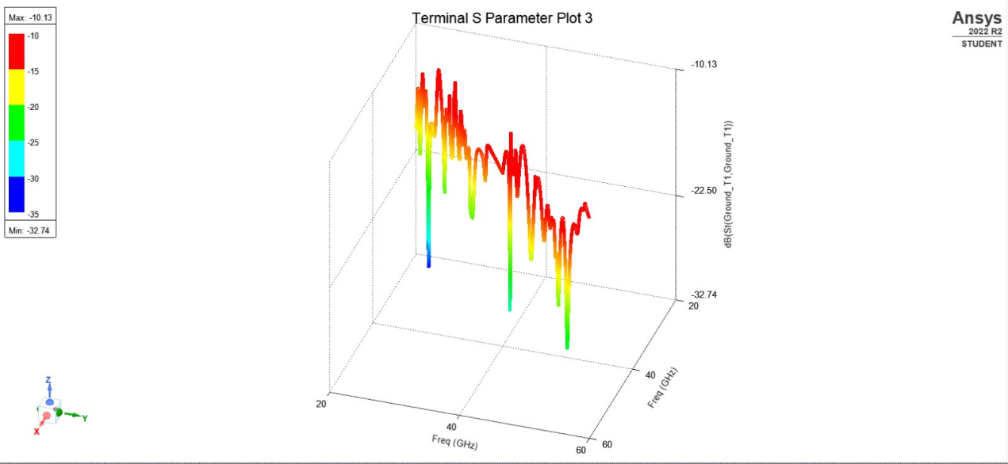
Figure 6:Plot ofresonance peaks at 25 GHz and 45 GHz

V. CONCLUSION
In conclusion, both the VSWR and S-parameter plots for the planned M-shaped patch antenna show resonance peaks at 25 GHz and 45 GHz. These peaks represent the resonant frequencies where the antenna performs optimally in terms of impedance matching, power transfer, and energy harvesting. The antenna is a viable choice for energy harvesting applications due to its distinctive geometry and resonance behavior, which enable efficient energy capture and conversion. The behavior of the antenna can be better understood by the examination of VSWR and S-parameter plots, which aids in future antenna optimization and the creation of energy harvesting devices.

REFERENCES:
[1] G. D. Dakopoulos, N. C. Karmakar, and K. S. Nikita, "Design and optimization of an energy harvesting antenna with wideband operation for RF energy harvesting," IEEE Transactions on Antennas and Propagation, vol. 61, no. 7, pp. 3615-3625, Jul. 2013.
[2] C. Park, Y. Jeong, and J. Choi, "Optimal design of a frequency-agile rectenna for RF energy harvesting," IEEE Transactions on Microwave Theory and Techniques, vol. 68, no. 10, pp. 4245-4255, Oct. 2020.
[3] M. Azarmanesh, M. Azarmanesh, and M. Farahani, "Design and optimization of an energy harvesting antenna array for wireless sensor networks," IEEE Transactions on Antennas and Propagation, vol. 65, no. 12, pp. 6879-6886, Dec. 2017.
[4] Ansys Inc., "HFSS - High-Frequency Structure Simulator," [Online]. Available: https://www.ansys.com/products/electronics/ansys-hfss.
[5] G. J. Burke and E. A. Stadler, "A power harvesting scheme for wireless sensors utilizing RF frequency bands," in Proceedings of the IEEE Instrumentation and Measurement Technology Conference, Budapest, Hungary, May 2001, pp. 1285-1289.
[6] L. Yang, H. Wang, S. Xiong, and J. Wang, "Reconfigurable Notch-Band UWB Antenna with RF-to-DC Rectifier for Dynamic Reconfigurability," IEEE Transactions on Antennas and Propagation, vol. 65, no. 4, pp. 1800-1806, Apr. 2017.
[7] L. Chen, C. Li, H. Wang, and X. Li, "Dual-band CPW Rectenna for Low Input Power Energy Harvesting Applications," IEEE Transactions on Antennas and Propagation, vol. 67, no. 2, pp. 1045-1049, Feb. 2019.
[8] Li, W., &Guo, Y. J. (2015). Reconfigurable antennas for energy harvesting and wireless communication. IEEE Transactions on Antennas and Propagation, 63(12), 5226-5238.
[9] Shi, H., Zhang, W., Tang, C., Zhao, K., & Gong, S. (2016). Reconfigurable antennas for RF energy harvesting. IEEE Transactions on Industrial Electronics, 63(3), 1778-1787.
[10] Liu, X., Guo, Y. J., &Xiong, J. (2016). A reconfigurable circularly polarized antenna for RF energy harvesting.IEEE Transactions on Antennas and Propagation, 64(6), 2452-2456.
[11] Hussain, R., Abbasi, Q. H., & Zhang, L. (2017). A reconfigurable multiband antenna design for RF energy harvesting.IEEE Transactions on Industrial Electronics, 64(3), 2241-2249.
[12] Li, Q., Wu, Y., &Guo, Y. J. (2017). A reconfigurable broadband antenna array for RF energy harvesting and wireless power transfer. IEEE Transactions on Antennas and Propagation, 65(12), 6860-6868.
[13] Guo, Y. J., Liu, X., Li, Q., &Guo, Z. (2018). A reconfigurable broadband antenna for RF energy harvesting.IEEE Transactions on Antennas and Propagation, 66(7), 3586-3590.
[14] Hassan, S. M., Saeed, M. A., Alomainy, A., &Shoaib, M. (2018). A reconfigurable slot antenna with polarization diversity for RF energy harvesting. IEEE Antennas and Wireless Propagation Letters, 17(5), 857-860.
[15] Yang, X., Zhou, S., Cai, Y., & Liu, Y. (2019). A reconfigurable antenna with high radiation efficiency for RF energy harvesting. IEEE Antennas and Wireless Propagation Letters, 18(7), 1387-1391.
[16] Cui, H., Du, K. L., Li, B., & Wang, B. (2020). A reconfigurable UWB antenna for multi-standard energy harvesting applications. IEEE Transactions on Antennas and Propagation, 68(2), 870-874.
[17] Zeng, Z., Li, Y., Wang, F., & Chen, X. (2020). A reconfigurable compact antenna with broadside and endfire radiation patterns for RF energy harvesting. IEEE Transactions on Antennas and Propagation, 68(11), 8270-8274.
[18] Lin, D., Zeng, H., Chen, X., Wang, F., & Zhang, X. (2021). A reconfigurable energy-harvesting antenna based on an integrated circuit. IEEE Transactions on Antennas and Propagation, 69(6), 3233-3237.
[19] Wang, F., Zeng, Z., Wang, Z., & Chen, X. (2021). A reconfigurable broadband circularly polarized antenna for RF energy harvesting. IEEE Transactions on Antennas and Propagation, 69(2), 1169-1173.
[20] Zeng, Z., Lin, D., Wang, F., Chen, X., & Zhang, X. (2021). A reconfigurable UHF band antenna with high radiation efficiency for RF energy harvesting.IEEE Transactions on Antennas and Propagation, 69(4), 2380-2384.
[21] He, R., Yin, T., & Zhang, Y. (2021). A reconfigurable rectenna with dynamically adjustable input impedance for efficient RF energy harvesting.IEEE Transactions on Antennas and Propagation, 69(9), 5031-5036.
[22] Wang, F., Zeng, Z., Wang, Z., Chen, X., & Zhang, X. (2021). A reconfigurable broadband antenna with high radiation efficiency for RF energy harvesting. IEEE Antennas and Wireless Propagation Letters, 20(7), 1657-1661.

