A Comparative Study on Electronic Waste (E- waste) Management Using Biological Systems:
-

Keka Bhattacharjee Department of Microbiology Assistant Professor Kingston College of Science Barasat, India
Email: keka.mymail@gmail.com

ABSTRACT

Technologically powered contaminants acknowledged certainly e-waste, comprise used electrical utilities whose services necessitate reclamation or suited disposal. Minimizing E-waste is a global question primarily due to the hazardous carcinogenic properties of some of its components when not handled correctly.

Introduction

"Squander" signifies substances that are correct now not being used by the client. Unsafe waste from electronic things is e-squander. Electronic trash subsections could truly be isolated through two obvious classes:
1) organic aspects come with the thermostat and thermos setting plastic
2) inorganic parts embrace metallic stuff and nonmetallic components.
Demonstrating presence of lethal synthetic compounds and harmful substance in the electronic devices, removal of e-waste is turning into a natural and wellbeing nightmare. American inhabitants impose roughly 7 kilograms per person every year, while Europeans produce roughly 20 kilogram / year/ individual. The entire thing distinct and outdated e- squander created throughout India is anticipated to be around 1, 46,000 tons yearly. E-waste comprises of additionally more than 1000 unique constituents which somewhat are catastrophic or non-hazardous. Comprehensively, it ultimately comprises of metals with names like copper, aluminum and irreplaceable metals like palladium, platinum and gold and so forth. Lead, mercury, arsenic, cadmium, selenium and hexavalent chromium as well as fire retardants, have an effect on climatic and living things. The disappreance of e- waste is a specific subject which was examined by several districts across the globe and is of concern principally because of the poisonous nature and cancer-causing nature of a portion of the substances if not handled appropriately.
It’s crucial to conduct research that compares the technologically powered contaminant management using biological framework is multifaceted and extends to various stakeholders, including policy makers, environmentalist researchers and industry players. Some key points highlighting its significance:
- Environmental Sustainability – Technologically powered contaminants are a noteworthy trigger to resource depletion and environmental worsening. Traditional cleaning methods discharge disruptive substance into the environs and fail to recuperate treasured assets. Biological systems cater to sustainable strategy by detoxifying contaminants simultaneously recycling resource, thereby mitigating adverse environmental footprint of e-waste.
- Health Protection-E- waste’s poor treatment and burial might have disastrous outcome for crew members along with communities. Biological procedures diminish exposure to unacceptable substance, making e- waste management safer for individual involved in the process and those living in proximity to disposal site.
- Scientific Advancement- Research on the comparative value of different natural system contributes regarding the scientific grasp of e-waste management. Regarding this threshold
- knowledge can lead to improvements in the current moment biotechnological approaches in addition to the discovery of novel methods for e- waste remediation.
A comparative study on technologically powered debris management using biological system is significant because it addresses pressing environmentally friendly and health concerns, promotes source resource conservation, guides policy expansion, encourages breakthrough, advances scientific knowledge and on top of incorporates concerning internationally efforts regarding mitigate one’s impacts of E-waste.

- Methodology: -
1. Micro remediation
Bioremediation at a small scale distinguished as parallel microbial exploitation to dispose epithetical contain or change the foreign substance to non- perilous or less unsafe structure in the climate through digestion system of microorganism (Mulligan et al., 2001).
There certainly are six significant systems in bioremediation regarding harmful metallic elements the fact that are getting bioleached.

- Microbial Leaching: -
Biological gathering implies utilization of an herbal cap an opportunity regarding the microbial organisms to convert metallic substance in existence side the waste in a strong shape in dissolved form. There are two types of bioleaching:

Draining Direct and Filtering by Circuits.

Direct Draining utilizes the natural acid delivered the organism, to oxidize insoluble harmful metal transforming them into ions via which they grow to be soluble.

In the case of indirect leaching steel microbes capable of combustion are used to oxidize steel surrounding the tiny organism in maximum instances of anion steel compound has been oxidized, giving out loose steel ions in aqueous medium (Tichy et al., 1998).

Table.1

Only a few inhabitants encountered for bioleaching process a fatal metal
The organism deployed | Type | Name of toxic metal removed
Acidithiobacilus thiooxidans | Bacterial | Pb, As
Micrococcus  Roseus | Bacterial | Cd
Thiobacillus  Ferrooxidans | Bacterial | As, Pb
Aspergillus  Fumigatus | Fungal | As
Aspergillus  Niger | Fungal | Cd, Pb
(Origin: Stephan & Ren et al., 2009; Macnaughtont, 1999)

.

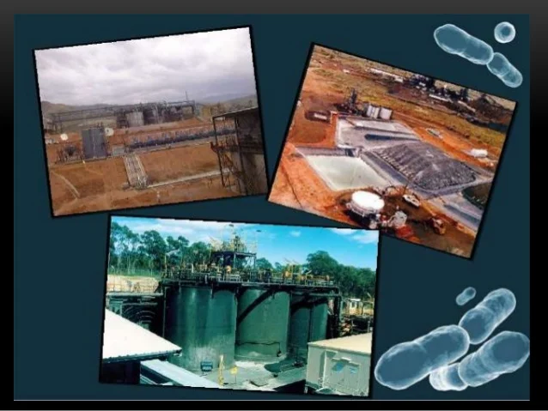

Figure 1: The extraction of live creature activated.

2. Biological Absorption: -

The term biological uptake an acronym via order regarding the entire act of concentrating and restricting of dissolvable impurities to the surface of the cell structure, it doesn’t require dynamic digestion, for this situation the dissolvable impurities are ionized poisonous metals (Volesky, and Holan, 1995).

The disgorgement of considerable weight incorporating elements into amphibians’ physiologic systems has turned into an issue, of anxiety in India for the last couple of years. The aforementioned infections are triggered inside some amphibian substructures altogether because of an array of modern tasks. Urbanization in India acquired energy with the inception for a long-term dynamic layout at the middle of the 50's. The contaminants of concern include lead, such hazardous element include chromium, mercury, uranium, selenium, zinc, arsenic, cadmium, gold, silver, copper and nickel. These harmful materials might be gotten from mining tasks, mineral refinement, muck removal, glide debris to incinerators, the handling of radioactive materials, metal plating, or the assembling of electrical gear, paints, composites, batteries, pesticides or additives. Weighty metals, for example, zinc, lead and chromium have various applications in fundamental designing works, paper and mash ventures, calfskin tanning, organ chemicals, petrochemicals fertilizers, and so on Significant lead contamination is through cars and battery producers. For zinc and chromium, the significant application is submitted in fertilizer and calfskin tanning individually (Trivedi, 1989). Over the years and years, a few methods had been created in order to treat as well as deportation of weighty metal.

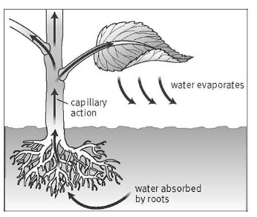
Table 2

The organism deployed | Type | Name of Toxic metal removed
Bacillus sphaericus | Bacterial | Cr
Myxococcus xanthus | Bacterial | U
Pseudomonas aeruginosa | Bacterial | Cd, U
Rhizopus arrhizal | Fungal | U
Saccharomyces cerevisiae | Fungal | Cd
(Source: Hu et al., 1996; Atkinson et al., 1998; Ahalya et al., 2003)
3.Bioaccumalation
It is depicted as the upkeep of defilements inside the current design which are moved into biomass cells inside the cell plan and through there this joint effort requires dynamic ingestion (Prakash et al., 2012). For regular defilements, there are now and again synthetic responses in the cell cytoplasm to change them over to other compounds; in any case the metal entering the cell cytoplasm won’t go through any response yet sequestered all things
considered (Hou et al., 2006).
The Spartina hedge can be observed in various regions around the world including Europe, Southern Africa and the South Atlantic Island this type of hedge is created through C4 movement across poaceae grasses.
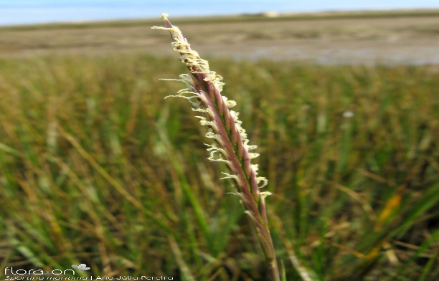
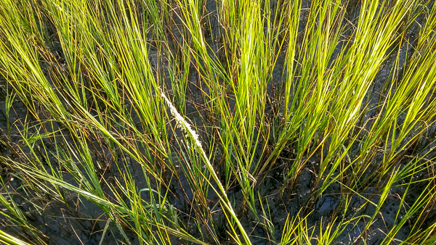
Figure 2b: Spartina maritima

Figure 2a: Spartina alterniflora

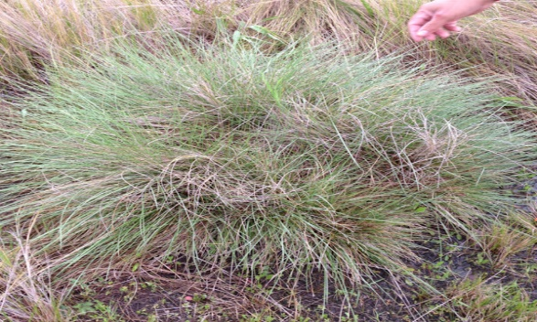
Figure 2c: Spartina argentinensis

Spartina alterniflora and Spartina maritima are two Spartina sp. that are often employed by researches owing to their salt tolerance and ability to flourish in salt marshes. The minerals zinc and copper drew the greatest attention in this research indicating that these metals were more carefully examined than other heavy metal.
Another Spartina sp. of Spartina argentinensis has the capable of hyperaccumulating particular heavy elements including chromium.
Did you know that Spartina sp. have a really cool ability? They can actually collect heavy metals, which makes them really helpful in environmental cleaning efforts!

Few organisms identified for bioaccumulation of toxic metal:

Table.3

The organism deployed | Type | Name of contaminate removed
Bacillus  circulans | Bacterial | Cr
Bacillus megaterium | Bacterial | Cr
Micrococcus  luteus | Bacterial | U
Aspergillus  niger | Fungal | Cr, Pb
(Source: Malik, 2004; Juwarkar and Yadav, 2010; Srinath et al. 2002; Demirbas,2001).

4. Biomineralization
The interaction in which toxic metal particles link with anions or ligands produced by bacteria to generate precipitation is shown by biomineralization (Ronald et al. 2005).
The impact of science in the field of biomineralization can be divided into three distant areas:
- The portrayal of crystallography, arrangement and natural chemistry of organic materials.
- The design of in vitro model frameworks to respond to scientific inquiries.

Few microorganisms identified for biomineralization of toxic metals

Table.5

Organism deployed | Type | Name of contaminate removed
Bacillus  fusiform | Bacterial | Pb
Soporosarcina  ginsengisoli | Bacterial | As
Aspergillus  flavus | Fungal | Pb

Phytoremediation for Electronic Waste

The demonstration of eliminating harmful metals extracted from ores the climate by the utilization of metal aggregating plants is named phytoremediation (Vinita, 2007). Phytoremediation takes advantage of plant’s natural organic instruments for human advantage. Four subsets of this innovation as pertinent to harmful metal remediation from soil and water are:
(i)Phytoextraction – the utilization of metal – aggregating plants to eliminate harmful metals from soil, (ii) Phytovolatilization – dissipation of specific metals from airborne pieces of the plant, (iii) Phyto stabilization the utilization of plants to dispose of the bioavailability of harmful metals in soils and (iv) Rhizofiltaration – the utilization of plant roots to eliminate harmful metals from dirtied waters (Vinita, 2007).

Phytoextraction

Metal phytoextraction depends on metal-amassing plants to ship and focus contaminating metals from soil into the harvestable over the ground shoots (Salt et al., 1998; Vassil et al., 1998). The plant material can consequently be utilized for nonfood purposes (for e.g., wood, cardboard) or ashed, trailed by removal in a landfill or, in the case of valuable metals, the gathered component can be reused. The latter is termed Phyto mining (Chaney et al., 2000). Well known species for phytoextraction are Indian mustard and sunflower because of their quick development, high biomass, and high tolerance and accumulation of metals and other inorganics (Blaylock and Huang, 2000; Salt et al., 1995b).

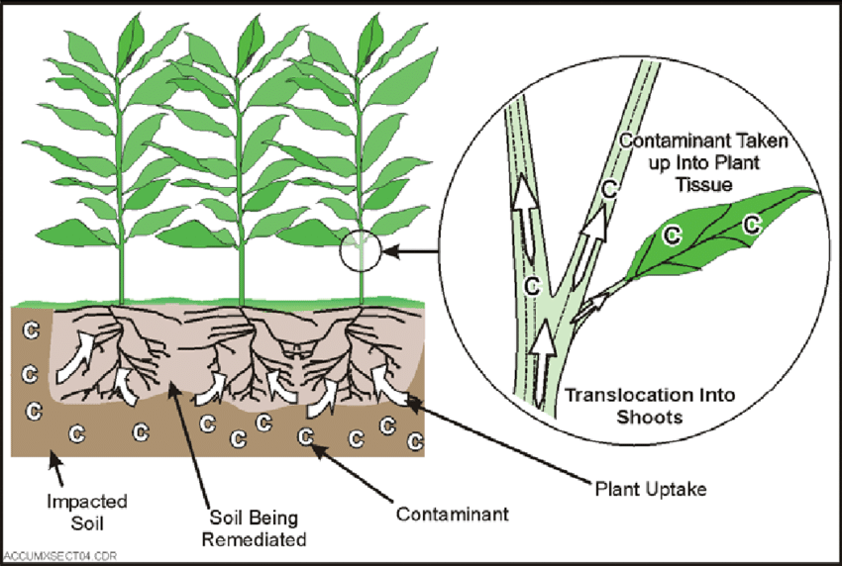

Restrictions of the innovation incorporate the potential for bringing the toxin into pecking order, long tidy up occasions required, bioavailability of foreign substance and
harmfulness experienced in setting up and keeping up with vegetation at squander locales. The utilization of phytoremediation is likewise restricted by the climatic and geologic states of the site to be cleaned, the temperature, soil type furthermore the availability for horticulture gear (Salt and Kramer, 2000; Schmoger et al., 2000).
Besides, instruments of a large portion of the natural cycles hidden phytoremediation, for example, plant metal take-up, movement, aggregation and/or corruption and plant microorganism communications, are inadequately perceived also need further examination.

Some plant species for phytoextraction of toxic metals

Table.6

Plant species | Name of contaminate removed
Thlaspi  caerulescens | Cd
Amaranthus  retroflexus | As
Chenopodium  album | Cd, Pb
Brassica  juncea | Cd, Cr
Helianthus  annuus | As, Pb
(Source: Lasat, 2002; McGrath, 2006; Rajiv et al.)

Result and discussion

Squander the broad alludes to all actions used to ensure human and ecological from the risk of constituents of electronic and different squanders. It is by and large attempted to lessen their impacts on the wellbeing. E-squander reusing is essential yet it ought to be directed in a protected and normalized house. The OK danger edges for perilous, optional e- squander substances ought not to be distinctive for creating and created nations. Be that as it may, the adequate limits ought to be distinctive for kids and grown-ups given the actual contrasts and articulated weaknesses of kids. Working on word related conditions for all e- squander labourers and making progress toward the destruction of youngster work is non- debatable.

References

- Mulligan, C. N., Yong, R. N., and Gibbs, B. F. 2001. Remediation technologies for metal-contaminated soils and groundwater: an evaluation. Engineering Geology. 60(1): 193- 207.

- Tichy, R., Rulkens, W.H., Grotenhuis, J.T.C., Nydl, V., Cuypers, C., and Fajtl , J .

1998.
3. Stephen, J.R and Macnaughtont, S.J. 1999; Ren et al., 2009.

4.Volesky and Holan, Z.R. 1995. Biosorption of heavy metals. Biotechnology progress.
11(3): 235-250.

David, E.S., Ilya R., and Robert D.S.1997. 2005 ; John, 2007.

