Advanced Ceramics:

Ceramics are inorganic,non metallic materials, which includes oxides,nitrides,carbides,borides, fall under the category of ceramics.It is also known as Engineering ceramics or technical ceramics.The atomic bonding in ceramics is partially ionic and partially covalent, with a predominantly ionic character. Ceramics are based on pure or nearly pure ceramics components alone or in combination.
Examples:- Aluminium Oxides (Al2O3),Zirconia (ZrO2),Silicon Carbide (SiC),Silicon nitrides (Si3N4),Barium titanate (BaTiO3) and High temperature superconductors
Classification:
Ceramic materials are divided into two group
- Traditional ceramics: Clay products,refractories and cement
- Advanced ceramics: Silicon carbide,alumina and silicon nitride are used in high technology applications like cutting tool material,abrasive etc.
Advanced ceramics are formed utilizing a variety of composition blends and processing procedures, and their raw ingredients must be properly treated in order to generate a regulated product. Currently, materials like glass, porcelain, bricks, tiles, etc. are typically categorized as ceramics.

Properties of Advanced Ceramics:

- Advanced ceramics are hard,stiff and Inert.
- They are poor conductors of heat and electricity
- They also have better corrosion resistance
- They are chemically very stable
- They have very low fracture toughness
- They possess high melting points due to their strong chemical bonds.
- They have high wear resistance
Structural Classification
Anion and cation make up the majority of the ionic bonding found in ceramics. The radius of the ions affects the crystal structure of ceramics.The radius ratio of the bonding ion determines the coordination number. Ceramics are categorized into AX, AX2, ABX3, and AB2X4 categories based on their crystal structure. Examples under each type are given below
AX: NaCl,ZnS,CsCl
AX2:SiO2,CaF2,PuO2
ABX3: BaTio3,SrZrO3
ABX4:MgAl2O4,FeAl2O4
Based on the structure it is classified as
- Crystalline ceramics
- Non-crystalline ceramics
Crystalline ceramics
  - Crystalline ceramics have regular arrangement of atoms with simple structure.
  - They are most often produced by compacting the powder and firing at high temperature.
  - The crystal structure of ceramics is due to the assembly of different size atoms.
Common crystal structures in crystalline ceramics are
Cesium Chloride structure
- It is simple cubic structures that are found in metal type ceramics.
- In this structure chlorine ions are arranged in a simple cubic structure with interstice occupied by cesium ions.
- If the positive and negative ions are about the same size the structure becomes a simple cubic (CsCl) structure.
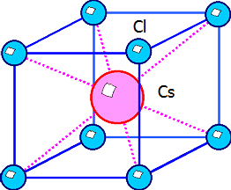

Rock Salt structure
- The rock salt structure has a face-centered cubic (fcc) structure, where the positive (Na+) and negative (Cl– ) ions are surrounded by 6 opposite ions (CN = 6).
- MgO, CaO, SrO, BaO, CdO, MnO, FeO, CoO, and NiO belong to the same group.
- The face centered cubic structure arises if the relative size of the ions is quite different 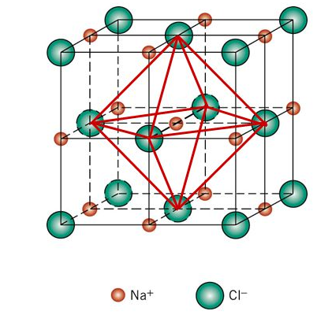
Zinc Blende Structure
- Two of the more cubic ceramic compounds which have atoms in the 4-fold sites, are zinc blende (ZnS), silicon carbide (SiC).
- The atomic coordination is 4. Each type of atom forms an fcc structure of its own.
- The structure is the same as the diamond cubic except that alternate atoms are of different elements
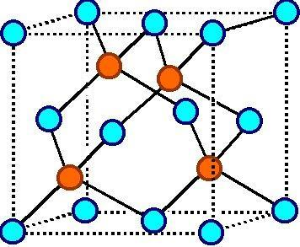

Perovskite Crystal Structure
- A unit cell of this structure is shown in figure.In this ceramic compounds more than two cations. For example Barium titanate having both Ba²⁺and Ti⁴⁺ cations are present
- Ba²⁺ ions are situated at all eight corners of the cube and a single Ti⁴⁺ is at the cube−center. The O²⁺ ions are located at the center of each of the six faces of the unit cell.
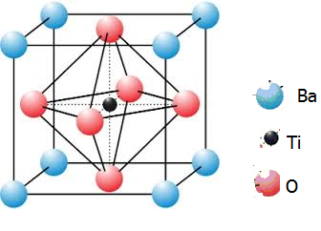
NON - CRYSTALLINE CERAMICS
- The materials, which do not have three-dimensional structures, but random structures are said to be amorphous or glassy. Many metal alloys, oxide compounds and non-oxide compounds form glassy structures. Fused silica or vitreous silica has a high degree of atomic randomness.
- Silicates and Silica Silicates are composed of silicon and oxygen, which are abundantly available in the Earth’s crust.
- A unit cell of silicate is a tetrahedron on which each atom of silicon is bounded to four atoms of oxygen as shown in figure. Oxygen atoms are located on the edges of a tetrahedron structure and silicon atoms are located at the center.
- There are three polymorphic forms of silica: (1) quartz, (2) cristobalite and (3) tridymite. This silica is used in the manufacture of different varieties of glasses.
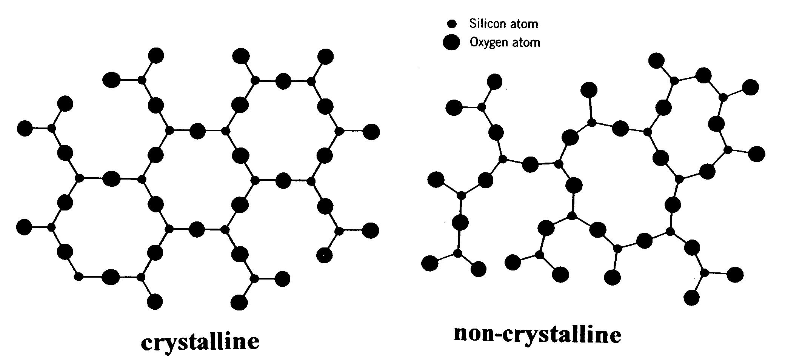
BONDED CERAMICS
These ceramics contain both crystalline and non-crystalline materials which are bound together by a glassy matrix after firing. This group includes the lining and clay products. Bonded ceramics are used as electrical insulators, refractory for furnaces, spark plugs etc.
Fabrication of Advanced ceramics:
Advanced ceramics are created using a multitude of techniques. A product's process selection is determined by its materials, shape complexity, cost, and suitability requirements. Ceramics are manufactured by the application of heat upon processed clays or other raw materials to form rigid products. The common shape forming methods for ceramics are
- Slip casting method
- Isostatic pressing method
- Slip Casting method
One of the more sophisticated methods of manufacturing ceramics into complex shapes that we use today is called slip casting. It is a method of producing ceramics with different shapes and sizes without use of heat
Step 1 -Mix a fine ceramic powder in water, along with some chemicals that help the powder to disperse throughout the liquid, you create what is called a slip.
Step 2- The slip is poured into a mold that removes some of the liquid from the slip near the mold wall
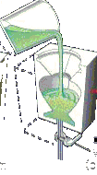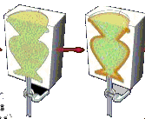1 Fill mold with slip 2 Formation of Cast

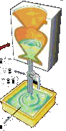Step3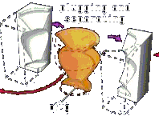
3 Excess slip draining 4 Removing Cast
Step3 Now soda ash is added to the slip to break the cluster of particles into uniform dispersed individual particles
Step 4 The water from slurry begins to move out through porous mold by capillary action
Step 5 When a sufficiently thicker cast is formed the rest of the slurry is removed. This process is called drain casting
Step 6 Mold and cast is allowed to dry. After drying casting (green ceramics) is removed from the mold
Step 7 The green ceramic is then dried and sintered at high temperature
Use of Slip Casting
- Low cost to make complex shapes
- Use to make teapot, jugs, statues etc
- standard method to make alumina crucible
(b) Isostatic pressing
It involves application of hydrostatic pressure to a powder in a flexible container. It results in uniform compaction of the powder. Isostatic pressing can be done either with or without applied heat.
The two types of isostatic pressing are
- Cold isostatic pressing Hot isostatic pressing
Cold isostatic pressing
A Powder-shaping technique with hydrostatic pressure without any high temperature is called cold isostatic pressing(CIP). There are two processes used in CIP. They are
1. Wet-bag cold isostatic pressing
2. Dry-bag cold isostatic pressing
Wet-bag cold isostatic pressing
The wet-bag CIP process is illustrated in figure

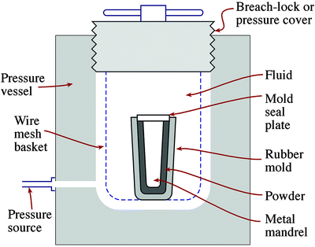

The following steps were adopted during the processing
Step 1 The powder is weighed into a rubber mold
Step2 The rubber bag is sealed by a metal mandrel over which mold seal plate is fixed
Step 3 The sealed rubber bag is placed inside a high pressure chamber that is filled with a fluid which is hydrostatically pressed
Step 4 The pressure is varied from about 20 MPa to 1GPa depending upon the application
Step 5 Once the pressing is complete the pressure is released slowly
Step 6 After the pressure is released the mold is removed from the chamber
Step 7 Finally the component is removed from the mold
Advantage
- Wide range of shape and size can be produced
- Pressed products have uniform density
- Tooling cost is low
Disadvantage
- It has poor shape
- Needs green machining after pressing
- It takes long cycle time with low product rates
Dry-Bag cold isostatic pressing
The Schematic diagram of a mol;d for the dry-bag CIP is shown in figure
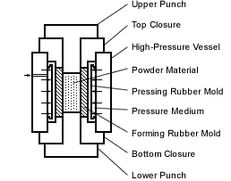

Process
The following steps were adopted during the processing
Step 1 Powder is taken in rubber mold which is the integral part of the process
Step 2 High pressure fluid nis applied using high pressure vessel
Step 3 The top & bottom closure and upper & lower punch help to hold the mold tightly while pressing
Step 4 the pressed ceramic part is removed without disturbing the mold
Advantage
- The process can be fully automated
- the production rates up to 1 part per second are being achieved
Uses
- dry-bag CIP is used in the production of spark plug insulators
- AC spark plugs are also produced by this method
Hot isostatic pressing (HIP)
HIP is a method used to densify a material by imposing the heat and pressure simultaneously. The pressure is applied from all the direction via the pressurized gas such as argon gas
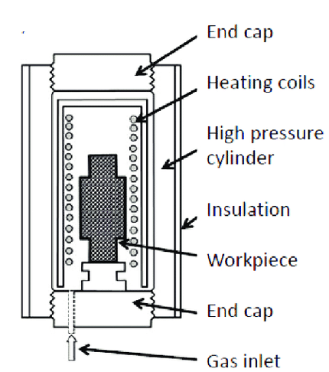
Construction
1. It consists of water cooled pressure vessel within which a furnace, thermally insulated form the pressure vessel
2. Heating element is arranged in multiple banks which can be controlled individually to obtain uniform temperature
3. Temperature is controlled by thermocouple while the gas pressure is controlled by compressor system
4. Excess pressure is released using vacuum pumps and materials pump
5. Furnaces are generally convection type heating elements covered by upper cover and cooling jacket.
Working
- The material to be prepared is kept inside the furnace
- The mold is degassed after filling the powder, then after sealed using upper cover
- The furnace heats tha material to be pressed, at the same time a pressuring medium, usually argon gas, is used to apply high pressure.
- The temperature and the pressure is raised to the desire level
- Furnace allowed to cool followed by depressuring the chamber and remove the parts
- In this process isotropic properties, parts with zero pores are obtained in continuous materials.
Advantage
- Various size and shape can be made
- HIP results in improved and enhanced mechanical property
- Tooling and machining is not required
- HIP produces dense material without growing grains
- Increase in design flexibility
Disadvantage
1. Cost is High
2. Design of equipments is complex
Uses
1. Used to fabricate components of metal
2. Used for bonding dissimilar material
3. Used for the formation of piezoelectric ceramics such as BaTiO₃ for acoustic wave fibrand oscillators
Properties of Ceramic Fibers
The ceramics possess the following properties
- Thermal properties
- Mechanical Properties
- Electrical properties
- Chemical Properties

Thermal Properties
- Ceramic Fibers is basically in amorphous state may be changes to crystalline state at devitrification temperature
- The ceramics fibers possess very low thermal conductivity and act as a insulators and it increases when density increases
- Ceramics are unaffected by thermal shock i.e no cracks or disintegration for sudden change in temperature
- Ceramic Fibers are zero coefficient of thermal expansion

Mechanical properties
  - Ceramic fibers exhibit high tensile strength
  - Compressive strength is several times more than tensile strength
  - It has a high modulus of elasticity. This elastic modulus decreases with increase in the temperature.
  - Non-crystalline ceramics are brittle
Electrical properties
- In general oxide ceramics (Al₂O₃) are poor electrical conductors than non-oxide ceramics fibers (SiC)
- Cubic boron nitride are good conductors of electricity
- SiC used as semiconductors in high temperature applications
- High temperature superconductors (YBa₂Cu₃O_{7-x+)} is ceramic material
Chemical Properties
- Several ceramic fibers (Al₂O₃, SiC) are highly resistant to all chemicals except Hydrofluoric acid.
- Oxide ceramic fibers are resistant to oxidation even at high temperature
- It is corrosion characteristics similar to glass fiber

Various Applications of Ceramics:

Advanced ceramics can be subdivided into structural and electronic ceramics based on primary function or application. Ceramics are useful in a variety of applications based on their mechanical strength and its usage in industrial applications. Some of the important advanced ceramics are discussed below.

S.No | Fields | uses
1 | Electronics | Substrates,chip carriers,electronic packaging,Capacitors,inductors,resistors,electrical insulation Transducer,servisors,electrodes igniters.Motor magnets,spark plug insulators
2 | Advanced structural materials | Cutting tools, wear-resistant inserts,Engine components,Resistant coatings,Dental and orthopedic prostheses,High efficiency lamps
3 | Chemical processing components | Ion exchange media,Emission control components, Catalyst support,Liquid and gas filters
4. | Refractory materials | Refractory lining in furnaces,Thermal insulations,Recuperators,regenerators,Crucibles,Metal processing materials,filters molds,Heating elements
5 | Construction materials | Tile,structural clay products,cement, concrete
6 | Institutional and domestic products | Cookware,Hotel china and dinnerware,Bathroom fixtures,Decorative fixtures and household items

