RADIOPHARMACEUTICAL SCIENCE
Rajni Dubey, Surendra Dangi, Satyabhavna Sakre

Associate Professor, School of Pharmacy and Research People’s University Bhopal, Madhya Pradesh.
Associate Professor, School of Pharmacy and Research People’s University Bhopal, Madhya Pradesh.
Assistant Professor, School of Pharmacy and Research People’s University Bhopal, Madhya Pradesh.

Introduction: - Radiopharmaceuticals constitute a fascinating field of scientific inquiry that revolves around the study of radioactive substances employed as medicinal agents. These substances are capable of spontaneously emitting continuous radiation, leading to their gradual decomposition into stable nuclei. Interestingly, the emission of radiation remains unaffected by external factors such as temperature, pressure, concentration, or catalyst presence.
Radiopharmaceuticals can be divided into four categories:
Radiopharmaceutical preparation-A radiopharmaceutical preparation is a medicinal product in a ready-to-use form suitable for human use that contains a radionuclide. The radionuclide is integral to the medicinal application of the preparation, making it appropriate for one or more diagnostic or therapeutic applications.
Radionuclide generator - A system in which a daughter radionuclide (short half-life) is separated by elution or by other means from a parent radionuclide (long half-life) and later used for production of a radiopharmaceutical preparation.
Radiopharmaceutical precursor- A radionuclide produced for the radio labeling process with a resultant radiopharmaceutical preparation.
Kit for radiopharmaceutical preparation- In general a vial containing the non radionuclide components of a radiopharmaceutical preparation, usually in the form of a sterilized, validated product to which the appropriate radionuclide is added or in which the appropriate radionuclide is diluted before medical use. In most cases the kit is a multidose vial and production of the radiopharmaceutical preparation may require additional steps such as boiling, heating, filtration and buffering. Radiopharmaceutical preparations derived from kits are normally intended for use within 12 hours of preparation.
Radioactivity- Radioactivity is a natural and spontaneous phenomenon wherein unstable atoms of certain elements release or radiate surplus energy in the form of particles or waves. Following emission, the resulting daughter atom can either be a lower-energy variant of the same element or an entirely different element altogether. These emitted particles or waves are termed ionizing radiations due to their capability to dislodge electrons from the atoms of any matter they encounter.
The most common form of radiations emitted has been traditionally classified as:
- α rays
- β rays
- γ rays
Radioactive rays
Alpha rays:
- The alpha particles are the heaviest as they are produced when the heaviest element decay.
- They are not waves but high energy particles which are expelled from unstable nuclei.
- These are similar to Helium atom and contain two protons and two neutrons, having a mass of 4 amu.
He or α-particle
4. These particles are large and heavy in nature, so cannot penetrate but easily get absorbed.
5. Due to less penetration of alpha particles, elements which emit them do not find any use in biological application as they cannot penetrate tissues.
6. When a radioactive element emits alpha particles, the resulting nucleus will have its atomic number less than two units and mass number will be less than 4 units as compared to the original.
Ra ⎯→ Rn + He (α)
7. They get deflected in electric and magnetic field.
8. They produce fluorescence and phosphorescence in some materials such as zinc sulphide.
9. They ionize the gas through which they pass and can penetrate through matter.
10. Their energy is about 6 meV.
Beta rays:
1. They are much lighter energy particles and have less ionizing power than alpha particles.
2. Beta particles are 8000 times smaller than the alpha particles.
3. The emission of beta particles from element does not alter the atomic mass and is converted to element with next higher atomic number
C ⎯→ N + β⁻
4. Beta particles have negligible masses, about 1/1836 than of hydrogen ion and are high speed electrons. (e or β-particle).
5. They get deflected in electric and magnetic field.
6. They ionize the gas through which they pass and can penetrate through matter. Their penetrating power is 100 times more than that of α-particles but ionizing strength is 1/100th of α-particles.
7. They produce fluorescence and phosphorescence in some materials such as zinc sulphide.
8. Their energy ranges from 2 to 3 meV.
Beta particles can be classified into two types:
Electron emission or negatrons: These are emitted by unstable nuclei in which neutrons are transformed into protons with beta emission.
n → p + β
Here the released proton particle has the same mass as that of original atom while the
β-particle has charge as an electron.
Positrons:
1. Positron is a type of beta particle, in which a proton inside a radionuclide nucleus is converted into a neutron. It is not very common and as they are short lived; they do not find any application in biological field.
2. Positron emission decreases proton number relative to neutron number and this kind of decay happens typically in large “proton-rich” radionuclide.
3. Isotopes which undergo this decay and thereby emit positrons include Carbon-11, Nitrogen-13, Oxygen-15, Aluminium-26, Sodium-22, Fluorine-18 and Iodine-121.
C ⎯→ B + $\begin{matrix}0 \\ 1\end{matrix}$β
Gamma rays:
- They are having completely different character. They do not have any charge or mass on them. It travels with the same velocity of light.
- Gamma rays are like X-rays, have shorter wavelength than the visible light.
- Penetrating power of gamma rays was found to be more than alpha and beta rays.
- When gamma rays are emitted from a radioactive element, no change or loss of atomic mass or number takes place, only there is lowering of nuclear energy.
- They produce fluorescence in some materials.
- They produce heat on the surface on which they fall and knock out electrons from it.
- They can produce nuclear reaction.

Properties of Alpha, Beta, and Gamma Radiations
Property | Type of Radiation
 | α | β | γ
Charge | + 1 | − 1 | 0
Mass | 6.64 × 10⁻²⁴ g | 9.11 × 10⁻²⁸ g | 0
Relative penetrating power | − | 100 | 10,000
Nature of radiation | He nuclei | Electron | High-energy photons

Isotopes:
Atoms of an element which have the same atomic number but different mass numbers are called as isotopes. Isotopes are also called as Nuclides. Nuclides have same number of protons but different number of neutrons. They are same chemically but have different physical properties due to different number of neutrons. e.g. Hydrogen has three isotopes which are:

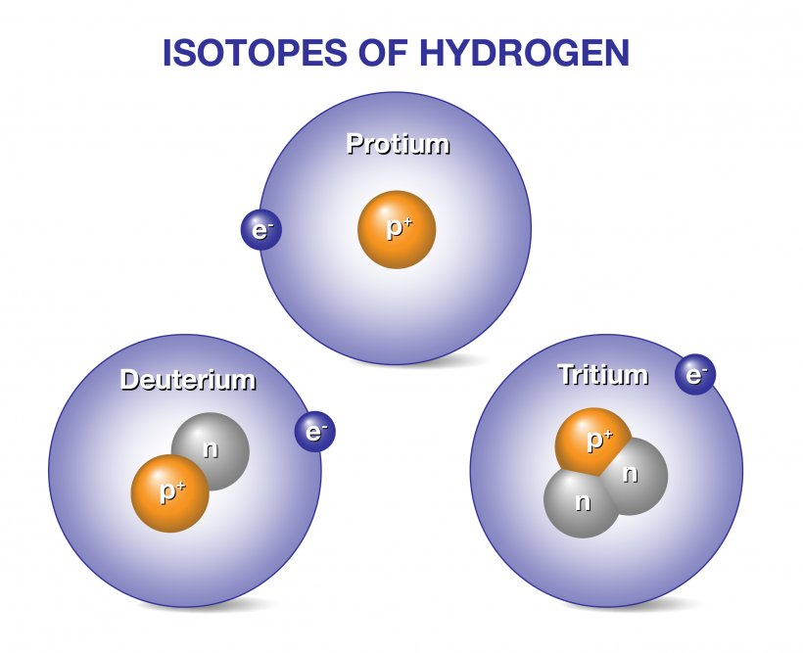
Isotopes are classified into two types:
1. Stable Isotopes
2. Radioactive Isotopes
Stable Isotopes: These isotopes are stable in nature and do not emit any kind of radiation. e.g. ¹³C, ³⁵Cl, ¹H (protium), ²H (deuterium)
Radioactive Isotopes: Radioactive isotopes are also called as radioisotopes. These are natural or artificially created isotopes of a chemical element having an unstable nucleus that decays, emitting alpha, beta and gamma rays until stability is reached. The stable end product is a non-radioactive isotope of another element. The original nuclide is called the parent and the product is called the daughter nuclide. This phenomenon of nuclear changes is termed as disintegration or radioactive decay. e.g.
X ⎯⎯⎯⎯⎯⎯⎯→ X + α-rays
Parent nuclei Daughter nuclei (Stable or unstable)
Radioactive Isotopes are of two types:
1. Naturally occurring: e.g. U²³⁵(Uranium), Ra²²⁶(Radium), Rb⁸⁷(Rubidium),
K⁴⁰ (Potassium)
2. Artificial radionuclides: They are produced in nuclear reactions. It is created by bombarding atoms of specific element with radiation particles, thus creating new atoms existing from another type of element. e.g. Formation of radioactive isotope of phosphorus by bombarding aluminium with alpha particles.
Al + He ⎯→ P + n
Stability of Isotopes:
The naturally occurring nuclides have a particular ratio of protons and neutrons in most of the elements. Any deviation in this ratio alters the atomic number and cause unstability of nucleus. e.g. Stable ratio of potassium is 1:1.115.
If more neutrons are added to the nucleus, this ratio will get disturbed and nuclide becomes unstable.
- Most isotopes of element with Z number 83 or less are stable and are called as stable isotopes.
- However, some naturally occurring isotopes with Z number less than 83 are unstable.
- All the nuclides with Z number above 83 whether naturally occurring or artificially prepared are unstable.
Radioactive decay
Radioactivity involves release of radiation from the nuclei of radioactive isotopes. The quantity of radioactivity contained in given sample does not remain same and keep on decaying continuously. Each radionuclide, whether natural or artificial get disintegrated by the emission of energy.
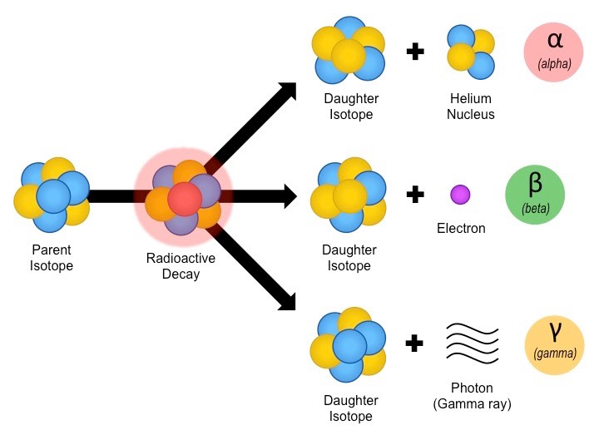
Identification of radioactive element depends upon:
- Disintegration rate
- Decay constant
- Half life
- Type of radiation emitted
Half-Life (t_{1/2}):
It is the time required for a radioactive isotope to decay to one half of its original value at any given point of time.
Each radioactive element has its own characteristic half-life (t_{1/2}), irrespective of quantity present.
t_{1/2} = λ where λ = Disintegration constant
The half-life period for any given radioelement remains unchanged under varying conditions of temperature, pressure and chemical environment. This is because radioactivity is a nuclear property and remains unaffected by changes in the outer electron arrangement.
e.g. Initially 64 micro curies of radioactivity occur in a given sample of ferric citrate (⁵⁹Fe) solution on a particular date.
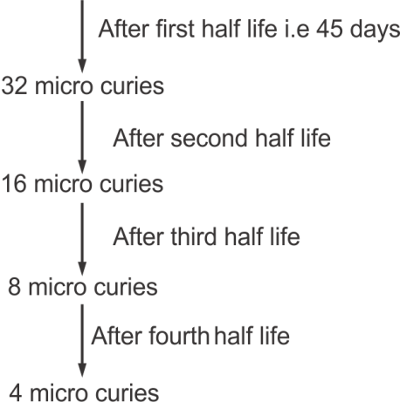
It was observed that radioactivity is reduced to 1/6th of its original value after 4th half life. In calculating the dose of any radiopharmaceutical i.e. t_{1/2} calculation needs to be considered.
Name | Half-life | Application
Ferric citrate (⁵⁹Fe) solution | 45 days | Study of iron metabolism and RBC formation
Sodium iodide (¹³¹I) | 8.06 days | Thyroid scanning and study of thyroid uptake
Sodium phosphate (³²P) injection | 14.2 days | Treatment of polycythemia (overproduction of RBCs)
Calcium chloride (⁴⁵Ca) | 160 days | Study of calcium metabolism disorder, bone cancer
Ammonium Bromide Injection (⁸²Br) | 36 hrs. | Extracellular water measurement

Units of Radioactivity:

Curie: It is defined as the quantity of any radioactive substance which undergoes the same number of disintegration in unit time as of 1 gm Radium and is equal to 3.7 × 10¹⁰ disintegrations per second. It is symbolized as ‘C’.
1 gm of radioactive element = 3.7 × 10¹⁰ disintegrations/sec

Roentgen: It is a unit of measurement for the exposure of X-rays and Gamma rays.
1R = 2.58 × 10⁻⁴ C kg⁻¹ (C = Couloumb)

RAD (Radiation Absorbed Dose): It is a unit of absorbed radiation dose.
1 RAD = 10⁻² J/kg
Each 1R absorption in the air has been equivalent to 0.87 RAD and for water it has been 0.97 RAD. Pharmaceutical dosage forms are described in terms of RAD units.

RBE (Relative Biological Effectiveness): Since the effect of given radiation on biological effectiveness depends upon the type of radiation, a unit known as Relative Biological Effectiveness or RBE has been introduced. This expresses the relative effects of radiations (alpha, beta and gamma) on the biological system.

Becquerel: One disintegration per second
1 Bq = 2.7 × 10⁻¹¹ Ci (Ci = Curie)
Radioactive Dosimetry:
Dosimetry is the measurement of radiation dose. Radiation dose can be calculated only if bio-distribution and clearance rate are known. Bio-distribution is the amount of activity within the organ, while the clearance rate is the rate at which the drug is eliminated from the body with respect to time.
The SI unit of dosimetry is Gray (Gy) or rad.
1 Gy or rad = One gray of radiation is equal to one joule of energy in the form of ionizing radiation, divided by one kilogram of matter.
Radiopharmaceuticals used in majority of diagnostic studies in adults ordinary result in organ dose of less than 5 rads, within dose to the whole body of less than 0.2 rads. Radiation dose below 1.0 rad are considered to be in ‘low dose’ range.
Radiation dose level is estimated using average activities administered to adults like:
Radiation dose | Diagnostic use
High doses (>5 rads) | - ¹³¹I- Sodium iodide for thyroid imaging  - ^{m}I-iodocholesterol for adrenal imaging  - ^{n}Se-Selenomethionine for pancreas imaging  - ^{99m}Tc-DMSA (dimercaptosuccinic acid) for renal imaging
Medium dose (1-5 rads) | - ^{99m}Tc-pertechnetate for brain imaging  - ^{99m}Tc-(DTPA Diethylenetriamine-pentaacetic acid) for brain imaging  - ^{99m}Tc-Sulphur colloid for liver imaging  - ^{99m}Tc-diphosphates for bone imaging  - ⁶⁷Ga-citrate for tumour and abscess imaging  - ²⁰¹Tl-chloride for heart imaging  - ⁵¹Cr-Sodium chromate for red cell studies  - ^{99m}Tc-gluceptate for brain and kidney imaging
Low dose (< 1 rad) | ^{99m}Tc (Technetium)-red blood cells for blood pool imaging  ^{99m}Tc-MAA (Macro aggregated albumin) for lung imaging  ¹³¹I-hippuran for kidney function studies  ¹²⁷Xe and ¹³⁰Xe for lung ventilation imaging

Mode of Decay:
Radionuclide can undergo disintegration by different modes until a stable nucleus does not form. If the daughter element is unstable it becomes a parent element and starts decaying, until it becomes stable. This series is called as radioactive series.
Daughter nucleus thus formed from the parent nucleus will have different number of neutrons or atomic number.
Measurement of Radioactivity
The measurement of nuclear radiation and detection is an important aspect in the identification of type of radiations (α, β, γ) and to assay the radionuclide emitting the radiation, suitable detectors are required. The radiations are identified on the basis of their properties.
e.g. Ionization effect is measured in Ionization Chamber, Proportional Counter and Geiger Muller Counter.
The scintillation effect of radiation is measured using scintillation detector and the photographic effect is measured by Autoradiography.
Principle: All the detectors are based on the principle that the radiation deposits its energy through the formation of charge carriers, either directly or indirectly in the detector which results in the flow of current or a voltage pulse. The ions created in the detector can be collected by applying the electric field within the detector and the current flowing through the detector can be measured using an electrometer.
Gas Filled Detectors:
1. Ionization Chamber:
It is the simplest gas filled detector which is based on the collection of all the charges created by direct ionization of the gas molecules through the application of electric field.
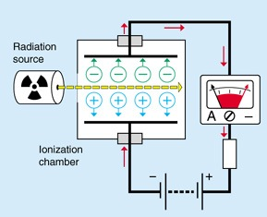

It consists of chamber filled with gas like Argon, Helium or Air etc. Ionization chamber is fitted with two electrodes kept at different electric potential (50-100V for each cm of distance between two electrodes) and a measuring device to indicate the flow of current. Radiations bring about ionization of gas molecules or ions which cause emission of electrons which in turn reveals the changes in electric current.
2. Proportional Counters:
It is the modified form of ionization chamber in which an applied potential causes ionization of primary electron which further leads to thunderous bursting/ production of more free electrons, which get carried to anode and current pulse through electric circuit gets amplified. The voltage range over which ionization occurs is called proportional region and counters working in this region is called proportional counter.
If the electric field gradient between the cathode and anode is increased by increasing applied voltage, the electron produced in primary ionization further ionize the gas molecule and number of ion pairs is multiplied. For each primary electron liberated, larger numbers of additional electrons are liberated and the current pulse get amplified.
The total charge collected becomes proportional to the original number of ion pairs. It is operated at pulse ratio and used in the form of gas filled or gas flow counter for α, β and fission fragment counting.
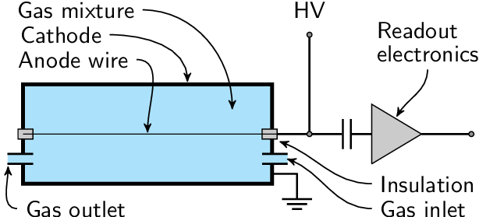

3. Geiger-Muller Counter:
GM counter was developed by Geiger and Muller in Germany in the year 1928. It is the oldest radiation detector due to its low cost, simplicity and in case of operation; it is the best detector among all.It does not require use of any high gain amplifier and can detect α, β, γ radiations easily.
Principle:
A GM counter consists of a GM tube, sensing element which detects the radiation and processing electronics which displays the result. The GM tube is filled with an inert gas such as Helium, Neon or Argon at low pressure, to which a high voltage (450-500 V) is applied. The tube conducts electrical charge when a particle or photon of incident radiation makes the gas conductive by ionization. The ionization considerably amplified within the tube to produce easily measured detection pulse, which is fed to processing electronics and display the result.
Construction:
- It consists of a cylinder 1-2 cm in diameter of stainless steel or glass coated with silver on inner side which acts as cathode.
- Internally a tungsten wire is suspended which is mounted at one end with a glass bead, act as anode.
- Cylinder is filled mixture of gas (argon and helium generally used) which also contain a small amount of quenching vapours.
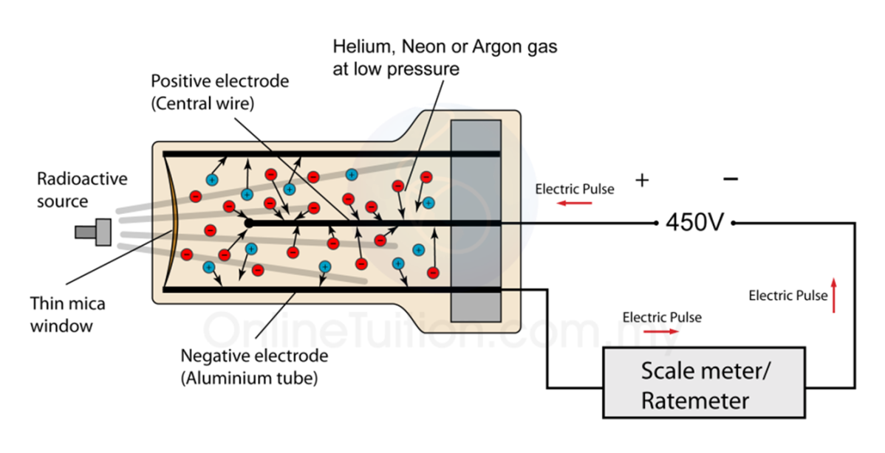
Quenching vapours are used:
(a) To prevent the false pulse that may be produced due to positive ion reaching the cathode.
(b) To absorb photons emitted by exciting atoms and molecules returning to their ground state.
Note: Chlorine, Bromine, Ethanol are commonly used as quenching agents.
Depending on purpose, different counters are used, like:
1. For counting the radioactive solid source, the end window type GM counter has been used in which window has been made up of Aluminum alloy (7 mg /cm²), Mica or may be thin glass bubble (15 mg/cm²).
2. For counting beta and gamma particles, thin glass walled counters may be used. These have been normally of about 1 cm in diameter, having a glass wall of
20-40 mg/cm² thickness and tube is coated on inside with Graphite to form cathode.
3. In order to count radioactive liquids, the counter having the capacity of 10 cm³ is used. In such a counter, 3% solution of Uranium salt gives nearly 10,000 counts per minute.
4. To count radioactive gases, radioactive gas is introduced together with counting gas. For more efficient gamma counting, counter having lead or copper cathode have been used.
Working:
- Radiations when enter the tube through a thin section also called as window causes the ionization of gas molecules. From these ionized atoms or molecules, an electron is knocked out of the atom and the remaining atom is positively charged.
- When the high voltage is applied across the electrode (300-1300), the electrons and positively charged ions are attracted towards anode and cathode respectively.
- Hence, each particle of radiation produces a brief flow or pulse of current which can be transmitted to radioactive sensor via an interface, which is finally recorded in computer.
- All pulses from a GM counter are of same amplitude for any incident radiations.

Disadvantages:
A GM counter cannot distinguish between types of different radiation and their energy. However, the multiplication factor is a big advantage in simple radioactive counting.

Scintillation Detector:
When high energy radiation or photons is incident on certain substance, a flash of light is emitted by the phenomenon called fluorescence or phosphorescence.

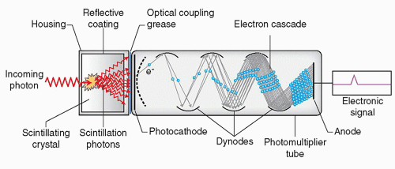
Scintillation Detector
This output light can be used as a measure of adsorbed radiation on scintillation detector. This emitted light when enters into photo-multiplier tube; it multiplies and amplifies even a small signal. So it becomes possible to measure alpha, beta or gamma radiation by scintillation detector.

Important properties of good scintillation detector are:
- High scintillation efficiency.
- The light produced should be proportional to the light incident on detectors.
- Detector material should be transparent to the wavelength range and must not produce any interference in the resultant spectra.
- Short decay time of the induced fluorescence can be increased by dynodes which are made up of phosphor or fluor which multiplies the electrons when strike to them. Hence various inorganic and organic scintillation detectors can be used to measure the incident radiation.
- Inorganic scintillation detectors like alkyl halides are most common compounds.
e.g. Sodium iodide, Cesium iodide, Lithium iodide.
- Organic Scintillators like plastic scintillators have good scintillation property but stilbene have low scintillation property.
Semiconductor Detector:
It is a diode of n (electron rich) and p (electron deficient) semiconductors. In a semiconductor the band gap is very small of the order of 2-3 eV and therefore large numbers of electron hole pairs are formed, thus, giving rise to very good resolution to these detectors. Application of a reverse bias across the diode causes transport of electrons towards the
n-end and that of ‘holes’ towards p-end. The absorption of incident radiations results in the formation of electron and hole pairs which move under the influence of applied electric field. The collection of electrons at the electrode produces a voltage pulse, which is proportional to the intensity of the incident radiation.
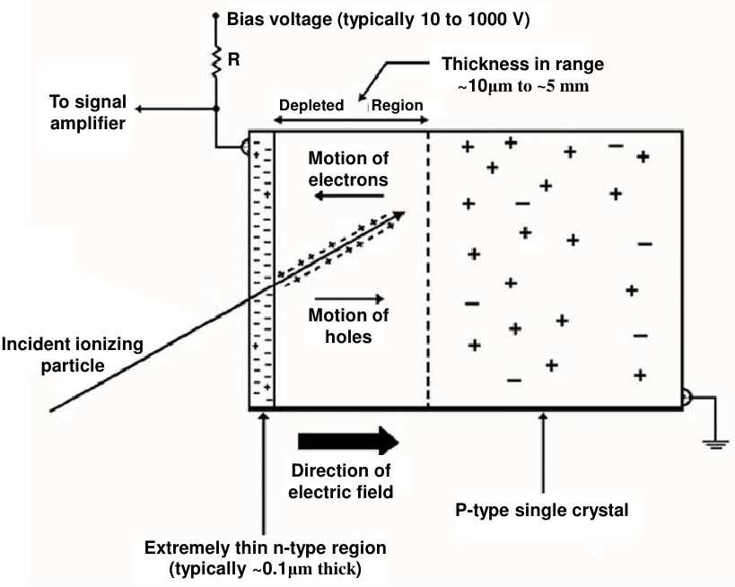
Solid State Detectors:
They have high resolution, compactness and easy interpretation of output signal.
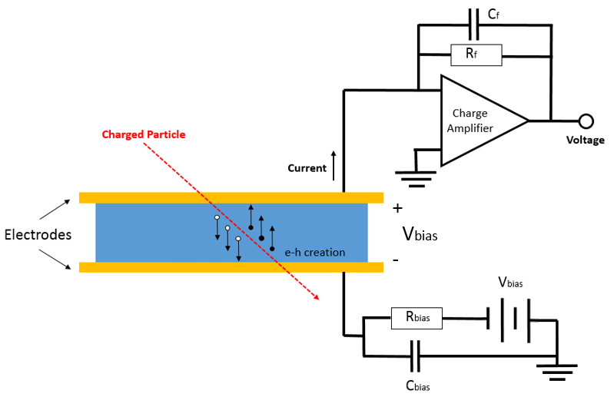

(a) Cerenkor Detector: These are based upon light which is emitted by fast charged particles through an optically transparent medium with refractive index of more than one. Schematic layout of the Cherenkov detector used in the experiment that discovered the antiproton. The peculiar arrangement of the cylindrical and plane mirrors (a) allows to select a well defined range of Cherenkov angles and to place the three PMTs outside the region traversed by the particles. The forward section of the counter is shown in (b).

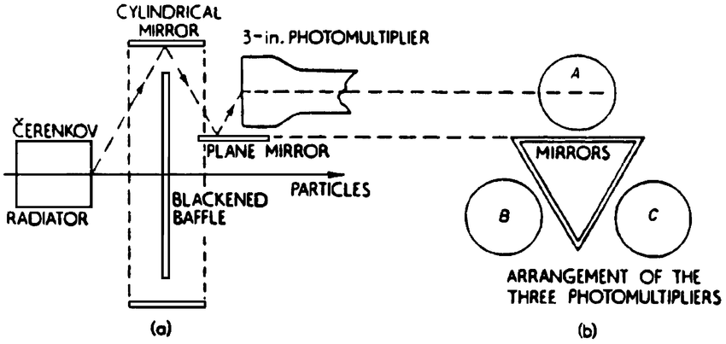

(b) Thermoluminescence dosimeters: These are made up of those inorganic crystals in which electron hole pairs have been formed due to radiations which can trap these pairs and on heating lead to emission of light. e.g. CaSO₄:Mn, LiF, CaF₂:Mn etc
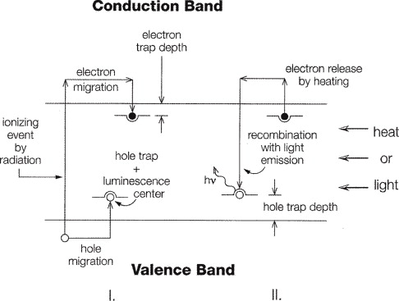
(c) Track-etch Detector: Ionizing radiations having higher linear energy transfer (LET), passing through a dielectric material create trail of damaged molecule along their path. In some material, the tract can be visible upon etching in a strong acid or alkali solution. The damaged molecular tracks are etched faster than the bulk and look like a pits on the surface. These tracks can be counted by viewing through a microscope. The commonly used track-etch materials are quartz, mica, silica glass, flint glass, polyethylene terephthalate, lexan, markrofol, cellulose triacetate, cellulose nitrate.
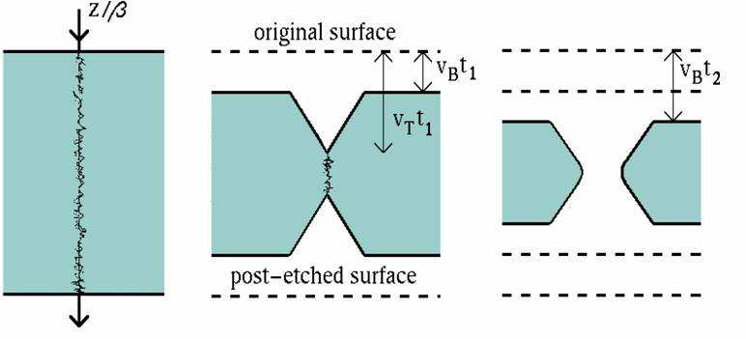
(d) Autoradiography (Photographic Emulsion): Ordinary photographic film is made up of silver halide grains (AgBr) suspended in Gelatin matrix and supported with a glass or cellulose acetate film. Incident radiation ionizes or sensitizes the silver halide grain which remains intact for indefinite period until they are developed. These are more useful in detecting and determining gamma radiations in physiological studies of plants and animals. First of all, administer radioactive substance to an animal, after sufficient time for localization, tissue is removed and embedded in paraffin. Now, cut into sections and kept with photographic emulsion in dark room. Radioactive particles emit radiations and darken the photographic emulsion, develop and fix the emulsion.
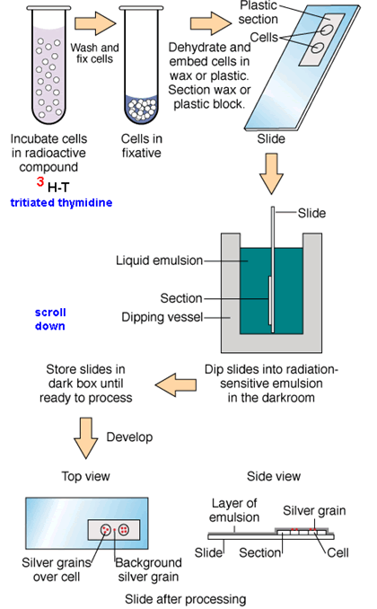
Handling and Storage of Radioactive Material:
Great care must be taken in handling and storage of radioactive material so as to protect the people from its harmful effects.
- The radioactive materials are stored in remote areas such that it should be away from exposure to human beings.
- α and β-emitters are stored in thick glass such that shielding effect is provided,
while γ-emitters are stored in lead containers.
- The area of radioactive material should be tested for intensity of radioactivity.
- Exposure to radioactive radiation can cause blood cancer to persons.
- Lead shielding is required while handling with radioactive substances.
- Shielding effect can also be achieved by water layer and concrete blocks. Water layer blocks only radiation which allows visible light to pass while concrete blocks all the radiations.
Certain precautions must be taken:
(i) Radioactive material should never be touched with hands but handled by means of forceps.
(ii) Food contaminated with radioactive material can cause serious damage to internal organs, so avoid any food intake, drinking and smoking within the lab.
(iii) Sufficient protective clothing or shielding must be used while handling the material.
(iv) Radioactive material should be kept in labeled containers and must be shielded.
(v) Area of storage must be under proper supervision.
(vi) Disposal of radioactive material is done with great care.

Sodium Iodide (I¹³¹)
Synonym: Radioactive iodine
Out of all radioactive isotopes of Iodine, I¹³¹ is most commonly used. It is used as an aqueous solution of sodium iodide having sodium thiosulphate in addition as a reducing agent.
Standards: It should not contain less than 90% and not more than 110% of labelled amount of Iodine-131 as iodide which is expressed in microcuries or millicuries at the time indicating in the labelling.
Method of Preparation:
The first production of Iodine-131 took place in France in the year 1949 at the Fort de Chatillon, the site of the first Zoe atomic reactor, before it was transferred to the nuclear research centre at Saclay. The isotope has been used since 1942, however, in the treatment of thyroid cancer.
Most I-131 is prepared in nuclear reactor by neutron-irradiation of a natural Tellurium target. Irradiation of natural tellurium produces almost entirely I-131 as the only radionuclide with a half-life longer than hours. Ultimately in 8.02 days it gets converted into Xenon-131 (stable isotope).
Te¹³⁰ ,⎯⎯→ Te¹³¹ β⎯⎯→ I¹³¹ βγ⎯⎯⎯→ Xe¹³¹
Properties:
- It forms a colorless solution.
- I¹³¹ have half-life of 8.4 days and emits beta and gamma radiations.
- Its solution is having pH range of 7 to 10.
Hyperthyroidism Treatment by I¹³¹:
Iodide inhibits the release of thyroid hormone and forms the basis for its use in hyperthyroidism. All the isotopes of iodine are rapidly taken up by thyroid follicles. Radioactive iodine i.e. I¹³¹ is available as NaI¹³¹ solution and is administered orally.
The absorption of I¹³¹ leads to highly localized destruction of thyroid follicles due to
β-particles emission. This property of I¹³¹ has promoted radioactive iodine as a therapeutic alternative in surgical removal of the gland. The radio iodine therapy is considered advantageous over surgery because of the simplicity of its procedure, its applicability to patients, avoidance of surgical risks and complications.
Sodium iodide-131 solution and capsule:
Sodium iodide (I¹³¹) are suitable both for oral or i.v. administration. The solution is clear and colourless, but as the time passes both the solution and glass may get darken due to the effect of radiation. The pH of solutions varies between 7.5-9.0.
For injection, a suitable preservative such as benzyl alcohol is added. A reducing agent such as sodium thiosulphate is also added to the solution, to prevent the oxidation of sodium iodide in aqueous solutions.
Potassium salt, iodide and iodate have been acting as a carrier for iodide ions and for iodate ions present in the sodium iodide I¹³¹ solution.
Sodium iodide (I¹³¹) capsules are prepared by evaporating an alcoholic solution of sodium radio-iodide directly on the walls of the capsule or on inert capsule filling material.
Radioactive Identification:
The spectrum of I¹³¹ has been complex but the most abundant type of photon is having energy of 0.364 MeV. It is possible to determine the energy in a spectrometer by detecting γ-radiation with a scintillation counter which is having a thallium activated. The γ-ray scintillation spectrum of sodium iodide (I¹³¹) solution has been found to be identical to that of specimen of I¹³¹of known purity, which exhibits major photoelectric peak, having energy of 0.365 MeV.
Assay:
It is possible to determine its activity, using suitable counting equipment by comparison with a standardized I-131 solution or by measurement of an instrument calibrated with the aid of such solutions. Iodine-131 has been emitting both beta and gamma particles in its decay process. Radioactivity has to be recorded on a counting assembly which is having either a Geiger-Muller counter or a scintillation detector used as a sensing unit and an electronic sealing device.
Packaging and Storage Condition:
The solution has to be prepared in single dose or multiple dose containers that have been previously treated to prevent absorption.
So as to avoid absorption of radionuclides on the wall of the container including laboratory vessels, it has been recommended that containers used to handle sodium iodide
I-131 solution, should be first of all rinsed with a solution having approximately 0.8% of sodium bisulphate and 0.25% of sodium iodide and then water until the last rinsing has been neutral to litmus.
Uses:
- Radioactive iodine is mainly used for the diagnosis of disorders of thyroid function.
- It is also used in the treatment of hyperthyroidism.
- Radioactive iodine is also used in the treatment of Grave’s disease (toxic diffused goiter).
- It is also used in radiotherapy of thyroid cancer.
- It is also used in the treatment of thyrotoxicosis.

Applications of Radioisotopes
Radioisotopes have their uses in medicines in four different ways:
(i) Radioactive tracers for diagnostic purpose.
(ii) Radiation source in therapy.
(iii) Research.
(iv) Sterilization.

(i) Radioisotopes in Diagnosis:
- Chromium in the form of sodium chromate attaches strongly to the hemoglobin of red blood cells. This makes radioactive chromium-151 an excellent isotope for determining the flow of blood through the heart. This isotope is also useful for determining the lifetime of RBC, which can be of great importance in the diagnosis of anemia.
- Cyanocobalamin (⁵⁷Co) is used for measuring glomerular filteration rate.
- Ferric citrate (⁵⁹Fe) injection finds the use in hematological disorders.
- Colloidal gold (¹⁹⁸Au ) has been used in studying the blood circulation in Liver.
- Sodium iodide (¹³¹I) injection is used to study the functioning of Thyroid gland.
- Iodinated (¹³¹I) human serum albumin injection finds the use to investigate cardiovascular functions.
- Radioactive cobalt (Cobalt-59 or Cobalt-60) is used to study defects in Vitamin B₁₂ absorption.
- Sodium iodohippurate I-131 injection finds the diagnostic use in the study of renal functions.
- Sodium rose Bengal I-131 injection finds use as a diagnostic agent to test liver functions.
(ii) Radioisotopes in Therapy:
The therapeutic use of radioisotopes depends on the ability of their ionization. These are useful to destroy or weaken malfunctioning cells. It is β-radiation that causes the destruction of damaged cells. The radionuclide therapy (RNT) or short range radiotherapy is known as brachytherapy and this is becoming the main means of treatment. Radiotherapy is less commonly used in the diagnosis of radioactive material present in medicines. An ideal therapeutic radioisotope should be a strong β-emitter with just enough γ to enable imaging. e.g.
- Yttrium-90 is used for the treatment of cancer particularly liver cancer and it is being used more widely including for arthritis.
- Iodine-131 is used to treat the thyroid for cancers and abnormal conditions such as hyperthyroidism.
- Phosphorus-32 is used to control the excess of RBC production in bone marrow
i.e. Polycythemia.
- Boron-10 is used in the treatment of tumor. Boron-10 gets concentrated in tumor and on irradiation with neutrons, it produces high energy α-particle which kills the cancer.
- Lead-212 can be attached to monoclonal antibodies for cancer treatment.
- The alpha decays of Bismuth-213 and Polonium-210 are the active ones destroying cancer cells over a couple of hours.
- Gold-198 finds use in carcinoma of uterus and urinary bladder.
- Cyanocobalamin finds use in diagnosis of pernicious anemia.
- Iodine-131 preparation finds use in the treatment of thyroid gland.
(iii) In Research:
Excellent biological and medicinal study can be carried out with radioactive isotopes as tracers. Generally Carbon-14 and Tritium are most commonly used.
(iv) Sterilization:
Thermolabile substances like vitamins, hormones, antibiotics can be safely sterilized by strong radiation sources. e.g. Cobalt-60 or Cesium-137 may be used for sterilizing surgical instrument.
1. Agricultural Use: Gamma rays are used to kill pests. These are used to induce genetic mutations in a plant in order to produce a better strain which has higher resistance against pest and diseases. Radioisotopes used as tracers in the effectiveness of fertilizers are N-15 and P-32.
2. Industrial Uses: Americium-241 is used in many smoke detectors for homes and business in thickness gauges designed to measure and control thickness during manufacturing processes. Californium-252 is used for neutron activation analysis,
to inspect airline luggage for hidden explosives.
3. Analytical Applications:
(a) Analytical procedures (b) Radioisotope dilution analysis
(c) Recovery indication in analysis (d) Radioimmuno Assay (RIA)
(e) Solubility determination (f) Activation analysis
(g) Enzyme assays (h) Receptor assays
4. Reaction Mechanism: Several instances have been reported of information concerning reaction mechanisms obtained with the aid of artificial radio elements.

Various therapeutic and diagnostic applications of radio-isotopes:

Sr. No. | Radio-isotope | Applications/Uses
1. | Calcium-44, 45 (Ca-44,45) | Study of bone structure and bone cancer
2. | Carbon-14(C-14) | Emit β-radiations, used in medical and pharmaceutical research
3. | Strontium-90(Sr-90) | Pure β-emitter, used in radiotherapy of superficial carcinoma.
4. | Cobalt-60(Co-60) | γ-emitter, radiotherapy , sterilization of heat labile substances, study of vitamin B₁₂
5. | Cobalt-57(Co-57) | Used in diagnosis of pernicious anemia

Sr. No. | Radio-isotope | Applications/Uses
6. | Hydrogen- ²H, ³H (β-emitter) | Used to determine total body water content
7. | Iron-59 (Fe-59) | Emit beta and gamma rays, used to study iron absorption, life span of red blood cells
8. | Nitrogen-13,15(N-13, N-15) | Used in investigation of amino acid and protein metabolism
9. | Oxygen-17,18(O-17, O-18) | To study organic reactions and photosynthesis
10. | Oxygen-15(O-15) | Cerebral blood flow imaging and myocardial blood flow imaging.
11. | Sodium-22,24(Na-22, Na-24) | Used in estimation of extracellular fluid, body circulation rate, excretion and distribution of water
12. | Sodium chromate  (Cr-51) solution | It finds use in measuring red cell volume and its survival time
13. | Cr-51 EDTA | For glomerular filtration rate estimation.
14. | Fluorine-18 (Positron emitter) | Used in investigation of tumor imaging, bone imaging, myocardial imaging.
15. | Gallium-67 (γ-emitter) | Tumor imaging and inflammation/infections imaging
16. | Gallium-68 (positron emitter) | Prostate cancer imaging
17. | Iodine-123 (γ-emitter) | Thyroid uptake and thyroid imaging, renal imaging
18. | Iodine-125 | Used in diagnosis of clotting by fibrinogen scan
19. | Iodine-131 | Used in thyroid uptake study, also used to treat thyroid carcinoma and non-toxic goiter.
20. | Krypton-81m (γ-emitter) | Lung ventilation and lung perfusion imaging
21. | Nitrogen-13 (positron emitter) | Myocardial blood flow imaging
22. | Phosphorus-32 | In the treatment of polycythemia and related disorders
23. | Radium-223 (α-emitter) | In the treatment of metastatic cancer in bone
24. | Selenium-75 (γ-emitter) | Investigation of adrenal gland imaging and bile salt absorption
25. | Technetium-99m (γ-emitter) | Investigation of stomach and salivary gland imaging, first pass blood flow imaging, bone marrow imaging, lacrimal imaging, gastric emptying imaging etc.

Hazards associated with Radiopharmaceuticals -The possible risks from radiation are limited to those effects resulting from altered individual cells (damaged either singly in small numbers) and include induction of cancer, genetic effects, and effects on an embryo. Effects such as cell depletion of a fine marrow and impaired fertility or sterility are associated with diagnostic radiopharmaceuticals.
The following hazards of radiation exposure and relative risk of such effects are observed:
1. Induction of Cancer: Cancer induction is probably at the greatest risk to humans exposed to low levels of radiation. Radiation induced cancer in humans are breast, thyroid, lung cancers, leukemia and alimentary tract cancer. The most significant human experience comes from the survivors of the 1945 Hiroshima and Nagasaki atomic bomb blasts.
2. Genetic Defects: The stimulation of genetic risk in humans is based on animal studies, since there is no significant demonstration of radiation induced gene mutation in humans. Thus the risk of a genetic defect in child of a patient who had undergone diagnostic test using radionuclide is insignificant.
3. Effect on the Embryo: The major effects of high doses of radiation on the embryo are death, malformation and reduced growth. These effects are more likely to occur with increasing doses. The stage of gestation during which the mother is irradiated is of major importance in determining effects as differentiating organ system is most sensitive at that time. During the period of organogenesis (about 11 to 50 days after fertilization), congenital malformation and retarded growth are the most likely consequences of radiation damage and after organogenesis, growth retardation is the major effect from high doses.
4. Lactation: The use of radiopharmaceuticals during lactation involves a risk as the radiation passes in breast milk. Therefore, a safe interval between administration
of radiopharmaceutical and resumption of breast feeding should be observed.
e.g. Tc-99 when administered, breast feeding should be discontinued for 24 hrs.

