Southern Corn Leaf Blight: Behavior of maize crop, Approaches and Future outlooks, and Research trends for disease control related to the effectiveness of new sources of resistance
Bitaisha Nakishuka Shukuru
Department of Plant Pathology, School of Agriculture, Lovely Professional University (LPU), PO Box 144411 Phagwara, Punjab, India.
* Author email adress: nakishuka.12111882@lpu.in
Author ORCID iD: https://orcid.org/0000-0002-3037-261X

Abstract
In several corn-growing areas, the average production is relatively low as compared to normal potential productions in many countries around the world, although the area of cultivation is somehow increasing by every day in those areas with low yield of maize. The most cultivated cultivars don’t resist Southern Corn Leaf Blight where the disease is reported. Farmers try to develop a disease management method without success due to lack of efficacity from used techniques. Fungi and fungal-like organisms (FLOs) collectively cause more plant diseases than any other group of pests. Bipolaris maydis was reported to be the most important fungal plant pathogen to cause SCLB disease in maize crop. Acquisition of knowledge in identifying and controlling fungal diseases, especially SCLB to reduce its effects of toxicity, is needed nowadays. It is known that the plant pathogenic fungus, Cochliobolus heterostrophus race T, produces T-toxin (HMT-toxin), one of the most dangerous mycotoxins affecting human life. Accordingly, it is estimated several millions of currencies are lost annually because of mycotoxin contamination of crops in many countries around the world. In maize, mycotoxin contamination often occurs in association with SCLB, which reduces quality and yield. This chapter gathered information on the use of integrated SCLB disease management and revealed some effective techniques for control of the pathogen. General principles used in plant disease management and concepts of disease triangle were developed and adapted in case of the current disease for better understanding of its control. The information generated from this endeavor benefits plant breeders and other scientists, including plant pathologists and researchers in the public and private sectors interested in improving resistance to the infection of the fungal pathogen.
Keywords: Maize, Bipolaris maydis, sources of resistance, integrated disease management

- Introduction
Maize, also known as corn, is widely grown throughout the world. It is the most produced grain in the world and has the highest production of all cereals. It is an important food staple in many countries. There are many causes of low yields of maize and a major role is played by diseases.
SCLB is considered as one of the serious and major important diseases worldwide with its effects on yield crop. It is a pandemic and widespread disease. It is found everywhere the corn is grown. Obviously, humans have little or no control over the evolution of pathogenic organisms. Like any living thing, fungi along with all other plant-pathogenic microbes and pests, will find a way to survive and propagate (Bruns, 2017). Collectively, fungi and fungal-like organisms (FLOs) cause more plant diseases than any other group of pathogens (Bruns, 2017; Ahmar et al., 2020). Southern Corn Leaf Blight (SCLB), also called Maydis Leaf Blight (MLB) or Southern Leaf Blight of Maize (SLB Zea mays) is due to the infection of Cochliobolus heterostrophus (teleomorph), also known as Bipolaris maydis (Nisikado and Miyake) Shoem (anamorph), Helminthosporium maydis Nisikado (anamorph) or Drechslera maydis (Nisikado and Miyabe) (anamorph) or Ophiobolus heterostrophus Drechsler (Burton, 1968; Mubeen et al., 2015; Wang et al., 2017; Wang et al., 2019; Jeevan et al., 2020; Castellanos Gonzalez et al., 2020; Rehman et al., 2021; Singh et al., 2021; Meshram et al., 2022).
For its identification, signs and common symptoms of disease involved by the pathogen are diversified, including lesions on glumes found in inflorescence; abnormal colors, fungal growth, and wilting located on leaves; discolorations and rot found on seeds; and discoloration of bark observed on stems. Based on what’s revealed by Agrios (2005) and Ali et al. (2011), SCLB symptoms depend on host germplasm and race of the pathogen (O, T and C). Generally, the methods used in management of SCLB include the utilization of chemicals including fungicides and botanical extracts, among which some of these practices are developed here.
The information gathered in this critical appraisal is more interesting as it focuses on the disease which attracted more alerts in the world since its apparition. In the USA, the main origin of SCLB, Ullstrup (1972) reported many alerts about the disease which attracted more of our interest. Accordingly, the SCLB disease epidemic led to immense worldwide publicity by international and local presses and other communication media, at its apparition. In his paper, the author said that no plant disease in the country has ever received so much attention at that time; that in a few period, (especially between August-November 1970); that the Chicago Tribune published about 37 articles on SCLB; people developed awareness about the disease thanks to the help of press including New York Times, Wall Street Journal, and many other influential daily newspapers and weekly news magazines as well; some printed newspapers served for information about the SCLB development in their localities; during their emissions on radio and television, journalists struggled a lot to describing the disease for people to understand it occurrence, impact and trying to cope with it. Technically, the Agricultural Experiment Stations in the country, released many bulletins and circulars, following several epidemiological studies, and different conferences, seminars, symposiums, workshops, and meetings held by different researcher scientists and government, and local leaders as well.
Furthermore, this review intends to identify the new sources of resistance to SCLB under laboratory and field conditions. It carried on the purpose of gaining knowledge on the effectiveness of both SCLB disease control and adoption of new measures to eradicate the pathogen. It is mostly focused on integrated SCLB disease management including complete removal of the pathogen in the growing area of the maize crop by using new techniques revealed here, such as creation of plant immunity and biological control. Empirical studies conducted in different areas in the world such as USA, India, China, Malaysia, and African countries were mostly considered in this review. More than a hundred articles were selected, including some recently published papers in the last five years, i.e., between 2017 to 2022. Around ten books served additionally as sources of information helping in the achievement of objectives of this review. Leaf symptoms (Figure 1) were taken from Shukuru’s master’s dissertation (Shukuru et al., 2023).

- Know the behavior of maize crop
  - Morphological and physiological description of corn
The word "corn" has many different meanings depending on what country you are in. Corn in the United States is also called Indian corn, or maize in many countries of Africa including DR Congo. Corn in England means wheat; in Scotland and Ireland, it refers to oats. Corn mentioned in the Bible probably refers to wheat or barley (Gibson and Benson, 2002). Zea meaning is related to “sustaining life” as derived from ancient Greek word and mays expresses the sense of “life giver” according to Taíno language. The word “maize” by the Spanish connotation “maiz” is the most suitable way of presenting the plant. Other names such as muhindi (Africa) or makki (India) are useful to identify the plant.
The corn, Zea mays, is an annual herbaceous cereal, with low to no tillering, of the Poaceae family, native to Central America. Like most of the tropical poaceous, it presents a metabolism of C4 type photosynthesis, which confers to the plant a higher efficiency than that of the temperate poaceous in the conversion of the light energy. It is a plant of short days whose tropical varieties are often photoperiodic. This oligogenic character could be eliminated at the time of the adaptation of the species to the temperate latitudes (often from 58°N to 40°S). Maize is a monoecious plant, it bears two types of inflorescences: male flowers, grouped on the branched terminal panicle, and female flowers, associated on one or a few cobs inserted in the leaf axils. Although corn is self-fertile, the allogamy is preponderant, and reaches 95%. It results from the monoecy and the protandry of the plant. The production of pollen by the flowers of the corn panicle is very abundant. The male flowering on a plant of corn is earlier than the female flowering (phenomenon of the protandry): that contributes to decrease very strongly the rate of self-pollination of the individuals which would not exceed 5%.
The spikelets of the male inflorescence are inserted in pairs. One of these spikelets is pedicellate and the other is sessile. Each biflorous spikelet, because it contains two flowers, is delimited by glumes, floral pieces with leaf structure. At maturity, the two flowers of each spikelet release their stamens. Each stamen is composed of a net and an anther, anther made of two pollen sacs. The female inflorescence of the corn is a ramification of the main stem. It is itself made up of a series of very short nodes. Each node carries a leaf organ called a spathe in the axil of which a bud remains non-functional. At the end of the branching develops the spike bearing spikelets, themselves composed of flowers and thus ovaries. These ovaries are surmounted by long silks or styles that receive pollen from the male flowers. The silks each surmount an ovary and escape from the "horn" of spathes to receive the pollen. The first setae that appear outside the spathe "cornet" are the setae that originate at the base of the spike. The spikelets are inserted in pairs on the central axis or stalk. Each pair of spikelets is surrounded on the stalk, by two tiny bracts barely visible on the screen (one at the extreme left and the other at the extreme right). Each spikelet is made of two glumes enclosing, on one hand, a sterile flower formed only by two glumellae, and, on the other hand, a fertile flower also composed of two glumellae embracing a gynoecium, i.e., an ovary surmounted by a style.
  - History, origin, and geographic distribution of corn
The origin of maize (Zea mays L. subsp. mays) was clearly established, and its primary center of origin is in Mexico, the native of maize where fossil maize pollen with other archeological evidence were discovered and the Central America. Maize was first domesticated in Tehuacán Valley (Gibson and Benson, 2002). Recent research has modified that it’s the adjacent Balsas River Valley (Piperno, 2011) of south-central Mexico.
Gibson and Benson (2002) reported that maize was only a garden curiosity in Europe, but it soon began to be recognized as a valuable food crop. Within a few years, it spread throughout France, Italy, Southeastern Europe, and North Africa. By 1575 it was making its way into western China and had become important in the Philippines and the East Indies. The main role of the corn plant during the 19th century was closely related to the development of the Midwest. In the westward movement, maize found its primary habitat in woodland clearings and grasslands in Ohio, Iowa, Indiana, Illinois, and adjacent states. These were places where it had not been widely cultivated in prehistoric times. Presently, maize is grown worldwide.
  - Corn diversity and environmental conditions
The genus Zea contains annual and perennial species native to Mexico and Central America. It includes wild forms, “teosinte”, and a cultivated form, “corn”. The genus Tripsacum includes many wild species whose center of diversity is in Mexico and Guatemala. It is a distant relative of corn. Corn is often classified as dent corn or field corn (Zea mays var. indentata), flint corn or Indian corn (Zea mays var. indurata), flour corn (Zea mays var. amylacea), popcorn (Zea mays var. everta), sweet corn (Zea mays var. saccharata), waxy corn or glutinous corn (Zea mays var. ceratina), and pod corn (Zea mays var. tunicata). Gibson and Benson (2002) reported that the corn plant great variability led to the selection of many widely adapted varieties that bore little resemblance. The plant may have varied from no more than a few feet tall to more than 20 feet. It wasn't like the uniform-sized plant most people know today. For the Aztecs, Incas, Mayas and various Pueblo inhabitants of the southwestern United States, maize cultivation took precedence over all other activities. The corn crop requires warm and sunny weather, between 23.9-30 °C, with intermittent moderate rains or artificial watering (around 50 cm) during growing season. Accordingly, Rehman et al. (2021) found that many fungal diseases are mostly favored by humid and warm environmental conditions, but some others are also prevalent in humid and cool weather. This constitutes a suitable interaction between the maize crop and the fungal pathogen.
  - Constraints linked to maize production
Despite the yield potential of maize and its economic advantages procured, its susceptibility to several biotic and abiotic stresses, including especially climate change and diseases, that constitute a major threat to its production. Most important crops next to wheat and rice in the world, and first crop in Africa, maize is often threatened by a variety of pathogens as well as poor crop management. The crop is prone to several biotic stresses, especially foliar diseases caused by fungi, bacteria, and viruses. Nematodes and caterpillars are also still causing damage to maize crop. Under favorable environmental conditions, these pathogens can cause huge yield losses and deteriorate the produce quality. Based on what said Rahul and Singh (2002), it’s about 65 pathogens causing disease to maize crop. Accordingly in Nepal, Subedi (2015) reported a total of 78 species (75 fungal and 3 bacterial species).
  - Maize genotypes sensitivity
Most cultivated clones of maize, whether local and improved, hybrids, inbred lines, or pure lines, don’t resist SCLB where the disease is reported. Cultivars used in rural areas by farmers are susceptible to varying levels of this disease as each genotype has its genetic heritage. In his study, Shukuru et al. (2023) reported specific genotypes demonstrating high resistance to SCLB, that can be grown by research institutions and farmers, and enhance quality of maize products and obtain expected yield.

- Symptomatology, pathogenesis, etiology and spread of the disease
SCLB is among serious and major important diseases worldwide. It is found on all continents of the world. As pointed out previously, symptoms of SCLB depend on the germplasm of the host and the race of the pathogen. For Pavan and Shete (2021), the fungus produces long ovoid and grayish lesions structured by a cigar on the underparts of the leaves. Ear wraps, leaves, cobs, ears, stalks, shanks and sheaths may be contaminated with B. Maydis. If sufficient infection occurs earlier on the shank, the ear can be killed prematurely, causing the ear to fall out. A felted black mold that can cause ear rot can coat grains infected with SCLB. Ear rot is more common on T-breed cms-T cytoplasmic corn (Calvert and Zuber 1973). Infected seedlings may show symptoms of wilting and the infected plant will die after planting within a few days (Agrios, 2005). Culture infected with race O exhibits symptoms such as small, tiny lesions and later turns into a triangle-shaped shape and becomes rectangular when mature (Pal and Kaiser, 2005; Ali et al., 2011). Damage to the photosynthetic area of the leaves, which could lead to improper filling of the grain.

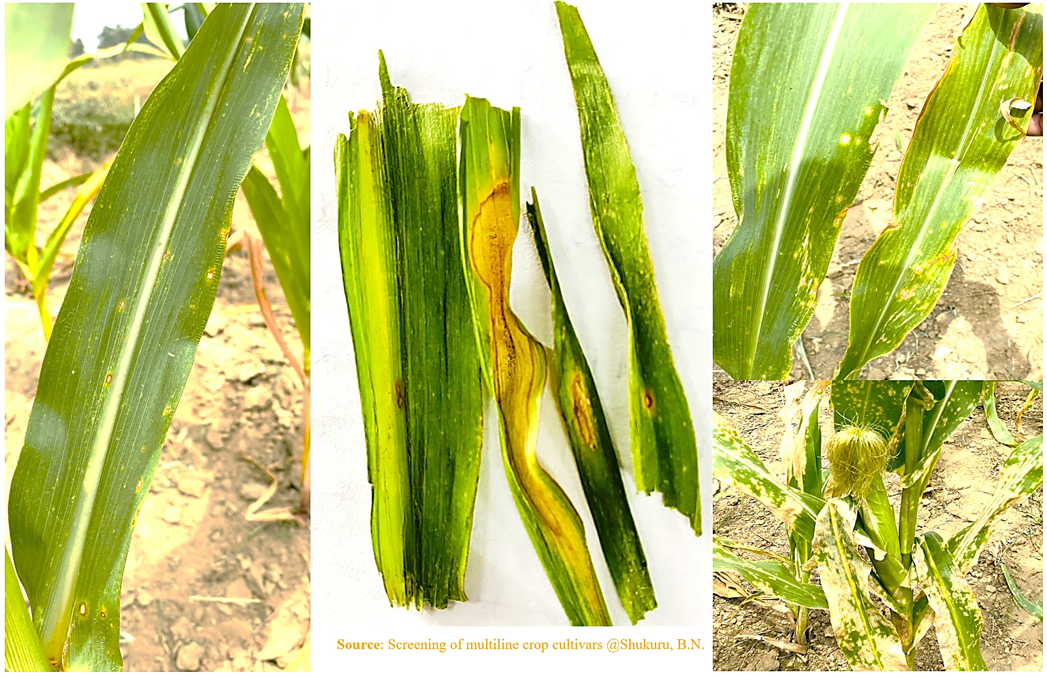

Figure 1. Symptomatology of B. maydis
Cochliobolus heterostrophus Drechsler is an accurately member of taxonomic group of Cochliobolus genus, Pleosporaceae family, order of Pleosporales, subclass of Pleosporomycetidae, class of Dothideomycetes, subphylum of Pezizomycotina, phylum of Ascomycota, kingdom of Fungi and domain of Eukaryota. The genus Bipolaris includes important phytopathogen species with worldwide distribution (Alcorn, 1988; Manamgoda et al., 2014; Sun et al., 2020). C. heterostrophus is heterothallic. It is either asexual conidia which is primary source of inoculum or sexual ascospores. It produces perithecia (Tinline and Dickson, 1958), or pseudothecia in some conditions. The cyclic pathway in B. maydis includes flowering, fruiting , seedling, and vegetative growing stages. In good conditions, spores can germinate and penetrate the plant in just 6 hours. B. maydis overwinters in plant debris as spores until favorable conditions return. Pointed out above, this fungus is also capable of following a sexual disease cycle, but this still only being found during manipulation in laboratory conditions.
Based on what is proved in the Plant pathology book of Agrios (2005), the C. heterostrophus releases spores to infect corn plants. In nature, the asexual cycle occurs primarily and is a major concern. Conidia are mainly released from lesions present on infected corn under favorable wet and warm conditions and transported to healthy plants by rain wind or wind. Germination of the pathogen through polar germ tubes can easily occur on the tissue once the conidia have landed on the leaf surface or leaf sheath of a healthy maize plant. The germ tubes, like stomata, pass through the leaves or reach a natural opening. The fungal mycelium invades parenchymal leaf tissue. The leaf tissue begins to turn brown and subsequently collapses. Such lesions lead to the formation of conidiophores that will further invade the main host plants (husks, grains, leaves, stalks) or release conidial spores to invade neighboring plants under favorable conditions.
According to Robert (1953), SCLB with no race designation, was first discovered in the USA in 1923. It affects mitochondria (Hussain et al., 2016), effectively reducing plant photosynthesis. Prior to the 1970 plant disease epidemic, SCLB was not considered a major corn disease in the USA except for some isolated outbreaks (Carson, 2016). For many research scientists, among them Reddy et al. (1973), and Nelson and Hill (1976), SCLB epidemic occurred in southern USA between 1970 and 1971 and had spread north to Maine and Minnesota by mid-August.
For having favorable conditions (Fig. 2.) of the pathogen means the water is present on the surface of the leaf (Rehman et al., 2021). For the survival and spread of the disease, favorable conditions mainly depend on rainfall amount, relative humidity, and temperature conditions of the area (Sumner and Littrell, 1974). Schenck et al. (1974) showed that prolonged sunny days with dry weather are not suitable for disease progress. Causal organisms survive in diseased maize debris on the surface of soil or inside seed. Based on research results of Aylor (1975), the temperature range of 20-28 °C when presence of continues light and 28 °C in total dark for race O is necessary for conidia sporulation, 20°C and 24 °C for race T, sequentially. B. maydis conidia are detached only in presence of wind speed at 18 km/h.

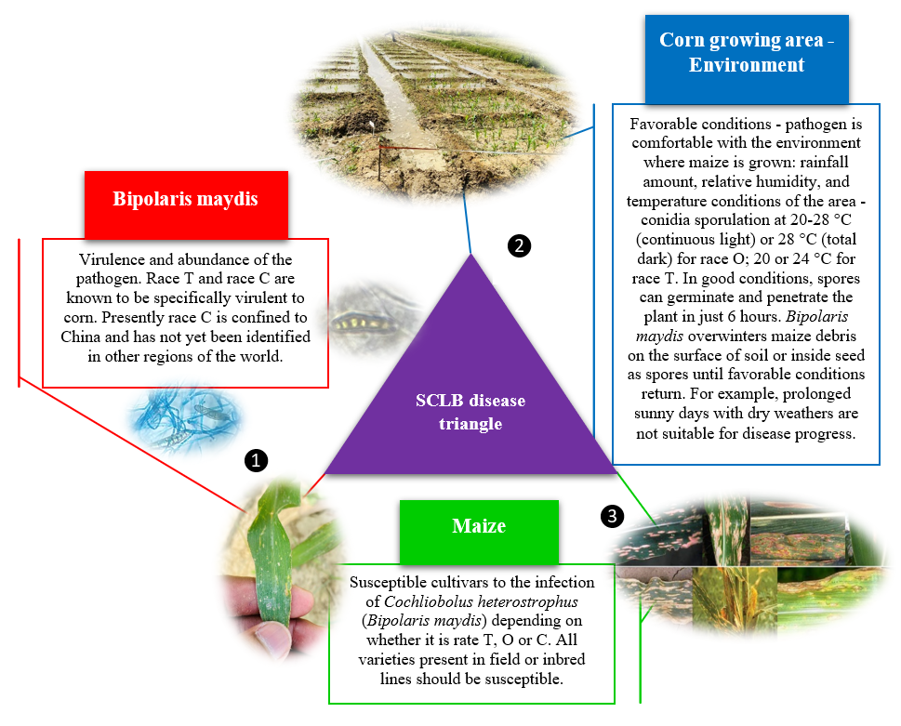
Figure 2. SCLB disease triangle adaptation. When these three elements coincide, SCLB disease will occur. But, eliminating one of them will keep corn cultivars healthy.

- Cytoplasmic male sterility, variability, and races diversity
C. heterostrophus has three races and can use ascospores or conidia to cause infection in maize, such as race T, O and C. Pathogen type like race T was found in India (Sharma et al., 1978). Race C is confined to China. Around the world, race O is mostly occurred and wider in distribution (Pavan and Shete, 2021). Male sterility in maize was first discovered in Peru by Emerson and Richey (Duvick, 1965) and in Argentina by Gini (1940) but has unfortunately been lost. In Chile, an unrelated artificial cross produced 45 male sterile F1 kernels: the fertilization with viable pollen led to the production of well-filled ears with no female sterility (Bruns, 2017).
However, Rogers and Edwardson (1952) reported that the origin of cytoplasmic Texas male sterile (cms-T) (Nopsa et al., 2014) in maize began with a discovery of male sterility in a field of white corn Mexican June. According to what is described by Bruns (2017), studies showed that SCLB resulted from an over reliance on cms-T lines in hybrid seed production and a natural mutation of a pathogen type race; discovered in the Philippines in 1961, this mutation first appeared in the Corn Belt in 1969, damaging leaves, stalks, ears, and developing kernels of maize plant hybrids containing cms-T genetics. The combination of a favorable environment with more than 85% of the hybrids grown being of cms-T genetics set the disease from its initial stage to an epidemic (Agrios, 2005; Nopsa et al., 2014). In 1971, the cms-T was discontinued, and hybrid seed production resumed using detachment for the female parent (Bruns, 2017). According to Dewey et al. (1987), two restorer genes Rf1 and Rf2 for cms-T plants are known to be involved in restoring phenotypic male fertility; accordingly, a plant that is heterozygous Rf1 rf1 Rf2 rf2 at both loci will produce viable pollen (Dewey et al., 1987; Bruns, 2017). As stated previously, a second cytoplasmic male sterile (cms) group cms-O (race O) will attack the leaf blade tissue of the corn plant (Agrios, 1997). A third cms group cms-C was discovered in a Brazilian cultivar Charrua and reported after the SCLB-race T epidemic by Beckett (1971). This cms has been used in breeding technique (especially more in modern hybrids) (Nopsa et al., 2014; Bruns, 2017), but succumbed to race C, first described by Wei et al. (1988). The race C, being confined to China, it has not yet been identified in other regions of the world, and its detailed description is currently limited.
Race T of SCLB is more destructive to host plants than race O because of its tendency to form lesions on the leaf sheaves, ear husk, developing grain on the ear, as well as leaf blades (Carson, 2016). The two most commonly races O and T are responsible to cause SCLB (Bruns, 2017). Recall that, lesions produced by T strain are oval and larger than those produced by O strain. T strain affects husks and leaf sheaths, while O strain does not. Race O still significant problem in parts of the world, including Africa, India, USA, and Europe.
Sharma et al. (2001) reported that races O and T significantly differ in expression of symptoms produced, cytoplasmic specificity, production of toxins, optimum growth temperature regimes, reproductive rates, and the site of infection in the plants. Though race T has been detected in India, its distribution and incidence are not widespread whereas race O has been the most prevalent one.

- Mycotoxin’s production
Mycotoxins are naturally occurring toxic substances commonly found in human and animal food, in field, after harvest, during storage, and in processed food products. As secondary metabolites, they are produced by certain filamentous fungal species, also called molds, affecting different crops among which cereals (especially maize, wheat, rice, barley, rye, oat) are the most important.
Mycotoxins contribute to yield losses and alter the physical quality of grains. They are resistant to cooking and even sterilization. They can therefore be found throughout the food chain.
The World Food Organization (2018), Haque et al. (2020), Kępińska-Pacelik and Biel (2021) reported that the toxigenic fungi, responsible of mycotoxin production worldwide, mostly belong to the genera Aspergillus, Fusarium (Gibberella), Penicillium, Claviceps, Alternaria, Ergot, and Byssochlamys. Zain (2011) included Stachybotrys in the most important genera of mycotoxigenic fungi.
Nowadays, about 500 different mycotoxins (Alhaddad, 2022; Zhang et al., 2022) have been identified but a limited number have been well studied among which the major mycotoxins with adverse effects in human and animal health, and with agriculture concern include aflatoxins, ochratoxins, fumonisins, trichothecenes like zearalenone, patulin, tremorgenic toxins, and ergot alkaloids (Zain, 2011; Assunção et al., 2016; Lee and Ryu, 2017; World Food Organization, 2018 ; El-Sayed et al., 2022; Gao et al., 2022; Li et al., 2022). Apart from these toxins, there exist other types of dangerous mycotoxins with big agriculturally importance infecting maize, like DON (deoxynivalenol) resulting from Fusarium infection on grains (Sumarah, 2022), and T-toxin infecting maize from field, caused by fungus, Cochliobolus heterostrophus (anamorph Bipolaris maydis) race T.
T-toxin production ability is complex and requires about three genes encoded at two unlinked loci including Tox1A and Tox1B (Kodama et al., 1999; Rose et al., 2002; Baker et al., 2006), but a research reported that six genes are involved in its production (Inderbitzin et al., 2010). The two physiologic races, T and O, that cause SCLB disease are morphologically similar, but race T is specifically pathogenic to maize, producing a pathotoxin that is highly toxic only to susceptible cms-T maize plant (Hooker et al., 1970), but race O produces only a small amount of a toxin non-specific to cytoplasms. In 1969, Smedegard-Peterson and Nelson conducted a study of intraspecific crosses among three wild-type isolates of C. heterostrophus from various geographical areas and reported that toxin production amount is under genetic control. In the same year, researchers like Lim and Hooker (1971), and Miller and Koeppe (1971) gave the statement that in both the selective pathogenicity and the specific pathotoxin production of race T for cms are monogenic in inheritance, and that two highly associated characters including severity of pathogenicity expressed and the pathotoxin amount produced, may be polygenic in inheritance.

- Host-pathogen interaction
The overall understanding of host-pathogen-environment relationships (Figure 3) is fundamental in the study of SCLB disease. It wants to demonstrate the passage of the pathogenic fungus from plant parts liable or not known to carry the pathogen in transport to corn and vice versa. The nature of the various interactions that occur in the pathological host-pathogen system, likely to influence the epidemiology of the SCLB disease.
Plant parts liable to carry the pathogen in transport are through (1) seeds (grains) colonized by hyphae and spores of fungi where the pathogen (or its parts) or symptoms usually invisible, (2) leaves by hyphae and spores where signs or symptoms usually visible to the naked eye, (3) flowers, inflorescences, cones, or calyx colonized by hyphae and spores with signs and symptoms usually visible to the naked eye. There exist also some plant parts not known to carry the plant pathogenic fungus in transport such as (4) bark, (5) bulbs, tubers, corms, or rhizomes, (6) fruits (pods), (7) growing medium accompanying plants, (8) roots, (9) seedlings or micropropagated plants, (10) stems (above ground), shoots, trunks, or branches, and (11) wood.
All these plant parts could play a role of potential reservoirs of the fungal pathogen B. maydis during the period the maize is absent in the area, by symbiosis and on which the pathogen can still acquire virulence for transmission to maize plants once present in the growing area.

- Diagnosis of the SCLB based on disease symptoms
There is a lot of overlap between fungal, bacterial, and viral disease symptoms. Also, abiotic diseases, pesticide injury and nematode problems must be considered possibilities when an unknown plant problem appears. Generally, two concepts that always claim confusion in identification of plant fungal infection based on disease symptoms, are diagnosis and detection. Diagnosis can be defined as a careful examination to determine underlying cause of the disease; whereas detection consist of finding out the presence or absence of a pathogen, which can be a fungus, bacteria, or virus.
For instance, following first steps are useful for diagnosing a plant fungal infection: observe disease in the field, determine affected plant species and cultivars, disease incidence and distribution within field (random-, clustering-, peripheral-, uniform-distribution of infected plants); record the symptoms and compare in literature for any similar descriptions on the same host in-country or elsewhere. This step is called visual examination.

- Leaf sampling, isolation, characterization, and inoculation
The steps described above can lead to the collection of infected plant samples of corn showing typical symptoms, with the purpose of identification of the fungal pathogen. In this case, examine maize leaf sample under microscope to detect any spore (conidia or ascospore) (Figure 3), this only after isolation of the pathogen; otherwise, use of lactophenol to stain the leaf is required. Apart from that, the standard tissue isolation method which can be used for isolation and characterization of B. maydis are described by different scientists (Nelson, 1957; Sleesman et al., 1974; Fry et al., 1983; Zaitlin et al. 1993; Chang and Peterson, 1995; Tskiboshi et al., 1996; Anjos et al., 2004; Shekhar and Kumar, 2012; Gogoi et al., 2014; Pal et al., 2015; Azra and Hussain, 2019; Aregbesola et al., 2020; Ferreira et al., 2022).

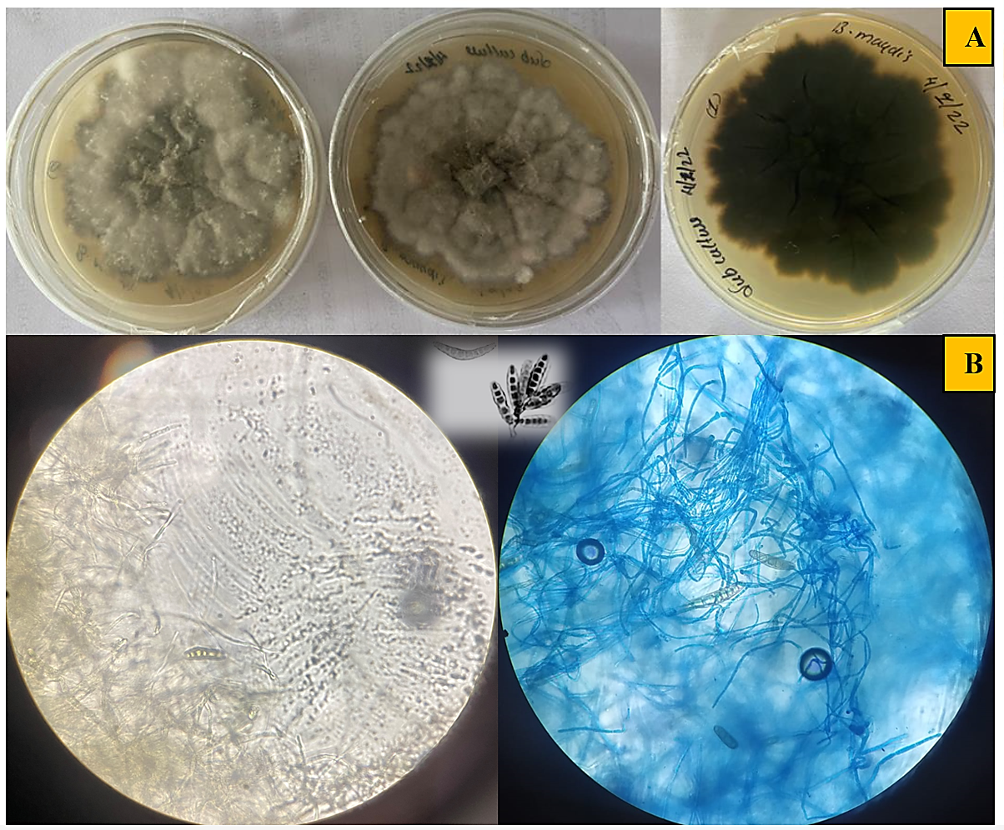
Figure 3. Mycelial (A) and conidia’ (B) formation of B. maydis
The pure culture of the pathogen can be confirmed based on the morphological and molecular methods. The pathogenicity of the causal organism can be proved by using Koch’s postulates including association of the fungal pathogen with the typical symptoms, isolation, inoculation, and re-isolation of the pathogen. In other words, inoculate (by spraying) the B. maydis to a range of test corn cultivars (health plants) and back inoculate to a parallel range of test cultivars to check possible multiple infections and to determine host range and symptoms; compare symptoms observed on experimental host range in literature for clues to identify or confirm the fungal pathogen; select systemically infected host for plant fungal propagation for purification purpose, local lesion host for fungus assays, and diagnostic species, which react uniquely to that causal fungus B. maydis. Thus, for purification and maintenance of the culture, the pathogen can be purified separately by transferring the tip of the mycelia into fresh PDA plates and maintained on PDA slants which must be stored at 4 °C.
Here are two detailed inoculation methods by Shekhar and Kumar with contributions of Gowda, Gogoi, Rai, Shetty, Sharma, Shekhar, Kumar, Shekhar, and Hooda (Shekhar and Kumar, 2012) for SCLB and other foliar diseases:
First Method. The pathogens are isolated by collecting diseased leaf lesions and placing in a moist chamber. After two-three days newly formed spores on the surface of the lesions are picked up with the help of fine flattened needle under a dissecting microscope, placed in a droplet of sterile water and streaked across the surface hardened, acidified water agar in Petri plates. After few hours the spores start to germinate, and they are cut out of the agar and transferred to hard, acidified PDA. After two weeks of incubation at 20-25 °C, this culture may be transferred to fresh plates of acidified PDA for multiplication. When the fungus growth covers the surface of Petri plate fully, the cultures are ready for use. About 20 Petri dishes of full-grown cultures are macerated in a warring blender for 15-30 seconds, strained through a layer of cheese or muslin cloth and made up to four five liters of suspension. This stock suspension is taken to the field and diluted in a compressed air sprayer (which is not ever used for pesticidal spray) 1 liter/12 liters of water. Spray should be done into the whorls of the plants where it will be retained for longer period/enough to permit the spore germination. If inoculation is sprayed over the leaves it evaporates before germination. Inoculation should be made twice a week for three weeks, when plants are 30-45 cm high, 120 Petri dishes of pure culture will be enough for 1000 plants.
Second Method. This is the easiest method to prepare inoculum by collecting heavily infected leaves collected in the previous year. This should be done before the leaves become fully mature. Infected leaves should be stored in large gunny bags in dry conditions protected from moisture and rodents. To prepare inoculum, the dry leaves are ground into a meal about the coarseness of wheat bran. Inoculation is done by placing a pinch of leaf meal into whorl of each plant, when plant attains the height of 30-45 cm. A second inoculation may be made five to ten days later. This method of inoculation will be ineffective if dry weather prevails following application of the leaf meal. To overcome this situation, 10-12 ml of water can be applied in the whorls by means of sprayer. High humid weather is congenial for inoculation and disease spread. In case of rain soon after inoculation, water spray is not at all required.
These two techniques are effective for inoculum preparation and field inoculation to create artificial epiphytotic condition to screen maize germplasm for SCLB. However, for genetic variability in isolates of B. maydis these steps can be followed, based on what Gogoi et al. (2014) reported: (1) collection of disease specimen and pathogen isolation; (2) isolation of genomic DNA from B. maydis; (3) nucleic acid extraction; (4) qualitative and quantitative analysis of B. maydis genomic DNA, (5) internal transcribed spacer-polymerase chain reaction (ITS-PCR), (6) random amplified polymorphic DNA analysis, (7) internal transcribed spacer-restriction fragment length polymorphism (ITS-RFLP), as well as data analysis with cluster.

- SCLB disease assessment
Standard cultural practices throughout the growing season are highly recommended in controlling the behavior of maize cultivars under field conditions: land reparation, sowing, plant protection, weeding and irrigation, fertilizer application, hoeing and thinning. For artificial inoculation, the inoculum should be always prepared before any observation.
To assess the SCLB disease, observations and data collection must include disease severity based on disease severity scale (reaction and scoring of disease), marking of monitored plants, leaf disease incidence, percentage disease index, disease intensity, percentage of leaf infection, percentage plant infection, area under disease progress curve, number of harvested ears, thousand Kernel Weight (TKW) or test Weight, harvesting , threshing and yield, shelling percentage, grain moisture content (MC), grain yield, phenological study SPAD (Soil Plant Analysis Development), and other important agronomical characters like height , diameter and leaf area.
Leaf area, LA =L x W x A where L=leaf length, W=leaf maximum width and A, constant (A=0,75, a K-coefficient for determination of leaf area for maize).
Leaf disease incidence, $lDI=\frac{iL}{tL}x100$ where iL is number of infected leaves, tL is total number of leaves assessed.
Percentage disease index, $DI(\%=\frac{n1x1+n2x2+n3x3}{Total number of leaves observed x Maximum rating value}x100$ where, n, number of days after lesion observes (interval), 5, 0, 5 etc., x, number of lesions after interval.
Disease intensity, $DIn\left(\%\right)=\{\left(\frac{n.v}{N. G}\right)\}x100$ where, (n.v) - Sum of score, N - Total number of leaves counted, G - Highest score.
Percentage of leaf infection, $PLI=\frac{number of leaves infected}{total number of leaves}x100$
Percentage plant infection, $PPI=\frac{number of plants infected}{total number of plants}x100$
Area under disease progress curve, $AUDPC=\sum_{i=1}^{n-1}{[\{\frac{\left(Y_{i}+Y_{i+1}\right)}{2}\}x(t_{i^{+1}}}-t_{i})]$ where, Y_{i} = disease severity on the i^{th} date, t_{i} = time on which Y_{i} will be recorded and n = number of times observations will be taken. AUDPC gives a quantitative measure of disease development and intensity (Reynolds and Neher, 1997), and disease resistance identification (Leath et al., 1990). The plant with lowest AUDPC value is considered the most resistant, and the most susceptible with higher score (Bhandari et al., 2017). Based on the mean AUDPC values, we have 4 groups of resistance level: resistant (1-30), moderately resistant (31-60), susceptible (61-90) and highly susceptible (> 90) (Magar et al., 2015), also used in the past years by scientists like Campbell and Madden (1990) and Ceballos et al. (1991).
SCLB disease confirmation. Infected maize leaf, after staining, should show pseudo-septate conidia under microscope (Fig. 3)
Number of harvested ears. Recorded the total number of ears harvested per plot or hectare.
Thousand Kernel Weight (TKW) or Test Weight. Randomly take and weigh in gram (g) one thousand shelled maize grains from each plot, kernels adjusted at 15% MC.
Reaction and scoring of disease. O- Highly resistant - no visible infection, R- Resistant - necrotic areas with or without minute uredia, MR- Moderately resistant - small uredia present surrounded by necrotic areas, MS - Moderately susceptible - medium uredia with no necrosis or distinct chlorosis, and S – Susceptible - large uredia and little or no chlorosis present severity (Razzaq et al., 2019). However, all the leaves on infected plants should be scored using 0-5 scale adopted by maize pathology unit (CIMMYT, 2004) as 0 = no visible lesion, 1= one to few scattered lesions on leaves covering up to 10% of leaf area, 2= lesions on leaf covering 11- 25% leaf area, 3= lesions on leaf covering 26-50% leaf area, 4 = lesions abundant on leaf covering 51-75% leaf area, 5 = lesions abundant on almost all leaf, plant prematurely, dried with 76-100% leaf area covered.
Shelling percentage. It is the ratio of grain to ear (grain: ear) (%).$Shelling percentage(SP)=\frac{Grain yield (kg)}{Cob yield(kg)}x100$
Grain moisture content (%). Depending on the field superficies, a number of maize ears can be selected randomly and central two kernel rows being shelled out, and GMC can be measured, for example, by multigrain moisture meter.
Grain yield. Grain yield/plot can be taken by weighing all dehusked cobs (shelling percentage considering to be 80%). $Yield=\frac{FW\left(Kg\right)x \left(100-MC\%\right)x 0.8 x 10}{NHA x 85}$ where, FW= fresh weight, NHA= net harvested area (m²), at 15% MC; or $Grain yield (Kg/ha)=\frac{FEW x SP x (100-GMC)}{NHA x 85 x 10}$ where FEW= filled ears weight (Kg), SP= shelling percentage (%), GMC = grain moisture content at harvest (%) and NHA = net harvested area (m²), depending on the field experiment.
Phenological Study-SPAD (Soil Plant Analysis Development). SPAD is used to measure the chlorophyll content of leaf. 15 SPAD readings of 5 to 10 randomly plants to be selected from each plot can be recorded and average SPAD above/ below cob can be calculated.
In addition, the general formula is that:
Disease Severity [DSI (%)] = $\frac{\sum{class frequency × score of rating class}}{total number of plants × maximal disease index}×100$
Disease Incidence, DI= $\frac{number of infected plants or leaves }{total number of observed plants or leaves}$
All these observations can be modified according to objectives pursued by a specific study. Here we shed light important information to be considered in SCLB disease assessment and gain more knowledge regarding the same. In case a researcher wants to go for screening of genotypes against SCLB and estimation of yield loss in maize cultivars, all these observations should be evaluated. Otherwise, there will be a lack of information.

- Real impact of SCLB disease on maize crop
  - Reduction in crop yield, costliest fungal disease
According to disease history, SCLB is the most devastating in maize crop (Mubeen et al., 2017). It was one of the costliest disease outbreaks to affect North American agriculture, destroying 15% of the crop at a cost of US$1.0 billion (Ullstrup, 1972; Wang et al., 2019; Santos et al., 2020), similar to ≥$6.0 billion by 2015 standards (Bruns, 2017). If the corn seeds are eventually exposed to race T (Bruns, 2017), estimated losses reach up to 100%, a total loss as reported many years ago by Southeast Farm Weekly (Ullstrup, 1972). For C. heterostrophus race O, grain yield loss was evaluated at ≥40%, by Gregory et al. (1979) and Byrnes et al. (1989). According to Rehman et al. (2021), it was not unusual for few farmers to bear 80-100% losses with an average of about 35 and 50% losses in corn belts. Tatum (1971) reported that losses to SCLB approached 710 million bushels. This amount is equivalent to 25,019,739.82 tones, i.e., economic loss around US$ 6,004,737,556.8 (with 1 tone being about $240 by 2022).
  - Increasing in corn price and demand, lack of grow seeds, affection of human health
Since its apparition (Ullstrup, 1972), Chicago Tribune and Wall Street Journal reported that SCLB epidemic increased the price of maize "futures" on the Chicago grain market in USA, soared from about $1.35/bushel in late July to $ 1.68/bushel (1bushel is about 8 gallons, equivalent to 36.4 liters or >64 US pints) by September 20, 1970, as well as from about $1.30/bushel in late May to about $1.63/bushel in late June in 1971. Demand in maize and its price increased also in United Kingdom at that time. For the first time, a disease seriously affected maize price; seed supplies almost not available in the country, making the demand for normal-cytoplasm seed being far beyond the supply. People have therefore resorted to importing seeds because of insufficient quantities, and many farmers were feeding infected grain and corn forage to animals. The infected properly dried corn was also being stored; milling difficulties were overcome by mixing infected maize with healthy maize. Scientists attributed effects like respiratory difficulties (asthma and hay fever symptoms, skin irritations) to C. heterostrophus race T (Ullstrup, 1972; Tatum, 1971; Bruns, 2017; Mubeen et al., 2017).

- Prophylactic measures in fields and Integrated SCLB management
SCLB is most prevalent though in the humid subtropical and warm temperate regions. Controlling the disease and its pathogen involves the use of botanical extracts, biocontrol agents, fungicides, resistant inbred and hybrid lines, tillage practices, and crop rotation with a non-host (Figure 4).
For different plant extracts like bael (Agelemarmelos) very toxic to many fungi, including SCLB pathogen (Karande et al., 2007), garlic (Allium sativum) in which was found suppression of 72.65% mycelial development (Khamari et al., 2015), neem (Azadirachta indica), the best one in management of the fungi (Gurjar et al., 2012; Kumar et al., 2021), onion (Allium cepa), ginger, turmeric (Kumar et al. 2021) and eucalyptus, their efficiency was tested individually against B. maydis. Above all, extracts evaluated individually against the B. maydis spore growth, were found being high effective at the range of 50% to 100%, compared to control (Jha et al., 2004). Thus, the garlic clove extracts are very effective in suppressing the growth of pathogen causing leaf blight up to around 85% (Kumar et al., 2009) or fully suppressed at 10% both in field and laboratory conditions (Meena et al., 2003).

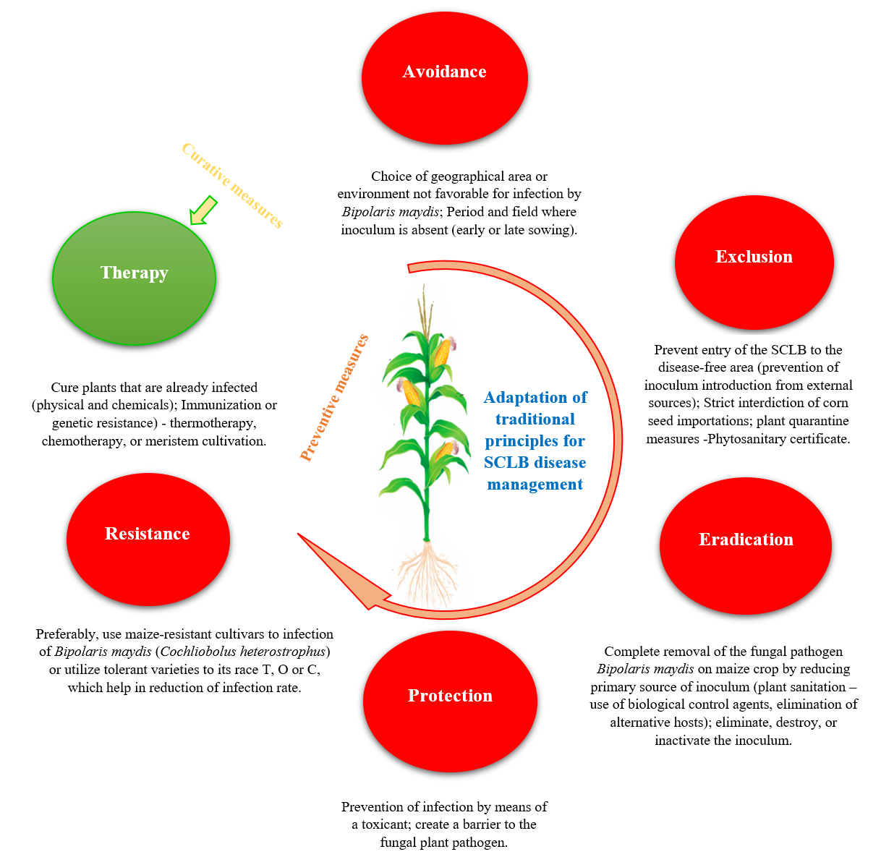
Figure 4. Principles applicable in SCLB disease management

Many species of the genus Trichoderma are mainly used as biocontrol agents against the pathogen. The Trichoderma populations suppress the growth of B. maydis. Natural enemies of the fungus are Trichoderma harzianum (Wang et al., 2019; Ashlesha et al., 2019; Harman, 2000), Burkholderia cepacia wich both control the pathogen by mechanism of antagonism while Chaetomium globosum, is a pathogen and Hypocrea rufa, a mycoparasite of B. maydis. Kumar et al. (2021) conducted an in vitro study and reported that all the Trichoderma isolates reduced the B. maydis mycelial growth.
Many scientists have proved that fungicides such as carbendazim, mancozeb, chlorothalonil (Harlapur, 2005; Harlapur et al., 2007; Kumar et al., 2021), propiconazole (Harlapur et al., 2007; Dai et al., 2018; Kumar et al. 2021), pyraclostrobin, fluxapyroxadare (Chapara et al., 2012), diniconazole and prochloraz (Dai et al., 2018), carboxin, thiram (Kumar et al., 2021) are effective against B. maydis. In the past years of disease apparition, controlled and replicated field experiments with fungicidal sprays showed significant reductions in disease severity and an increase in maize crop yield with applications of Manzate 200, Dithane M-45, and Citcop 4E (Ullstrup, 1972).
Rehman et al. (2021) reported that B. maydis overwinters in leaf or leaf sheath debris; thus, it is indispensable to check for the crop debris between growing seasons. They suggested other methods include crop rotation with nonhost, and foliar fungicides, recalling that SCLB control is crucial from 15 days before to 21 days after the tasseling because of severe infection that occurs at that period. The also stated that the breeding for SCLB disease-plant host resistant is the best method, and the distribution of all B. maydis races can be prevented by other regulation measures (Figure 4).

- Effective approaches and research trends for disease control
  - Genes as sources of resistance
The only well-known means of controlling the SCLB is the use of resistant inbred and hybrid lines, or generally, resistant maize varieties.
Resistance is the ability to prevent infection or limit parasite replication (Råberg, 2014). For example, fungal cell wall is source of resistance (Díaz-Jiménez et al., 2012). Based on what said Bilichak et al. (2020), the ability to make specific modifications to a genetic material of a plant creates lots of opportunities for the rapid development of high-quality cultivars with desired characteristics, including resistance and yield increasing (Shukuru et al., 2022). By 1950, the agriculture department along with the agricultural experiment stations in Indiana, North Carolina, and Georgia had discovered several sources of resistance that research scientists have used to improve maize inbred lines (Robert, 1953). According to Sharma et al. (2001) CM-104 and CM-105 have been considered as the two sources of resistance to SCLB during the last two decades, their resistant reaction being controlled by additive genes with negative effects appeared to be highly efficient in transferring high level of resistance in a direct crossing programme for hybrid development under this genetic situation.
Among the twenty maize genotypes experimented in Rampur, Chitwan, Nepal by Magar et al. (2015), RML-32/RML-17, RML-4/RML-17 and RML-4/NML-2 had appeared resistant to SCLB. Accordingly, Santos et al. (2020) reported that the hybrids L61xL76, L61xL77 and L76 x P1 were the most promising for resistance to SCLB and other fungal diseases. In the same way, lines like SE-013, PR-023, SAM, PA-170-R, PARA-172, PA-091, BOZM-260, CHZM-13-134, ARZM-07-04 are resistant to the pathogen (Saluci et al., 2020). Shekhar and Kumar (2012) said that, to minimize losses caused by plant diseases and simultaneously increasing the crop production to meet the demand, it is indispensable to introgress an adequate level of genetic resistance against SCLB and other economically important diseases of maize. Kraja et al. (2000) identified several temperate and tropical maize germplasm accessions as sources of alleles to improve resistance to Bipolaris species among them tropical×Mo17, a germplasm highly resistant to SCLB.
The works conducted by Sharma et al. (1982) and Sharma et al. (2021) reported different new resistance sources, with distinct resistant genotypes. Cai et al. (2003) found that the co-dominant AFLP marker, p7m36, combined with agrP144, may be useful for map-based cloning of the rhm gene and marker-assisted selection for rhm. Accordingly, Zhao et al. (2012) suggested that LHT1 is the best candidate gene for rhm1 against SCLB.
  - Challenges and upcoming outlooks
No doubt there are several methods to control fungal diseases including SCLB. Fungicides are by far effective, giving rapid response by suppressing the fungal pathogen populations, compared to other management techniques, but most fungicides are continuously being banned and withdrawn for use in disease management. Also, few fungicides are effective against the pathogen, B. maydis, after it has infected the maize crop. Biofungicdes should therefore be privileged instead of chemical fungicides; that for many reasons such as phytotoxicity, environmental hazards and human health. For example, Bacillus subtilis DZSY21 was isolated from the Eucommia ulmoides leaves and effectively colonized corn plant leaves. DZSY21 and its lipopeptides showed high antagonistic activity against the fungal pathogen B. maydis (Ding et al., 2017). Several biological agents described above play an important role in SCLB management.
Presently, as well as in future, disease resistant sources of male-sterility may be given priority and attention, and rapidly recommend its employment by the Scientific Committee. The truth is that such sources are at hand, but their usefulness and potential hazards still pose a barrier to their use, because an effective examination should be done carefully. Ullstrup (1972) reported that, carefully tested, chemical gametocides may become useful in hybridization. He also gave a statement that so far, no chemical pesticide has been found to destroy or sterilize pollen with the thoroughness needed for large scale maize seed production. For Bruns (2017), Ullstrup’s warning is as potentially true today as it was in the year 1972: “never again should a major cultivated plant species be molded into such uniformity that it is so worldwide vulnerable to attack by a pest, weed, or environmental stress. Plant diversity must be maintained in both the genetic and cytoplasmic constitution of all important species”. The duplex PCR based method can also prevent infections in corn crop by detecting infected seeds or plant and discarding them. Other than saving time and effort, early diagnosis helps to avoid plant infections, establish thorough disease management systems, and secure healthy maize seeds (Kang et al., 2018).

- Concluding remarks
This chapter explored different ways that can be used to control SCLB disease. Understanding recent approaches and research trends are helpful; considering the economic yield loss registered in maize crop is key in SCLB management. SCLB is caused by the fungus B. maydis. There exist three races of the pathogen. Race O attacks only leaves, with tan lesions, somewhat rectangular in shape along with reddish-brown margins. Race T attacks several plant parts that include leaves, husks, leaf sheaths, stalks, ears, shanks, and cobs. The yield losses in maize reported in the world due to SCLB disease and its pathogen since its discovery are still worrying scientists. Resistant hybrids and inbred, or pure lines are available. Some foliar fungicides labeled for SCLB are available. Regarding restrictions required in hybrid seed production, and in use of chemical fungicides, integrated disease management is most encouraged nowadays, especially using crop rotation, tillering system, natural enemies including biofungicides and resistant cultivars.
Declaration of Competing Interest
The one and only author declares that he has no known competing personal relationships that could have appeared to influence this golden endeavor.

References
Agrios, G.N., 1997. Foliar diseases caused by ascomycetes and imperfect (asexual) fungi. In: Plant pathology. 4th ed. Academic Press, San Die go, CA.
Agrios, G.N., 2005. Plant pathology: Fifth edition. Elsevier Academic Press, London.
Ahmar, S., Gill, R.A., Jung, K.H., Faheem, A., Qasim, M.U., Mubeen, M., Zhou, W., 2020. Conventional and Molecular Techniques from Simple Breeding to Speed Breeding in Crop Plants: Recent Advances and Future Outlook. International Journal of Molecular Sciences 21(7), 2590. https://doi.org/10.3390/ijms21072590.
Alcorn, J.L., 1988. The Taxonomy of "Helminthosporium" Species. Annual Review of Phytopathology 26, 37-56. https://doi.org/10.1146/annurev.py.26.090188.000345.
Alhaddad, A.A. (2022). Mycotoxins … Silent Death. In (Ed.), Mycotoxins and Food Safety - Recent Advances. https://doi.org/10.5772/intechopen.104382.
Ali, F., Rahman, H., Durrishahwar, N.F., Munir, M. and Ullah, H., 2011. Genetic analysis of maturity and morphological traits under maydis leaf blight (MLB) epiphytotics in maize (Zea mays L.). Journal of Agricultural and Biological Science 6(8), 13-18.
Anjos, J.R.N., Charchar, M.J.A., Teixeira, R.N., Anjos, S.S.N., 2004. Occurrence of Bipolaris maydis causing leaf spot in Paspalumatratum cv. Pojuca in Brazil. Fitopatologia Brasileira 29(6), 656-658. https://doi.org/10.1590/S0100-41582004000600010.
Aregbesola, E., Ortega-Beltran, A., Falade, T., Jonathan, G., Hearne, S., Bandyopadhyay, R., 2020. A detached leaf assay to rapidly screen for resistance of maize to Bipolaris maydis, the causal agent of southern corn leaf blight. European Journal of Plant Pathology 156(1), 133-145. https://doi.org/10.1007/s10658-019-01870-4.
Ashlesha, Oberoi, H., Kumar, P., 2019. Rhizosphere Trichoderma Isolates as Potential Biocontrol Agent for Maydis Leaf Blight Pathogen (Bipolaris maydis) in Fodder Maize. Proceedings of the Indian National Science Academy 85(4), 885-893. https://doi.org/10.16943/ptinsa/2019/49607.
Assunção, R., Martins, C., Dupont, D., Alvito, P. (2016). Patulin and ochratoxin A co-occurrence and their bioaccessibility in processed cereal-based foods: A contribution for Portuguese children risk assessment. Food and Chemical Toxicology 96, 205-214. https://doi.org/10.1016/j.fct.2016.08.004.
Aylor, D.E., 1975. Force required to detach conidia of Helminthosporium maydis. Plant Physiology 55(1), 99-101. https://doi.org/10.1104/pp.55.1.99.
Azra, N., Hussain, S., 2019. Screening of maize genotypes against southern corn leaf blight (Bipolaris maydis) under artificial epiphytotic conditions. Sarhad Journal of Agriculture 35(4), 1122-1128. http://dx.doi.org/10.17582/journal.sja/2019/35.4.1122.1128.
Baker, S.E, Kroken, S., Inderbitzin, P., Asvarak, T., Li, B.-Y., Shi, L., Yoder, O.C., Turgeon, B.G., 2006. Two Polyketide Synthase-encoding Genes are Required for Biosynthesis of the Polyketide Virulence Factor, T-toxin, by Cochliobolus heterostrophus. Molecular Plant-Microbe Interactions 19(2), 139-149. https://doi.org/10.1094/MPMI-19-0139.
Beckett, J.B., 1971. Classification of male-sterile cytoplasms in maize (Zea mays L.). Crop Science 11(5), 724-727. https://doi.org/10.2135/cropsci1971.0011183X001100050037xa.
Bhandari, R.R., Aryal, L., Sharma, S., Acharya, M., Pokhrel, A., Apar, G.C., Kaphle, S., Sahadev, K.C., Shahi, B., Bhattarai, K., Chhetri, A., Panthi, S., 2017. Screening of maize genotypes against southern leaf blight (Bipolaris maydis) during summer season in Nepal. World Journal of Agricultural Research 5(1), 31-41.
Bilichak, A., Gaudet, D., Laurie, J., 2020. Emerging Genome Engineering Tools in Crop Research and Breeding. In: Vaschetto, L. (eds) Cereal Genomics. Methods in Molecular Biology 2072, pp.165-181. Humana, New York, NY. https://doi.org/10.1007/978-1-4939-9865-4_14.
Bruns, H.A., 2017. Southern Corn Leaf Blight: A Story Worth Retelling. Agronomy Journal 109(4), 1-7. https://doi.org/10.2134/agronj2017.01.0006.
Burnette, D.C., White, D.G., 1985. Inheritance of resistance to Bipolaris maydis race O in crosses derived from nine resistance inbred lines of maize. Phytopathology 75(11), 1195-1200. http://dx.doi.org/10.1094/Phyto-75-1195.
Burton, C.L., 1968. Southern leaf blight on sweet corn ears in transit. Plant Disease Reporter 52(11), 847-850.
Byrnes, K.J., Pataky, J.K., White, D.G., 1989. Relationship between yield of three maize hybrids and severity of southern leaf blight caused by race O of Bipolaris maydis. Plant Disease 73(10), 834-840. https://doi.org/10.1094/PD-73-0834.
Cai, H.W., Gao, Z.S., Yuyama, N., Ogawa, N., 2003. Identification of AFLP markers closely linked to the rhm gene for resistance to Southern Corn Leaf Blight in maize by using bulked segregant analysis. Molecular Genetics and Genomics 269(3), 299-303. https://doi.org/10.1007/s00438-003-0837-z.
Calvert, O.H., Zuber, M.S., 1973. Ear-rotting potential of Helminthosporium maydis race T in corn. Phytopathology 63(6), 769-772. https://doi.org/10.1094/Phyto-63-769.
Campbell, C.L., Madden, L.V., 1990. Introduction to Plant Disease Epidemiology. 1st Edition, John Wiley and Sons, New York.
Carson, M.L., 2016. Foliar diseases. In: Munkvold, G.P., White, D.G., editors, Compendium of Corn Diseases. 4th ed. The American Phytopathological Society St, Paul, MN. pp.29-31.
Castellanos Gonzalez, L., Prado, R. de M., Silva Campos, C.N., da Silva Junior Fiallos, G.B. 2020. Development of the southern corn leaf blight caused by Bipolaris maydis (teleomorph: Cochliobolus heterostrophus) in sweet corn as a function of nitrogen, potassium, and silicon under greenhouse conditions. Revista Corpoica-Ciencia y Tecnologia Agropecuaria 21(3), e1508. https://doi.org/10.21930/rcta.vol21_num3_art:1508.
Ceballos, H., Deutsch, J.A., Gutierrez, H., 1991. Recurrent selection for resistance to Exserohilum turcicum in eight subtropical maize populations. Crop Science 31(4), 964-971. https://doi.org/10.2135/cropsci1991.0011183X003100040025x.
Chandrashekara, C., Jha, S., Arunkumar, R., Agrawal, P., 2014. Identification of new sources of resistance to Turcicum Leaf Blight and Maydis Leaf Blight in maize (Zea mays L.). SABRAO Journal of Breeding and Genetics 46(1), 44-55.
Chang, R.Y., Peterson P.A., 1995. Genetic Control of Resistance to Bipolaris maydis: One Gene or Two Genes? Journal of Heredity 86(2), 94-97. https://doi.org/10.1093/oxfordjournals.jhered.a111555.
Chapara, V., Pedersen, D.K., Balint-Kurti, P., Esker, P.D., Robertson, A.E., Paul, P.A., Bradley, C.A., 2012. Baseline sensitivity of Exserohilum turcicum to the quinone outside inhibitor pyraclostrobin. Phytopathology 102, S4.21.
CIMMYT, 2004. Maize Diseases: A Guide for Field Identification. 4th edition. Mexico, D.F.: The CIMMYT Maize Program,112p.
Dai, Y., Gan, L., Ruan, H., Shi, N., Du Y., Wei, Z., Chen, F., Yang, X. (2018). Sensitivity of Cochliobolus heterostrophus to three demethylation inhibitor fungicides, propiconazole, diniconazole and prochloraz, and their efficacy against southern corn leaf blight in Fujian Province, China. European Journal of Plant Pathology 152(2), 447-459. https://doi.org/10.1007/s10658-018-1490-z.
Dewey, R.E., Timothy, D.H., Levings, C.S., 1987. A mito chondrial protein associated cytoplasmic male sterility in the T cytoplasm of maize. Proceedings of the National Academy of Sciences USA 84 (15), 5374-5378. https://doi.org/10.1073/pnas.84.15.5374.
Dey, S.K., Dhillon, B.S., Saxena, V.K., Kanta, U., Khehra, A.S., 1988. Improvement for resistance to maydis leaf-blight (Drechslera maydis) and maize-borer (Chilo partellus) in maize (Zea mays). Indian Journal of Agricultural Sciences 58(11), 837-839.
Díaz-Jiménez, D. F., Pérez-García, L. A., Martínez-Álvarez, J. A., Mora-Montes, H. M., 2012. Role of the fungal cell wall in pathogenesis and antifungal resistance. Current Fungal Infection Reports 6, 275-282. https://doi.org/10.1007/s12281-012-0109-7.
Ding, T., Su B., Chen, X., Xie, S., Gu, S., Wang, Q., Huang, D., Jiang, H., 2017. An Endophytic Bacterial Strain Isolated from Eucommia ulmoides inhibits Southern Corn Leaf Blight. Frontiers in Microbiolgy 8, 903. https://doi.org/10.3389/fmicb.2017.00903.
Duvick, D.N., 1965. Cytoplasmic Pollen Sterility in Corn. Editor(s): Caspari, E.W. , Thoday, J.M. Advances in Genetics, Academic Press, 13, pp.1-56. https://doi.org/10.1016/S0065-2660(08)60046-2.
El-Sayed, R.A., Jebur, A.B., Kang, W., El-Demerdash, F.M. (2022). An overview on the major mycotoxins in food products: characteristics, toxicity, and analysis. Journal of Future Foods, 2 (2), 91-102. https://doi.org/10.1016/j.jfutfo.2022.03.002.
Ferreira, C.M., Saluci, J.C.G., Vivas, M., Santos, J.S., de Andrade Junior, M.S., Vivas, J.M.S., Ramos, G.K.S., Graviana, G.A., 2022. Characterization of the Bipolaris maydis: symptoms and pathogenicity in popcorn genotypes (Zea mays L.). Brazilian Journal of Biology 84, e256799. https://doi.org/10.1590/1519-6984.256799.
Fry, W.E., Yoder, O.C., Apple, A.E., 1983. Influence of naturally occurring marker genes on the ability of Cochliobolus heterostrophus to induce field epidemics of southern corn leaf blight. Phytopathology 74, 175-178. https://doi.org/10.1094/Phyto-74-175.
Gao, D., Cao, X., Ren, H., Wu, L., Yan, Y., Hua, R., Xing, W., Lei, M., Liu, J. (2022). Immunotoxicity and uterine transcriptome analysis of the effect of zearalenone (ZEA) in sows during the embryo attachment period. Toxicology Letters, 357, 33-42. https://doi.org/10.1016/j.toxlet.2021.12.017.
Gengenbach, B.G., Green, C.E., 1975. Selection of T-cytoplasm maize callus cultures resistant to Helminthosporium maydis race T pathotoxin. Crop Science 15(5), 645-649. https://doi.org/10.2135/cropsci1975.0011183X001500050011x.
Gibson, L., G. Benson, G., 2002. Origin, History, and Uses of Corn (Zea mays). Iowa State University, Ames, ‎Iowa‎, USA.
Gini, E., 1940. Estudios sobre esterilidad en maices regionals de la Argentina. An Inst. Fito. Santa Catalina (La Plata, Ang.) 1, 135-158.
Gogoi, R., Singh, S., Singh, P.K., Kulanthaivel S., Rai, S.N., 2014. Genetic variability in the isolates of Bipolaris maydis causing maydis leaf blight of maize. African Journal of Agricultural Research 9(24), 1906-1913. https://doi.org/10.5897/AJAR2012.7280.
Gregory, L.V., Ayers, J.E., Nelson, R.R., 1979. The influence of cultivar and location on yields loss in corn due to southern corn leaf blight Helminthosporium maydis. Plant Disease Reporter 63, 891-895.
Gurjar, M., Ali, S., Akhtar, M., Singh, K., 2012. Efficacy of plant extracts in plant disease management. Agricultural Sciences, 3(3), 425-433. https://doi.org/10.4236/as.2012.33050.
Haque, M.A., Wang, Y., Shen, Z., Li, X., Saleemi, M.K., He, C. (2020). Mycotoxin contamination and control strategy in human, domestic animal and poultry: A review. Microbial Pathogenesis, 142, 104095. https://doi.org/10.1016/j.micpath.2020.104095.
Harlapur, S.I., 2005. Epidemiology and management of turcicum Leaf blight of maize caused by Exserohilum turcicium (pass.) Leonard and suggs. Ph.D. (Plant Pathology). Thesis, University of Agricultural Sciences, Dharwad.
Harlapur, S.I., Kulkarni, M.S., Wali, M.C., Kulkarni S., 2007. Evaluation of Plant Extracts, Bio-agents and Fungicides Against Exserohilum turcicum (Pass.) Leonard and Suggs. Causing Turcicum Leaf Blight of Maize. Journal of Farm Sciences 20(3), 541-544.
Harman, G.E., 2000. Myths and dogmas of biocontrol changes in perceptions derived from research on Trichoderma harzianum T-22. Plant disease 84(4), 377-393. https://doi.org/10.1094/PDIS.2000.84.4.377.
Holley, R.N., Goodman, M.M., 1989. New sources of resistance to Southern corn leaf blight from tropical hybrid maize derivatives. Plant Disease 73(7), 562-564. http://dx.doi.org/10.1094/PD-73-0562.
Hooker, A.L., Smith, D.R., Lim, S.M., Beckett, J.B., 1970. Reaction of corn seedlings with male-sterile cytoplasm to Helminthosporium maydis. Plant Disease Reporter 54, 708-712.
Hussain, H., Raziq, F., Khan, I., Shah, B., Altaf, M., Attaullah, Ullah, W., Naeem, A., Adnan, M., Junaid, K., Shah, S. R. A., and Iqbal, M. (2016). Effect of Bipolaris maydis (Y. Nisik & C. Miyake) shoemaker at various growth stages of different maize cultivars. Journal of Entomology and Zoology Studies, 4(2): 439-444.
Inderbitzin, P., Asvarak, T., Turgeon, B.G., 2010. Six new genes required for production of T-toxin, a polyketide determinant of high virulence of Cochliobolus heterostrophus to maize. Molecular Plant-Microbe Interactions 23(4), 458-472. https://doi.org/10.1094/MPMI-23-4-0458.
Jeevan, B., Gogoi, R., Sharma, D., Manjunatha, C., Rajashekara, H., Ram, D., Mishra, K.K., Mallikarjuna, M.G., 2020. Genetic analysis of maydis leaf blight resistance in subtropical maize (Zea mays L.) germplasm. Journal of Genetics 99, 89. https://doi.org/10.1007/s12041-020-01245-3.
Jha, M.M., Kumar, S., Hasan, S., 2004. Efficacy of some fungicides against maydis leaf blight of maize caused by Helminthosporium maydis in vitro. Annals of Biology 20(2), 181-183.
Kang, I.J., Shim, H.K., Roh, J.H., Heu, S., Shin, D.B., 2018. Simple Detection of Cochliobolus Fungal Pathogens in Maize. Plant Pathology Journal 34(4), 327-334. https://doi.org/10.5423/PPJ.FT.10.2017.0209.
Karande, M.G., Raut, S.P., Gawande, A.D., 2007. Efficacy of fungicides, bio-organics and plant extracts against Colletotrichum gloeosporioides and Fusarium oxysporum. Annals of Plant Protection Sciences 15(1), 267-268.
Kępińska-Pacelik, J., Biel, W. (2021). Mycotoxins—Prevention, Detection, Impact on Animal Health. Processes, 9(11), 2035. https://doi.org/10.3390/pr9112035.
Khamari, B., Beura, S.K., Ranasingh, N., 2015. Bio-Efficacy Study of Botanicals against Helminthosporium maydis, the Incitant of Maydis Leaf Blight of Maize. Environment & Ecology 33(4B), 1898-1900.
Kodama, M., Rose, M.S., Yang, G., Yun, S.H., Yoder, O.C., Turgeon, B.G., 1999. The Translocation-Associated Tox1 Locus of Cochliobolus heterostrophus Is Two Genetic Elements on Two Different Chromosomes. Genetics 151(2), 585-596. https://doi.org/10.1093/genetics/151.2.585.
Kraja, A., Dudley, J.W., White, D.G., 2000. Identification of tropical and temperate maize populations having favorable alleles for disease resistance. Crop Science 40(4), 948-954. http://dx.doi.org/10.2135/cropsci2000.404948x.
Kumar, C., Chand, P., Choudhary, C.S., Akhtar, N.S., Rai, B., 2021. In vitro evaluation of fungicides, botanicals and bio-agents against the maydis leaf light disease of maize caused by Helminthosporium maydis. The Pharma Innovation Journal 10(6), 399-406.
Kumar, S., Rani, A., Jha M.M., 2009. Evaluation of plant extracts for management of maydis leaf blight of maize. Annals of Plant Protection Science 17(1),130-132.
Kump, K.L., Bradbury, P.J., Wisser, R.J., Buckler, E.S., Belcher, A.R., Oropeza-Rosas, M.A., Zwonitzer, J.C., Kresovich, S., Mcmullen, M.D., Ware, D., Balint-Kurti, P.J., Holland, J.B., 2011. Genome-wide association study of quantitative resistance to southern leaf blight in the maize nested association mapping population. Nature Genetics 43(2), 163-168. http://dx.doi.org/10.1038/ng.747.
Leath, S., Thakur, R.P., Leonard, K.J., 1990. Variation in expression of monogenic resistance in corn to Exserohilum turcicum race 3 under different temperature and light regimes. Phytopathology 80(3), 309-313. http://dx.doi.org/10.1094/Phyto-80-309.
Lee, H.J., Ryu, D. (2017). Worldwide Occurrence of Mycotoxins in Cereals and Cereal-Derived Food Products: Public Health Perspectives of Their Co-occurrence. Journal of Agricultural and Food Chemistry 65(33), 7034-7051. https://doi.org/10.1021/acs.jafc.6b04847.
Li, F., Zhao, X., Jiao, Y., Duan, X., Yu, L., Zheng, F., Wang, X., Wang, L., Wang, J.-S., Zhao, X., Zhang, T., Li, W., Zhou, J. (2022). Exposure assessment of aflatoxins and zearalenone in edible vegetable oils in Shandong, China: health risks posed by mycotoxin immunotoxicity and reproductive toxicity in children. Environmental Science and Pollution Research, 20 https://doi.org/10.1007/s11356-022-22385-2.
Liang, G.Q., Dai, J.G., Xie, Y.J., 1988. Selection of C-cytoplasm maize mutants resistant to Helminthosporium maydis race C pathotoxin. Genome 30(1), 464.
Lim, S.M., Hooker, A.L., 1971. Southern Corn Leaf Blight: Genetic Control of Pathogenicity and Toxin Production in Race T and Race O of Cochliobolus heterostrophus. Genetics 69(1), 115-117. https://doi.org/10.1093/genetics/69.1.115.
Magar, P.B., Khatri-Chhetri, G.B., Shrestha, S.M., Rijal, T.R., 2015. Screening of maize genotypes against Southern Leaf Blight (Bipolaris Maydis) during summer In Rampur, Chitwan, Nepal. Journal of the Institute of Agriculture and Animal Science 33-34, 115-122.
Manamgoda, D.S., Rossman, A.Y., Castlebury, L.A., Crous, P.W., Madrid, H., Chukeatirote, E., Hyde, K.D., 2014. The genus Bipolaris. Studies in Mycology 79, 221-288. http://dx.doi.org/10.1016/j.simyco.2014.10.002.
Martinez, C.A., Bruni, O., 1972. Maize blight caused by Helminthosporium maydis. II. Reaction of genotypes and cytoplasm to race T. Informe Tecnico, Estacion Experimental Regional Agropecuaria Pergamino 117: 10.
Meena, R.L., Rathore, R.S., Mathur, K., 2003. Evaluation of fungicides and plant extracts against banded leaf and sheath blight of maize. Indian Journal of Plant Protection 31(1), 94-97.
Meshram, S., Robin Gogoi, R., Bashyal, B.M., Kumar, A., Mandal, P.K., Hossain, F., 2022. Comparative Transcriptome Analysis of Fungal Pathogen Bipolaris maydis to Understand Pathogenicity Behavior on Resistant and Susceptible Non-CMS Maize Genotypes. Frontiers in Microbiology 13:837056. https://doi.org/10.3389/fmicb.2022.837056.
Miller, R.J., Koeppe, D.E., 1971. Southern corn leaf blight: susceptible and resistant mitochondria. Science 173(3991), 67-69. https://doi.org/10.1126/science.173.3991.67.
Mubeen, S., Rafique, M., Munis, M.F.H., Chaudhary, H.J., 2017. Study of southern corn leaf blight (SCLB) on maize genotypes and its effect on yield. Journal of the Saudi Society of Agricultural Sciences 16(3), 210-217. http://dx.doi.org/10.1016/j.jssas.2015.06.006.
Nelson, R.R., 1957. Heterothallism in Helminthosporium maydis. Phytopathology 47, 191-192.
Nelson, R.R., Hill, J.P., 1976. The effect of serial passage of Helminthosporium maydis race T on normal cytoplasm and race O on male sterile cytoplasm. Proceedings of the American Phytopathological Society 3, 218.
Nopsa, J.F.H., Thomas-Sharma, S. & Garrett, K.A. (2014). Climate Change and Plant Disease. In: Editor(s): Van Alfen, N.K. Encyclopedia of Agriculture and Food Systems, Academic Press, pp. 232-243. https://doi.org/10.1016/B978-0-444-52512-3.00004-8.
Pal, D., Kaiser, S.A.K.M., 2005. Biological control of Maydis leaf blight pathogen (race 'O' of Drechslera maydis) of maize with Drechslera oryzae and Helminthosporium sativum. Journal of Mycopathological Research 43(2), 229-232.
Pal, I., Singh, V., Gogoi, R., Hooda, K.S., Bedi, N., 2015. Characterization of Bipolaris maydis isolates of different maize cropping zones of India. Indian Phytopathology 68(1), 63-66. https://doi.org/10.13140/RG.2.2.24187.21281.
Pavan, G.S., Shete, P., 2021. Symptomatology, etiology, epidemiology and management of Southern corn leaf blight of maize (Bipolaris maydis) (Nisikado and Miyake) Shoemaker. The Pharma Innovation Journal 10(5), 840-844.
Piperno, D.R., 2011. The Origins of Plant Cultivation and Domestication in the New World Tropics: Patterns, Process, and New Developments. Current Anthropology 52(S4), The Origins of Agriculture: New Data, New Ideas, pp. S453-S470. https://doi.org/10.1086/659998.
Råberg, L., 2014. How to live with the enemy: understanding tolerance to parasites. PLoS Biology 12(11), e1001989. http://dx.doi.org/10.1371/journal.pbio.1001989.
Rahul, K., Singh, I.S., 2002. Inheritance of resistance to banded leaf and sheath blight (Rhizoctonia solam f. sp. Sasakii) of maize. Proceedings of the Eighth Asian Regional Maize Workshop. Bangkok, Thailand 5(8), pp.356-365.
Razzaq, T., Khan, M.F., Awan, S.I., Tariq, H., Ilyas M., 2019. Screening of maize genotypes under northern corn leaf blight (NCLB) epiphtotic at Rawlakot Azad Kashmir. Pakistan Journal of Botany 51(5), 1865-1875. https://dx.doi.org/10.30848/PJB2019-5(10).
Reddy, M.N., Peterson, P.A., Tipton, C.L., 1973. Activity of some hydrolytic enzymes in maize during development of southern leaf blight disease caused by Helminthosporium maydis race T. Phytopathologische Zeitschrift 78(3), 264-273. https://doi.org/10.1111/j.1439-0434.1973.tb04176.x.
Rehman, F.U., Adnan, M., Kalsoom, M., Naz, N., Husnain, M.G., Ilahi, H., Ilyas, M.A., Yousaf, G., Tahir, R. and Ahmad, U., 2021. Seed-borne fungal diseases of maize (Zea mays L.): A review. Agrinula : Jurnal Agroteknologi dan Perkebunan 4(1), 43-60. https://doi.org/10.36490/agri.v4i1.123.
Reynolds, L., Neher, D.A., 1997. Statistical comparison of epidemics. In: L. J. Francl and D. A. Neher (eds.), Exercises in Plant Disease Epidemiology. APS Press, St. Paul, USA. pp. 34-37.
Robert, A.L., 1953. Some of the leaf blights of corn. In: A. Stefferud, editor, Plant diseases, The yearbook of agriculture. Superin tendent of Documents, Washinton, DC. pp.380-385.
Rogers, J.S., Edwardson, J.R., 1952. The utilization of cytoplasmic male-sterile inbreds in the production of corn hybrids. Agronomy Journal 44(1), 8-13. https://doi.org/10.2134/agronj1952.00021962004400010004x.
Rose, M.S., Yun, S.-H., Asvarak, T., Lu, S.-W., Yoder, O.C., Turgeon, B.G., 2002. A decarboxylase encoded at the Cochliobolus heterostrophus translocation-associated Tox1B locus is required for polyketide (T-toxin) biosynthesis and high virulence on T-cytoplasm maize. Molecular Plant-Microbe Interactions 15(9), 883-893. https://doi.org/10.1094/MPMI.2002.15.9.883.
Saluci, J.C.G., Vivas, M., de Almeida, R.N., Dutra, I.P., Carlos, M.C., do Amaral Júnior, A.T., Scapim, C.A., 2020. Potential of Popcorn S₄ lines for resistance to southern corn leaf blight. Functional Plant Breeding Journal 2(2), 79-87. http://dx.doi.org/10.35418/2526-4117/v2n2a6.
Santos, J.S., Souza, Y.P., Vivas, M., do Amaral Júnior, A.T., de Almeida Filho, J.E., Mafra, G.S., Viana1, A.P., de Amaral Gravina, G., Ferreira, F.R.A., 2020. Genetic merit of popcorn lines and hybrids for multiple foliar diseases and agronomic properties. Functional Plant Breeding Journal 2(2), 3-47. http://dx.doi.org/10.35418/2526-4117/v2n2a2.
Schenck, N.C., Stelter, T.J., 1974. Southern Corn Leaf Blight Development Relative to Temperature, Moisture, and Fungicide Applications. Phytopathology 64, 619-624. https://doi.org/10.1094/Phyto-64-619.
Sharma, G., Chandel, U., Guleria, S.K., Devlash, R., 2021. Identification of New Resistance Against Turcicum Leaf Blight and Maydis Leaf Blight in Maize (Zea mays L.). Himachal Journal of Agricultural Research 47(1), 84-87.
Sharma, R.C, Rai S.N, Mukherjee B.K., Gupta N.P, 2001. Assessing potential of resistance source for the enhancement of resistance to Maydis leaf blight (Bipolaris maydis) in maize (Zea mays L.). Indian Journal of Genetics and Plant Breeding 63(1), 33-36.
Sharma, R.C., Lilaramani, J., Payak, M.M., 1978. Outbreak of a new pathotype of Helminthosporium maydis on maize in India. Indian Phytopathology 31, 112-113.
Sharma, S.C., Khehra, A.S., Saxena, V.K., Dhillon, B.S., Malhi, N.S., 1982. Note on screening of germplasm of maize against Drechslera maydis (Helminthosporium maydis). Indian Journal of Agricultural Sciences 52(5), 341.
Shekhar, M., Kumar, S., 2012. Inoculation methods and disease rating scales for maize diseases. 2nd Edition, Directorate of Maize Research, Pusa Campus, New Delhi.
Shukuru, B.N., Archana, T.S., Bisimwa, E.B., Birindwa, D.R., Sharma S., Kurian, J.A., & Casinga, C.M. (2022). Screening of cultivars against cassava brown streak disease and molecular identification of the phytopathogenic infection-associated viruses. Archives of Phytopathology and Plant Protection, 55(16), 1899-1929. https://doi.org/10.1080/03235408.2022.2123590.
Singh, V., Lakshman, D.K., Roberts, D.P., Ismaiel, A., Abhishek, A., Kumar, S., Hooda, K.S., 2021. Fungal Species Causing Maize Leaf Blight in Different Agro-Ecologies in India. Pathogens 10(12), 1621. https://doi.org/10.3390/pathogens10121621.
Sleesman, J.P., Larsen, O.P., Safford, J., 1974. Maintenance of stock cultures of Helminthosporium maydis (races T and O). Plant Disease Reporter 58(4), 334-336.
Subedi, S., 2015. A review on important maize diseases and their management in Nepal. Journal of Maize Research and Development, 1(1), 28-52.
Sumarah, M.W. (2022). The Deoxynivalenol Challenge. Journal of Agricultural and Food Chemistry, 70(31), 9619-9624. https://doi.org/10.1021/acs.jafc.2c03690.
Sumner, D.R., Littrell, R.H., 1974. Influence of tillage, planting date, inoculum survival, and mixed populations on epidemiology of southern corn leaf blight. Phytopathology 64(2), 168-173.
Sun, X., Qi, X., Wang, W., Liu, X., Zhao, H., Wu, C., Chang, X., Zhang, M., Chen, H., Gong, G., 2020. Etiology and Symptoms of Maize Leaf Spot Caused by Bipolaris spp. in Sichuan, China. Pathogens 9(3), 229. https://doi.org/10.3390/pathogens9030229.
Tatum, L.A., 1971. The southern corn leaf blight epidemic. Science 171(3976), 111-1116. https://doi.org/10.1126/science.171.3976.1113.
Tinline, R.D., Dickson, J.G., 1958. Cochliobolus sativus. I. Perithecial Development and the Inheritance of Spore Color and Mating Type. Mycologia 50(5), 697-706. https://doi.org/10.2307/3756179.
Tskiboshi, T., Koga, H., Uematsu, T., 1996. Races of Bipolaris maydis Occurring in Japan and Their Pathogenicity to the rhm Resistant Corn Line. Japan Agricultural Research Quarterly 30(2), 91-96.
Tsukiboshi, T., Koga, H., Uematsu, T., 1992. Components of partial resistance to southern corn leaf blight caused by Bipolaris maydis race O in six corn inbred lines. Annals of the Phytopathological Society of Japan 58(4), 528-533.
Ullstrup, A. J., 1972. The impacts of the southern corn leaf blight epidemics of 1970-1971. Annual Review of Phytopathology 10, 37–50. https://doi.org/10.1146/annurev.py.10.090172.000345.
Wang, M., Wang, S., Ma, J., Yu, C., Gao, J., Chen, J., 2017. Detection of Cochliobolus heterostrophus races in South China. Journal of Phytopathology 165(10), 681–691. https://doi.org/10.1111/jph.12607.
Wang, S., Ma, J., Wang, M., Wang, X., Li, Y., Chen, J., 2019. Combined application of Trichoderma harzianum SH2303 and difenoconazole-propiconazolein controlling Southern corn leaf blight disease caused by Cochliobolus heterostrophus in maize. Journal of Integrative Agriculture 18(9), 2063–2071. https://doi.org/10.1016/S2095-3119(19)62603-1.
Wei, J.-K., Liu, K.-M., Chen, J.-P., Luo, P.-C., Lee-Sladelmann, O.Y., 1988. Pathological and physiological identification of Race-C of Bipolar maydis in China. Phytopathology 78, 550-554. https://doi.org/10.1094/Phyto-78-550.
World Food Organization (2018). Mycotoxins. https://www.who.int/news-room/fact-sheets/detail/mycotoxins. (Accessed October 23, 2022).
Zain, M.E. (2011). Impact of mycotoxins on humans and animals. Journal of Saudi Chemical Society, 15(2), 129–144. https://doi.org/10.1016/j.jscs.2010.06.006.
Zaitlin, D., Demars, S., Ma, Y., 1993. Linkage of rhm, a recessive gene for resistance to southern corn leaf blight, to RFLP marker loci in maize (Zea mays) seedlings. Genome 36(3), 555-564. https://doi.org/10.1139/g93-076.
Zhang, N., Han, X., Zhao, Y., Li, Y., Meng, J., Zhang, H., Liang, J. (2022). Removal of aflatoxin B1 and zearalenone by clay mineral materials: In the animal industry and environment. Applied Clay Science, 228, 106614. https://doi.org/10.1016/j.clay.2022.106614.
Zhao, Y., Lu, X., Liu, C., Guan, H., Zhang, M., Li, Z., Cai, H., Lai, J., 2012. Identification and fine mapping of rhm1 locus for resistance to Southern corn leaf blight in maize. Journal of Integrative Plant Biology 54(5), 321-329. https://doi.org/10.1111/j.1744-7909.2012.01112.x.

