Chapter 1: Multiband Frequency Reconfigurable Antennas for 5G and Satellite Communication
Author: Birendra Kumar Pandey
The ever-increasing demand for wireless communication technologies has driven the need for antennas with versatile characteristics that can adapt to different operating frequencies, polarizations, and radiation patterns. Frequency reconfigurable antennas have emerged as a promising solution, providing the capability to switch between resonating frequencies and enabling efficient operation in various frequency bands. This chapter introduces a novel design for a dual-band frequency reconfigurable antenna, offering high bandwidth to cover both 5G and satellite communication applications. The antenna's Reconfigurability is achieved through the use of PIN diodes, which facilitate frequency switching among different frequency bands. The proposed design features key advantages such as multiband operation, high gain, cost-effectiveness, lightweight construction, and extended coverage range.
1. Introduction
In the era of modern wireless communication, there is an escalating demand for antennas that can adapt to the changing needs of different frequency bands. Multiband frequency reconfigurable antennas have become a subject of intense research due to their ability to dynamically switch between multiple operating frequencies, thereby accommodating the requirements of diverse wireless communication standards. This chapter presents a frequency reconfigurable antenna design that supports both 5G and satellite communication frequency ranges.

2. Literature
2.1 Frequency Reconfigurability Techniques
Various techniques have been employed to achieve frequency Reconfigurability in antennas. One of the most widely used methods is the utilization of PIN diodes as switching devices. M. Jenath et al. (2017) presented a dual-band frequency reconfigurable antenna for 5G applications using PIN diodes to alter the antenna's radiation characteristics. Their design allowed for seamless switching between two frequency bands, enabling efficient communication in the 5G frequency range.
Another study by Kim et al. (2020) explored the integration of micro electro mechanical systems (MEMS) switches in frequency reconfigurable antennas. The MEMS switches offered enhanced performance and lower power consumption compared to traditional PIN diodes. The researchers successfully achieved frequency Reconfigurability for 5G and satellite communication bands, showcasing the potential of MEMS switches in antenna design.
2.2 Dual-Band and Multiband Frequency Reconfigurable Antennas
Dual-band and multiband frequency reconfigurable antennas have gained traction due to their ability to cover multiple frequency ranges. Wang et al. (2019) proposed a tri-band frequency reconfigurable antenna for 5G applications, utilizing varactor diodes to achieve frequency switching. Their design covered the frequency bands of 2.4 GHz, 3.5 GHz, and 5.8 GHz, making it suitable for diverse wireless communication standards.
In a study by Liping Han et al. (2016), a frequency reconfigurable antenna was presented with four operating bands for satellite communication and 5G applications. The antenna employed varactor diodes to achieve frequency switching among the four bands. The researchers demonstrated how this multiband antenna could serve as a versatile solution for future communication systems.
2.3 Compact and Lightweight Designs
As the demand for portable and wearable devices grows, research has focused on developing compact and lightweight frequency reconfigurable antennas. N.O. Parchin et al. (2019) proposed a compact reconfigurable antenna for 5G and satellite communication, designed on a low-cost FR4 substrate. The antenna exhibited efficient frequency switching using PIN diodes and offered high gain performance, making it suitable for handheld communication devices.
Similarly, L.H Trinh et al. (2015) explored the design of a miniaturized frequency reconfigurable antenna for 5G applications. The antenna achieved frequency switching through varactor diodes and demonstrated high radiation efficiency across the 5G frequency range.
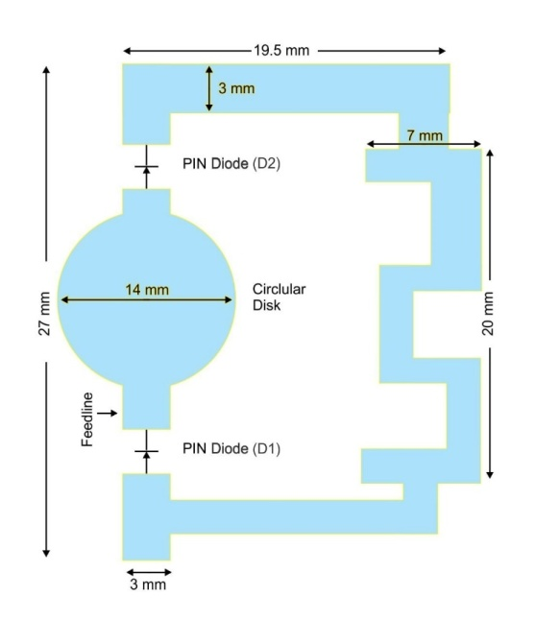
3. Frequency Reconfigurability Using PIN Diode
Frequency Reconfigurability in the proposed antenna is achieved through the utilization of PIN diodes. PIN diodes act as switching devices, enabling the antenna to change its resonating frequency by toggling between ON and OFF states. In the ON state, the PIN diode alters the antenna's slot elements, allowing it to operate at specific resonant frequencies, while in the OFF state; the antenna exhibits a different set of resonant frequencies.
- FRA Layout Design

4. Antenna Design and Characteristics
The proposed antenna is designed on a low-cost FR4 substrate, with dimensions of 28×32×1.625 mm³, making it compact and cost-effective. Its key features include:
4.1 Dual-Band Frequency Reconfigurability
The antenna achieves dual-band frequency Reconfigurability, making it suitable for operating in both 5G and satellite communication frequency bands. In the ON state of the PIN diode, the resonating frequencies with reference to -10 dB are achieved at 9.7 GHz (s11=-27 dB) and 13.5 GHz (s11=-27.7 dB). Additionally, in the switching state (OFF state) of the PIN diode, the antenna exhibits dual-band resonance at 24.5 GHz (s11=-14.7 dB) and 30 GHz (s11=-15.6 dB).
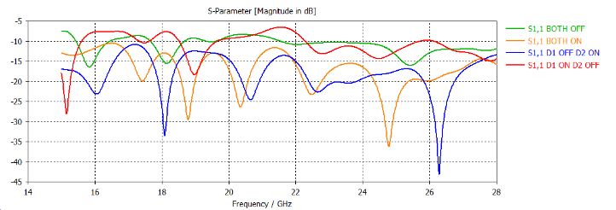

- Comparative Results of Simulation

4.2 Ultra-Wide Band Range
The frequency Reconfigurability of the antenna allows it to cover an ultra-wide band range, further enhancing its versatility and compatibility with various communication standards.
4.3 Coverage Range
With its high gain and frequency agility, the proposed antenna achieves an extended coverage range, making it an excellent choice for next-generation wireless communication applications.
5. Application in 5G and Satellite Communication
The multiband frequency Reconfigurability of the antenna makes it ideal for 5G and satellite communication applications. The frequency range covered by the antenna aligns with the FR2 frequency band of 5G applications, while the frequency switching capability allows operation in the satellite frequency range. Thus, the antenna serves as a reliable solution for modern communication systems that require flexibility and adaptability.

6. Future Developments and Challenges
As the demand for advanced wireless communication technologies continues to rise, the development of frequency reconfigurable antennas is expected to progress rapidly. Several avenues for future research and development in this area can be explored:
6.1 Higher Frequency Bands
With the constant evolution of wireless communication technologies, the need for antennas operating at even higher frequency bands may arise. Future research can focus on designing frequency reconfigurable antennas capable of accommodating the requirements of emerging communication standards.
6.2 Advanced Switching Techniques
While PIN diodes have proven to be effective switching devices, alternative and more sophisticated switching techniques could be investigated. The integration of newer technologies may further enhance the performance and capabilities of frequency reconfigurable antennas.
6.3 Compact and Miniaturized Designs
Efforts to reduce the size and form factor of the frequency reconfigurable antenna can be pursued to cater to portable and small-scale communication devices. Miniaturization without compromising performance will be a significant challenge in this regard.
7. Practical Implementation
The practical implementation of frequency reconfigurable antennas involves considerations beyond just the design itself. Real-world challenges, such as fabrication, integration, and power consumption, must be addressed to ensure the successful deployment of these antennas in practical applications.
8. Conclusion
This chapter presented a comprehensive study on multiband frequency reconfigurable antennas with a focus on a dual-band design catering to 5G and satellite communication. Utilizing PIN diodes as switching devices, the proposed antenna demonstrated remarkable frequency switching capability, achieving high gain and wide bandwidth. Its lightweight and cost-effective design further enhances its practicality for various wireless communication applications. The integration of this antenna into 5G and satellite systems showcases its potential to revolutionize modern communication networks, enabling seamless connectivity and robust performance.

Reference:
- M. Jenath and V. Nagarajan, “Review on frequency Reconfigurable antenna for Wireless Application,” IEEE International conference on communication and signal processing April 6-8, 2017, India.
- Liping Han, Caixia Wang, “Compact frequency Reconfigurable Slot Antenna for Wireless Application”, IEEE Antenna and Wireless Propagation Letters, Vol:15, P.N 1795, March 2016.
- N.O. Parchin. “Recent development of Reconfigurable antennas for current and future Wireless communication systems,” Electronics, vol. 8, P.N 1-17, 2019.
- L.H Trinh et al, “Reconfigurable antenna for future spectrum reallocation in 5G communication,” IEEE Antenna wireless propagation lett., vol 15, pp 1297-1300,2015

About the Author
Mr. Birendra Kumar Pandey is a distinguished academician, researcher, and educator who has made significant contributions to the fields of engineering and technology. Currently associated with Malaviya National Institute of Technology, Jaipur, With an unwavering passion for research, Birendra Kumar Pandey pursued a PhD in the area of MIMO (Multiple-Input Multiple-Output) antenna technology from Rajasthan Technical University and SKIT Jaipur. The research focused on advancing the capabilities of wireless communication systems through innovative antenna designs and optimization techniques. Birendra Kumar Pandey's work in this domain has garnered attention and recognition from peers and experts alike. Apart from being an accomplished researcher, Birendra Kumar Pandey possesses an extensive teaching experience at the graduate level, spanning seven years. Throughout this time, Birendra Kumar Pandey has played a crucial role in shaping the minds of aspiring engineers, imparting not just technical knowledge but also fostering critical thinking and problem-solving skills among students.

