A framework that uses augmented reality to enhance students' critical thinking skills and boost their learning outcomes in the field of Physics

Harun¹
^{harun.e11421@cumail.in,}

Abstract : Physics, a scientific discipline concerned with the characteristics of energy and matter, draws heavily on principles from Mathematics, Mechanics, Optics, Electricity, Magnetism, and Thermodynamics. However, many students struggle to comprehend these concepts due to the lack of visual representation, which contributes to a waning interest in STEM subjects. To address this challenge, augmented reality (AR) technology emerges as a powerful tool, offering students an immersive experience with lifelike three-dimensional virtual objects to facilitate learning.

"This research paper centers on the creation of an augmented reality (AR)-based learning environment designed to assist students in grasping various Physics concepts, such as magnetic fields, electric current, electromagnetic waves, Maxwell's equations, and Fleming's rules for electromagnetism. In order to evaluate the impact of the AR intervention on students' learning and critical thinking abilities, an experimental study was carried out with a participant pool of 80 engineering students who were divided into two groups: the AR teaching group (N = 40) and the conventional teaching group (N = 40). The AR teaching group experienced the subject matter through the AR-based learning environment, while the conventional teaching group received instruction through traditional teaching methods.

The findings of the experiment revealed that the AR-based learning environment had a significantly positive effect on students' critical thinking skills and learning outcomes. By providing students with the ability to visualize abstract Physics concepts, the AR experience improved their comprehension and engagement with the subject matter."
Keyword : Augmented reality, Virtual Objects, Learning , thinking , virtualization.

Introduction: Conventional teaching involves a teacher mentoring students to gain the knowledge through reading and memorization method, often relying on text, videos, projections, traditional learning tools, such as pen or paper, and (2D) images, having lack the ability to offer actual practice and involvement with 3D content. However, recent research has shown that using 3D animated content can significantly enhance learners' immersive experience. Given the evolving pedagogical approach in engineering education, there is a shift towards incorporating new methods of learning. However, modern methods, particularly those incorporating augmented reality (AR), offer more benefits to students as they enhance engagement throughout the learning process [32, 35]. Basically, augmented reality (AR) creates an interactive learning environment by overlaying images, videos, text, and audio over the real world, making even abstract content more tangible and hands-on for students [1, 21]. This technology encourages interaction and engagement with the educational material, which enhances learning results. [3, 16, 30].

"Critical thinking plays a vital role in science learning, empowering students to tackle complex problems through logical reasoning and decision-making skills [10, 20]. Among various learning methods, AR-based learning media has been proven to effectively encourage critical thinking. AR achieves this by allowing students to interact with virtual components using simple operations like drag, drop, grab, and flip, surpassing the limitations of conventional teaching systems.

Physics holds immense significance in engineering courses as it forms the bedrock for various engineering concepts and theories. Nonetheless, students often encounter difficulties in visualizing certain concepts and phenomena [23]. In this study, an AR application is developed to aid students in understanding electromagnetism. The AR-based learning environment (ARLE) aims to achieve the following learning objectives:

1. Promote experiential learning over passive reading.
2. Facilitate understanding of abstract Physics concepts.
3. Enable visualization of phenomena in 3D and interaction with virtual objects.

The interactive ARLE focuses on the behavior of magnetic field lines, electric current, DC operated motors, and the working of generators in Physics. It enables students to visualize and interact with virtual components related to these concepts, such as bar magnets, current-carrying conductors, galvanometers, and power supplies. Additionally, students can gain insight into the significance of Maxwell's equations, such as Gauss's law in magnetism. The ARLE is designed to enhance students' learning and training skills, thereby improving their conceptual understanding, critical thinking ability, and knowledge retention [31]. Through the use of ARLE, students can experience fundamental Physics concepts in an immersive manner."

The paper addresses two main research questions:
1. What difference does an AR-based intervention make to students' learning gains from a traditional teaching approach?
2. How does AR influence students' critical thinking ability compared to traditional teaching methods?

The paper's structure includes a literature review on AR in education in Section 2, followed by the methodology for deploying the ARLE system on engineering students represented in third section. Fourth section presents the investigation of the results from the ARLE-based study. Finally, Section 5 contains the discussion and conclusions drawn from the research.

Literature Review:

The use of augmented reality (AR) and virtual reality (VR) in the classroom has increased student learning and understanding. Several studies have looked into how AR affects cognition, engagement, and learning abilities. [6, 10, 12]. Various AR/VR-based experiences are employed in engineering education, but there is little study on their usage in Physics to help students understand abstract concepts. While certain AR-based interaction methods have been utilized to instruct students about magnetism, they frequently fall short in terms of involvement. According to earlier research, although the magnetic field may be displayed using augmented reality (AR) techniques, the experience is static and lacks a 3D model and real-time interactivity. [24].

Studies that effectively integrated AR into physics instruction may be found. In order to teach the fundamentals of magnetism, Dünser et al. [15] employed handheld devices and augmented reality applications, exemplifying how augmented reality helps interactions with abstract Physics ideas. In a different research, Sonntag et al. [34] created a magnetic model using a teaching application and virtually generated magnetic induction lines. By spreading and charting induction lines using a computer-generated bar magnet, Matsutomo et al. [28] improved the model even further. Additionally, Ibanez et al. [23] created an AR application that effectively raises comprehension levels compared to web-based apps for electromagnetic principles and associated phenomena.
A variety of AR-based learning environments, simulations, and games that employ computer-generated 3D models to engage students in the study of complicated subjects have been investigated in earlier studies [11, 14, 22, 26, 39]. The learning process is made more manageable with AR technology, which also lessens the teacher's burden [25]. Additionally, AR applications have demonstrated their value in reproducing difficult investigations like convex imaging-based studies [4] as well as complex theoretical ideas, including interactive inquiry-based microparticle experiments [7].

Methodology :

- Participants

Students having an electrical engineering background made up the research sample. The study involved 80 engineering students, all of whom had little to no prior experience with augmented reality (AR) technology. Detailed information about the participants is available in Table 1. Throughout the study, both groups were taught by the same professor in order to minimize any potential instructor bias.

TABLE 1 | Participants details
Gender | AR group | Conventional teaching group
Male | 34 | 35
Female | 6 | 5
Total | 40 | 40

- Material

The Augmented Reality Learning Environment (ARLE) proposed in this study is an interactive application designed to improve students' comprehension of various Electric Engineering based concepts. These include electric motors and generators, electromagnetics, the working principles of galvanometers, voltmeters, ammeters, and Gauss's law in (Maxwell equations). The ARLE incorporates marker-based technology, interactive 3D models, and animations to enhance virtual objects by overlaying them in real-time using the device's camera. The 3D replicas and simulations were established using Autodesk Maya, while the application itself was created using Unity 3D and C#.

- Design of Experiment

The flowchart of the Augmented Reality Learning Environment (ARLE) is illustrated in Figure 1. It shows the sequence of actions that take place during the AR system's gameplay. When the camera identifies the designated marker, the AR visualization initiates, allowing students to access AR content associated with a specific learning activity, depending on the type of marker used. Each learning activity is linked to a different paper marker.

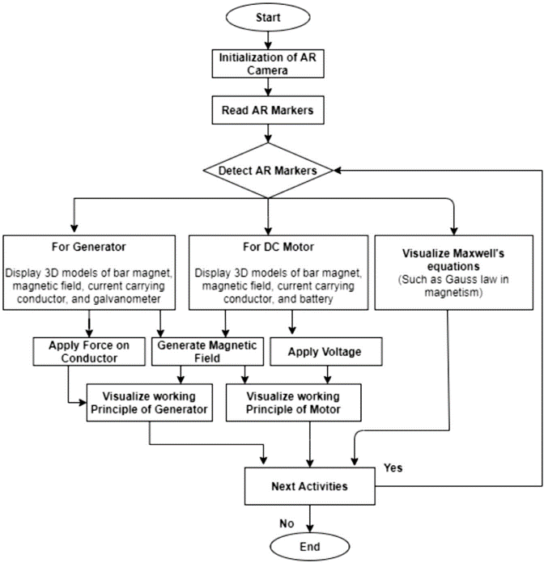

Fig 1: Flow chart of the developed system.

Students can interact with a variety of concepts within the Augmented Reality Learning Environment (ARLE), including creating magnetic fields, observing the behavior of a magnetic field produced by a bar magnet's North and South Poles, applying force to a conductor, and changing the supply DC voltage. Students are guided through the ARLE experience with the use of audio and video lessons. Five options are available for choosing various AR learning activities on the user interface. The user's screen displays the matching AR view as soon as an activity is selected.

Figure 2 displays the AR view associated with the selected learning activity, while Figure 3 illustrates the visualization of a generator. Additionally, Figure 4 and Figure 5 showcase the AR views of "Maxwell's equation" and "Solenoid carrying current," respectively. Students may see how altering the voltage affects in a motor in Figure 4 and how Gauss's law in magnetism is shown in Figure 5, which allows students to see the magnetic field that the current-carrying solenoid creates.

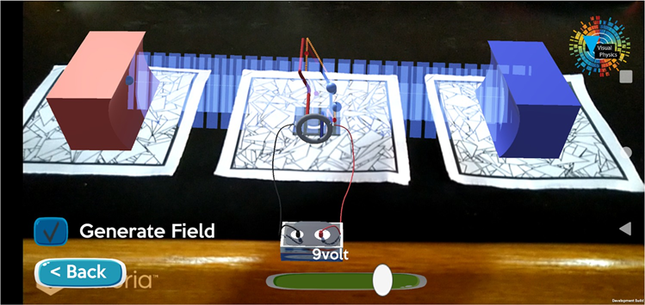
Fig 2: DC motor virtualization

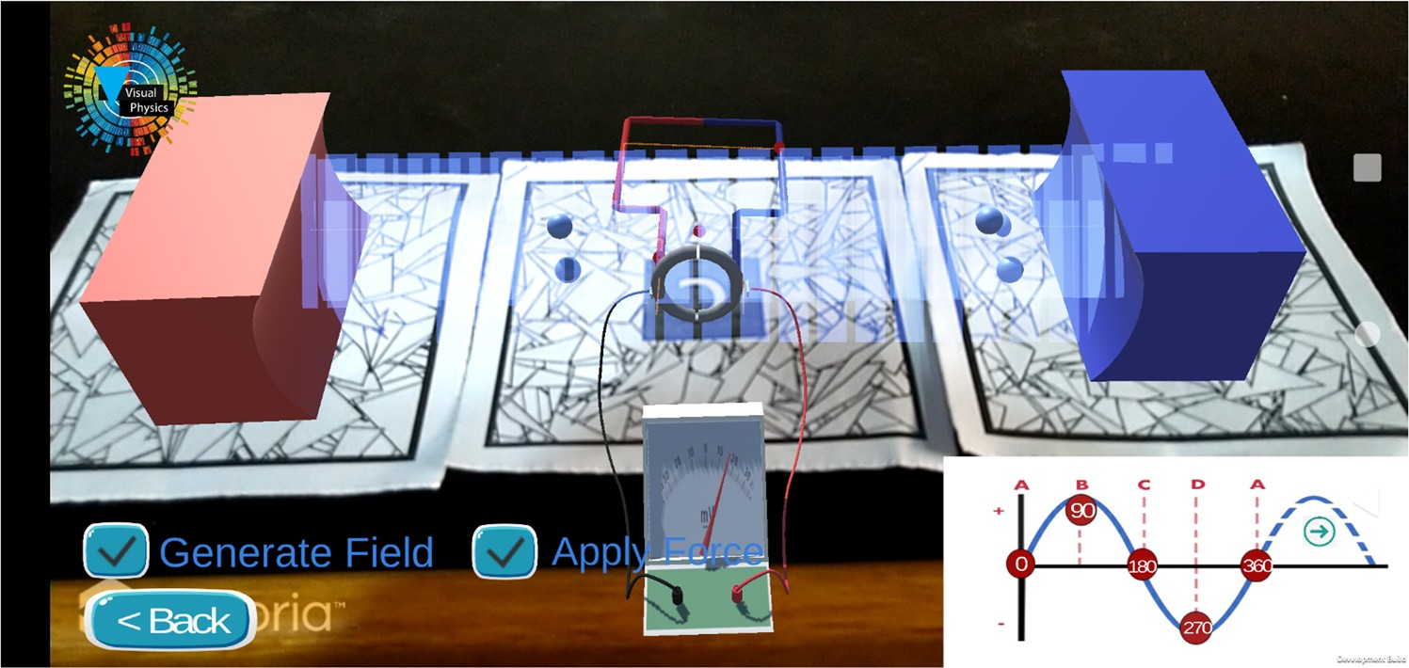
Fig 3: AC motor virtualization

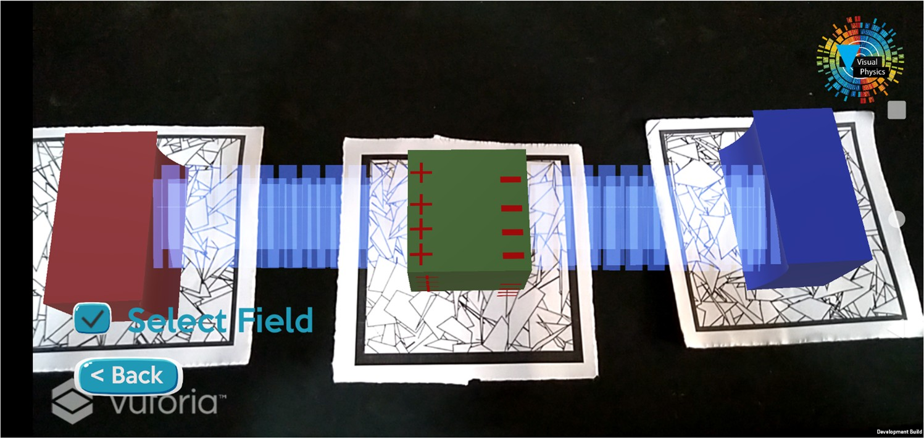
Fig 4: Virtualization of Gauss law in magnetism

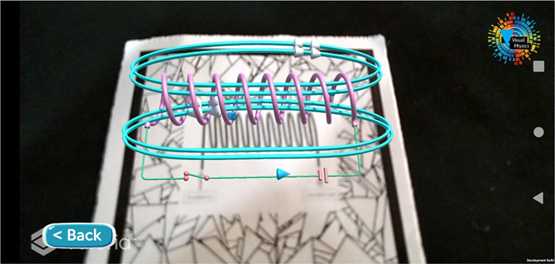

Fig 5: Virtualization of solenoid

Using 3D representations of bar magnets, conductors, batteries, galvanometers, spheres, cubes, and tori as game elements, the entire ARLE system is created as a mobile application. These game elements are managed by C# scripts, which establish the rules for gaming.

The educational exercise was carried out at a physics research facility. The students first learned about some of the most basic ideas in physics, such as the Maxwell equations, magnetism, Gauss's law of magnetism, Fleming's rule, the fundamentals of motors and generators, and galvanometers. They became acquainted with the topic and the procedure of experimental research during this introduction session. Students choose to participate in this educational activity on the basis of their interests. They were made aware that the results of the pretest and posttest would not be used into the overall course evaluation.

The students were randomized into two groups at random after the introduction lesson: the group receiving AR instruction and the group receiving traditional instruction. To guarantee perfect random distribution of students, the randomization method was carried out by a faculty member who was uninformed of the experimental investigation. Prior to the intervention, each student took a pretest to gauge their level of familiarity with the problem and to guarantee that both groups had similar learning potential. The pretest consisted of a questionnaire with 15 multiple-choice questions about the material, where students had 20 minutes to select the best response from four possibilities.

The conventional teaching group also had 40 students who were instructed using conventional lecture-based techniques, whereas the AR teaching group contained 40 students who were trained utilizing the ARLE methodology. The same instructor taught both groups while being aware of the various interventions to guarantee unbiased evaluation.

The AR teaching group got instruction on how to comprehend concepts like motors and generators, Maxwell's equations, electricity, magnetism, and Fleming's rule utilizing the ARLE approach throughout the learning process. Through the ARLE, they were also helped to comprehend how magnetic fields and current-carrying conductors behave, resolving the issue of seeing the magnetic field lines produced by the current-carrying solenoids [23, 40]. For each group, the educational activity lasted 60 minutes.

Both groups participated in a posttest that had a maximum score of 20 and was made up of 10 multiple-choice questions worth 1 mark each and 5 multiple-choice questions worth 2 marks each. The posttest has a 20-minute time restriction for both groups to finish it. Students were also requested to complete a Critical Thinking Questionnaire, and students in the AR teaching group were interviewed to get their opinions on the ARLE. Figure 6 shows the research design tailed to conduct the entire procedure.

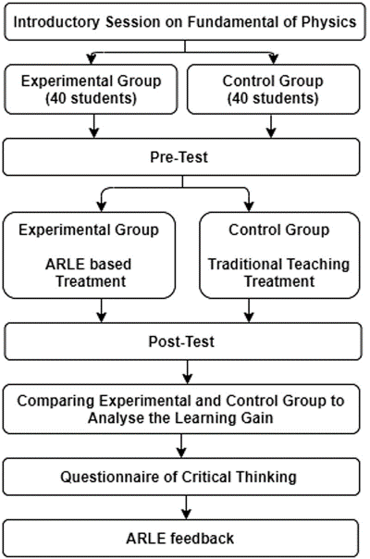

Fig 6: design flow of the experiment conduct.

- Measuring equipment’s

The measurement instruments utilized in this study include a knowledge test and a Critical Thinking Questionnaire. The knowledge test was used to assess students' understanding of fundamental Physics concepts, while the Critical Thinking Questionnaire was employed to evaluate their critical thinking skills.

The knowledge test followed a pretest and posttest design. The pretest aimed to gauge students' knowledge before the experiment, while the posttest assessed their knowledge after the intervention. The pretest comprised 15 multiple-choice questions, with a maximum score of 15, and the posttest consisted of 15 multiple-choice questions, with a maximum score of 20. Both the pretest and posttest were designed by a teacher with six years of experience in the relevant field.

Critical thinking involves the process of analyzing, synthesizing, and evaluating information to form judgments and draw conclusions. It encompasses various aspects, including Interpretation, Analysis, Evaluation, Inference, and Explanation. Interpretation involves expressing the meaning of various experiences, judgments, beliefs, rules, events, and procedures. Analysis entails identifying relationships among concepts, descriptions, statements, and questions. Evaluation refers to assessing the credibility of representations and descriptions based on students' perceptions and experiences. Inference involves identifying reasonable conclusions and forming hypotheses. Explanation entails presenting the results of specific reasoning and providing justifications for that reasoning based on perceptions and experiences.

The Critical Thinking Questionnaire utilized to measure students' critical thinking abilities was adapted from a questionnaire created by Chai et al. [9]. It consists of six items, such as "I will think about whether what I have learned in this learning activity is correct or not" and "In this learning activity, I will try to understand the new knowledge from a different point of view." Students were asked to respond on a 10-point scale, ranging from 1 to 10.

Analysis of results :

The data obtained from the experimental study underwent analysis using the SPSS software to determine the study's outcomes. Prior to applying any statistical tests to the collected data, the normality of the data was assessed. Descriptive statistics for the pretest, posttest, and critical thinking scores are presented in Table 2, suggesting that the data follows a normal distribution. As a result, an independent sample t-test can be utilized to determine the difference between the two groups.

Analysis of Knowledge Test:

Initially, a t-test was conducted to assess the students' knowledge of fundamental Physics concepts before the experiment. The t-test analysis of the pretest, as shown in Table 3, indicates that there is no significant difference between the mean scores of the two groups, with a p-value greater than 0.05.

Subsequently, after the experiment, Levene's test was performed to examine the equality of variances in posttest scores for both groups. The p-value of Levene's test was greater than 0.05, and the F-value was 0.574, suggesting insufficient evidence to conclude a difference in variances between the two groups. Thus, equal variance was assumed between the groups. Following this, a t-test was conducted to determine the difference in knowledge between the two groups after the interventions. Table 4 displays the t-test analysis of posttest scores.
.

TAB LE 2 Pretest, Posttest, and Critical Thinking Descriptive Statistics

Variable | N  Statistic | Mean Statistic | SD  Statistic | Variance Statistic | Skewness  Statistic | SE | Kurtosis  Statistic | SE
Pretest | 80 | 11.385 | 3.052 | 9.376 | 0.423 | 0.279 | −0.814 | 0.522
Posttest | 80 | 13.935 | 3.139 | 9.791 | −0.086 | 0.269 | −0.964 | 0.522
Critical thinking | 80 | 8.187 | 1.501 | 2.256 | −0.812 | 0.269 | −0.029 | 0.542
Standard deviation (SD) and standard error (SE) are abbreviations.

TAB LE 3 Evaluation of the pretest

 |  |  |  |  |  |  | Interval of the difference
Dependent variable Group | N | Mean | SD | t | df | p | Lower Upper
Pretest Teaching group for AR | 40 | 10.09 | 3.038 | −0.228 | 77 | .827 | −1.522 1.222
Conventional teaching | 40 | 10.99 | 3.122
group
Standard deviation, augmented reality, and standard error are all abbreviations.

TAB LE 4 Evaluation of the posttest
95% Confidence interval of the difference
Dependent variable | Group | N | Mean | SD | t | df p Cohen's d | Lower | Upper
Posttest | Teaching group of AR | 40 | 15.76 | 2.533 | 6.13 | 78 .000 1.374 | 2.397 | 4.702
 | Conventional teaching | 40 | 12.16 | 2.535
group
Standard deviation, augmented reality, and standard error are all abbreviations.

An investigation of critical thinking

Levene's test was used to gauge the equality of variation in both groups' capabilities for critical thought. The results of Levene's test yielded a p-value of less than 0.05, and the corresponding F-value was 8.704, showing that the variance between the two groups is not comparable. Assuming equal variance between the groups was therefore incorrect. Instead, a Welch t-test was used to examine how the two groups differed in their capacity for critical thought. Table 5 displays the findings of the Welch t-test.

TAB LE 5 Welch t‐test analysis of critical thinking ability
95% Confidence interval of the difference
Dependent variable Group
N Mean SD t
df
p Cohen's d Lower
Upper

Critical thinking | AR based teaching group | 40 | 8.74 | 1.107 3.694 67.22 .001 | 0.807 | 0.501 | 1.748
ability | Conventional based teaching | 40 | 7.63 | 1.543
group
Standard deviation, augmented reality, and standard error are all abbreviations.

Conclusion :

This study's main goal was to determine how Augmented Reality Learning Environment (ARLE) affected engineering students' learning gains and critical thinking skills. The ARLE was created to provide students with an active learning environment that concentrated on the principles of electromagnetic. In the experimental study, students were split into two groups and given distinct teaching interventions — one group was taught using ARLE, and the other group was taught using a traditional teaching strategy. The experiment's findings show that, when compared to the traditional teaching method, ARLE had a favorable impact on students' learning gains and critical thinking skills.
The mean posttest score for the AR teaching group was 15.76 in terms of information gained, compared to 12.16 for the traditional teaching group. This statistically significant difference suggests that the AR intervention considerably improved engineering students' learning gains. Students were able to engage with 3D virtual information through the usage of ARLE, which helped them visualize different physics ideas. This enhanced their capacity to remember information and use it realistically while also fostering a greater comprehension of the fundamental ideas. These results are consistent with earlier research by Singh et al., Chang et al., and Ibanez et al..

Additionally, the study showed a clear distinction between the two groups' critical thinking skills. The students' critical thinking skills were greatly improved by the AR intervention, as evidenced by the mean critical thinking score of 8.7 for the AR teaching group and 7.6 for the control group. This improvement can be linked to the students' greater motivation for learning as a result of their higher participation in ARLE-based learning activities. Students claimed that ARLE improved knowledge by enabling them to picture complex physics ideas. Students' engagement, participation, and motivation increased because to the immersive experience offered by ARLE, which allowed for visualization and interaction with 3D virtual animated content.

Overall, this study offers proof that AR improves students' knowledge, focus, and practical abilities. It shows that students are eager and motivated to study using digital learning settings and platforms. AR and VR technologies can show to be useful tools for instructors and academics in creating successful online learning environments and giving students an immersive learning experience, particularly during the COVID-19 epidemic. Academic institutions should encourage researchers and instructors in this attempt even if creating AR/VR learning environments takes time and money because of its immense potential as a useful tool for students and teachers during online teaching.

REFERENCES
- H. Altinpulluk, Determining the trends of using augmented reality in education between 2006‐2016, Educ. Inf. Technol. 24 (2019), 1089–1114.
- I. M. Astra, and F. Saputra, The development of a Physics Knowledge Enrichment Book “optical Instrument Equipped with Augmented Reality” to improve students’ learning outcomes, J. Phys.: Conf. Ser. 1013 (2018), 012064.
- C. Avilés‐Cruz, and J. Villegas‐Cortez, A smartphone‐based augmented reality system for university students for learning di- gital electronics, Comput. Appl. Eng. Educ. 27 (2019), 615–630.
- R. I. Barraza Castillo, V. G. Cruz Sánchez, and
O. O. Vergara Villegas, A pilot study on the use of mobile aug- mented reality for interactive experimentation in quadratic equations, Math. Probl. Eng. 2015 (2015), 1–13.
- M. Bower et al., Augmented Reality in education—cases, places
and potentials, Educ. Media Int. 51 (2014), 1–15.
- S. Cai et al., Applications of augmented reality‐based natural
interactive learning in magnetic field instruction, Interact. Learn. Environ. 25 (2017), 778–791.
- S. Cai, X. Wang, and F.‐K. Chiang, A case study of augmented
reality simulation system application in a Chemistry course, Comput. Human. Behav. 37 (2014), 31–40.
- A. Cerrato, G. Siano, and A. De Marco, Experience augmented reality: From education and training applications to assessment procedures, Qwerty 13 (2018).
- C. S. Chai et al., Assessing multidimensional students’ percep- tions of twenty‐first‐century learning practices, Asia Pacific Educ. Rev. 16 (2015), 389–398.
- S.‐C. Chang, and G.‐J. Hwang, Impacts of an augmented reality‐ based flipped learning guiding approach on students’ scientific
project performance and perceptions, Comput. Educ. 125 (2018), 226–239.

- K.‐H. Cheng, and C.‐C. Tsai, Affordances of augmented reality in science learning: Suggestions for future research, J. Sci. Educ. Technol. 22 (2013), 449–462.
- T. H. C. Chiang, S. J. H. Yang, and G.‐J. Hwang, Students’
online interactive patterns in augmented reality‐based inquiry activities, Comput. Educ. 78 (2014), 97–108.
- Y. D. Choi, and H. J. Yun, Vector field platform for visualizing electric and magnetic fields in matter using Mathematica, J. Korean Phys. Soc. 74 (2019), 530–541.
- Á. Di Serio, M. B. Ibáñez, and C. D. Kloos, Impact of an aug-
mented reality system on students’ motivation for a visual art course, Comput. Educ. 68 (2013), 586–596.
- A. Dünser et al., Creating interactive Physics education books with augmented reality, Proc. 24th Aust. Comput. Interact. Conf. OzCHI 2012.
- A. Echeverría et al., Exploring different technological platforms for supporting co‐located collaborative games in the classroom, Comput. Human. Behav. 28 (2012), 1170–1177.
- J. Franklin, and A. Ryder, Electromagnetic field visualization in virtual reality, Am. J. Phys. 87 (2019), 153–157.
- J. D. González et al., Impact of the use of virtual laboratories of
electromagnetism in the development of competences in en- gineering students, J. Phys.: Conf. Ser. 1247 (2019), 012018.
- R. Gusmida, and N. Islami, The development of learning media for the kinetic theory of gases using the ADDIE Model with augmented reality, J. Educ. Sci. 1 (2017), 1.
- H. Heflin, J. Shewmaker, and J. Nguyen, Impact of mobile technology on student attitudes, engagement, and learning, Comput. Educ. 107 (2017), 91–99.
- K. T. Huang et al., Augmented versus virtual reality in education:
An exploratory study examining science knowledge retention when using augmented reality/virtual reality mobile applications, Cyberpsychol. Behav. Soc. Netw. 22 (2019), 105–110.
- M.‐B. Ibanez et al., Support for augmented reality simulation
systems: The effects of scaffolding on learning outcomes and behavior patterns, IEEE Trans. Learn. Technol. 9 (2016), 46–56.
- M. B. Ibáñez et al., Experimenting with electromagnetism using
augmented reality: Impact on flow student experience and edu- cational effectiveness, Comput. Educ. 71 (2014), 1–13.
- F. Mannus et al., Augmenting magnetic field lines for school
experiments, 2011 10th IEEE Int. Symp. Mix. Augment. Real., IEEE, 2011, pp. 263–264.
- A. Mart et al., Supporting teacher orchestration in ubiquitous
learning environments: A study in primary education, IEEE Trans. Learn. Technol. 8 (2015).
- J. Martín‐Gutiérrez et al., Augmented reality to promote colla-
borative and autonomous learning in higher education, Comput. Human. Behav. 51 (2015), 752–761.
- J. Martín‐Gutiérrez et al., Virtual technologies trends in educa-
tion, Eurasia J. Math. Sci. Technol. Educ. 13 (2017), no. 2, 469–486.
- S. Matsutomo et al., Real‐time visualization system of magnetic
field utilizing augmented reality technology for education, IEEE Trans. Magn. 48 (2012), 531–534.
- M. Ozdemir et al., The effect of augmented reality applications in
the learning process: A meta analysis study, Eurasian J. Educ. Res. 18 (2018), 1–22.
- S. Park, and C. Kim, Boosting learning‐by‐teaching in virtual
tutoring, Comput. Educ. 82 (2015), 129–140.
- D. Prit Kaur, A. Mantri, and B. Horan, A framework utilizing augmented reality to enhance the teaching–learning experience of linear control systems, IETE J. Res. 2063 (2018), 1–10.
- G. Singh et al., Evaluating the impact of the augmented reality learning environment on electronics laboratory skills of en- gineering students, Comput. Appl. Eng. Educ. 27 (2019), 1361–1375.
- M. Sirakaya, and E. Kiliç Çakmak, Investigating student atti-
tudes towards augmented reality, Malaysia Online J. Educ. Tech. 6 (2018), no. 1, 30–44.
- D. Sonntag et al., Hybrid learning environments by data‐driven
augmented reality, Procedia Manuf. 31 (2019), 32–37.
- S. Tumkor, Personalization of engineering education with the mixed reality mobile applications, Comput. Appl. Eng. Educ. 26 (2018), 1734–1741.
- Y.‐H. Wang, Using augmented reality to support a software
editing course for college students, J. Comput. Assist. Learn. 33
(2017), 532–546.
- X. Wei et al., Teaching based on augmented reality for a tech- nical creative design course, Comput. Educ. 81 (2015), 221–234.
- H.‐K. Wu et al., Current status, opportunities and challenges of augmented reality in education, Comput. Educ. 62 (2013), 41–49.
- M.‐T. Yang, and W.‐C. Liao, Computer‐assisted culture learning in an online augmented reality environment based on Free‐Hand Gesture Interaction, IEEE Trans. Learn. Technol. 7 (2014), 107–117.
- E. Özdemir, and M. Coramik, Reasons of student difficulties with right‐hand rules in electromagnetism, J. Balt. Sci. Educ. 17 (2018), 320–

