CHAPTER-1. Bioengineering- An emerging trend in biology (An Introduction)
Bioengineering is also known as Biological Engineering. It is the study of applied engineering practices in general biology. It is used to manufacture visible, accessible, and cost effective products. It gives the knowledge and learning related to applied sciences like biocatalysts, biomechanics, bioinformatics, bioreactor designing, fluid mechanics, mass and heat transfer, polymer science kinetics, separation and purification, science of surface studies, and thermodynamics.

It is used in the designing of medical equipment (like diagnostic devices) to add the life values in the society. It tries to meet in integrative, innovative, collaborative and interdisciplinary manner. It provides the solutions for the problems that are unable to solve by the disciplines of engineering and physical and life science.

This branch of biology meets with technology so that challenges that remain unaddressed can create a novel change in this world. It provides devises and innovative solutions to open-ended, which can solve the unknown issues that present in biology, health and medicine.

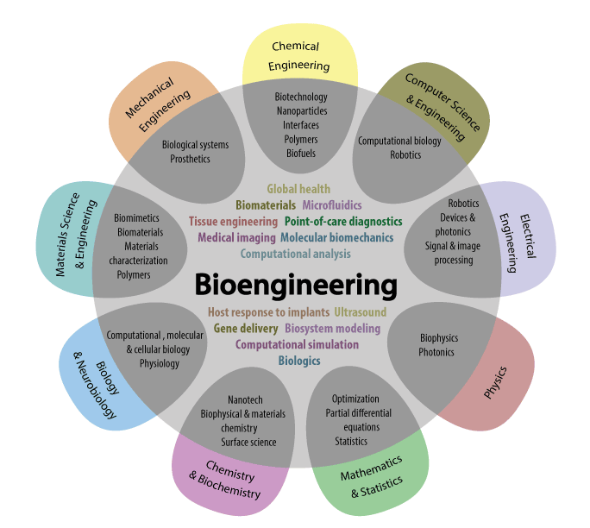

Fig. Explanation of various field collaboration and related to Bioengineering.

Bioengineering make a bridge between engineering, biology and physical science. It possesses a different perspective of academics. Subjects like Applied Mathematics, Computer Science and Engineering creates connections and collaborations among engineering, physical and quantitative sciences. Biochemistry and Oceanography makes an intersection between life, physical and quantitative sciences. Environmental and Civil Engineering provides some unique principles to specific area of life sciences.
Bioengineering is used to get applicable the knowledge of engineering to connect and collaborate them in the different fields of medical and biological sciences. This subject matter applies engineering principles of designing and analytical knowledge to the biological systems and biomedical technologies.
A bioengineer works on a way which is apply to various areas of natural sciences to face different issues at different pace. They always become excited to make modify and control some products, of biological systems. They can be work with doctors, medical professionals, and researchers. They become trained in disciplines of biology and engineering, such as electrical and mechanical engineering, chemistry, and biology computer and, materials science.
Examples of bioengineering research include bacterial engineering for producing different kinds of chemicals, medical imaging technology, quick disease analysis equipment, prosthetics, bio-pharmaceuticals, and artificial tissue engineered organs. In some sorts of knowledge bioengineering cross bridges over biotechnology and biomedical sciences.
History
The term Bioengineering was unknown before World War-II and less in communication and. But agricultural engineers and the chemical engineers, who were performing the fermentation processes are said to be bioengineers because they work with biologists and deals with biological systems to modify the process for creating new and diverse variants.
The civil engineers, who completed their specialization in sanitation, applied many biological principles for creating aseptic environment to performing their job. Mechanical Engineers worked in the collaboration of Professionals related to medical science to develop an artificial limb. Engineers and physiologists worked together in the early 1920s to observe the result of temperature with humidity on human beings to giving a design of equipment for heating and air-conditioning purpose.
In 1954 term ‘Bio-engineering’ was coined by British scientist Heinz Wolff at National Institute. For the first time, here bioengineering was known as its own branch. Primarily, electrical engineering focused on bioengineering, due to involvement of work with medical equipment.
In 1950s the field of bioengineering becomes dominated and used in medical electronics with the help of electrical engineers. Medical instrumentation and medical electronics becomes attractive along with the biological modeling, blood-flow dynamics, biomechanics (dynamics of body motion and strength of materials), biological heat transfer, biomaterials, and prosthetics etc.
As the surgeons needs to bypass heart, and to replace the organs ‘Bioengineering’ got developed. At that time interactions between physicians, physiologists, and engineers creates the result of education.
As engineers and life science workers started working with each other, they recognized that the engineers didn't have potential knowledge about the actual working biological science. For solving these issues, engineers who really want to do something related to biological engineering gives much time to studying the processes of biological, psychological, and medicinal sciences.
In 1966 biological engineering program was started primarily at University of California. Recently, some novel and valuable programs have been launched at MIT and Utah State University. Over the world some old agricultural engineering departments are converted as an agriculture and biological engineering. Professor Doug Lauffenburger of MIT proposed that biological engineering has a wide range used to applying principles of engineering on the biochemistry, cytology, immunology, microbiology, molecular biology, neuroscience, pharmacology, and (which involves the proper study of various devices and sensors). They can be applicable over whole macroscopic organisms (like plants, animals) that are present in the biomes and ecosystems.

1.2. Role of bioengineering in the field of medical Science:-
- Various “smart” therapies are used for treating cancer.
- By making biocompatible implants which are used in resisting the infection.
- By using nanoparticles for imaging enhancement.
- Different kinds of paper-based diagnosis are used for checking health at home and it is used globally.
- Various adaptable prosthesis techniques are used for amputees.
- Bio-Engineered heart cells can be prepared for improving cardiac functions from post-heart attack issues.
- Artificially prepared biomimetic materials are used to prevent various gut infections.
- By creating miniature cell culture techniques are used for learning neurobiology science.
- Synthesis of bio-materials can be made for using as biofuels.
- Preparation of “Catch” bonds for creating various novel adhesives.
- For making photonic biosensors artificially for sensing blood typing.
- An important role played by high intensity focused ultrasound which is used to stop unnecessary bleeding.
- Different types of computational methods are using for monitoring brain growth and development at different levels.
- Under in vitro condition DNA, protein and glycan microarrays are used for various kinds of drug production.
- Different technologies are used for learning and making cure during neuro-rehabilitation.
- For treating cardiac damage and failure in different situations.
- For diagnosing various diseases.

1.3. As a Bioengineer, one can do following:-
  - Biology, health & medicine: One can solve the issues created in biology, health and medicine to make progress in human life.
  - Quantitative approach: One can use the quantitative tools and techniques such as mathematical modeling and simulation.
  - Solving open-ended problems: One can produces novel varieties of solutions for cure the real-world issues at different levels.
  - Independent research & design: One can conduct research independently and designing the various projects (in vitro, in vivo and in silico) reports which can be mentoring by leaders of bioengineers.
  - Hands-on learning: One can enjoyed the learning of technologies by experimenting, via performing experiments in labs, preparing projects for completing projects research.
  - Problem solving by team-work: One can perform their work with smart, mature and diverse team leaders by solving the different issues creatively and instantly.
  - Broad knowledge: One can acquired the broad range of knowledge by spanning engineering, biology and the physics.
  - Cohort experience: One can move forward sequentially and smartly through a core course of curriculum and with the help of talented and knowledgeable peers of Bio-Engineering.

1.4. Branches of Bioengineering:-
- Medical engineering: In this branch we have to study about the principles of medical problems, such as damaged organs replacement, instrumentation, and the health care systems, like diagnostic applications through computers by using various databases.
- Agricultural engineering: In this branch we have to study about how to cure the issues related with the creation of biological production in the external environment and their operations which trigger its production.
- Biochemical engineering: It is the branch which deals with the study of fermentation engineering, in which one can use microscopic biological systems to make new products by artificial synthesis, such as production of protein.
- Human-factors or ergonomics engineering: In this branch we can study about physiology (study of external body parts), and psychology (study of mental condition) to optimize the relationship between human and machine.
- Environmental health engineering: It is also known as bio-environmental engineering; this branch is used to control the environment for providing the health benefits, comfort, and security of individuals.
- Genetic engineering: This branch is used to manipulate gene structure artificially, modify, and recombinant the nucleic acid molecules for creating some useful modifications in an organism. It is used to produce the medical products, like insulin, growth hormone, albumin of human, vaccines for hepatitis-B, covid-19, antihaemophilic factors monoclonal antibodies, follistim (for infertility treatment) etc.
1.5. Sub- Branches of Bioengineering:-
Followings are the sub-branches of Bioengineering:-
- Biomedical engineering: It is the science in which one can study about principles of engineering and design for making medicine for improving someone’s health.
  - Biomechanics
  - Clinical engineering
  - Neural engineering
  - Pharmaceutical engineering
  - Tissue engineering
- Bio-system engineering: It is used to apply the knowledge of engineering and designing principles. Under this category agriculture, food sciences, and ecosystems come and falls together.
- Bioprocess engineering: It is used to develop the technology for monitoring the conditions at which a particular process can take place, (such as bio-catalysis, bioenergy, bioprocess design, bio-separation etc.)
- Biotechnology: It is used for living beings and organisms to create various products. (Such as pharmaceuticals, Bioinformatics, Genetic engineering).
- Biomimetic: It is used to study the model imitation, various systems, and different elements of nature to solve the complicated human health issues. (Like Velcro, designed after George de Mestral noticed that burs stuck to a dog's hair easily).
- Bio-electrical engineering: It is used to incorporate living cells and tissues into micro-devices, which are then incorporated into micro-devices, that are used to study the mechanisms of thought processes and memory related issues, mechanical properties of cells, bio-sensing and drug screening.
- Biomechanical engineering: It is used for mechanical engineering principles and different biological systems to determine the different areas in relation of that, which can be then further integrated to improve the human health.
- Bionics: It is used for integration of biomedical substrates for assisted technologies like robotics. (such as prosthetics)
- Bio-printing: It is used to utilize the biomaterials to print new tissues and organs.
- Bio-robotics: It is used in the electrical prosthetics.
- System biology: It is used to study the molecules, cells, organs, and organisms in terms of their relation, interactions and behaviors.

1.6. Roles of bioengineering in medical science:-

Four ways by which biomedical engineering can enhance the healthcare are given below:-
Biomedical Engineers can operate in an environment which promotes creativity, and allowed to create treatments for a wide range of health problems to cure. Below four ways which Biomedical Engineers improved in the healthcare services are:-

1. Inventions
Some incredible healthcare inventions are created by Biomedical Engineers recently. For example: developing of prosthetics limbs, artificial hearts, livers, and bionic contacts lenses, etc.

2. Medicine
Various new researches related to body functions can develop new medicines and drugs to cure our health, keeps us fit and used in treatment of various diseases well (like cancer). Newly synthesize medicines can also use to solve long-term health issues.

3. Tools and Devices
Bioengineers create some important tools and devices such as MRI, dialysis, ultrasound and various other diagnostic equipments. They inventing different kinds of devices because they have to work with various other medical and healthcare professionals, like doctors, nurses, compounders, M.R., surgeons and lab technicians, to cure the different kinds of health issues.

4. Biological processes

In this new version of technology of Bioengineering like wearable sensors and pacemakers makes patients feel comfortable and monitor their health conditions remotely, sequentially and on right time. For example; hemodialysis.
Biomedical engineering is used to study how one can apply the engineering principles and designing the medical and biological system for improving someone’s health (like diagnosis). It is also works as various simple to advance health care treatment, observations, analyzing, and therapeutics.
1.7 Other Fields included in Bioengineering:-

1. Bioinformatics:-

It is a branch of Biology in which methods and software tools are being studied for understanding the biological data. It connects the engineering with computer science, statistics, and mathematics, to observe and concluded the biological data for uses of various purposes. It is used for biological studies in which use of programming of computer act as its methodology part, a reference for analyzing and use of specific data which is used repeatedly, basically in the disciple of genomics. It is used to study and identify the particular individual genes and single nucleotides phosphates.

It is used for taking the good understanding of genetic diseases, adaptations with unique characters, properties with desired characters (especially in agricultural species), and also identify the main and basic differences between populations. It also tries to explain the principles of organization that are present behind nucleic acid and sequences of protein.

2. Biomaterial Science/ Biomaterials Engineering

Biomaterial Science is the study of any matter, surface, and construct which creates interactions and connections with living beings. Bio-materials are found around 50 years old according to science. It is also known as biomaterial engineering. It grows steadily and strongly over the past history. Large number of companies investing lots of money in developing new variety products is also included in this. Biomaterials science possessing the courses related to biological, chemical, medicinal, tissue based and materials science.

3. Biomedical optics (BMO)

BMO is the science in which one can learn the principles of physical, and biological science include with engineering, to study the collaboration of biological tissue with light, and the method by which it can be used for sensing, imaging, and health treatment. It has so much importance, in the area of optical imaging, microscopy, ophthalmoscopy, spectroscopy, and therapeutic uses. Few examples of BMO technology are confocal and fluorescence microscopy, optical coherence tomography, and photodynamic therapy. OCT uses light to create high-resolution, 3D images of internal structures so that, we can identify where is retina present in our eye and where is coronary arteries present in our heart.

By using Fluorescence microscopy we can label with fluorescent dyes to the particular molecules and can visualize them by utilizing the light, which clears the idea about biological processes and the mechanism of diseases. Today, we uses an adaptive optics which helps in correcting aberrations by imaging the biological tissue which enables and creates higher resolution imaging and that can helps to improve in accuracy of the process like retinal imaging and its laser surgery, if it is required.

4. Neural engineering

Neural engineering is a branch of bioengineering in which engineering techniques are used to know the process which helps to repair, replace, and enhance neural systems of a human body. Neural engineers are become able and qualified to solve the designing issues at the interface of living and non-living neural tissues.

5. Tissue engineering

Tissue engineering is also a part of biotechnology like genetic engineering, which is also somewhat similar to the biomedical engineering. Its main focus is preparing the organs artificially for organ transplantations in patients who require, by using biological material. Recently, biomedical engineers had grown bones of solid jaw and tracheas by using human stem cells, which have capacity to grow rapidly.

Large amount of artificial urinary bladders are preparing commonly in research labs for transplantation into human body successfully and grow liver cells inside an artificial bioreactor by using various hepatic assisted devices.

6. Pharmaceutical engineering

It is a branch of science in which pharmaceutical technology, drug delivery and construction, and targeting are included. It is the unit operations of chemical engineering with pharmaceutical analysis. It can be consider as a part of pharmacy because of the way it is uses in technology on chemical agents for providing better medicinal treatment and cure.

7. Hospital and medical devices
It is the branch in which one can study the useful health care products which do not achieve their target results via medical and pharmaceutical means by using vaccines. The process of metabolism is also does not considered.
The medical device is used:
- To identify the medical issues related to some diseases.
- To find out the right cure of various diseases.
E.g. Artificial preparation of pacemakers, infusion pumps, different organs, heart, lungs and dialysis machines, corrective lenses, cochlear and dental implants, ocular, facial and somatic prosthetics.
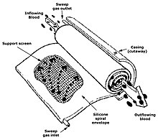
Fig. Diagrammatic representation of silicone membrane oxygenator.

8. Biomedical imaging

It is related to the study of medical devices. In this technique we can study about the procedure of imaging of the internal parts of one’s body for clinical observations and medical treatments. For this purpose we can use waves of ultrasound, magnetic frequencies, UV lights, some radiations, and various other tools and techniques. For example, placements of catheter into the brain which can be alternatively navigated and guided by using various equipment.

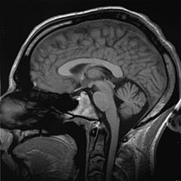
Fig. Diagrammatic representation of MRI scan of a human head comes under Biomedical Imaging.
Imaging technologies are commonly used for various medical diagnostic purposes, and are typically having the most complex equipment in some hospitals. Fluoroscopy, MRI, nuclear medicine, positron emission tomography, PET-CT scans, tomography, waves of ultrasound, optical microscopy, and electron microscopy as a projection radiography.

9. Medical implants technology
It is used to study in which we can replace a missing and dysfunctional biological structure of human body by using various medical devices. When the surface of implants comes and interact with the body can be made by different biomedical materials like titanium, silicone or apatite, which is depends on functionality. Implants contain electronics in some cases, e.g. preparation of artificial pacemakers and implants of cochlea.
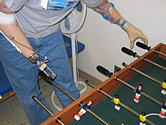
Fig. Diagrammatic representation of Artificial limbs: The right arm shows prosthesis, and left arm shows myoelectric control.
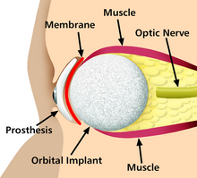
Fig. Diagrammatic representation of a prosthetic eye, an example of medical implants

10. Bionics
Under bionics we have to study about the artificial body part replacements, which is the most important application of this branch of Bioengineering. It is concerned with the knowledge regarding with various properties and functions of parts of human body. It can be used to resolve so many issues related to engineering. Study in a proper way, different functions and processes of eyes, ears, and various other organs give the right direction in improving good resolution cameras, television, radio transmitters and receivers, and much more.

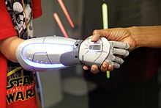
Fig. Diagrammatic representation of Bionics (An organ replacement technology)

11. Biomedical sensors
Biomedical sensors technology is based on microwave, which gained the most attention. Different sensors are manufacturing for particular uses in both to diagnose and monitor various diseases, for example microwave sensors can be used to monitor the lower extremity trauma as a complementary technique by using X-rays. Biomedical sensors notice the changes present in various tissues of bones, muscles, fat etc. under the skin, which can be monitor by the dielectric properties. So, during the healing process, which is measuring at different levels the response from the sensors changes with the healing of trauma.
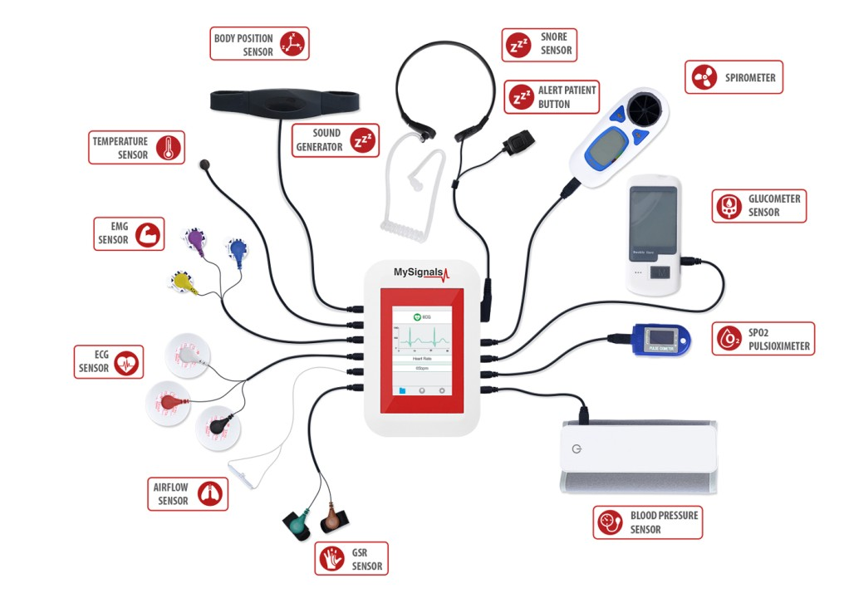
Fig. Diagrammatic representation of biomedical sensors.
12. Clinical Engineering
A branch of biomedical engineering that shares the knowledge in relation of the process of implementation of different kinds of equipment and technologies that are useful for hospitals and other clinical labs is known as clinical engineering.
Clinical engineers also works in the collaboration of medical device producers related to various design improvements, which are based on their clinical experiences.
They also monitor to redirect procurement patterns accordingly the state of the art by using its projections.
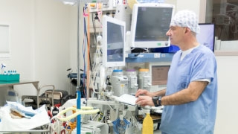

Fig. A clinical Engineer supervising the medical equipment.

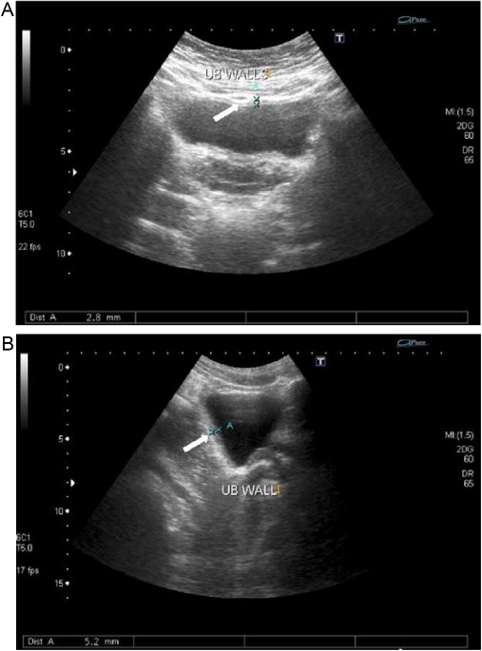
Fig. Diagrammatic representation of Ultra-sound of urinary bladder (black butterfly-like shape) shows hyperplastic prostate, which is an example of practical and medical science working together.

13. Rehabilitation engineering

Rehabilitation engineering is related with the science of engineers in which students will learn to solve the problem related to the person, who possesses physical disabilities by designing, developing, adapting, testing, evaluating, applying, and distributing the problem related organs. Problems related to mobilization, communications, hearing, vision, cognition, and activities related with their jobs, independent living, education, and interaction with their community are solve under this disciple.

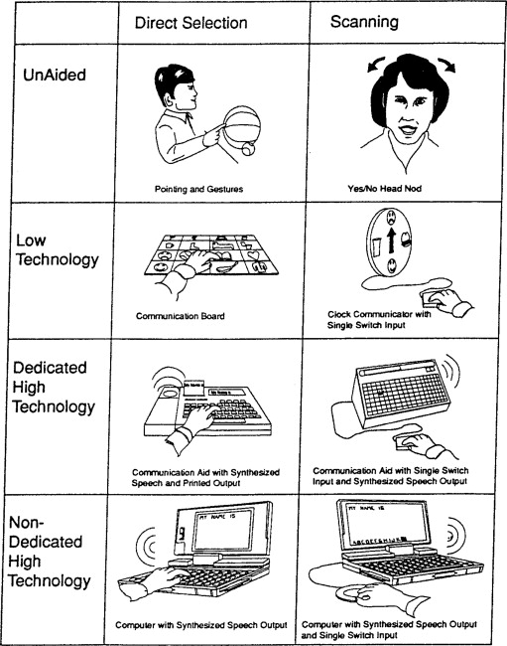

Fig. Diagrammatic representation of a hearing, vision, and cognition through Rehabilitation engineering.

