Gender Predisposition in Indian Society: A Study on Violence against Women
Halima Ali Ahmada Research Scholar Department of Psychology Lovely Professional University, Phagwara, Punjab India-
144411
Email: Id halimaahmada@gmail.com
Tariq Abubakar Ally
Research Scholar Department of Law, Lovely Professional University, Phagwara, Punjab, India-
144411
Email Id: tariqally333 @gmail.com
Dr. Rubina Fakhr
Assistant Professor, Department of Psychology, Lovely Professional University, Phagwara, Punjab-, India-
144411
Email Id: rubina.27967@lpu.co.in

Abstract
Gender discrimination, characterized by unequal or disadvantageous treatment based on one's gender, remains a pervasive issue worldwide, particularly affecting women. This study delves into the various forms of violence experienced by women, encompassing both physical and sexual violence. The research reveals a heightened vulnerability among women in developing countries, with a specific focus on the substantial challenges faced by Indian women. Among developing nations, Indian women stand out as enduring significantly higher rates of both sexual and physical violence. Specifically, this study finds that 10% of Indian women experience sexual violence, while 35% endure physical violence. Comparatively, Poland reports 9.9% in sexual violence and 32% in physical violence, Australian women face 8% in sexual violence and 25% in physical violence, United States women contend with 7.7% in sexual violence and 22% in physical violence, and South African women encounter 4.4% in sexual violence and 12% in physical violence. One prominent finding of this study is that many women, particularly in India, lack a fundamental understanding of how socio-economic and political forces influence their lives. Through this research, we aim to shed light on the pressing issue of gender discrimination and the unequal treatment experienced by women in India.

Keywords; Equal Opportunities, Gender Inequality, Patriarchy, Social injustice and Empowerment.

Introduction
In the context of Indian society, being born as a woman often entails confronting gender discrimination across various aspects of life. The term 'gender' encompasses a broad spectrum of socially constructed roles, relationships, personality traits, attitudes, behaviors, beliefs, and the relative allocation of power and influence that society assigns to individuals based on their sex. Gender is an interconnected concept, involving roles and traits that are not independent but rather defined in relation to one another through interactions between individuals of different genders, such as girls and boys, women and men, and individuals of diverse gender identities (Vlassoff, 2007).
Distinguishing between 'gender' and 'sex,' the former pertains to societal distinctions, while the latter refers to biological differences. Gender inequality is a complex issue that affects both men and women in India. While some argue that certain gender equality indices disadvantage men (Sundar, 2017), a comprehensive examination reveals that women face significant challenges when considering the entire population of India. Discriminatory attitudes have persisted in Indian society for centuries, impacting the lives of individuals of all genders. Despite the Indian Constitution guaranteeing equal rights, gender disparities continue to exist.
These gender inequities, rooted in deep-seated social factors, affect critical dimensions of women's lives in India, including the sex ratio, women's lifelong health, educational attainment, and economic circumstances (Karak, 2016). Collectively, disparities in health, education, economics, and politics are referred to as gender inequality (Karak, 2016a). India's rankings vary across these metrics, and its overall position in numerous global gender disparity indices remains a subject of debate (Sharma, 2015).
Studies consistently reveal that gender discrimination tends to favor men in various contexts, including employment. Discrimination permeates multiple aspects of women's lives, impacting their career advancement and mental well-being. Despite Indian laws aimed at protecting women's rights in areas such as rape, dowry, and adultery, these overtly discriminatory actions continue to occur at an alarming rate, adversely affecting the lives of many individuals today. Discrimination against women and girls remains an enduring issue deeply embedded in Indian society.

Gender inequality in India encompasses disparities in education, economics, and politics (Karak, 2016a). India's rankings on these metrics vary, and its overall standing in global gender disparity indices is a subject of debate (Sharma, 2015). Research indicates that gender discrimination often privileges men, impacting various aspects of women's lives, including their career advancement and mental well-being. Despite legal provisions aimed at safeguarding women's rights, such as laws concerning rape, dowry, and adultery, these discriminatory practices continue unabated, negatively affecting the lives of many individuals today.
Discrimination against women and girls remains a deeply ingrained and pervasive issue in Indian society. Despite India's relatively robust economic growth, progress towards gender equality, as reflected in indices like the Gender Development Index, has been disappointingly slow. Over the past decade, despite a 6 percent increase in India's GDP, female labor force participation has significantly declined, dropping from 34 percent to 27 percent. The persistent 50 percent wage gap between men and women remains unchanged. Incidents of violence against women, particularly heinous crimes like rape, dowry killings, and honor killings continue to rise. These trends are concerning, as one might expect that development would be accompanied by increased knowledge, prosperity, and a shift away from traditional norms and socially prescribed gender roles that impede women's progress.

Gender-Based Violence
Gender violence in India can manifest through domestic abuse, rape, and violence related to dowries. According to the National Crime Records Bureau's 2013 annual report, India recorded 24,923 rape cases in 2012. Alarmingly, 24,470 of these cases involved perpetrators who were either family members or neighbors, indicating that in 98 percent of these instances, the victim knew the alleged rapist. Addressing gender-based discrimination in India necessitates ensuring that girls have the opportunity to access education and personal growth. This not only empowers them economically, but also equips them to contribute positively to their own advancement and that of society as a whole.

Gender inequality and societal expectations regarding gender-appropriate behavior are deeply influenced by cultural norms in India, particularly those related to patrilineally (inheritance through male descendants) and patrilocality (married couples residing with or near the husband's parents). The cultural preference for sons often stems from their perceived role as caregivers to parents in old age, resulting in adverse outcomes for daughters. Another institution perpetuating gender inequality is the dowry system, which involves payments made by the bride's family to the groom's family, either in cash or in-kind, at the time of marriage. Regrettably, the practice of demanding dowries often leads to various forms of abuse against women and contributes to instances of intimate partner violence.

In the Table 1, we will try to explore the situation of percentage of violence’s committed by intimate partners;
Figure: 1
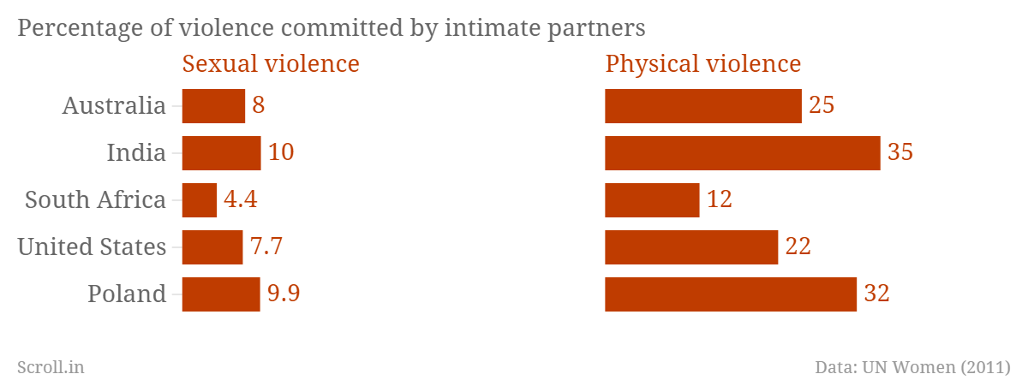
Source; Gender-Based Violence table in India - Bing images: https://www.bing.com/

In Figure -1, which presents data on the percentage of violence committed by intimate partners in five countries, India stands out as having the highest rates of both sexual and physical violence. India reports the highest levels of violence against women, with 10% experiencing sexual violence and 35% enduring physical violence. Poland ranks second, with 9.9% experiencing sexual violence and 32% facing physical violence, followed by Australia with 8% in sexual violence and 25% in physical violence, the United States with 7.7% in sexual violence and 22% in physical violence, and South Africa with 4.4% in sexual violence and 12% in physical violence.

Dowry payments have been on the rise across all socioeconomic classes and regions, often resulting in dowry-related violence against women by their husbands and in-laws, especially when the dowry is perceived as insufficient or as a pretext to demand additional payments. Such practices discourage parents from having female children or investing adequately in the health and education of girls. In India, the increasingly skewed sex ratios reflect these parental decisions.

Gender disparity plagues the Indian economy, extending its influence into other domains like healthcare, education, economics, and politics. These sectors have traditionally been male-dominated, illustrating the deeply rooted sexism in Indian society. Despite advancements in gender equality since independence, persistent efforts are required to bridge the gap and ensure equal opportunities for men and women.

In recent times, women have actively participated in economic activities and the labor force, with women constituting 74 percent of the agricultural workforce. However, despite the advocacy of reformists and feminists for equal pay, gender-based wage disparities persist across the Indian economy. It's crucial to recognize that women are not inferior to men but complement them. Historically, women in India have been marginalized and viewed as an oppressed group. While the birth of a son is celebrated, the birth of a daughter is often met with disappointment (Amutha, 2017). Gender-based stereotypes persist, with girls being encouraged to stay at home and be reserved while boys are urged to be assertive and outgoing. These gender-based distinctions negatively impact development goals and hinder economic progress. Restricting women from participating in social, political, and economic activities has far-reaching consequences for society, undermining overall well-being. Therefore, gender inequality is a unique form of disparity that necessitates distinct attention due to its significant impact on various aspects of society.

In India, gender inequality remains a significant and persistent challenge. While women in India have made notable strides across various fields, a substantial portion of the female population continues to face discrimination and gender inequity (Rane, 2014). According to the UNDP report's Gender Inequality Index (GII), India is ranked 132 out of 187 countries, underscoring the need for ongoing efforts to address and rectify these disparities.

India's low ranking in gender equality can be attributed to several factors, as per official data. One significant issue is the imbalanced sex ratio, with just 914 females for every 1000 males. UNDP data from 2011 reveals that only 29 percent of Indian women over the age of 15 were employed, compared to 80.7 percent of men. The 2011 census highlights the skewed birth sex ratio in various states: Jammu and Kashmir had 128 boys per 100 girls, Haryana had 120, Punjab had 117, Delhi had 114, and Uttarakhand had 117.
Female foeticide is a growing concern in India, often linked to the misuse of sex-determination tools like ultrasound scans. In some rural areas, female infanticide, the killing of girl infants, remains prevalent, largely driven by economic factors. These factors include men's perceived greater earning potential as primary breadwinners, concerns about dowry payments, and the expectation that girls who marry will leave their families. While dowry demands are illegal in India, they persist in some socioeconomic strata, contributing to female infanticide, as girl babies are viewed as a financial burden.
Despite laws such as the Pre-conception and Pre-natal Diagnostics Technique Act of 1994, which prohibit gender selection and selective abortion, these practices continue. Islam, one of the world's major religions, strictly forbids female foeticide. However, many Muslims, especially those living in secular nations, may disregard these religious teachings due to the influence of other cultural customs or external pressures.
Efforts to improve the status of girls and combat female infanticide include initiatives such as government campaigns labeling female foeticide as a sin, as well as observances like Girl Child Day. Gender discrimination continues to manifest in various ways and remains a significant challenge.

Mental Health Concerns
In India, the ratio of male to female adult suicides has been steadily increasing. This male-to-female ratio aligns with global trends (Kolves, 2022). The suicide rate in India showed an upward trend between 1987 and 2007, with higher rates observed in the southern and eastern states of the country (Radhakrishnan & Chittaranjan, 2012). In 2012, states like West Bengal, Tamil Nadu, and Maharashtra had the highest percentage of female suicides. Among states with significant populations, Tamil Nadu and Kerala reported the highest female suicide rates per 100,000 residents in the same year.
Research conducted in South India has linked gender-based disadvantages, including societal attitudes that hinder women's empowerment, to suicidal behavior and common mental health issues such as anxiety and depression. Women's mental health, influenced by various social factors, can be examined across different settings, including family, workplace, and educational institutions. A study conducted in 2001 by U. Vindhya and others found that, compared to men in the study, women tended to experience a higher prevalence of conditions like depression, somatoform disorders, and dissociative disorders (Undurti, Kiranmayi, Vijayalakshmi, 2001).

Inequalities in Politics
When assessing gender disparity, the differences between men and women in political decision-making at the highest levels are taken into account. India has consistently ranked among the top 20 nations globally in this regard, achieving the 9th-best ranking in 2013. This ranking reflects that India exhibits lower gender inequality in political empowerment compared to countries like Denmark, Switzerland, Germany, France, and the United Kingdom.

India has a history of electing a substantial number of women to its state legislative assemblies and national parliament, including positions such as the prime minister and chief ministers of various states. In the 2014 parliamentary elections held in April and May, a remarkable 260.6 million women exercised their right to vote.

The 73rd and 74th Constitutional Amendments in India, ratified in 1993, mandated a quota of 33 percent for women's representation in local self-government institutions, and these amendments came into effect in the same year. According to research by Ghani and colleagues (2014), these amendments have had a significant positive impact on women's empowerment in various areas.

However, it's important to note that whether women's leadership styles are more effective or respected than men's is subjective and may vary depending on individual perspectives and contexts. Leadership effectiveness is not solely determined by gender but by a combination of skills, qualities, and circumstances.

Gender Inequality Caused by Cultural Factors
In India, a strong preference for male offspring persists due to deep-rooted cultural norms and biases that affect both men and women to varying degrees across different contexts (Vlassoff, 2007a). This preference is evident in practices such as female infanticide and sex-selective abortions, which reflect the lower status of women in Indian society. Activists estimate that around eight million female fetuses may have been aborted in the past decade, contributing to a decline in the number of girls under the age of seven according to the 2011 census. Additionally, the 2005 census reports that infant mortality rates for males and females are 61 and 56 out of 1000 live births, respectively, with females being more vulnerable to abortion due to biased attitudes, cultural stereotypes, and insecurity.
Despite women having equal legal rights to own and inherit property, practical disparities persist. National laws like the Married Women Property Rights Act of 1974 offer protection, but legal action is rarely pursued. When considering gender disparity, it's essential to recognize that economic disparities aren't the only differentiating factor between the rich and poor. Even in the presence of cultural influences, underdevelopment can exacerbate gender inequalities, as it often amplifies cultural forces that favor men.
One significant cultural practice contributing to gender disparity is the custom of a woman joining her husband's family upon marriage, leaving her biological family behind. In this system, parents may prioritize investing in a son's health and education over a daughter's, as sons typically remain members of the family after marriage, while daughters do not (Ebenstein, 2014). Gender disparity tends to be more pronounced in northern India compared to the south due to the stronger prevalence of patrilocal (and patrilineal) systems in the north (Dyson & Moore, 1983). Historical data from the 1901 Indian Census, as explored by Chakraborty and Kim (2010), also reveals a less skewed sex ratio in the southern regions, which persists today.
Gender disparities in access to education, healthcare, and nutrition may arise from these cultural practices, particularly if parents do not fully internalize the potential benefits of investing in their daughters. In reality, parents often invest disproportionately in their sons due to longer shared time and pooling of resources. For instance, when faced with a sick child, parents are more likely to seek medical attention for a son than a daughter. A study by Ramakrishnan et al. (2011) found that after a year, 70 percent of males, but only 44 percent of females, underwent surgery for a congenital cardiac issue. This underscores the prevalent belief that raising daughters is akin to benefiting someone else's interests, as expressed in Indian and Chinese proverbs.
Poverty can exacerbate this tendency to invest more in sons than daughters. When both boys and girls would benefit from medical treatment, with boys having slightly higher returns, a family with limited resources might prioritize their son's healthcare. However, with greater means, they may seek treatment for both their son and daughter, demonstrating that the marginal spending of parents may not necessarily favor the disadvantaged group, as suggested by theoretical models (Kanbur & Haddad, 1994).
Notably, improved access to healthcare in India, as suggested by Oster (2009), initially widens the gender disparity in vaccination rates, but subsequent advancements reduce this gap. Gender inequality is a longstanding global issue rooted in human-created gender stereotypes and norms (Scott, 1986). It is linked to cultural practices and family structures that shape social life and relationships and perpetuate the subordination of women within societal hierarchies. While cultural factors contribute to the prevalence of son preference, a major element in daughter neglect in India, the causes of gender inequality are multifaceted and interconnected. Figure 1 illustrates these underlying causes of gender inequality.

Figure 2- Causes of Gender Inequality;
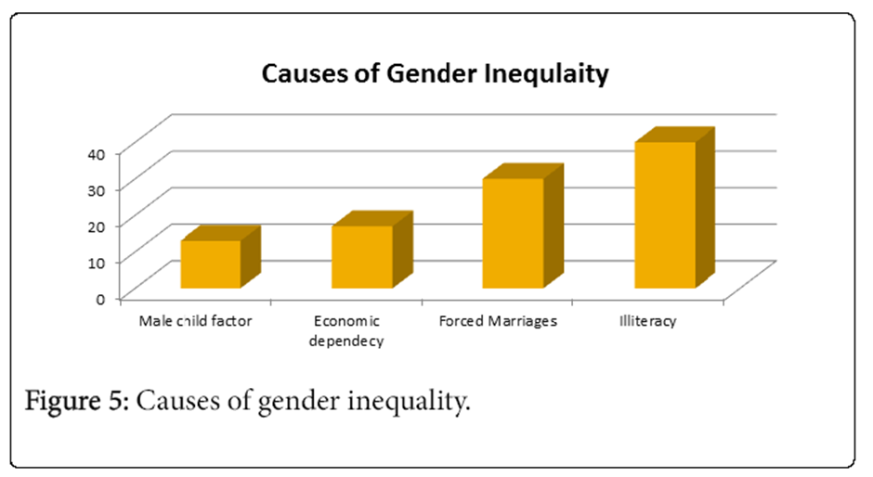
Source: Gender Inequality Caused by Cultural Factors - Bing images

Gender inequality in India is driven by several factors, including:
Literacy and Education: Gender-wise, literacy rates in India reveal a significant gap between men and women. Despite continuous improvement, the female literacy rate remains lower than the male literacy rate (Singh, 2015). According to the 2011 Census of India, female literacy rates stand at 65.46 percent, while male literacy rates are at 82.14 percent. Girls' school enrollment rates are also lower than boys, especially in states other than Kerala and Mizoram, where female literacy rates are closer to universal. Educational disparities persist, with fewer girls completing secondary education compared to boys (Sundar, 2017).
Patriarchal Culture: India adheres to strict patriarchal and patrilineal traditions, where men hold power over female family members and have entitlements to inherit family wealth and titles. Examples of patriarchy in India include passing inheritance from father to son, newlyweds moving in with the husband's family, and practices like bride prices or dowries. These traditions confer societal and financial advantages for raising sons while disadvantaging daughters.
Son Preference: The preference for sons, based on the belief that they are more economically valuable, is a significant driver of gender inequality (Pande & Malhotra, 2007). Sons are seen as essential for carrying on the family name, providing labor in agriculture, and conducting certain religious rituals, which are typically male-only. The cost of dowries and the fear of daughters being absorbed into the husband's family further discourage the birth of girls.
Prejudice Against Women: Despite surveys showing that most women prefer to have at least one son, evidence suggests that discrimination against girls persists once they are born. Discrimination in healthcare access and vaccination rates, particularly in low-income families, contributes to health and survival disparities for girls.
Dowry System: The practice of dowry in India, where gifts or cash payments are given to the groom's family along with the bride, adds to gender inequality. The belief that girls are a financial burden on families restricts resources allocated to daughters and bargaining power within families. Although laws like the 1961 Dowry Prohibition Act exist, the institution of dowry continues to exert influence.
Entrepreneurship: Women's participation in entrepreneurship is low, with less than 5 percent of enterprises owned by women (Rao et al., 2011). Despite comprising more than 50 percent of the population, women make up only 7 percent of all Indian entrepreneurs, with men dominating the field. Women entrepreneurs face obstacles such as limited access to institutional finance, which hinders business growth.
Scientific Professions: Discrimination against women in science and technology fields has been reported, with female faculty members experiencing gender-based discrimination in hiring and promotion (2003 research on Indian institutes). Biased recruiting practices have been noted, with concerns about work-family balance and perceived lower commitment to jobs after marriage. These challenges have slowly improved over time.
Addressing gender inequality in India requires comprehensive efforts, including improving educational opportunities, challenging patriarchal norms, promoting gender-neutral practices, and supporting women's participation in various sectors of society.

Economic Underdevelopment as a Cause of Gender Inequality
In India, gender inequality persists across various indicators, often resulting in unfavorable outcomes for women compared to men. This inequality extends beyond differences in earnings patterns and encompasses various aspects influenced by economic potential. Lower labor productivity among women can explain disparities not only in income but also in other areas.

Education and Labor Allocation: In India, certain societal and economic factors contribute to gender disparities. For example, the primary benefit of education is often seen as the ability to secure higher wages in the labor market. This perspective can lead parents to invest more in the education of their sons, particularly when men specialize in physically demanding jobs while women engage in mentally demanding roles. As a result, boys may receive more schooling during early development. However, as the economy shifts towards industries that rely on cognitive skills rather than physical strength, girls may catch up in terms of education. In fact, if the returns on education are higher in industries that require cognitive abilities, girls may even surpass boys in educational attainment. This shift can be attributed to greater returns on education, which, in turn, can have spillover effects on gender equality in various domains.

Patriarchal Culture: Patriarchal traditions, which are prevalent in much of India, grant men power over female family members, including control over inheritance, property, and political leadership. These customs, such as the passing of inheritance from father to son and the practice of newlyweds moving in with the husband's family, often result in advantages for raising sons and disadvantages for raising daughters.

Son Preference: The preference for sons in India, based on the belief that they are more economically valuable, remains a major driver of gender inequality. Sons are seen as crucial for carrying on the family name, providing labor in agriculture, and conducting certain male-only religious rituals. The cost of dowries and concerns about daughters leaving the family after marriage further discourage the birth of girls.

Prejudice Against Women: Despite surveys indicating a preference for at least one son, evidence suggests that discrimination against girls continues after birth. Discrimination in healthcare access and vaccination rates, particularly among low-income families, results in health and survival disparities for girls.

Dowry System: The practice of dowry in India, where gifts or cash payments are given to the groom's family, perpetuates gender inequality by reinforcing the belief that girls are a financial burden on families. Despite legal measures like the Dowry Prohibition Act, the institution of dowry remains influential.

Entrepreneurship: Women's participation in entrepreneurship is limited, with a small percentage of enterprises being owned by women, despite comprising more than half of the population. Barriers, such as limited access to institutional finance, hinder the growth of women-led businesses.

Scientific Professions: Discrimination against women in science and technology fields has been reported, with female faculty members experiencing gender-based discrimination in hiring and promotion. Biased recruiting practices and stereotypes about work-family balance continue to affect women in these professions.

Economic Development and Changing Roles: Economic development in India has led to shifts in employment patterns, with women entering new sectors such as business process outsourcing (BPO). These opportunities have expanded women's choices and aspirations, delaying marriage and childbirth and increasing school attendance among younger generations. Economic development has also reduced the amount of domestic work through technological advancements like electrification.

In summary, gender inequality in India is a complex issue influenced by a combination of cultural, economic, and social factors. While progress has been made, there is still much work to be done to achieve gender equality in all aspects of society.

Conclusion
In conclusion, it is evident that legislative measures aimed at empowering women are imperative, given the ongoing gender disparities in India despite the country's economic progress. Both men and women play vital roles in the development of their families and society as a whole. The global women's movement has long advocated for gender equality, and recent literature provides insights from successful policy interventions.
One notable policy experiment involved village administration, mandating a minimum of one-third female representation in local leadership positions. This initiative yielded positive outcomes, with female residents' preferences better represented in villages governed by women. Women felt more confident in reporting offenses that were previously considered too stigmatizing to bring to light. Female leaders served as role models, inspiring young women and their parents to pursue education and careers. Although there may be a short-term backlash from men as established gender norms are challenged, studies indicate that negative perceptions eventually diminish. This underscores the importance of sustained affirmative action to reduce gender bias.
Responses to another policy adjustment aimed at equalizing land inheritance rights between sons and daughters have been mixed. While it led to increased educational attainment and delayed marriages for girls, it also raised issues of spousal conflict and domestic violence. Improved employment opportunities can contribute to women's independence. Research has shown that informational visits by job recruiters to communities increased young women's participation in the labor market and enrollment in professional training.
To achieve gender parity in India and maintain its position as a global growth leader, coordinated efforts at the local, state, and national levels, as well as involvement from the private sector, are essential. While increasing the representation of women in public positions is a necessary step that can be achieved through affirmative action, a change in attitudes is also crucial to ensure equal treatment of women in their homes and society at large. Educating Indian children early about the value of gender equality would be a significant first step in this direction.
Gender disparities persist in the lives of girls and boys in India, affecting their opportunities and outcomes. Girls face unique challenges related to societal norms, customs, and traditions, limiting their freedom and decision-making power in areas like education, employment, and marriage. These disparities widen as children grow into adulthood, with only a quarter of women in formal employment. The deeply entrenched patriarchal attitudes and systems in India restrict the full realization of women's rights.
Despite these challenges, some Indian women have emerged as global leaders and influential figures in various fields. Girls and women continue to face hazards, abuses, and vulnerabilities, especially during crises and natural disasters. This review-based study highlights the significant gender gaps that persist in developing countries and raises important questions about the potential for these gaps to narrow and eventually disappear over time.
While economic modernization may naturally diminish cultural practices favoring males and contribute to closing gender gaps, policymakers also have a role to play in expediting progress toward gender equality.

