ADVANCES IN SUPER CRITICAL FLUID EXTRACTION Sudhadevi G ¹, Vyshnavi A¹, Udaykumar Nidoni² , Sharanagouda H² and Pramod Katti²

¹Assistant Processor, ²Professor, ³Research scholar

Department of Processing and Food Engineering,

College of Agricultural Engineering, University of Agricultural Sciences, Raichur

*Corresponding author: Sudha Devi G; Email: sugang17@gmail.com

Abstract:
In this chapter, Super-Critical fluid Extraction a new separation technique developed in recent years is discussed. It is used to extract and separate substances using a supercritical fluid as a solvent. This chapter focuses on difference between super critical fluid extraction and other extraction techniques; Terminology related to Super critical fluid extraction; General principles of Extraction; Fundamentals of super critical fluid extraction; Super critical fluid; Properties of Super Critical Fluid; Parameters Affecting the Extraction Process; Advantages and drawbacks of supercritical fluid Extraction; Special applications of supercritical fluids to food processing; Recent advances and applications of supercritical fluid extraction
KEYWORDS
Supercritical fluid extraction, Super critical fluid, Solvent extraction, Modifiers, Food industry

ADVANCES IN SUPER CRITICAL FLUID EXTRACTION

- INTRODUCTION
One sector within the food and chemical processing industries that has been garnering increasing attention is extraction. Extraction, also known as solvent extraction, entails the separation of a particular substance (referred to as the solute) from a mixture, be it in solid or liquid form, by dissolving it in a liquid solvent. This separation process involves two distinct phases. The solvent is introduced to create a phase distinct from the one in which the material to be separated initially resided. Separation is achieved as the substance to be isolated dissolves in the solvent, while the remaining components remain in their original location. These two phases can encompass solid and liquid states, immiscible liquid phases, or solid and gas phases. Depending on the initial phase of the mixture and the extraction agent utilized, extraction can be categorized into various types:
- liquid - liquid extraction,
- solid - liquid extraction,
- supercritical extraction,
Extraction can be defined as the process of extracting soluble substances from an insoluble residue, whether in liquid or solid form, by treating it with a liquid solvent. This process is fundamentally a solution-based method, relying on the principles of mass transfer phenomena. Typically, the rate of extraction is primarily influenced by the diffusion rate of the solute through the liquid boundary layer at the interface.
In the realm of extraction, the objective often revolves around separating the biologically active constituents of plant or animal tissues from inert or inactive components, accomplished by employing selective solvents in standardized extraction procedures. The resulting products derived from plants are typically somewhat impure, existing in the form of liquids, semisolids, or powders primarily intended for oral or external use. Consequently, extraction remains a subject of significant interest, particularly for achieving enhanced yields of pharmaceuticals sourced from plants and animals.
Extraction extends its utility to diverse domains, including the extraction of spice oils and natural flavor extracts within the flavor industry. The rising demand for functional food additives for fortifying formulated food products has driven the development of extraction systems designed to isolate valuable ingredients from waste generated in food processing and medicinal plant industries.
Furthermore, extraction plays a pivotal role in the beet sugar industry, enabling the separation of sugar from sugar beets. When it comes to sugar cane, the separation process involves a series of mechanical expression stages, incorporating the introduction of water between these stages—a method that can also be considered a form of extraction. The utilization of roller mills for mechanically expressing sugar cane juice is not only capital-intensive but also prone to extended downtime in the event of breakdowns. Moreover, it consumes a substantial amount of energy. Consequently, modern cane sugar processing plants are increasingly adopting diffusers, a water-based extraction process, as an alternative to the conventional multiple roller mills.
Extraction has a long-standing history in the vegetable oil industry as well. Oils derived from soybean, corn, and rice bran, due to their nature, cannot be effectively separated through mechanical pressing alone. Therefore, solvent extraction is employed to recover these oils.
In various segments of the food industry, water extraction is employed to extract caffeine from coffee beans, and it is also utilized in the preparation of soluble coffee and tea products for subsequent freeze or spray drying. Additionally, supercritical fluid extraction has emerged as an effective method for decaffeinating coffee and tea, as well as for producing distinctive flavor extracts from the fruits and leaves of various plants.
TERMINOLOGY:
Extraction: Extraction is a process characterized by contact equilibrium, involving the interaction between a solid material containing a desired solute and a liquid solvent. A period of time is allotted for the establishment of equilibrium, during which the desired component migrates from the solid phase to the liquid phase. Subsequently, the separation of the solid and liquid phases is accomplished through physical methods. This principle holds true for liquid-liquid extractions as well.
Supercritical: The term "supercritical" denotes a substance existing as a single-phase fluid that does not condense when raised above its critical temperature (Tc) and critical pressure (Pc). Once this threshold is surpassed, the substance enters a supercritical state, characterized by distinctive physicochemical properties that combine features of both gases and liquids. These properties include high density, intermediate diffusivity, and low viscosity and surface tension.$\left[63\right]$
Supercritical Fluid: A fluid existing at temperature and pressure levels beyond its critical point is termed a supercritical fluid. This unique state of matter exhibits characteristics that fall between those of a gas and a liquid. It possesses a density akin to that of a liquid, while its viscosity and diffusivity closely resemble those of a gas. Consequently, a supercritical fluid can function as a solvent much like a liquid but with significantly improved mass transfer kinetics.
Supercritical fluid Extraction (SFE) principle: Supercritical carbon dioxide technology (SC-CO2 technology) harnesses pressure in conjunction with carbon dioxide to effectively eliminate microorganisms while preserving the nutritional content and organoleptic qualities. This innovative approach shows great promise as an alternative to conventional heat-based pasteurization methods for bioactive compounds in the food and pharmaceutical industries, where traditional thermal processes could otherwise degrade these valuable compounds$\left[32\right]$ The driving factor behind any extraction process hinges on the solubility of the desired compound within the chosen solvent, a characteristic determined by the interactions between the solvent and solute. Supercritical fluid extraction (SFE) has arisen as a superior alternative method for extracting bioactive substances from natural sources. This is due to several advantages it offers, including reduced extraction time, lower consumption of organic solvents, suitability for temperature-sensitive materials, and the production of cleaner extracts with environmental friendliness. $\left[68\right]$ SFE is based on the solvating properties of supercritical fluid (SF), which can be obtained by employing pressure and temperature above the critical point of a compound, mixture or element. By proper controlling of SFE parameters, the extractability of supercritical fluid can also be modified which enable this process to find its field from food to pesticide researches. Even though CO₂ is the preferred extraction solvent (for extracting non-polar compounds), the polarity of supercritical SC-CO₂ can be increased by the addition of a miscible polar compound (such as ethanol) as modifier. $\left[65\right]$ Due to the selectivity involved in the SFE process, the extracts obtained by this technique possess low concentration of undesired compounds. $\left[57\right]$ Besides, SC- CO₂ becomes gaseous after depressurization and can be easily eliminated from a flow system.

- GENERAL PRINCIPLES OF EXTRACTION
Diffusion: Diffusion involves the movement of molecules within a compound through a continuous phase or across phase interfaces. In the context of solid-liquid extraction, it is essential for the solvent to diffuse into the solid material to enable the solute to dissolve in the solvent. Simultaneously, the solute needs to diffuse out of the solvent-saturated solid into the solvent phase. The rate of diffusion plays a pivotal role in determining the time required to establish equilibrium between these phases. The duration for diffusion to reach equilibrium is inversely proportional to the square of the diffusion path length. Consequently, in solvent extraction processes, smaller particle sizes result in shorter residence times for solids within each extraction stage. However, it's crucial to strike a balance between particle size and the solvent's ability to percolate through the solid bed. Excessively small particles can impede solvent flow through the solids, increasing the risk of fines being carried into the solvent phase, which can disrupt subsequent solute and solvent recovery processes.
For instance, in the extraction of soybean oil, the soybeans are conditioned to a specific moisture content, allowing them to pass through flaking rolls, producing thin flakes without breaking down into fine particles. These thin flakes offer a minimal diffusion path for the oil, leading to rapid equilibrium in each extraction stage. Solvent introduced at the top of the flake bed can percolate smoothly through it. In this system, the presence of fine solid particles is undesirable, as they are difficult to separate from the solvent heading to the solvent/oil recovery system. Furthermore, elevated temperatures required to remove the solvent can result in the production of dark-colored oil if there is a significant concentration of fine particles.
In cases where raw materials contain lipoxygenase, an enzyme that catalyzes oil oxidation, oil extraction from rice bran involves the use of an extruder to heat the bran before extraction, deactivating lipoxygenase. The extruder forms small pellets, which streamline the extraction process by minimizing the presence of fines in the solvent phase.
In cane sugar diffusers, hammer mills are employed to break down the cane into particles not exceeding twice the size of the juice cells. This ensures almost instantaneous equilibrium upon contact with water. Pre-pressing the cane through a roller mill can further crush it, producing finely shredded solids ideal for the extraction battery.
Solubility: The maximum concentration of solute achievable in the final extract exiting an extraction system is known as the saturation concentration. Consequently, it is imperative to maintain a sufficiently high ratio of solvent to solids. This ensures that when fresh solvent interacts with fresh solids, the resulting solution, once equilibrium is reached, remains below the saturation concentration of the solute. In systems where solids are subjected to repetitive extraction cycles using recycled solvent, such as in supercritical fluid extraction, a high solute solubility plays a crucial role in reducing the number of solvent recycle iterations necessary to achieve the desired level of solute removal.
Equilibrium: When the ratio of solvent to solid is sufficient to meet the solubility of the solute, equilibrium represents a state in which the solute concentration in both the solid and solvent phases becomes identical. Consequently, the solution adhering to the solids will exhibit the same solute concentration as the liquid or solvent phase. However, when the quantity of solvent is insufficient to dissolve all the solute present, equilibrium signifies a condition where no further alterations in solute concentration occur in either phase, even with extended contact time. To achieve equilibrium, it is essential to provide ample contact time for both the solid and solvent phases. The degree to which the equilibrium concentration of solute in the solvent phase is attained in an extraction stage is referred to as stage efficiency. When equilibrium is achieved in an extraction stage, the stage is considered 100% efficient and is referred to as an "ideal stage."
- TYPES OF EXTRACTION:
- Liquid - liquid extraction, where a solvent extracts a solute from a liquid phase;
- Solid - liquid extraction, or leaching, where a solvent extracts a solute from a solid phase;
- Supercritical extraction, where a fluid under supercritical conditions is used as the solvent
Solvent extraction or Liquid-Liquid extraction: Solvent extraction, also known as liquid-liquid extraction or partitioning, is a technique employed to separate compounds based on their varying solubilities in two distinct, immiscible liquids, typically water and an organic solvent. Essentially, it involves the extraction of a substance from one liquid phase into another. In chemical laboratories, this fundamental method is frequently executed using a separatory funnel. In essence, solvent extraction is the process of selectively dissolving a specific substance from a mixture into a suitable solvent. Solvent extraction finds utility in various applications, whether analytically, for concentrating or isolating particular substances, or for separating complex mixtures. Typically, this process segregates a soluble compound from an insoluble one. Industries such as nuclear processing, ore processing, the production of refined organic compounds, and the manufacture of perfumes often rely on solvent extraction for their processes.
Despite its versatility for extracting and preconcentrating a broad range of non-volatile or semi-volatile species from water, utilizing standard laboratory equipment, its usage has been waning in many scenarios. This decline is attributed to the costliness of obtaining solvents with the required purity levels and the challenges related to proper disposal after use.
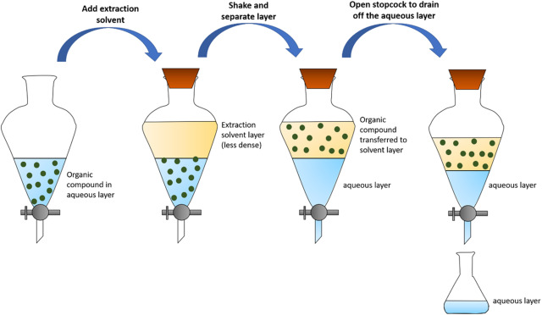
Figure: 1.1 The solvent–solvent extraction technique using separation funnel.

Leaching (Solid-Liquid Extraction): The majority of extractions in the food industry are solid-liquid extractions, commonly referred to as SLE. This process involves the separation of a soluble component (A) from a solid substance (C) by bringing them into contact with a liquid solvent (B). SLE is sometimes known as leaching, a term that may be reserved for situations where the dissolution of A is induced or accompanied by a chemical reaction.
A common occurrence in the food industry, solid-liquid extraction is exemplified by everyday practices such as brewing coffee from ground coffee beans with hot water. The desired outcome of leaching can be the solute itself (which may require subsequent separation from the solvent in the extracted liquid using other methods), the liquid extract (comprising the solute-solvent solution), or the solid material left behind.

Osmo-dehydration, on the other hand, involves the extraction of water using a low water activity solution, often a concentrated sugar solution, alongside the diffusion of other solutes into the solid material. Solid-liquid extraction remains a widely employed process in the food industry, and its applications continue to expand. To enhance the diffusion of solutes from the solid material, leaching is frequently preceded by various forms of size reduction, such as grinding, breaking, cutting, or flaking. It's worth noting that the necessary extraction time is directly related to the square of the particle size, as will be discussed later. Additionally, grinding serves the purpose of breaking down the cell wall structure found in many food items, thereby facilitating the diffusion process.
EQUIPMENT
Due to the difficulty of circulating solids, leaching is often carried out in batch fashion. Therefore, leaching equipment can be classified into batch extractors and continuous extractors.
Batch Extractors: Agitated vessels are frequently employed for batch leaching processes involving small particles that can be readily suspended in the liquid. Various types of impellers, propellers, or paddles can be used within these vessels. The duration of leaching is contingent on factors such as particle size, the diffusivity of the solute within the solid matrix, and the mass transfer coefficient. The latter is influenced by the flow pattern and the mechanical energy input provided by the mixer. Once the desired residence time is achieved, agitation is halted, allowing the solid material to settle out of the liquid. Subsequently, the liquid can be decanted or filtered.
Alternatively, percolators offer an effective approach, especially when dealing with larger or denser particle sizes that are challenging to maintain in a suspended state. In this method, the solid is contained in a vessel while the solvent is introduced from the top and percolates down through the bed, sometimes under pressure to enhance the flow rate. An iconic example of this approach is the espresso coffee machine.
Counter-current Extractors: Batch extraction exhibits limited efficiency because it can only achieve a single equilibrium stage within each batch unit. Similar to Liquid-Liquid Extraction (LLE), higher extraction efficiencies necessitate a counter-current cascade, where solid and solvent move in opposing directions. Batch percolating extractors can be operated semi-continuously in a counter-current cascade manner. Multiple vessels are connected in a series, with the solvent sequentially flowing through them, typically from left to right. When the solid in the first (leftmost) vessel becomes depleted, it is emptied, refilled with fresh solid, and shifted to the end of the cascade, while the second tank receives fresh solvent. In practice, this reconfiguration is easily achieved by redirecting fluid flow using a valve system (see Figure 1.2).
Alternatively, a counter-current cascade can also be established using continuous mixers and separators, akin to the mixer-settlers employed in LLE. Separators may include various options such as gravity settlers (like clarifiers and thickeners), filters, hydro-cyclones, or centrifugal separators. Dedicated counter-current leaching units integrate multiple counter-current stages within the same vessel. These units primarily differ in how they convey solid material from one stage to the next. Figure 1.2(a) and Figure 1.2(b) display two examples of such commercial solid-liquid extractors.
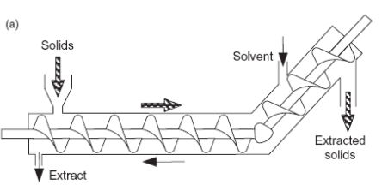
Fig:1.2 (a) Hildebrandt screw extractor

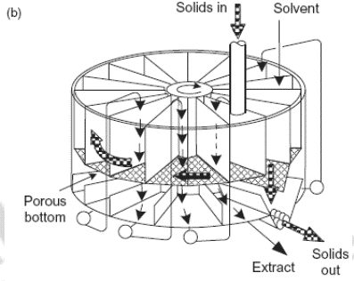
Fig:1.2 (b) Rotocel extractor.
Belt and screw conveyors can be easily transformed into leaching equipment by incorporating a liquid circulation system, either through a pump or gravity. In the case of the perforated-belt extractor, a horizontal perforated belt moves the solid material from left to right. Solvent is introduced as a spray at the right end, collected beneath the belt, and then pumped to the subsequent spray nozzle on the left, and so forth. This arrangement facilitates counter-current contact between the solid and solvent. In screw extractors, the screw mechanism conveys the solid material upwards on an incline, while the solvent percolates downwards along the slope (refer to Figure 1.2).
SUPERCRITICAL FLUID EXTRACTION:
Supercritical fluid extraction (SFE) is a process designed to separate one component, known as the extractant, from another, referred to as the matrix, using supercritical fluids as the extracting solvent. Typically, this extraction is performed on solid matrices, but it can also be applied to liquid materials. SFE serves multiple purposes, ranging from sample preparation in analytical contexts to large-scale applications such as removing unwanted substances from a product (e.g., decaffeination) or harvesting desired products (e.g., essential oils). The primary supercritical fluid used is carbon dioxide (CO2), sometimes modified by co-solvents like ethanol or methanol. Extraction conditions for supercritical CO2 involve operating above its critical temperature of 31°C and critical pressure of 74 bars, although the addition of modifiers may slightly alter these parameters. Supercritical extraction, often employing high-pressure carbon dioxide, is favored for extracting high-value components from natural materials. Notably, this extraction process leaves no solvent residue, and CO2 is lauded for its non-toxic, non-flammable, odorless, tasteless, inert, and cost-effective properties. Its low critical temperature of 31°C makes carbon dioxide exceptionally well-suited for use in the food, aroma, essential oil, and nutraceutical industries.
Supercritical fluid extraction can be applied to either solids or liquids. The solvent utilized is a dense gas that operates under conditions exceeding the critical temperature and pressure, wherein further pressure increase or temperature reduction will not cause a transition from gas to liquid. While the density of a supercritical fluid closely resembles that of a liquid, it is important to note that it does not behave as a true liquid. Extraction with supercritical fluids (SCFs) is based on the experimental finding that many gases become effective solvents for both solids and liquids when compressed to conditions above the critical point. The solubility of solutes in a supercritical fluid closely approximates their solubility in a liquid. Thus, the fundamental principle of extracting solutes from solids using a supercritical fluid closely parallels that of solid-liquid extractions.
FUNDAMENTALS OF SUPERCRITICAL FLUID EXTRACTION
The concept of supercritical fluid extraction was initially introduced back in 1879 by Hannay and Hogarth. However, despite the many advantages associated with the use of supercritical fluids as extracting agents, it wasn't until around the 1960s that this technique began to be extensively explored as an alternative to traditional extraction methods, such as solid-liquid extraction (SLE) and liquid-liquid extraction (LLE). These conventional methods required the use of substantial quantities of hazardous chemicals, including chlorinated solvents.…………………………………………………………………….
Investigations into supercritical fluids date back to the last century, with significant early commercial interest centering on the utilization of supercritical toluene in the refining of petroleum and shale oil during the 1970s. Researchers also explored supercritical water for applications like waste disposal and as an unconventional medium for chemical synthesis. In the past decade, the primary focus has been on the applications of supercritical carbon dioxide, primarily because it possesses a critical temperature close to ambient conditions (around 31°C). Consequently, biological materials can be processed at temperatures approximately around 35°C. Additionally, the density of supercritical CO2 at roughly 200 bar pressure closely resembles that of hexane, and its solvation characteristics are also similar to hexane, making it function as a non-polar solvent.
Around the supercritical region, CO2 can dissolve triglycerides at concentrations of up to 1% by mass. A notable advantage is that a slight decrease in temperature or a somewhat larger reduction in pressure will cause almost the entire solute to precipitate out as the supercritical conditions shift or become subcritical. One of the significant benefits of supercritical fluids is their ability to yield products without any solvent residues. Examples of products produced at both pilot and production scales include decaffeinated coffee, cholesterol-free butter, low-fat meat, evening primrose oil, and squalene from shark liver oil, among others. It's worth noting that the solvation characteristics of supercritical CO2 can be altered by the addition of an entrainer, such as ethanol. However, some entrainer may remain as a solvent residue in the final product, which may negate some of the advantages of "residue-free" extraction.
Supercritical Fluid:
A supercritical fluid refers to any substance existing at a temperature and pressure exceeding its critical point. Such a fluid possesses unique characteristics: it can permeate solids like a gas while dissolving materials like a liquid. Moreover, when nearing the critical point, even minor alterations in pressure or temperature can lead to significant changes in density, allowing for precise adjustments of various properties. Supercritical fluids have proven to be valuable alternatives to organic solvents in numerous industrial and laboratory processes.
Among supercritical fluids, carbon dioxide and water are the most frequently utilized. Carbon dioxide, for instance, finds application in decaffeination processes, while water is employed in power generation. Notably, CO2 serves as an exceptional extraction solvent for botanical substances, leaving no toxic residues. Its extraction capabilities can be finely tuned through subtle adjustments in pressure and temperature, making it a versatile choice for various applications.
PROPERTIES OF SUPERCRITICAL FLUIDS USED IN FOODS
Carbon dioxide stands out as the most extensively employed supercritical fluid due to its highly desirable attributes. It is non-toxic, non-flammable, widely available in high purity, and cost-effective. The critical point of carbon dioxide occurs at 31.1ºC and 7.39 MPa (74 Bars). In some extractions, ethanol can also be introduced in small quantities to alter the polarity of supercritical carbon dioxide. The critical point of ethanol is 243ºC and 6.38 MPa (64 Bars). Supercritical fluids exhibit unique characteristics, with a relative density typically ranging from 0.1 to 1, in contrast to a density of 1 for liquids and 0.001 for gases. Their relative viscosity falls within the range of 0.1 to 1, compared to a value of 1 for liquids and 0.01 for gases. Furthermore, their relative diffusivity ranges from 10 to 100, while it is 1 for liquids.
Properties of Supercritical Fluid
I. I. Supercritical fluids represent a unique state of matter, being highly compressed gases that combine the characteristics of both gases and liquids in a captivating manner.
II. Supercritical fluids possess the potential to facilitate reactions that are often challenging or even unattainable when conventional solvents are employed.
III. These remarkable fluids exhibit solvent capabilities similar to those of light hydrocarbons for the majority of solutes. Notably, fluorinated compounds, in particular, tend to demonstrate enhanced solubility in supercritical CO2 compared to hydrocarbons, a feature of significant importance in polymerization processes.
IV. Solubility within supercritical fluids increases in tandem with rising density, typically corresponding to an elevation in pressure. The rapid expansion of supercritical solutions leads to the precipitation of finely divided solids, a crucial characteristic, especially in flow reactors.
V. Frequently, these versatile fluids are miscible with permanent gases like N2 or H2, enabling the attainment of substantially higher concentrations of dissolved gases compared to what can be achieved using conventional solvents.
Physical Properties of Supercritical Fluids: As a substance approaches its critical temperature, the characteristics of its gas and liquid phases begin to converge, culminating in the presence of a single phase at the critical point—an entirely homogeneous supercritical fluid. At and beyond this critical point, the heat of vaporization becomes zero, rendering any distinction between the two phases obsolete. In the pressure-temperature diagram (Figure 1.3 A), the convergence of critical temperature and critical pressure defines the critical point of the substance. Beyond the critical temperature, raising the pressure will not yield a liquid phase, although sufficient pressure may induce the formation of a solid phase. The critical pressure corresponds to the vapor pressure at the critical temperature. In the vicinity of the critical point, even a slight increase in pressure results in substantial increases in the density of the supercritical phase (Figure 1.3 B).
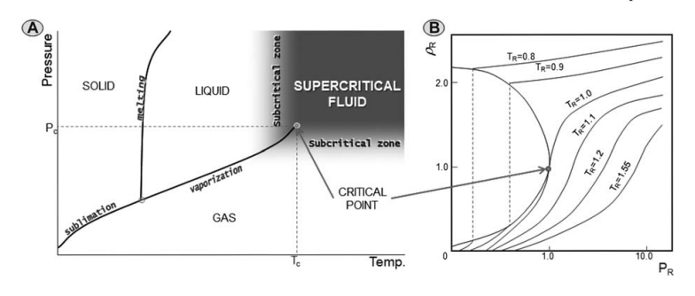
Figure:1.3 Carbon dioxide pressure–temperature phase diagram (A) and density–pressure phase diagram at different temperatures (B) considering reduced variables (TR = T/T_{C}, PR= P/P_{C} and $ρ$ _{R} = $ρ$ / $ρ$ _{C}).
The physical properties of supercritical fluids exhibit characteristics that fall between those of gases and liquids, as illustrated in Table 1.1, which includes data sourced from Pereda, Bottini, and Brignole. For instance, the density of a supercritical fluid is akin to that of a liquid, while its viscosity resembles that of a gas, and its diffusivity falls between that of gases and liquids. Thermal conductivities are notably high in supercritical fluids, particularly in proximity to the critical point, where they attain substantial values. Surface tension near the critical point approaches zero, aligning more closely with gases and significantly deviating from the higher values typical of liquids. Various other physical properties, such as relative permittivity and solvent strength, which are closely linked to density, exhibit substantial changes with increasing pressure above the critical point. These alterations in physical properties play a pivotal role in extraction processes since they correspond to shifts in solubility and mass transfer rates. Consequently, they are intimately connected to variations in the selectivity of the solvent.
TABLE:1.1 COMPARISON OF GASES, SUPER CRITICAL FLUIDS AND LIQUIDS
 | Density (kg/m³) | Viscosity (µPa-s) | Diffusivity (mm²/s)
Gases | 1 | 10 | 1-10
Supercritical fluids | 100-1000 | 50-100 | 0.01-0.1
Liquids | 1000 | 500-1000 | 0.001

The solvent strength of a supercritical fluid can be characterized, among others, by the Hildebrand solubility parameter, d, which relates to the density of the solvent as follows:
$δ=$1.25$P_{c}^{1/2}\left[\frac{ρ}{ρ_{liq}}\right]$

where P_{c} is the critical pressure, $ρ$ is the gas density, and $ρ_{liq}$ is the liquid density. At low pressures, the density of a gas is low, so the solvating power is rather low; at near critical conditions, the density increases rapidly approaching that of a liquid and thus the solubility parameter increases as the critical pressure is approached.
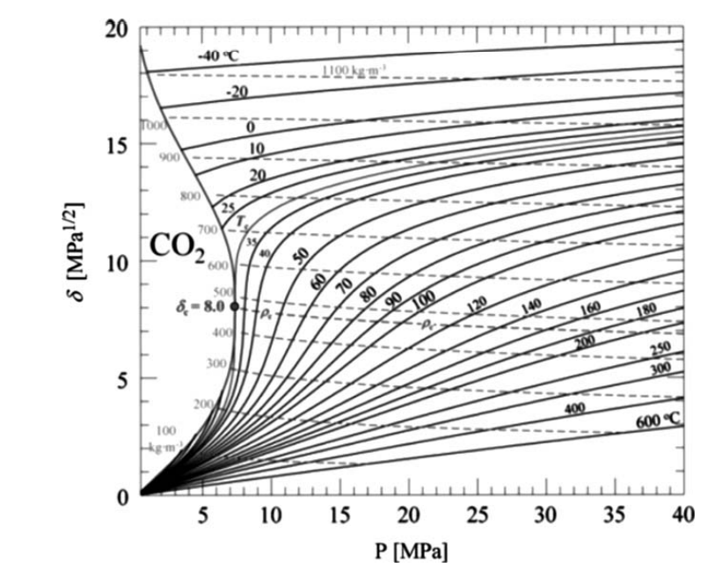
Figure: 1.4 Solubility parameter of carbon dioxide. Reprinted from Machida et al., The Journal of Supercritical Fluids, Vol. 60, December 2011, pp. 2–15, copyright 2011, with permission from Elsevier.
This effect can be seen graphically in Figure 1.4 in which the Hildebrand solubility parameter for CO₂ is represented as a function of the pressure for different temperatures.38 This represents one of the pivotal aspects of Supercritical Fluid Extraction (SFE), as even slight adjustments in pressure and temperature can exert a substantial impact on the solvating capability of the fluid. These alterations can either promote the extraction of the desired compounds or induce the precipitation of solutes that were initially dissolved in the supercritical fluid.
Supercritical Solvents: Although there is a wide range of compounds that can be used as supercritical fluids (see Table 1.2 in which the critical properties of several solvents used in SFE are given), it is true that after the Montreal Protocol, introduced in 1987 to restrict or eliminate the manufacture and use of particularly damaging ozone depleting solvents (at present signed by 170 nations), there is a worldwide pressure for the industry to adopt new sustainable processes that do not require the use of environmentally damaging organic solvents.7

TABLE:1.2 CRITICAL PROPERTIES OF SOME SOLVENTS USED IN SFE
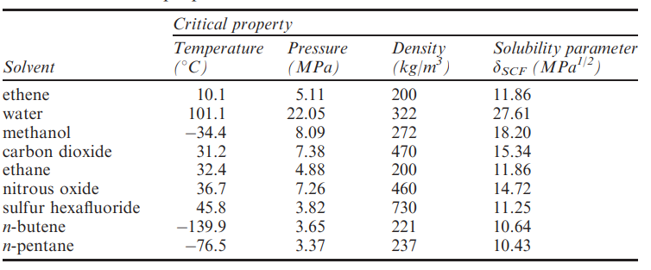
In this context, Supercritical Fluid Extraction (SFE) utilizing green solvents has emerged as a cleaner and more environmentally friendly alternative to hazardous processes, gaining traction in various applications. Among the green solvents employed in SFE, carbon dioxide (with critical conditions of 31.2°C and 7.38 MPa) stands out as the most widely used. CO₂ is not only cost-effective but also environmentally benign, earning the designation of "generally recognized as safe" (GRAS). Supercritical CO₂ (SC-CO₂) possesses a compelling combination of attributes, including high diffusivity and the flexibility to adjust its solvent strength easily. An additional advantage is that CO₂ remains in a gaseous state at room temperature and pressure, simplifying the recovery of extracts and ensuring solvent-free final products. Particularly noteworthy for food and natural products is the capability of SFE using CO2 to operate at low temperatures within a non-oxidative environment, enabling the extraction of thermally sensitive or easily oxidizable compounds.$\left[60\right]$ As can also be seen in Table 1.2, supercritical CO₂ has a low polarity (with a low solubility parameter, around 15 MPa^{1/2}), and therefore, its efficiency to extract polar compounds from natural matrices is quite limited. To overcome this problem, polar co-solvents (methanol, ethanol, water) are commonly used in small amounts to increase the solubility of polar compounds in the supercritical mixture.
The most extensive utilization of supercritical fluids, particularly carbon dioxide, is in the field of extraction. The initial patent related to supercritical fluid extraction was submitted by Messmore in 1943, though the first industrial application was pioneered by Zosel in 1978. Over time, supercritical fluids have been employed for the isolation of natural products, but for a substantial duration, the applications were limited to only a select few. Nevertheless, the ongoing advancement of processes and equipment is yielding significant dividends, as industries are becoming increasingly intrigued by supercritical techniques. This growing interest is further underscored by the substantial volume of scientific papers addressing supercritical fluid extraction (SFE) published in recent years. Furthermore, there has been a notable surge in industrial applications of SFE, particularly evident in the surge of patents since the 1990s.$\left[60, 28\right]$ Supercritical Fluid Extraction (SFE) has found application across various industries, including food, pharmaceuticals, chemicals, and fuels. Thanks to its advantages, such as the absence of toxic residues in the final product, supercritical fluids prove exceptionally beneficial in two key scenarios:
(a) Extracting Valuable Bioactive Compounds: This involves the extraction of precious bioactive compounds like flavors, colorants, and other biomolecules.
(b) Removing Undesirable Compounds: SFE is instrumental in eliminating undesirable substances such as organic pollutants, toxins, and pesticides.
Within the scope of this chapter, our focus will be directed toward the utilization of supercritical fluids for extracting valuable compounds from plant-based and marine sources, as well as from by-products originating in the food industry (49)
Extraction Principles:
Supercritical fluid extraction is commonly carried out in a single-stage contactor, with the option of incorporating solvent recycling. In cases where solvent recycling is employed, the process involves reducing pressure to decrease the supercritical fluid's solvating capabilities, allowing solids to separate naturally due to gravity. The gas, now at a lower pressure, is then compressed back to supercritical conditions and recycled for further use. Alternatively, temperature reduction can be applied to precipitate the solute, and the solvent is subsequently reheated for recycling, eliminating the need for recompression. Figure 1.5 provides a schematic representation of a supercritical fluid extraction system for reference.
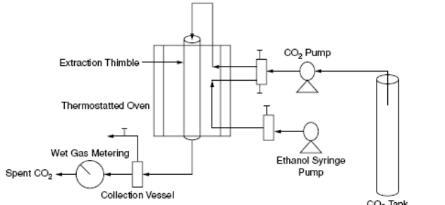
Figure 1.5 Schematic diagram of a supercritical fluid extraction system using entrained ethanol in supercritical carbon dioxide
The core components of a supercritical fluid extraction system include an extractor tank and an expansion tank. The extractor is maintained at supercritical fluid conditions, with temperature carefully regulated in both tanks. The charging and emptying of the extractor occur as batch operations. To reduce the pressure of the supercritical fluid, it is throttled through a needle valve or orifice, entering the expansion tank where it transforms into a gas. In the expansion tank, solute separates from the gas since solubility in the gas is significantly lower than in the supercritical fluid. The spent gas is then recompressed and recycled. Heat exchanges are crucial to maintain temperatures and prevent excessive cooling at the throttling valve, which can occur due to the Joule-Kelvin effect.
In supercritical fluid extraction, two significant challenges are commonly encountered: the occurrence of solvent flow channeling through the solid bed and the entrainment of non-extractable components by the solvent. The contact time between the solid material and the solvent is governed by the ratio of the extraction vessel's volume to the volumetric flow rate of the solvent. This volume is computed based on the temperature and pressure conditions within the extraction vessel. Typically, the solvent volume is quantified at atmospheric pressure immediately after exiting the expansion tank. Utilizing this measured volume, the number of gas moles is calculated, allowing for the determination of the volume of the supercritical fluid within the extraction vessel through the application of gas equations of state.
Achieving adequate contact time is essential to allow the solvent to penetrate solid particles and permit solute diffusion from within the solid particles into the solvent phase. Equilibrium between the solution inside the solid particles and the solvent phase is necessary. The solvent flow rate must be adjusted to ensure the required contact time and to provide sufficient solvent, such that the concentration of dissolved solutes in the solvent phase remains below the solubility limit. A larger quantity of solute to be extracted would necessitate a higher solvent flow rate to achieve thorough solute extraction within a reasonable timeframe. While supercritical fluid penetration into the interior of solids is rapid, the diffusion of solute from the solid into the supercritical fluid may be slow, requiring extended contact time in the extraction vessel. Solvent flow rate, pressure, and temperature within the extraction vessel are the primary parameters governing the supercritical fluid extraction process.
Instrumentation:
Supercritical fluid extraction is commonly carried out considering two basic steps:
- Extraction of soluble substances from the matrix by the supercritical fluid and
- Separation or fractionation of the extracted compounds from the supercritical solvent after the expansion.
The fundamental instrumentation required for conducting supercritical fluid extractions should be constructed from materials capable of withstanding high pressures, typically reaching up to 50 MPa (although systems requiring extraction pressures as high as 70 MPa have been employed). The necessary equipment varies depending on whether the application involves solid or liquid samples. Figure 1.6 illustrates the two setups for a supercritical fluid extraction system designed for solid and liquid samples. Notably, the primary differences lie in the design of the extraction cell.
For solid samples, the equipment includes an extraction vessel with a specified internal volume (see Figure 1.6 A). Conversely, the extraction apparatus for liquid samples employs an extraction column, enabling extraction to occur in a counter-current mode (Figure 1.6 B). Counter-current extraction (CC-SFE) is executed by introducing the sample into the system from the top of the column and the pressurized solvent from the bottom. In this process, the components partition between the solvent and the liquid sample, which flows counter-currently through the separation column. Achieving the desired contact time between the solvent and the sample can be attained by adjusting the height at which the sample is introduced into the extraction column. Additionally, it can be fine-tuned by altering the characteristics of the separation column, including its height, diameter, or the type of packing material employed (structured/random, packing dimensions, surface area, etc.). Factors like the solvent-to-feed ratio play a pivotal role in this type of extraction.
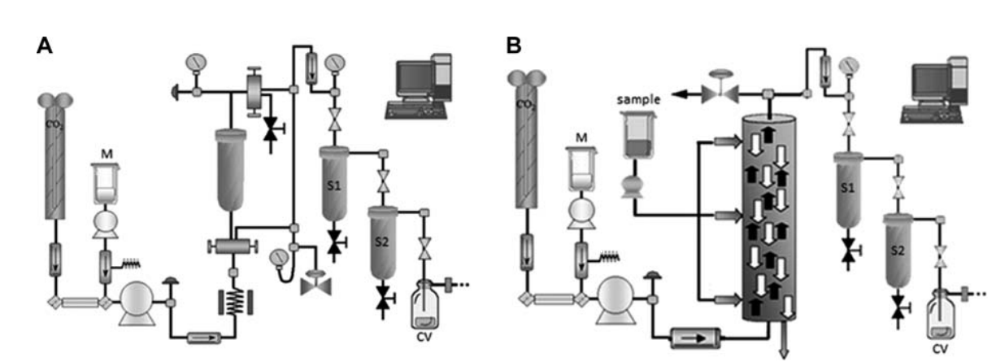
Figure 1.6 (A) Scheme of a typical SFE instrument for the extraction of solid samples. (B) Scheme of a typical SFE plant for the extraction of liquid samples. M= modifier reservoir, S1= separator 1, S2= separator 2, CV = collection vessel.
As depicted in Figure 1.6, both systems comprise several key components: a tank for the extracting solvent, typically CO2; a pump for pressurizing the gas to the desired extraction pressure; a restrictor or valve to maintain high pressure within the system; and a trapping vessel (or separation cell, also referred to as a fractionation cell) for recovering the extracts. Several factors need to be optimized to prevent the loss of extracted compounds. One critical factor is the trapping method, which should be selected based on considerations such as extract volatility and polarity, the volatility of the extracting agent, the volatility of any modifier used, and the solvent flow rate, among other parameters. Various trapping methods are available, including solid trapping, liquid trapping, cool trapping, and more. In pilot or industrial systems, the collection of extracted solutes is achieved by rapidly reducing pressure, increasing temperature, or employing a combination of both techniques. In such cases, depressurization can be performed in cascade mode, taking into account that each separation vessel can have specific temperature and pressure conditions to induce the precipitation and separation of some of the extracted compounds. Additionally, the system may include another pump to introduce an organic modifier (co-solvent), which is sometimes necessary to enhance the solvent capabilities of supercritical CO2, enabling the extraction and recovery of more polar compounds.
Regarding the extraction mode, at a small scale, solid samples can be extracted in dynamic or static modes or a combination of both. In static conditions, the supercritical fluid is introduced into the extraction vessel and allowed to contact the sample for a predetermined extraction time. Once the desired time has elapsed, the extract is released through the pressure restrictor into the trapping vessel. In a dynamic process, the supercritical fluid continuously enters the extraction vessel and flows through the sample towards the separators for a cascade fractionation. In the combined mode, a static extraction is performed for a set period, followed by a dynamic extraction. Medium and large-scale SFE processes are typically conducted in dynamic conditions, where the supercritical solvent flows through the solid material, extracting the target compounds until the substrate is depleted.
In contrast, liquid samples, depending on the extractor design, are often extracted in a continuous mode. Figure 1.7 provides an example of a process flow diagram for an industrial-scale SFE process, showcasing the various components required for large-scale operations. In this specific case, prebiotic carbohydrates were extracted from a complex mixture using a combination of carbon dioxide and ethanol-water. The process involves pumping carbon dioxide (stream 1) and a co-solvent mixture (stream 2), which are mixed in a heat exchanger (HE1) to ensure that the solvent reaches the extraction cell at the desired temperature. Following the extraction cell, a valve controls the extraction cell pressure. Carbon dioxide depressurizes through this valve and is removed as a gas (at low pressures) in stream 9. Subsequently, carbon dioxide is recompressed to 4–5 MPa, condensed in heat exchanger 3 (HE3) to become liquid, and is recirculated into the system. Extracted solutes remain dissolved in the co-solvent and are withdrawn from the collection vessel in stream 11. Additional operations for collecting and purifying the extracts can be performed subsequently.
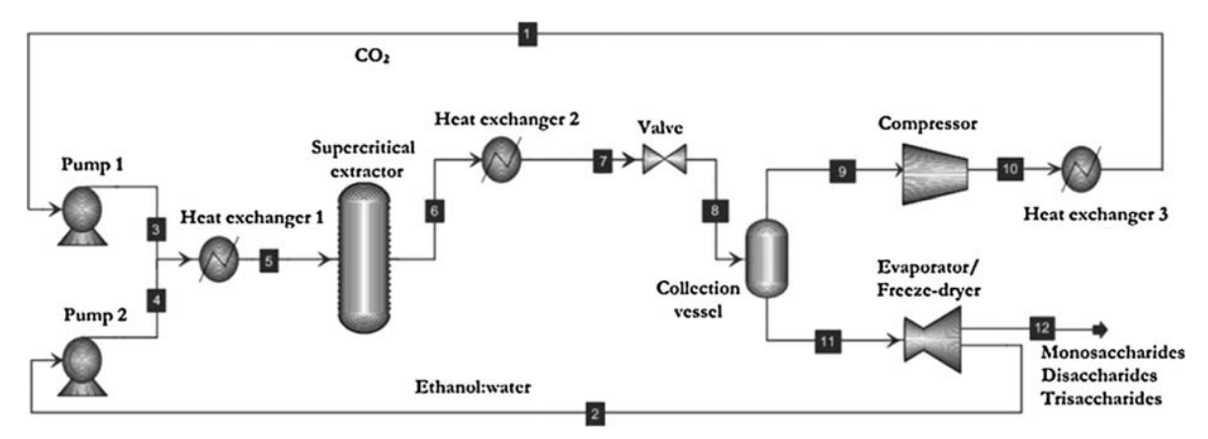
Figure 1.7 Flow diagram of SFE process at industrial scale. Reprinted from Montanes et al., Journal of Chromatography A, Vol. 1250, 10 August 2012, pp. 92–98, copyright 2012, with permission from Elsevier.
- PARAMETERS AFFECTING THE EXTRACTION PROCESS
The extraction of soluble substances from a matrix is a multistep process, and each step is influenced by various factors that require careful optimization. When dealing with solid samples, the extraction process initiates with the diffusion of the solvent into the matrix, causing the supercritical solvent to be absorbed and reducing mass transfer resistance. After this initial step, the soluble compounds dissolve into the supercritical fluid and are subsequently transported via diffusion. Initially, they move from the surface of the solid, penetrating deeper into the bulk of the fluid phase. The extraction process culminates with the transportation of the solute and the bulk fluid phase, ultimately leading to their removal from the extractor.
To assess the kinetics of the extraction process, one can monitor the amount of extracted material, typically measured as the mass of extract or yield, over time (or solvent consumption). This tracking results in the creation of an overall extraction curve (OEC). Figure 1.8 provides an illustrative example of such a curve. While this figure specifically represents the extraction rate of artemisinin, the underlying concept holds true for a wide range of extraction processes (52). It shows the typical behaviour of SFE. A typical extraction curve can be divided into three periods.49,40
- The initial phase, known as the Constant Extraction Rate (CER), is marked by the extraction of solute from the easily accessible surface of the particles. Mass transfer in this stage is primarily governed by convection.
- Subsequently, there is a transition into the Falling Extraction Rate (FER) period, where a significant portion of the readily available solute has been extracted. Mass transfer now begins to be influenced by diffusion.
- Lastly, the extraction process enters the Diffusion-Controlled Rate (DCR) phase, where all easily extractable solute has been depleted. This stage is characterized by the diffusion of the solvent within the particles and the diffusion of solute combined with solvent towards the surface.
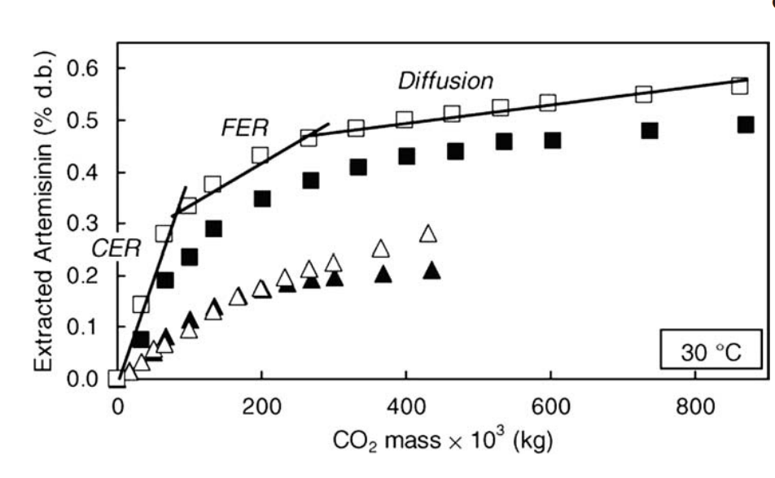
Figure 1.8 Overall extraction curves for artemisinin obtained in different conditions of SFE: (m, n) 5.5×10⁻⁵ kg CO₂/s; (’, &) 1.1 ×10⁻⁵ kg CO₂/s (full symbols: 40MPa and empty symbols: 20MPa), reprinted from Quispe-Condori et al., 52 Journal of Supercritical Fluids, Vol. 36, Issue 1, 2005, pp. 40–48, copyright 2005, with permission from Elsevier.
In some cases, the slope of the straight line corresponding to CER can be used as an indication of solubility, depending on the flow rate considered (for a more in-depth discussion, readers are referred to Rodrigues et al. $\left[54\right]$).
When working with liquid samples, the process follows a similar pattern, yet additional complexity is introduced. Factors like the dimensions of the column and the properties of the packing material used in the counter-current column become significant considerations. Additionally, for more intricate separations, it may be necessary to conduct theoretical calculations of separation efficiency based on experimental data to optimize the experimental conditions.
In the following section, we will delve into an explanation of the key factors that influence the Supercritical Fluid Extraction process.
- Raw Material (Particle Size, Porosity, Location of the Solute, Moisture Content)
- Solubility (Pressure and Temperature)
- Solvent Flow Rate (Solvent-to-Feed Ratio)
- Use of Modifiers
9.1 Raw Material (Particle Size, Porosity, Location of the Solute, Moisture Content)
Although the selection of the raw material is frequently predetermined in the extraction process, there are several vital factors that demand consideration. The influence of the physical state of the sample, whether it is solid or liquid, on the extraction results is widely acknowledged. However, in the case of solid samples, there are added considerations such as the particle size, shape, and porosity of the solid material, all of which play a critical role in determining the rate of mass transfer throughout the process.To enhance the extraction rate, it is necessary to break down the solid matrix, increasing the surface area available for mass transfer. However, it's important to avoid excessively small particles, as they can lead to compaction within the extraction bed, thereby increasing internal mass transfer resistance and causing uneven extraction, ultimately resulting in a reduced extraction rate. $\left[49\right]$
As an illustration, the degree of crushing was a very significant factor in the extraction of carotenoids from Haematococcus pluvialis microalgae. $\left[19\right]$ It was demonstrated how an increase in the crushing procedure produced an enhancement in the carotenoid extraction yield. This effect can be attributed to an increase of the mass transfer rate as a consequence of the lower particle size as well as to the increase of carotenoids in the medium as a result of the disruption of cells in the heavier crushing procedure. $\left[19\right]$ Supercritical solvents, while generally exhibiting greater diffusivity within the raw material matrix compared to liquids, tend to yield higher extraction efficiency when the sample particle size is reduced. This increase in efficiency results from the expanded contact surface area between the sample and the solvent, particularly when diffusion is hindered by internal mass transfer resistance. However, in specific applications, such as those involving high-water content samples, employing dispersing agents (e.g., diatomaceous earth) to prevent sample clogging, along with a hydro matrix to absorb the liquid component from the sample, can prove advantageous.
In general, drying the raw material is recommended; however, in some cases the presence of water is necessary to favour the interaction of the solvent with the solute, as in the extraction of caffeine from green coffee beans, or due to its role in the swelling of the cell, which facilitates the flow of the solvent into the cell. $\left[49\right]$ In the case of liquid samples, two primary strategies are commonly employed:
(a) The first strategy involves trapping the liquid sample on a solid support, such as sepiolite, effectively treating it as if it were a solid. However, this approach is primarily utilized at a smaller scale, as the use of solid supports can raise extraction costs.
(b) The second strategy entails conducting column counter-current extractions (as depicted in Figure 1.6 B). In this approach, the liquid sample is continuously introduced into a column from either the top or middle point, while the supercritical phase is supplied from the bottom. This method has proven highly effective in the field of oil refining.
Hurtado-Benavides et al. conducted a study on the impact of column packing type, size, and structure on the efficiency and performance of counter-current systems for supercritical fluid extraction of olive oil. Their results demonstrated the significant influence of these factors on the mass transfer ratio. For instance, the authors found that using a column packing with a high surface area yielded results similar to reducing the mean particle size of a solid raw material.
9.2 Solubility (Pressure and Temperature):
As mentioned earlier, numerous physical properties of supercritical fluids are significantly influenced by the interplay between pressure and temperature. When designing processes involving supercritical solvents, a crucial consideration is the phase equilibrium behavior, which is exceptionally responsive to variations in operating conditions. Consequently, phase equilibrium engineering, which involves the methodical application of phase equilibrium principles to process development, assumes a pivotal role in shaping and designing such processes. $\left[72\right]$
In general, both the yield of a solute and the separation selectivity, which heavily rely on solubility characteristics, are influenced by operating pressure and temperature. Under supercritical fluid extraction (SFE) conditions, the solvent's capacity for solubilization increases with pressure while maintaining a constant temperature, thereby enhancing the extraction of constituents from the raw material. Broadly speaking, elevating the pressure results in an exponential boost in solubility, particularly in proximity to the critical point where densities are higher (Figure 1.3 B). As a general guideline, components with higher vapor pressure exhibit greater solubility in supercritical mediums. The solubility of most substances in supercritical fluids (SCFs) rises with an increase in SCF density, attainable by raising the extraction pressure. Other vital factors influencing component solubility in SCFs include polarity, molecular weight, and extraction temperature. In SFE processes employing CO₂, solute solubility diminishes as the polarity and/or molecular weight of the solutes increase.
Raising the temperature at a consistent pressure yields two opposing outcomes: it diminishes CO₂'s solvent power due to density reduction, while simultaneously elevating the vapor pressure of solutes, making their transfer to the supercritical phase easier. The net effect on solute solubility in the supercritical solvent hinges on the operating pressure. Near the critical pressure, fluid density's impact predominates, causing a modest temperature rise to yield a significant decrease in fluid density and, consequently, solute solubility. Conversely, at high pressures, the rise in vapor pressure prevails, leading to an increase in solubility with temperature. This phenomenon is referred to as the retrograde behavior of solid solubility, asillustrated in Figure 1.9. At pressures exceeding the critical point (Pc), the solubility isotherms exhibit a peak in solubility.
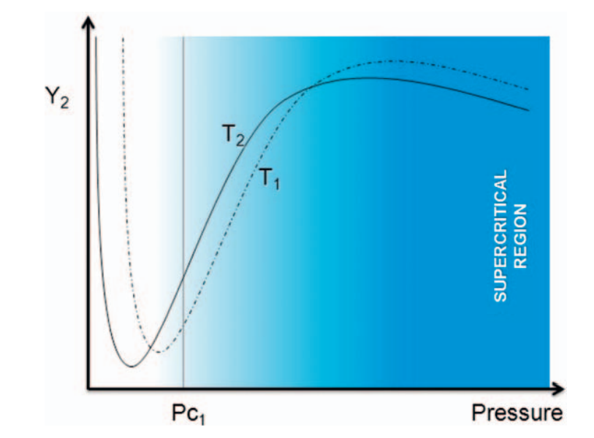
Figure 1.9 Typical isotherms of solid solubility in SFE (T1>T2>T_{c1}).
When confronted with intricate matrices or the extraction of multiple components, as frequently encountered in natural product extraction processes, thermodynamic calculations can become exceedingly intricate. An alternative method to navigate this complexity is to utilize experimental designs as a means to establish a reliable extraction process. These designs provide a structured framework wherein researchers conduct experiments, manipulating key variables to predict or determine outcomes based on independent and dependent variables. Experimental designs offer the advantage of assessing interactions between factors, such as pressure and temperature, while simultaneously minimizing the number of experiments required (60).
9.3 Solvent Flow Rate (Solvent-to-Feed Ratio):
The Solvent-to-Feed Ratio (S/F) stands out as the paramount parameter in supercritical fluid extraction, once the extraction pressure and temperature have been determined. The solvent's flow rate must strike a delicate balance; it should be sufficiently high to ensure a rapid and efficient extraction yield, while also allowing for adequate contact time between the solvent and solutes. Additionally, it's crucial to bear in mind that a higher solvent flow rate tends to drive up both operational and capital costs, which necessitates thorough consideration, especially in the context of industrial applications. Typically, S/F ratios of approximately 25–100:1 are commonly employed for analytical purposes, while larger-scale processes tend to favor ratios in the range of 5–15:1. It is crucial to take into account the expenditure of CO2 as a cost factor, particularly in the context of industrial processes. In industrial-scale operations, attention is primarily focused on the initial segments of the extraction curve (as depicted in Figure 1.8). This differs from analytical operations where precise quantification is the primary objective. Consequently, analytical-scale processes often consume larger quantities of CO2, leading to the utilization of higher S/F ratios (49).
S/F is also very important when dealing with counter-current column extractions. Generally, the efficiency of the column decreases as the CO₂ flow rate increases, since the HTU (height of a transfer unit) increases with increasing CO₂ loading, as demonstrated by Hurtado-Benavides et al.31 and Brunner et al.10
9.4 Use of Modifiers
CO2 stands as the predominant solvent of choice for performing Supercritical Fluid Extraction (SFE). However, when it comes to the extraction of natural products, a notable drawback arises from its inherent low polarity, which significantly restricts its capacity to extract polar components from raw materials. Although, like many substances, its dielectric constant can vary with density, even at high densities, CO2 demonstrates limited ability to dissolve highly polar compounds.To address this challenge, a solution involves introducing small quantities of co-solvents, often referred to as modifiers, into the CO2 stream. This addition of modifiers to CO2 can enhance extraction efficiency by increasing the solubility of the target solutes. To elucidate the effects of this approach, Pereira and Meireles have proposed two distinct mechanisms: [Include information about the proposed mechanisms if available or desired].
- solute–co-solvent interactions, caused by increase in solvent polarity;
- matrix swelling that facilitates the contact of the solute by the solvent.
The effect is not only dependent on the nature of the modifier used, but also on the type of matrix, and the target solutes.
As a general rule, the amount of modifier used is lower than 10–15%. The most used modifiers are methanol, ethanol, and water. A key point when working with modifiers is to consider that the critical point of the mixture CO₂: modifier is different than the one of pure compounds and it also depends on the proportions of each.27 In fact, two or three different phases may coexist at the same conditions. It must be taken into account that modifiers are not gases at room conditions and, therefore, liquid residues are obtained in extracts and remaining matrix after SFE. This is the main reason for not recommending the use of methanol in the extraction of natural products since the presence of this toxic solvent can preclude the further use of the extracts, for instance, in food applications.
Ethanol, recognized as a Generally Recognized As Safe (GRAS) solvent, finds extensive use as a modifier in the extraction of natural products. However, its suitability ultimately hinges on its capacity to enhance the solubility of the target compound within the CO2-modifier mixture. From the perspectives of toxicity and polarity, water might appear to be an intriguing modifier option. Nonetheless, several drawbacks accompany its use, including:
- Increased Formation of Ice Blockages: Water can lead to an escalation in the formation of ice blockages due to the Joule-Thompson effect within the separator vessel.
- Potential Ionization and Hydrolysis: The presence of water may induce ionization and hydrolysis of compounds, affecting the extraction process.
- Foam Formation: The co-extraction of saponins can trigger foam formation, resulting in a loss of selectivity during the extraction process.

These considerations underscore the need for a careful evaluation of the modifier choice in CO2-based extractions, taking into account both its advantages and limitations.Sometimes modifiers are not only used to increase the polarity of the solvent phase, but also to improve the extraction rate of non-polar solvents. The use of oil as modifier came from the observations of Bamberger et al.64 that the solubility of a less volatile lipid component was significantly enhanced by the presence of a more volatile triglyceride species in the system. Sun and Temelli conducted experiments showcasing the effectiveness of vegetable oils as modifiers in augmenting the yield of carotenoids, which are non-polar and exhibit low volatility, during the extraction process from carrots. In the absence of a co-solvent, alterations in pressure and temperature had a minimal impact on the extraction yield. However, when canola oil was introduced, the extraction yields experienced a notable enhancement, increasing by a factor of 3–4. In particular, the addition of 5% canola oil (w/w) to the SC-CO2 extraction substantially surpassed the carotenoid yield achieved through traditional solvent-based extraction methods.
ADVANTAGES AND DRAWBACKS OF SUPERCRITICAL CO₂ (SC-CO₂):
Numerous compounds can serve as supercritical fluid agents, but carbon dioxide stands out as the predominant choice. In the context of pharmaceuticals, nutraceuticals, and food applications, carbon dioxide emerges as an excellent solvent due to its several advantageous qualities. It possesses a non-toxic, non-flammable nature, cost-effectiveness, ease of product removal, and relatively low critical temperature and pressure (Tc=31.1°C, pc=72 bar), rendering it highly significant in the preparation of food and natural product samples. One of the key benefits of employing supercritical fluid extraction (SFE) with CO2 is its capacity to operate at low temperatures within a non-oxidizing medium, enabling the extraction of thermally delicate or readily oxidizable compounds. Furthermore, it aligns with environmentally friendly practices and enjoys recognition as safe by regulatory bodies such as the FDA and EFSA. These attributes make it particularly well-suited for extracting thermally fragile and non-polar bioactive substances. However, it is worth noting that due to its non-polar characteristics, CO2 is unsuitable for dissolving polar molecules.
Enhancing the solubility of polar compounds and refining the selectivity of the process can be achieved by incorporating minute amounts of additional solvents, such as ethanol, into the primary fluid, referred to as a co-solvent or modifier. This approach offers several advantages, including reduced processing times, elevated yields, and the ability to operate under gentler processing conditions. However, it also introduces complexities in the thermodynamics of the system and results in higher capital expenses. [3]. The necessity for employing high-purity SFE-grade CO2 is not obligatory, yet industrial-grade CO2 can accumulate impurities and moisture, potentially causing interference.. in subsequent analytical procedures, including gas or liquid chromatography. To address this concern, an online fluid purification system can be utilized to eliminate trace contaminants.
An inherent limitation of supercritical CO₂ (SC-CO₂) and, in fact, most other supercritical fluids, is their predominant reliance on non-polar extraction solvents, such as CO2. Consequently, an evident avenue for expanding the applicability of this technique involves exploring innovative methods to reduce the polarity of analytes. This endeavor aims to enhance their solubility in non-polar supercritical fluids. To this end, chemical in situ derivatization has been employed to enhance the extraction's selectivity toward a specific group of compounds. [33,56]. So the solvent power of SC-CO₂ can be summarized by a few rules:
- It can dissolve non-polar or slightly polar compounds
- Its solvent strength is high for low molecular weight compounds and decreases as molecular weight increases.
- SC-CO₂ displays a strong affinity for oxygenated organic compounds of moderate molecular weight.
- Solubility is low for free fatty acids and their glycerides.
- Pigments exhibit even lower solubility.
- Water has limited solubility.
- Proteins, polysaccharides, sugars, and mineral salts are insoluble.
- SC-CO2 can separate compounds that are less volatile, possess a higher molecular weight, or are more polar as pressure increases. [49].
- SPECIAL APPLICATIONS OF SUPERCRITICAL FLUIDS TO FOOD PROCESSING:
- Depletion of fat content in food products.
- Enhancement of vitamin E isolation from natural origins.
- Elimination of alcohol content from wine, beer, and associated processes.
- Encasing liquids to produce solid engineering products.
- Extraction and analysis of functional compounds.
4 Current Applications of Supercritical Fluid Extraction
Supercritical fluid-based technologies have witnessed remarkable advancements across a diverse range of industrial sectors in recent years. Notably, the extraction using supercritical fluids has found widespread use in the food, pharmaceutical, and cosmetic industries. The food industry stands out as one of the primary domains where supercritical fluid extraction (SFE) has gained substantial traction. A multitude of samples, materials, target compounds, and extraction methodologies have been documented in recent publications. A relatively innovative category of applications that has emerged involves the extraction and fractionation of carbohydrates through SFE. While supercritical CO2, being the commonly employed solvent, may not initially seem ideal for this group of compounds due to its low polarity, researchers have demonstrated its efficacy by incorporating a modest quantity of a polar entrainer. Employing a comprehensive factorial design approach, the impact of extraction pressure, temperature, and modifier flow rate (and thus the proportion of the modifier) was systematically evaluated for the selective fractionation of carbohydrate mixtures comprising lactose and lactulose. The results, subjected to multiple linear regression analysis, identified the optimal conditions as 100 bar pressure, 100°C temperature, and a co-solvent flow rate of 0.2 ml/min (equating to 4% modifier) for the preferential recovery of lactulose [43]. This strategy was also applied to other carbohydrates [42,46].
These studies collectively underscore the critical significance of the choice of modifier in achieving selective fractionation, with ethanol/water emerging as the most effective co-solvent. Indeed, researchers have conducted experiments to determine the solubilities of various carbohydrates in supercritical carbon dioxide when paired with ethanol/water as a co-solvent, and have subsequently developed thermodynamic models to describe these interactions [45].
Crude vegetable oils are widely used in the food industry for a number of applications. Usually, oils have to be refined to remove undesirable compounds before consumption; during this refining process, valuable compounds contained in the oils can be also lost. SFE has been suggested as an alternative to refining procedures, to obtain extracts enriched with the particular compounds of interest; this is the case for instance of wheat germ oil [19], green coffee oil obtained by pressing [18], rice bran oil [13] or crude palm oil [17].
SFE has been also used to remove unwanted compounds from other matrices; for example, supercritical CO₂ with water as cosolvent has been employed to selectively extract caffeine from green tea while avoiding the extraction of antioxidants from the matrix [36]. The selectivity of the different extraction conditions studied was confirmed by HPLC.
Essential oils [2,41,65], fatty acids [2,41,65] and/or bioactive compounds [41,26 ,9 ,67] have been extracted from fruits and vegetables using supercritical CO₂. Soy isoflavones have been also widely studied; aqueous methanol seems to be the most appropriate modifier to carry out isoflavones supercritical CO₂ extractions [37], although the use of acetonitrile has been also tested [37]. Daidzein and genistein were effectively extracted under high-pressure conditions, ranging from 350 to 500 bar [71,70]. In all of these investigations, High-Performance Liquid Chromatography (HPLC) was the chosen analytical method for quantifying these flavonoids. These compounds, along with other bioactive substances, were extracted using Supercritical Fluid Extraction (SFE) from various matrices. For instance, stilbenes like cajaninstilbene were extracted from pigeonpea. [37], cinnamic derivatives from propolis [12] or carotenoids and flavonoids from black rice [47]
One of the limited instances where Supercritical Fluid Extraction (SFE) employed a solvent other than CO2 pertains to the extraction of fatty acids from a fish oil sample. In this scenario, the potential of ethane as an alternative to the more common usage of CO2 for fatty acid extraction was investigated. Furthermore, a thermodynamic model was utilized to determine the optimal conditions for extracting the maximum amounts of eicosapentaenoic (EPA) and docosahexaenoic (DHA) acids. Ethane exhibited superior selectivity and greater solubility for EPA and DHA esters compared to other esters with the same carbon count. By applying conditions of 60°C and 84 bar pressure, it was possible to achieve a concentration of 60% for both ethyl esters of these fatty acids using ethane as the supercritical solvent. [21].
Supercritical fluid extraction (SFE) has found extensive application in the evaluation of by-products within the food industry. These by-products are typically generated as a result of food manufacturing processes and typically lack commercial value. Through by-product extraction, valuable and noteworthy compounds that would otherwise go unused can be effectively recovered. For instance, the extraction of polyphenols with antioxidant properties from rice wine lees has been explored as a notable example of this application. The quantity of ethanol modifier employed alongside supercritical carbon dioxide was identified as the most pivotal factor in maximizing the extraction of polyphenols. A comparison was made between Soxhlet ethanol extraction and supercritical CO₂ extraction with ethanol as a co-solvent. It was found that the polyphenol content obtained through supercritical fluid extraction was only 43% of that achieved with Soxhlet ethanol extraction.. However, it's worth noting that SFE offered the significant advantage of considerably shorter extraction times [69].
Supercritical fluid extraction (SFE) has recently emerged as a significant method in food sample preparation, particularly in the context of characterizing amino acid profiles in diverse genetically modified strains of maize and soybean. To extract amino acids, a supercritical CO₂ system augmented with 35% methanol was employed under precise conditions: 80°C and 120 bar. Following the extraction process, the amino acids were subjected to analysis using GC–MS. The determination of these optimal extraction parameters was facilitated by a central composite design and subsequent statistical analysis of the collected data. In this experimental framework, the sum of the areas corresponding to the aromatic amino acids was selected as the response variable. This method enabled direct comparisons among various genetically modified organisms (GMOs) and their corresponding non-transgenic isogenic counterparts. The results of this analysis unveiled statistically significant differences in amino acid content among the studied samples. Importantly, this modified CO₂ extraction method offered a swifter and more efficient recovery of amino acids from maize and soybean grains when compared to previous techniques. [8].
5 Application of SC-CO2 in Food Industry
One of the primary trends in the food industry is the demand for all-natural food ingredients free of chemical additives. Natural food antioxidants are derivatives of plant by-products. Food waste valorization is under intense worldwide investigation topic and supercritical fluid extraction has been reported as one of the best ways to valorize agro-industry by-products. Those extracts showed sustainable use in food industries as a good source of phenolic compounds with antioxidant activities. For example, the extract of mango peel has been used as a natural antioxidant in sunflower oil to control lipid oxidation; the optimal conditions were 25 MPa, 60 ⁰C and 15% ethanol in water by using a Box–Behnken design. Supercritical fluid extraction is also applied in the extraction of cholesterol and other lipids from egg yolk, extraction of lipids and cholesterol from meat and meat products, decaffeination of coffee and tea [39], extraction of hops [55,59], extraction of bioactive compounds [9], extraction of free amino acids [67], extraction of lipids and cholesterol from fish [22], extraction of natural glycosides [20], fractionation of natural colourings, natural flavourings, and fragrances from several foodstuffs [7], and the separation of spices and essential oils [14,61,24,8].
6 Application of SC-CO₂ in the Pharmaceuticals Industry
Within the pharmaceuticals industry, there is a prevailing preference for enhancing the properties of active pharmaceutical ingredients. A notable challenge in this pursuit is the reduction of particle size, a critical factor that can significantly enhance bioavailability [35]. Supercritical fluids find their principal application in the pharmaceuticals sector across a spectrum of processes. These include particle formation for drug delivery systems and crystal engineering, the intricate complexing of cyclodextrins, coating and foaming for pharmaceutical purposes, tissue engineering, impregnation and the purification of pharmaceutical excipients, as well as sterilization and the removal of solvents [3].
The most prominent application of supercritical fluids in the pharmaceutical industry pertains to the isolation of bioactive compounds from various mixtures. This includes purification from chemical reactions, quantification of active enantiomers, and extraction from natural matrices [39]. Different plants have been used for the extraction of compounds to be used in pharmacy, such as Catharanthus roseus, a rich source of alkaloids, from which two dimeric alkaloids were extracted that are extensively used as antineoplastic drugs vinblastine and vincristine [22,35]. Artemisia annual. exhibits a vigorous antimalarial activity due to the existence of artemisinin and its derivatives (like dehydro-artemisinin). These compounds are particularly active against drug-resistant strains of Plasmodium falciparum [6]. Melocactus zehntneri is a medicinal cactus that is unusual pharmacologically because it contains iso-quinoline and indole alkaloids, which are used in several drugs.
7 Application of SC-CO₂ in the Cosmetics Industry
Cosmetics, everyday products widely available in the market, have seen a shift in consumer preferences towards natural ingredients. People have come to recognize the pivotal role antioxidants play in cosmetics, as these compounds can disrupt radical-chain processes, aid in skin repair, enhance cell rejuvenation, and help prevent skin cancer. Various studies have demonstrated that supercritical carbon dioxide (SC-CO₂) extraction is an excellent technique for obtaining natural extracts with appealing fragrances or active components, thereby elevating the functionality and characteristics of cosmetics. (SC-CO₂ extraction has been successfully employed for isolating antioxidants and parabens from cosmetic formulations. For instance, Vogt et al. (in their study titled "The effect of selected supercritical CO₂ plant extract addition on user properties of shower gels") explored the extraction of natural extracts from blackcurrant seeds, strawberry seeds, hop cones, and mint leaves using SC-CO₂. Their findings indicated that these natural extracts could serve as valuable ingredients in the production of shower gels and shampoos, offering potential benefits to cosmetic products.
References:
- Abbas, K.A., Mohamed, A., Abdulamir, A.S. and Abas, H.A., 2008. A review on supercritical fluid extraction as new analytical method. American Journal of Biochemistry and Biotechnology, 4(4), pp.345-353.
- Abbasi, H., Rezaei, K. and Rashidi, L., 2008. Extraction of essential oils from the seeds of pomegranate using organic solvents and supercritical CO2. Journal of the American Oil Chemists' Society, 85(1), pp.83-89.
- Adeoye, O.; Costa, C.; Casimiro, T.; Aguiar-Ricardo, A.; Cabral-Marques, H. Preparation of ibuprofen/hydroxypropyl-γ-cyclodextrin inclusion complexes using supercritical CO2 -assisted spray drying. J. Supercrit. Fluids 2018, 133, 479–485
- Ahmed, J. and Rahman, M.S., Handbook of Food Process Design. Blackwell Publishing Ltd. 2012.
- Araújo, J.M., Silva, M.V. and Chaves, J.B., 2007. Supercritical fluid extraction of daidzein and genistein isoflavones from soybean hypocotyl after hydrolysis with endogenous β-glucosidases. Food chemistry, 105(1), pp.266-272.
- Baldino, L.; Reverchon, E.; Della Porta, G. An optimized process for SC-CO2 extraction of antimalarial compounds from Artemisia annua L. J. Supercrit. Fluids 2017, 128, 89–93.
- Basegmez, H.I.O.; Povilaitis, D.; Kitryte, V.; Kraujalien ˙ e, V.; Šulni ˙ ut¯ e, V.; Alasalvar, C.; Venskutonis, P.R. ˙ Biorefining of blackcurrant pomace into high value functional ingredients using supercritical CO2 , pressurized liquid and enzyme assisted extractions. J. Supercrit. Fluids 2017, 124, 10–19.
- Bernal, J.L., Nozal, M.J., Toribio, L., Diego, C., Mayo, R. and Maestre, R., 2008. Use of supercritical fluid extraction and gas chromatography–mass spectrometry to obtain amino acid profiles from several genetically modified varieties of maize and soybean. Journal of Chromatography A, 1192(2), pp.266-272.
- Bravi, M., Spinoglio, F., Verdone, N., Adami, M., Aliboni, A., d’Andrea, A., De Santis, A. and Ferri, D., 2007. Improving the extraction of α-tocopherol-enriched oil from grape seeds by supercritical CO2. Optimisation of the extraction conditions. Journal of Food Engineering, 78(2), pp.488-493.
- Brunner, G., 1998. Industrial process development: countercurrent multistage gas extraction (SFE) processes. The Journal of supercritical fluids, 13(1-3), pp.283-301.
- Brunner, G., 2005. Supercritical fluids: Technology and application to food processing. J. Food Eng., 67: 21-33. DOI:10.1016/j.jfoodeng.2004.05.060
- Chen, C.R., Lee, Y.N., Lee, M.R. and Chang, C.M.J., 2009. Supercritical fluids extraction of cinnamic acid derivatives from Brazilian propolis and the effect on growth inhibition of colon cancer cells. Journal of the Taiwan Institute of Chemical Engineers, 40(2), pp.130-135.
- Chen, C.R., Wang, C.H., Wang, L.Y., Hong, Z.H., Chen, S.H., Ho, W.J. and Chang, C.M.J., 2008. Supercritical carbon dioxide extraction and deacidification of rice bran oil. The Journal of Supercritical Fluids, 45(3), pp.322-331.
- Conde-Hernández, L.A., Espinosa-Victoria, J.R. and Guerrero-Beltrán, J.Á., 2017. Supercritical extraction of essential oils of Piper auritum and Porophyllum ruderale. The Journal of Supercritical Fluids, 127, pp.97-102.
- Conde-Hernández, L.A., Espinosa-Victoria, J.R., Trejo, A. and Guerrero-Beltrán, J.Á., 2017. CO2-supercritical extraction, hydrodistillation and steam distillation of essential oil of rosemary (Rosmarinus officinalis). Journal of food engineering, 200, pp.81-86.
- Danh, L.T., Truong, P., Mammucari, R. and Foster, N., 2010. Extraction of vetiver essential oil by ethanol-modified supercritical carbon dioxide. Chemical Engineering Journal, 165(1), pp.26-34.
- Davarnejad, R., Kassim, K.M., Zainal, A. and Sata, S.A., 2008. Supercritical fluid extraction of β-carotene from crude palm oil using CO2. Journal of Food Engineering, 89(4), pp.472-478.
- De Azevedo, A.B.A., Kieckbush, T.G., Tashima, A.K., Mohamed, R.S., Mazzafera, P. and De Melo, S.V., 2008. Extraction of green coffee oil using supercritical carbon dioxide. The Journal of Supercritical Fluids, 44(2), pp.186-192.
- Eisenmenger, M. and Dunford, N.T., 2008. Bioactive components of commercial and supercritical carbon dioxide processed wheat germ oil. Journal of the American Oil Chemists' Society, 85(1), pp.55-61.
- Erkucuk, A.; Akgun, I.H.; Yesil-Celiktas, O. Supercritical CO2 extraction of glycosides from Stevia rebaudiana leaves: Identification and optimization. J. Supercrit. Fluids 2009, 51, 29–35.
- Espinosa, S., Diaz, M.S. and Brignole, E.A., 2008. Food additives obtained by supercritical extraction from natural sources. The Journal of Supercritical Fluids, 45(2), pp.213-219.
- Falcão, M.A.; Scopel, R.; Almeida, R.N.; Espirito Santo, A.T.; Franceschini, G.; Garcez, J.J.; Vargas, R.M.F.; Cassel, E. Supercritical fluid extraction of vinblastine from Catharanthus roseus. J. Supercrit. Fluids 2017, 129, 9–15.
- Fiori, L.; Manfrini, M.; Castello, D. Supercritical CO2 fractionation of omega-3 Montañés, F., Fornari, T., Martín-Álvarez, P.J., Montilla, A., Corzo, N., Olano, A. and Ibáñez, E., 2007. Selective fractionation of disaccharide mixtures by supercritical CO2 with ethanol as co-solvent. The Journal of Supercritical Fluids, 41(1), pp.61-67.feasibility. Food Bioprod. Process. 2014, 92, 120–132.
- Frohlicha, P.C.; Santosa, K.A.; Palúa, F.; Cardozo-Filho, L.; Da Silva, C.; Da Silva, E.A. Evaluation of the effects of temperature and pressure on the extraction of eugenol from clove (Syzygium aromaticum) leaves using supercritical CO₂ , J. Supercrit. Fluids 2019, 143, 313–320.
- Fundamentals of Food Process Engineering (2nd Edition), Romeo T. Toledo, CBS Publ., New Delhi, 1991.
- Glišić, S.B., Mišić, D.R., Stamenić, M.D., Zizovic, I.T., Ašanin, R.M. and Skala, D.U., 2007. Supercritical carbon dioxide extraction of carrot fruit essential oil: Chemical composition and antimicrobial activity. Food chemistry, 105(1), pp.346-352.
- Güçlü-Üstündağ, Ö. and Temelli, F., 2005. Solubility behavior of ternary systems of lipids, cosolvents and supercritical carbon dioxide and processing aspects. The Journal of supercritical fluids, 36(1), pp.1-15.
- Herrero, M., Mendiola, J.A., Cifuentes, A. and Ibáñez, E., 2010. Supercritical fluid extraction: Recent advances and applications. Journal of Chromatography a, 1217(16), pp.2495-2511.
- Herrero, M., Mendiola, J.A., Cifuentes, A. and Ibáñez, E., 2010. Supercritical fluid extraction: Recent advances and applications. Journal of Chromatography a, 1217(16), pp.2495-2511.
- Hoshino, Y., Ota, M., Sato, Y., Smith Jr, R.L. and Inomata, H., 2018. Fractionation of hops-extract–ethanol solutions using dense CO2 with a counter-current extraction column. The Journal of Supercritical Fluids, 136, pp.37-43.
- Hurtado-Benavides, A.M., Señoráns, F.J., Ibáñez, E. and Reglero, G., 2004. Countercurrent packed column supercritical CO2 extraction of olive oil. Mass transfer evaluation. The Journal of supercritical fluids, 28(1), pp.29-35.
- Jimenez-Sanchez, C., Lozano-Sanchez, A. S. G., & Fern andez-Gutierrez, A. (2017) Alternatives to conventional thermal treatments in fruit-juice processing. Part 1: Techniques and applications, Critical Reviews in Food Science and Nutrition, 57, 501-523.
- José, A.M., Miguel, H., Alejandro, C. and Elena, I., 2007. Use of compressed fluids for sample preparation. Food Appli. J. Chromatog, 1152, pp.234-246.
- Joung, S.N., Yoo, C.W., Shin, H.Y., Kim, S.Y., Yoo, K.P., Lee, C.S. and Huh, W.S., 2001. Measurements and correlation of high-pressure VLE of binary CO2–alcohol systems (methanol, ethanol, 2-methoxyethanol and 2-ethoxyethanol). Fluid Phase Equilibria, 185(1-2), pp.219-230.
- Karimi, M.; Raofie, F. Micronization of vincristine extracted from Catharanthus roseus by expansion of supercritical fluid solution. J. Supercrit. Fluids 2019, 146, 172–179.
- Kim, W.J., Kim, J.D., Kim, J., Oh, S.G. and Lee, Y.W., 2008. Selective caffeine removal from green tea using supercritical carbon dioxide extraction. Journal of Food Engineering, 89(3), pp.303-309.
- Kong, Y., Fu, Y.J., Zu, Y.G., Liu, W., Wang, W., Hua, X. and Yang, M., 2009. Ethanol modified supercritical fluid extraction and antioxidant activity of cajaninstilbene acid and pinostrobin from pigeonpea [Cajanus cajan (L.) Millsp.] leaves. Food Chemistry, 117(1), pp.152-159.
- Machida, H., Takesue, M. and Smith Jr, R.L., 2011. Green chemical processes with supercritical fluids: Properties, materials, separations and energy. The Journal of Supercritical Fluids, 60, pp.2-15.
- Machmudah, S.; Kitada, K.; Sasaki, M.; Goto, M.; Munemasa, J.; Yamagata, M. Simultaneous Extraction and Separation Process for Coffee Beans with Supercritical CO2 and Water. Ind. Eng. Chem. Res. 2011, 50, 2227–2235
- Martinez, J.L., 2007. Supercritical fluid extraction of nutraceuticals and bioactive compounds. CRC press.
- Martínez, M.L., Mattea, M.A. and Maestri, D.M., 2008. Pressing and supercritical carbon dioxide extraction of walnut oil. Journal of food engineering, 88(3), pp.399-404.
- Montañés, F., Corzo, N., Olano, A., Reglero, G., Ibáñez, E. and Fornari, T., 2008. Selective fractionation of carbohydrate complex mixtures by supercritical extraction with CO2 and different co-solvents. The Journal of Supercritical Fluids, 45(2), pp.189-194.
- Montañés, F., Fornari, T., Martín-Álvarez, P.J., Montilla, A., Corzo, N., Olano, A. and Ibáñez, E., 2007. Selective fractionation of disaccharide mixtures by supercritical CO2 with ethanol as co-solvent. The Journal of Supercritical Fluids, 41(1), pp.61-67.
- Montañés, F., Fornari, T., Olano, A. and Ibáñez, E., 2012. Isolation of prebiotic carbohydrates by supercritical fluid extraction. Scaling-up and economical feasibility. Journal of Chromatography A, 1250, pp.92-98.
- Montañés, F., Fornari, T., Stateva, R.P., Olano, A. and Ibáñez, E., 2009. Solubility of carbohydrates in supercritical carbon dioxide with (ethanol+ water) cosolvent. The Journal of Supercritical Fluids, 49(1), pp.16-22.
- Montañés, F., Olano, A., Reglero, G., Ibáñez, E. and Fornari, T., 2009. Supercritical technology as an alternative to fractionate prebiotic galactooligosaccharides. Separation and Purification Technology, 66(2), pp.383-389
- Nakornriab, M., Sriseadka, T. and Wongpornchai, S., 2008. Quantification of carotenoid and flavonoid components in brans of some Thai black rice cultivars using supercritical fluid extraction and high‐performance liquid chromatography‐mass spectrometry. Journal of Food Lipids, 15(4), pp.488-503.
- Nobre, B., Marcelo, F., Passos, R., Beirão, L., Palavra, A., Gouveia, L. and Mendes, R., 2006. Supercritical carbon dioxide extraction of astaxanthin and other carotenoids from the microalga Haematococcus pluvialis. European Food Research and Technology, 223(6), pp.787-790.
- Pereira, C.G. and Meireles, M.A.A., 2010. Supercritical fluid extraction of bioactive compounds: fundamentals, applications and economic perspectives. Food and Bioprocess Technology, 3(3), pp.340-372.
- Perretti, G., Motori, A., Bravi, E., Favati, F., Montanari, L. and Fantozzi, P., 2007. Supercritical carbon dioxide fractionation of fish oil fatty acid ethyl esters. The Journal of supercritical fluids, 40(3), pp.349-353.
- Prado, J. and Rostagno, M. eds., 2022. Natural product extraction: principles and applications. Royal Society of Chemistry.
- Quispe-Condori, S., Sánchez, D., Foglio, M.A., Rosa, P.T., Zetzl, C., Brunner, G. and Meireles, M.A.A., 2005. Global yield isotherms and kinetic of artemisinin extraction from Artemisia annua L leaves using supercritical carbon dioxide. The Journal of supercritical fluids, 36(1), pp.40-48.
- Ramsey, E., Qiubai, S., Zhang, Z., Zhang, C. and Wei, G., 2009. Mini-Review: Green sustainable processes using supercritical fluid carbon dioxide. Journal of Environmental Sciences, 21(6), pp.720-726.
- Rodrigues, V.M., Sousa, E.M., Monteiro, A.R., Chiavone-Filho, O., Marques, M.O. and Meireles, M.A.A., 2002. Determination of the solubility of extracts from vegetable raw material in pressurized CO2: a pseudo-ternary mixture formed by cellulosic structure+ solute+ solvent. The Journal of supercritical fluids, 22(1), pp.21-36.
- Rój, E., Tadić, V.M., Mišić, D., Žižović, I., Arsić, I., Dobrzyńska-Inger, A. and Kostrzewa, D., 2015. Supercritical carbon dioxide hops extracts with antimicrobial properties. Open Chemistry, 13(1).
- Rozzi, N.L. and Singh, R.K., 2002. Supercritical fluids and the food industry. Comprehensive reviews in food science and food safety, 1(1), pp.33-44.
- Sa´nchez-Camargo, A. P., Mendiola, J. A., Iba´n˜ ez, E., Herrero, M., in: Reedijk, J. (2014) (Ed). Reference Module in Chemistry, Molecular Sciences and Chemical Engineering, Elsevier Inc, Waltham, M. A. pp 1–14.
- Sánchez-Vicente, Y., Cabañas, A., Renuncio, J.A. and Pando, C., 2009. Supercritical fluid extraction of peach (Prunus persica) seed oil using carbon dioxide and ethanol. The Journal of Supercritical Fluids, 49(2), pp.167-173.
- Sapkale, G.N., Patil, S.M., Surwase, U.S. and Bhatbhage, P.K., 2010. Supercritical fluid extraction. Int. J. Chem. Sci, 8(2), pp.729-743.
- Schütz, E., 2007. Supercritical fluids and applications–a patent review. Chemical Engineering & Technology: Industrial Chemistry‐Plant Equipment‐Process Engineering‐Biotechnology, 30(6), pp.685-688.
- Shahsavarpour, M., Lashkarbolooki, M., Eftekhari, M.J. and Esmaeilzadeh, F., 2017. Extraction of essential oils from Mentha spicata L.(Labiatae) via optimized supercritical carbon dioxide process. The Journal of Supercritical Fluids, 130, pp.253-260.
- Shi, J., Yi, C., Ye, X., Xue, S., Jiang, Y., Ma, Y. and Liu, D., 2010. Effects of supercritical CO2 fluid parameters on chemical composition and yield of carotenoids extracted from pumpkin. LWT-Food Science and Technology, 43(1), pp.39-44.
- Spilimbergo, S. & Bertucco A. (2003) Biotech-nol. Bioeng., 84, 627–638
- T. Bamberger, J. C. Erickson, C. L. Cooney and S. K. Kumar, J. Chem. Eng. Data, 1988, 33, 327. 29. M. Sun and F. Temelli, J. Supercrit. Fluids, 2006, 37, 397
- Taylor, S. L., Eller, F. J. & King, J. W. (1997) A comparison of oil and fat content in oilseed and ground beef- using supercritical fluid extraction and related analytical techniques, Food Res Int., 30(5), 365-370.
- Uwineza, P.A. and Waśkiewicz, A., 2020. Recent advances in supercritical fluid extraction of natural bioactive compounds from natural plant materials. Molecules, 25(17), p.3847.P. Mitra, G.S. Ramaswamy, K.S. Chang, J. Food Eng. 95 (2009) 208.
- Varaee, M.; Honarvar, M.; Eikani, M.H.; Omidkhah, M.R.; Moraki, N. Supercritical fluid extraction of free amino acids from sugar beet and sugar cane molasses. J. Supercrit. Fluids 2019, 144, 48–55.
- Vigano, J., Machado, A. P. F., & Martínez, J. (2015) Sub- and supercritical fluid technology applied to food waste processing. The Journal of Supercritical Fluids, 96, 272-286.
- Wu, J.J., Lin, J.C., Wang, C.H., Jong, T.T., Yang, H.L., Hsu, S.L. and Chieh-ming, J.C., 2009. Extraction of antioxidative compounds from wine lees using supercritical fluids and associated anti-tyrosinase activity. The Journal of Supercritical Fluids, 50(1), pp.33-41.
- Yu, J., Liu, Y.F., Qiu, A.Y. and Wang, X.G., 2007. Preparation of isoflavones enriched soy protein isolate from defatted soy hypocotyls by supercritical CO2. LWT-Food Science and Technology, 40(5), pp.800-806.
- Zuo, Y.B., Zeng, A.W., Yuan, X.G. and Yu, K.T., 2008. Extraction of soybean isoflavones from soybean meal with aqueous methanol modified supercritical carbon dioxide. Journal of Food Engineering, 89(4), pp.384-389.
- Pereda. S, Bottini. S and Brignole. E, Fundamentals of Supercritical Fluid Technology, in Supercritical Fluid Extraction of Nutraceuticals and Bioactive Compounds, ed. J. L. Martinez, CRC Press, Boca Raton, FL, USA, pp. 1, 2007. ISBN: 978-0-8493-7089-2

