Detection of disease from Chilly Plant Using Vegetation Indices
Different vegetation indices used to detect the plant diseases are discussed in this paper. Over forty Vegetation indices are available to identify plant diseases and content of leaf. The vegetation indices indicate the amount of vegetation, with the help of vegetation indices. We can distinguish between soil and vegetation with the help of Vegetation Indices. Different methods used to detect disease of vegetation are reviewed in the paper. Yield of chilly is very important aspect for farmer, it is depend on the supplied water to plant and use of pesticide. The chilly plant is mostly infected by white fly, bacterial leaf spot, pepper mosaic virus. In this paper we use peeper mosaic virus infected leaves of chilly plant. We also use four different vegetation Indices and Support Vector Machine classification to classify between diseased and non-diseased leaf. Among four vegetation indices, we found NPCI is better indices in this study work.
To increase the maximum capacity of yield and reduce the use of pesticides, is very important aspect for farmers. Detection of diseases of plant,prevention of plant from diseases is also important task. Plant diseases are reason for loss in yields. Using spectroscopy to detect diseases of plant is very convenient option. With the help of vegetation indices we can detect the diseases of plant. Simple solution to detect diseases is vegetation index, “A Vegetation Index is an indicator that shows the health of vegetation”1. Vegetation indices are fusion of spectral band and that points the spectral properties of green plants so that they appear distinct from other plant. There are several vegetation indices but they are of mainly two types, Multispectral vegetation indices and hyper spectral vegetation indices. The Multispectral Vegetation indices have developed by radiometric data used to show the green vegetation2. While hyper spectral vegetation indices have developed for hyper spectral data. The indices like Normalized Difference Vegetation index(NDVI),Soil adjusted vegetation index(SAVI), Modifier Soil adjusted vegetation index these(MCARI) are the multispectral vegetation indices while Yellowness Index, Crop Chlorophyll Content Prediction Index are the hyper spectral indices.
To increase the maximum capacity of yield and reduce the use of pesticides is very important aspect for farmers. Detection of diseases of plant, prevention of plant from diseases is also important task. Plant diseases are reason for loss in yields. Using spectroscopy to detect diseases of plant is very convenient option. With the help of vegetation indices we can detect the diseases of plant. Simple solution to detect diseases is vegetation index, “A Vegetation Index is an indicator that shows the health of vegetation”[1]. Production of more chilly in some region of Marathwada i.e. Jalna, Bhokardhan, Sillod. The farmers are also facing problem of diseases and that diseases are white fly, ahid, leaf spot, pepper mosaic virus. Pepper mosaic virus is spread by aphids and whitefly, this virus is injected straight into the leaves and stems of chili plants. Symptoms of this diseases is alternate patches of green and yellow in a mosaic pattern on leaves, distorted and curled leaves, plant growth greatly slowed. Stunted pod growth and very poor yield. Ramin shamshiri used spectroscopy and monochromatic camera to collect data and used NDVI to identify yellow colored spore on leaves of wheat[2].

In agriculture point of view, study of chlorophyll content is very important. Chlorophyll is Leaf pigments, there are three pigment present in the Leaf of tree i.e. chlorophyll, carotenoids, anthocyanin’s[3].There are more vegetation indices are available to study the pigments of leaf. Kerstin Groll et.al. Used ASD Field Spec Spectroradiometer to collect data and MCARI, TCARI, NPCI, OSAVI were use and the value of OSAVI decreases and NPCI increases[4]. Rainer laudien et al used ASD field spec to collect data and CAI indices was used to detect sugar beat diseases, and they

found low value of diseased sugar beat leaf using CAI[5]. Dr. Agrarwissens chaften also used FieldSpecPro FR and FieldSpecProJR with NDVI, NPCI Vegetation indices to detect diseases6. F. Ghobadifar used spectral radiance measurement to identify functional changes inside vegetation using NDVI,RVI,SDI and found unhealthy plants have spectrum that is different form healthy7. W.C.Chew et.al. also use spectroscopy with DVI,CAI,PRI,TVI,MCARI
,They found PRI has decreased the photosynthic rate in infected plant8. Davoud Ashourloo et al used RGB Digital camera to determine rust of leaf and NDVI,TCARI,NPCI vegetation indices used detect infected leaf. The investigation carried out between spectra of Red and Red-edge region9.

Vegetation indices are defined as the indicator which indicate the content of leaf or any other material according to content of that material we can analysis or detect features. More than twenty vegetation indices are available; they are mainly pigment indices, foliar chemistry indices, water indices. Some vegetation indices with their range and definition are as follows:

  - NDVI: NDVI is good parameter for leaf detection. NDVI is used to distinguish between infected and non-infected leaf. The NDVI is also used to analyse green vegetation or not .To calculate NDVI Vegetation index is as follows:
NDVI= 𝑁𝐼𝑅−𝑅𝑒𝑑
𝑁𝐼𝑅+𝑅𝑒𝑑

Where NIR represents reflectance at near infrared band (801 nm) and Red reflectance in the Red Band (670 nm).The values range from +1.0 to -1.0. High NDVI values are approximately 0.6 to 0.9[3]. NDVI is useful for vegetation monitoring. It is also useful for global vegetation monitoring.
  - MCARI: Modified chlorophyll absorption in reflectance index is intrinsic indices. It is developed by Kim² in 1994. MCARI is used for reduce the effect of non- photosynthetic materials on spectral estimates of absorbed photo synthetically active radiation. To calculate MCARI vegetation index is as follows

MCARI= [(R700–R670)-0.2(R700-R550)*(R700/R670)].

  - TCARI: The MCARI is affected by various parameter like LA, Chlorophyll and background reflectance. The variations of reflectance characteristics of background materials (soil and no photosynthetic components) and to increase the sensitivity at low chlorophyll values, the transformed chlorophyll absorption ratio index (TCARI) can be defined^{3,4}

TCARI=3[(R700–R670)-0.2(R700- R550) (R700/R670)]
  - OSAVI: Daughtry et al.³ proved that when MCARI united with a soil line vegetation index like optimized soil-adjusted vegetation index (OSAVI), the sensitivity to the hidden soil reflectance properties can be reduced. OSAVI belongs to the SAVI; developed by Huete, 1988, Family and OSAVI is defined by equation

OSAVI= (1 + 0.16) (R800 - R670)/ (R800 + R670 + 0.16)

  - NPCI: NPCI is Normalized Pigment Chlorophyll Index .Because of chlorophyll pigment leaf reflectance in visible is influenced. Information contained in reflectance spectra has been used to estimate plant nitrogen status. NPCI is defined as following equation⁵

NPCI= (R680-R430)/ (R680+R430).

  - GNDVI: It is a leading version than NDVI. It is more responsive to find the change of chlorophyll content in the crop. It is useful for assessing the canopy variation in biomass, and it is also shows the growth of stress or late maturity stage of crops. This index can be used to analyze crops in growth stages⁶.

GNDVI= 𝑁𝐼𝑅−𝐺𝑟𝑒𝑒𝑛
𝑁𝐼𝑅+𝐺𝑟𝑒𝑒𝑛

  - PRI: PRI is Photochemical Reflectance index. It is to changes in carotenoid pigments in live foliage.it used in study of vegetation productivity and stress. It is defined as⁷,

PRI = (R570-R531)/ (R570+R531).

Table 1: Comparative Study of Various Authors with Methods and Result

Sr.  No. | Author | Techniques | Outcome
1 | Ramin Shamshiri⁸ | The spectroscopy used and monochromatic CCDcamera was used to collect the data. Diseased detection algorithm was used based on neural network and NDVI used for leaf  detection. | The result of this analysis shows that NDVI vegetation index was used to detect diseases of wheat. The yellow colored spore produce on leaves of wheat due to yellow rust. The NDVI is good parameter  for leaf detection.
2 | Kerstin Gröll, Simone Graeff, | To collect the data spectroradiometer was used. | The result of this analysis shows that the reflectance data and their
 | Wilhelm Claupein9 | The hyper spectral Spectroradiometer ASD’s Field spec handheld is used. The MCARI, TCARI, OSAVI,  NPCI vegetation indices were used for disease detection. | four vegetation indices indicated that there are significant difference between healthy and diseased plant. The value of OSAVI is decreases from .07814 to 0.6558 and value of NPCI increases from 0.0510 to 0.6558.
3 | Rainer Laudien, Georg Bareth, Reiner Doluschitz10 | The hyper spectral spectroradiometer “Field spec Handheld” by ASD was used. The low cost GPS was also used to locate spot. The red edge and mCAI vegetation indices used  for diseases detection. | The result shows that they have used red edge and CAI Vegetation indices to detect diseases of Sugar beat. The red edge and CAI shows high value of healthy plants where red edge and CAI shows low  value of diseased plant.
4 | Dr. Agrarwissens chaften7 | The ASD FieldSpecPro FR and ASD FieldSpecPro JR is used. ASD ViewSpecPro Is also used to remove spectral jumps between the spectrometers Detectors. SR, NDVI, NPCI vegetation indices used for diseases detection. | The result shows that the potential of hyper spectral non imaging and imaging sensors for detection, differentiation and quantification of foliar diseases of sugar beat. In this paper potential and negotiability of hyper spectral diseases detection in the field has  been analysed.
5 | F. Ghobadifar , A Wayayok , M Shattri ,H Shafri11 | The spectral radiance measurement is used to identify functional changes inside vegetation and then applied NDVI, RVI, SDI vegetation indices. | Result shows that unhealthy plants have spectrum that is noticeably different form healthy plants. A spectral variance between the infected plants and healthy plants was minor in identical range of  the wavelength.
6 | Dr. Hongjie Xie, Blake Weissling12 | The spectroscopy used and Analytical Spectral Devices (ASD) Field Spec Pro spectroradiometer was used. | The result shows that a better predictive model for Leaf area index could be built and also these result suggest a new vegetation  indices.
7 | W C Chew, M Hashim, A M S Lau, A E Battay | The spectroscopy was used. The CAI, PRI, NDVI, SIPI, TVI,  NRI, MCARI these vegetation  indices were used to detect diseases of leaves. | The CAI and NDVI vegetation index was used. The PRI has decreased the photosynthetic rate of infected plant. “The study has  proven that invasive of Ralstonia
 | and C S Kang13 |  | solanacearum gives negative impact on leaves chlorophyll while extreme light stress is speed up the infection and also impact on chlorophyll concentration of infected host plant”.
8 | Davoud Ashourloo  , Mohammad Reza Mobasheri and Alfredo Huete14 | For leaf reflectance data collection, the  spectroradiometer was used. The RGB digital camera was used and determine the ratio and symptoms of leaf rust diseases. The NBNDVI, NRI, PRI,  TCARI, NPCI vegetation indices were used to detect leaves of leaf. | The result shows that leaf rust has various symptoms with distinct spectrum for each. The investigation carried out between spectra of Red and Red-edge regions. At these regions, there exist between reflectance spectra of diseases symptoms and those of non-infected areas. Both indices have capability to estimate rust diseases. The data scattering increases when diseases develops.
9 | Davoud Ashourloo  , Mohammad Reza Mobasheri , and Alfredo Huete15 | The ASD spectrometer was used to measure spectral reflectance of leaves. The spectral vegetation indices were evaluate diseases. To extract diseases area texture recognition algorithm were used to determine boundaries of infected areas. They were used NDVI, NPCI, TCARI, NRI,  TVI vegetation indices to detect  diseases. | The result shows that the spectral mixture analysis of diseases symptoms reduce spectral vegetation indices accuracy. With the help of spectral vegetation indices estimation of diseases symptoms were possible.

The above table shows Comparative Study of the different method used by the various authors. The table shows different method and result used by authors for study of detection of diseases using vegetation indices. In 2008 Ramin Shamshiri⁸ worked to detect plant diseases using spectral band selection. He has used NDVI to detect yellow rust disease on wheat using spectroscopy and monochromatic camera. A disease detection algorithm based on neural network i.e. genetic search algorithm was used. In 2006 Kerstin Groll et al.⁹
worked to detect plant diseases using vegetation indices. They had used MCARI, TCARI, NPCI, OSAVI vegetation indices to detect wheat diseases. They chose Monopol and Empire variety of wheat for experiment and ASD’s Field spec handheld is used. In 2002 Rainer LAUDIEN et al.¹⁰ worked to analysis and detection of sugar beat diseases from hyper spectral data. The handheld spectroradiometer and the wavelength range 325nm to 1075nm were used. The reflection curve showed significant difference between healthy and diseased sugar beets. They used red edge and CAI vegetation indices. In 2010 Doctor der Agrarwissenschaften et al.⁷ worked to detection, denitrification and quantification fungal diseases of sugar beat leaves using hyper spectral technique. The spectroradiometer was used and also Field spec Pro FR and Field spec Pro JR was used and to analysis the data ViewSpec Pro was used. They had used combination of vegetation index for diseases identification combination like NDVI and PSNDa, ND and SR. In 2015 F Ghorbanifar et al.¹¹ research using spot 5 images in rice farming for detecting Brown plant hopper. They had used spectral radiance measurement was used to identify functional changes inside vegetation and then applied vegetation indices. They used NDVI, SDI, RVI vegetation indices. In 2005 Dr. Hongjie Xie, et al.² worked for early detection of oak wild diseases in quercus. The spectroscopy used and Analytical Spectral Devices (ASD) Field Spec Pro Spectroradiometer was used. The result shows that a better predictive model for Leaf area index could be built. In 2014 author W C Chew et al.¹³ early detection of plant disease using spectroscopy. They used spectroradiometer and NDVI and CAI vegetation index is used to detect plant diseases. In 2014 Davoud Ashourloo et al.^{14,15} worked to develop two spectral, disease indices for detection of wheat leaf rust, they used spectroradiometer and RGB digital camera. They compare result with vegetation indices like NRI, PRI, TCARI, and NPCI
.They evaluated the effect of various wheat rust diseases symptoms on vegetation indices using hyper spectral measurement. In Jan-2018 Priyanka U Randive et al.¹⁶ concluded that vegetation indices determine health of plant, she found that spectroscopy technique is best for analysis of plant diseases.

The effect of disease on plants reduce the yield. Diseases detection is important aspect. Using the spectroscopy we can detect diseases with the help of vegetation indices but more vegetation indices require to plant diseases detection. Most of the study shows that the vegetation indices are used to identify plant diseases. There was no specific vegetation indices for only one of the disease.

To increase the maximum capacity of yield and reduce the use of pesticides is very important aspect for farmers. Detection of diseases of plant, prevention of plant from diseases is also important task. Plant diseases are reason for loss in yields. Using spectroscopy to detect diseases of plant is very convenient option. With the help of vegetation indices we can detect the diseases of plant. Simple solution to detect diseases is vegetation index, “A Vegetation Index is an indicator that shows the health of vegetation”[16]. Production of more chilly in some region of Marathwada i.e. Jalna, Bhokardhan, Sillod. The farmers are also facing problem of diseases and that diseases are white fly, ahid, leaf spot, pepper mosaic virus. Pepper mosaic virus is spread by aphids and whitefly, this virus is injected straight into the leaves and stems of chili plants. Symptoms of this diseases is alternate patches of green and yellow in a mosaic pattern on leaves, distorted and curled leaves, plant growth greatly slowed. Stunted pod growth and very poor yield. Ramin shamshiri used spectroscopy and monochromatic camera to collect data and used NDVI to identify yellow colored spore on leaves of wheat[17].

In agriculture point of view, study of chlorophyll content is very important. Chlorophyll is Leaf pigments, there are three pigment present in the Leaf of tree i.e. chlorophyll, carotenoids, anthocyanin’s[18].There are more vegetation indices are available to study the pigments of leaf. Kerstin Groll et.al. Used ASD Field Spec Spectroradiometer to collect data and MCARI, TCARI, NPCI, OSAVI were use and the value of OSAVI decreases and NPCI increases[19]. Rainer laudien et al used ASD field spec to collect data and CAI indices was used to detect sugar beat diseases, and they

found low value of diseased sugar beat leaf using CAI[20]. Dr. Agrarwissens chaften also used FieldSpecPro FR and FieldSpecProJR with NDVI, NPCI Vegetation indices to detect diseases[21]. F. Ghobadifar used spectral radiance measurement to identify functional changes inside vegetation using NDVI,RVI,SDI and found unhealthy plants have spectrum that is different form healthy[22]. W.C.Chew et.al. also use spectroscopy with DVI,CAI,PRI,TVI,MCARI
,They found PRI has decreased the photosynthic rate in infected plant[23]. Davoud Ashourloo et al used RGB Digital camera to determine rust of leaf and NDVI,TCARI,NPCI vegetation indices used detect infected leaf. The investigation carried out between spectra of Red and Red-edge region[24].

Data collection by Leaf spectral reflectances were measured in the laboratory with an ASD (Analytical Spectral Devices) Fieldspec-Pro spectroradiometer in the (0.4–2.5 μm) spectral domain with a spectral resolution of 3 nm in the (0.4–1.0 μm) domain and of 10–12 nm in the (1.0–2.5 μm) domain. The sample of database was collected from 10 KM away from Aurangabad CITY. It is carry in lab within 30Minutes; It is composed of 40 leaf samples.
B. Measurement Method
Before started to take sample, we taken white reference and then Spectral signature of every leaf. Each leaf sample is clean with cloth due to dust on it then reflectance spectra i.e. spectral signature is collected form every sample. Every sample is collected at 8 degree of FOV. In following figure 1 shows reflectance spectra of normal leaf and figure 2 shows reflectance spectra of diseased leaf.
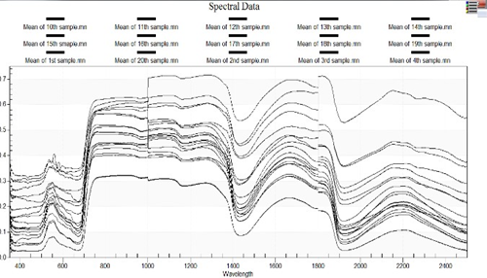

Figure1. Spectral Signature of Normal Leafs samples
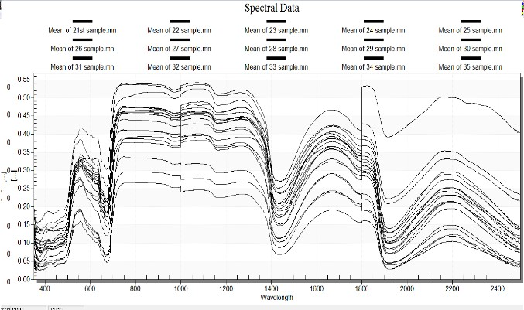
Figure2. Spectral Signature of Diseased Leaf samples

Support vector machine (SVM) is a discriminative classifier formally defined by a separating hyperplane. In other words, given labeled training data (supervised learning), the algorithm outputs an optimal hyperplane which categorizes new examples. In two dimentional space this hyperplane is a line dividing a plane in two parts where in each class lay in either side10 .we can use support vector machine when data has exactly two class. An SVM classifies data by finding the best hyperplane that separates all data points of one class from those of the other class. The best hyperplane for an SVM means the one with the largest margin between the two classes. Margin means the maximal width of the slab parallel to the hyperplane that has no interior data points.The support vector are the data points that are closest to the separating hyperplane; these points are on the boundary of the slab. The following figure illustrates these definitions, with + indicating data points of type 1, and – indicating data points of type –1.

We used Support Vector Machine to classify diseased and normal samples, we have exactly two classes i.e. diseased and normal, and we use SVM. After classification we found that the NPCI index is use to identify leaf is healthy or diseases.

- Normalized Pigment Chlorophyll Index (NPCI):
Because of chlorophyll pigment leaf reflectance in visible is influenced. Information contained in reflectance spectra has been used to estimate plant nitrogen status. NPCI is defined as following equation [26]

NPCI= (R680-R430)/ (R680+R430)

- Modified chlorophyll absorption in reflectance index (MCARI):
MCARI is intrinsic indices. It is developed by Kim[27] in 1994. MCARI is used for reduce the effect of non- photosynthetic materials on spectral estimates of absorbed photo synthetically active radiation. To calculate MCARI vegetation index is as follows

MCARI= [(R700–R670)-0.2(R700-R550)*(R700/R670)]

- Normalized Difference Vegetation Index (NDVI):
NDVI is good parameter for leaf detection. NDVI is used to distinguish between infected and non-infected leaf. The NDVI is also used to analyse green vegetation or not .To calculate NDVI Vegetation index is as follows

NDVI
Where NIR represents reflectance at near infrared band (801 nm) and Red reflectance in the Red Band (670 nm).The values range from +1.0 to -1.0. High NDVI values are approximately 0.6 to 0.9[28]. NDVI is useful for vegetation monitoring. It is also useful for global vegetation monitoring.

- Transformed Chlorophyll Absorption Index (TCARI):

The MCARI is affected by various parameter like Chlorophyll and background reflectance. The variations of reflectance characteristics of background materials (soil and no photosynthetic components) and to increase the sensitivity at low chlorophyll values, the transformed chlorophyll absorption ratio index (TCARI) can be defined [29]

TCARI=3[(R700–R670)-0.2(R700- R550) (R700/R670)]

It should include important

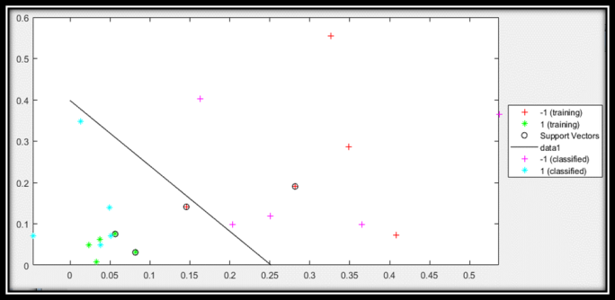
Figure 3. Classification Using SVM by using NPCI
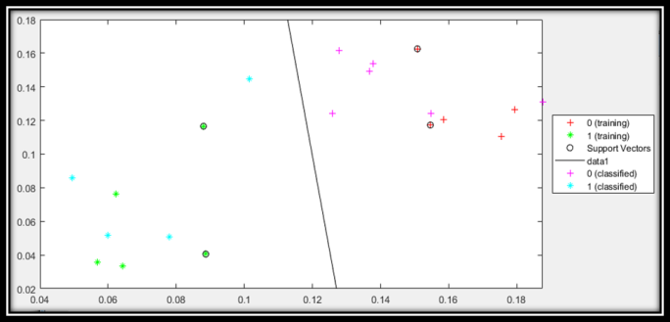
Figure 4. Classification Using SVM by using MCARI

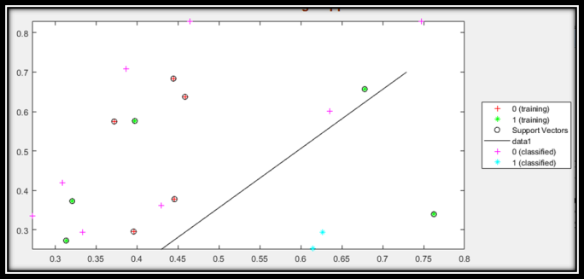
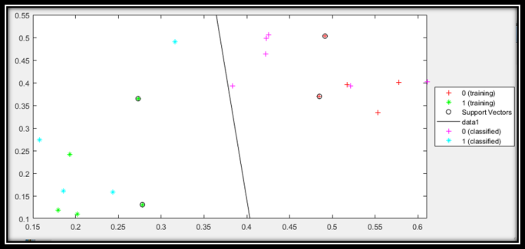
Figure 5. Classification Using SVM by NDVI

Fig 6:- Classification Using SVM by TCARI

In fig 3 SVM classify data using NPCI index, first we calculated NPCI index and then provided index value to SVM classifier for training and then testing. In first case we found 0.1 Miss Classification rate and 0.888547 mean squared errors. In fig 4 shown SVM classified data using MCARI index and then provided index value to SVM classifier for training and then testing, in this case we got 0.2 Miss Classification rate and 0.458796 is mean squared error. In fig 5 SVM classified data using NDVI index, first we calculated NDVI index and then provided index value to SVM classifier for training and then testing, in third case we get 0.4 Miss Classification rate and 0.339065 mean squared error. In fig 6 SVM classified data using TCARI index, first we calculated TCARI index and then provided index value to SVM classifier for training and then testing, in fourth case we got 0.2 Miss Classification rate and 0.428319 mean squared error.
Table.1 Miss Classification Rate and MSE of Classifier

Vegetation  Index | Miss classification Rate | Mean Squared  error
NPCI | 0.1 | 0.888547
MCARI | 0.2 | 0.458796
NDVI | 0.4 | 0.339065
TCARI | 0.2 | 0.428319
The tables and figures without repeating their contents. Interpret the findings in view of the results obtained in this and in past studies on this topic. State the conclusions in a few sentences at the end of the paper. However, valid colored photographs can also be published.

Table.2 (a) Normal Vegetation Indices of Forty Samples
NORMAL
 | MCARI | TCARI | OSAVI | NPCI | NDVI
1 | 0.2902 | 0.3640 | 0.8536 | 0.0588 | 0.6644
2 | 0.2550 | 0.2780 | 0.9228 | 0.0377 | 0.7624
3 | 0.0898 | 0.1930 | 0.5012 | 0.0328 | 0.3972
4 | 0.1908 | 0.2730 | 0.8462 | 0.0818 | 0.6779
5 | 0.0724 | 0.1795 | 0.4244 | 0.0566 | 0.3133
6 | 0.0822 | 0.2019 | 0.4403 | 0.0238 | 0.3207
7 | 0.0529 | 0.1307 | 0.4406 | 0.0631 | 0.3394
8 | 0.1293 | 0.2411 | 0.7504 | 0.0073 | 0.5760
9 | 0.2679 | 0.3647 | 0.8668 | 0.0308 | 0.6569
10 | 0.0463 | 0.1187 | 0.3665 | 0.0752 | 0.2725
11 | 0.0421 | 0.1099 | 0.5035 | 0.0493 | 0.3726
12 | 0.0784 | 0.1856 | 0.6210 | -0.0465 | 0.4641
13 | 0.3400 | 0.4220 | 0.8128 | 0.0385 | 0.6351
14 | 0.3400 | 0.4220 | 0.8128 | 0.0385 | 0.6351
15 | 0.0632 | 0.1576 | 0.3695 | 0.0493 | 0.2718
16 | 0.2068 | 0.3163 | 0.7916 | 0.0130 | 0.6145
17 | 0.1619 | 0.1614 | 0.9183 | 0.0714 | 0.8295
18 | 0.1570 | 0.1585 | 0.9156 | 0.0714 | 0.8286
19 | 0.3531 | 0.4628 | 0.7870 | 0.0488 | 0.6012
20 | 0.1349 | 0.2732 | 0.4416 | 0.1399 | 0.3353

Table.2 (b) Diseased Vegetation Indices of Forty Samples
DISEASED
 | MCARI | TCARI | OSAVI | NPCI | NDVI
1 | 0.2865 | 0.4906 | 0.3756 | 0.3473 | 0.2520
2 | 0.4066 | 0.5174 | 0.5467 | 0.3266 | 0.3957
3 | 0.4467 | 0.5533 | 0.5943 | 0.2817 | 0.4443
4 | 0.5142 | 0.5773 | 0.6243 | 0.3487 | 0.4585
5 | 0.3508 | 0.4914 | 0.5130 | 0.4085 | 0.3721
6 | 0.3356 | 0.4848 | 0.5928 | 0.1456 | 0.4456
7 | 0.2421 | 0.3950 | 0.4051 | 0.5540 | 0.2954
8 | 0.4153 | 0.3346 | 0.7309 | 0.1905 | 0.6835
9 | 0.5300 | 0.4004 | 0.7630 | 0.2870 | 0.6373
10 | 0.4228 | 0.5029 | 0.7386 | 0.0730 | 0.5748
11 | 0.2455 | 0.3698 | 0.4877 | 0.1410 | 0.3776
12 | 0.4513 | 0.6106 | 0.5496 | 0.2507 | 0.3868
13 | 0.2744 | 0.4252 | 0.4345 | 0.5367 | 0.3088
14 | 0.2960 | 0.4226 | 0.5380 | 0.1628 | 0.4297
15 | 0.3768 | 0.5212 | 0.4794 | 0.3650 | 0.3333
16 | 0.3768 | 0.5212 | 0.4794 | 0.3650 | 0.3333
17 | 0.4494 | 0.4016 | 0.8498 | 0.1186 | 0.7080
18 | 0.3629 | 0.5062 | 0.5557 | 0.3643 | 0.4186
19 | 0.3446 | 0.4978 | 0.4968 | 0.4033 | 0.3612
20 | 0.2244 | 0.3932 | 0.3934 | 0.0985 | 0.2943

As shown in Table 2. Left hand side shows the indices value of normal 20 samples and in Right hand side the indices values of diseased sample. We calculated the five indices i.e. MCARI, TCARI, OSAVI, NPCI, NDVI throughout the table index the value of NPCI normal sample is low as compare to diseased sample. Diseased sample shows high value .In other indices like MCARI they shows same value or increase or decrease value in normal and diseased, in TCARI also shows same value or decrease value, in also NDVI shows same or increase or decrease value in normal and diseased sample. Preesan Rakwatin et al observed that NPCI behaved as a rough estimate of the ratio total pigments chlorophyll, NPCI
decrease in healthy plants and increase in stressed plants15. Figure 8. Normal sample Reflectance Spectra at 450nm to 700nm In Figure 7 absorbance from 450nm to 700nm is week absorbance while in fig 8 more abosorbance shows high peck which show’s it is diseased19.
The NPCI was suitable to detect diseases from chilly plant, more vegetation indices have to test. According to result of SVM and observation from table 2 NPCI is used to detect the disease of chilly plant. according to Preesan Rakwatin et.al. also found that, it will decrease in healthy plants and increase in diseased plant15. According to Anatoly A. Gitelson et al and observation from fig E and fig F with the range of 450nm to 700nm, we can predict the diseased or normal leaf.

REFERENCES

- J Brown, NDVI, the Foundation for Remote Sensing Phenology. Available: https://phenology.cr.usgs.gov/ndvi_foundation.php, 2017.

- Yong-Hyun Kim et al, “Comparative Analysis of the Multispectral Vegetation Indices and the Radar Vegetation Index.” Journal of the Korean Society of Surveying, Geodesy, Photogrammetry & Cartography, 2014 32(6): 607-615.
- C. S. T. Daughtry C. L. Walthall, M. S. Kim, E. Brown de Colstoun‡ and J. E. McMurtrey III “Estimating Corn Leaf Chlorophyll Concentration from Leaf and Canopy Reflectance.” Elsevier Science Inc. Remote sensing, 2000, 74:229–239..
- Chaoyang Wu, Zheng Niu, Quan Tang, Wenjiang Huang “Estimating chlorophyll content from Hyper spectral vegetation indices: Modeling and validation.” Agricultural and Forest Meteorology, 2008,148, 1230-1241.
- J. Penuelas, J.A.Gamon, A.L redeen, J.Marineo, C, B, Field “Reflectance indices Associated with Physiological changes in Nitrogen-and water limited sunflower leaves.” Remote Sensing of Environment, 1994, 48, 2, 135-146.
- Precision Hawk, Green Normalized Difference Vegetation Index. Available: https://www
.precisionmapper.com/algorithms/green-normalized-difference-vegetation-index.
- Dr.Agrarwissenschaften “Detection, identification, and quantify cation of fungal diseases of sugar beet Leaves using imaging and non-imaging hyper spectral techniques.” Ph.D. Inaugural- dissertation, Institute of Crop Science and Rescource Conservation – Phytomedicine, Ansbach, 2011.
- R Shamshiri “Plant disease detection based on spectral band selection.” Department of Agricultural and Biological Engineering, University of Florida, Gainesville, USA, 2008.
- Kerstin Grill, Simone Graeff, Wilhelm laupein, “Use of Vegetation indices to detect plant diseases.” The 27th GIL Annual Meeting, 5-7, Stuttgart, Germany, March 2007.
- Rainer Laudien, Georg Bareth, Reiner Doluschitz “Analysis of hyperspectral field data for detection of Sugar beet diseases.” 5-9, EFITA Conference, Debrecen, Hungary,2003
- F Ghobadifar, A Wayayok, M Shattri, H Shafri “Using SPOT-5 images in rice farming for detecting BPH.” In Conf .Earth and Environmental Science, Kuala Lumpur, Malaysia, 2014.
- [12Blake Weissling “Early Detection of Oak Wilt Disease in Quercus ssp. A Hyper spectral Approach.” University of Texas, San Antonio, May 6, 2005.
- W C Chew, M Hashim2, A M S Lau1,4, A E Battay3 and C S Kang “ Early detection of plant Disease using close range sensing system for input Into digital earth Environment.”, In Conf. Earth and Environmental Science, Kuching, Sarawak, Malaysia, 2013.
- Davoud Ashourloo, Mohammad Reza Mobasheri, Alfredo Huete, “Developing Two Spectral Disease Indices for Detection of Wheat Leaf Rust.” Remote Sensing 2014, 6(6), 4723-4740.
- Davoud Ashourloo, Mohammad Reza Mobasheri, Alfredo Huete, “Evaluating the Effect of Different Wheat Rust Disease Symptoms on Vegetation Indices Using hyper spectral Measurements.” Remote Sensing 2014, 6(6), 5107-5123.
- J Brown. NDVI, the Foundation for Remote Sensing Phenology. Available:“https://phenology.cr.usgs.gov/ndvi_foundation.php201 7”
- R Shamshiri “Plant disease detection based on spectral band selection.” Department of Agricultural and Biological Engineering, University of Florida, Gainesville, USA, 2008.
- Leaf Pigment, Available: http://harvardforest.fas.harvard.edu/leaves/pigment , time 4.14 PM 31/8/2018.
- Kerstin Grill, Simone Graeff, Wilhelm laupein, “Use of Vegetation indices to detect plant diseases.” The 27th GIL Annual Meeting, 5-7, Stuttgart, Germany, March 2007.
- Rainer Laudien, Georg Bareth, Reiner Doluschitz “Analysis of hyperspectral field data for detection of Sugar beet diseases.” 5-9,
- EFITA Conference, Debrecen, Hungary, 2003
- Dr.Agrarwissenschaften “Detection, identification, and quantify cation of fungal diseases of sugar beet Leaves using imaging and non-imaging hyper spectral techniques.” Ph.D. Inaugural- dissertation, Institute of Crop Science and Rescource Conservation
- – Phytomedicine, Ansbach, 2011
- F Ghobadifar, A Wayayok, M Shattri, H Shafri “Using SPOT-5 images in rice farming for detecting BPH.” In Conf .Earth and Environmental Science, Kuala Lumpur, Malaysia, 2014.
- W C Chew, M Hashim2, A M S Lau1,4, A E Battay3 and C S Kang “ Early detection of plant Disease using close range sensing system for input Into digital earth Environment.”, In Conf. Earth and Environmental Science, Kuching, Sarawak, Malaysia, 2013.
- Davoud Ashourloo, Mohammad Reza Mobasheri, Alfredo Huete, “Developing Two Spectral Disease Indices for Detection of Wheat Leaf Rust.” Remote Sensing, 6(6), 4723-4740, 2014.
- Support Vector Machine [online] https://medium.com/machine- learning-101/chapter-2- svm-support-vector-machine-theory- f0812effc7217. time 4.14 PM, 31/8/2018
- J. Penuelas, J.A.Gamon, A.L redeen, J.Marineo, C, B, Field “Reflectance indices Associated with Physiological changes in Nitrogen-and water limited sunflower leaves.” Remote Sensing of Environment, 48, 2, 135-146, 1994.
- Yong-Hyun Kim et al, “Comparative Analysis of the Multispectral Vegetation Indices and the Radar Vegetation Index.” Journal of the Korean Society of Surveying, Geodesy,

