ODONTOGENIC KERATOCYST-A TYPE OF BENIGN CYSTIC NEOPLASM/AGGRESSIVE CYST
Nishtha .U. More¹
morenishtha03@gmail.com
+91 8237928894
Yogita dental college and Hospital
Narangi river side dapoli road
Khed 415709
ABSTRACT

Odontogenic Keratocyst (OKC) is a type of odontogenic cyst (OC) which is distinctive form of developmental odontogenic cyst. It is deserving special consideration because of its specific histopathological features and clinical behaviour i.e of aggressive type. FNAC is most of useful in oral cancer detection of squamous cell carcinoma. Odontogenic Keratocyst, was first identified and described in 1876. 39 cases of Odontogenic Keratocyst are reported from 1971 till date making it a rare case.

Keywords - Odontogenic Keratocyst (OKC), odontogenic cyst(OC),Conebeam CTScan (CBCT), Fine needle aspiration cytology (FNAC).dental lamina, resorption of bone, bone aggressive behaviour, periapical cyst and dentigerous cyst.

- INTRODUCTION

Odontogenic Keratocyst can be described as an epithelial lined pathologic cavities surrounded by fibrous tissue that originate from odontogenic tissues that occurs in tooth bearing regions of maxilla and mandible. Cystic conditions of jaw cause bony destruction and may cause resorption or displacement of adjacent teeth.More cases are found in adult age group than pediatric population.Periapical cyst and dentigerous cyst are reported regularly in dental practice.Odontogenic cyst are diagnosed using Fine needle aspiration biopsy (FNAB)/Fine needle aspiration cytology (FNAC).FNAC is most useful in oral cancer detection of squamous cell carcinoma. Early recognition and referral to Oral Surgeon minimise extent of jaw bone destructure and can be treated by enucleation. Odontogenic Keratocyst was first identified and described in 1876. From 1971, till date only 39 cases of Odontogenic Keratocyst are found. This Odontogenic cyst are relatively common lesions and accounts to form a major part of total biopsies received by any pathology service. The cyst arises from cell rests of dental lamina. This cyst shows different growth mechanism and biological behaviour from more common dentigerous cyst and radicular cyst. As these two cysts enlarge as a result of increased osmotic pressure within lumen of cyst. This mechanism does not appear to hold true for Odontogenic Keratocyst as its growth maybe related to unknown factors inherent in epithelium itself or enzymatic activity in fibrous wall but,what makes this cyst special is its aggressive behaviour and high recurrent rate. In 1962, Pindborg and Hansen suggested that histological criteria necessary to diagnose Odontogenic Keratocyst. In recent years, World Health Organisation (WHO) recommended term Cystic neoplasm (now known as KOCT) for this lesion. Histologically high mitotic rate and association with genetic and chromosomal abnormalities. Odontogenic Keratocyst found in patients who range in age from infancy to old age,but about 60% of all cases diagnosed in people between 10-40 years of age. There is slight male predilection. Mandibule is involved in 60% to 80% of cases,with a marked tendency to involve posterior body and ascending rahmus.

Small Odontogenic Keratocyst are usually asymptomatic and discovered only during course of radiographic examination. Later Odontogenic Keratocyst maybe associated with pain, swelling or drainage. Some extremely large cyst, however,may cause no symptoms.Odontogenic Keratocyst shows thin,friable wall that is often difficult to enucleate from bone in one piece. The cystic lumen may contain a clear liquid similar to transudate of serum or maybe filled with chessy material consisting of keratinaceous debris. Microscopically,thin fibrous wall is devoid of any inflammatory infiltrate.The epithelial linning is composed of an uniform layer of stratified squamous epithelium, usually 6-8 cells in thickness. The epithelium and rete ridge formation is unconspicuous. Detachment of portions of cyst linning epithelium from fibrous wall is commonly observed. Luminal cells are parakeratinized.

- CASE REPORT

A 31 year old male reported to the clinic with a history of epigastric pain, retromal discomfort, burning, nausea and vomiting. Treatment was done by diet counseling and antacid/acid blocking mediators. It was thought that it was a case of Gastritis but later when the patient revisited later with complaint of pain and pus discharge in lower left back region of jaw; after diagnosis it was recognized as a case of OKC.Investigations showed CBCT of lower jaw (fig.2) and multiloculated scalloped radiolucent panormic body and rahmus region of left mandible. Patient was advised for FNAC treatment by surgical intervention under GA. After some years, the patient again reported with growth of lesion over time. OKC recurrence rate is 2.5% to 62%(14). So it can be considered rare Intervention - As usual treatment protocol; marsupialization was 1st attempted 1st immunohistochemical analysis revealed reduce expression of ki-67 and B-cell lymphoma 2 (bcl-2) markers after marsupialization.However due to incomplete resolution lower left posterior region, an aggressive approach was taken by cutting it out surgically. Later more recurrence has been seen.The diagnosis concluded that OKC originated from Odontogenic epithelium i.e. dental lamina in the alveolus left from tooth development stages. Mainly thought to arise from rests of serres. Regzi and others(13) have attempted to explain the pathogenic mechanism of OKC. They mention the mechanism that favours growth and expansion of OKCs are high proliferation rate, over expression of antiapoptoticproteins(bcl-2)and expressionofMatrixmetalloproteinase(MMPs2and9).Mutation in PTCH1(patched) gene has also been considered asresponsible for the pathogenesis of this cyst(12,13,14).

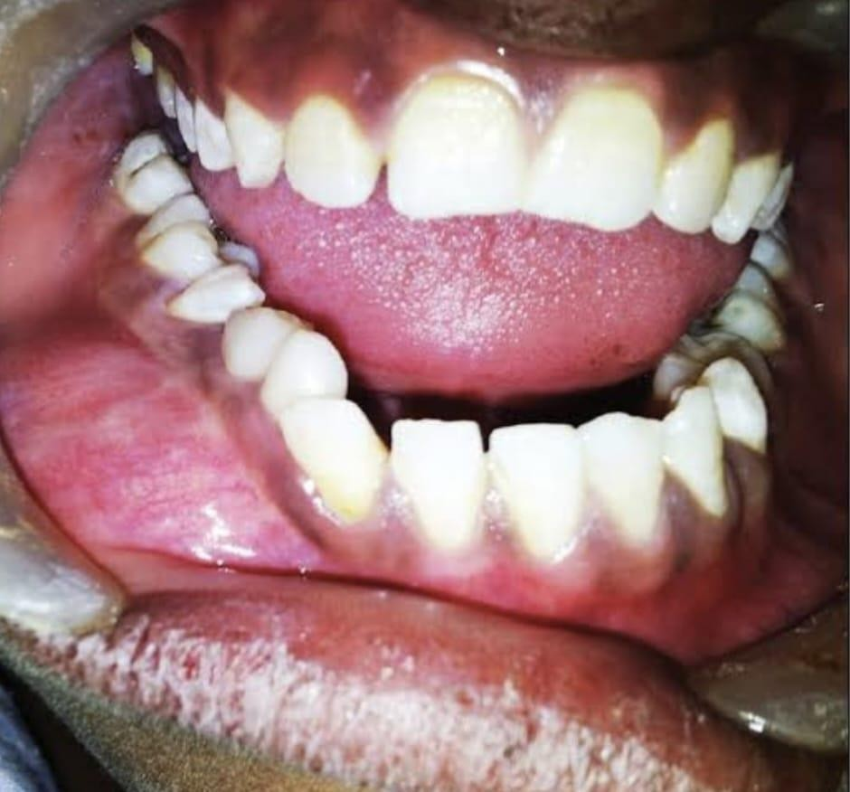

Figure 1: Odontogenic Keratocyst (OKC) noted in the basal epithelial layer

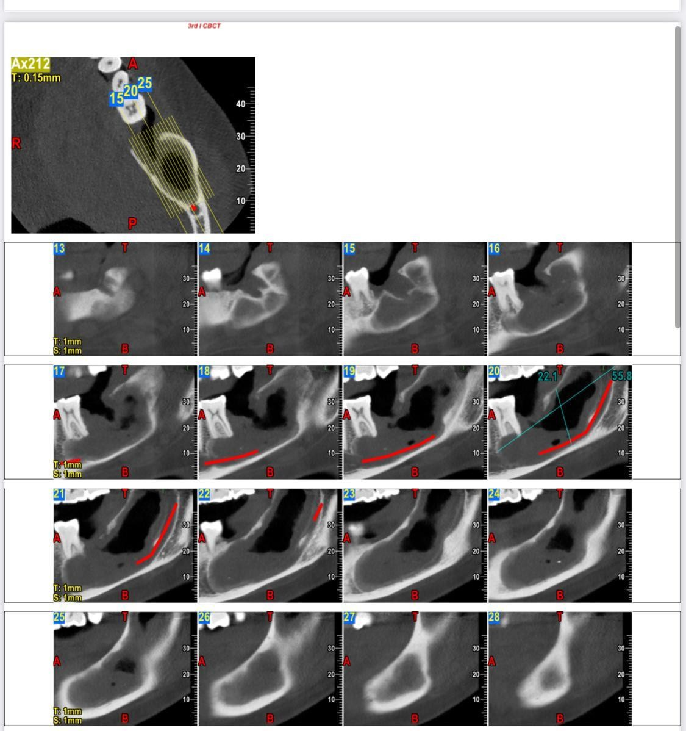
Figure 2: shows that Conebeam CT Scan (CBCT) of lower jaw and multiloculated scalloped radiolucent panormic body and rahmus region of left mandible.

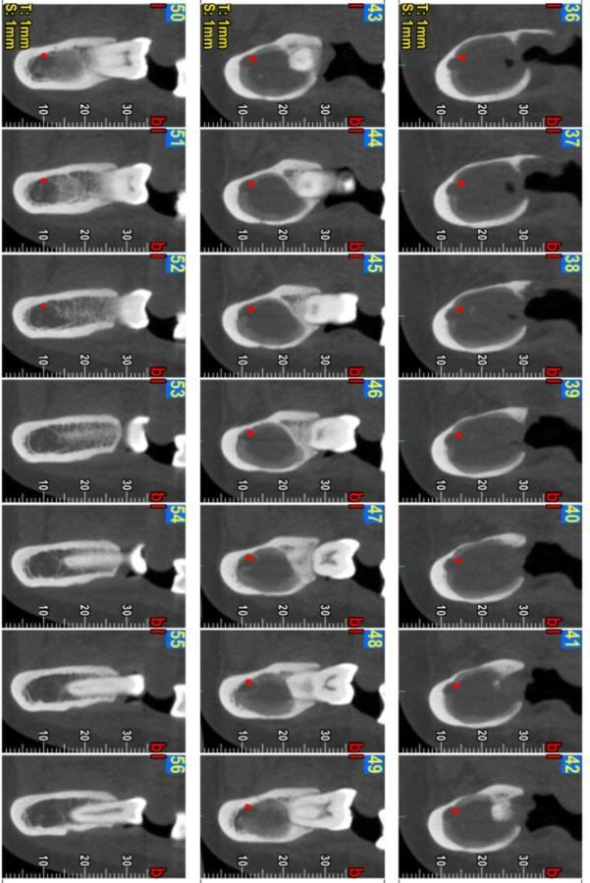

Figure 3 : In this Image shows (Black region)the cyst has caused resorption of bone with the pus formation(white part 50 -54).

III.GENETICS

The PCTH gene has been mapped to chromosome 9q22.3-q31 and it probably functions as a tumor suppressor(3) .The Protein Patched Homolog1 (PCTH1) is an important molecule in the so-called Hedgehog (Hh) signalling pathway(14). Normally,PTCH forms a receptor complex with the oncogene SMO ("smoothened") for the SHH ( "sonic hedgehog") ligand(18). Studies on NBCCS and Sporadic KCOT have provided molecular evidence of a two- hit mechanism in the pathogenesis of these tumors demonstrating allelic loss, at two or more loci, of 9q22 (19,20) leading to the over expression of bcl-1 and TP53 in the Neviod Basal carcinoma syndrome (NBCCS). This supports the concept that KCOT represents a neoplasm(20). There is also accumulating evidence that the PTCH gene might be a significant factor in the development of sporadic KCOT. Further more, preliminary results have shown over- expression and amplification of genes located in 12q(21).The epithelial linning of OKC/KOT are PTCH2 and SUFU. Few authors also have demonstrated loss of LTAS2, and FHIT genes(14). These findings are helpful to explain the aggressive behaviour of OKC.

IV.TREATMENT

OKC is well known for their strong tendency to recur(11). Much debate has been done and various studies performed, to as certain ideal treatment modality for OKC/KOT.Mostly these arguments revolve around whether to treat OKC as a cyst or as a benign neoplasm.Whatever modality has been implied,none of these have shown to completely prevent recurrence of the lesion,the problem is still compounded in case of NBCCS and multiple lesions. Eyre and Zakrezewska in 1985, have stated the following treatment modalities for OKC / KOT- like enucleation with primary closure / with packing / with chemical / fixation with cryosurgery ; Marsupialization only followed by enucleation ; Resection (22). The choice of treatment has always been difficult, since the patient well-being is of prime concern, although notcompromising the chances of recurrences. Morgan and his colleagues(23) have categorised surgical treatment methods for KOT as conservative / aggressive. The conservative treatment is 'cyst oriented ' and this includes enucleation, with or without curettage or marsupialization. The advantage is presentation of anatomical structures and reduced morbidity to the patient. The aggressive treatment is done considering 'neoplastic nature' of KOT and includes peripheral osteotomy, chemical curettage, or enbloc resection. It is mostly recommended for large lesions, recurrentcasesand syndromicpatients.Decompression has also been used to treat KOTs,which have aggressive behaviour and having tendency to recur(14).Few authors recommended "site and size based" approach for the treatment of KOT. Dammer et al have suggested conservative approach for small KOTs ( maximum 1cm in diameter) near alveolar process, andradical excision for larger lesions near the base of skull that has invaded soft tissue(24). On the contrary, forsell and coworkers have reported that the size of the lesion does not affect the recurrencerate(25).

V. CONCLUSION

Odontogenic Keratocyst is still considered as diagnostic challenge and should be considered especially in patient with predominance with it. Prognosis is very much favourable in patient when diagnosed earlier as prevents resorption of bone. Suspected cases should be subjected to histological investigation and should consider possibility for Odontogenic Keratocyst after 5-10 years. So the whole process of classifying and renaming the odontogenic cyst and tumors continues as the understanding of these lesions takes a giant leap in its stride. There is as yet no international consensus,either on the question of the cyst's neoplasmic nature, or on a name change. A famous oral surgeon "Gordon Hardman" was quoted saying "We always knew some cysts recurred so the patient came to have them curetted out every 5-10 years. So what, we never had to give them separate names"(6) This attitude of the surgeons overlooking the multiple recurrences has always been suppressing the concept of reclassifying these lesions ( favourite work of the pathologists). The controversies over the nature of OKC are infact a reflection of our limited knowledge of this fascinating entity.(14) "A rose is a rose is not a rose," when it implies to OKC/KOT. The term "odontogenic keratocyst" is so engraved in the literature only time can tell us whether the term "Keratocystic odontogenic tumor" can substitute this term successfully or not. Recent advances in genetic and molecular understanding have led to eventually eliminate the need for agressive treatment modalities. This article is in a hope to suggest that the naming of KOC as a benign tumor allows the surgeon to tailor their treatment aptly.

VI. REFERENCES

- Philipsen HP, Reichart PA. Classification of odontogenic tumors. A historical review. J Oral Patho Med.2006;35:525-9.
- Hauer A. Ein Cholesteatom I'm linken Unterkiefer unter eninem retinierten Weisheitszahn. Zeitsschrift fir Stomatologie. 1926;24:40-59.
- Barnes L, Eveson JW, Reichart P, Sidranksy D,editors. Lyon:IARC Press;2005. Pathology and genetics of head and neck tumors.
- Toller P. Origin and growth of cysts of the jaws. Ann R Coll Surg Engl. 1967;40:306-36.
- Robinson HB. Primordial cysts versus keratocysts. Oral Surg Oral Path Oral Med.1975;40:326- 4.
- Pogrel MA, Schmidt BL. The odontogenic keratocyst. Oral Maxillofac Surf Clin North Am.2003;15:321-6
- Soskolne WA, Shear M. Observations on the pathogenesis of primordial cysts. Br Dent J. 1967;123:321–6.
- Forssell K, Sainio P. Clinicopathological study of keratinized cysts of the jaws. Proc Fin Dent Soc. 1979;75:36–45.
- Philipsen HP. Om keratocyster (kolesteatom) i kaeberne. Tandlaege bladet. 1956;60:963–81.
- Pindborg JJ, Hansen J. Studies on odontogenic cyst epithelium. 2. Clinical and roentgenologic aspects of odontogenic keratocysts. Acta Pathol Microbiol Scand. 1963;58:283–94.
- Ahlfors E, Larsson A, Sjögren S. The odontogenic keratocyst: A benign cystic tumor? J Oral Maxillofac Surg. 1984;42:10–9.
- Shear M. The aggressive nature of the odontogenic keratocyst: Is it benign cystic neoplasm? Part 1 Oral Oncol. 2002;38:219–26.
- Regezi, Sciubba, Jordan . 4th ed. St. Louis, Missouri: Saunders Company; 2003. Oral Pathology Clinicopathological correlations; pp. 250–2.
- TJ. The odontogenic keratocyst: A cyst, or a cystic neoplasm? J Dent Res. 2011;90:133–42.
- Brannon RB. The odontogenic keratocyst A clinicopathologic study of 312 cases. Part I. Clinical features. Oral Surg Oral Med Oral Pathol. 1976;42:54–72.
- Reichart PA, Philipsen HP. London: Quintessence Publishing; 2004. Odontogenic tumors and allied lesions.
- Neville BW. Update on Current Trends in Oral and Maxillofacial Pathology. Head Neck Pathol. 2007;1:7580.
- Madras J, Lapointe H. Keratocystic odontogenic tumour: Reclassification of the odontogenic keratocyst from cyst to tumour. J Can Dent Assoc. 2008;74:165–65h.
- Levanat S, Gorlin RJ, Fallet S, Johnson DR, Fantasia JE, Bale AE. A two-hit model for developmental defects in Gorlin syndrome. Nat Genet. 1996;12:85–7.
- Lo Muzio L, Staibano S, Pannone G, Bucci P, Nocini PF, Bucci E, et al. Expression of cell cycle and apoptosis-related proteins in sporadic odontogenic keratocysts and odontogenic keratocysts associated with the nevoid basal cell carcinoma syndrome. J Dent Res. 1999;78:1345–53.
- Heikinheimo K, Jee KJ, Morgan PR, Nagy B, Happonen RP, Knuutila S, et al. Gene expression profiling of odontogenic keratocyst. J Oral Pathol Med. 2004;33:462.
- Eyre J, Zakrezewska JM. The conservative management of large odontogenic keratocysts. Br J Oral Maxillofac Surg. 1985;23:195–203.
- Morgan TA, Burton CC, Qian F. A retrospective review of treatment of odontogenic keratocyst. J Oral Maxillofac Surg. 2005;63:635–9.
- Dammer R, Niederdellmann H, Dammer P, Nuebler-Moritz M. Conservative or radical treatment of keratocysts: A retrospective review. Br J Oral Maxillofac Surg. 1997;35:46–8.
- Forssell K, Forssell H, Kahnberg KE. Recurrence of keratocysts. A long term follow-up study. Int J Oral Maxillofac Surg. 1988;17:25–8.
- di Magliano Pasca M, Hebrok M. Hedgehog signaling in cancer formation and maintenance. Nat Rev Cancer. 2003;3:903–11.
- Taipale J, Chen JK, Cooper MK, Wang B, Mann RK, Milenkovic L, et al. Effects of oncogenic mutation in Smoothened and Patched can be reversed by cyclopamine. Nature. 2000;406:1005–9.
Zhang L, Sun ZJ, Zhao YF, Bian Z, Fan MW, Chen Z. Inhibition of SHH signaling pathway: Molecular treatment strategy of odontogenic keratocyst. Med Hypotheses. 2006;67:1242–4.

References
The incidence of recurrence of OKC has varied from 2.5% to 62%.(14) The great degree of variation in these reports are mainly because some series included cysts from patients with Nevoid Basal cell carcinoma syndrome (NBCCS), while other reasons for this variation can be due to duration of the follow up period and method of treatment used.(14)
In 1976, Brannol (15) proposed three mechanisms for OKC recurrence: Incomplete removal of the cyst linning, growth of a new OKC from satellite cysts( or Odontogenic rests left behind after surgery), and development of a new OKC in an adjacent area.
Histopathological features that can be considered predict recurrence in OKC are
Higher level of cell proliferative activity in the epithelium
Budding in the basal layer of the epithelium
Parakeratinization of the surface layer
Supraepithelial spilt of the epithelial linning
Subepithelial split of the epithelial linning
Presence of remnants/cell rests as well as daughter cysts.

