A Brief Overview into the Concept of Forest Certification
Nayana M D
MSc forestry in Forest Products and Utilization.
Karnataka, India.
nayumalige67@gmail.com

Ramana P
Professor and HOD
College of Forestry, UASD
Sirsi, Karnataka, India

Chiranjeevi M D
MSc Scholar in Remote sensing
Karnataka, India

Harish M R
MSc Scholar in Remote sensing
Karnataka, India

Abstract

Forest certification is used as market-based tool to fulfill the demands desired by peoples of the world. Earlier, it has been launched to protect the biodiversity in the tropical forests later, evolved to work on sustainable forest management. Forest stewardship council (FSC) and Programme for Endorsement of Forest Certification (PEFC) are the major international schemes, competing each other for their remarks. Comparatively, FSC has strict guidelines for conservation purpose, whereas PEFC has towards multi-stakeholders’ concerns. After 2015, India has its own certification scheme known as Network for Certification and Conservation of Forests (NCCF).
Keywords: Forest certification, FSC, PEFC, NCCF

INTRODUCTION

Need for Certification
Forest managers are expecting good prices for their products, on other side, society demanding quality products with easy market accessibility with better supply. Many global environment protecting agencies demanding for biodiversity conservation. Therefore, the forest certification was used as market-based tool to concern about the deforestation, environmental quality (Adamowicz and Veeman, 1998) and to achieve the sustainable management goals mainly in tropics (Cashore et al., 2003). However, as the supply and demand for certified forests and products continuously rising, certification has developed into a huge business pot. In reality, many businesses aiming a key strategic concern to project an ecologically sensitive image for forest certification.

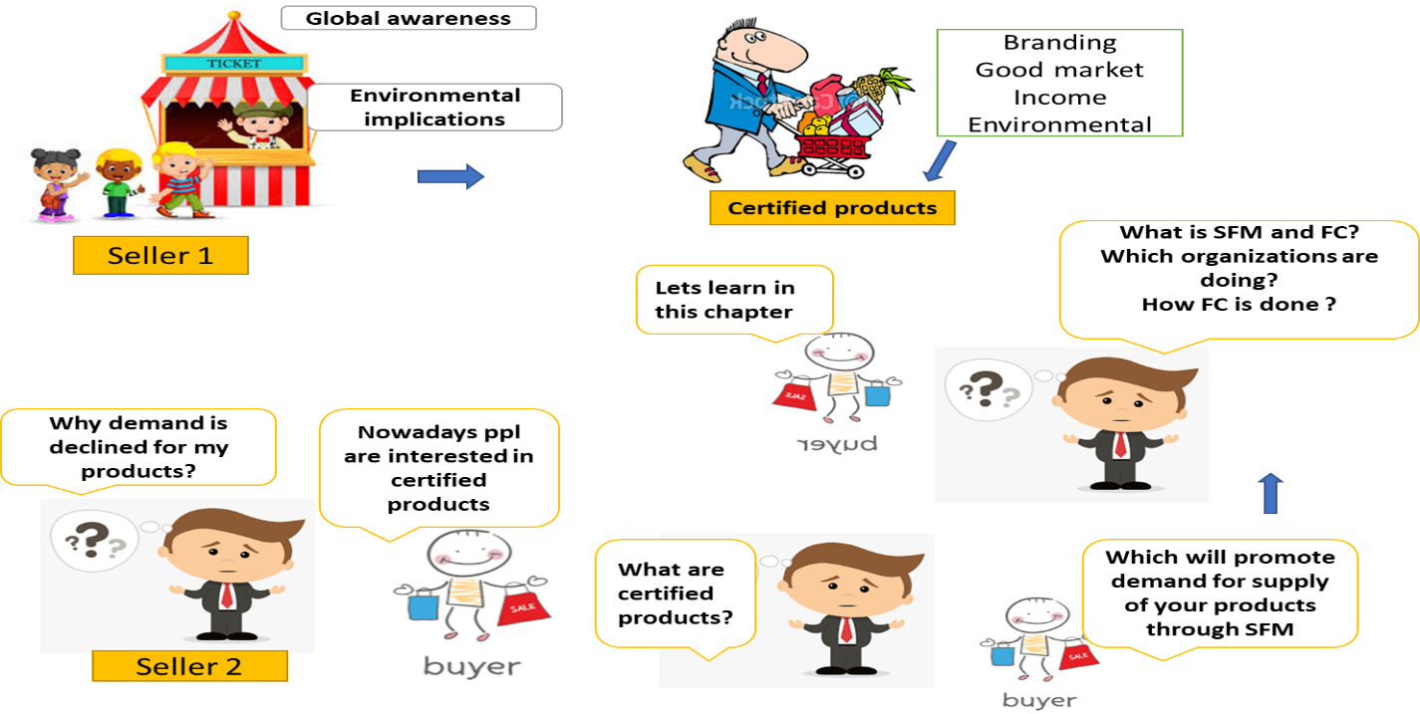
Origin and evolution
During 1637, Europe to a French royal decree members started labelling wood for their quality, which stipulated them even to label furniture they made. Approximately 17 million hectares of tropical forests were cleared in 1990, at a rate of more than an acre per second. The strain on the forest resource comes on two main fronts, commercial use of wood and deforestation due to land use changes (Rametsteiner and Simula, 2003). The majority of terrestrial biodiversity is found in forests, and half of it is considered to be located in tropical forests (Alfonso et al., 2001). In 1988, a number of environmental organizations pushed the International Tropical Timber Organization (ITTO) to create a labeling program to identify tropical timber that was produced sustainably in an effort to address this growing problem. Another proposal for a global forest treaty backed by the G-7countries had to be abandoned months before the Rio Summit due to opposition by the G-77 developing countries (Kiekens, 2003). As a result, a voluntary non-profit organization called the Forest Stewardship Council (FSC) was launched in 1993 with the coalition of Worldwide Fund for Nature and other leading environmental organizations. The number of certified areas worldwide has significantly increased during the last three years (Rametsteiner and Simula, 2003). Now, forest certification is the first genuinely accepted eco-certification (Rametsteiner, 2000). The various certification programs developed during the past ten years have so far certified around 124 million ha, or 3.2%, of the world's forests.

Forest certification- definition
Forest certification is a voluntary process where by an independent third party (the“certifier”) assesses the quality of forest management and production against a set of requirements (“standards”) predetermined by a public or private certification organization. Forest certification, and associated labelling, is a way of informing consumers about the sustainability of the forests from which wood and other forest products were produced.
Forest certification is a process which results in a written certification being issued by an independent third party, attesting to the location and management status of a forest which is producing timber (Baharuddin and Simula, 1994). It entails evaluating the effectiveness of forest management in light of a predetermined set of principles and criteria. Additionally, forest certification offers customers a reliable assurance that the product is made from sustainably managed, socially beneficial, and environmentally responsible forest (Merry and Carter 1996 and Kiekens 2003).

Components of a credible forest certification
Three separate functions, performed by independent organizations:
- Standard Setting: defining requirements for certification in collaboration with stakeholders (e.g.: NCCF)
- Certification: Process of checking whether an organization fulfills certification requirements; carried out by Certification Bodies
- Accreditation: Process of assessing competence of CBs; carried out by an Accreditation Body.
[For India: National Accreditation Board for Certification Bodies (NABCB)]

There are two types of forest certification:
- Certification of forest management, which assesses whether forests are being managed according to a specified set of standards; and
- Certification of the chain of custody (sometimes referred to as CoC certification), which verifies that certified material is identified or kept separate from non-certified or non-controlled material through the production process, from the forest to the final consumer. To label an end product as certified, both forest management certification and chain-of-custody certification are required.

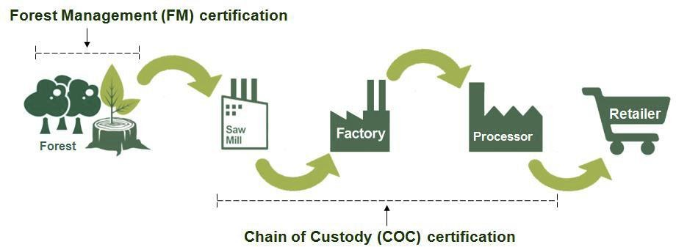

Global Forest Certification Schemes
International schemes:
- Forest Stewardship Council (FSC)
- Programme for Endorsement of Forest Certification (PEFC)

Regional & Country specific Forest certification Schemes:
• Sustainable Forestry Initiative (SFI)
• American Tree Farm System (ATFS)
• Canadian Standards Association (CSA)
• Malaysian timber Certification Council (MTCC)
• China National Forest Certification Scheme (CNFCS)
• Sustainable Green Ecosystem Council (SGEC), Japan

Forest Stewardship Council (FSC)
The FSC was founded in 1990 after a meeting in California, USA, with wood consumers, traders, and representatives of organizations working for the environment and human rights to examine the need for a reliable way to identify products made from forests that are being managed sustainably. The requirement for a global, independent institution to streamline the certification process was underlined throughout this conference. The provisional FSC board of directors was founded in 1992 in Washington, D.C., and the FSC founder assembly was held in Toronto, Canada in 1993 with 130 participants from 26 nations (FSC, 2004). FSC has now grown to be the world's largest third-party certification voluntary programme (Humphries,1999). It mainly concentrates towards the sustainable forest management concept than others.
FSC has mainly 10 principles: 1: Compliance with laws, 2: Workers’ rights and employment conditions, 3: Indigenous peoples’ rights, 4: Community relations, 5: Benefits from the forest, 6: Environmental values and impacts, 7: Management planning, 8: Monitoring and assessment, 9: High conservation values and 10: Implementation of management Activities.

Programme for Endorsement of Forest Certification (PEFC)
Formerly, known as Pan European Forest Certification established by forest owners of six countries in 1999 (France, Sweden, Australia, Finland, Germany and Norway). FSC scheme was opposed by forest owner of UK, majorly because of the standards and FSC principles which are highly suitable for tropical countries. PEFC is a “mutual recognition framework” where, all national certification schemes have equivalent standards to recognize each other. It sets “criteria and standards” according to countries at national level rather than single C & I like FSC and These operational level guidelines were adopted by Ministerial Conference on the Protection of Forests in Europe (Dilip, 2017).
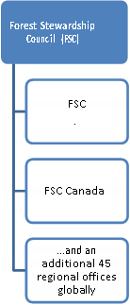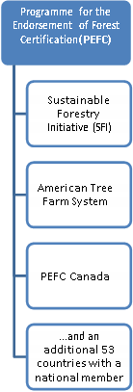
FSC
Bonn, Germany – 1993
International forest standards
Use of generic standard in countries prior to their own standard
Supports SFM
Major NGOs like WWF, green peace, friends of earth and woodland trust are the supporters

PEFC
Geneva, Switzerland – 1999
National FS
Umbrella system, also endorsing independent national standards.
Favorside for private industries
Forest owners and industries

Both are third part assessment dependent and full chain supply for CoC

Forest Certification Program Relationships
(Fernholz et al., 2021)
Global status of forest certification
- Globally over 525 million ha (11%) of forest area certified
and 52,143 CoC certificates
- 11% of the world forest are certified
- 28% of the world’s industrial round wood supply is certified
- 89% of world’s forests are still uncertified
- 54% of area is certified in North America, 35% in Europe, 5% in Asia, 4% Oceania and 2% in Central and South America.
- In India, totally 1.02 million hectare was certified, 12 FM certificates issued till date and 665 Chain of Custody certificates.
(Source: Webinar on FC by NCCF-2020)

Benefits of forest certification
- Can place valuable quality products in the market with wider accessibility.
- Biodiversity conservation along with production and enhancement of ecosystem function and vitality
- Maintenance and concern of social, cultural, traditional and spiritual values of the communities related to the forests.
- Increased returns compared to uncertiﬁed timber to the communities
- Provide job opportunities
- It fulfills products’ legal requirements – such as illegal operation for timber and NTFP’s.
- It may improve working conditions and protect health of workers.
- It will boost company’s image.
- Brand creativity

Cost of certification
- Direct costs are those which include certifiers expenditure for assessment, consultations, subsequent audits and reports preparing costs.
- Indirect costs are investments for machineries, infrastructures and logistics, staff training.
Usually, indirect costs are higher than direct costs because, direct costs are fixed but indirect costs increase with extension of work to improve the work. A certificate is issued for products and management unit is valid for a specified period in terms of years after compliance has been achieved.

Meeting Financial Resources for Certification
- Compensatory Afforestation Fund Rules, 2018:
- “Forest certification and development of certification standards are eligible activities for utilizing State Compensatory Afforestation Funds.
- Forestry Projects under Externally Aided Funding through JICA, UNDP, World Bank, GIZ, USAID, DFID, etc. are trying to promote certification
- SFDs/SFDCs may use their own budgetary resources for certification

Markets
Strongest market for certified products can be seen in USA and in Western Europe. According to Dixon (1999), For instance, Price Waterhouse Coopers predicts an increase in US certified forest products market by 100 to 150% per year. “Buyer groups – retailers and traders” are leading these markets.
UK’s B&Q and Homebase, Lowe’s and Home Depot in the USA and Sainsbury and Meyers are some of the important members of buyer group. However, compared to markets in North America and Europe, certification not yet attained a complete market share in important Asian markets like China, Japan and Korea. These nations are among the top purchasers/importers of tropical timber (Kanowski et al., 2019).

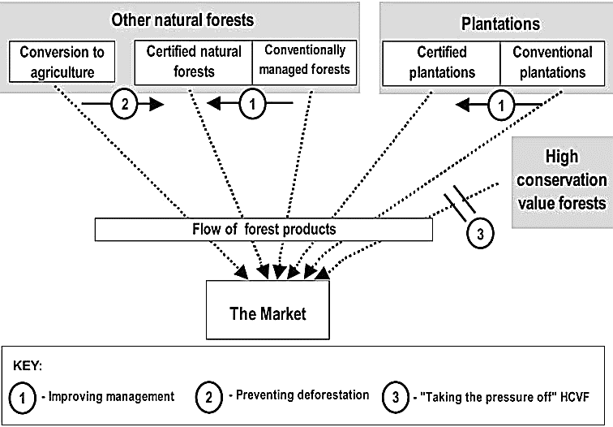
Biodiversity conservation through forest certification, does it really work?
Gullison (2003) analyzed on above question by considering 14 important countries data along with 156 certified companies performance index. He concluded along with his data that, Comparatively European countries fulfilling biodiversity conservation strategy of forest certification (Estonia-51%, Poland-39.7%, Sweden-37.35% forest cover certified`). In many countries, available incentives are even not capable of retaining their forest cover for sustainable management, rather they clearing their land for timber and agriculture. Due to lack of better amount of incentives in tropical countries, certification process failed to attract efficient producers and market benefits that they are receiving are less than the cost of management to fulfill the guidelines produced by FSC (Forest Stewardship Council). In overall, FSC increasing the conservation but to step on greater inroads-FSC should reduce the costs and government should encourage the people.
It’s difficult to conclude by considering only one certification agency, another back pulling factor is he referred till 2003. Let’s study further in detail about the facts.
Three possible ways to conserve biodiversity through forest certification

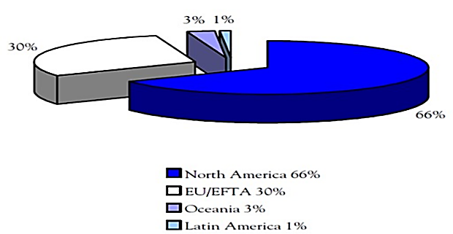
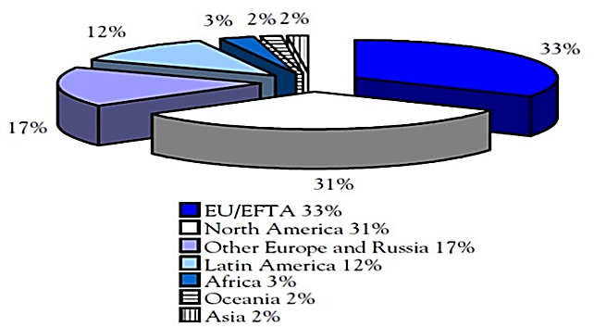
2
1

Regional distribution of certiﬁed forest area by FSC, 2006 (1) and PEFC (and PEFC- endorsed systems)- [2],
These results showed the efficiency of both agencies. During 2006, PEFC is absent in Asia, Africa, some other countries of Europe and Russia. PEFC (66%) showing drastic high percentage in Europe regions compare to FSC. Asia has least certified area with 2%. Latin America has 12% with FSC and least with PEFC (1%). Kraxner et al. (2006)

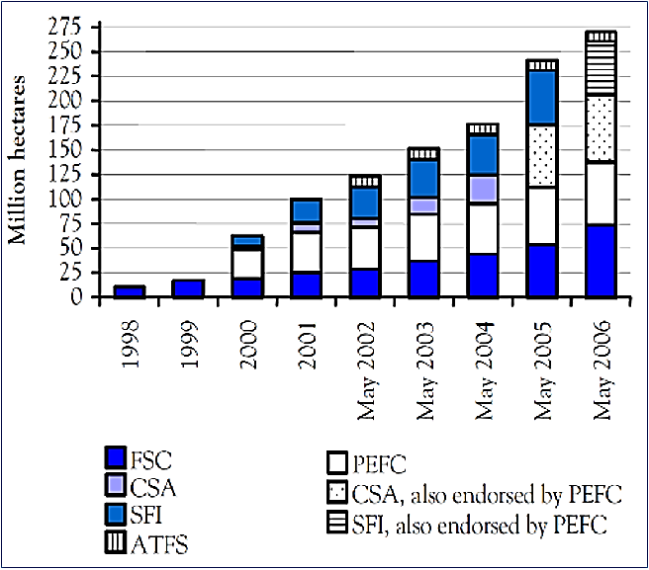
- FSC and PEFC showed increased certified area with years
- SFI is absent in 2006 and SFI, also endorsed by PEFC started in 2006.
- CSA is present from 2001 to 2004, after this CSA, also endorsed by PEFC started.
- ATFS maintained consistency and its presence is from 2002 to 2006

Forest area certiﬁed by major certiﬁcation schemes
Kraxner et al., 2006
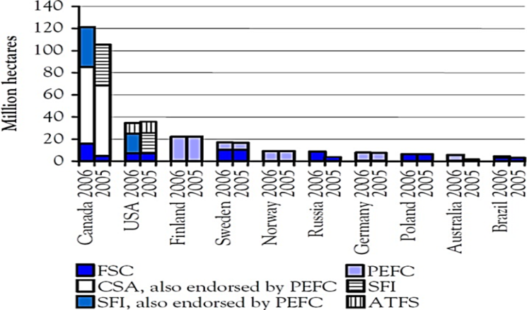
- Canada showing nearly 120 m. ha certified area and CSA is the dominant one along with FSC and SFI. And it was followed by USA with SFI, ATFS and FSC agencies
- Finland, Norway, Germany and Australia have only PEFC and Russia, Poland and Brazil have only FSC, whereas Sweden has both. All these countries have minimum area with positive growth trend.

Kraxner et al., 2006
Top 10 countries’ certiﬁed forest area

Fernholz et al. (2021) reported on pace of change in forest certification by referring Dovetail Partners documentation. They have been documenting changes in forest certification since 2004. They have covered a lot of territory with the topic in their more than fifty reports. They wanted to assist land managers in determining whether certification may be advantageous for them and, if so, which programs might be the greatest fit when they published their first study on third-party forest certification. The Forest Stewardship Council (FSC), the programme for the Endorsement of Forest Certification (PEFC), and the Sustainable Forestry Initiative (SFI) are the certification schemes that were thoroughly evaluated in this research.

Summary of FSC and PEFC Program Structures and Certification Activity`
Programme | North  American  offices | Global  Offices/country  members | Certificate  Holders, forest  management | Certificate  Holders  Chain of custody | Certified area (acre/  Hectare), as of  December 2020
FSC | 2 | 49 | 1,777 | 44,934 | 222 m. ha  548 m. acres
PEFC | 3 | 55 | 11,875 | 23,478 | 320 m. ha  790 m. acres

By 2020, PEFC certified almost 320 million ha area around the globe followed by FSC International (222 m. ha). SFI certified 152 million ha and least was FSC US and FSC Canada with 68 million ha. After 2004, area wise PEFC increased its work rapidly, it might be due to the simple guidelines, cost effective, endorsement of other agencies, fast and significant work compare to FSC. Besides it, FSC has highest number of CoC certificate holder.
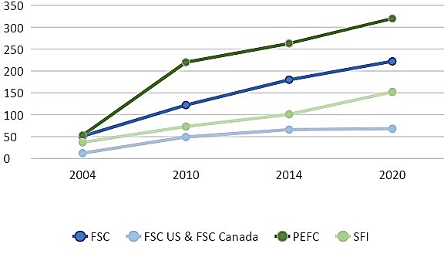

Growth in Forest Certification Programs, 2005-2020 (million hectares)

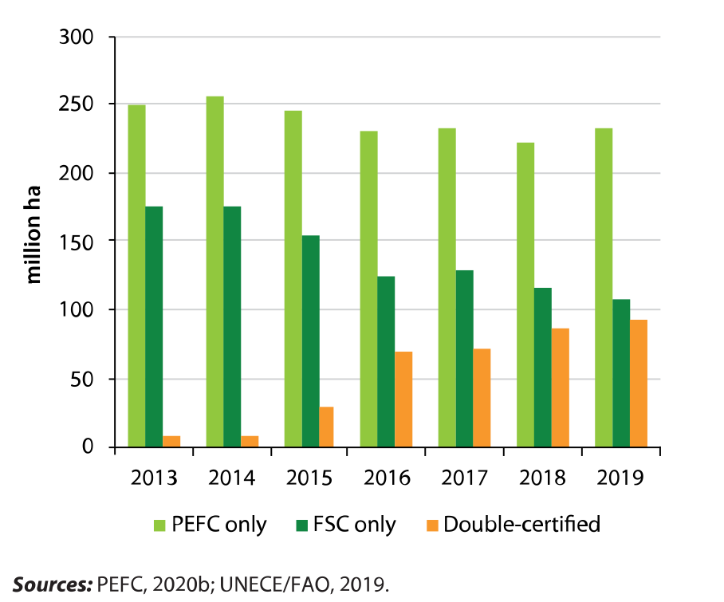
- Increased area under double certification can be observed
- Might pose good demand for products in the market as it is come from double certification

Global Certified Forest Area, Adjusted for Double-Certified Area

Forest Certiﬁcation in India
To meet export demands, India has secured 1 FSC Forest Management Unit Certiﬁcate and 6 CoC certiﬁcates by small and medium companies. Only one rubber plantation (private) of 644 ha in Tamil Nadu got FM certiﬁcate. 92% of Indian forests are being managed by forest department. Hence the DGF has written letter on 11th December 2019 to all SFDs to initiate forest certification voluntarily. He has suggested that its non-regulatory and facilitative tool for sustainable forest management. It helps to monitor, trace and labelling of timber and NTFPs. It brings credibility with international recognition which enhance the market facility to slow down the imports. Economic prospects of many farm forestry/ agro-forestry areas in India may get adversely affected.

Forest Certification Challenges in India
- Certification is voluntary, not statutory
- Lack of awareness about certification
- Low level of people’s sensitization and conviction; movement required
- Inadequate government incentives for certified products
- Certification generally missing in public procurement policies
- Limited and uncertain benefits in domestic markets
- Certification cost is high, particularly for farmers/small producers, MSMEs
- SFDs/SFDCs as largest stakeholders, have major role to play

Forest Certification Initiatives in India
- MoEFCC constituted a Committee on Certification under chairmanship of Dr Maharaj Muthoo, a veteran professional forester and expert on certification
- The Committee in its report recommended various measures to promote forest certification in India.
- An important recommendation was to have an internationally benchmarked and India specific certification scheme.
- NCCF, a non-profit organization, registered as a society has developed the Indian scheme of Forest Certification

Indian Forest Certification Scheme: Network for Certification and Conservation of Forests (NCCF); PEFC Endorsed Scheme
NCCF:
NCCF is the only not-for-profit Indian Scheme of forest certification in India established on 2015, through a multistakeholder standard development group chaired by Mr. Avani Varma (ex PCCF & HoFF, Karnataka) following the standard setting process. It’s the only member of PEFC council for India (40th member), member of IUCN and observer of UNCCD after CoP14. The standard has themes, criteria, principles and indicators and these has been endorsed by the PEFC, giving it an international recognition. NCCF has organized workshops in many states of India and the sustainability standards are developed for: NWFP certification standards, FMC, protected areas and wetlands, quality planting material, ecotourism, biofuel and biomass, development carbon registry-India and the trees outside forest.
Core working areas of NCCF are: sustainable standards, policy advocacy, natural conservation and management, multi-stakeholder engagement and capacity building. Specially done certification for trees outside the forests (ToF) in 2022, as it is the source of 85% of wood and wood products.

Current Status of NCCF-PEFC Certifications
Forest Management (1 Certificate): Uttar Pradesh Forest Corporation; 41 Divisions; 4.5 lakh ha. Karnataka has initiated for 1 division and 2 in Tripura.
Chain of Custody (31 Certificates): Pulp & Paper, Packaging, Furniture, Textile, etc. (Hindustan pencils, Birla cellulosic, durian industries etc.,)
(Source: Webinar on FC by NCCF-2020).
Conclusion
Forest Certiﬁcation has emerged as a market-based mechanism in support of Sustainable Forest Management (SFM). Globally, nationally and locally- FC should be on the top of sustainability agenda. The two factors that encouraged the development and practice of certiﬁcation of forests are Global awareness and Economic Implications. Most of the certified areas are in the temperate and boreal zone, with North America and Europe as the most important region. Only around ten per cent is located in tropical countries. Tropical countries should encourage certification process. There are several certiﬁcation schemes in the operation of which Forest Stewardship Council (FSC) certiﬁcation is one of the most popular and credible certiﬁcation schemes globally. PEFC has certified more hectares of area compared to FSC – Certification. State Forest Departments need to play an active role in ensuring the availability of certiﬁed forest produce in the country. Region specific guidelines in collaboration with central and state ministries along with the suggestions from industries, forest stakeholders and forest department will help to encourage the certification system.

References
A. Alfonso, F. Dallmeier, E. Granek, and P. Raven, “Biodiversity: Connecting with the Tapestry of Life.” Smithsonian Institution/Monitoring and Assessment of Biodiversity Program and President’s Committee of Advisoron Science and Technology. Washington, D C, USA, 2001.
A. Dixon, “Beauty and the Beasts.” Tim. W. Pro. Int. 1997.
A. K. Srivastava, 2020, “Introduction to forest certification and NCCF.” Certification promotes sustainable management of forests. Network for Certification and Conservation of Forests, webinar on 19th may, 2020.
Anonymous, “Annual Review and Assessment of the World Timber Situation.” I. T. T. O. Yokohama, Japan, 2004.
Anonymous, “Ten years of FSC-Looking to the Future.” F. S. C. Bonn, Germany, 2004.
B. Cashore, G. Auld, and D. Newsom, “Forest certification (eco-labelling) programme and their policy-making authority: explaining divergence amount North American and European case studies. For. Poli. and Econ. Vol.5. issue 3, pp. 225-247, 2003.
D. F. Merry, and D. R. Carter, “Programs and markets for ecologically certified wood products.” Southern Forest Economics Workshop, Gatlinburg, 1996.
E. Rametsteiner, “Sustainable Forest management certification; framework conditions, system designs and impact assessment. A policy analysis of certification of forest management as a policy instrument to promote multifunctional sustainable forest management conducted in the context of the EU research project.” Ministerial Conference on the Protection of Forests in Europe, Viena (Austria), pp. 95-766, 2000.
E. Rametsteiner, and M. Simula, “Forest certification—an instrument to promote sustainable forest management.” J. Env. Manag. vol.67, pp.87-98, 2003.
F. Kraxner, E. Hansen, and T. Owari, Public procurement policies driving certification. Cert. For. Prod. Mar. 2006.
F. S. C. http://www.fsc.org, 2004.
H. J. Baharuddin, and M. Simula, “Certification Schemes for all Timber and Timber Products.” I. T. T. O. Yokohama, Japan, 1994.
J. Kiekens, “Forest certification in North America: selected developments.” 12th World Forestry Congress, Canada, 2003.
K. Fernholz, J. Bowyer, G. Erickson, H. Groot, M. Jacobs, A. McFarland, and E. Pepke, “Forest certification update 2021: the pace of change.” Dove. Par. United States, 2021.
K. P. J. Dilip, “Forest certification: relevance, challenges and way forward in India.” For. Mats. vol.4, pp. 47-51, 2017.
P. Kanowski, M. Tricallotis, and N. Gunnigham , “The drivers and evolution of competing forest certification schemes in Chilean forestry industry.” Int. For. Rev. Chile, vol.21,: pp.516-527, 2019.
R. E. Gullison, “Does Forest certification conserve biodiversity?” Faun. Flo. Int. vol.37, pp.153-165, 2003.
S. Humphries, “Forest Certification Handbook: For the Southeastern United States.” The For. Manage. T. Gainesville, FL, 1999.
W. L. Adamowicz, and T. S. Veeman, “Forest policy and the environment: changing paradigms,” Canadian Pub. Poli. pp.160, 1998.

