D. GAYATHRY
Research Scholar,
Department of Computer Science
St. Peter's Institute of Higher Education and Research
Chennai - 600 054, Tamil Nadu, INDIA
gaya200689@gmail.com

Dr. R. LATHA Professor & Head
Department of Computer Science & Applications
St. Peter's Institute of Higher Education and Research
Chennai - 600 054,INDIA
latharamavel@gmail.com

REAL TIME FACE RECOGNITION AND DETECTION USING DEEP LEARNING ALGORITHM

Abstract: Nowadays, face recognition is a reliable and accurate
access control technique which is used along with other biometric methods. Face recognition is a process of recognizing the face sample of particular person from the set of face samples stored in the system. It can be done by converting images into digital binary representation to extract features using various techniques. In this paper, we propose

Index Terms - Face Recognition, Convolutional Neural Networks, Deep Learning.

- INTRODUCTION
There are many access control strategies available to provide security in the twenty-first century. Biometric identification is used in the majority of methods. Face recognition is frequently used in public security, daily life, military contexts, and banking as a method of access control for identifying a person. The face recognition system is one of computer vision's most important applications. A facial recognition system can identify a human face from a digital image or a video frame against a database of faces. This technology is frequently used to authenticate users through ID verification services. Since the advent of deep learning, face recognition technology based on CNNs (Convolutional Neural Networks) has become the industry standard. neural network convolution There are many access control strategies available to provide security in the twenty-first century. Biometric identification is used in the majority of methods. Face recognition is frequently used in public security, daily life, military contexts, and banking as a method of access control for identifying a person. The face recognition system is one of computer vision's most important applications. A facial recognition system can identify a human face from a digital image or a video frame against a database of faces. This technology is frequently used to authenticate users through ID verification services. Since the advent of deep learning, face recognition technology based on CNNs (Convolutional Neural Networks) has become the industry standard. neural network convolution
II . RELATED WORK
In recent years variety of research and methods are discovered to
execute face recognition and to increase accuracy of face recognition system. In authors have implemented In authors have proposed the face recognition system using improved CNN with the development of computer vision and artificial intelligence. Author have tested the model for activation function accuracy, dropout layer accuracy and overall system accuracy. In the authors have described face recognition system using deep learning CNN. Authors used triplet loss function to tweak neural network weights. With the help of KNN model classification the overall system accuracy achieved around 95%. The CNN-PCA (Convolutional Neural Network - Principal Component Analysis) hybrid feature extraction method was used by the authors to develop a face recognition system. Histogram equalization method of contrast-brightness adjustment is used to improve facial recognition process. After performing experiment, the accuracy produced by PCA algorithm was in between 90- 96%, on the other hand CNN-PCA method gives accuracy up to 98%. In authors have proposed a face recognition system using CNN with Dlib face alignment. The proposed system mainly focused on face alignment and reduction of False Acceptance Rate (FAR). The face recognition model gives overall accuracy of 96% on Face Recognition Grand challenge (FRGC) dataset. In this paper authors have briefly discussed about development stage of face recognition and different early-stage methods like Linear Discriminate Analysis (LDA) and Principal Component Analysis (PCA). Support Vector Machine (SVM), Adaboost, and other artificial features and classifiers were also covered by the authors. In authors have
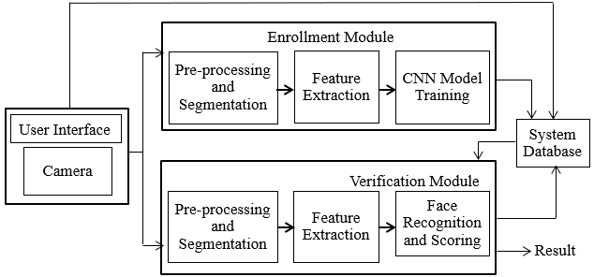
implemented a face recognition algorithm for biometric based attendance system. This paper shows accuracy comparison between face recognition algorithms Eigenface and Fisherface provided by OpenCV According to research Eigenface achieves better result than Fisherface. In this paper authors have discussed how Convolutional Neural Network (CNN) work. Authors also discussed about different layers of CNN, their mathematical computations and working with diagrams, data transfer between different layers of CNN. In authors have created image classification model based on simple convolutional neural network. Also, author studied different learning rate methods and optimization algorithms with their parameters for image classification. The proposed model is tested on cipher-10 and MNIST dataset for error rate calculation. In authors have discussed about different face detection techniques like skin likelihood image, skin segmentation etc. and some face recognition techniques.
- PROPOSED WORK

System Overview
With the aid of transfer learning and the VGG16 CNN approach, the major goal of the proposed system is to improve the accuracy of the face recognition system. The suggested solution uses IOT and has real-time face recognition capabilities. Figure 1 depicts the suggested facial recognition system design.

Figure 1: System Architecture

The proposed system is divided into 4 main part User Interface, Enrolment Module, Verification Module and

Database. System starts by collecting face samples of users with the help of camera module. In enrolment module, the collected face samples from user are undergo pre-processing and then stored to the train folder. Verification module contains CNN model training and testing. While face recognition user’s face is extracted from continuous stream of video and compare with trained model. Based on CNN model prediction result will be generated.

Methodology
The workflow diagram of proposed system is as shown below. In machine learning data is centralized and important entity. For training of CNN model, we collected data of 20 persons. For each person 30 images were collected for training set and 5 images for validation dataset.

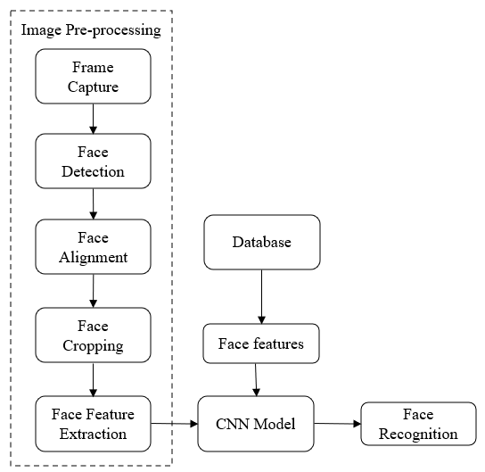

Figure 2: Workflow Diagram

Face identification from a continuous video stream is the initial stage in a face recognition system. For the system to operate more accurately, accurate and error-free face detection is essential. Face detection is a function of computer vision technology. Haarcascade_frontalface_default.xml, a pre-trained classifier, is used to do this. This classifier was learned using various image tones. This classifier detects faces in grayscale images only. Fig.3 Showed the input image and detected face with the help of OpenCV library.

Figure 3: i) Normal image ii) Detected face

An open-source framework called Open CV offers the greatest environment for creating various systems that need image pre-processing. Typically, not all of the faces that are recognized are in the correct alignment. It causes a mistake in the facial recognition procedure. To achieve high accuracy in the face recognition process, the cropped face photos must be aligned before being sent to the neural network. We convert a specified set of points from the input image into the output coordinate system during this operation. a coordinate system for the output based on the idea of nodal points. There are 80 different nodal points on our face, including the nose width, length of the jawline, space between the eyes, curve of the cheekbones, and eye socket. We must first extract a specific area of the image before feature extraction.

The feature extraction from aligned faces is the most important aspect of this approach. Because CNN is employed in deep learning to work on data with grid-like structure, such as photographs, feature extraction is carried out via CNN. A 128-d vector can be extracted by CNN from aligned faces. It creates a binary version of a graphical image known as a digital image. This digital image will also be utilized to train a model. We employed a convolutional neural network with the pretrained VGG16 architecture. VGG16 accepts 224 x 224 input images with three channels, R, G, and B, respectively.

The RGB values for each pixel of the input image are normalized. Each pixel value is subtracted from the mean value to achieve this. Following that, the image is sent to the first two convolution layers.
At the time of face recognition, with the help of OpenCV system detect face in continuous stream of video and extract features from it. This face will be given to cnn model to predict. Convolutional Neural Networks' primary objective is to discover patterns in the image's extracted pixels. This aids CNN with locating the classification objectives. These patterns enable us to assign our photographs to the appropriate classes. In order to discover the best class that matches such patterns, classification is done by passing the patterns from one layer to another layer. Based on prediction the class name is displayed on the face by making a rectangle around detected face in video stream.

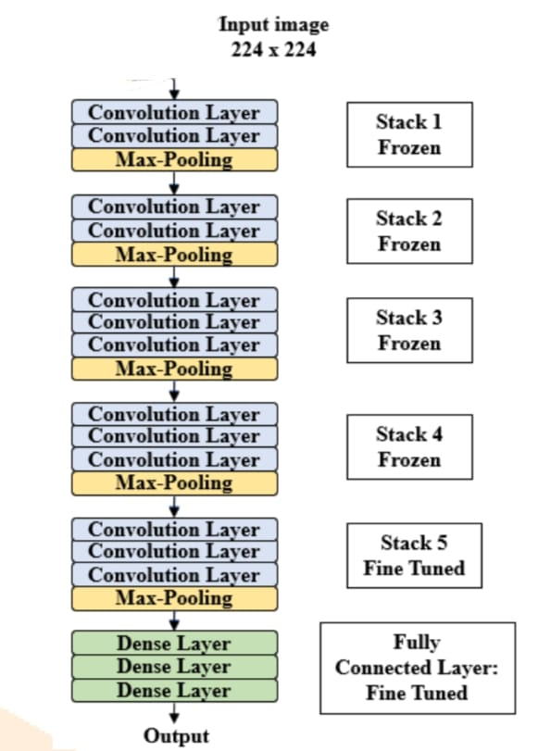

Figure 5: VGG16 Architecture

- RESULT AND DISCUSSION
The following experiment is used to calculate the system's overall accuracy: 20 users' faces were gathered, and after completing picture preprocessing tasks such face identification, face alignment, and face cropping, the samples were saved into a folder called "train." For each person 30 images are captured. After collecting face samples VGG16 cnn model is trained based on train dataset. The trained model saved for face recognition.
The experiment was performed on 20 users containing 10 male and 10 female. The proposed model is tested in real time. Each user comes in front of camera 5 times. The system detected faces from video stream and predict the name of the user. After the face recognition process experiment results stored for the further evaluation.
The experiment is carried out on NVIDIA Jetson Nano Development kit, which is small, powerful computer to run neural networks.
We used TensorFlow, Keras as deep learning framework. We set batch sizes equal to 32. We used Adam optimizer function.

- Effect of no. of users:
There is considerable impact of number of users on the system. We started with 4 users and increase the no of users up to 20. When there were only 4 users, the accuracy of the system was almost 99%. But after increasing the number of users to the 20 the accuracy of the system decreases to approximately 97%. So, there is slight decrease in the accuracy after increasing no of users.

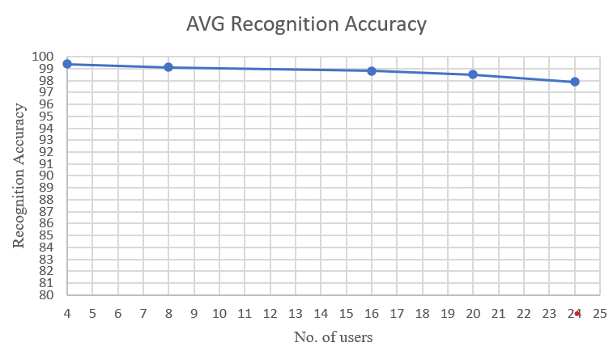

Figure 5: Average Recognition Accuracy

ii )Effect of facial expressions and occlusion:
Small change in face feature can decrease the accuracy of face recognition system. Accuracy may be affected due to expressions like laugh, crying etc. Because expressions lead to change in face geometry. Another factor that affects to the accuracy is occlusion of the face due to face mask, spectacles, earrings. Also, this happens because of hair, mustache, and beard. Due to facial expressions and occlusion of face system fails to identify the person and accuracy of the system decreases.

iii)Effect of other factors:
There are some more important factors which lower down accuracy of face recognition system. Lowresolution images affect the accuracy of the system. Noise present in images of different type like Gaussian, Poisson Speckle etc. This noise performs major role while accuracy calculation. Light and shadow falling on face also reduces the recognition accuracy.

iv)Overall accuracy:
The proposed facial recognition system's experimental findings were contrasted with those of competing approaches. The effectiveness of several strategies at identifying objects is displayed in the following comparison table. It is evident from the comparison table that the suggested technique provides greater accuracy when compared to existing approaches. Transfer learning and the VGG16 model provide a decent accuracy rate.

Table 4.1: Accuracy Comparison

Techniques | Accuracy
VGG16 | 94.4%
Normal CNN | 93%
CNN+PCA | 95%

- CONCLUSION
This study implements a real-time facial recognition system using CNN's VGG16 architecture. Additionally, transfer learning methodology was applied to achieve high accuracy. The system can find and recognize faces in a continuous video stream. The face sample collection, image preprocessing, model training, and face recognition task are all parts of the implementation process. Figure 6 illustrates the achievement of a recognition accuracy of 97-99% on average. The suggested system is further examined in terms of speaker count, lighting effects, face expressions, occlusion, low-resolution image effects, noise, light, and shadow effects, among other factors. The experiment's findings indicate that the system provides superior facial recognition accuracy up to 20 users. Thus, VGG16 convolutional networks with transfer learning can be inferred.

REFERENCES

- T. Guo, J. Dong, H. Li and Y. Gao, "Simple convolutional neural network on image classification," 2017 IEEE 2nd International Conference on Big Data Analysis (ICBDA), 2017, pp. 721-724, doi: 10.1109/ICBDA.2017.8078730.

- K. Yan, S. Huang, Y. Song, W. Liu and N. Fan, "Face recognition based on convolution neural network," 2017 36th Chinese Control Conference (CCC), 2017, pp. 4077-4081, doi: 10.23919/ChiCC.2017.8027997.
- D. Wang, H. Yu, D. Wang and G. Li, "Face Recognition System Based on CNN," 2020 International Conference on Computer Information and Big Data Applications (CIBDA), 2020, pp. 470-473, doi: 10.1109/CIBDA50819.2020.00111.
- M. Heidari and K. Fouladi-Ghaleh, "Using Siamese Networks with Transfer Learning for Face Recognition on Small-Samples Datasets," 2020 International Conference on Machine Vision and Image Processing (MVIP), 2020, pp. 1-4, doi: 10.1109/MVIP49855.2020.9116915.
- M. Owais, A. A. Jalal, M. M. Hassan and A. Shaikh, "Facial Recognition based Attendance System Using CNN and Raspberry Pi," 2020 4th International Symposium on Multidisciplinary Studies and Innovative Technologies (ISMSIT), 2020, pp. 1-5, doi: 10.1109/ISMSIT50672.2020.9254300.
- E. Winarno, I. Husni Al Amin, H. Februariyanti, P. W. Adi, W. Hadikurniawati and M. T. Anwar, "Attendance System Based on Face Recognition System Using CNN-PCA Method and Real-time Camera," 2019 International Seminar on Research of Information Technology and Intelligent Systems (ISRITI), 2019, pp. 301-304, doi: 10.1109/ISRITI48646.2019.9034596.
- S. Sharma, K. Shanmugasundaram and S. K. Ramasamy, "FAREC — CNN based efficient face recognition technique using Dlib," 2016 International Conference on Advanced Communication Control and Computing Technologies (ICACCCT), 2016, pp. 192-195, doi: 10.1109/ICACCCT.2016.7831628.
- L. Li, X. Mu, S. Li and H. Peng, "A Review of Face Recognition Technology," in IEEE Access, vol. 8, pp. 139110-139120, 2020, doi: 10.1109/ACCESS.2020.3011028.
- A. R. S. Siswanto, A. S. Nugroho and M. Galinium, "Implementation of face recognition algorithm for biometrics based time attendance system," 2014 International Conference on ICT For Smart Society (ICISS), 2014, pp. 149-154, doi: 10.1109/ICTSS.2014.7013165.
- S. Albawi, T. A. Mohammed and S. Al-Zawi, "Understanding of a convolutional neural network," 2017 International Conference on Engineering and Technology (ICET), 2017, pp. 1-6, doi: 10.1109/ICEngTechnol.2017.8308186.

