A REVIEW OF COGNITIVE WIRELESS NETWORK TECHNOLOGY

P. Elechi, W. Minah–Eeba, U. Ekwueme, T.S. Ibanibo and M. Okudu
Department of Electrical and Electronic Engineering, Rivers State University, Nigeria
elechi.promise@ust.edu.ng

Abstract
Wireless communication systems have limited access to and a valuable resource in the electromagnetic radio spectrum. Nevertheless, the spectrum has run out due to the development of new wireless technologies and rising bandwidth requirements. Remarkably, research has revealed that most of the allotted spectrum is utilized inefficiently, which exacerbates the scarcity problem. The issue stems from both wasteful use and rigid spectrum management. To address the challenge of enhancing bandwidth utilization, this paper explores the concept of cognitive radio networks (CRNs). CRNs introduce a new approach to spectrum access, topology, spectrum sensing techniques, applications, problem formulation, benefits, challenges, and various features that are vital for the development of next-generation cognitive wireless networks (CWN) communication systems. The key idea is to enable secondary users (SU) to access temporarily unused licensed bands, known as white spaces or spectrum holes, without causing significant interference to primary users (PU). This is achieved by adjusting the secondary users' transmitting parameters intelligently. By doing so, CRNs aim to make more efficient use of the available spectrum and alleviate the spectrum scarcity problem.
Keywords: CR, CRN, SDR, CR Challenges, Spectrum Sensing, PU, SU
1.0 Introduction
It will be challenging to imagine life without wireless communication in this modern era. There are large numbers of users of wireless communication, but the available spectrum is limited. Thus, spectrum scarcity becomes an issue. CR was created and built to be able to sense the wireless environment and communicate effectively and efficiently to lessen this challenge. Many studies have been conducted recently on the usage of these spectrum bands, which are either underutilized or empty. In 1999, Dr. Joseph Mitola made the initial recommendation for CR technology. Software-based CR technology senses the electromagnetic field in which it operates, identifies dormant frequency bands, and then broadcasts in these bands by utilizing radio operating parameters [1].
The objective of CRNs is to efficiently utilize temporarily inactive licensed spectrum resources for communication purposes, either at specific times or in designated locations. In CRNs, users fall into two categories: Primary Users (PUs) and Secondary Users (SUs). PUs, often referred to as licensed users, enjoy priority access to the spectrum and are protected from interference that could potentially disrupt their operations. Secondary Users, or cognitive users, employ advanced radio access techniques and dynamic spectrum allocation procedures to coexist with PUs, ensuring that their own activities do not hinder the performance of the PUs [2]. This approach allows CRNs to effectively address the challenges posed by limited radio frequency availability.
The primary aim of this review is to offer a concise overview of the current state-of-the-art research within the field of cognitive radio systems, as well as anticipated future advancements. The subsequent sections of the review are structured as follows: After covering the foundational concepts of cognitive radio, we delineate the constituents of a cognitive radio network (CRN) and present a concise summary of the primary research challenges. Subsequently, we provide a condensed overview of the latest advancements in spectrum sensing and spectrum-sharing techniques applicable to CR systems. A brief summary of the research related to the economic and security aspects of CRNs is presented. The review then delves into applications, including areas such as smart grid [3,4], machine-to-machine (M2M) communications [5,6], and cloud computing [6], while also addressing the current and forthcoming trends in cognitive radio. Furthermore, we identify and outline the ongoing research topics that remain open for exploration. Lastly, we summarize the standardization efforts pertaining to cognitive radio.
A crucial technology that enables a network to use the spectrum dynamically is CR technology. Governments manage the range of electromagnetic radiation known as a spectrum, which is what allows for wireless communication. A radio that has the ability to alter its transmitter characteristics in response to interactions with its surroundings is known as a cognitive radio [7]. Utilizing unused radio spectrum, CRbecame visible technology recently [8], helping to prevent congestion in wireless communication.
In the realm of transmission and reception parameters, cognitive radio (CR) can be categorized as Full Cognitive Radio and Spectrum-Sensing Cognitive Radio. In the case of Full CR, every individual parameter is meticulously monitored by a wireless node, whereas Spectrum-Sensing Cognitive Radio focuses its attention on monitoring the radiofrequency (RF) spectrum. Concerning spectrum availability, CR is further classified into Licensed-Band Cognitive Radio and Unlicensed-Band Cognitive Radio.
Licensed-Band CR possesses the capability to utilize frequency bands that are officially allocated to licensed users. Notably, the IEEE 802.22 standard was developed to enable wireless regional area networks (WRANs) to operate within TV white spaces, which represent unused television channels. On the other hand, Unlicensed Band Cognitive Radio operates within the unlicensed segments of the radio frequency spectrum [9, 10].
Cognitive radio fundamentally governs how intelligent radio devices and interconnected networks communicate and adapt their operational parameters to align with the requirements of users or networks. This adaptation occurs in real-time and online, involving adjustments to transmission parameters such as transmission power, modulation mode, and frequency band [10]. Communication within Cognitive Radio Networks (CRNs) is established by CR users or nodes, with communication parameters being dynamically modified in response to variations in network topology, radio conditions, user demands, or operational circumstances.
It's essential to emphasize that cognitive radio operates as a secondary user, lacking primary rights to pre-assigned frequency bands. Consequently, it is incumbent upon cognitive radio to effectively detect the presence of primary users within the spectrum [8].

The two groups that comprise the CR network structure in Figure 1 are the primary network and the cognitive network (CN). The primary network (PN) is the legacy network that has the exclusive right to use a specific frequency band. However, CN is not permitted to operate in the designated band. A main network (PN) consists of a primary base station and a collection of primary users. Primary users may use specific licensed spectrum bands in conjunction with primary base station usage. Their transmission should not be impeded by secondary networks (SN). CR services are usually unavailable to principal users and primary base stations. Consequently, in order to prevent interference with the primary transmission in the event that an SN and PN share a legal spectrum band, the secondary network must promptly identify the existence of a primary user and reroute the secondary transmission to a different available band. This is on top of utilizing the optimal spectrum band and identifying the white space in the spectrum. An SN is a network of secondary users (SU) that may or may not have a secondary base station. Secondary users can only access the licensed spectrum while the prime user is not using it. Managing secondary users' opportunistic spectrum access is mostly the responsibility of a secondary base station, a fixed infrastructure component serving as the secondary network's central hub. Both secondary base stations and SU have CR features [11].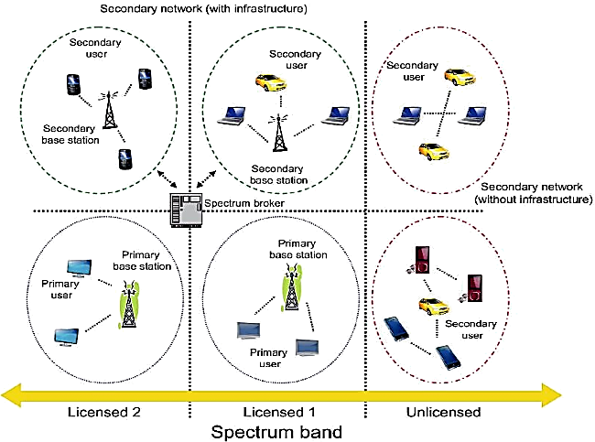
Figure 1: Cognitive radio network topology [11]
2.0 Review of Related Literature
Junhui and Tao presented a power control technique tailored for cognitive radio (CR) systems, with a keen consideration of transmitter power constraints and interference temperature limits. Their approach incorporates interference constraints to safeguard the quality of service while incorporating non-cooperative power control models for the primary users (PUs) [12].
Lu Yang delved into the realm of multiuser diversity within uplink multiple-input multiple-output (MIMO) cognitive radio networks. In this context, they introduced a two-stage opportunistic user scheduling scheme [13].
Wenhao Xiong delved into user selection strategies designed for the downlink of MIMO cognitive radio networks. This strategy revolves around the selection of underlay CR secondary users, which share sub-channels with primary users through cognitive base stations (CBS) [14].
Duoying Zhang's investigation revolved around spectrum sharing within a multiple-input multiple-output cognitive interference channel, where numerous primary users (PUs) coexist alongside multiple secondary users (SUs). They introduced an interference alignment (IA) approach that allows SUs to access licensed spectrum without inducing harmful interference to PUs. The numerical results demonstrated that this design not only enhanced the achievable degree of freedom (DoF) for primary links but also delivered significant overall data rates for both secondary and primary transmissions, even under rank limitations [15].
Junhui and Qiping proposed an optimization algorithm that seamlessly combines diverse spectrum sharing bandwidths and power allocation strategies within cognitive radio systems. This innovative approach empowers the cognitive user (CU) to dynamically switch between the Underlay spectrum sharing model and the Overlay spectrum sharing model as needed [16].
Top of Form
Cui & Gao focused on the crucial aspect of supportive spectrum sensing in cognitive radio (CR). Their proposed spectrum sensing algorithm demonstrated significantly improved performance compared to existing algorithms, and it also considered multiple primary users simultaneously [17]. Sidhu and Gao conducted research on resource allocation in relay-assisted orthogonal frequency division multiplexing (OFDM) cognitive radio networks. They employed a combined subcarrier pairing and power allocation approach to maximize the throughput of secondary users while ensuring that interference to primary receivers remained within acceptable limits. They also developed a sub-optimal resource allocation technique to reduce computational complexity, and simulation results showed enhanced performance compared to standard resource allocation methods [18]. Lu and Wang introduced an FD (full-duplex) opportunity spectrum-sharing protocol that takes action when the primary system experiences poor channel conditions. They jointly optimized subcarrier allocation and power distribution to maximize the transmission rate of the secondary system while ensuring that the primary system achieves its target rate. The modelling results suggested that such secondary spectrum access strategies could be beneficial for both primary and secondary systems [19]. In summary, Table 1 in this paper outlines the limitations of existing works and presents the author's contributions to address these gaps in knowledge. The paper provides a comprehensive overview of cognitive radio, covering its topology, spectrum sensing techniques, applications, problem formulation, benefits, challenges, and other essential features crucial to cognitive wireless networks (CWN) communication systems. Ultimately, the paper offers a forward-looking perspective on the necessary steps to expedite the development of this promising generation of wireless communication.
Table 1. Limitations of some added related works and contributions.

Ref. | Focus and Coverage | Limitations | This Paper’s Contributions
20  21  22  23  24  25  26  27 | Presented the fundamental concept about CR technology and CR capability functions.  Challenges and security issues of CR networks were discussed.  To explore the application of CR technology in machine-to-machine communication.  The study presents basic theory and Key Technologies in CWN.  Issues from network architecture to multi-dimension sensing technologies and radio resource management.  Introduce the fundamentals of CRN.  Architecture of a CRN and applications.  Provide a study on the recent advances and applications of  CR in various domains, such as military emergency response, communication, and commercial  communication.  The authors provide a brief overview of operation, principles, architecture and  security of CR.  Methods and practices in CRN to improve the performance of the CRN. Various models and schemes in Cross Layer and Design Network environment.  Reviewed CR technology and its numerous  Features.  Roles in the field of next-generation wireless communication networks. | Challenges with enabling technology were not properly stated.  Applications were not clearly outlined.  Related literature not emphasized.  Limited practical applications of CR were presented.  Future focus not presented.  Problem of selecting a suitable frequency band as the working spectrum channel of the testbed.  Future Research Directions not clearly outlined.  Applications are not clearly itemized.  Challenges with supporting  technologies are not clearly defined.  Methods not presented.  Applications not clearly outlined.  Future Research guidelines not outlined.  No clear application was presented.  The challenge with each supporting technology is not well presented.  The importance of the concept is not stated.  No connecting related works outlined.  Challenges with methods and model if any not stated.  No cohesion between the abstract and the conclusion.  Enabling technologies were discussed, but no clearly outlined challenges.  Future focus directions are not presented. | Clear understanding of CR technology.  Its role in national development.  Future focused - Security issues and efficient spectrum management challenges.  Described in full the machine-to-machine communication survey.  Examine the distinctions between wireless communication systems used by CR and conventional methods.  Purpose of the research well presented.  Discussion on Flexible network architecture, cognition of multi-dimension environment, and discretionary resource management were presented as key technologies to make CWN a reality.  Challenge with each supporting  technology presented.  Architecture of a CRN discussed.  Security challenges extensively  discussed.  Enabling technologies clearly outlined.  Clearly outlined key principles of CR.  Applications were presented.  The architecture of a CRN is well discussed.  An overviewof security threats, including physical, link, network and transport layer attacks is presented. The future research focus is clearly outlined.  Performances in Cross Layer networks and solutionsare well outlined.  The needed resources are clearly outlined.  Problems and solutionsare clearly stated.  Future focus stated.  Spectrum sensing techniques in CR were mentioned.  Cyclostationary detection is the best.  spectrum sensing technique, it senses a spectrum even in low SNR.

3 Three Major Tasks of the CR

(i) Radio-scene analysis,
(ii)Channel identification, and
(iii) Dynamic spectrum management and transmit-power control. [28]:

The receiver's execution of radio-scene analysis encompasses several key tasks, including the assessment of the interference temperature within the local radio environment, predictive modeling of the environment, and the identification of spectrum gaps. To facilitate coherent message signal recognition and enhance spectrum utilization, the receiver also incorporates channel identification. Ultimately, the transmitter's dynamic spectrum management and transmit-power control system leverage the insights gained from radio-scene analysis and channel identification to make informed decisions regarding transmission parameters.
4 Fundamental Cognitive Radio Cycle (CRC)
Spectrum sensing, spectrum mobility, spectrum management, and spectrum sharing are the fundamental CR operations. Some fundamental features of CR technology benefit consumers in the following ways:
(i) Spectrum sensing - to detect the part of the spectrum that is free and detect the presence of licensed users when a user is active in a licensed band. It is the first and fundamental function of cognitiveradio; unused portions of the spectrum are used opportunistically upon detection.
(ii) Spectrum management to choose the optimal channel that is offered. The CR needs to be able to choose the channel that best fits its communication needs when spectrum gaps are found.
(iii) Spectrum sharing - -to arrange for other users' access to this channel. An algorithm must be scheduled in a CR network to guarantee that each cognitive radio has an equal opportunity to access the spectrum.
(iv) Spectrum mobility - when detecting a licensed user, to release the channel. The CR is assigned a lower priority, so when a licensed user returns, they should be able to easily switch to another free channel and end their conversation [1]. Comprising a Cognitive radio cycle is Figure 2. 23]
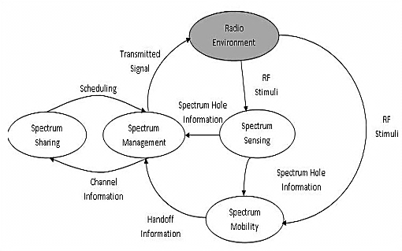
Figure 2 Cognitive Radio Cycle
The CR can also be considered a continuous process consisting of the following steps:
(i) Sensing,
(ii) Understanding,
(iii) Deciding
(iv) Adapting
according to Figure 3. CR takes use of this cycle by making the spectrum the primary object to be felt, with all subsequent processes centered around handling the spectrum in light of the observations.Reference [28]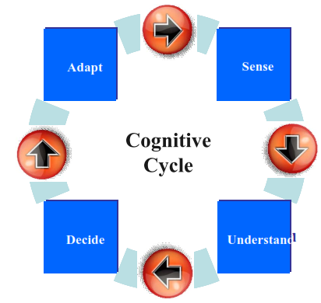
Figure 3. Generic CRC.
The cognitive tasks encompassing the CC are depicted in Figure 4. The feedback channel, serving as the conduit for intelligence within the CR, plays a pivotal role. It is essential for conveying the following information [29]:
- The centre frequencies and bandwidths of the spectrum holes,
- The combined variance of interference plus thermal noise in each spectrum hole,
- The estimate of SNR for adaptive transmission.
A CC link with the transmitter and receiver located in different CR devices is seen in Figure 4. The CR devices are transceivers and have a radio scene analysis unit on the transmitter side to detect the spectrum in the immediate area of the transmitter. However, this sensing unit is not depicted in Figure 4 because it is part of a different link.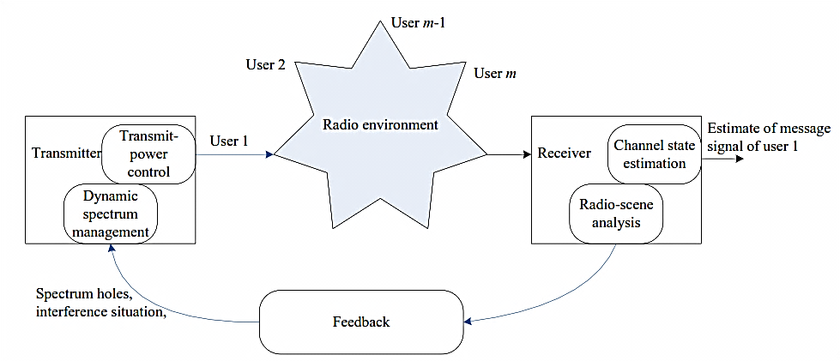
Figure 4. CC for cognitive radio link. [29]

If several SNs share one common spectrum band, their spectrum usage may be organized by a central network, called spectrum broker [30].
5 Spectrum Sensing Methods
CR is a crucial technique that enables opportunistic, efficient use of scarce and underutilized frequency bands. Whether the spectrum sensing function is carried out correctly or not has a significant impact on the communication performance and stability in CR networks.
Spectrum sensing is a significant concern in CR technology due to the wireless channels' fading and time-varying characteristics, along with shadowing effects. Various spectrum sensing approaches have been proposed in the literature to detect unused or underutilized frequency bands. These include techniques such as cyclostationary-based sensing [31, 32], waveform-based sensing [32], matched filtering [34, 35], eigenvalue-based sensing [36, 37], energy detection sensing [38–39], and wavelet-based sensing [40].
- Cycle-based detection. is a method for detecting PU transmissions that makes use of the received signal's cyclostationary characteristics [41]. To detect the presence of PUs, it makes use of the periodicity in the primary signal that was received. This allows the detector to differentiate between PU signals, SU signals, and interference. However, the effectiveness of this detection method depends on having enough samples, which makes the calculation more difficult. performs well in comparison to other detection systems despite its nonlinearity, spectrum leakage of large amplitude signals, and expensive costs [42].
- Sensing based on waveforms. utilized in systems that have recognized signal patterns. Preambles, midambles, regularly broadcast pilot patterns, and spreading sequences are examples of these patterns [43]. A midamble is communicated in the middle of a burst or slot, whereas a preamble is an identifiable sequence transmitted before each burst. With a known model, the function of spectrum detection is carried out by comparing the received signal to a duplicate of itself.
- Detection using matched filtering. If specific signal characteristics, such as bandwidth, modulation type and grade, operating frequency, frame structure of the PU, and pulse shape, are known, matched filtering detection approaches with shorter detection times are employed [44, 45]. This technique's detection performance mostly depends on the channel reaction. To get around this, both the physical and media access control layers must be perfectly timed and synchronized. The sensing performance, however, rapidly deteriorates if the PU information is provided improperly to the matched filter detector. [46, 47]
- Spectrum sensing is based on eigenvalues. It is not necessary to have a thorough understanding of PU signals and noise power [48] for this. This detection method idea was first presented in 2007 [49]. The decision threshold for making hypothesis testing in the eigenvalue-based spectrum detecting techniques was obtained using random matrix theory. The decision threshold is compared to the test statistic created using the ratio of the greatest or average eigenvalue to the minimum eigenvalue to determine the existence or absence of the PU signal. However, this method's high-functioning complexity is negative [50, 51].
- Energy detection is a spectrum sensing approach that works by detecting the received signal energy and comparing it to a threshold to determine whether the PU is present or not. The noise power affects how the threshold function is calculated [4652]. Depending on the channel circumstances, the threshold may change or remain constant. However, this method is unreliable [53].
- The wavelet transform is a great tool for investigating edges and singularities. The interest frequency bands in the wavelet-based spectrum sensing technique are frequently broken down into a series of successive frequency sub-bands [54]. To find out if the spectrum is full or empty, abnormalities in these bands are detected using the wavelet transform.
Hybrid models, which combine the use of two or more detection strategies, have recently been developed to increase a CRN's capacity for spectrum sensing. Hybrid models frequently employ machine learning algorithms (MLA) and artificial intelligence (AI) [55].
5.1 The Best Standard Spectrum Detection Techniques are:
(i) Cyclostationary feature detection
(ii) Energy detection
(iii) Matched filter detection

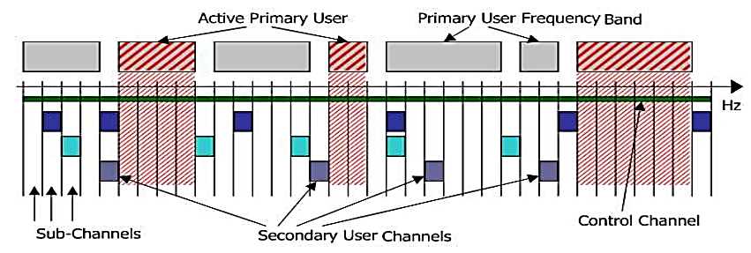
Figure 5: Spectrum pooling idea [56]
6.0 Features of the Cognitive Radio:
- Cognitive capability (CC) - The ability of radio equipment to collect information from its radio surroundings. The best spectrum and the most suitable operational parameters can be selected by determining which parts of the spectrum are inactive at a given time or place.
- Reconfigurability (RC) - Reconfigurability enables the radio to be dynamically programmed in accordance with the radio environment, whereas spectrum awareness is provided by the CC. More specifically, CRs can be designed to employ a variety of transmission access protocols provided by their hardware and to broadcast and receive data at a wide range of frequencies, as shown in Figure 6 [9].

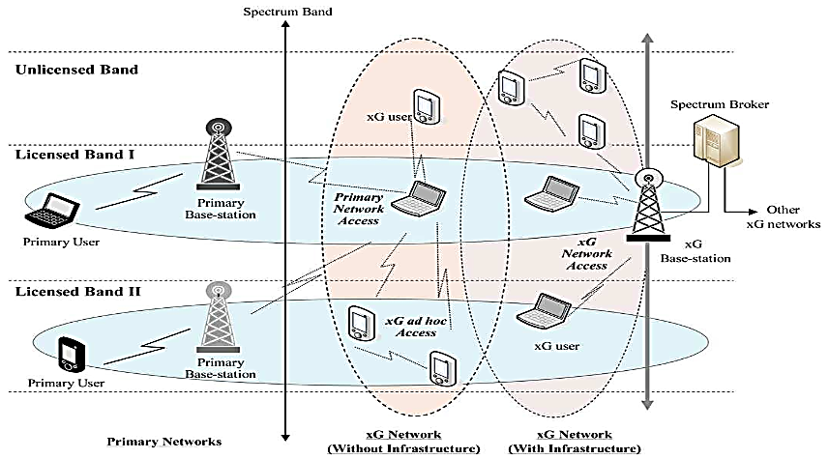
Figure 6: Cognitive radio network system [56].
6.1 Cognitive Radio (CR) and Software Defined Radio (SDR)
A type of radio known as SDR has physical layer functionalities that are defined by software. This contrasts with hardware radio, where changes to the communications scheme can be made by altering the hardware, as opposed to software that is factory-programmed and cannot be changed due to radio topological rigidity. Given its capacity for adaptation and reconfiguration, cognitive radio is regarded as the next evolution of reconfiguration flexibility, following SDR. It wouldn't be incorrect to characterize a cognitive radio as a software-defined radio, where the radio's cognitive functionality is secured by the software. Not every SDR with cognitive impairment is a CR [57].
6.2 Spectrum Hole or White Space
Spectrum Hole or white space is nothing but the available free spectrum of the primary user. It is shown in bellows Figure 7. The main challenge for cognitive radio systems is to sense the spectrum when it lies within such a spectrum hole [58]. High Utilization of lower frequency band and lower utilization of higher frequency spectrum. This lower spectrum utilization is known as a spectrum hole. CR searches the free frequency and allocates this frequency to spectrum utilization is termed a spectrum hole [16]
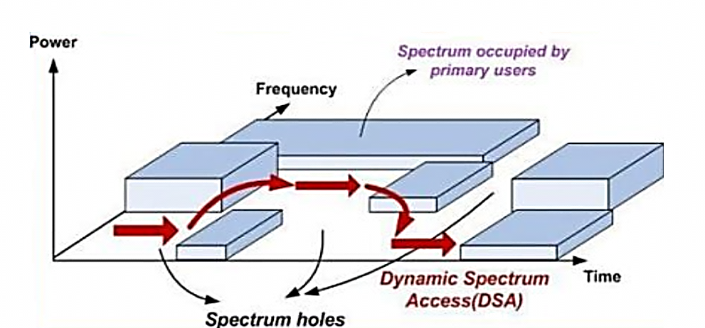
Figure 7: Spectrum hole (white space concept)
In another view, a spectrum hole is deﬁned as a band of frequencies readily allocated to a PU, though; it may not always be used by the PU at a particular time or in a geographic area (see Figure 8), [28].
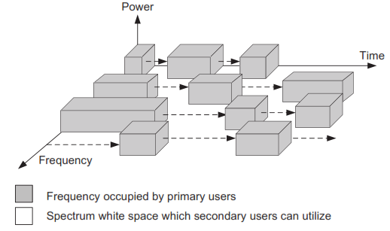
Figure 8: Example of a Spectrum Distribution Graph.
The following frequency, time, or space parameters can be used to determine spectrum holes depending on the communication environment [59, 60]:
- i. A temporal spectrum hole is a frequency band that is not used by a principal user (PU) for a predetermined amount of time. A secondary user (SU) can identify these spectrum holes and take advantage of them without impairing the primary user's quality of service by using sophisticated spectrum sensing techniques.
- ii. Frequency spectrum hole: In this instance, the secondary user's actions don't negatively interfere with the primary user’s activity. This keeps primary user communications uninterrupted while enabling the secondary user to use the spectrum.
- Spatial spectrum hole: This type of spectrum hole pertains to a specific geographical area where the transmission of the primary user is currently occupying the spectrum. However, if the secondary user is located outside of this area (as depicted in Figure 9), they can make use of this spectrum without causing interference to the primary user's transmission.
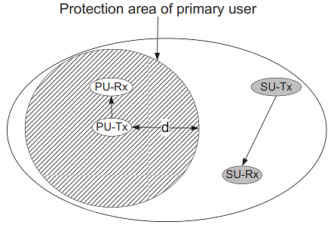
Figure 9: Spatial spectrum hole where the secondary user (SU) is not permitted to operate within the protected area of the primary user (PU).

Furthermore, spectrum holes can be classified into different spaces as described below [28]:
(i) Black spaces: These are areas where high-power signals interfere with control for a certain period.
(ii) Gray spaces: In these spaces, low-power signals cause moderate interference with control.
(iii) White spaces: No interfering signals are present, but natural noises like broadband thermal noise and impulsive noise can be observed.
7 CR Characteristics
A cognitive radio network (CRN) differs from conventional wireless communication networks primarily by its cognitive capabilities. With the help of these skills, a secondary user (SU) can identify numerous characteristics of the radio environment in its vicinity, including distance, temperature, noise power, and other variables. The SU can choose the best frequency, transmit power level, and modulation scheme based on the information gathered to achieve optimum performance. The following traits should be included in CRNs during actual implementation [59]:
- Efficient spectrum sensing and analysis methods should be employed by the SU to ensure continuous spectrum availability and reliable communication.
- The SU should share spectrum information with other users and coordinate communication to minimize interference and avoid collisions with primary users using the same frequency bands.
- The SU's architecture should be unified and designed across different layers to meet diverse Quality of Service (QoS) requirements.
- Dynamic spectrum access methods should be employed by the SU, allowing it to adapt to the fluctuating nature of the CRN.
7.1 Cooperative Spectrum Sensing (CSS)
Wireless communications are susceptible to natural phenomena like multi-path fading, shadowing, and noise, all of which can affect the received signal's strength. For example, if there is a considerable distance between a primary user (PU) and a secondary user (SU), or if the PU's signal is obstructed by a significant obstacle, the signal received by the SU may be attenuated. Consequently, accurately detecting the presence of a PU can become quite challenging. Figure 10 depicts a scenario in which the PU's transmitter (PU Tx) is obscured by an obstacle, making it problematic for the secondary transmitter (SU Tx) to perceive the PU Tx signal. This situation may lead the SU Tx to inadvertently introduce detrimental interference to the PU's receiver (PU Rx) while it starts utilizing the licensed spectrum for communication with the secondary receiver (SU Rx).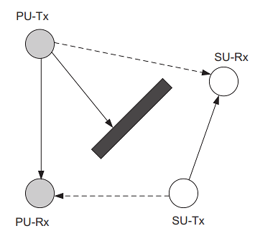
Figure 10: Example of a hidden PU where SU Tx can’t sense the presence of the PU Tx due toobstacles.
CSS has been recommended to prevent these hiccups [61, 62]. Multiple users' separate fading channels and spatial diversity have been shown to be advantageous for improving detection probability and cutting down on sensing time in cooperative networks [63]. Figure 11 depicts a case where CSS might be used. With the aid of SR1 and SR2, two secondary relays (SRs), the SU Tx may detect the PU Tx.
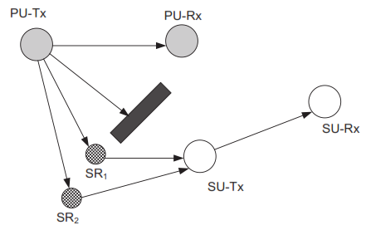
Figure 11: Two SRs support the SU Tx in detecting a hidden PU Tx.
7.2 Current State-of-the-Art Review on Spectrum Sharing in CRNs
This review encompasses the development of cognitive radio (CR) research, encompassing diverse aspects of spectrum sharing. These elements consist of signal and waveform design [85–95], statistical modeling of spectrum consumption [78–84], spectrum measurements, and spectrum sensing [64–77]. Furthermore included in the paper are spectrum mobility [96–105], multiple access, resource allocation and power regulation, cognitive learning, adaptability, and self-configuration [106–117], as well as multihop transmission and routing [118–123].
7.2.1 Spectrum sensing, interference modelling,measurements, and statistical modellingof spectrum usage:
In order to allow Secondary Users (SUs) to take advantage of opportunities to access the spectrum, it is imperative that PUs provide accurate information about how they are using the spectrum. In order to acquire this information, the following areas are the focus of research:
(i) Spectrum sensing: This fundamental process enables SUs to assess whether PUs is currently utilizing the spectrum. Without this information, SUs may face challenges in accessing idle spectrum effectively, leading to reduced spectrum utilization, or they might unknowingly interfere with PUs occupying the spectrum.
(ii) Interference modeling: SUs may encounter interference on the spectrum due to two main reasons. First, SUs must ensure that their own transmissions do not disrupt ongoing PUs' communications. Second, when interference is present, SUs needs to access the spectrum in a manner that satisfies their transmission requirements. Interference modeling helps SUs achieve these objectives.
(iii) Measurements and statistical modeling of spectrum usage: While spectrum sensing provides instantaneous information about the spectrum status, spectrum measurement is conducted over a more extended period, often spanning several months, to gather statistical data about PUs' usage patterns. This valuable knowledge assists SUs in devising their spectrum access strategies, such as selecting specific times of the day to minimize interference to PUs.
7.2.2 Waveform and Modulation Design for Cognitive Radios:
It is possible to modify the waveform and modulation design of signals coming from Secondary Users (SUs) in order to lessen the interference that PUs receive. In an underlay spectrum access scenario, for example, SUs can employ ultra-wideband transmission and adjust the pulse width and/or position to prevent interfering with PUs' narrowband transmission. In a similar vein, SUs can minimize interference in an overlay spectrum access scenario by employing multicarrier modulation techniques such as orthogonal frequency division multiplexing (OFDM).
7.2.3 Multiple Access, Resource Allocation, Power Control, and Spectrum Mobility:
The difficulties of attaining the best possible spectrum sharing among Secondary Users (SUs) in a spectrum underlay scenario can be expressed as an optimization problem with a suitable objective function and a set of constraints. These limitations include things like user equity, maintaining Quality of Service (QoS) for SUs, and complying with interference thresholds for Primary Users (PUs). An admission control method is used to restrict the number of admitted SUs in cases when highly loaded networks or strict limitations make the optimization problem unfeasible. Power allocation for the admitted SUs can then be carried out.
Using Code Division Multiple Access (CDMA) technology at the physical layer (PHY), a strategy suggested in [99] addresses the dual challenge of admission control and power allocation to achieve fairness across SUs in real-world scenarios. For power allocation solutions, it is crucial to predict the instantaneous channel gains among SUs and the interference from Secondary Transmitters (STs) to Primary Receivers (PRs). To satisfy the target interference constraint violation probability for PRs, cautious power allocations for STs are required when only estimates of average channel gains are known [101].
In reference [102], the objective of optimizing the total data transmission rate for secondary transmitters (STs) is explored within a Cognitive Radio Network (CRN) featuring numerous STs and primary receivers (PRs), with each PR being equipped with a single antenna. This optimization encompasses joint beamforming and power allocation strategies. Furthermore, [103] provides an overview of dynamic resource allocation approaches designed for CR systems that operate based on the interference temperature-based spectrum sharing model.
8.1 Economics of Cognitive Radio Networks:
Pricing is important in CR systems because it incentivizes primary and secondary users to share available spectrum by engaging in spectrum trading [127]. Through monetary transactions or other resource exchanges (bartering), spectrum trading enables organizations in the CR system, including main and secondary users, spectrum owners, service providers, and customers, to trade radio resources. Auction-based and open market-based strategies are the two main methods used in spectrum trading.
8.2 Price Competition in the Open Market:
In the unregulated open market paradigm, main and secondary users are able to freely sell and buy radio resources. The price method used by primary users is significant since it defines their income and affects secondary users' decisions about whether to purchase radio resources. Multiple major networks have been proposed with competitive pricing strategies based on non-cooperative games [128]. A spectrum trading framework for such circumstances was devised in [129]. In more general scenarios, spectrum trading in CR systems may involve many spectrum suppliers and purchasers.
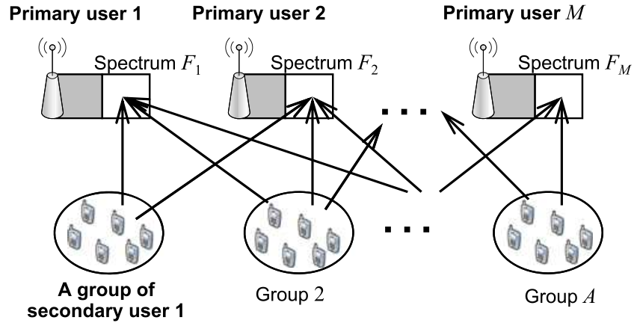
Figure 12. Spectrum trading in CR with multiple spectrum sellers and buyers [129].
9.1 Problem Formulation
The review identified several challenges. Firstly, there is the optimization challenge during data transmission, which encompasses issues related to the complexity associated with multiple cognitive base stations (CBS) and primary users (PU). Additionally, there are challenges involving interference scenarios in channels with multiple CBSs and PUs, as well as issues related to primary and secondary cognitive base stations and user interactions. Lastly, there is the challenge of determining transmission ranks when dealing with multiple users [130].
9.2 Implementation Challenges
Implementing a cognitive radio (CR) is a complex and thought-provoking task. The CR system must be designed to ensure that its transmission and reception do not interfere with the operations of Primary Users (PUs). Various techniques can be employed to avoid such interference and enable efficient frequency tuning [131], including:
(i) Adaptive frequency hopping
(ii) Dynamic frequency selection
(iii) RF band switching
Furthermore, there are several other challenges in deploying a Cognitive Radio Network (CRN), particularly in terms of monitoring the surrounding environment and logically acquiring resources based on established practices. These important challenges in implementing a cognitive radio are [132]:
(i) RF front-end-transceiver challenges
(ii) ADC and DAC challenges
(iii) Baseband challenges
Successfully addressing these challenging issues is crucial for cognitive radio to achieve sustainable and reliable communication.
9.3 The Technical Challenges Are:
As mentioned in [133], cognitive radio (CR) encounters highly demanding obstacles to establishing efficient communication. These challenges involve the design of the RF front-end, ensuring the performance and flexibility of ADC/DAC, and enabling support for flexible wideband multiband communication. Additionally, CR must address issues related to spectrum sensing, channel estimation, modulation and coding, spectrum shaping, transmit power control, interference avoidance, and the capability to sense, discover, negotiate, and transfer.
9.4 Security Challenges in CRNs
Security and privacy have been crucial concerns since the beginning of the information era. To address these concerns, a well-defined security system has been established, comprising security mechanisms, security attacks, and security requirements/services. This system allows for a systematic approach to defining, studying, and evaluating security challenges.
In the context of wireless communication, security is of utmost importance. Traditional wireless networks often face significant security attacks, posing major issues. In Cognitive Radio Networks (CRNs), two main types of security issues have been identified [134]:
(i) Traditional security threats
(ii) CRN-specific threats
The categorization of security attacks in CRNs includes two categories: infrastructure-based and infrastructure-less CRN-specific attacks.
9.3.1 Infrastructure-Based CRN Attack.It istime-consuming and costly. The CRNs will practically be adjusted towards frequency bands with second-importance spectrum stability. There are several attackers in the infrastructure-based CRN, they are:
(i) IE (Incumbent Emulation)
(ii) Control channel jamming
(iii) SSDF (Spectrum Sensing Data Falsification)
9.3.2 Infrastructure–Less CRN Specific Attacks.
There are three major types of attackers in this context:
(i) Intruding Attackers:
Ad-hoc Cognitive Radio Networks (CRNs) are susceptible to challenger nodes that attempt to enter the system under false pretenses and impersonate authorized nodes. The CRN's total spectrum sensing decision may be influenced by these malicious nodes, which could lead to a security vulnerability called Spectrum Sensing Data Falsification (SSDF). This exploit creates the impression of a busy channel by repeatedly reporting bogus information. This attack is difficult to detect and identify.
(ii) Exogenous Attacker:
An exogenous attacker is not a part of the CRN and, therefore, is not included in the CRN's spectrum sensing process. However, this attacker can still disrupt the functioning of the ad-hoc CRN.
(iii) Jamming:
Jamming is a commonly used attack on wireless transmissions. It involves transmitting noise over the receiving channel, reducing the Signal-to-Noise Ratio (SNR) below the desired threshold [135].
9.3.3 Other security challenges
(i) Confidentiality: The prevention of unauthorized disclosure of transmitted information, which could occur due to passive attacks like eavesdropping, is ensured. This is achieved by implementing encryption and cyphers to encode the data before transmission, using a secret key that is shared exclusively with the intended recipients.
(ii) Integrity: The protection against any unlawful modification of transmitted information is guaranteed. This includes preventing unauthorized changes, creations, deletions, replaying of messages, or delays in transmission.
(iii) Authentication: Authentication safeguards protected systems from unauthorized access by verifying both the identity and authority of users. It is a necessary process to ensure that only approved users can gain access.
(iv) Non-repudiation: non-repudiation ensures that neither the sender nor the receiver of a message can deny the transmission. In the context of Cognitive Radio Networks (CRNs), non-repudiation techniques can be utilized to prove the misbehaviour of malicious CRUs that violate the protocol, resulting in the banning of such malicious users from the network.
(v) Availability: Devices and applications should continue to be able to access the network services via communication channels. The ability of Primary Users (PUs) and Cognitive Radio Users (CRUs) to access the spectrum is referred to as availability in the context of CRNs. For PUs, availability refers to their capacity to transmit in the authorized spectrum without suffering detrimental CRU interference [135].
10.1 Benefits of Cognitive Radio
The following are some of the benefits of CWN.
(i) Implementation cost is low
(ii) It increases link reliability
(iii) Less complexity.
(iv) Overcome radio spectrum scarcity
(v) It has easy network topology.
(vi) It offers better spectrum utilization and efficiency.
(vii) Uses modern network topology.
(viii) Configuration and upgrade are easy.

11.1 Areas for Future Consideration
CR technology has many areas for future investigations which can be considered to better understand the behaviour of user detection. Under listed are some of these areas:
(i) Cooperative approach for detecting and isolating intruders.
(ii) Assessment of denial-of-service (DoS) attack scenarios and methods for defence.
(iii) Implementation of hybrid sensing approach.
(iv) Consideration of multiple attackers’ defencemechanisms.
(v) Investigations to introduce capable preventive techniques to mitigate threats and attacks that CR networks face.
(vi) Using Cyclostationary detectors which employ second-order signal structure.

12 CR STANDARDIZATION
At present, the primary standards governing Cognitive Radio (CR) are IEEE 802.22 and SCC 41, which have gained significant attention in the field of Cognitive Radio [136]. Nonetheless, several other standards are currently in the developmental stage. The IEEE formed the 802.22 Working Group (WG) for Wireless Regional Area Networks (WRANs) in November 2004. The goal of this working group was to provide an air interface (PHY and MAC) for unlicensed operation in TV broadcast bands based on CRs. The primary objective of IEEE 802.22 is to offer broadband wireless connectivity in rural areas, with a significantly greater coverage area than that of IEEE 802.16 [137]. In conclusion, there are numerous standardization initiatives presently in progress in the industry.
12.1. IEEE 802.22:
Those who have studied 802.22 architecture [138, 139] have provided an overview of its entities, connections, and topology; requirements such as service coverage, MAC layer details, and service capacity; and applications and coexistence challenges (e.g., TV, antenna, and wireless microphone protection and sensing). The IEEE 802.22 networks support several international TV channels with bandwidths of 6, 7, and 8 MHz and operate in the 54–862 MHz frequency spectrum in North America. With these systems, the consumer premise equipment (CPEs) is controlled by the base station via a fixed point-to-multipoint air interface.
12.2. IEEE 1900–SCC41-DYSPAN:
To standardize Cognitive Radio (CR), the IEEE 1900 task force [140] was replaced by the IEEE Standard Coordinating Committee 41 (SCC41), which was created with an emphasis on dynamic spectrum access (DSA) networks. Four Working Groups (1900.x) make up SCC41, and they are all focused on different facets of CR standardization. The following are the main standards created under SCC41-DYSPAN:
IEEE P1900.1 (Terminology and Ideas for Spectrum Management and Next-Generation Radio Systems): Key terms and concepts for Software-Defined Radio (SDR), Adaptive Radio, Policy-Defined Radio, Spectrum Management, and Interconnected Technology are defined in this standard. It lists the capabilities of several technologies and compares them [141].
IEEE P1900.2 (Recommended Practice for Interference and Coexistence Analysis): The 1900.2 Working Group establishes guidelines for interference analysis and provides a framework for tracking and assessing interference. An organized approach to handling interference and coexistence issues is provided by this standard.
IEEE P1900.3 (Dependability and Evaluation of Regulatory Compliance for Radio Systems with DSA): The 1900.3 Working Group is devoted to developing test methods for SDR device evaluation. Before final devices are certified, its primary goal is to confirm that software modules for CR devices are compliant and coexist.
IEEE P1900.4 (Architectural Building Blocks Enabling Network-Device Distributed Decision Making for Optimized Radio Resource Usage in Heterogeneous Wireless Access Networks): For radio systems that make use of different Radio Access Technologies (RATs), this standard was developed [142, 143]. It facilitates flexible operations in several frequency bands and supports end-user terminal users through the use of multiple RATs and Cognitive Radio capabilities. IEEE 1900.4 describes the reconfiguration of management entities to aid in decision-making at the terminal and network levels.
12.3. International Telecommunication Union Standardization
The standardization of Cognitive Radio Networks (CRNs) falls under the purview of the International Telecommunication Union (ITU) Radio communication sector (ITU-R) Study Group 8. This study group is responsible for Radio Determination, Mobile, Related Satellite Services, and Amateur Services. There have been two reports issued by ITU-R Study Group 8 [144, 145] that focus on Software Defined Radio (SDR) technology. These reports specifically explore the integration of SDR technology within IMT-2000 (International Mobile Telecommunications-2000) systems. IMT-2000 systems of the third generation provide access to a wide array of telecommunication services, both those supported by fixed telecommunications networks (such as PSTN/ISDN/IP) and those tailored for mobile users. SDR technology is utilized in the base stations and controllers of mobile radio access networks, enhancing the adaptability and flexibility of these networks.
Conclusion
Cognitive Radio (CR) represents a novel approach to developing intelligent wireless networks that address the issue of spectrum scarcity and significantly enhance spectrum efficiency. We have conducted a comprehensive review of research activities in the field of Cognitive radio communication networks. The review encompassed major challenges in CR design, including spectrum sensing, dynamic spectrum access (DSA), applications, and standardization. Additionally, we provided a historical perspective on CR as a driving force for dynamic and efficient next-generation wireless systems. Various methods of spectrum sharing in CR were examined, and security and economic considerations were also discussed. Moreover, we explored future research focuses and highlighted open research areas. Finally, some standardization activities related to CR were summarized.
References
[1] Mitola, J. (2000). Cognitive Radio: An integrated agent architecture for software-defined radio. PhD dissertation, KTH Royal Institute of Technology, (Sweden, 2000)
[2] Hung, T. (2013). Performance Analysis of Cognitive Radio Networks with Interference Constraints. School of Computing. Publisher: Blekinge Institute of Technology, SE-371 79 Karlskrona, Sweden. Printed by Printfabriken, Karlskrona, Sweden 2013
[3] Deng, R, Chen J,Cao, X,Zhang, Y., Mahajan, S. and Gjessing S. Sensing-performance tradeoff in cognitive radio enabled smart grid. IEEE Transactions onSmart Grid 2013; 4(1): 302–310.
[4] Huang J, Wang H, Qian Y, Wang C. Priority-based trafﬁc scheduling and utility optimization for cognitive radio communication infrastructure-based smart grid. IEEE Transactions on Smart Grid 2013; 4(1):78–86.
[5] Zhang Y, Yu R, Nekovee M, Liu Y, Xie S, Gjessing S. Cognitive machine-to-machine communications: visions and potentials for the smart grid. IEEENetwork 2012; 26(3): 6–13.
[6] Wu SH, Chao HL, Ko CH, Mo SR, Jiang CT, Li TL, Cheng CC, Liang CF. A cloud model and concept prototype for cognitive radio networks. IEEEWireless Communications 2012; 19(4): 49–58.
[7] Abu, B., Soumik, G., Ashok, K., & Magdy, B. (2007). A Cognitive Radio Perspective for Next Generation (XG Communication, IEEE CIRCUITS AND SYSTEMS MAGAZINE, 2007.
[8] LIU, X., & ZHONG, W. (2015). Optimization and Performance Analysis for Bandwidth Spectrum Sensing in Cognitive Radio. Journal of Southwest JiaotongUniversity, 50 (1). Available from http://jsju.org/index.php/journal/article/view/191
[9] PREET, A., & KAUR, A. (2014). Cognitive Radio Networking and Communications. International Journal of Computer Science and Information Technologies, 5 (4), pp. 5508-5511.
[10] Bakare, B.I., &Okolie, E.E. (2022). A Review of Cognitive Radio (CR) Technology Application, Prospect and Challenges. European Journal of Advances in Engineering and Technology, 2022, 9(1):1-5
[11] [50] Popoola, J., & Van, R. (2011). Application of neural network for sensing primary radio signals in a cognitive radio environment, in IEEE Africon ’11, Livingstone, 13–15 September 2011. https://doi.org/10.1109/AFRCO N.2011.6072009
[12] Junhui Z., Tao, Y., & Yi, G. (2013). Power Control Algorithm of Cognitive Radio Based on Non-Cooperative Game Theory [J]. China Communications, vol. 10, no. 11, pp. 143-154, 2013.
[13] Lu, Y. (2014). “Opportunistic User Scheduling In Mimo Cognitive Radio Networks” IEEE International Conference on Acoustic, Speech and Signal Processing (ICASSP)- 2014.
[14] Wenhao, X. (2016). “MIMO Cognitive Radio User Selection with and without Primary Channel State Information” IEEE-2016.
[15] Duoying, Z. (2016). “Rank-Constrained Beamforming for MIMO Cognitive Interference Channel” Hindawi Publishing Corporation Mobile Information Systems Volume 2016
[16] Junhui, Z., Qiping, L., & Yi, G. (2018). Joint Bandwidth and Power Allocation of Hybrid Spectrum Sharing in Cognitive Radio[C]// IEEE 87th Vehicular Technology Conference (VTC Spring), 2018.
[17] Cui, T., Gao, F., &Nallanathan, A. (2011). Optimization of Cooperative Spectrum Sensing in Cognitive Radio[J]. IEEE Transactions on Vehicular Technology, vol. 60, no. 4, pp. 1578-1589, 2011.
[18] Sidhu, G. A. S., Gao, F., & Wang, W. (2013). Resource Allocation in Relay-Aided OFDM Cognitive Radio Networks[J]. IEEE Transactions on Vehicular Technology, vol. 62, no. 8, pp. 3700-3710, 2013.
[19] Lu, W., & Wang, J. (2014). Opportunistic Spectrum Sharing Based on Full-Duplex Cooperative OFDM Relaying. IEEE communications letters, vol. 18, no. 2, pp. 241-244, 2014.
[20] Oladele, R. O., & Damilola, N. A. (2019). Contemporary Issues in Cognitive Radio Network Anale. Seria Informatica. Vol. XV fasc. 2 – 2017 Annals. Computer Science Series. 15th Tome 2nd Fasc. – 2017
[21] Negasa, B. T., & Habib, M. H. (2018). Review on Cognitive Radio Technology for Machine to Machine Communication. ICST Institute for Computer Sciences, Social Informatics and Telecommunications Engineering 2018 F. Mekuria et al. (Eds.): ICT4DA 2017, LNICST 244, pp. 347–355, 2018. https://doi.org/10.1007/978-3-319-95153-9_31
[22] Ying, X., Zhiyong, Feng., & Ping, Z. (2012). Research on Cognitive Wireless Networks : Theory, Key Technologies and Testbed. CROWNCOM 2011, June 01-03, Osaka, Japan Copyright © 2012 ICST https://doi.org/10.4108/icst.crowncom.2011.245826
[23] Pooja, A., Nidhi, J., & Mahima, K. (2014). Cognitive Radio: A Review.International Journal of Engineering Research & Technology (IJERT) NCETECE`14 Conference Proceedings ISSN: 2278-0181
[24] Ayushi, &Priyanka, J. (2023). Methods for Detecting Energy and Signals in Cognitive Radio: A Review. International Research Journal of Engineering and Technology (IRJET). Volume: 10 Issue: 04 | Apr 2023.
[25] Nikita, T., Archana, I., Karishma, R., & Madhura, T. (2015). Cognitive Radio Network – A New Paradigm in Wireless Communication. International Journal of Computer Applications (0975 – 8887) National Conference on Role of Engineers in Nation Building (NCRENB-15)
[26] Rushabh, M. (2016). Cognitive Radio Networks Issues and Solutions. https://www.researchgate.net/publication/311949773.
[27] Nandhakumar, P., & Arun, K. (2017). A Review on Cognitive Radio for Next Generation Cellular Network and its Challenges. American Journal of Engineering and Applied Sciences 2017, 10 (2): 334.347 https://doi.org/10.3844/ajeassp.2017.334.347.
[28] Haykin, S. (2005). “Cognitive radio: Brain-empowered wireless communications,” IEEE Journal on Selected Areas in Communications, vol. 25, pp. 201–220, February 2005.
[29] S. M. Haykin, Cognitive radio and radio networks. INFWEST seminar in Helsinki, 27-28 June 2007.
[30] Raman, C., Yates, R. D., &Mandayam, N. B. (2005). “Scheduling variable rate links via a spectrum server,” in Proc. IEEE Symp. New Frontiers in Dynamic Spectrum Access Networks (DySPAN), Baltimore, MD, Nov. 2005, pp. 110–118.
[31] Urriza, P., Rebeiz, E., &Cabric, D. (2013). Multiple antenna cyclostationary spectrum sensing based on the cyclic correlation signiicance test. IEEE J. Sel. Areas Commun. 31(11), 2185–2195 (2013). https://doi.org/10.1109/JSAC.2013.131118.
[32] Li, Y., & Jayaweera, S. (2013). Dynamic spectrum tracking using energy and cyclo stationarity-based multi-variate non-parametric quickest detection for cognitive radios. IEEE Trans. Wirel. Commun. 12(7), 3522–3532 (2013). https://doi.org/10.1109/TW.2013.060413.121814
[33] Iqbal, M., & Ghafoor, A. (2012). Analysis of multiband joint detection framework for waveform-based sensing in cognitive radios, in 2012 IEEE Vehicular Technology Conference (VTC Fall) (3–6 September 2012), pp. 1–5. https://doi.org/10.1109/VTCFa ll.2012.6399372
[34] Proakis, J., & Salehi, M. (2007). Digital Communications, 5th edn. (McGraw-Hill, Boston, 2007).
[35] Tandra, R., & Sahai, A. (2005). Fundamental limits on detection in low SNR under noise uncertainty, in 2005 International Conference on Wireless Networks, Communications and Mobile Computing (13–16 June 2005), pp. 464–469. https://doi.org/10.1109/WIRLE S.2005.1549453
[36] Zeng, Y., Koh, C., & Liang, Y. C. (2008). Maximum eigenvalue detection: theory and application, in IEEE International Conference on Communications, ICC ’08 (19–23 May 2008), pp.4160–4164. https://doi.org/10.1109/ICC.2008.781
[37] Pillay, N., & Xu, N. (2012). Blind eigenvalue-based spectrum sensing for cognitive radio networks. IET Commun. 6(11), 1388–1396 (2012). https://doi.org/10.1049/iet-com.2011.0506
[38] Ruttik, K., Koufos, K., &Jantti, R. (2009). Detection of unknown signals in a fading environment. IEEE Commun. Lett. 13(7), 498–500 (2009). https://doi.org/10.1109/LCOMM.2009.090169
[39] Herath, S., Rajatheva, N., Tellambura, C. (2011). Energy detection of unknown signals in fading and diversity reception. IEEE Trans. Commun. 59(9), 2443–2453 (2011). https://doi.org/10.1109/TCOMM.2011.071111.090349
[40] Lu, L., Zhou, X., Onunkwo, U., & Li, G. (2012). Ten years of research in spectrum sensing and sharing in cognitive radio. EURASIP J. Wirel. Commun. Netw. 1–16, 28 (2012). https://doi.org/10.1186/1687-1499-2012-28
[41] Rao, S.V.R.K., & Singh, G. (2012). Wavelet-based spectrum sensing techniques in cognitive radio. Procedia Eng. (2012). https://doi.org/10.1016/j.proeng.2012.06.111
[42] Mohapatra, S., Mohapatra, A.G., &Lenka, S.K. (2013). Performance evaluation of cyclostationary based spectrum sensing in cognitive radio network proceedings of the International Multi-Conference on Automation, Computing, Communication, Control and Compressed Sensing, Mar. 22-23, IEEE Xplore Press, pp: 90-97. https://doi.org/10.1109/iMac4s.2013.6526389
[43] Gardner, W.A. (1999). Exploitation of spectral redundancy in cyclostationary signals. IEEE Signal Process. Mag. 8(2),14–36 (1991). https://doi.org/10.1109/79.81007
[44] Yucek, Y., & Arslan, H. (2009). A survey of spectrum sensing algorithms for cognitive radio applications. IEEE Commun. Surv. Tutor. 11(1), 116–130 (2009)
[45] Ma, L., Li, Y., & Demir, A. (2012). Matched filtering assisted energy detection for sensing weak primary user signals, in IEEE International Conference on Acoustics, Speech, and Signal Processing (ICASSP), 25–30 March 2012, pp. 3149–3152. https://doi.org/10.1109/ICASSP.2012.6288583
[46] Zeng, Y., & Liang, Y.-C. (2009). “Spectrum-sensing algorithms for cognitive radio based on statistical covariances,” IEEE Trans. Veh. Technol., vol. 58, no. 4, pp. 1804–1815, May 2009.
[47] Zeng, Y., & Liang, Y.-C. (2007). “Covariance based signal detections for cognitive radio,” in Proc. IEEE International Symposium on New Frontiers in Dynamic Spectrum Access Networks, Dublin, Ireland, Apr. 2007, pp. 202–207.
[48] Zhang, X., Chai, R., & Gao, F. (2014). Matched filter based spectrum sensing and power level detection for cognitive radio network, in IEEE Global Conference on Signal and Information Processing (Global SIP), Atlanta, 3–5 December 2014, pp. 1267–1270. https://doi.org/10.1109/GlobalSIP.2014.7032326
[49] Tsinos, C.G., &Berberidis, K. (2015). Decentralized adaptive eigenvalue-based spectrum sensing for multiantenna cognitive radio systems. IEEE Trans. Wirel. Commun. 14(3), 1703–1715 (2015). https://doi.org/10.1109/TWC.2014.2372756
[50] Zeng, Y., Koh, C. L., & Liang, Y. C. (2008). Maximum eigenvalue detection: Theory and application, in 2008 IEEE International Conference on Communications (ICC ’08), 19–23 May 2008, pp. 4160–4164. https://doi.org/10.1109/TCOMM.2009.06.070402
[51] Atapattu, S. (2011). Energy Detection based cooperative spectrum sensing in cognitive radio networks. IEEE Trans. Wirel. Commun. 10(4), 1232–1241 (2011). https://doi.org/10.1109/TWC.2011.01241 1.100611
[52] Digham, F. F., Alouini, M. S. & Simon, M. k. (2007). On the energy detection of unknown signals over fading channels. IEEE Trans. Commun. 55(1), 21–24 (2007). https://doi.org/10.1109/TCOMM .2006.887483
[53] Sansoy, M., & Buttar, A. (2015). Spectrum sensing algorithms in cognitive radio: A survey. Proceedings of the IEEE International Conference on Electrical, Computer and Communication Technologies, Mar. 5-7, IEEE Xplore Press, pp: 1-5. https://doi.org/10.1109/ICECCT.2015.7226181
[54] Gorcin, A., Qaraqe, K.A., Celebi, H., & Arslan, H. (2010). An adaptive threshold method for spectrum sensing in multi-channel cognitive radio networks, in 17th International Conference on Telecommunications (ICT’10), Doha, 4–7 April 2010, pp. 425–429. https://doi.org/10.1109/ICTEL .2010.54787 83
[55] Zhi, T., Giannakis, G. (2006). A wavelet approach to wideband spectrum sensing for cognitive radios, in 2006 1st International Conference on Cognitive Radio Oriented Wireless Networks and Communications, 8–10 June 2006, pp. 1–5. https://doi.org/10.1109/CROWN COM.2006.36345 9
[56] Mahamuni, S.M., Vivekanand, M., Wadhai, V.M. (2010). Cognitive Networks: Smart Network. Journal of Engineering Research and Studies. JERS/Vol.I/ Issue II/Oct.-Dec.,2010/121-134
[57] Brown, T. X. (2005). “An analysis of unlicensed device operation in licensed broadcast service bands,” in Proc. IEEE DySPAN 2005, pp. 11–29, Nov. 2005.
[58] Wassim, E., Haidar, S., & Mohsen, G. (2011), Survey of Security Issues in Cognitive Radio Networks, Journal of Internet Technology Volume 12 (2011) No.2
[59] Ma, J., Li, G., &Juang, B. H. (2009). “Signal processing in cognitive radio,” Proc. IEEE, vol. 97, no. 5, pp. 805–823, May 2009.
[60] Tandra, R., Sahai, A., & Mishra, S. (2009). “What is a spectrum hole and what does it take to recognize one?” Proc. IEEE, vol. 97, no. 5, pp. 824–848, May 2009.
[61] Letaief, K. B., & Zhang, W. (2009). “Cooperative communications for cognitive radio networks,” Proc. IEEE, vol. 97, no. 5, pp. 878–893, May 2009.
[62] Ghasemi, A., & Sousa, E. (2005). “Collaborative spectrum sensing for opportunistic access in fading environments,” in Proc. IEEE International Symposium on New Frontiers in Dynamic Spectrum Access Networks, Baltimore, U.S.A., Nov. 2005, pp. 131–136.
[63] Ganesan, G., & Li, Y. (2007). “Cooperative spectrum sensing in cognitive radio, part I: Two user networks,” IEEE Trans. Wireless Commun., vol. 6, no. 6, pp. 2204–2212, Nov. 2007
[64] Yucek T, Arslan H. A survey of spectrum sensing algorithms for cognitive radio applications. IEEECommunications Surveys and Tutorials 2009; 11(1): 116–130.
[65] Zeng Y, Liang YC, Hoang AT, Zhang R. A review on spectrum sensing for cognitive radio: Challenges and solutions. EURASIP Journal on Advances in SignalProcessing 2010; 2010. Article ID 381465.
[66] Sutton PD, Nolan KE, Doyle LE. Cyclostationary signatures in practical cognitive radio applications. IEEEJournal on Selected Areas in Communications 2008; 26(1): 13–24.
[67] Molisch AF, Shaﬁ M, Greenstein LJ. Propagation issues for cognitive radio. Proceedings of the IEEE, Special Issue on Cognitive Radio 2009; 97: 787–804.
[68] Ghasemi A, Sousa ES. Fundamental limits of spectrum-sharing in fading environments. IEEETransactions on Wireless Communications 2007; 6(2): 649–658.
[69] Zeng Y, Liang YC. Eigenvalue based spectrum sensing algorithms for cognitive radio. IEEE TransactionsCommunications 2009; 57(6): 1784–1793.
[70] Mariani A, Giorgetti A, Chiani M. Effects of noise power estimation on energy detection for cognitive radio applications. IEEE Transactions on Communications 2011; 59(12): 3410–3420.
[71] Tandra R, Sahai A. SNR walls for signal detection. IEEE Journal of Selected Topics in Signal Processing 2008; 2(1): 4–17.
[72] Haykin S, Thomson D, Reed J. Spectrum sensing for cognitive radio. Proceedings of the IEEE, Special Issue on Cognitive Radio May 2009; 97(5): 849–877.
[73] Liang YC, Zeng Y, Peh ECY, Hoang AT. Sensing– throughput tradeoff for cognitive radio networks. IEEE Transactions on Wireless Communications 2008; 7(4): 1326–1337.
[74] Letaief KB, Zhang W. Cooperative communications for cognitive radio networks. Proceedings of theIEEE 2009; 97(5): 878–893.
[75] Ganesan G, Li Y. Cooperative spectrum sensing in cognitive radio, part I: two user networks. IEEETransactions on Wireless Communications 2007; 6(6): 2204–2213.
[76] Ganesan G, Li Y. Cooperative spectrum sensing in cognitive radio, part II: multiuser networks. IEEETransactions on Wireless Communications 2007; 6(6): 2214–2222.
[77] Unnikrishnan J, Veeravalli VV. Cooperative sensing for primary detection in cognitive radio. IEEE Journalof Selected Topics in Signal Processing 2008; 2(1): 18–27.
[78] Stuber GL, Almalfouh SM, Sale D. Interference analysis of TV-band white space. Proceedings of the IEEE 2009; 97(4): 741–754.
[79] Rabbachin A, Quek TQS, Shin H, Win MZ. Cognitive network interference. IEEE Journal onSelected Areas in Communications 2011; 29(2): 480–493.
[80] Roberson DA, Hood CS, LoCicero JL, MacDonald JT. Spectral occupancy and interference studies in support of cognitive radio technology deployment, In Proc. of First IEEE Workshop on NetworkingTechnologies for Software Deﬁned Radio Networks, September 2006; 26–35.
[81] Datla D, Wyglinski AM, Minden GJ. A spectrum surveying framework for dynamic spectrum access networks. IEEE Transactions on Vehicular Technology 2009; 58(8): 4158–4158.
[82] Ghosh C, Pagadarai S, Agrawal D, Wyglinski AM. A framework for statistical wireless spectrum occupancy modeling. IEEE Transactions on WirelessCommunications 2010; 9(1): 38–44.
[83] Wellens M, Mähönen P. Lessons learned from an extensive spectrum occupancy measurement campaign and a stochastic duty cycle model. MobileNetworks and Applications June 2010 2010; 15(3): 461–474.
[84] Canberk B, Akyildiz IF, Oktug S. Primary user activity modeling using ﬁrst-difference ﬁlter clustering and correlation in cognitive radio networks. IEEE/ACM Transactions on Networking 2011; 19(1): 170–183.
[85] Wei F, Xia P, Yang Z, Tian F. Decentralized waveform design for MIMO cognitive radio under interference temperature constraint, In Proc. of 2011Second International Conference on Networking andDistributed Computing (ICNDC), September 2011; 159–162.
[86] Zhou LL, Zhu HB, Zhang NT. Iterative solution to the notched waveform design in cognitive ultra-wideband radio system. Progress In Electromagnetic Research 2007; 75: 271–284.
[87] Tian Z, Leus G, Lottici V. Joint dynamic resource allocation and waveform adaptation in cognitive radio networks, In Proc. of IEEE International Conferenceon Acoustics, Speech and Signal Processing (ICASSP2008), April 4 2008-March 31 2008; 5368–5371.
[88] Chakravarthy V, Li X, Wu Z, Temple M, Garber F, Kannan R, Vasilakos A. Novel overlay/underlay cognitive radio waveforms using SD-SMSE framework to enhance spectrum efﬁciency—part i: theoretical framework and analysis in AWGN channel. IEEE Transactions on Communications 2009; 57(12): 3794–3804.
[89] Pagadarai S, Kliks A, Bogucka H, Wyglinski AM. On non-contiguous multicarrier waveforms for spectrally opportunistic cognitive radio systems, In Proc.of 2010 International Waveform Diversity and DesignConference (WDD), 8–13 August 2010; 177–181.
[90] Hu Z, Guo N, Qiu R. Wideband waveform design for relay cognitive network, In Proc. of IEEE MilitaryCommunications Conference (Milcom 2010), November 3-October 31 2010; 749–754.
[91] Hu Z, Guo N, Qiu R. Wideband waveform optimization for multiple input single output cognitive radio with practical considerations, In Proc. of IEEE MilitaryCommunications Conference (Milcom 2010), November 3-October 31 2010; 1227–1232.
[92] Kollar Z, Horvath P. Physical layer considerations for cognitive radio: Modulation techniques, In Proc.of 2011 IEEE 73rd Vehicular Technology Conference(VTC Spring), 15–18 August 2011; 1–5.
[93] Chen Y, Alouini MS, Tang L. Performance analysis of adaptive modulation for cognitive radios with opportunistic access, In Proc. of 2011 IEEE International Conference on Communications(ICC), 5–9 June 2011; 1–5.
[94] Zamanian M, Tadaion AA, Sadeghi MT. Modulation classiﬁcation of linearly modulated signals in a cognitive radio network using constellation shape, In Proc. of 2011 7th International Workshop on Systems,Signal Processing and their Applications (WOSSPA), 9–11 May 2011; 13–16.
[95] Khanzadi MR, Haghighi K, Panahi A, Eriksson T. A novel cognitive modulation method considering the performance of primary user, In Proc. of 20106th Conference on Wireless Advanced (WiAD), 27–29 June 2010; 1–6.
[96] Khoshkholgh MG, Navaie K, Yanikomeroglu H. Access strategies for spectrum sharing in fading environment: overlay, underlay and mixed. IEEE Transactions on Mobile Computing 2010; 9(12): 1780–1793.
[97] Tannious RA, Nosratinia A. Cognitive radio protocols based on exploiting hybrid ARQ retransmissions. IEEE Transactions on WirelessCommunications 2010; 9(9): 2833–2841.
[98] Xing Y, Chandramouli R, Mangold S, Sankar N, S. Dynamic spectrum access in open spectrum wireless networks. IEEE Journal on Selected Areas inCommunications 2006; 24(3): 626–637.
[99] Le LB, Hossain E. Resource allocation for spectrum underlay in cognitive wireless networks. IEEE Transactionson Wireless Communications 2008; 7(12): 5306–5315.
[100] Liang YC, Zeng Y, Peh ECY, Hoang AT. Sensing– throughput tradeoff for cognitive radio networks. IEEE Transactions on Wireless Communications 2008; 7(4): 1326–1337.
[101] Kim DI, Le LB, Hossain E. Joint rate and power allocation for cognitive radios in dynamic spectrum access environment. IEEE Transactions on WirelessCommunications 2008; 7(12- part 2): 5517–5527.
[102] Zhang R, Liang Y-C. Exploiting multi-antennas for opportunistic spectrum sharing in cognitive radio networks. IEEE Journal of Selected Topics in SignalProcessing 2008; 2(1): 88–102.
[103] Zhang L, Liang Y-C, Xin Y. Joint beamforming and power allocation for multiple access channels in cognitive radio networks. IEEE Journalon Selected Areas in Communications 2008; 26(1): 38–51.
[104] Zhang R, Liang Y-C, Cui S. Dynamic resource allocation in cognitive radio networks. IEEE Signal ProcessingMagazine 2010; 27(3): 102–114.
[105] Hossain E, Le L, Devroye N, Vu M. Cognitive radio: from theory to practical network engineering. In invited chapter in Advances in Wireless Communications, Tarokh V (ed.). Springer, 2009.
[106] Nie N, Comaniciu C. Adaptive channel allocation spectrum etiquette for cognitive radio networks, In Proc. of First IEEE International Symposium onDynamic Spectrum Access Networks (DySPAN05)November 2005; 269–278.
[107] Pang J-S, Scutari G. Joint sensing and power allocation in nonconvex cognitive radio games: quasi-Nash equilibria. IEEE Transactions on Signal Processing 2013; 61(9): 2366–2382.
[108] He A, Bae KK, Newman T, Gaeddert J, Kim KMenon R, Morales-Tirado L, Neel J, Zhao Y, Reed J, Tranter W. A survey of artiﬁcial intelligence for cognitive radios. IEEE Transactions on VehicularTechnology 2010; 59(4): 1578–1592.
[109] Xing Y, Chandramouli R. Human behaviour inspired cognitive radio network design. IEEE CommunicationsMagazine 2008; 46(12): 122–127.
[110] Clancy C, Hecker J, Stuntebeck E, OShea T. Applications of machine learning to cognitive radio networks. Wireless Communications August 2004; 14(4): 47–52.
[111] Serrano AG, Giupponi L. Distributed Q-learning for aggregated interference control in cognitive radio networks. IEEE Transactions on Vehicular Technology 2010; 59(4): 1823–1834.
[112] Han Z, Zheng R, Poor H. Repeated auctions with Bayesian nonparametric learning for spectrum access in cognitive radio networks. IEEE Transactions onWireless Communications 2011; 10(3): 890–900.
[113] Clancy T, Khawar A, Newman T. Robust signal classiﬁcation using unsupervised learning. IEEE Transactionson Wireless Communications 2011; 10(4): 1289–1299.
[114] Maskery M, Krishnamurthy V, Zhao Q. Decentralized dynamic spectrum access for cognitive radios: cooperative design of a non-cooperative game. IEEE Transactions on Communications 2009; 57(2): 459–469.
[115] Van der Schaar M, Fu F. Spectrum access games and strategic learning in cognitive radio networks for delay-critical applications. Proceedings of the IEEE 2009; 97(4): 720–740.
[116] Baldo N, Tamma B, Manojt B, Rao R, Zorzi MA neural network based cognitive controller for dynamic channel selection, In Proc. of IEEE InternationalConference on Communications (ICC09), June 2009; 1–5.
[117] Tumuluru V, Wang P, Niyato D. A neural network-based spectrum prediction scheme for cognitive radio, In Proc. of IEEE International Conference onCommunications (ICC’10), May 2010; 1–5.
[118] Akyildiz IF, Lee WY, Chowdhury KR. CRAHNs: cognitive radio ad hoc networks. Ad Hoc Networks (Elsevier) 2009; 7(5): 810–836.
[119] Yang Z, Cheng G, Liu W, Yuan W, Cheng W. Local coordination-based routing, and spectrum assignment in multi-hop cognitive radio networks. ACM MONET 2008; 13: 67–81.
[120] Hou YT, Shi Y, Sherali HD. Spectrum sharing for multi-hop networking with cognitive radios. IEEE Journal on Selected Areas in Communications 2008; 26(1): 146–155.
[121] Urgaonkar R, Neely MJ. Opportunistic scheduling with reliability guarantees in cognitive radio networks. IEEE Transactions on Mobile Computing 2009; 8(6): 766–777.
[122] Xue D, Ekici E. Cross-layer scheduling for cooperative multi-hop cognitive radio networks. IEEE Journal on Selected Areas in Communications 2013; 31(3): 534–543.
[123] Song SH, Hasna MO, Letaief KB. Prior zero-forcing for cognitive relaying. IEEE Transactions on Wireless Communications 2013; 12(2): 938–947.
[124] Wei F, Xia P, Yang Z, Tian F. Decentralized waveform design for MIMO cognitive radio under interference temperature constraint, In Proc. of 2011Second International Conference on Networking and Distributed Computing (ICNDC), September 2011; 159–162.
[125] Zhou LL, Zhu HB, Zhang NT. An iterative solution to the notched waveform design in cognitive ultra-wideband radio system. Progress In Electromagnetic Research 2007; 75: 271–284.
[126] Tian Z, Leus G, Lottici V. Joint dynamic resource allocation and waveform adaptation in cognitive radio networks, In Proc. of IEEE International Conference on Acoustics, Speech and Signal Processing (ICASSP2008), March 31, 2008; 5368–5371.
[127] Niyato D, Hossain E. Spectrum trading in cognitive radio networks: a market-equilibrium-based approach. IEEE Wireless Communications Magazine 2008; 15(6): 71–80.

[128] Niyato D, Hossain E, Han Z. Dynamics of multiple sellers and multiple-buyer spectrum trading in cognitive radio networks: a game theoretic modelling approach. IEEE Transactions on Mobile Computing 2009; 8(8): 1009–1022.

[129] Niyato D, Hossain E. Competitive pricing for spectrum sharing in cognitive radio networks: Dynamic game, inefﬁciency of Nash equilibrium, and collusion. IEEE Journal on Selected Areas in Communications 2008; 26(1): 192–202.

[130] Hyunsung, K. (2013). Privacy-Preserving Security Framework For Cognitive Radio Networks, IETE Technical Review,Vol 30, Issue 2, Mar-Apr 2013

[131] Samar, K. T. (2020). Cognitive Radio, Journal of Southwest Jiaotong University. Vol. 55 No. 1 Feb. 2020
[132] Nguyen, V., Villain, F., & Guillou, Y. L. (2011). Cognitive radio systems: Overview and challenges. Proceedings of the 3rd International Conference on Awareness Science and Technology, Sept. 27-30, IEEE Xplore Press, pp: 497-502. https://doi.org/10.1109/ICAwST.2011.6163179
[133] Brodersen, R.W., Wolisz, D., Cabric, S.M., & Mishra, D. (2004). “Corvus: a cognitive radio approach for usage of virtual unlicensed spectrum,” Berkeley Wireless Research Center (BWRC) White paper, 2004.
[134] Attar, A., Tang, H., Vasilakos, A.V., Yu, F.R., & Leung, V. (2012). A survey of security challenges in cognitive radio networks: Solutions and future research directions. Proc. IEEE, 100: 3172-3186. https://doi.org/10.1109/JPROC.2012.2208211
[135] Yang, Y. (2015). “Underlay MIMO Cognitive Radio Downlink Scheduling with Multiple Primary Users and no CSI” .semanticscholar.org-2015.
[136] Granelli F, Pawelczak P, Venkatesha Prasad R, Subbalakshmi KP, Chandramouli R, Hoffmeyer JA, Berger S. Standardization and research in cognitive and dynamic spectrum access networks: IEEE SCC 41 efforts and open issues. IEEE Communications Magazine 2010; 48(1): 71–79.
[137] Overview of the IEEE 802.22 Standard on Wireless Regional Area Networks (WRAN) and Core Technologies. IEEE 802.22 Working Group Website, (Available from: http://ieee802.org/22/). [accessed in June 2023].
[138] Cordeiro C, Challapali K, Birru D, Shankar NS. IEEE 802.22: the ﬁrst worldwide wireless standard based on cognitive radios, In Proc. of First IEEE International Symposium on Dynamic Spectrum Access Networks (DySPAN05), 8–11 November 2005; 328–337.
[139] Stevenson C, Chouinard G, Lei Z, Hu W, Shellhammer S, Caldwell W. IEEE 802.22: the ﬁrst cognitive radio wireless regional area network standard. IEEE Communications Magazine 2009; 47(1): 130–138.
[140] Murroni M, et al. IEEE 1900.6 Spectrum sensing interfaces and data structures for dynamic spectrum access and other advanced radio communication systems standard: technical aspects and future outlook. IEEE Communications Magazine 2011; 49(12): 118–127.
[141] IEEE, Standard Deﬁnitions and concepts for Spectrum Management and Advanced Radio Technologies, June 2007. P1900.1 drafts std, v.031.
[142] Holland O, et al. Development of a radio enabler for reconﬁguration management within the IEEE P1900.4 Working Group, In Proc. of IEEE DySPAN2007, Dublin, Ireland, April 2007.
[143] Buljore S, Merat V, Harada H, Filin S, Houze P. IEEE P1900.4 system overview on architecture and enablers for optimized radio and spectrum resource usage, In Proc. of IEEE symposium on New Frontiers in Dynamic Spectrum Access Networks (DySPAN’08), October 2008.
[144] ITU-R Report 2063. The impact of software deﬁned radio on IMT-2000, the future development of IMT2000 and systems beyond IMT-2000.
[145] ITU-R Report M.2064. Software-deﬁned radio in the land mobile service.

