***FUZZY LOGIC BASED SYSTEMS***

***Dr. Manish Kumar Dr. Harendra Kumar***

*H.O.D. Dept of Mathematics H.O.D. Dept. of Sociology & M.S.W.*

*Government Degree College, J.S. Hindu (P.G.) College, Amroha*

*Nanauta, Saharanpur*

***From Albert Einstein:***

" ... as far as the propositions of mathematics refer to reality, they are not certain; and as far as they are certain, they do not refer to reality."

*Geometry and Experience, Lecture before the Prussian Academy of Sciences, January 27, 1921*

***From Philosopher and Logician Bertrand Russell:***

When one admits that nothing is certain one must, I think, also add that some things are more nearly certain than others.

*Am I An Atheist Or An Agnostic?, 1947*

***From Physicist and Nobel Laureate Richard Feynman:***

I have approximate answers and possible beliefs in different degrees of certainty about different things, but I'm not absolutely sure of anything.

*Interview in BBC program Horizon, 1981.*

All these famous quotes states uncertainty and its importance around us. Mathematically this uncertainty is proclaimed as a set by Lotfi Zadeh in 1965 who put the notion of fuzzy set which is also known as uncertain set. In a crisp set, the definition is quite clear so that any element can have only one state either of belongingness to the set or not belongingness e. g. the set of science students, humans, animals etc are all crisp set. But when the definition is not clear and uncertainty or vagueness is present there, the set so generated is called fuzzy set or uncertain set e. g. set of brilliant students, young scientists, red tomatoes, honest employee are some examples of fuzzy sets as here the words brilliant, young, redness, honest are having vagueness. A fuzzy set is defined as a set in which each element has a grade of membership or belongingness so that a membership function characterize a fuzzy set by providing membership value between 0 and 1 to each element of the universal set over which the fuzzy set is to be defined. Membership value 0 resembles to those elements which are absolutely not-belonging while membership value 1 resembles to those one which are absolutely belonging to the set.

Fuzzy set theory can offer psychology new concepts to use as building blocks for improved theories. In return, psychology can offer fuzzy set theory not only continuing challenges and test problems but also methods of experimentation. It is more fruitful to introduce the notions of fuzzy set theory when the need for them arises in the development of psychological conceptualizations than to seek out psychological problems for potential applications of fuzzy set theory. This chapter presents ideas and work, which originated with the recognition, during the course of developing a new model of cognitive learning, that fuzzy sets are relevant, useful, and possibly necessary to explain certain psychological findings. Fuzzy set theory applied to psychology might be interpreted to suggest the general hypothesis that most people are estimators rather than thresholders or reliables. If enough people in a sample behave as if their strength of belief varies nearly continuously with the stimulus variable in the statement to be believed, then this hypothesis would be supported and the psychological reality of fuzzy sets would be made more evident.

**Fuzzy Logic**

Fuzzy logic incorporates approximate human reasoning capabilities to be used in knowledge-based systems. The fuzzy logic theory gives a mathematical way of apprehending ambiguities in the human cognitive process, such as thinking and reasoning, and it may also deal with the issue of lexical imprecision and uncertainty.

Lightbox

**Fuzzy Decision-Making**

Fuzzy decision-making environments provide appropriate methods to treat uncertainties in the form of ambiguity and vagueness. Ambiguity refers to the type of uncertainty in which the selection of multiple options among a set of alternatives is plausible. In other words, the meaning of ambiguous statements cannot be resolved definitely using a procedure consisting of a finite number of steps. However, a concept may be considered as vague if its extension is unclear or imprecise, due to the uncertainty about the objects that belong to the concept, or has difficulty in defining precise boundaries for some domains of interest. The major difference between ambiguity and vagueness is, that ambiguous concepts may be interpreted by specific or distinct statements, whereas it is nearly impossible to form any specific interpretations about vague concepts. Fuzzy decision-making approaches can be investigated in two classes, fuzzy flexible programming and fuzzy probabilistic programming. Fuzzy flexible programming models contain flexible goals and soft constraints that represent the flexibility of the target values of objective functions and the elasticity of constraints. In other words, in a flexible programming problem, fuzzy goals and sets characterize the vagueness related to the decision maker’s aspirations and constraints, respectively. Ambiguity in the coefficients of objective functions and constraints cannot be considered by fuzzy flexible programming, which is the key drawback of this approach. Fuzzy probabilistic programming makes it possible to deal with ambiguous coefficients in objective functions and constraints. When it is difficult to determine the exact value of model parameters, fuzzy probabilistic programming provides an efficient framework, by using probability distributions to model fuzzy parameters based on limited available data, as well as knowledge and experiences of decision-makers.

**Characteristics of Fuzzy Logic:**

Following are the characteristics of fuzzy logic:

1. This concept is flexible and we can easily understand and implement it.
2. It is used for helping the minimization of the logics created by the human.
3. It is the best method for finding the solution of those problems which are suitable for approximate or uncertain reasoning.
4. It always offers two values, which denote the two possible solutions for a problem and statement.
5. It allows users to build or create the functions which are non-linear of arbitrary complexity.
6. In fuzzy logic, everything is a matter of degree.
7. In the Fuzzy logic, any system which is logical can be easily fuzzified.
8. It is based on natural language processing.
9. It is also used by the quantitative analysts for improving their algorithm's execution.
10. It also allows users to integrate with the programming.

**Architecture of a Fuzzy Logic System:**

In the architecture of the Fuzzy Logic system, each component plays an important role. The architecture consists of the different four components which are given below.

Rule Base

Fuzzification

Inference Engine

Defuzzification

Following diagram shows the architecture or process of a Fuzzy Logic system:

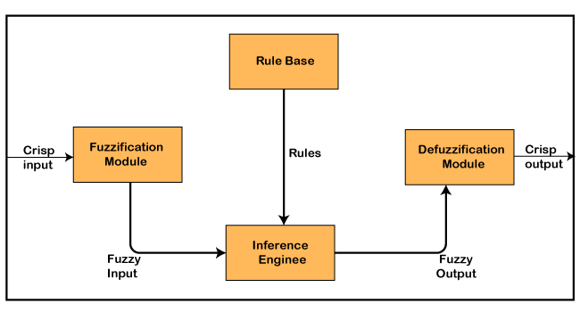

**1. Rule Base**

Rule Base is a component used for storing the set of rules and the If-Then conditions given by the experts are used for controlling the decision-making systems. There are so many updates that come in the Fuzzy theory recently, which offers effective methods for designing and tuning of fuzzy controllers. These updates or developments decreases the number of fuzzy set of rules.

**2. Fuzzification**

Fuzzification is a module or component for transforming the system inputs, i.e., it converts the crisp number into fuzzy steps. The crisp numbers are those inputs which are measured by the sensors and then fuzzification passed them into the control systems for further processing. This component divides the input signals into following five states in any Fuzzy Logic system:

Large Positive (LP)

Medium Positive (MP)

Small (S)

Medium Negative (MN)

Large negative (LN)

**3. Inference Engine**

This component is a main component in any Fuzzy Logic system (FLS), because all the information is processed in the Inference Engine. It allows users to find the matching degree between the current fuzzy input and the rules. After the matching degree, this system determines which rule is to be added according to the given input field. When all rules are fired, then they are combined for developing the control actions.

**4. Defuzzification**

Defuzzification is a module or component, which takes the fuzzy set inputs generated by the Inference Engine, and then transforms them into a crisp value. It is the last step in the process of a fuzzy logic system. The crisp value is a type of value which is acceptable by the user. Various techniques are present to do this, but the user has to select the best one for reducing the errors.

**Why Use Fuzzy Logic in Control Systems**

A control system is an arrangement of physical components designed to alter another physical system so that this system exhibits certain desired characteristics. Following are some reasons of using Fuzzy Logic in Control Systems −

* While applying traditional control, one needs to know about the model and the objective function formulated in precise terms. This makes it very difficult to apply in many cases.
* By applying fuzzy logic for control we can utilize the human expertise and experience for designing a controller.
* The fuzzy control rules, basically the IF-THEN rules, can be best utilized in designing a controller.

Assumptions in Fuzzy Logic Control (FLC) Design

While designing fuzzy control system, the following six basic assumptions should be made −

* **The plant is observable and controllable** − It must be assumed that the input, output as well as state variables are available for observation and controlling purpose.
* **Existence of a knowledge body** − It must be assumed that there exist a knowledge body having linguistic rules and a set of input-output data set from which rules can be extracted.
* **Existence of solution** − It must be assumed that there exists a solution.
* **‘Good enough’ solution is enough** − The control engineering must look for ‘good enough’ solution rather than an optimum one.
* **Range of precision** − Fuzzy logic controller must be designed within an acceptable range of precision.
* **Issues regarding stability and optimality** − The issues of stability and optimality must be open in designing Fuzzy logic controller rather than addressed explicitly.

**Example of a Fuzzy Logic System:**

Fuzzy logic is applied with great success in various control application. Almost all the consumer products have fuzzy control. Some of the examples include controlling your room temperature with the help of air-conditioner, anti-braking system used in vehicles, control on traffic lights, washing machines, large economic systems, etc.

Example-1

Let us consider an air conditioning system with 5-level fuzzy logic system. This system adjusts the temperature of air conditioner by comparing the room temperature and the target temperature value.

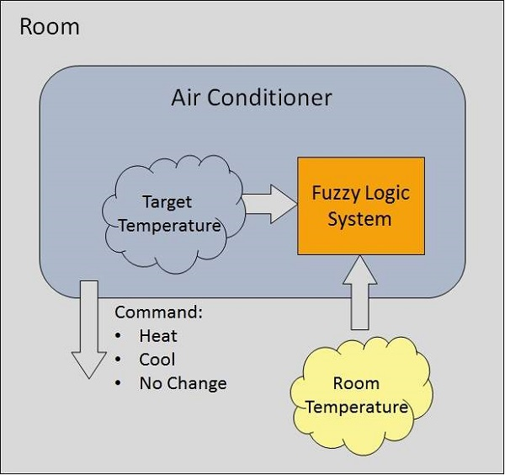

**Algorithm**

* Define linguistic Variables and terms (start)
* Construct membership functions for them. (start)
* Construct knowledge base of rules (start)
* Convert crisp data into fuzzy data sets using membership functions. (fuzzification)
* Evaluate rules in the rule base. (Inference Engine)
* Combine results from each rule. (Inference Engine)
* Convert output data into non-fuzzy values. (defuzzification)

**Development**

**Step 1 − Define linguistic variables and terms**

Linguistic variables are input and output variables in the form of simple words or sentences. For room temperature, cold, warm, hot, etc., are linguistic terms.

Temperature (t) = {very-cold, cold, warm, very-warm, hot}

Every member of this set is a linguistic term and it can cover some portion of overall temperature values.

**Step 2 − Construct membership functions for them**

The membership functions of temperature variable are as shown −

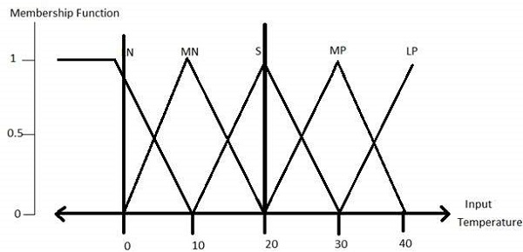

**Step3 − Construct knowledge base rules**

Create a matrix of room temperature values versus target temperature values that an air conditioning system is expected to provide.

|  |  |  |  |  |  |
| --- | --- | --- | --- | --- | --- |
| **RoomTemp. /Target** | **Very_Cold** | **Cold** | **Warm** | **Hot** | **Very_Hot** |
| Very_Cold | No_Change | Heat | Heat | Heat | Heat |
| Cold | Cool | No_Change | Heat | Heat | Heat |
| Warm | Cool | Cool | No_Change | Heat | Heat |
| Hot | Cool | Cool | Cool | No_Change | Heat |
| Very_Hot | Cool | Cool | Cool | Cool | No_Change |

Build a set of rules into the knowledge base in the form of IF-THEN-ELSE structures.

|  |  |  |
| --- | --- | --- |
| **Sr. No.** | **Condition** | **Action** |
| 1 | IF temperature=(Cold OR Very_Cold) AND target=Warm THEN | Heat |
| 2 | IF temperature=(Hot OR Very_Hot) AND target=Warm THEN | Cool |
| 3 | IF (temperature=Warm) AND (target=Warm) THEN | No_Change |

**Step 4 − Obtain fuzzy value**

Fuzzy set operations perform evaluation of rules. The operations used for OR and AND are Max and Min respectively. Combine all results of evaluation to form a final result. This result is a fuzzy value.

**Step 5 − Perform defuzzification**

Defuzzification is then performed according to membership function for output variable.

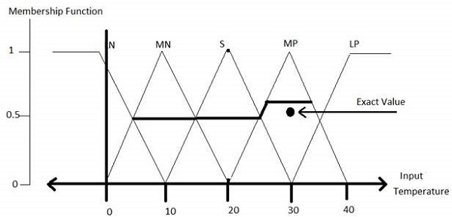

**Example-2**

Let us design a simple fuzzy control system to control operation of a washing machine such that the fuzzy system controls the washing process, water intake, wash time and spin speed.

The input parameters here are the volume of clothes, degree of dirt and type of dirt. While the volume of clothes would determine the water intake, the degree of dirt in turn would be determined by the transparency of water and the type of dirt is determined by the time at which the water color remains unchanged.

**Step 1**: The first step would involve defining linguistic variables and terms. For the inputs, the linguistic variables are as given below

1. Type of Dirt: {Greasy, Medium, Not Greasy }
2. Quality of Dirt: {Large, Medium, Small }

For output, the linguistic variables are as given below

Wash Time: {Short, Very Short, Long, Medium, Very Long}

**Step 2**: The second step involves construction of membership functions.

Given below are graphs determining membership functions for the two inputs are as given below:

Membership Functions for Quality of Dirt

**[[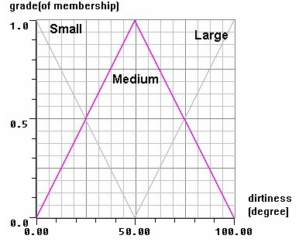](https://www.electricaltechnology.org/wp-content/uploads/2018/01/Membership-Functions-for-Quality-of-Dirt.jpg)](https://www.electricaltechnology.org/wp-content/uploads/2018/01/Membership-Functions-for-Quality-of-Dirt.jpg)**

**Membership Functions for Type of Dirt**

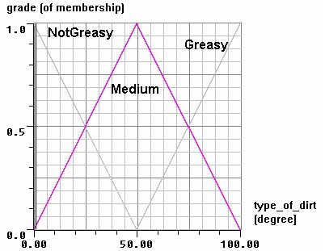

**Step 3**: The third step involves developing a set of rules for the knowledge base. Given below are the set of rules using IF-THEN logic

1. IF quality of dirt is Small AND Type of dirt is Greasy, THEN Wash Time is Long.
2. IF quality of dirt is Medium AND Type of dirt is Greasy, THEN Wash Time is Long.
3. IF quality of dirt is Large and Type of dirt is Greasy, THEN Wash Time is Very Long.
4. IF quality of dirt is Small AND Type of dirt is Medium, THEN Wash Time is Medium.
5. IF quality of dirt is Medium AND Type of dirt is Medium, THEN Wash Time is Medium.
6. IF quality of dirt is Large and Type of dirt is Medium, THEN Wash Time is Medium.
7. IF quality of dirt is Small AND Type of dirt is Non-Greasy, THEN Wash Time is Very Short.
8. IF quality of dirt is Medium AND Type of dirt is Non-Greasy, THEN Wash Time is Medium.
9. IF quality of dirt is Large and Type of dirt is Greasy, THEN Wash Time is Very Short.

**Step 4**: The fuzzifier which initially had converted the sensor inputs to these linguistic variables, now applies the above rules to perform the fuzzy set operations (like MIN and MAX) to determine the output fuzzy functions. Based upon the output fuzzy **Step 5**: The final step is the defuzzification step where the Defuzzifier uses the output membership functions to determine the output washing time.

sets, the membership function is developed.

Application Areas of Fuzzy Logic

Applications of Fuzzy Logic

The Fuzzy logic is used in various fields such as automotive systems, domestic goods, environment control, etc. Some of the common applications are:

* 1. It is used in the aerospace field for altitude control of spacecraft and satellite.
  2. This controls the speed and traffic in the automotive systems.
  3. It is used for decision making support systems and personal evaluation in the large company business.
  4. It also controls the pH, drying, chemical distillation process in the chemical industry.
  5. Fuzzy logic is used in Natural language processing and various intensive applications in Artificial Intelligence.
  6. It is extensively used in modern control systems such as expert systems.
  7. Fuzzy Logic mimics how a person would make decisions, only much faster. Thus, you can use it with Neural Networks.

These were some of the common applications of the Fuzzy Logic.

The key application areas of fuzzy logic are as given −

**Automotive Systems**

* Automatic Gearboxes
* Four-Wheel Steering
* Vehicle environment control

**Consumer Electronic Goods**

* Hi-Fi Systems
* Photocopiers
* Still and Video Cameras
* Television

**Domestic Goods**

* Microwave Ovens
* Refrigerators
* Toasters
* Vacuum Cleaners
* Washing Machines

**Environment Control**

* Air Conditioners/Dryers/Heaters
* Humidifiers

**Advantages of Fuzzy Logic**

Fuzzy Logic has various advantages or benefits. Some of them are as follows:

1. The methodology of this concept works similarly as the human reasoning.
2. Any user can easily understand the structure of Fuzzy Logic.
3. It does not need a large memory, because the algorithms can be easily described with fewer data.
4. It is widely used in all fields of life and easily provides effective solutions to the problems which have high complexity.
5. This concept is based on the set theory of mathematics, so that's why it is simple.
6. It allows users for controlling the control machines and consumer products.
7. The development time of fuzzy logic is short as compared to conventional methods.
8. Due to its flexibility, any user can easily add and delete rules in the FLS system.

**Disadvantages of Fuzzy Logic**

Fuzzy Logic has various disadvantages or limitations. Some of them are as follows:

1. The run time of fuzzy logic systems is slow and takes a long time to produce outputs.
2. Users can understand it easily if they are simple.
3. The possibilities produced by the fuzzy logic system are not always accurate.
4. Many researchers give various ways for solving a given statement using this technique which leads to ambiguity.
5. Fuzzy logics are not suitable for those problems that require high accuracy.
6. The systems of a Fuzzy logic need a lot of testing for verification and validation.

**References**

1. Zadeh L A, Fuzzy sets, Inf. Control 89 (1965) 353-383.
2. Atanassov K. (1986) Intuitionistic fuzzy sets, Fuzzy Sets and Systems, 20, 87–96.
3. Alsina C., Trillas E. and Valverde L., “On some logical connectives for fuzzy set theory”. Journal of Mathematical Analysis and its Applications, 93 (1) 15-26, 1983
4. Driankov D., Hellendorn H. and Reinfrank M., An Introduction to Fuzzy Control. Springer-Verlag, Berlin, 1996
5. Klir G.J. and Yuan B., Fuzzy Sets and Fuzzy Logic, Prentice-Hall, N.J., 1995.
6. Zadeh L.A., “A rationale for fuzzy control”, Jr. of Dynamic Systems, Measurements and Control 34, 3-4, 1972
7. Tanaka K., An Introduction to Fuzzy Logic for Practical Applications, Springer, N.Y., 1997
8. Amiya Patanaik, " Fuzzy Logic Control of Air Conditioners", Indian Institute of Technology, Kharagpur, - 721302, India
9. Technical case studies and articles on fuzzy logic and fuzzy logic based control systems www.sciencedirect.com, http://en.wikipedia.org and <http://www.aptronix.com/>.
10. Allahverdi N, “Expert Systems, An Application of Artificial Intelligent”, Atlas Press, Istanbul, 2002.
11. R. Narayan, “Fuzzy Logic Washing Machines”, Electronics for You, (2003).
12. Lohani,P.,& Hasan ,S.R., “ Design of an Improved Controller Microchip For Washing Machine” 16th Annual Electronics New Zealand Conference (pp. 20- 26).Dunedin : Otago University Press.(2009)
13. Workman. M, “Hardware requirement for Fuzzy Logic Control Systems”, Lubbock, TX: Texas Tech University. (1996)